Isolation, purification, and identification of antifungal protein produced by Bacillus subtilis SL-44 and anti-fungal resistance in apple
Wumei Chen, Zhansheng Wu*, Yanhui He

Xi’an Key Laboratory of Textile Chemical Engineering Auxiliaries, School of Environmental and Chemical Engineering, Xi’an Polytechnic University, Xi’an 710048, PR China

*Corresponding author: Zhansheng Wu, Tel: 86029 62779279, Fax: 86029 6277928 Email address: wuzhans@xpu.edu.cn

Table S1. Response surface test design and results.
Run | Coded variables |  |  | Uncoded variable |  |  | Response
Run | X₁ | X₂ | X₃ | X₁: Initial pH | X₂: Inoculum volume  (%) | X₃: Rotation speed  (rpm) | Inhibitory zone  (mm)
1 | 1 | 0 | 1 | 9 | 2 | 200 | 9.80
2 | -1 | 1 | 0 | 5 | 3 | 180 | 9.90
3 | 0 | 0 | 0 | 7 | 2 | 180 | 14.50
4 | 1 | 1 | 0 | 9 | 3 | 180 | 11.70
5 | 0 | -1 | -1 | 7 | 1 | 160 | 10.70
6 | -1 | 0 | 1 | 5 | 2 | 200 | 9.80
7 | 1 | 0 | -1 | 9 | 2 | 160 | 9.90
8 | 0 | 0 | 0 | 7 | 2 | 180 | 14.60
9 | 0 | 0 | 0 | 7 | 2 | 180 | 14.50
10 | 0 | 0 | 0 | 7 | 2 | 180 | 14.70
11 | -1 | 0 | -1 | 5 | 2 | 160 | 10.00
12 | -1 | -1 | 0 | 5 | 1 | 180 | 10.10
13 | 1 | -1 | 0 | 9 | 1 | 180 | 10.00
14 | 0 | 1 | 1 | 7 | 3 | 200 | 10.50
15 | 0 | -1 | 1 | 7 | 1 | 200 | 10.50
16 | 0 | 1 | -1 | 7 | 3 | 160 | 9.90
17 | 0 | 0 | 0 | 7 | 2 | 180 | 14.60

Table S2. Response surface regression model analysis of variance.
Source | Sum of squares | DF | Mean square | F-value | P-value | Significance
Model | 69.09 | 9 | 7.68 | 42.63 | < 0.0001 | Extremely significant
A | 0.36 | 1 | 0.36 | 2.01 | 0.1996 | Non-significant
B | 0.080 | 1 | 0.080 | 0.44 | 0.5264 | Non-significant
C | 0.00125 | 1 | 0.00125 | 0.006942 | 0.9359 | Non-significant
AB | 0.81 | 1 | 0.81 | 4.50 | 0.0716 | Non-significant
AC | 0.0025 | 1 | 0.0025 | 0.014 | 0.9095 | Non-significant
BC | 0.16 | 1 | 0.16 | 0.89 | 0.3773 | Non-significant
A² | 23.30 | 1 | 23.30 | 129.40 | < 0.0001 | Extremely significant
B² | 14.06 | 1 | 14.06 | 78.09 | < 0.0001 | Extremely significant
C² | 23.30 | 1 | 23.30 | 129.40 | < 0.0001 | Extremely significant
Residual | 1.26 | 7 | 0.18
Lack of fit | 1.23 | 3 | 0.41 | 58.69 | 0.0009 | Extremely significant
Pure error | 0.028 | 4 | 0.0007
Cor total | 70.35 | 16
R²=0.9821 | R² adj=0.9590 | R² pre=0.7191
Adeq precision | 15.148

Fig. S1. Characterization and identification of the antifungal protein. (A) Functional classification of GO annotation with genomic P2-1. (B) Gene distribution is based on the KEGG pathway of P2-1.
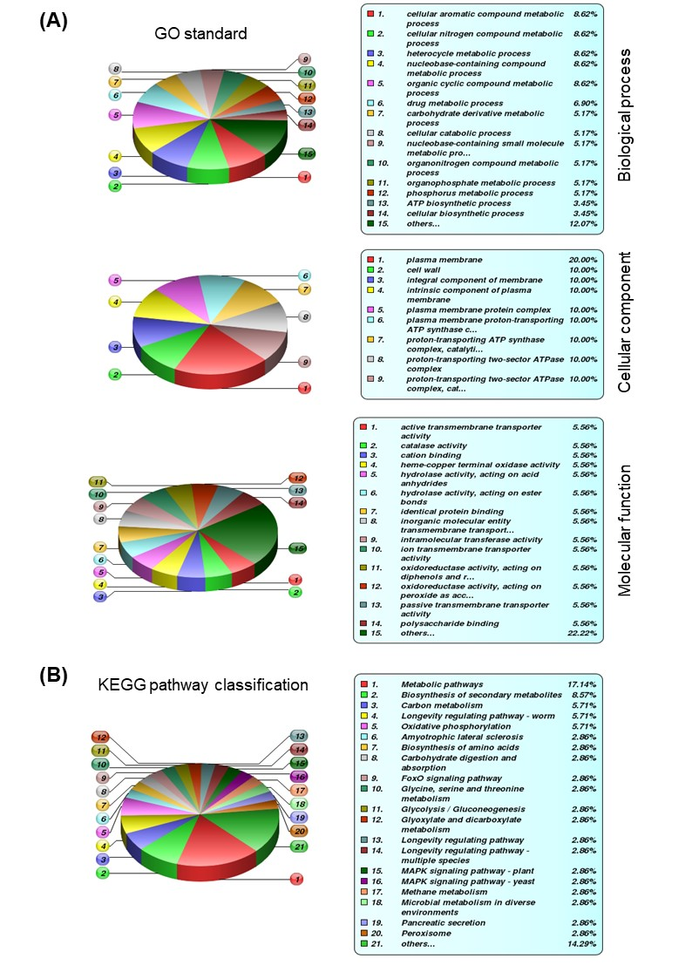
Fig. S2 Antibiotics biosynthesis gene clusters in B. subtilis SL-44.
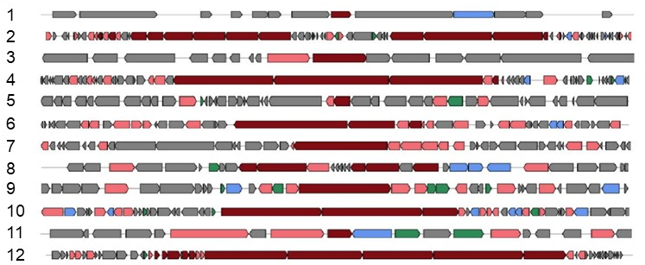

Table S3. The predicted characterization of BGCs of B. subtilis SL-44 in antiSMASH
 | Clusters | From | to | Most Similar known Cluster | Similarity
1 | RIPP-like | 1,554 | 11,898 | - | -
2 | NRPS, betalactone, transAT-PKS | 85,572 | 223,824 | fengycin | 100%
3 | terpene | 242,684 | 263,808 | - | -
4 | transAT-PKS | 301,982 | 388,597 | anthracimycin | 22%
5 | T3PKS | 394,855 | 435,273 | - | -
6 | NRPS, ladderane | 580,468 | 637,100 | pelgipeptin | 25%
7 | NRPS | 1,328,138 | 1,374,018 | bacillibactin | 100%
8 | Thiopeptide, LAP | 1,391,711 | 1,421,817 | - | -
9 | NRPS | 2,457,139 | 2,502,696 | rhizocticin | 45%
10 | NRPS | 2,619,367 | 2,683,195 | surfactin | 86%
11 | terpene | 3,458,255 | 3,479,097 | - | -
12 | TransAT-PKS, PKS-like, T3PKS, NRPS | 4,109,952 | 4,217,729 | bacillaene | 100%

