Safety and feasibility of apheresis to harvest and concentrate parasites in subjects with induced blood stage Plasmodium vivax infection supplementary material
Fig. 1 Design of apheresis study
Schematic illustrating the main study activities.

Fig. 2 Fold enrichment of P. vivax parasites determined by 18S qPCR/RBC
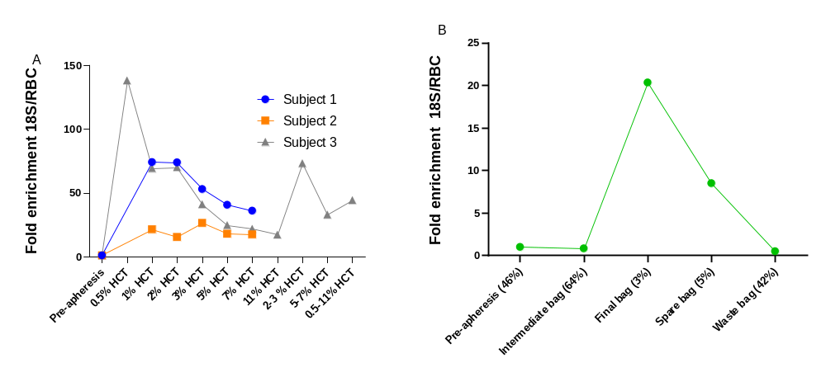
Fold enrichment of P. vivax parasites corrected for red blood cell counts as determined by 18S qPCR in samples collected using apheresis compared to the pre-apheresis sample in subjects 1, 2 and 3 (A) and subject 4 (B).

Figure 3. Schematic of cohort 4 sampling
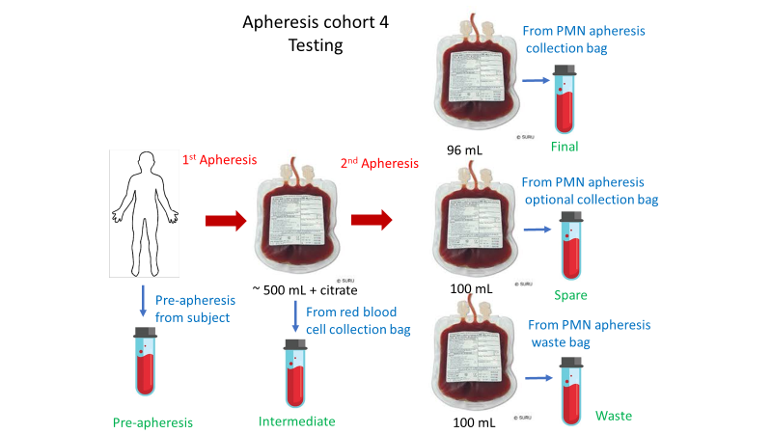
Schematic illustrating the origins of the pre-apheresis, intermediate, final, spare and waste samples collected during cohort 4. Cohort 4 involved two consecutive apheresis procedures. The first was a red blood cell depletion protocol resulting in production of the intermediate bag (~ 500 ml 64% HCT). A polymorphonuclear (PMN) collection was then conducted on this red blood cell collection bag and involved sampling of ~ 96 ml of the lowest HCT layers of the sample (final bag 3% HCT) followed by ~ 100 ml of the subsequent lowest HCT layers (spare bag 5% HCT) and then the remainder ~ 100 ml (waste bag 42% HCT). PMN; polymorphonuclear.
Fig. 4 Fold Enrichment female P. vivax gametocytes determined by pvs25/RBC.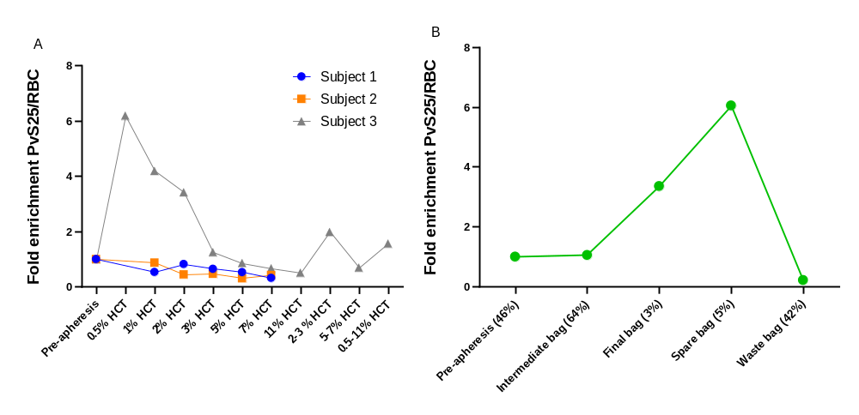

Fold enrichment of female P. vivax gametocytes corrected for RBC counts determined by pvS25 collected using apheresis compared to the pre-apheresis sample in subjects 1 , 2 and 3 (A) and subject 4 (B).
Fig. 5 Fold Enrichment of P. falciparum parasites in pre-clinical experiment.
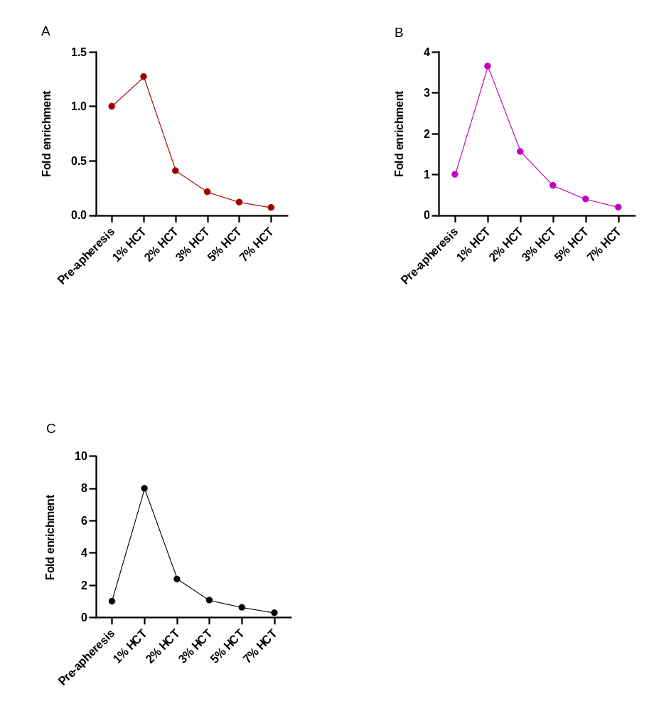
Fold enrichment of parasites seen in hematocrit layer samples taken during apheresis compared to the pre-apheresis sample. 5A Fold enrichment of asexual P. falciparum parasites as measured by 18S qPCR, 5B Fold enrichment of female P. falciparum gametocytes as measured by pfs25 qRT PCR/ml, and 5C Fold enrichment of male P. falciparum gametocytes as measured by pfMGET qRT PCR.

Table 1. Pre-clinical experiment P. falciparum asexual parasites/ml
Sample Type | asexual parasites (18S qPCR/ml) | Fold enrichment asexual parasites compared to pre-apheresis
Pre-apheresis | 9,547,013,966 | 1
1% HCT | 12,150,153,926 | 1.27
2% HCT | 3,907,293,793 | 0.41
3% HCT | 2,061,766,413 | 0.22
5% HCT | 1,153,158,327 | 0.12
7% HCT | 689,601,796 | 0.07
Fold enrichment of asexual parasites as measured by 18S qPCR/ml seen in hematocrit layer samples taken during apheresis compared to the pre-apheresis sample for asexual P. falciparum parasites.
Table 2. Pre-clinical experiment P. falciparum female gametocytes/ml
Sample Type | female Gametocytes (pfS25/ml) | fold enrichment female gametocytes compared to pre-apheresis
Pre-apheresis | 3,626,818 | 1
1% HCT | 13,247,518 | 3.65
2% HCT | 5,669,575 | 1.56
3% HCT | 2,652,747 | 0.73
5% HCT | 1,446,435 | 0.40
7% HCT | 719,056 | 0.20
Fold enrichment of female gametocytes as measured by pfS25/ml seen in hematocrit layer samples taken during apheresis compared to the pre-apheresis sample for P. falciparum female gametocytes.

Table 3. Pre-clinical experiment P. falciparum male gametocytes/ml
Sample Type | Male Gametocytes (pfMGET/ml) | fold enrichment male gametocytes compared to pre-apheresis
Pre-apheresis | 1,795,051 | 1
1% HCT | 14,370,397 | 8.01
2% HCT | 4,265,936 | 2.38
3% HCT | 1,917,837 | 1.07
5% HCT | 1,114,766 | 0.62
7% HCT | 508,801 | 0.28
Fold enrichment of male gametocytes as measured by pfMGET/ml seen in hematocrit layer samples taken during apheresis compared to the pre-apheresis sample for P. falciparum male gametocytes.

Figure 6. P. falciparum pre-clinical experiment.
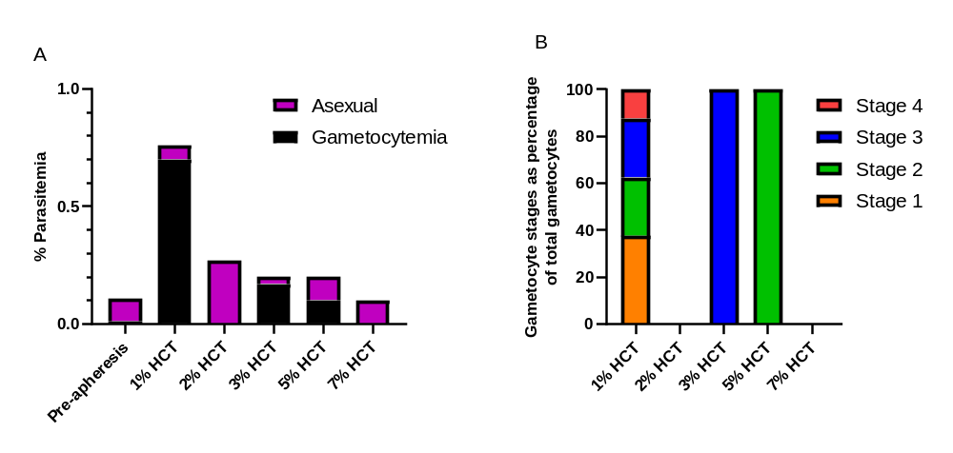6A microscopy of samples taken during apheresis compared to the pre-apheresis sample. Microscopy is split by P. falciparum asexual parasites and gametocytes. 6B gametocyte stages identified during microscopy of samples taken during apheresis. In the 2% HCT, 7% HCT and pre-apheresis samples gametocytes were not observed by microscopy.

Table 4. Pre-clinical experiment P. falciparum parasitemia
Sample | Gametocytemia |  | Asexual parasitemia
Sample | % | Fold enrichment compared to pre-apheresis | % | Fold enrichment compared to pre-apheresis
Pre-apheresis | 0.01 | N/A | 0.1 | N/A
1% HCT | 0.76 | 76 | 0.06 | 0.6
2% HCT | 0 | N/A | 0.27 | 2.7
3% HCT | 0.17 | 17 | 0.03 | 0.3
5% HCT | 0.1 | 10 | 0.1 | 1
7% HCT | 0 | N/A | 0.1 | 1
Microscopy of samples taken during apheresis compared to the pre-apheresis sample. Microscopy is split by P. falciparum asexual parasitemia and gametocytemia as defined by % of infected red blood cells.

Table 5. Pre-clinical experiment P. falciparum parasitemia
Sample | % Stage 1 | % Stage 2 | % Stage 3 | % Stage 4
1% HCT | 37.5 | 25 | 25 | 12.5
2% HCT | N/A | N/A | N/A | N/A
3% HCT | 0 | 0 | 100 | 0
5% HCT | 0 | 100 | 0 | 0
7% HCT | N/A | N/A | N/A | N/A
Microscopy staging of P. falciparum gametocytes identified insamples taken during apheresis. In the samples collected pre-apheresis and from the 2% HCT, 7% HCT layers gametocytes were not observed by microscopy.

Table 6. Haematocrit and Red cell counts
Subject | Sample Type | Actual HCT | Red Cell Count (× 10⁶/L)
1 | Pre-apheresis | 0.38 | 4.35 × 10³
1 | 1% HCT | 0.01 | 1.40 × 10²
1 | 2% HCT | 0.02 | 1.90 × 10²
1 | 3% HCT | 0.03 | 3.00 × 10²
1 | 5% HCT | 0.04 | 4.30 × 10²
1 | 7% HCT | 0.05 | 5.90 × 10²
2 | Pre-apheresis | 0.41 | 4.81 × 10³
2 | 1% HCT | 0.01 | 2.00 × 10²
2 | 2% HCT | 0.03 | 3.50 × 10²
2 | 3%HCT | 0.03 | 2.60 × 10²
2 | 5% HCT | 0.03 | 4.30 × 10²
2 | 7% HCT | 0.05 | 5.00 × 10²
3 | Pre-apheresis | 0.44 | 5.34 × 10³
3 | 0.5% HCT | 0.01 | 7.00 × 10
3 | 1% HCT | 0.01 | 1.40 × 10²
3 | 2% HCT | 0.01 | 1.50 × 10²
3 | 3% HCT | 0.03 | 3.50 × 10²
3 | 5% HCT | 0.04 | 4.40 × 10²
3 | 7% HCT | 0.07 | 7.70 × 10²
3 | *8% HCT | 0.11 | 1.23 × 10³
3 | 2-3% HCT | 0.02 | 2.60 × 10²
3 | 5-7% HCT | 0.05 | 6.10 × 10²
3 | 0.5-8%* HCT | 0.04 | 4.50 × 10²
4 | Pre-apheresis | 0.46 | 5.22 × 10³
4 | Intermediate sample | 0.64 | 7.18 × 10³
4 | Final sample | 0.03 | 2.90 × 10²
4 | Spare sample | 0.05 | 4.80 × 10²
4 | Waste sample | 0.42 | 3.94 × 10³
*8% HCT was subsequently renamed as 11% HCT given the Sysmex HCT result
Haematocrit and red cell count results for samples taken pre-apheresis and during apheresis for subjects 1 to 4.

Fig. 7 RBC/WBC ratio in apheresis samples
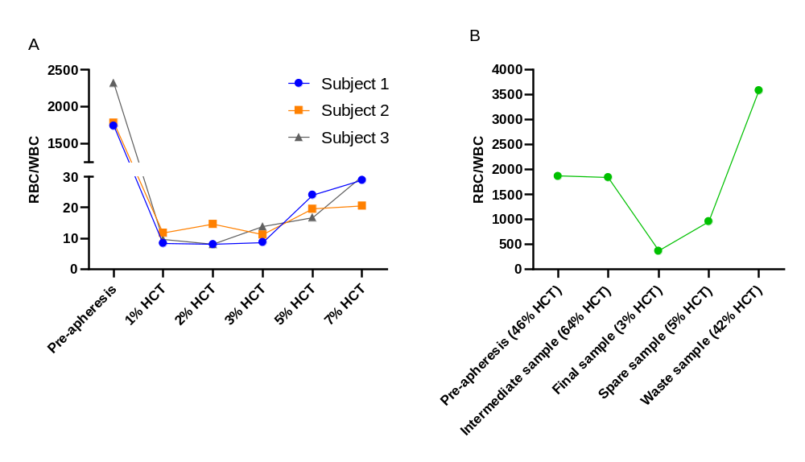7A RBC/WBC ratio results for samples taken pre-apheresis and from the 1% HCT, 2% HCT, 3% HCT, 5% HCT and 7% HCT layers during apheresis from subjects 1 to 3. The apheresis HCT layers selected for the figure were those that were sampled across all 3 subjects. Subject 4 was not included as the composition of samples differed significantly from subjects 1 to 3. 7B RBC/WBC ratio results for samples taken pre-apheresis and during apheresis from subject 4.

Table 7. P. vivax asexual parasites/ml and asexual parasites/RBC apheresis clinical study
Subject | Sample Type | Asexual parasites/ml | fold enrichment asexual parasites compared to pre-apheresis | Red Cell Count | asexual parasites/RBC | fold enrichment asexual parasites/RBC compared to pre-apheresis
1 | Pre-apheresis | 11,497 | 1 | 4.35E+09 | 2.64E-06 | 1.00
1 | 1% HCT | 27,394 | 2.38 | 1.40E+08 | 1.96E-04 | 74.03
1 | 2% HCT | 37,064 | 3.22 | 1.90E+08 | 1.95E-04 | 73.81
1 | 3% HCT | 41,945 | 3.65 | 3.00E+08 | 1.40E-04 | 52.90
1 | 5% HCT | 46,105 | 4.01 | 4.30E+08 | 1.07E-04 | 40.57
1 | 7% HCT | 56,180 | 4.89 | 5.90E+08 | 9.52E-05 | 36.03
2 | Pre-apheresis | 24,100 | 1 | 4.81E+09 | 5.01E-06 | 1.00
2 | 1% HCT | 21,409 | 0.89 | 2.00E+08 | 1.07E-04 | 21.36
2 | 2% HCT | 27,022 | 1.12 | 3.50E+08 | 7.72E-05 | 15.41
2 | 3%HCT | 34,406 | 1.43 | 2.60E+08 | 1.32E-04 | 26.41
2 | 5% HCT | 38,646 | 1.6 | 4.30E+08 | 8.99E-05 | 17.94
2 | 7% HCT | 43,480 | 1.8 | 5.00E+08 | 8.70E-05 | 17.36
3 | Pre-apheresis | 25,475 | 1 | 5.34E+09 | 4.77E-06 | 1.00
3 | 0.5% HCT | 46,009 | 1.81 | 7.00E+07 | 6.57E-04 | 137.77
3 | 1% HCT | 46,212 | 1.81 | 1.40E+08 | 3.30E-04 | 69.19
3 | 2% HCT | 50,077 | 1.97 | 1.50E+08 | 3.34E-04 | 69.98
3 | 3% HCT | 68,441 | 2.69 | 3.50E+08 | 1.96E-04 | 40.99
3 | 5% HCT | 51,600 | 2.03 | 4.40E+08 | 1.17E-04 | 24.58
3 | 7% HCT | 80,024 | 3.14 | 7.70E+08 | 1.04E-04 | 21.78
3 | 11% HCT | 100,951 | 3.96 | 1.23E+09 | 8.21E-05 | 17.20
3 | 2/3% HCT | 90,662 | 3.56 | 2.60E+08 | 3.49E-04 | 73.09
3 | 5/7% HCT | 95,699 | 3.76 | 6.10E+08 | 1.57E-04 | 32.89
3 | 0.5-11% HCT | 94,785 | 3.72 | 4.50E+08 | 2.11E-04 | 44.15
4 | Pre-apheresis | 94,965 | 1 | 5.22E+09 | 1.82E-05 | 1.00
4 | Intermediate | 108,041 | 1.15 | 7.18E+09 | 1.50E-05 | 0.83
4 | Final | 107,251 | 1.14 | 2.90E+08 | 3.70E-04 | 20.33
4 | Spare | 74,149 | 0.79 | 4.80E+08 | 1.54E-04 | 8.49
4 | Waste | 36,059 | 0.38 | 3.94E+09 | 9.15E-06 | 0.50
P. vivax asexual parasites/ml and asexual parasites/RBC apheresis clinical study data from subjects 1 to 4 including fold enrichments as measured by 18S qPCR.

Table 8. P. vivax gametocytes/ml and gametocytes/RBC apheresis clinical study
Subject | Sample | gametocytes/ml | fold enrichment gametocytes/ml compared to pre-apheresis | Red Cell Count | gametocytes/RBC | fold enrichment gametocytes/RBC compare to pre-apheresis
1 | Pre-apheresis | 26,458 | 1.00 | 4.35E+09 | 6.08E-06 | 1.00
1 | 1% HCT | 454 | 0.02 | 1.40E+08 | 3.24E-06 | 0.53
1 | 2% HCT | 952 | 0.04 | 1.90E+08 | 5.01E-06 | 0.82
1 | 3% HCT | 1,186 | 0.04 | 3.00E+08 | 3.95E-06 | 0.65
1 | 5% HCT | 1,388 | 0.05 | 4.30E+08 | 3.22E-06 | 0.53
1 | 7% HCT | 1,146 | 0.04 | 5.90E+08 | 1.94E-06 | 0.32
1 | Percoll | 9,396 | 0.36 | N/A | N/A | N/A
2 | Pre-apheresis | 88,670 | 1.00 | 4.81E+09 | 1.84E-05 | 1.00
2 | 1% HCT | 3,216 | 0.04 | 2.00E+08 | 1.61E-05 | 0.87
2 | 2% HCT | 2,871 | 0.03 | 3.50E+08 | 8.20E-06 | 0.44
2 | 3%HCT | 2,246 | 0.03 | 2.60E+08 | 8.64E-06 | 0.47
2 | 5% HCT | 2,429 | 0.03 | 4.30E+08 | 5.65E-06 | 0.31
2 | 7% HCT | 3,907 | 0.04 | 5.00E+08 | 7.81E-06 | 0.42
2 | Percoll | 2,064,260 | 23.28 | N/A | N/A | N/A
3 | Pre-apheresis | 114,495 | 1.00 | 5.34E+09 | 2.14E-05 | 1.00
3 | 0.5% HCT | 9,283 | 0.08 | 7.00E+07 | 1.33E-04 | 6.19
3 | 1% HCT | 12,573 | 0.11 | 1.40E+08 | 8.98E-05 | 4.19
3 | 2% HCT | 10,983 | 0.10 | 1.50E+08 | 7.32E-05 | 3.42
3 | 3% HCT | 9,390 | 0.08 | 3.50E+08 | 2.68E-05 | 1.25
3 | 5% HCT | 8,100 | 0.07 | 4.40E+08 | 1.84E-05 | 0.86
3 | 7% HCT | 10,999 | 0.10 | 7.70E+08 | 1.43E-05 | 0.67
3 | 11% HCT | 13,472 | 0.12 | 1.23E+09 | 1.10E-05 | 0.51
3 | 2/3% HCT | 11,035 | 0.10 | 2.60E+08 | 4.24E-05 | 1.98
3 | 5/7% HCT | 9,097 | 0.08 | 6.10E+08 | 1.49E-05 | 0.70
3 | 0.5-11% HCT | 15,054 | 0.13 | 4.50E+08 | 3.35E-05 | 1.56
3 | Percoll | 3,618,500 | 44.8 | N/A | N/A | N/A
4 | Pre-apheresis | 547,975 | 1.00 | 5.22E+09 | 1.05E-04 | 1.00
4 | Intermediate | 794,329 | 1.45 | 7.18E+09 | 1.11E-04 | 1.05
4 | Final | 102,192 | 0.19 | 2.90E+08 | 3.52E-04 | 3.36
4 | Spare | 304,977 | 0.56 | 4.80E+08 | 6.35E-04 | 6.05
4 | Waste | 90,743 | 0.17 | 3.94E+09 | 2.30E-05 | 0.22
P. vivax gametocytes/ml and gametocytes/RBC apheresis clinical study data from subjects 1 to 4 including fold enrichments as measured by pvS25 qPCR.

Fig. 8 P. vivax asexual parasites and gametocytes pre and post apheresis.
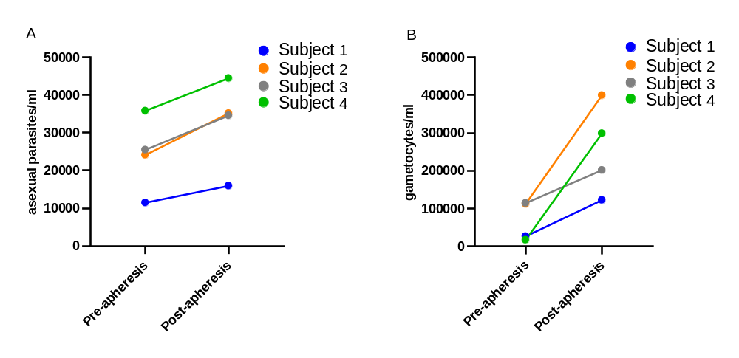
Change in P. vivax asexual parasites/ml (8A) and gametocytes/ml (8B) from whole blood samples taken from subjects pre and post-apheresis, as measured by 18S qPCR/ml and pvS2 qPCR respectively.

Fig. 9 Flow cytometry in Subject 1.
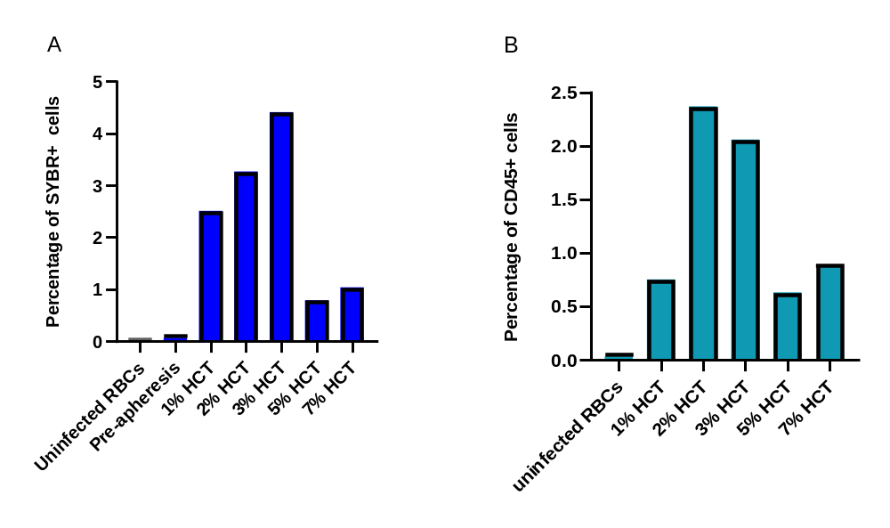
Flow cytometry single staining for SYBR green (9A) and CD45 (9B) in subject 1.

Fig. 10 Subject 2 flow cytometry findings CD45 and SYBR green stains
Pre-apheresis
1% HCT
2% HCT
CD45 (405-50 nm)
3% HCT
5% HCT
7% HCT
SYBR green (530-30 nm)

Fig. 11 Subject 3 flow cytometry findings CD45 and SYBR green stains
1% HCT
2% HCT
3% HCT
0.5% HCT
CD45 (405-50 nm)

11% HCT
7% HCT
5% HCT

SYBR green (530-30 nm)
Pre-apheresis
Uninfected RBCs
CD45 (405-50 nm)

Pool 0.5-11% HCT
Pool 5-7% HCT
Pool 2-3% HCT
SYBR green (530-30 nm)

Fig. 12 Subject 4 flow cytometry findings CD45 and SYBR green stains
Intermediate bag (64% HCT)
Pre-apheresis (46% HCT)
Uninfected RBCs
CD45 (405-50 nm)

Waste bag (42% HCT)
Spare bag (5% HCT)
Final Bag (3% HCT)

SYBR green (530-30 nm)

Table 9. P. vivax microscopy findings for subjects 1 to 3
Sample | Subject 1 |  | Subject 2 |  |  |  | *Subject 3
Sample |  |  | Reader 1 |  | Reader 2
Sample | Thick film | Thin film | Thick film | Thin film | Thick film | Thin film | Thick film | Thin film
Pre-apheresis | unreadable | 2 rings | 2 rings | 0 | 3 rings | 0 | 17 | 0
Percoll | unreadable | 1 ring | n/a | 0 | n/a | 0 | 70 | unreadable
0.5% HCT | unreadable | n/a | n/a | n/a | n/a | n/a | unreadable | unreadable
1% HCT | unreadable | 2 rings | 8 rings | 0 | 12 rings | 1 ring | unreadable | unreadable
2% HCT | unreadable | 1 ring | 1 ring | 1 ring | 2 rings | 0 | unreadable | 1
3% HCT | unreadable | 0 | 0 | 1 ring | 0 | 0 | unreadable | 7
5% HCT | unreadable | 0 | 1 ring | 0 | 1 ring | 0 | unreadable | 4
7% HCT | unreadable | 0 | 1 ring | 0 | 1 ring | 0 | unreadable | 1
11% HCT | unreadable | n/a | n/a | n/a | n/a | n/a | unreadable | 0
Pool 2-3% | unreadable | n/a | n/a | n/a | n/a | n/a | unreadable | 12
Pool 5-7% | unreadable | n/a | n/a | n/a | n/a | n/a | unreadable | 6
Pool 0.5-11% | unreadable | n/a | n/a | n/a | n/a | n/a | unreadable | 0
Two microscopists reviewed thick and thin films from subject 2. Subjects 1 and 3 involved only one microscopists who reviewed both thick and thin films.
*microscopist did not specifically document the type of P. vivax parasites in each sample but simply commented there were “rings and trophozoites and a single gametocyte”. P. vivax parasite denominators can be found in supplementary material.

Table 10. P. vivax microscopy findings for subject 4.
Sample (HCT) | Reader 1 thick film | Reader 2 thick film | Reader 3 thin film
Pre-apheresis (46%) | 7 rings | 6 trophozoites 2 female gametocytes | 1 trophozoite
Intermediate (64%) | 3 trophozoites | 6 trophozoites | n/a
Final (3%) | n/a | 4 trophozoites | n/a
Spare (5%) | n/a | n/a | n/a
Waste (42%) | 3 trophozoites | 2 rings 8 trophozoites | 1 trophozoite
Two microscopists reviewed the thick films and one the thin films from subject 4. P. vivax parasite denominators can be found in supplementary material.
Fig. 13 Apheresis single use cassette used during P. vivax apheresis clinical study

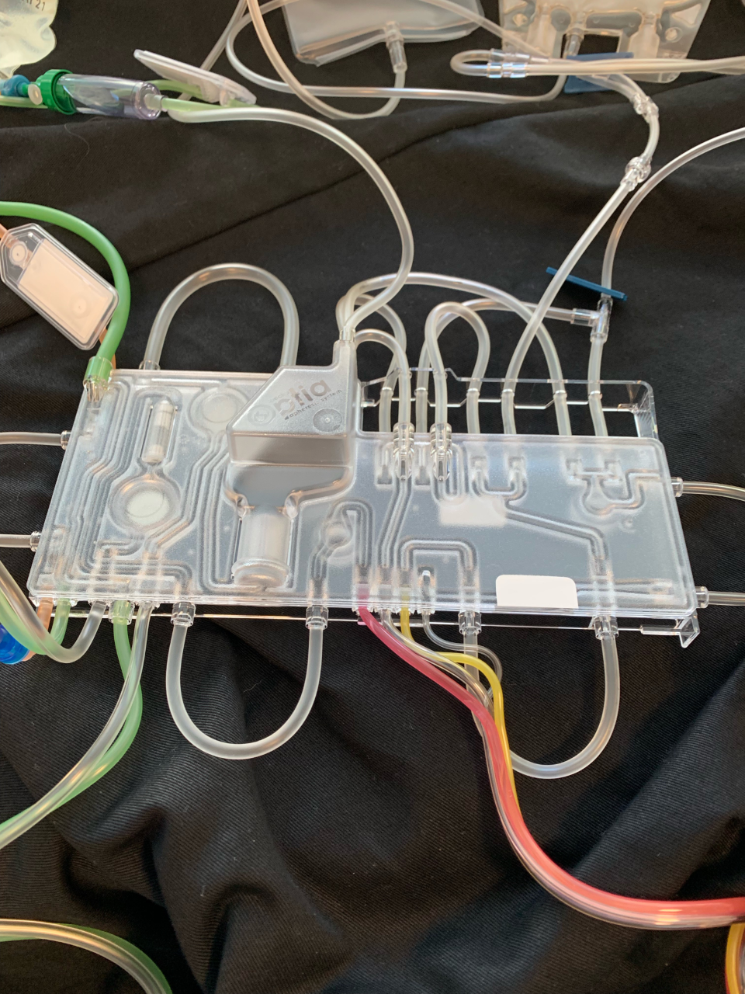
Magnet 2
Silo
Magnet 1
Example of an intermediate density layer apheresis single use casette used during apheresis. The 2 magnets and silo structure, where blood clots were found following subject 3’s apheresis procedure, are identified. Blood clots subsequently underwent 18S qPCR testing.

Fig. 14 Subject 3 additional testing P. vivax asexual parasites/ml
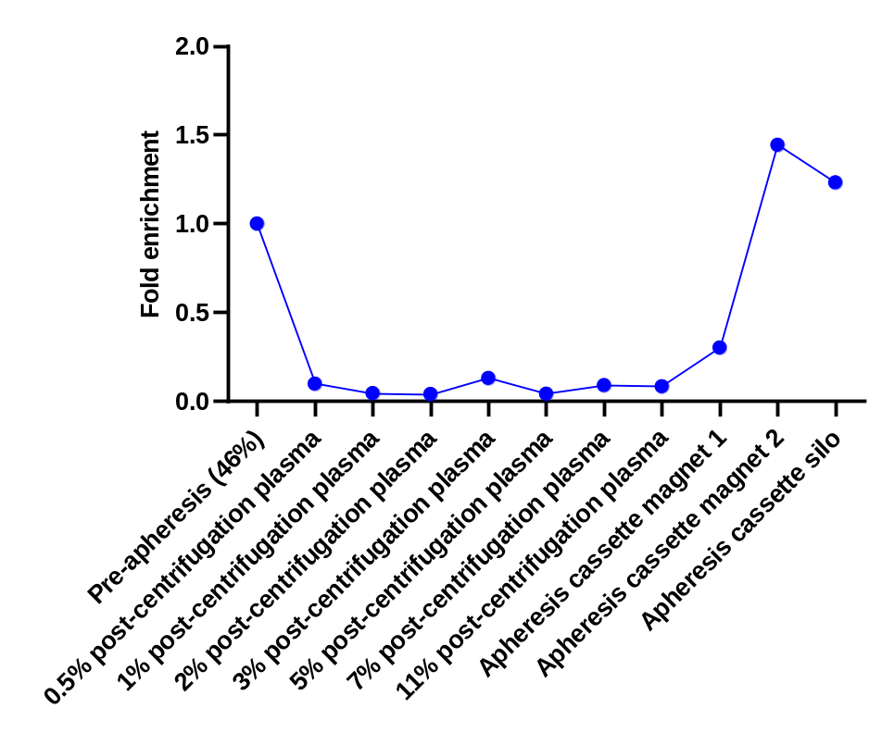
Fold enrichment of P. vivax asexual parasites/ml compared to pre-apheresis, of blood clots around magnet 1, magnet 2, and silo in within the apheresis cassette and of post-centrifugation plasma originating from the collection bag. Asexual parasites were measured using 18S qPCR.

Table 11. Subject 3 additional testing P. vivax asexual parasites/ml
Sample | asexual parasites/ml | Fold enrichment asexual parasites/ml compared to pre-apheresis
Pre-apheresis | 25,475 | 1
0.5% post-centrifugation plasma | 2,515 | 0.10
1% post-centrifugation plasma | 1,168 | 0.05
2% post-centrifugation plasma | 1,044 | 0.04
3% post-centrifugation plasma | 3,345 | 0.13
5% post-centrifugation plasma | 143 | 0.04
7% post-centrifugation plasma | 2,300 | 0.09
11% post-centrifugation plasma | 2,160 | 0.08
Apheresis cassette magnet 1 | 7,710 | 0.30
Apheresis cassette magnet 2 | 36,790 | 1.44
Apheresis cassette silo | 31,401 | 1.23
Subject 3 additional testing P. vivax asexual parasites/ml and fold enrichment compared to pre-apheresis. Asexual parasites were measured using 18S qPCR.

Table 12. Apheresis HMP bank if equivalent of HMP-013 P. vivax bank
 | Number of parasite vials
Maximum | 107
Required for Sterility (10%) | 11
*Current stability testing | 24
**Dose testing | 9
Vials Remaining | 63
Trials Possible of 1 patient | 21
* Assuming a minimum of three years use under the current testing frequency of 8 tests per year
**3 vials required in triplicate
Table outlining the potential usage of a HMP bank produced by apheresis if that bank was equivalent in parasite concentration and volume to the HMP-013 P. vivax bank. Calculations based on experience from current HMP bank.

Human malaria parasite bank formation
The maximum level of asexual parasite enrichment per ml of sample compared to pre-apheresis was 4.9-fold. Percoll concentration increases the theoretical level of enrichment to 15.5-fold compared to pre-apheresis.
The HMP-013 P. vivax parasite bank produces vials each of which contains 2.08 × 10⁶ parasites. The following formulas were used to calculate the viability of apheresis as a method to concentrate parasites. Maximum enrichment values were used as the purpose was to assess the possibility of producing a HMP bank using apheresis rather than the practicality.
Parasites/ml of enriched blood = Pre-apheresis whole blood 18S-qPCR/ml × Fold enrichment derived from percoll × Maximum fold enrichment from apheresis
Parasites/ml of packed blood (based on bank HCT of 0.39) = Parasites/ml of enriched blood/0.39
Number of parasites/vial compared based on 248 ul = (Parasites/ml of packed blood/1000) × 248
Parasites/ml of enriched blood = 25,475 × 3.17 × 4.89 = 3.95 × 10⁵
Parasites/ml of packed blood (based on bank HCT of 0.39) = 3.95 × 10⁵/0.39 = 1.01 × 10⁶
Number of parasites/vial based on 248ul = (1.01 × 10⁶/1000) × 248 = 2.51 × 10⁵
Hence apheresis and percoll cannot concentrate parasites enough to create HMP bank vials equivalent to those used to infect subjects in this study (2.51 × 10⁵ compared to 2.08 × 10⁶). If only apheresis is used to concentrate parasites the vials would contain a maximum of 7.92 × 10⁴ parasites.

