Apheresis Procedure: QIMR Study cohort 2
Version 3: 04/04/2018

Bone Marrow Transplant Program
Metro North Health Hospital and Health Service
Royal Brisbane & Women’s Hospital
Children's Health Queensland Hospital and Health Service
Lady Cilento Children’s Hospital

Purpose

This SOP describes how to perform a continuous mononuclear cell (CMNC) procedure. It is intended to be used in conjunction with:

Spectra Optia Essentials

Spectra Optia Continuous Mononuclear Cell Collection (CMNC) Procedure Guide

Scope

The target audience for this resource are the registered nurses and medical officers who care for patients in the Apheresis Unit, Royal Brisbane & Women’s Hospital (RBWH), who are involved and trained in apheresis.

Patient safety takes priority during a CMNC collection, therefore only competent nurses can perform this procedure.

All apheresis procedures will comply with 05009/WUG: Apheresis

All deviations and associated corrective actions shall be documented in the patient medical record.

Principle / Background

Apheresis refers to a number of procedures involving the removal of whole blood, separating it into the various blood components through centrifugation, removing a desired component (white/red cells, platelets and plasma with or without replacement fluids) and returning the rest of the components. Access to the intravascular compartment is required and efficacy of the treatment will depend on the volume of blood processed.

All patients requiring a CMNC collection are under the direct care of a Haematologist.

The RBWH Apheresis Unit is accredited by:

Australian Bone Marrow Donor Registry (ABMDR)

National Association of Testing Authorities (NATA)

Foundation for the Accreditation of Cellular Therapies (FACT)

The Royal Brisbane & Women’s Hospital (RBWH) is accredited by the Australian Council on Healthcare Standards (ACHS)

The Disaster Plan (Section 11) addresses those elements most considered to be at risk and provides guidelines to cover some of the potential serious emergencies that may arise. All staff involved in apheresis procedures are responsible for following this plan as directed by senior personnel.

Objectives / Endpoints

All apheresis procedures shall be performed safely and appropriately.

Documentation

Policy and Standard/s

ACHS EQUiP National

Blood and Blood Products, Management of PROC103 Doc 110/15 (MNHHS)

Clinical Incident and Disclosure Management PROC007 Document 13/14 (MNHHS)

Procedures, Guidelines, Protocols

Australian Guidelines for the Prevention and Control of Infection in Healthcare (2010)

COLGDE001: RBWH Guidelines in the Management of Potential Adverse Events in Apheresis

02002/Proc: Medications Management

21605/Proc: Blood collection (Adult)

05009/Proc: Apheresis

05450/Proc: Peripheral Intravenous Cannulation, Venepuncture and Infusions – Adult and Paediatrics

74100/Proc: Documentation in the Patient Record

81000/Proc: Aseptic Non Touch Technique

000342/Proc: Standard Precautions

003139/Proc: Cleaning and Decontamination – patient environment and clinical equipment

Forms and Templates

CLIFRM013: RBWH Donor Consent for Bone Marrow Harvest or Apheresis Procedure

COLFRM009: RBWH Apheresis Patient Checklist label

COLFRM028: RBWH Apheresis Service Request

COLFRM030: RBWH Apheresis Product Collection Form

COLFRM053: RBWH Apheresis Procedure Run Sheet: Spectra Optia

Definitions and Abbreviations

AIM Automated interface management

ABMDR Australian Bone Marrow Donor Registry

ACD-A Acid citrate dextrose - solution A

BTS Biomedical Technical Services

CMNC Continuous mononuclear cell

CMV Cytomegalovirus

CP Collection preference

ELFT Electrolyte & liver function tests

FBC Full blood count

Hb Haemoglobin

HBV Hepatitis B virus

HCV Hepatitis C virus

HIV Human immunodeficiency virus

IDM Infectious disease marker

IV Intravenous

MNC Mononuclear cell

MNHHS Metro North Hospital and Health Service

NUM Nurse Unit Manager

ODTU Oncology Day Therapy Unit

QIMR Queensland Institute of Medical Research

RBWH Royal Brisbane & Women’s Hospital

RN Registered nurse

SOP Standard operating procedure

TBV Total blood volume

Materials

Equipment

Spectra Optia Apheresis System (version 11.3) – CMNC Collection.

IDL filler

Electronic blood pressure monitor

Volumetric infusion pump

Heat sealer

Disposables and Reagents

Spectra Optia IDL Set (Ref: 10310).

ACD-A anticoagulant (750ml)

0.9% normal saline (1000ml)

Alcohol swab

3 way taps (2)

SmartSite® Bag Access Device Needle-Free Valve

Accessory Platelet Storage Sets (5)

IV cannulation or central line equipment. Refer to procedures: 05450/Proc: Peripheral Intravenous Cannulation, Venepuncture and Infusions – Adult and Paediatrics; 05501/Proc: Cannulation of Haemodialysis Access; 05600/Proc: Central Venous Access Devices (CVADs), Management – Adult. Ensure use of sufficient gauge cannulas (backeye needles are preferable for inlet venous access) to allow for adequate flow required for the procedure (preferably at least 16G for inlet and 18G for return)

Blood collection tubes

Intravenous giving set

Burette

Special Considerations

This procedure describes how to perform a CMNC procedure.

Ensure haematocrit is accurate, as this is used to calculate:

The limit for collect volumes

The plasma pump flow rate before the AIM system manages the concentration of cells in the collect port

Changing the haematocrit after the interface has been established will not change the interface position

The packing factor whilst collecting MNC defaults to 4.5

No plasma is to be collected

There MUST be FBC and ELFT blood test results available (taken within the previous 24hrs) PRIOR to commencement of procedure.

The minimum FBC criteria required in order to proceed with the procedure is described below.
QIMR volunteer | Platelet > 100 x 10⁹/L
QIMR volunteer | Hb > 100G/L

There is a risk of deranged electrolytes due to the effects of the procedure. This effect is usually transient and resolves quickly upon cessation of CMNC collection. Electrolyte replacement may be required. Calcium gluconate is the most frequently required electrolyte replacement and the amount and rate is dependent on symptoms of hypocalcaemia during the procedure. Magnesium and potassium replacement can also be required, below is a guide for when supplementation may be required:

Pre-Procedure Electrolyte | Replacement guide
Magnesium < 60 mmol/L | 10 – 20 mmols IV magnesium sulphate may be required during procedure
Potassium between 3.0 – 3.5 mmol/L | Oral potassium may be required e.g 1-2 chlorvescent tablets
Potassium < 3.0 mmol | IV potassium chloride 20 mmols may be required during the procedure and / or 3 oral chlorvescent

Procedure

Confirm the following forms are current and valid:

CLIFRM013: RBWH Donor Consent for Bone Marrow harvest or Apheresis Procedure

COLFRM028: RBWH Apheresis Service Request

Prior to commencement of procedure, ensure patient has had appropriate IDMs taken.

HIV serology

Hepatitis B serology

Hepatitis C serology

Syphilis

All stock used to collect the product must be visually examined prior to use for signs of damage and contamination, as per COLSOP004: Apheresis Inventory Control Procedure. Record expiry date and lot number of all stock used on COLFRM030: RBWH Apheresis Product Collection form. Check expiry dates and lot numbers of procedure kit and intravenous fluid bags with 2nd RN and record on COLFRM053: RBWH Apheresis Procedure Run Sheet: Spectra Optia

Confirm that all consumables and reagents used during the procedure are satisfactory for use; inspect for damage or evidence of contamination and mark the appropriate check box on COLFRM030: RBWH Apheresis Product Collection form

Set up, load and prime Spectra Optia IDL Set (Ref: 10310) as per on screen instructions

There will be multiple collection bags required during the procedure. Different desired hct layers will be collected into different collection bags.

Insert a SmartSite Bag Access Device Needle-Free Valve into the Spectra Optia Set collection bag

Attach an Accessory Platelet Storage Set( collection bag) to the SmartSite Bag Access Device Needle-Free Valve

Place the Accessory Platelet Storage Set into the appropriate heated compartment as directed by the QIMR scientist

Follow machine prompts and enter patient data.

The default end point is TBV Processed: 3BV

Change the end point to RunTime (min): 180 min (see appendix 1 for Initial Run Parameters)

The default collect flow rate is 1ml/min

Change Collect Flow Rate (ml/min) to 2ml/min (see appendix 1 for Initial Run Parameters)

The default AC ratio is 15:1

Change the AC ratio to 8:1(see appendix 1 for Initial Run Parameters)

Educate patient of signs and symptoms of potential adverse reactions, emphasising importance of informing nursing staff if he/she experiences any such reactions

Perform baseline observations (temperature, pulse, respirations and blood pressure) and record on run sheet

Ensure COLFRM009: RBWH Apheresis Patient Checklist has been completed

Perform Cannulation according to 05450/Proc: Peripheral Intravenous Cannulation, Venepuncture and Infusions – Adult and Paediatrics

Collect blood samples if required.

Follow machine prompts to commence procedure

Review run screen to ensure pump flow rates are appropriate for the procedure. Monitor the AC infusion rate, ensuring that it does not exceed 0.9 ml/min

The AC ratio should remain at 8:1 for the first 500mls of inlet volume processed

Once 500mls has been processed, change the AC ratio to 10:1 for the next 500ml of inlet volume processed

Once 1000mls has been processed, change the AC ratio to 12:1 for the remainder of the procedure

The Spectra Optia system will attempt to establish the interface at commencement of the procedure, during this time, the collect valve will remain closed.

The AIM system monitors the collect port and changes the plasma pump flow rate to manage the concentration of cells that flow through the collect port. When the AIM system detects cells in the collect port, the collect valve opens and starts collecting. Ensure the collect flow rate is set at 2ml/min.

Close the collect valve if the desired collection hct has not been reached

The CP defaults to 50 at commencement of procedure. The apheresis nurse can set the CP to collect lighter or darker from the buffy coat. Use the collection preference tool as a guide for attaining the appropriate CP. See appendix 2 for the appropriate CP, using the collection preference tool.

A higher CP results in collecting lighter in the buffy coat

A lower CP results in collecting darker in the buffy coat

Ensure the collect valve remains closed until the desired collection hct has been reached
      - If the collect valve is closed for more than 5 minutes, the pumps will stop and the following alarm will be triggered “Cells were not collected”.
      - Due to the pumps stopping, the interface will be temporarily lost.
      - To prevent this issue whilst attempting to establish the desired collection hct, the apheresis nurse should open the collect valve after 4 minutes then immediately close it again – this will reset the timer and prevent the pumps from stopping

Once the desired collection hct has been reached and the interface is stable, open the collect valve and collect the appropriate volume of the layer

Once the appropriate volume of a particular layer has been reached, close the collect valve and strip the collect line using the blue clamps

Adjust the CP to reach the next desired collection hct

While the new collect layer is being established, empty all the collected cells from the collection bag into the Accessory Platelet Storage Set and heat seal the Accessory Platelet Storage Set line.
      - This will need to be performed with assistance from the QIMR scientist to ensure the collection remains at the appropriate temperature
      - Once the Accessory Platelet Storage Set line has been heat sealed, reopen the blue clamp on the collect line

Attach a new Accessory Platelet Storage Set to the SmartSite Bag Access Device Needle-Free Valve

Repeat steps 9.18.4 – 9.18.9 until all desired layers have been collected
      - The desired collection hct and volumes are as follows:

COLLECTION HCT | VOLUME REQUIRED
1% | 90ml
2% | 90ml
3% | 30ml
5% | 30ml
7% | 30ml

Monitor and record patient’s vital signs and run parameters q30 minutes or as clinically indicated. Monitor for signs of adverse reactions and record on procedure run sheet, reporting adverse events on PRIME.

Ensure patient comfort and safety throughout the procedure.

QIMR staff are responsible for the labelling of each collection bag.

At the end of the procedure, follow the system prompts to rinseback

Seal the collection bags using a heat sealer prior to disconnection of the patient. QIMR staff will indicate the most appropriate point to heat seal line.

QIMR staff will organise transportation to QIMR of the collected cells. The time of collection completion shall be recorded on COLFRM030: RBWH Apheresis Product Collection form.

On completion of rinseback, collect routine blood samples (usually FBC and ELFT).

Perform final set of observations and record on procedure run sheet

Remove venous access as appropriate

Record final values on COLFRM053: RBWH Apheresis Procedure Run Sheet and complete COLFRM030: RBWH Apheresis Product Collection form.

Once paperwork is complete, scan / photocopy all procedural paperwork and send to QIMR.

Unload set and dispose of waste appropriately

Decontaminate Spectra Optia as per protocol (see COLSOP005: RBWH Apheresis Equipment Cleaning Procedure). Decontaminate all other equipment involved in performing the procedure, in accordance with 003139/Proc: Cleaning and Decontamination – patient environment and clinical equipment. Once all equipment used during the procedure has been cleaned, tick appropriate area at the end of the run sheet, confirming completion of cleaning tasks.

Document all care given in patient medical notes. Include all completed paperwork with patient’s medical notes.

Record relevant statistical information in: G:\Oncology\Apheresis\Log and Statistics

End Points

Total procedure time should not exceed 180 minutes

Discuss with QIMR staff if total procedure time is expected to exceed 180 minutes. QIMR staff will advise apheresis nursing staff of most appropriate action

The total collect volume must not exceed 450ml

Discuss with QIMR staff if total collect volume is expected to exceed 450ml. QIMR staff will advise apheresis nursing staff of most appropriate action

Disaster Plan

This section describes the actions to be taken in the event of serious problems which may arise in the Apheresis Unit which may impact on either:

The ability to perform the CMNC collection to the required specification

The quality of the collected product

Air-Conditioning System Failure – in the event that the air-conditioning system malfunctions, contact hospital maintenance and arrange for urgent repairs (ext. 67963).

Loss of Power – All critical equipment used to perform apheresis procedures should be connected to red emergency power points. These power points are supplied with the electricity from the emergency backup power generators, and in the event of a power failure, are automatically activated.

Critical equipment used within the apheresis unit includes:
      - Cell separators
      - Blood warmers
      - Electronic blood pressure monitors
      - Intravenous volumetric pumps
      - Heat sealers

In the event of an interruption to normal power supply, there may be a temporary loss of power before the emergency generator is activated. If there is an interruption of the power supply:
      - Close clamps on collect line immediately
      - If the emergency power supply is activated, power will resume, and the Spectra Optia system will reset. After system resets, a screen will appear with instructions for how to proceed.
      - To restart the procedure, follow onscreen instructions
      - To abort procedure, press RINSEBACK (if appropriate) or DISCONNECT and follow on screen instructions

In the event of a complete loss of power with no emergency power supply:
      - The Spectra Optia cell separator will shut down completely. Close clamps on collect line immediately. Seal the collection bags using a heat sealer (these should still be functional if battery charged)
      - Contact the patient physician and inform him of events and that the procedure may be aborted
      - Consult with the Director of the Haematology & BMT
      - The extracorporeal volume in the kit will be 297ml
      - The patient may be disconnected without performing RINSEBACK or perform MANUAL RINSEBACK as per instructions in Spectra Optia Essentials Guide, pp.73-76 (in the event that a blood prime was performed, RINSEBACK is not necessary)

Immediate evacuation – in the event that an immediate evacuation is required:

Close clamps on collect line if possible. NURSE AND PATIENT SAFETY IS PARAMOUNT, therefore do not complete this step if completion may endanger the health and safety of the nurse or the patient

Disconnect patient immediately and evacuate as per RBWH Code Orange Evacuation procedure. N.B. since RINSEBACK has not been performed, the patient will have a 297ml fluid deficit and may become hypotensive, monitor patient accordingly

Structural damage (e.g. fire, water / flood damage) – in the event of structural damage, relocate product, material and patient files as required, to another area of ODTU if possible. Depending on the scale of the problem, a final decision on a temporary location may need to be determined on a case-by-case assessment by a structural engineer and the Director of the BMT program

All critical equipment and/or consumables which may have incurred damage should be discarded and replaced as soon as possible

Contact hospital maintenance (ext. 67963) and organise for them to inspect critical equipment as soon as possible

Suspend all operational activities until repairs are complete and the facility is signed off as safe to reoccupy

Critical equipment failure – Perform troubleshooting as per relevant equipment manuals. If unable to resolve problem, contact BTS or manufacturer representative.

Critical consumable shortage – if a critical consumable shortage occurs, contact the following Apheresis Units to source consumables:

Greenslopes Private Hospital (Speed dial *2521).

Lady Cilento Childrens’ Hospital (Jo Ritchie – 3068 5686, or Jill Shergold – 3068 5767)

Once alternative supply has been sourced, organise transport of the required consumables. Liaise with the NUM, ODTU to organise payment of delivery e.g. courier service

Critical staff shortage – The Apheresis Nurse Practitioner shall liaise with the NUM, ODTU regularly to ensure staffing requirements of the apheresis unit are met. In the event that key personnel are unavailable to perform critical procedures:

Contact Apheresis Nurse Practitioner (pager# 26299) and NUM, ODTU (ext. 68754 / 73991) informing them of the situation

The NUM / Apheresis Nurse Practitioner will attempt to adequately staff the Apheresis Unit

If appropriate, the situation can be escalated to the Director of the BMT program and the Nursing Director, CCS

If adequate staffing cannot be accomplished, the Apheresis Nurse Practitioner shall liaise with the Director of the BMT Program to discuss requesting the assistance of other apheresis units in the area. Alternative units may be affiliated with the RBWH e.g. Greenslopes Private Hospital, or other similarly accredited Apheresis Units e.g. Princess Alexandra Hospital or the Mater Public Hospital

Responsibility
 | Final Approval | Implement | Quality Assurance | Review | Perform Procedure
Apheresis Nurse Practitioner |  | X | X | X | X
Medical Director | X | X
QIMR staff |  |  |  | X
Nursing Staff |  |  |  |  | X

Occupational Health and Safety

Standard precautions shall be maintained throughout the procedure. Refer to 000342/Proc: Standard Precautions.

Risk

Low to Medium (case dependant).

Consultation

Director Haematology & Bone Marrow Transplant Glen Kennedy

Apheresis Nurse Practitioner Kari Mudie

QIMR Registrar Anand Odedra

Appendix 1 – Initial run parameters

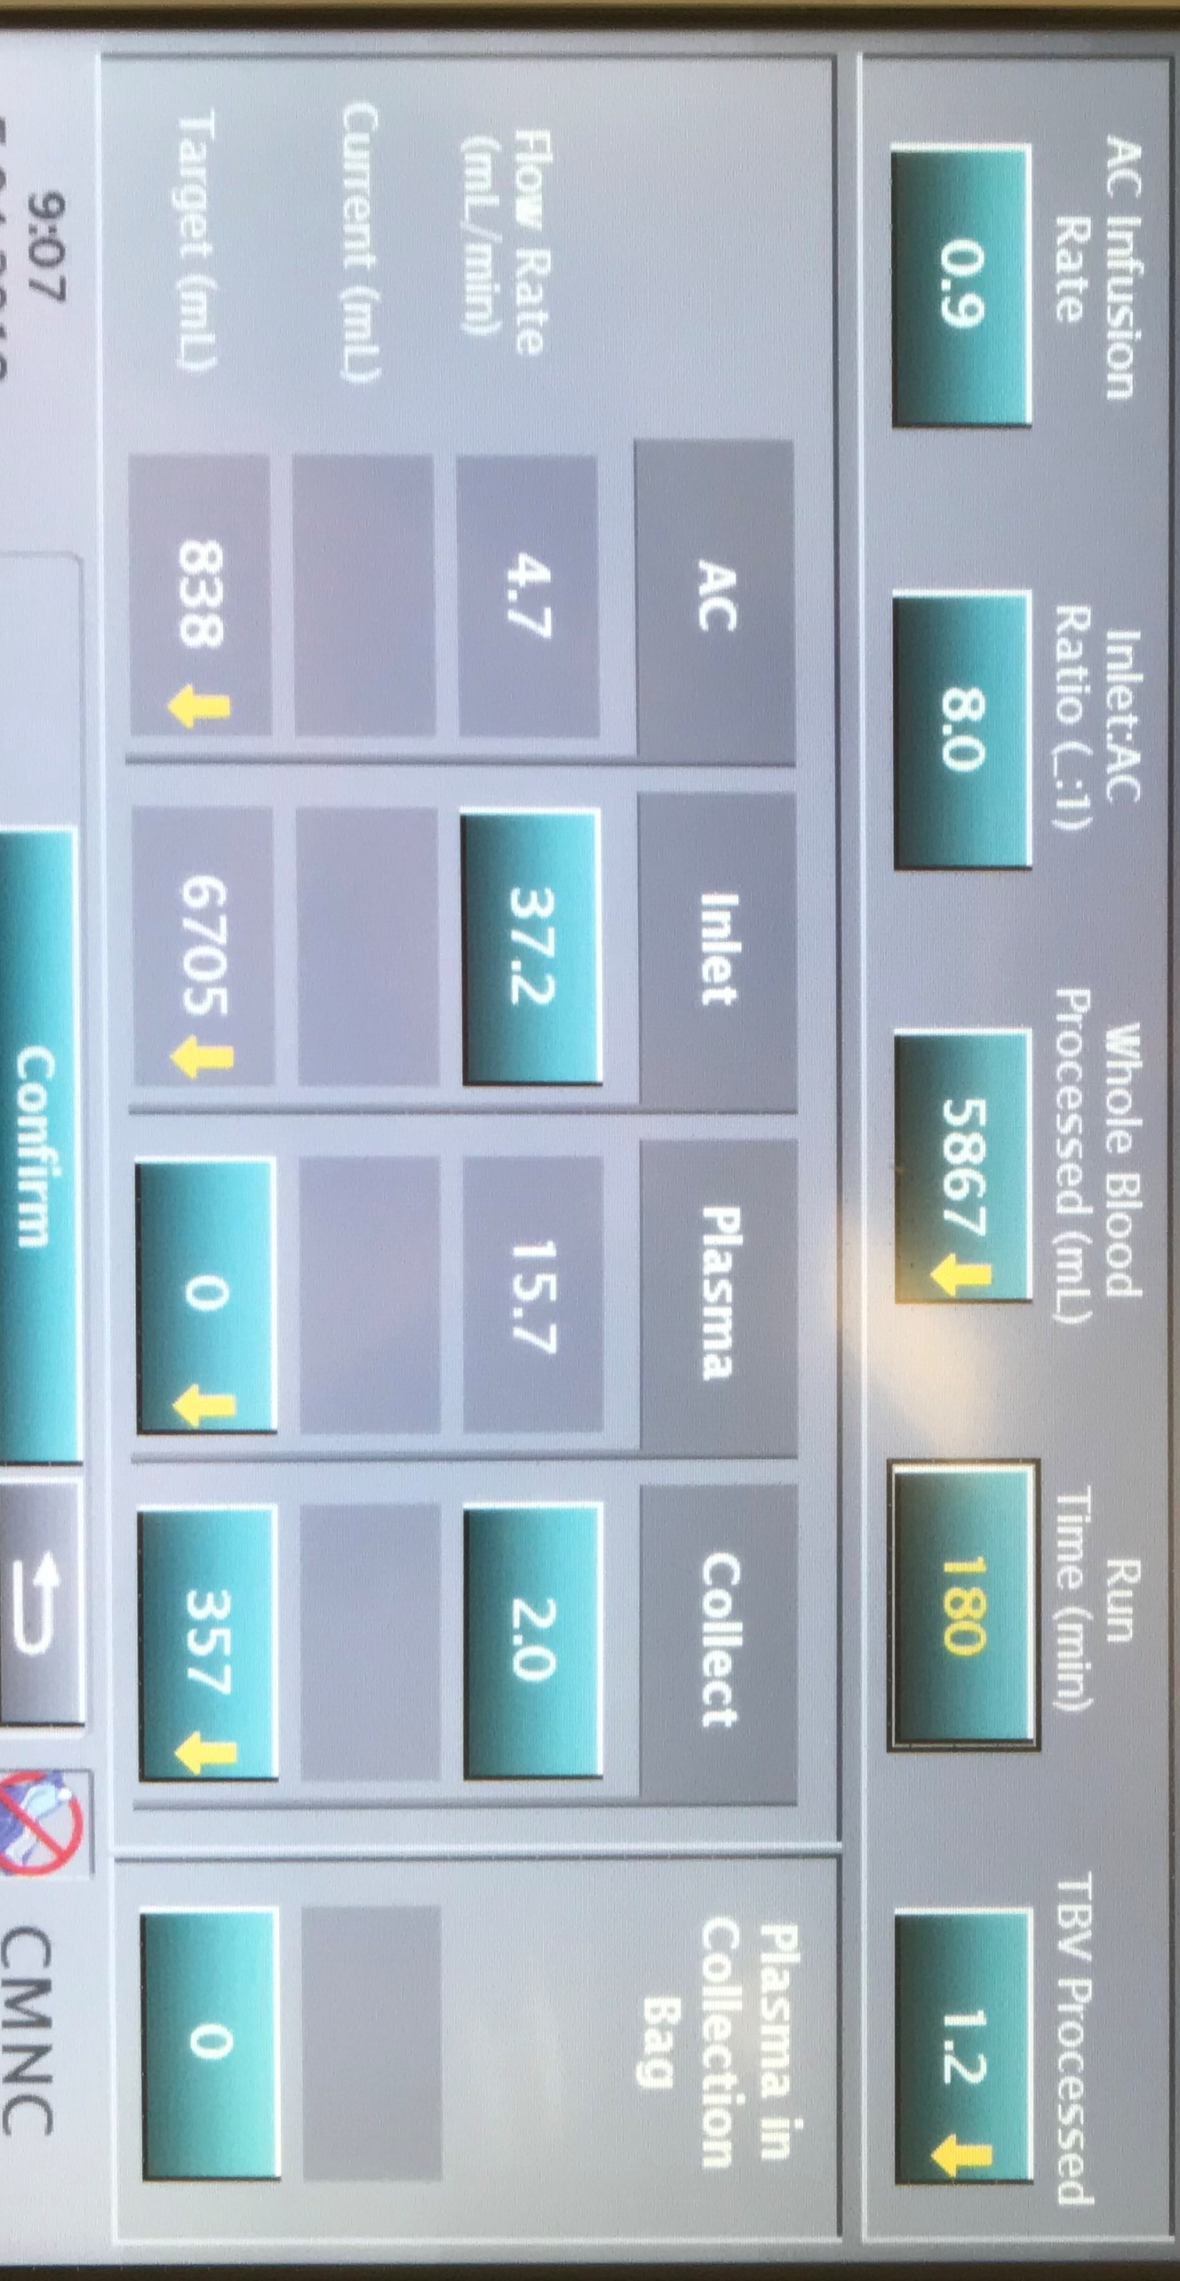

Appendix 2 – Collection preference guide

1%
7.5%
3%

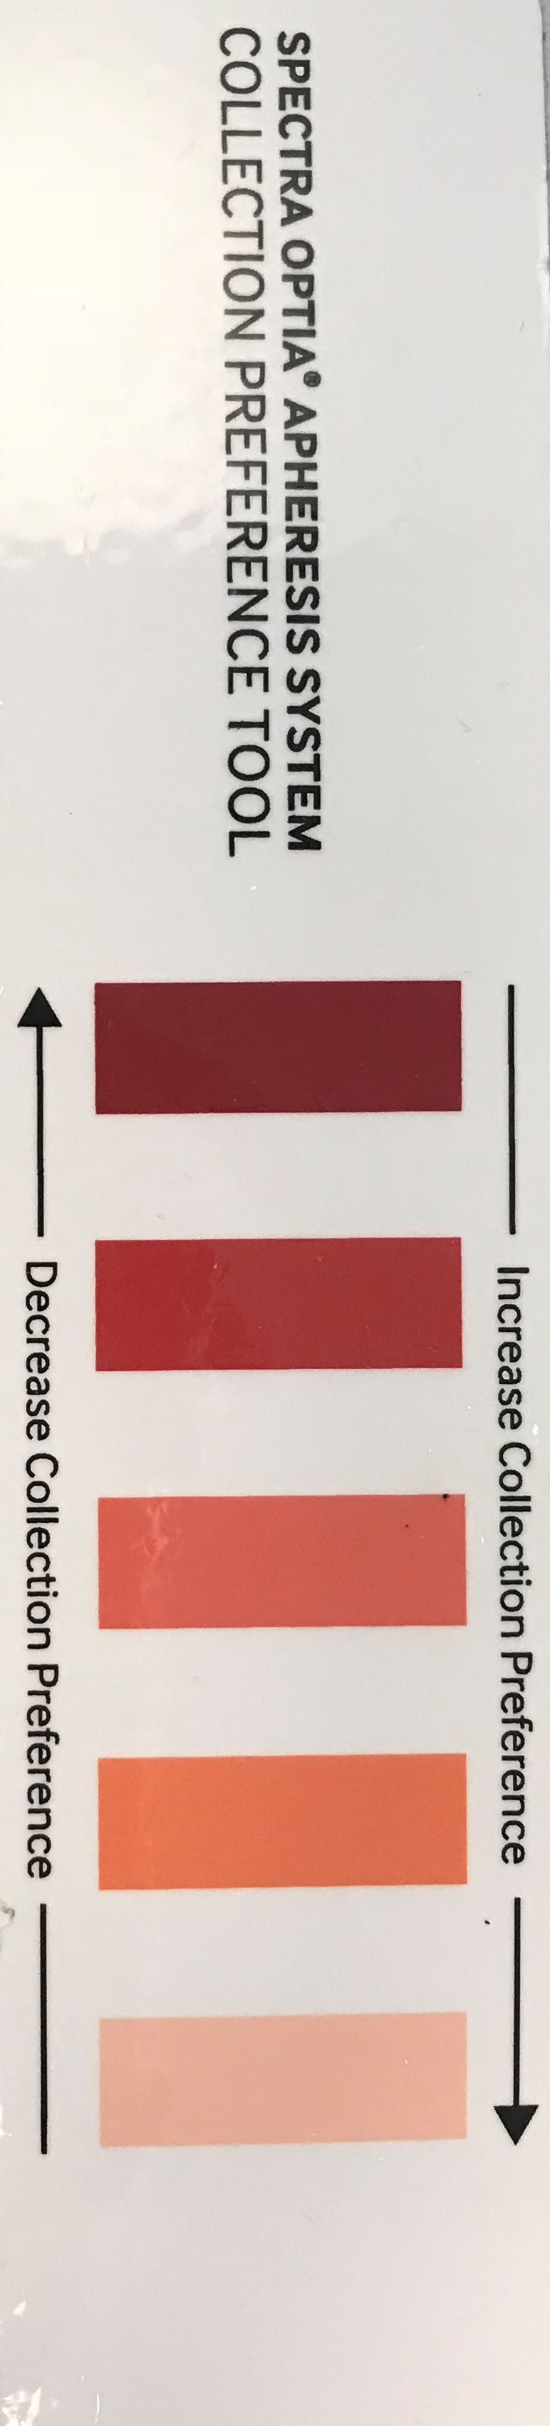
2%

5%

END OF PROCEDURE

