A high-throughput methodology for the efficient isolation of highly pure extracellular vesicles from skeletal muscle myoblasts
María Fernández-Rhodes¹, Bahman Adlou¹, Soraya Williams¹, Aveen R. Jalal¹, Mark P. Lewis¹, Owen G. Davies¹
¹ School of Sports, Health and Exercise Sciences, Loughborough University, Loughborough, Leicestershire, UK
Corresponding author: o.g.davies@lboro.ac.uk

SUPPLEMENTARY FIGURES
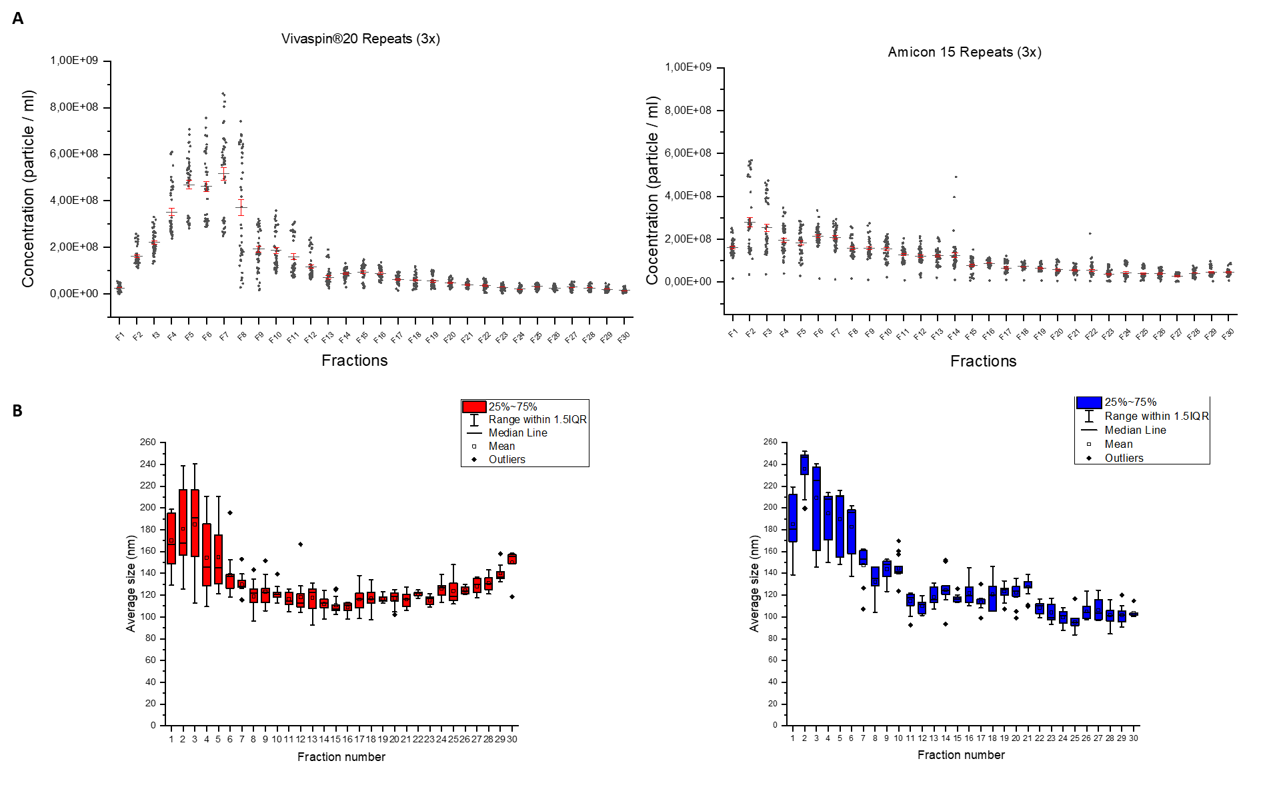
Supplementary Figure 1: Supplementary analysis on the individual 30 fractions after SEC isolation. (A) Grouped dot plot of 45 particle concentrations per fraction (15 x 3 repeats) between Vivaspin and Amicon. Vivaspin fractions =<14: 2.43E+08 ± 6.35E+07 and fractions >=15: 4.27E+07 ± 8.08E+06. Amicon fractions =<14: 1.76E+08 ± 3.45E+07 and fractions >=15: 5.39E+07 ± 6.40E+06. (B) Target fractions size distributions for each filter. Amicon (red) and Vivaspin (blue) Amicon average size distribution: 158.15 ± 19.33 nm vs. Vivaspin’s 163.41 ± 30.12 nm.
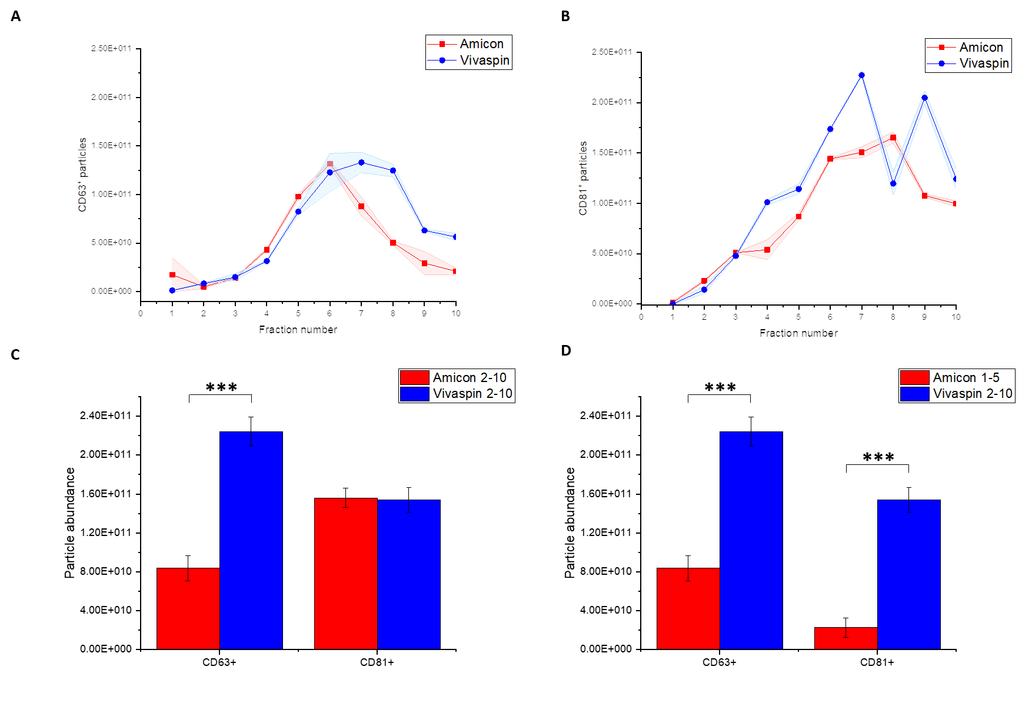
Supplementary Figure 2: ExoELISA analysis. (A) Presence of CD63⁺ particles in Amicon (red) and Vivaspin (blue) over fractions 1 to 10 (B) Presence of CD81⁺ particles in Amicon (red) and Vivaspin (blue) over fractions 1 to 10 (C) CD63⁺ and CD81⁺ particle abundance in final preparations after Amicon or Vivaspin pre-concentration, combining fractions 2 to 10 (D) Presence of CD81⁺ particles in Amicon (red) and Vivaspin (blue) over fractions 1 to 10 (C) CD63⁺ and CD81⁺ particle abundance in final preparations after combining fractions 1 to 5 after Amicon pre-concentration and fractions 2 to 10 after Vivaspin pre-concentration ( ***;p<0.001).
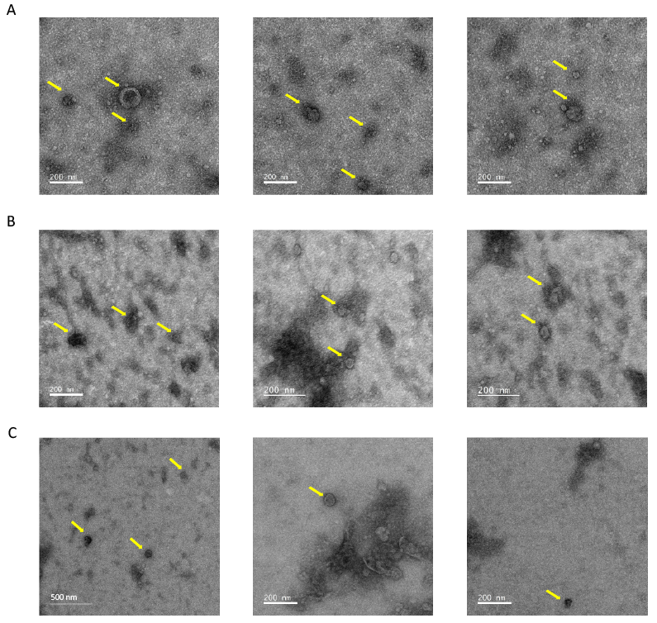
Supplementary Figure 3: TEM images of SM-EV collected after different UF+SEC protocols. (A) Images panel for samples obtained after Amicon UF formed by fractions 2-10 (B) Images panel for samples obtained after Vivaspin UF formed by fractions 2-10 (C) Images panel for samples obtained after Amicon UF formed by fractions 1-5.

