Table S1 Baseline characteristics of airway abnormalities assessed by impulse oscillometry in COPD patients (FEV₁/FVC < LLN)
 | R₅ |  | R₂₀ |  | R₅-R₂₀ |  | X₅ |  | AX |  | F_{res}
Value | Normal | Abnormal | Normal | Abnormal | Normal | Abnormal | Normal | Abnormal | Normal | Abnormal | Normal | Abnormal
Number, n (%) | 306 (41.4) | 434 (58.6) | 524 (70.8) | 216 (29.2) | 286 (38.6) | 454 (61.4) | 362 (48.9) | 378 (51.1) | 297 (40.1) | 443 (59.9) | 249 (33.6) | 491 (66.4)
Age | 63.68 (7.29) | 64.62 (7.12) | 64.19 (7.07) | 64.34 (7.54) | 62.78 (7.15) | 65.15 (7.09) * | 63.05 (7.17) | 65.37 (7.06) * | 62.94 (7.17) | 65.10 (7.10) * | 62.21 (7.21) | 65.26 (6.99) *
Male, n (%) | 281 (91.8) | 394 (90.8) | 478 (91.2) | 197 (91.2) | 253 (88.5) | 422 (93.0) † | 335 (92.5) | 340 (89.9) | 274 (92.3) | 401 (90.5) | 224 (90.0) | 451 (91.9)
BMI | 22.14 (2.92) | 21.84 (3.38) | 21.86 (3.12) | 22.23 (3.39) | 22.34 (3.09) | 21.73 (3.25) † | 22.12 (2.92) | 21.82 (3.44) | 22.12 (3.02) | 21.86 (3.31) | 22.44 (3.16) | 21.73 (3.20) †
Smoking statue, n (%)
Never | 42 (13.7) | 57 (13.1) | 66 (12.6) | 33 (15.3) | 46 (16.1) | 53 (11.7) | 49 (13.5) | 50 (13.2) | 42 (14.1) | 57 (12.9) | 42 (16.9) | 57 (11.6)
Ever | 68 (22.2) | 140 (32.3) † | 138 (26.3) | 70 (32.4) | 60 (21.0) | 148 (32.6) † | 79 (21.8) | 129 (34.1) † | 63 (21.2) | 145 (32.7) † | 52 (20.9) | 156 (31.8) †
Current | 196 (64.1) | 237 (54.6) | 320 (61.1) | 113 (52.3) | 180 (62.9) | 253 (55.7) | 234 (64.6) | 199 (52.6) | 192 (64.6) | 241 (54.4) | 155 (62.2) | 278 (56.6)
Pack-years | 30.00 (13.75 – 46.00) | 30.00 (14.63 – 50.00) | 30.00 (15.00 – 48.00) | 30.00 (10.00 – 47.50) | 29.50 (11.88 – 45.00) | 30.00 (14.00 – 50.00) | 29.00 (13.50 – 46.00) | 32.25 (15.00 – 50.00) | 30.00 (14.00 – 45.00) | 30.00 (14.13 – 50.00) | 28.75 (11.38 – 45.00) | 31.00 (15.00 – 50.00) †
Family history of respiratory diseases, n (%) | 53 (17.3) | 82 (19.0) | 93 (17.7) | 42 (19.7) | 54 (18.9) | 81 (17.9) | 66 (18.3) | 69 (18.4) | 52 (17.6) | 83 (18.8) | 42 (16.9) | 93 (19.0)
Occupational exposures, n (%) | 84 (27.5) | 118 (27.2) | 131 (24.8) | 72 (33.3) † | 77 (26.9) | 125 (27.5) | 112 (30.9) | 90 (23.8) † | 80 (26.9) | 122 (27.5) | 66 (26.5) | 136 (27.7)
History of bronchitis, n (%) | 18 (5.9) | 34 (7.8) | 37 (7.1) | 15 (6.9) | 18 (6.3) | 34 (7.5) | 24 (6.6) | 28 (7.4) | 18 (6.1) | 34 (7.7) | 11 (4.4) | 41 (8.4) †
Drug treatment, n (%) | 113 (36.9) | 196 (45.2) † | 205 (39.1) | 104 (48.1) † | 105 (36.7) | 204 (44.9) † | 141 (39.0) | 168 (44.4) | 112 (37.7) | 197 (44.5) | 89 (35.7) | 220 (44.8) †
Clinical symptoms(n%)
Cough | 99 (32.4) | 180 (41.5) † | 194 (37.0) | 85 (39.4) | 89 (31.1) | 190 (41.9) † | 126 (34.8) | 153 (40.5) | 96 (32.3) | 183 (41.3) † | 76 (30.5) | 203 (41.3) †
Phlegm | 110 (35.9) | 203 (46.8) † | 213 (40.6) | 100 (46.3) | 104 (36.4) | 209 (46.0) † | 139 (38.4) | 174 (46.0) † | 105 (35.4) | 208 (47.0) † | 87 (34.9) | 226 (46.0) †
Wheeze | 25 (8.2) | 78 (18.0) * | 65 (12.4) | 38 (17.6) | 25 (8.7) | 78 (17.2) † | 35 (9.7) | 68 (18.0) † | 26 (8.8) | 77 (17.4) † | 21 (8.4) | 82 (16.7) †
Dyspnea | 67 (21.9) | 183 (42.3) * | 164 (31.3) | 86 (40.0) † | 60 (21.0) | 190 (41.9) * | 88 (24.3) | 162 (43.0) * | 64 (21.5) | 186 (42.1) * | 49 (19.7) | 201 (41.0) *
FEV₁<80% | 113 (36.9) | 358 (82.5) * | 304 (58.0) | 167 (77.3) * | 104 (36.4) | 367 (80.8) * | 157 (43.4) | 314 (83.1) * | 106 (35.7) | 365 (82.4) * | 78 (31.3) | 393 (80.0) *
SAD, n (%) | 305 (99.3) | 435 (100.0) | 523 (99.6) | 217 (100.0) | 285 (99.3) | 455 (100.0) | 361 (99.4) | 379 (100.0) | 296 (99.3) | 444 (100.0) | 248 (99.2) | 492 (100.0)
Emphysema on CT, (%) | 58 (19.0) | 162 (37.3) * | 154 (29.4) | 66 (30.6) | 44 (15.4) | 176 (38.8) * | 78 (21.5) | 142 (37.6) * | 53 (17.8) | 167 (37.7) * | 38 (15.3) | 182 (37.1) *
Gas trapping on CT, (%) | 137 (44.8) | 298 (68.7) * | 294 (56.1) | 141 (65.3) † | 118 (41.3) | 317 (69.8) * | 167 (46.1) | 268 (70.9) * | 128 (43.1) | 307 (69.3) * | 98 (39.4) | 337 (68.6) *
Data are presented as the mean (standard deviation) or median (interquartile range) and were analyzed by Student’s t-test or Wilcoxon’s rank-sum test.; BMI, body mass index; MMEF, maximum mid expiratory flow, MMEF; FEV₁, forced expiratory volume in one second; CT, computerized tomography. SAD, Two of MMEF, FEF50, FEF75 < 65%. †: P < 0.05; *: P <0.001
Table S2 spirometry and impulse oscillometry parameter of airway abnormalities in COPD patients (FEV₁/FVC < LLN)
 | R₅ |  | R₂₀ |  | R₅-R₂₀ |  | X₅ |  | AX |  | F_{res}
Value | Normal | Abnormal | Normal | Abnormal | Normal | Abnormal | Normal | Abnormal | Normal | Abnormal | Normal | Abnormal
Spirometry
FEV₁, L | 2.30 (0.51) | 1.72 (0.55) * | 2.02 (0.61) | 1.82 (0.56) * | 2.31 (0.51) | 1.74 (0.56) * | 2.27 (0.54) | 1.67 (0.51) * | 2.34 (0.49) | 1.71 (0.54) * | 2.38 (0.49) | 1.75 (0.54) *
FEV₁, %predicted | 83.16 (14.20) | 63.92 (17.17) * | 73.70 (18.94) | 67.45 (16.97) * | 83.97 (13.34) | 64.26 (17.38) * | 81.36 (15.12) | 62.80 (17.03) * | 84.17 (13.45) | 63.63 (16.96) * | 85.48 (13.13) | 64.98 (17.11) *
FVC, L | 3.69 (0.74) | 3.16 (0.72) * | 3.45 (0.78) | 3.21 (0.72) * | 3.69 (0.75) | 3.18 (0.72) * | 3.70 (0.74) | 3.07 (0.66) * | 3.76 (0.70) | 3.12 (0.71) * | 3.77 (0.72) | 3.18 (0.72) *
FVC, %predicted | 105.16 (15.85) | 92.08 (16.24) * | 98.88 (17.57) | 94.13 (16.23) * | 106.12 (15.21) | 92.06 (16.34) * | 104.74 (15.51) | 90.55 (16.08) * | 106.56 (15.08) | 91.41 (16.02) * | 107.12 (14.95) | 92.61 (16.37) *
FEV₁/FVC, L | 62.21 (6.10) | 54.16 (10.21) * | 58.06 (9.44) | 56.11 (9.87) † | 62.28 (6.08) | 54.28 (10.02) * | 61.15 (6.95) | 53.99 (10.46) * | 62.34 (5.94) | 54.24 (10.20) * | 63.15 (5.43) | 54.62 (9.98) *
FEF₅₀, %predicted | 44.03 (14.55) | 28.53 (13.76) * | 36.17 (16.45) | 31.95 (14.53) † | 44.81 (14.54) | 28.71 (13.62) * | 42.41 (15.51) | 27.78 (13.31) * | 44.83 (14.32) | 28.31 (13.49) * | 46.48 (14.12) | 29.08 (13.57) *
FEF₇₅, %predicted | 36.91 (14.49) | 28.63 (12.15) * | 32.38 (13.97) | 31.25 (13.30) | 37.29 (14.64) | 28.75 (12.10) * | 36.02 (14.41) | 28.26 (11.98) * | 37.47 (14.82) | 28.42 (11.72) * | 37.73 (14.31) | 29.17 (12.57) *
MMEF, %predicted | 41.42 (12.97) | 28.84 (12.47) * | 34.91 (14.32) | 31.96 (13.40) † | 42.25 (13.26) | 28.88 (12.04) * | 40.13 (13.42) | 28.22 (12.18) * | 42.23 (13.13) | 28.56 (11.92) * | 43.43 (12.86) | 29.29 (12.21) *
IOS
R₅ | 0.26 (0.23 – 0.29) | 0.42 (0.36 – 0.50) * | 0.31 (0.25 – 0.39) | 0.44 (0.38 – 0.54) * | 0.27 (0.24 – 0.32) | 0.41 (0.34 – 0.49) * | 0.28 (0.24 – 0.34) | 0.42 (0.36 – 0.51) * | 0.27 (0.23 – 0.32) | 0.40 (0.33 – 0.48) * | 0.27 (0.23 – 0.32) | 0.40 (0.33 – 0.48) *
R₂₀ | 0.23 (0.20 – 0.25) | 0.30 (0.26 – 0.34) * | 0.25 (0.22 – 0.27) | 0.33 (0.31 – 0.37) * | 0.25 (0.22 – 0.30) | 0.27 (0.24 – 0.32) * | 0.25 (0.22 – 0.30) | 0.28 (0.25 – 0.33) * | 0.25 (0.22 – 0.30) | 0.27 (0.24 – 0.32) * | 0.25 (0.22 – 0.30) | 0.27 (0.24 – 0.32) *
R₅-R₂₀ | 0.03 (0.01 – 0.05) | 0.12 (0.08 – 0.19) * | 0.06 (0.03 – 0.13) | 0.10 (0.05 – 0.17) * | 0.02 (0.01 – 0.04) | 0.12 (0.08 – 0.18) * | 0.04 (0.02 – 0.06) | 0.13 (0.08 – 0.20) * | 0.02 (0.01 – 0.04) | 0.11 (0.07 – 0.17) * | 0.02 (0.01 – 0.04) | 0.11 (0.07 – 0.17) *
X₅ | -0.09 (-0.11 – 0.07) | -0.16 (-0.24 – 0.12) * | -0.11 (-0.16 – 0.08) | -0.15 (-0.23 – 0.10) * | -0.09 (-0.11 – 0.07) | -0.16 (-0.23 – 0.11) * | -0.09 (-0.10 – 0.07) | -0.18 (-0.25 – 0.14) * | -0.08 (-0.10 – 0.07) | -0.15 (-0.22 – 0.11) * | -0.08 (-0.10 – 0.07) | -0.15 (-0.23 – 0.11) *
AX | 0.24 (0.15 – 0.40) | 1.22 (0.63 – 2.17) | 0.47 (0.22 – 1.16) | 0.99 (0.41 – 2.25) * | 0.22 (0.13 – 0.32) | 1.16 (0.63 – 2.07) * | 0.25 (0.15 – 0.41) | 1.43 (0.80 – 2.35) * | 0.19 (0.12 – 0.27) | 1.04 (0.56 – 1.99) * | 0.19 (0.12 – 0.27) | 1.04 (0.56 – 2.01) *
F_{res} | 12.32 (9.64 – 15.25) | 21.42 (17.25 – 25.03) * | 15.87 (11.44 – 21.22) | 20.09 (14.32 – 26.16) * | 11.39 (9.31 – 13.72) | 21.22 (17.21 – 24.88) * | 12.88 (9.85 – 15.94) | 21.70 (17.95 – 25.38) * | 10.66 (9.17 – 12.81) | 20.73 (16.82 – 24.55) * | 10.66 (9.16 – 12.81) | 20.77 (16.82 – 24.57) *
Data are presented as the mean (standard deviation) or median (interquartile range) and were analyzed by Student’s t-test or Wilcoxon’s rank-sum test; IOS, impulse oscillometry; R₅, resistance at 5 Hz; R₂₀, resistance at 20 Hz; R₅-R₂₀, difference from R₅ to R₂₀; X₅, reactance at 5 Hz; F_{res}, resonant frequency. †: P < 0.05; *: P <0.001.
Table S3 Risk of AECOPD in the previous year of airway abnormalities in COPD patients (FEV₁/FVC < LLN)
Abnormal vs normal | AECOPD in the previous year, n (%) | OR*(95%CI) | P Value
R₅ | 60 (13.8) vs 30 (9.8) | 1.298 (0.832 – 2.025) | 0.251
R₂₀ | 26 (12.0) vs 64 (12.2) | 0.933 (0.590 – 1.475) | 0.933
R₅-R₂₀ | 65 (14.3) vs 25 (8.8) # | 1.494 (0.933 – 2.393) | 0.094
X₅ | 59 (15.6) vs 31 (8.6) # | 1.654 (1.057 – 2.589) | 0.028
AX | 66 (14.9) vs 24 (8.1) # | 1.680 (1.043 – 2.706) | 0.033
F_{res} | 70 (14.3) vs 20 (8.0) # | 1.661 (0.998 – 2.763) | 0.051

*: After adjusting for age, sex, BMI, smoking index, smoking statue, Poisson regression was applied to analyze the risk of acute exacerbation of COPD. OR, odds ratio; CI, confidential intervals; #: p < 0.05.
Figure S1 mMRC and CAT scores between airway abnormalities group and non-airway abnormalities group in COPD patients (FEV₁/FVC < 0.7), dates were shown as mean (SE).
** means <0.01, *** means <0.001
Figure S2 risk factors of airway abnormalities in COPD subjects (FEV1/FVC < 0.7). adjusted for age, sex, BMI, smoking status, smoking index.
Figure S3 Proportion of airway abnormalities in COPD patients (FEV₁/FVC < LLN) with different GOLD grades
Figure S4 After adjusting for age, sex, BMI, smoking index, smoking statue, multiple logistic regression was applied to analyze association between airway abnormalities and radiologic features in COPD subjects (FEV₁/FVC < LLN). OR, odds ratio; CI, confidential intervals.
Figure S5 mMRC and CAT scores between airway abnormalities group and non-airway abnormalities group in COPD patients (FEV₁/FVC < LLN), dates were shown as mean (SE).
** means <0.01, *** means <0.001
Figure S6 Risk Factors of airway abnormalities in COPD subjects (FEV₁/FVC < LLN). adjusted for age, sex, BMI, smoking status, smoking index

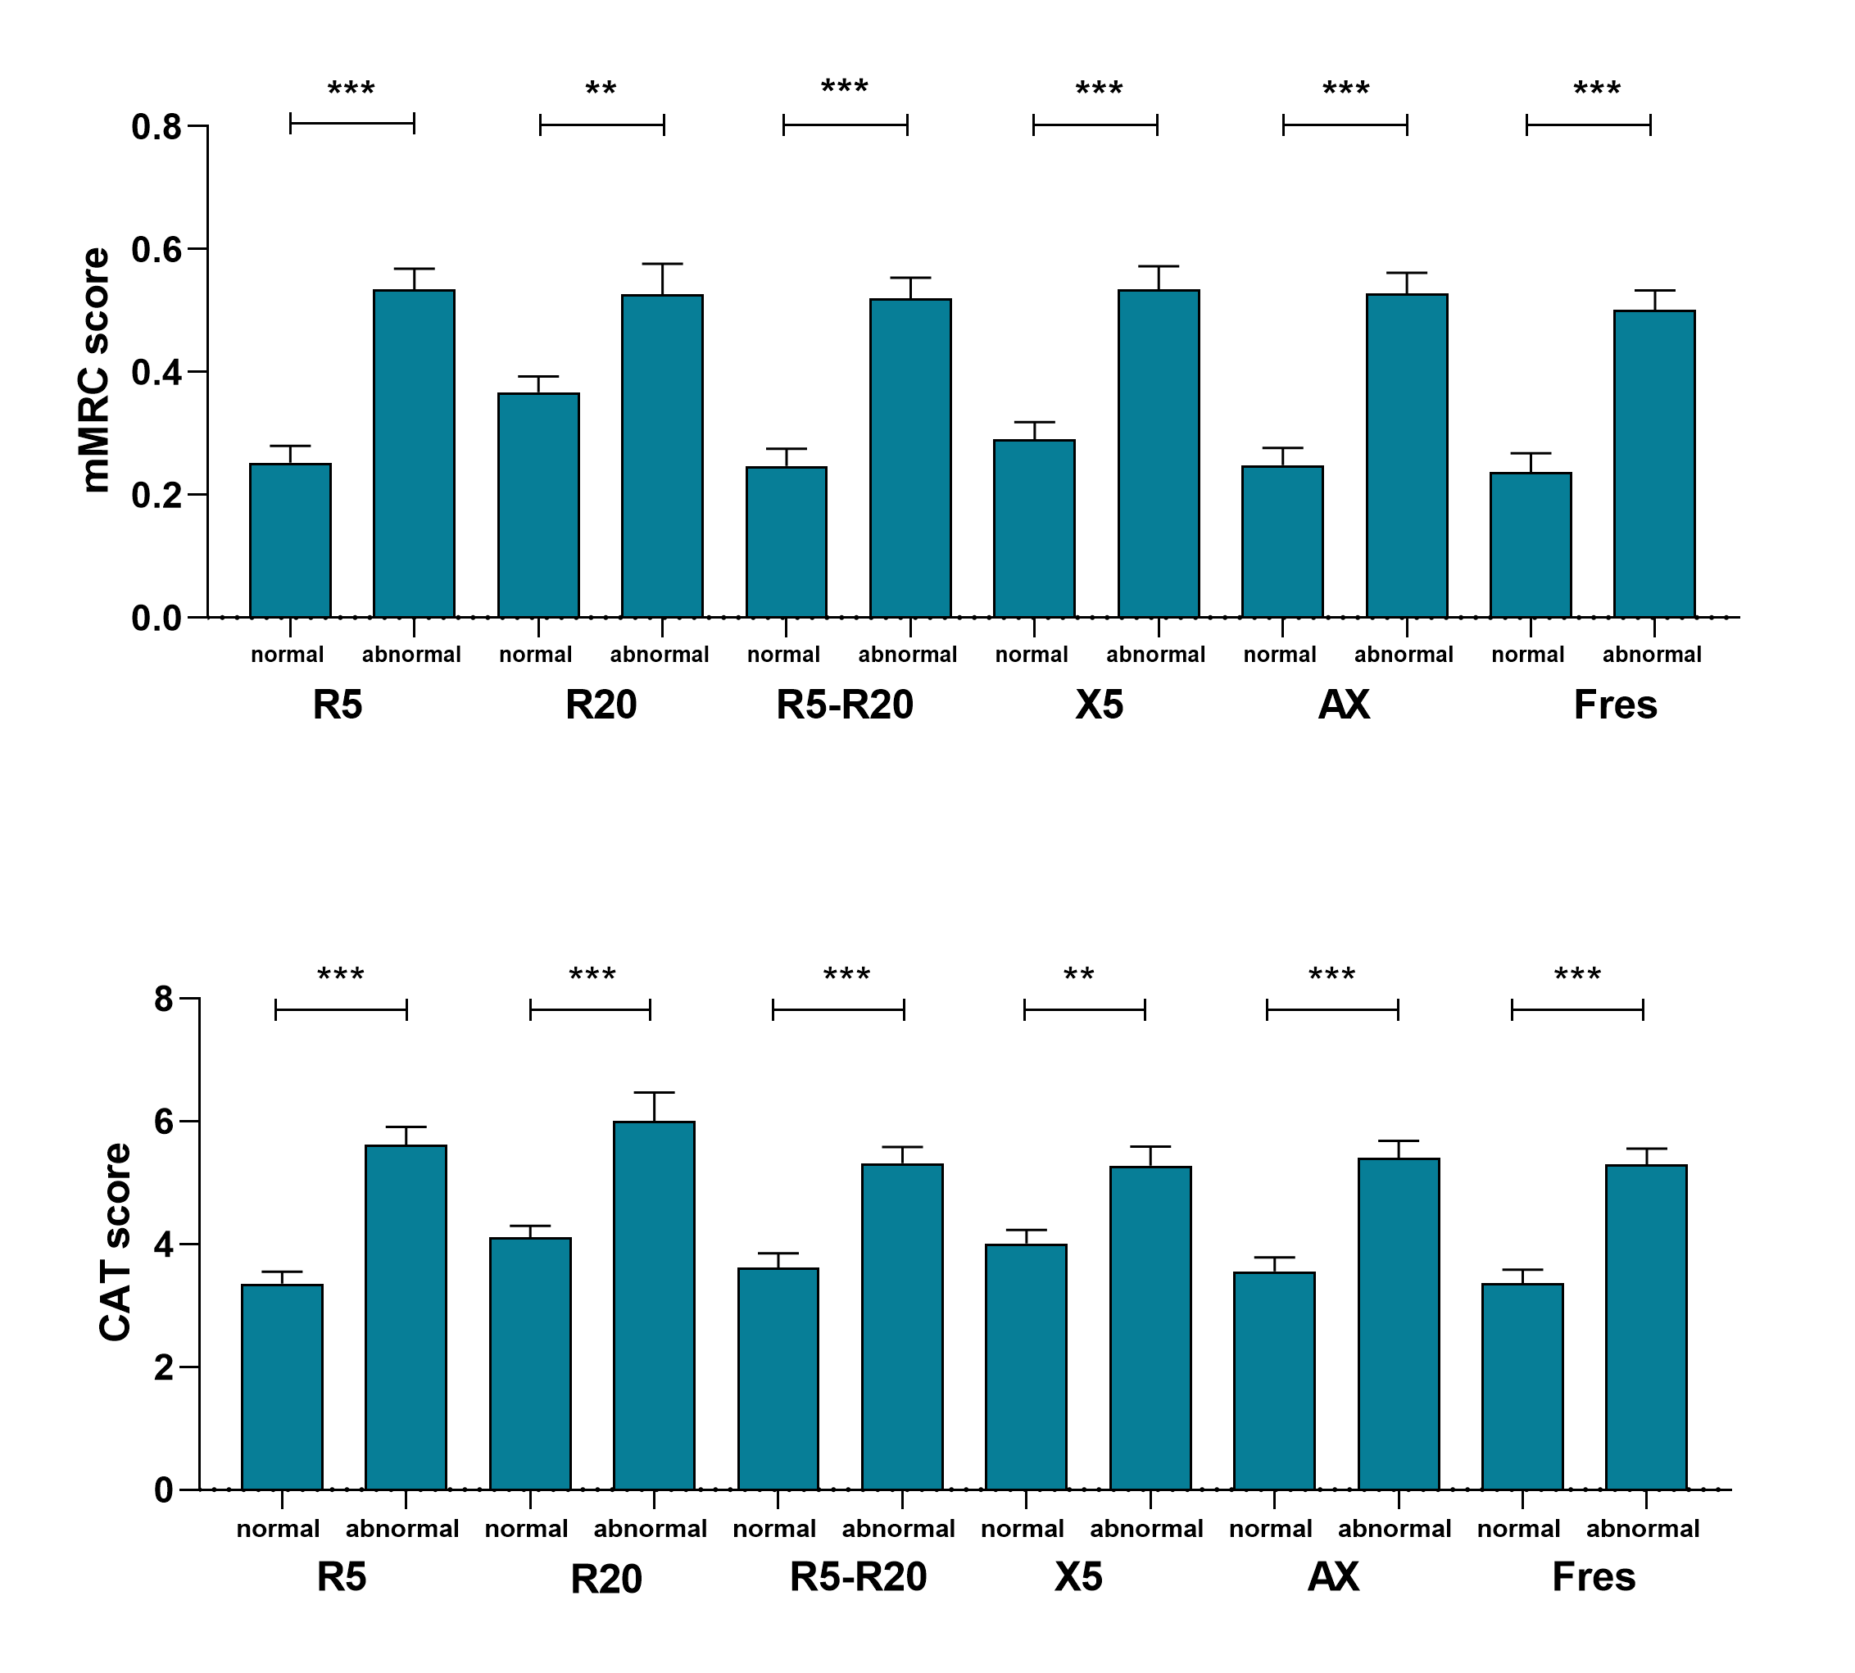Figure S1
Figure S2

Figure S3
Figure S4
Fig. S5
Fig. S6

