This document contains all statistical analyses conducted for the manuscript. Note that due to the random iterative nature of some analyses (such as RDA & PCA) some of the figure parameters will change slightly during reanalysis, though core results will remain essentially unchanged.

Results:
PCoA:
# Qiime software
multiple_rarefactions_even_depth.py -i otu_biom -d min_depth -n 10 -o output
--lineages_included
beta_diversity.py -i output -m
weighted_unifrac,unweighted_unifrac,bray_curtis,binary_jaccard,euclidean -o
beta_diversity -t min_depth
make_emperor.py –I beta_diversity/unweighted_unifrac_pcoa_coordinates_pcoa_coordinates
-m mapping.txt -o beta_diversity/unweighted_unifrac_pcoa_jackknifed_3D_PCoA
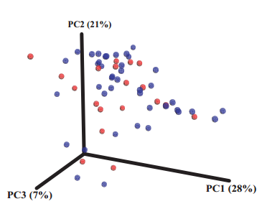

Boxplot:
library(ggplot2)
a<-read.table('diff_box.txt',sep="\t",header=T)
group = length(unique(a$Group))
a$P<-as.factor(a$P)
fa<- unique(a$Group)
a$Group<-factor(a$Group,levels=fa)
ggplot(data=a, aes(x=axis,y=Abundance))+geom_boxplot(aes(fill=Group),outlier.size = 0)+
facet_wrap( ~ id, scales="free",nrow=1)+
labs(title=newname,x='genus',y="Abundance")+theme_bw()+
theme(axis.text.x = element_text(size=8,angle = 0,face = "bold",vjust=0),strip.text.x =
element_text(colour = "black", angle = 15, size = 8,hjust = 0.5, vjust =
0.4),strip.background = element_rect(colour = "white", fill = "white"))
ggsave('diff_box_top10.pdf',width=7,limitsize=FALSE)
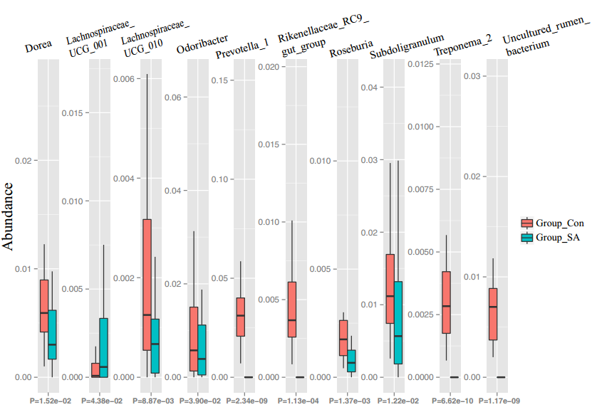

LEfSe:
code download from http://huttenhower.sph.harvard.edu/galaxy/
# Fig3A
python plot_res.py LEfSe_table.res --left_space 0.3 --right_space 0.3
LEfSe_table.res.pdf --format pdf
# Fig3B
python plot_cladogram.py LEfSe_table.res LEfSe_table.cladogram-add_genuslabel.pdf --
format pdf --labeled_stop_lev 6 --abrv_stop_lev 6 --title_font_size 9 --label_font_size
4 --class_legend_font_size 5 --right_space_prop 0.32
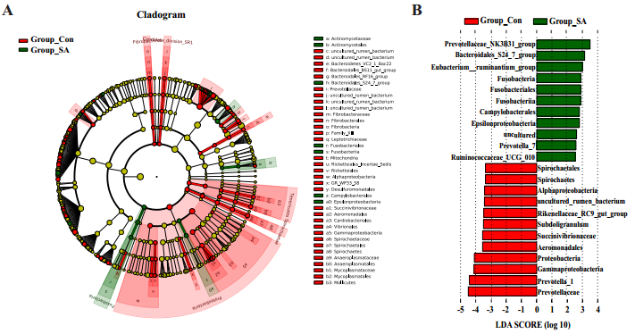

OPLS-DA:
software:SIMCA 14.1

Volcano plot:
library("ggplot2")
data<- read.table("vol.txt",head = T,sep="/t",row.names=1,encoding="utf-
8",check.names=F,quote="",as.is=TRUE)
ggplot(data, aes(x= FC, y= P))+
geom_point(aes(color=Status))+
scale_color_manual(values=c("blue","grey","red"))+
labs(title="Volcanoplot",x="log2(FC)",y="-log10(pvalue)")+
geom_hline(yintercept=1.3,linetype=2)+theme_bw()+theme(panel.grid=element_blank(),legen
d.position=c(0.9,0.9),plot.title = element_text(size = 15,face = "bold", vjust = 0.5,
hjust = 0.5),legend.background =
ggplot2::element_rect(fill="white",colour="black",size=0.3),legend.margin = margin(t =
0, r = 6, b = 6, l = 2, unit = "pt"))+geom_hline(yintercept = c(-
log10(0.05)),linetype="dashed",size=0.5,colour = "black")+
guides(color=guide_legend(title=NULL))+
annotate("text", label = paste0("p-value=",0.05), x = 8, y = c(-log10(0.05))-0.2,
size = 4, colour = "black")

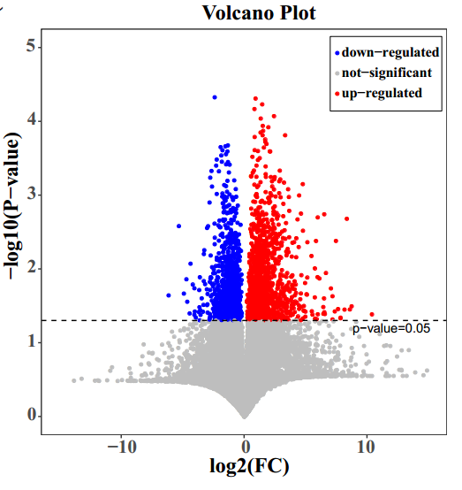
Barplot:
data<- read.table("rich.txt",head = T,sep="/t",row.names=1,encoding="utf-
8",check.names=F,quote="",as.is=TRUE)
cex=4.8/(2+sqrt(dim(data)[1]))
colwidth=c(0.01,rep(0.5,dim(data)[1]),0.01)
ylab="-log10(p-value)"
space=1+2/dim(data)[1]
col=c("#FFFFFF",colorRampPalette(c("black", "blue"))(dim(data)[1]),"#FFFFFF")
srt=40
family="sans"
opar <- par(no.readonly = TRUE)
par(mar =c(18,15,5,5),font.lab=2)
labels <- as.vector(data[,1])
labels1<-c("",labels,"")
counts <- as.vector(data[,2])
counts1 <- c(0,counts,0)
if((max(counts)-floor(max(counts)))>=0.9){yl <- ceiling(max(counts))+0.5
}else if((max(counts)-floor(max(counts)))>=0.4){yl <- ceiling(max(counts))
}else{yl <- floor(max(counts))+0.5}
if(yl<2.5){yl=2.5}
op<-barplot(counts1,width =colwidth,ylab=ylab,col=col,ylim=c(0,yl),space
=space,family=family)
axis(side=1,c(-100,op[c(-1,-dim(op)[1]),],100),tcl=-0.2, labels=FALSE)
#axis(side=1,c(-100,100),tcl=-0.2, labels=FALSE)
axis(side=2, c(-100,100),tcl=-0.2, labels=FALSE)
axis(side=3, c(-100,100),tcl=-0.2, labels=FALSE)
axis(side=4, c(-100,100),tcl=-0.2, labels=FALSE)
abline(h=-log10(0.05), col="blue",lty=2,lwd=1.5)
abline(h=-log10(0.01), col="red",lty=2,lwd=1.5)
text ( x=op,y=-yl/30,srt = srt, adj = 1,labels = labels1, xpd = TRUE, cex=cex,
family = family)
par(opar)
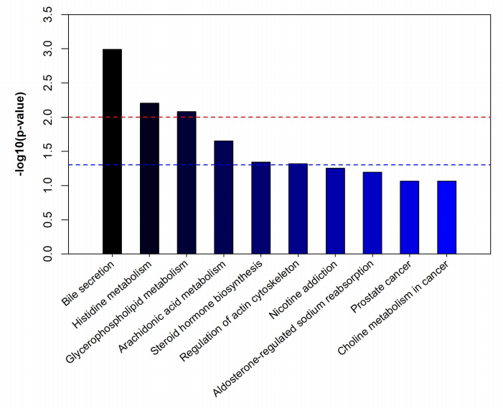
Heatmap:
library("pheatmap")
data1<- read.table("heatmap.txt",head = T,sep="/t",row.names=1,encoding="utf-
8",check.names=F,quote="",as.is=TRUE)
pheatmap(data1,treeheight_row=40,treeheight_col=40,
scale="row",cluster_cols=F,cluster_rows=T,
display_numbers=F,number_format="%.3f",
fontsize_ro=10,fontsize_col=15,cellwidth =18,
cellheight =10,show_colnames=TRUE,
color = colorRampPalette(c("green", "black","red"))(50000),
border_color="white")
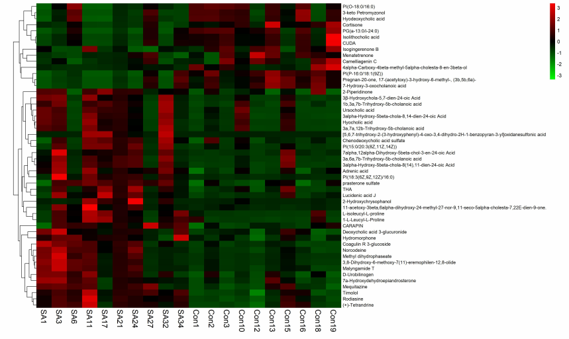
VIP score:
data<-openxlsx::read.xlsx(xlsxFile ="different metabolites.xlsx",sheet=1)
data1<-data[,c("Metabolites","VIP","average(SA)","average(Con)")]
names(data1)<-c("Metabolites","VIP","SA","Con")
data1<-data1[1:16,]
auto_vipmap<-function(data,
name=NA,
type=NA,
dpi=300,
compression ="zip",
width=15,
height =5,
order=T){
library("ggplot2",quietly = T)
library("patchwork",quietly = T)
data1<-data
names(data1)[1]<-"Metabolites"
names(data1)[2]<-"VIP"
if(order){data1<-data1[order(data1$VIP),]}
data1$Metabolites<-factor(data1$Metabolites,levels = data1$Metabolites)
data2<-data1[,c("Metabolites","VIP")]
plot1 <-ggplot(data2, aes(x = VIP, y = Metabolites)) +
geom_point() +
labs(y="",x="VIP Score")+
theme_bw()+
#scale_y_discrete(labels=NULL)+
theme(panel.background = element_blank(),
panel.grid=element_blank(),
axis.line = element_line(colour = "black"))+
theme(panel.grid.major.y = element_line(colour = "grey",linetype = 3))
data3<-data1[,-2]
data3[,"aver"]<-apply(data3[,-1], 1, mean)
data3[,2:(dim(data3)[2]-1)]<-data3[,2:(dim(data3)[2]-1)]/data3[,"aver"]
data3<-data3[,-dim(data3)[2]]
data3<-reshape2::melt(data3,id=c("Metabolites"))
names(data3)<-c("Metabolites","Group","value")
plot3 <-ggplot(data3, aes(x = Group,y=Metabolites,color=value)) +
geom_point(shape=15,size=7)+
labs(y="",x="")+
theme_bw()+
theme(panel.background = element_blank(),
panel.grid=element_blank(),
panel.border = element_blank(),
axis.line.x = element_line(colour = "black"))+
scale_y_discrete(name = NULL, labels = NULL, breaks = NULL)+
scale_colour_gradient(low="green",high="red",name="",breaks=c(min(data3$value),max(data3$va
lue)*1.0),labels=c("low","high"))
plot <- {plot1 + plot3 + plot_layout(ncol = 2, widths = c(7, 1))}
if(is.na(name)){
return(plot)
}else{
if(type=="tiff"){
ggsave(name,plot,dpi=dpi,width=width,height=height,compression =compression)
}else{ggsave(name,plot,dpi=dpi,width =width,height = height)}
}
} a
uto_vipmap(data=data1,name="VIP-SA_Con.pdf",type="pdf")
auto_vipmap(data=data1,name="VIP-SA_Con.jpg",type="jpg")

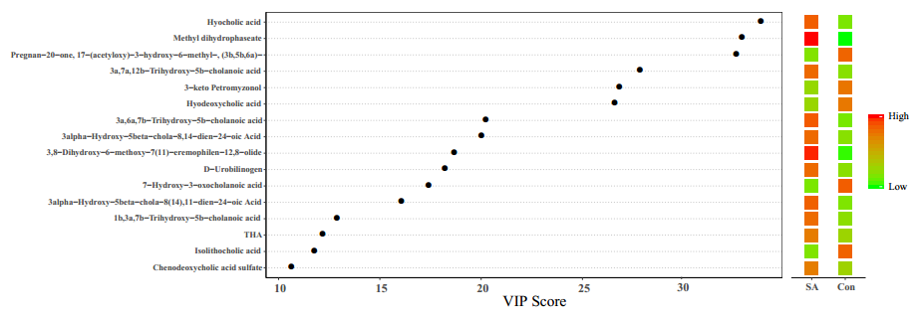
Correlation：
library(readxl)
library(tidyr)
setwd("~/Documents/R project/lessons/ ")
data1 <- read_excel("correlation analysis.xlsx",
sheet = "diversity and cytokines ") %>% as.data.frame()
data1<- data1[,-1]
multiCor<- function(data,x1,x2){

b<- list()
for (i in colnames(data)[1:x1]) {
for (y in colnames(data)[(x1+1):x2]) {

b[[i]][[y]]<- cor.test(data[,i],data[,y],method = "pearson")

}
}
d2<- sapply( names(b),function(x){
sapply(names(b[[x]]), function(y){
cbind( b[[x]][[y]][["estimate"]], b[[x]][[y]][["p.value"]])
})}
)
d2<- d2 %>% as.data.frame()
paste0(rep(colnames(data)[(x1+1):x2],each=2),c("_estimates","_pvalue"))
d2$cor <- paste0(rep(colnames(data)[(x1+1):x2],each=2),c("_estimates","_pvalue"))
return(d2)
}
d1<- multiCor(data1,9,21)
write.table(d1,"shee1.csv",sep = ",",col.names = T,row.names = F)
####################plot#########################
data <- data1
if (!dir.exists("sheet1")) {
(dir.create("sheet1"))
}
colnames(data)<- make.names(colnames(data))
if (!dir.exists("sheet1/x_y")) {
(dir.create("sheet1/x_y"))
}
for (i in colnames(data)[1:9]) {
for (y in colnames(data)[10:21]) {
dir <-"sheet1/x_y/"
pdf(file=paste0(dir,i,"_",y,".pdf"))
plot(data[,i],data[,y], xlab =i, ylab = y)
abline(lm(data[,y]~data[,i]), col = "blue")
dev.off()
}
}
if (!dir.exists("sheet1/y_x")) {
(dir.create("sheet1/y_x"))
}
colnames(data)<- make.names(colnames(data))
for (i in colnames(data)[1:9]) {
for (y in colnames(data)[10:21]) {
dir <-"sheet1/y_x/"
pdf(file=paste0(dir,y,"_",i,".pdf"))
plot(data[,y],data[,i], xlab =y, ylab = i)
abline(lm(data[,i]~data[,y]), col = "blue")
dev.off()
}
} 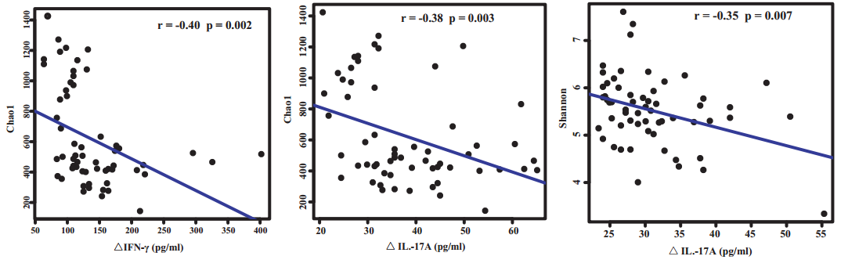
Network：
library("dplyr")
library("tidyr")
library("ggplot2")
library("scales")
library("network")
library("sna")
library("GGally")
library("igraph")
correlation<- read.csv("p0.05.xls",header=T,sep="\t")
colnames(correlation) <-
c("From","to","Correlation","Pvalue","Type","AdjPvalue","Significance","Positive_Negati
ve")
category1 <- cbind(as.data.frame(unique(correlation$From)),"Metabolites")
category2 <- cbind(as.data.frame(unique(correlation$to)),"OTU")
colnames(category2) <- c("label","Category")
colnames(category1) <- c("label","Category")
nodes <- rbind(category1,category2)
em.cet<-as.character(nodes$Category)
names(em.cet) = nodes$label
edges<- correlation
em.net <- edges[, c("From", "to") ]
em.net <- network::network(em.net, directed = F)
em.net %v% "curr_empl_type" <-
em.cet[ network.vertex.names(em.net) ]
col<-ifelse(as.numeric(edges[,3])<0,"green","red")
network::set.edge.attribute(em.net, "n", abs(edges[, 3 ]) / 2)
network::set.edge.attribute(em.net, "m",col)
set.seed(10312016)
ggnet2(em.net, color = "curr_empl_type",size = 6,label=TRUE,label.size=1.0, palette =
"Set2",arrow.size = 5, arrow.gap = 0.02,edge.alpha = 0.25, mode =
"fruchtermanreingold",edge.size="n",edge.color = "m",color.legend = "Category") +
theme(legend.position = "bottom")
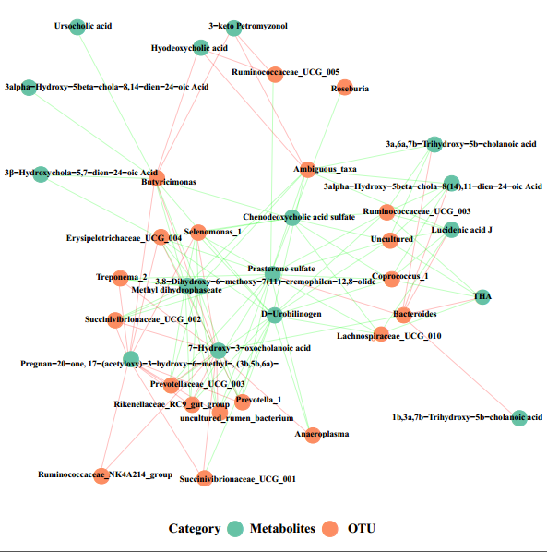
RDA:
library(vegan)
sp <- read.table(file=file.choose(),sep="\t",header=T,row.names=1)
sp
se <- read.table(file=file.choose(),sep="\t",header=T,row.names=1)
se
decorana(sp)
sp0 <- rda(sp ~ 1, se)
sp0
plot(sp0)
sp1 <- rda(sp ~ ., se)
sp1
plot(sp1)
new<-sp1$CCA
new
samples<-data.frame(sample=row.names(new$u),RDA1=new$u[,1],RDA2=new$u[,2])
samples
species<-data.frame(spece=row.names(new$v),RDA1=new$v[,1],RDA2=new$v[,2])
species
envi<-data.frame(en=row.names(new$biplot),RDA1=new$biplot[,1],RDA2=new$biplot[,2])
envi
line_x = c(0,envi[1,2],0,envi[2,2],0,envi[3,2],0,envi[4,2],0,envi[5,2],0,envi[6,2])
line_x
line_y = c(0,envi[1,3],0,envi[2,3],0,envi[3,3],0,envi[4,3],0,envi[5,3],0,envi[6,3])
line_y
line_g = c("IL2"," IL17A"," IL17F","TNFa","IFNr")
line_g
line_data = data.frame(x=line_x,y=line_y,group=line_g)
line_data
library(ggplot2)
ggplot(data=samples,aes(RDA1,RDA2)) + geom_point(aes(color=sample),size=2) +
geom_point(data=species,aes(shape=spece),size=2) +
geom_text(data=envi,aes(label=en),color="blue") +
geom_hline(yintercept=0) + geom_vline(xintercept=0)+
geom_line(data=line_data,aes(x=x,y=y,group=group),color="green") +
theme_bw() + theme(panel.grid=element_blank())
ggsave("RDA2.PDF")
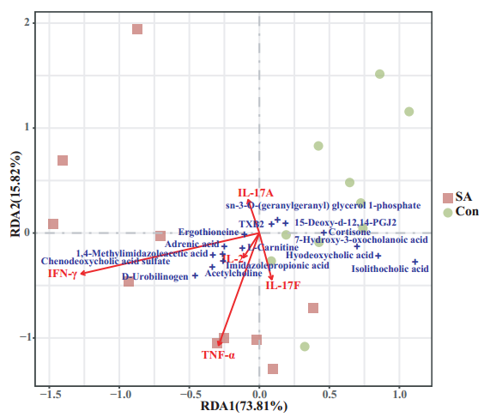

ROC：
data<-openxlsx::read.xlsx(xlsxFile ="heatmap.xlsx",sheet=1,rowNames=T)
data1<-data[1:2,]
data1<-as.data.frame(t(data1))
data2<-reshape2::melt(data1,id=c("Group"))
names(data2)<-c("Group","Metabolites","Expression")
library("ggplot2",quietly = T)
library("plotROC",quietly = T)
p<-ggplot(data2, aes(m = Expression, d = Group,color=Metabolites)) +
geom_roc(labels=F,n.cuts = 0)+
theme_bw()+
facet_wrap(~ Metabolites)+
theme(legend.position='none')+
xlab("1 - Specificity")+
ylab("Sensitivity")+
scale_x_continuous(expand = c(0.01, 0.01))+
scale_y_continuous(expand = c(0.01, 0.01))+
geom_hline(yintercept=c(0,1))+
geom_vline(xintercept=c(0,1))+
scale_colour_manual(values="black")+
geom_abline(slope=1, intercept=0,linetype="dashed")+
theme(text=element_text(family="sans"),
panel.grid=element_blank(),
plot.title = element_text(hjust = 0.5),
aspect.ratio=1,
axis.text=element_text(size=10),
axis.title=element_text(size=10),
legend.text=element_text(size=10),
legend.title=element_text(size=10),
plot.margin = unit(c(0.3,0.3,0.3,0.3),"in"))
ggsave("ROC.jpg",p,width=5,height=5)
ggsave("ROC.pdf",p,width=5,height=5)
