Attribution of Wintertime Extreme Rainfall over the Pearl River Delta to Anthropogenic Influences

Supporting material
Rui Zhao^{1,2} $∙$ Chi-Yung Tam¹ $∙$ Sai-Ming Lee³

✉ Chi-Yung Francis Tam
Francis.Tam@cuhk.edu.hk
¹ Earth System Science Programme, The Chinese University of Hong Kong, Hong Kong, China
² Fujian Key Laboratory of Severe Weather, Fujian Institute of Meteorological Sciences, Fuzhou, 350001, Fujian, China
³ Hong Kong Observatory, Hong Kong, China

Table S1. Descriptions of CMIP5 GCMs used in this study.
No. | Acronym | Institute and Country | Resolution  (Lon$×$Lat) | Mean anomaly of initial T_{sfc} in D02 ($℃$)
1 | Bcc-csm1-1 | Beijing Climate Center, China Meteorological Administration, China | 128×64 | 0.63
2 | CanESM2 | Canadian Centre for Climate Modelling and Analysis, Canada | 128×64 | 0.61
3 | CCSM4 | National Center for Atmospheric Research, USA | 288×192 | 0.74
4 | GFDL_ESM2M | Geophysical Fluid Dynamics Laboratory, USA | 144×90 | 0.72
5 | IPSL-CM5A-LR | L’Institut Pierre-Simon Laplace, France | 96×96 | 1.03
6 | IPSL-CM5A-MR | L’Institut Pierre-Simon Laplace, France | 96×96 | 0.79
7 | MRI-CGCM3 | Meteorological Research Institute, Japan | 256×128 | 0.62

Table S2. Combinations of microphysics and cumulus schemes used in the WRF multi-physics ensemble.
No. | EXP | Microphysics | Cumulus schemes
1 | WG3 | WSM6 | Grell 3D
2 | WKF | WSM6 | Kain–Fritsch
3 | WBMJ | WSM6 | Betts–Miller–Janjic
4 | TG3 | Thompson | Grell 3D
5 | TKF | Thompson | Kain–Fritsch
6 | TBMJ | Thompson | Betts–Miller–Janjic

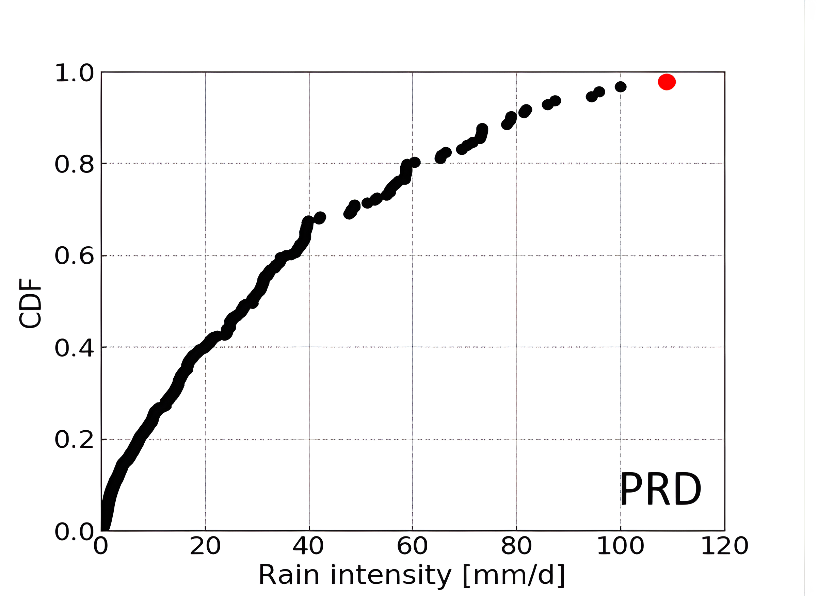
Figure S1. Cumulative distribution function (CDF) distribution of four-day accumulated rainfall (units: mm d⁻¹) during wintertime over the PRD region from 1998 to 2018, based on TRMM 3B42 observations. The red dot denotes the extreme rainfall event during December 14-17, 2013.

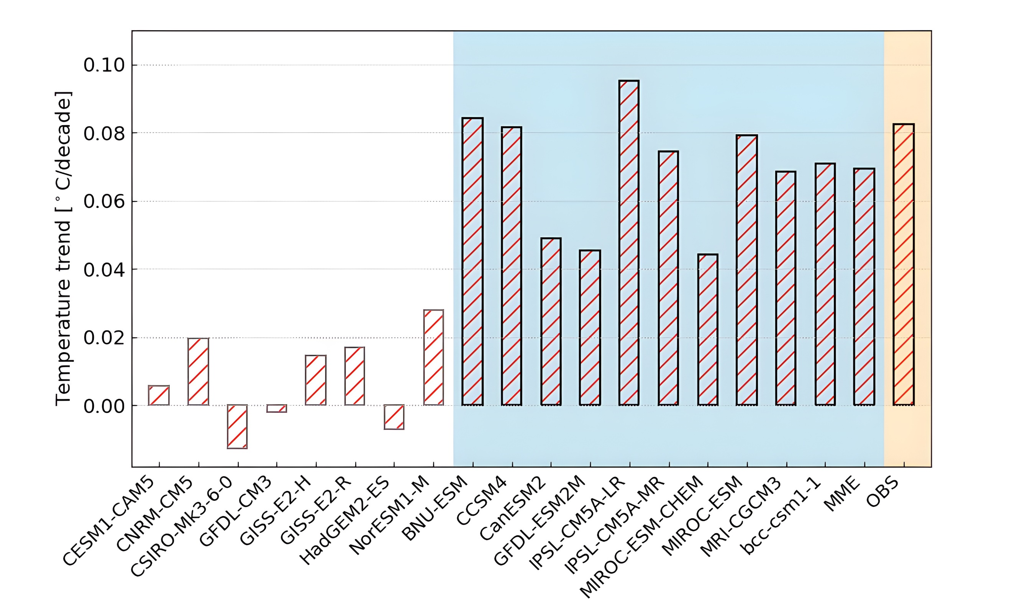
Figure S2. Surface temperature trends (units: $°$C per decade) for the period of 1901-2005, averaged over domain 2 (SC), derived from the historical runs of individual CMIP5 models. Also shown is the selected models and multi-model ensemble mean (MME), as well as the observed trends (OBS). See text for details.

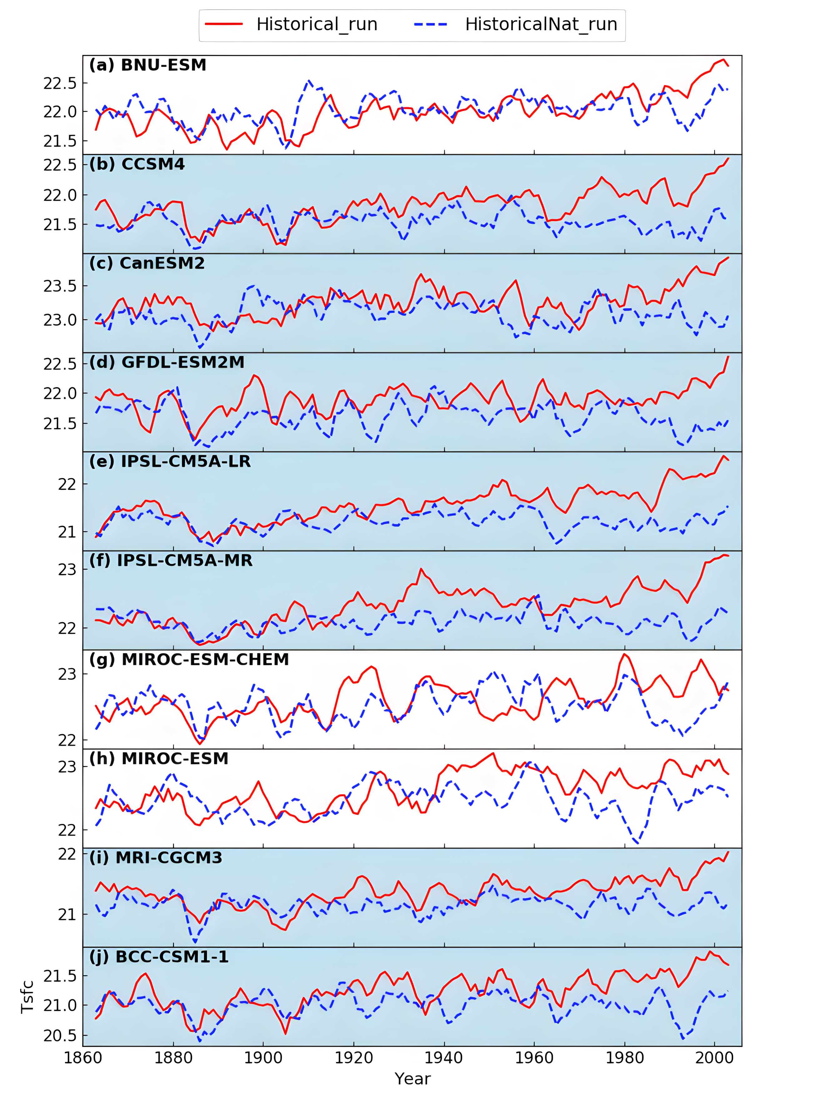
Figure S3. Time evolution of the annual mean surface temperature (units: $°$C) over SC from 1861-2005 taken from the (a) BNU-ESM, (b) CCSM4, (c) CanESM2, (d) GFDL-ESM3M, (e) IPSL-CM5A-LR, (f) IPSL-CM5A-MR, (g) MIROC-ESM-CHEM, (h) MIROC-ESM, (i) MRI-CGCM3, (j) BCC-CSM1-1 historical (red) and historicalNat (blue) runs. Models selected for obtaining anthropogenic forcing signals are indicated with blue backgrounds. See text for details.

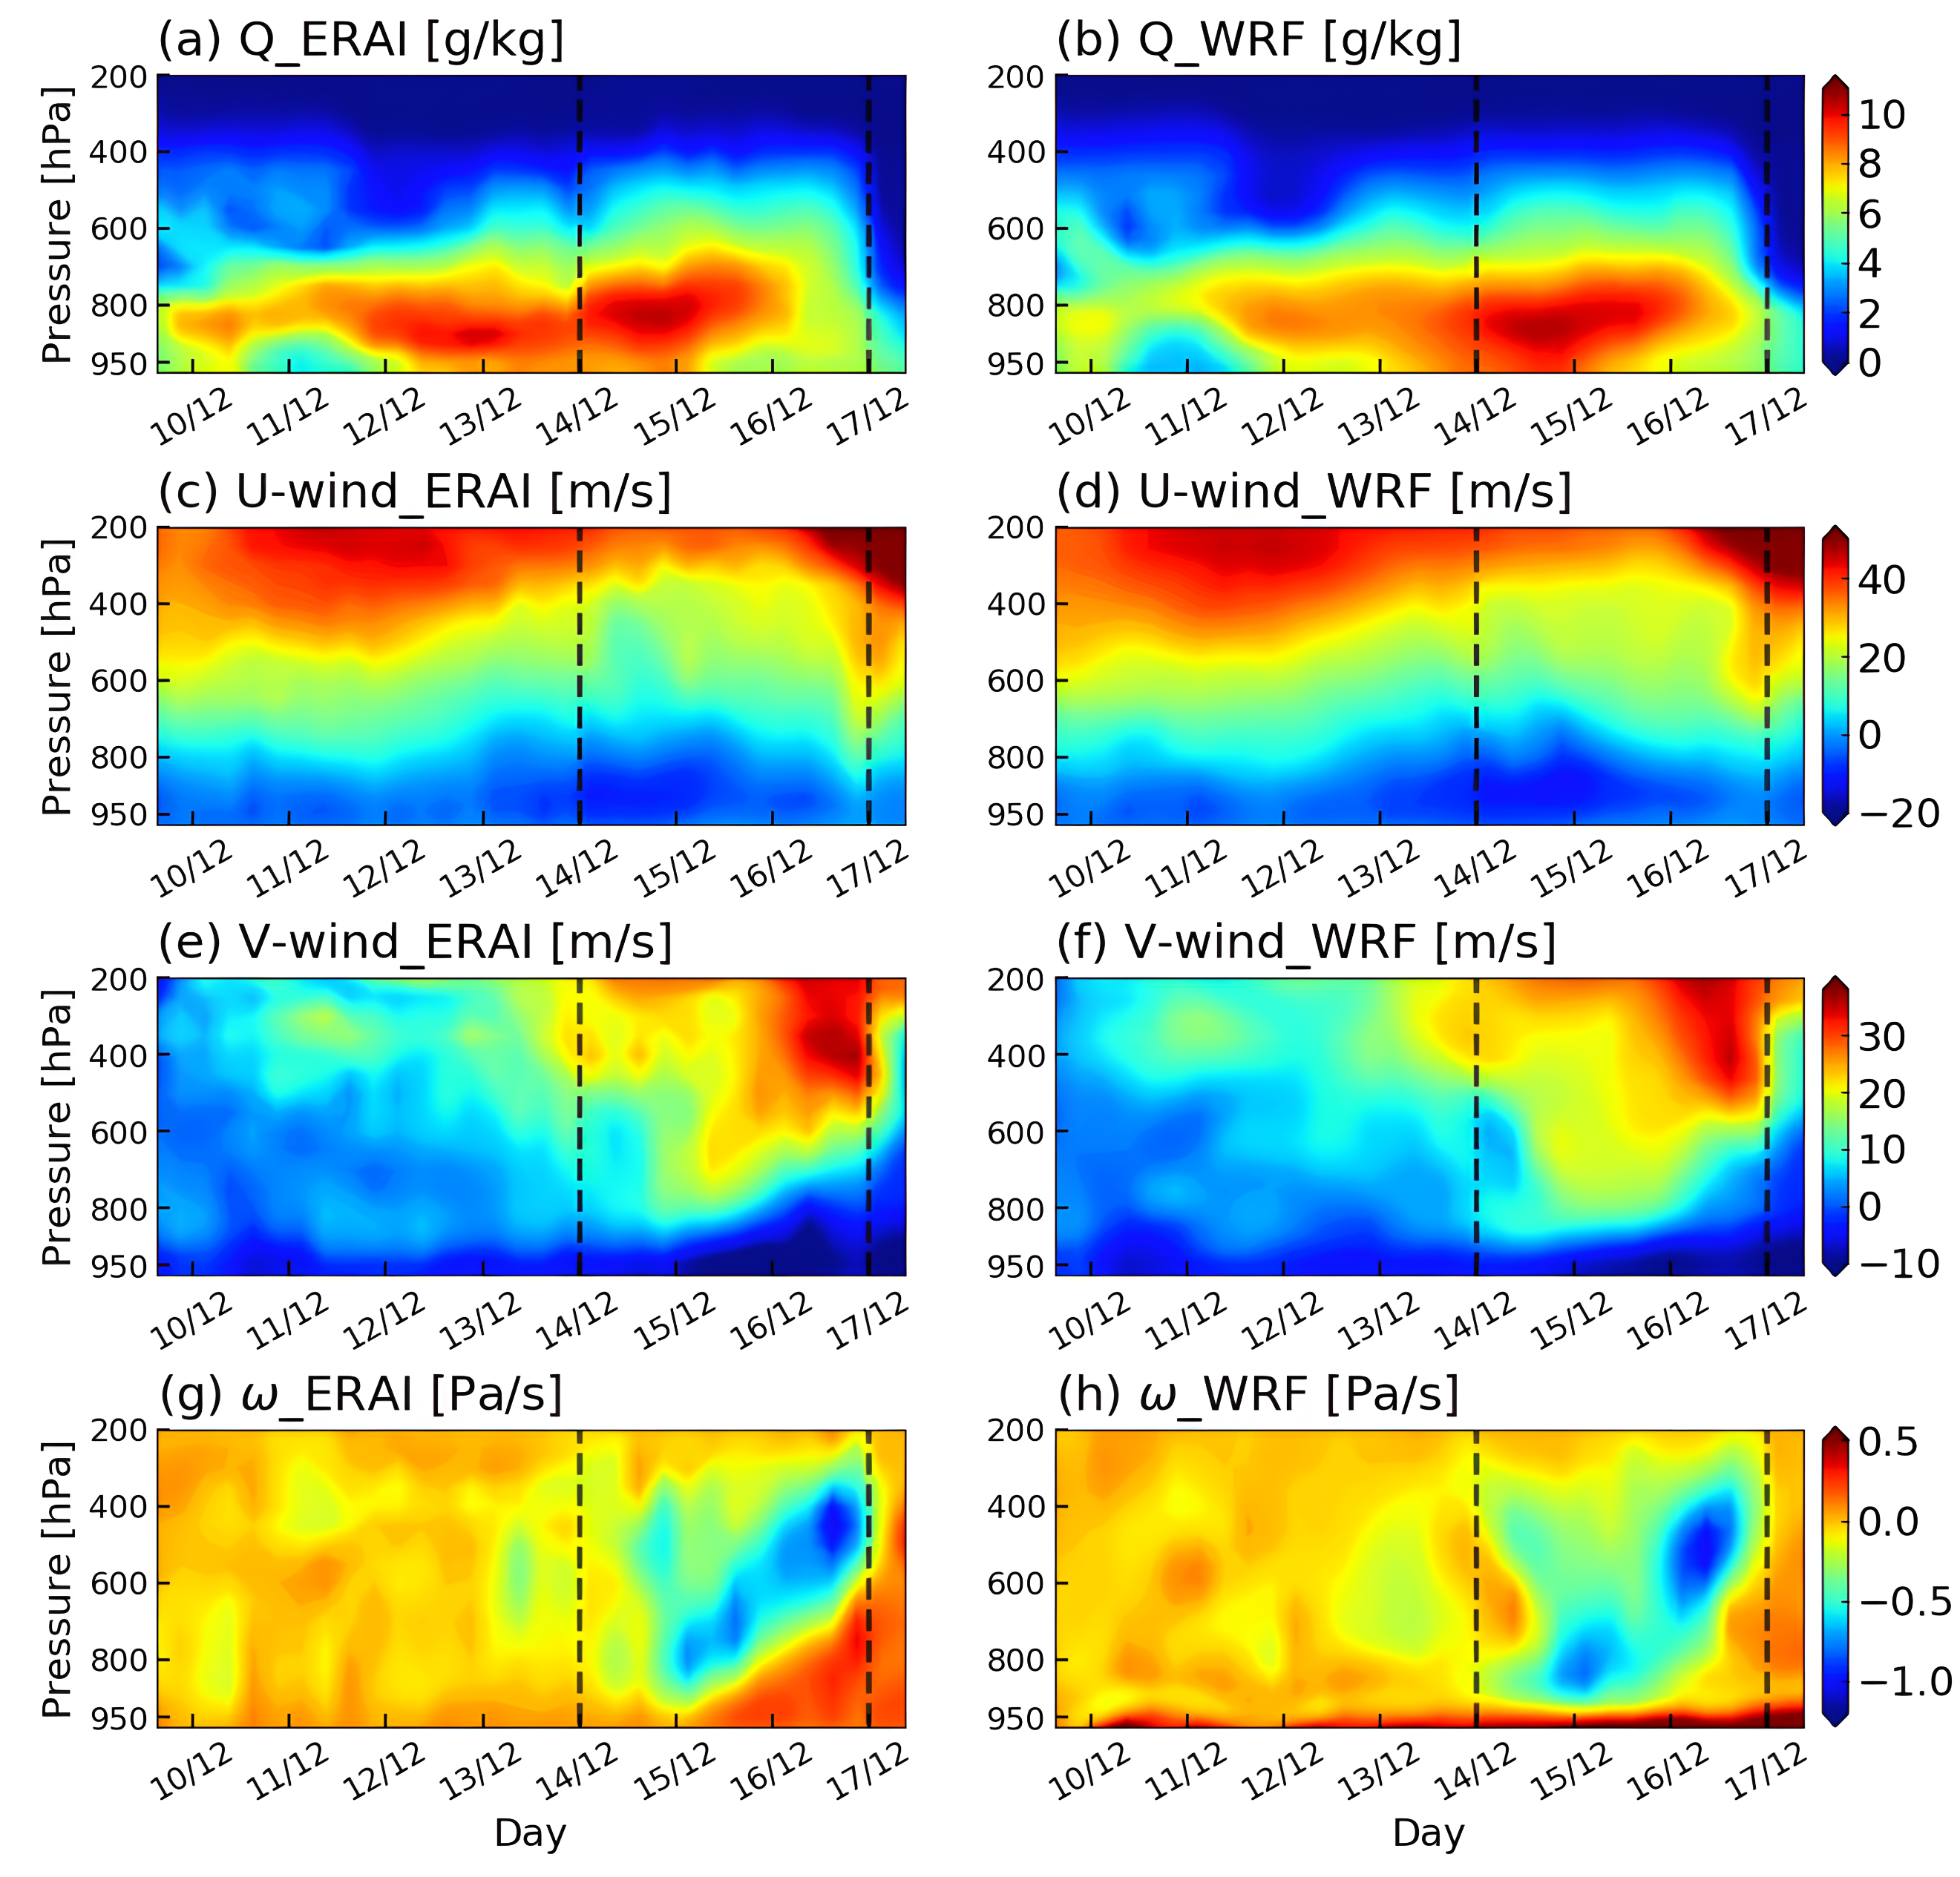
Figure S4. Time evolution of (a, b) specific humidity (units: g kg⁻¹), (c, d) U-wind (units: m s⁻¹), (e, f) V-wind (units: m s⁻¹), and (g, h) pressure velocity (units: Pa s⁻¹) vertical profiles averaged over the PRD region from ERA-Interim (left column) and WRF control runs (right column). The rainfall period is marked by the black dashed lines. See text for details.

