Supplementary material

Table 1. Performance of biochemical markers at admission in predicting pancreatic necrosis: Triglyceride ≥200mg/dL, Creatinine ≥1.8 mg/dL, Hematocrit ≥44%, BUN ≥20mg/dL, C-reactive protein ≥15mg/dL.
 | AUC (CI 95%) | P | Sensitivity | Speciﬁcity | PPV | NPV
Biochemical markers
Triglyceride | 0.601 (0.519-0.684) | 0.015 | 38.7% | 83.8% | 56.9% | 71.3%
Creatinine | 0.611 (0.53-0.692) | 0.008 | 6.8% | 93.3% | 35.7% | 64.6%
Hematocrit | 0.644 (0.562-0.727) | 0.001 | 53.3% | 74.3% | 53.3% | 74.3%
BUN | 0.56 (0.477-0.643) | 0.152 | 52.7% | 55.6% | 39.4% | 68.2%
C-reactive protein | 0.579 (0.494-0.663) | 0.066 | 23.9% | 88.3% | 53.1% | 67.7%
AUC: area under the curve, BUN: Blood urea nitrogen.
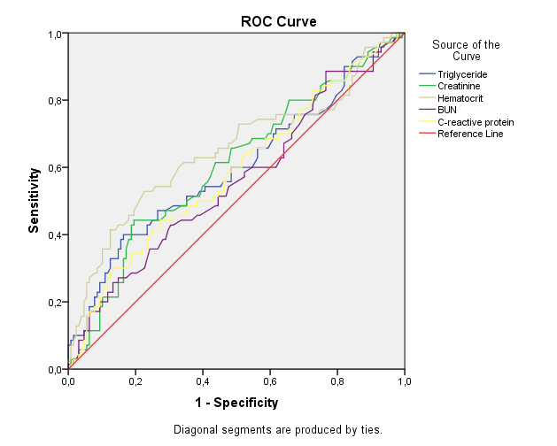
Figure 1. Receiver operating characteristic (ROC) curve for pancreatic necrosis of triglycerides and biochemical markers at admission.

