Table. S1. One-way ANOVA analysis (p values) of three factors (sterilization, plant, and microbial inoculant) on soil nutrient and enzyme activities. Note: ns indicates no significant effect, * indicates p＜0.05, **indicates p＜0.01, and ** indicates p＜0.001.
 | Sterilization | Plant | Microbial inoculant | Sterilization×  Plant | Sterilization×  Microbial inoculant | Plant×  Microbial inoculant | Sterilization×  Plant×  Microbial inoculant
Aboveground length | *** | × | *** | × | ns | × | ×
Underground length | ** | × | ** | × | ns | × | ×
Plant length | *** | × | ** | × | ns | × | ×
Aboveground dry weight | *** | × | *** | × | * | × | ×
Underground dry weight | ** | × | ** | × | ns | × | ×
Plant dry weight | *** | × | *** | × | * | × | ×
pH | ns | ns | ns | *** | ns | ns | ns
Total carbon | ** | ** | ** | * | ns | ** | ****
Soil organic carbon | *** | *** | ns | ns | ns | * | ns
β-1,4-glucosidase | *** | ** | * | ns | ns | ns | ns
Invertase | *** | ns | * | ns | ns | ns | ns
Polyphenol oxidase | * | ns | * | ns | v | ns | ns
Peroxidase | ns | ns | * | ns | ns | ns | ns
Total nitrogen | ** | ns | ns | ** | ns | ns | ns
NH₄⁺-N | *** | *** | *** | *** | *** | ns | ns
NO₃⁻-N | ** | *** | ns | * | ns | ns | ns
β-1,4-N-acetylglucosaminidase | *** | *** | *** | * | * | ns | ns
Urease | *** | ** | ns | * | ns | ns | ns
Available phosphorus | ns | ns | * | ns | ns | ns | ns
Acid phosphatase | ns | ** | ns | * | ns | ns | ns
Neutral phosphatase | ** | ns | ns | ns | ns | ns | ns
Alkaline phosphatase | ns | *** | ** | *** | ns | ns | ns
Total sulfur | ns | ns | ns | ** | ns | ns | ns
Arylsulphatase | *** | ** | *** | *** | *** | ns | ns
Total potassium | ns | ns | ns | ns | ns | ns | ns
Available potassium | *** | *** | *** | ns | ns | ns | ns
Soil multifunctionality | *** | *** | *** | ** | * | * | ns

Fig. S1. Soil nutrient indexes in response to plant, sterilization, and microbial inoculant treatments. Note: ns indicates no significant effect, * indicates p＜0.05, **indicates p＜0.01, and ** indicates p＜0.001.
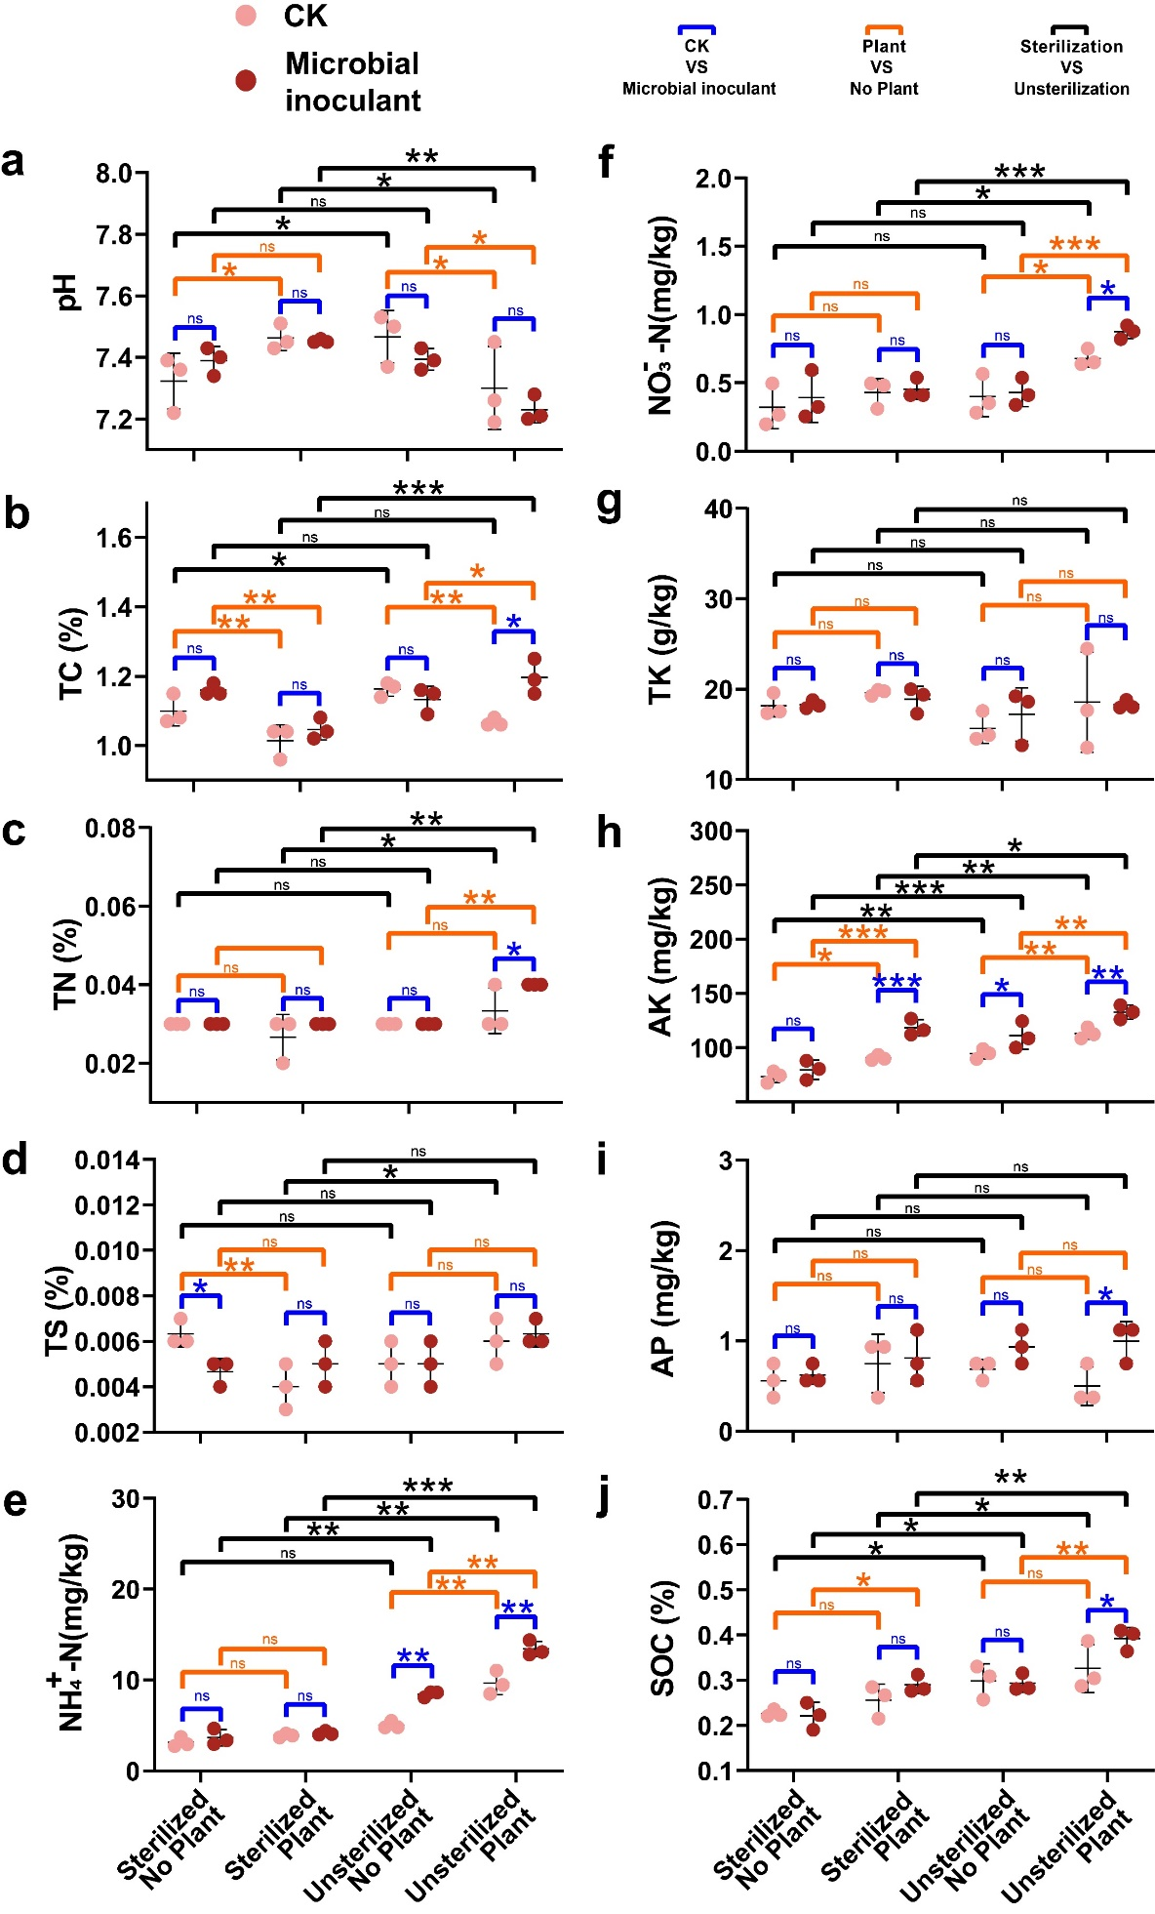

Fig. S2. Soil enzyme activity indexes in response to plant, sterilization, and microbial inoculant treatments. Note: ns indicates no significant effect, * indicates p＜0.05, **indicates p＜0.01, and ** indicates p＜0.001.
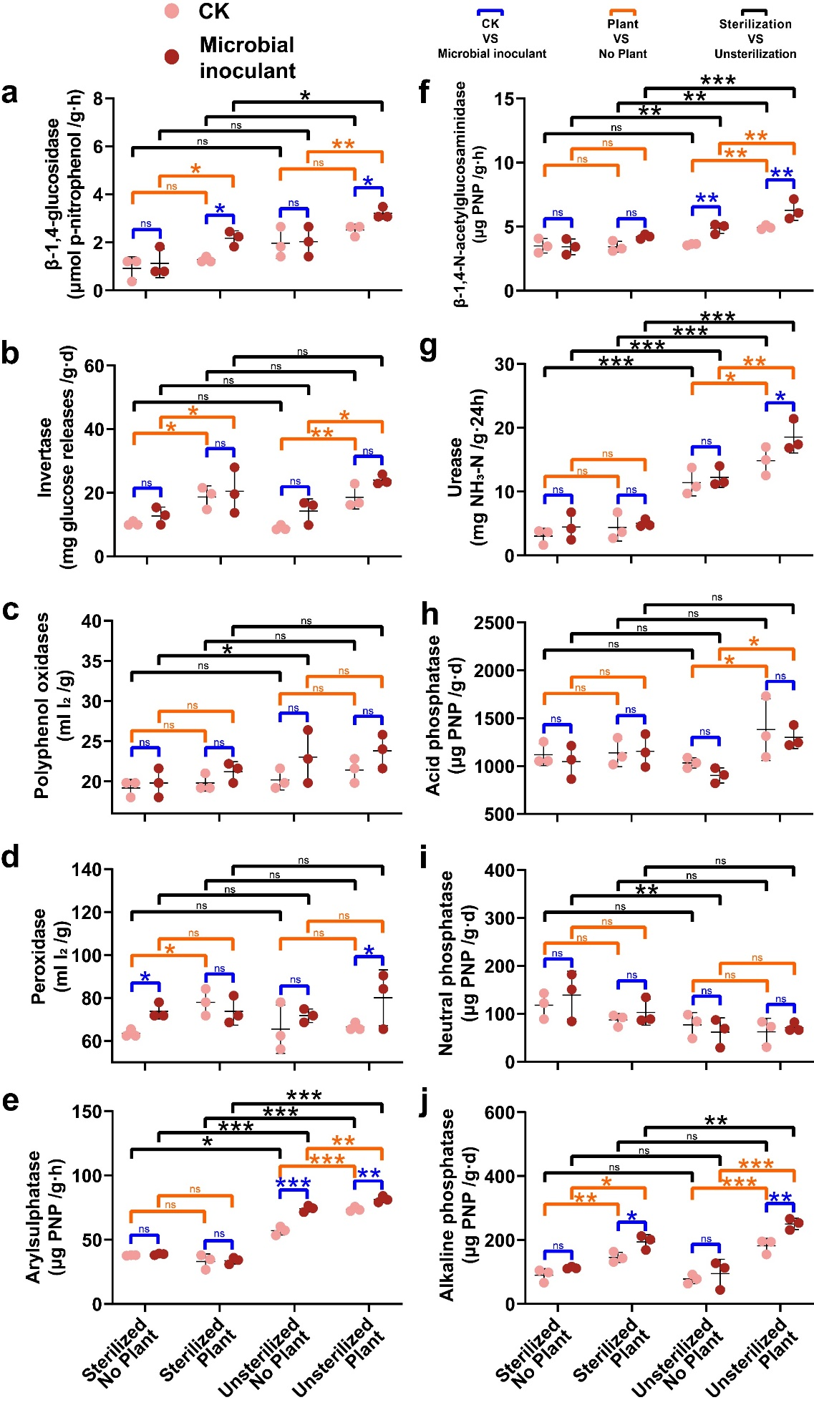

Fig. S3. Nonmetric multidimensional scaling (NMDS) analysis was based on Bray-Curtis dissimilarity.
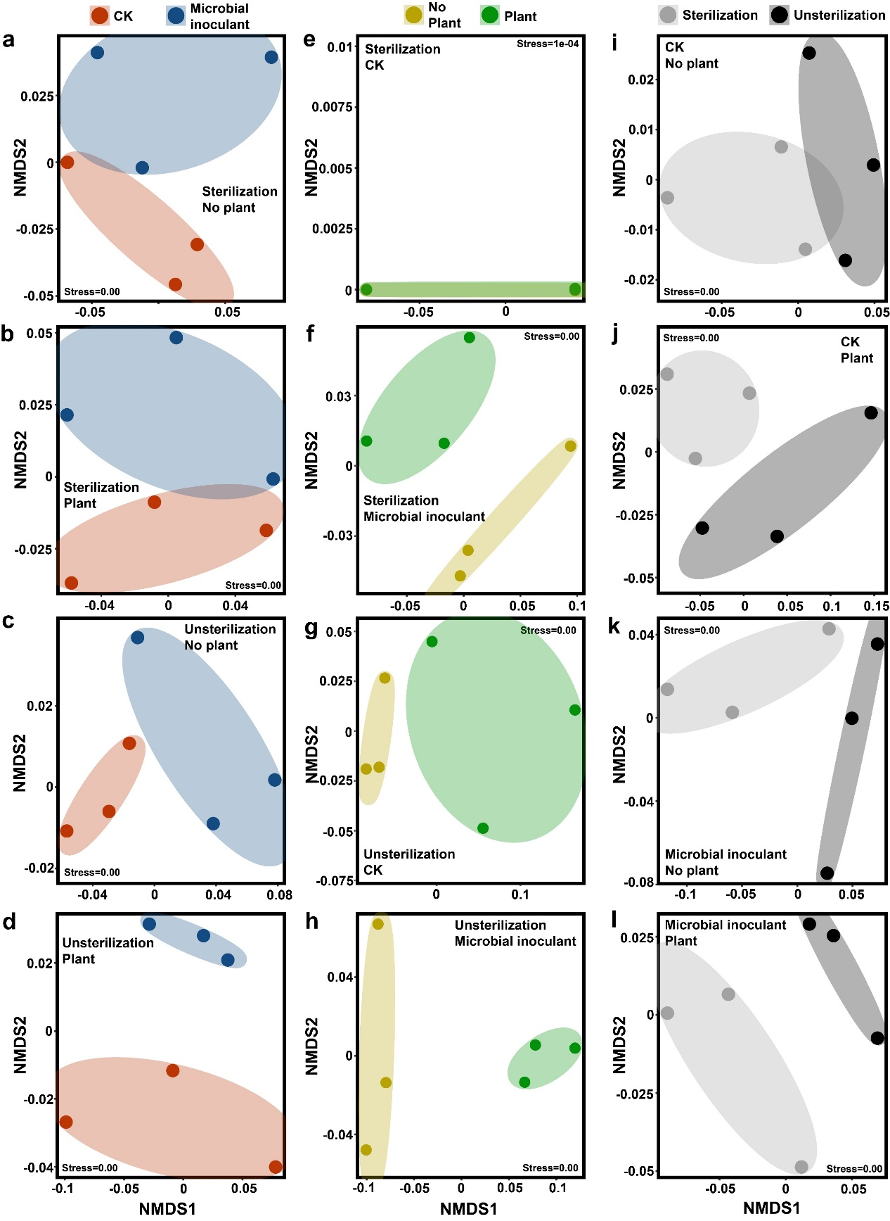

Fig. S4. The relationship among soil multifunctionality index, soil nutrient, and enzyme activity. In the square, the blue and red colors represent a positive and negative correlation, respectively, between the two variables. The association between the variables is stronger the deeper the hue.

