Supplementary Material
Improving the malignancy prediction of breast cancer based on the integration of radiomics features from dual-view mammography and clinical parameters
Chenyi Zhou¹, Hui Xie¹, Fanglian Zhu¹, Wanying Yan², Ruize Yu², Yanling Wang*¹
- Department of Radiology, The People`s Hospital of Suzhou New District, Jiangsu Province 215129, China;
1270363634@qq.com (C.Z.);sky_xiehui@163.com(H.X.);2442966072@qq.com (F.Z.);
- Beijing Infervision Technology Co. Ltd., Beijing 100025, China;
yanwanying1996@163.com (W.Y.);yuruize1997@outlook.com (R.Y.);
Correspondence: wyd_wjq1992@163.com; Tel.18362755698

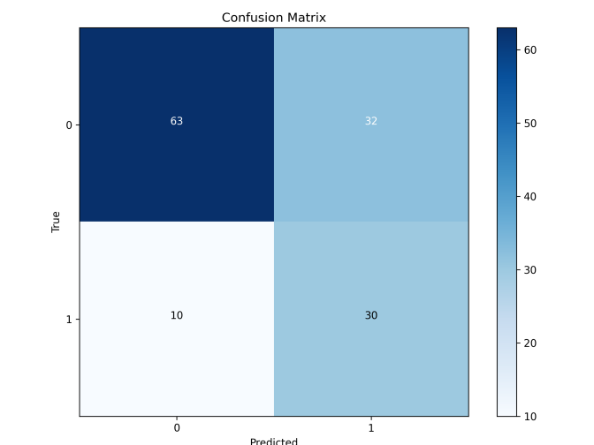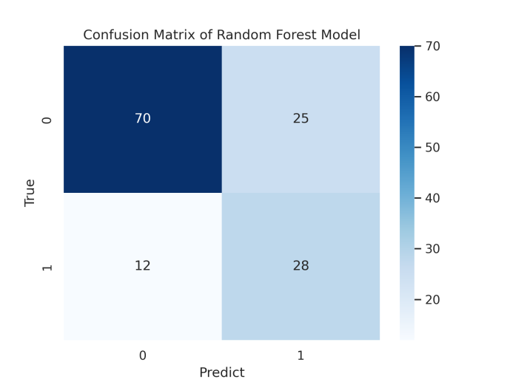
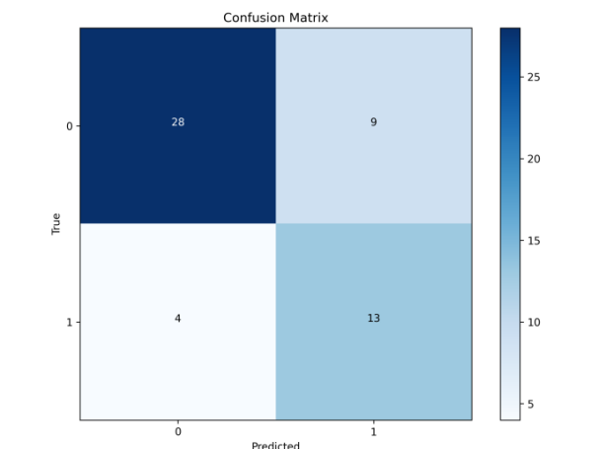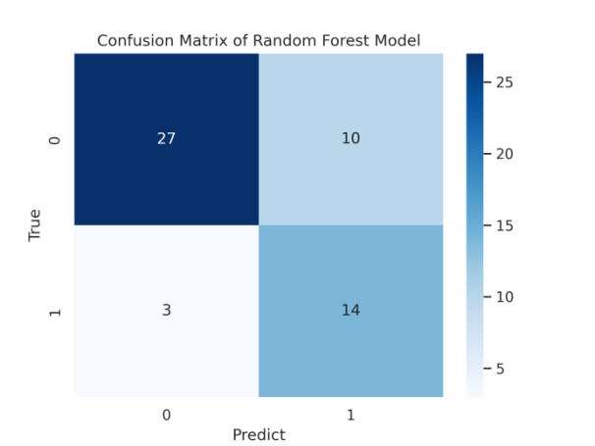
Fig. S2 Confusion matrix of predicting breast lesions with random forest using features from a lesion alone. b lesion with clinical information. c dual-view lesion. d dual-view lesion with clinical information.

Exact definition and detailed description of each radiomics feature can be found on https://ibsi.readthedocs.io or https://pyradiomics.readthedocs.io

