Repression of the expression of proinflammatory genes by mitochondrial transcription factor A is linked to its alternative splicing regulation in human lung epithelial cells

Jinsong Luo^{1,a,#}, Hong Liu^{1,a}, Daniel K. Jun Li^{2,3}, Bin Song², Yi Zhang²
- Department of Pediatrics, Renmin Hospital of Wuhan University, Wuhan, Hubei, China
- ABLife BioBigData Institute, Wuhan, Hubei, China
- Department of Biology and Biotechnology, School of Chemistry, Chemical Engineering and Life Science, Wuhan University of Technology, Wuhan, Hubei, China
a. These persons contributed equally to this work.
#Correspondence: 1661617514@qq.com
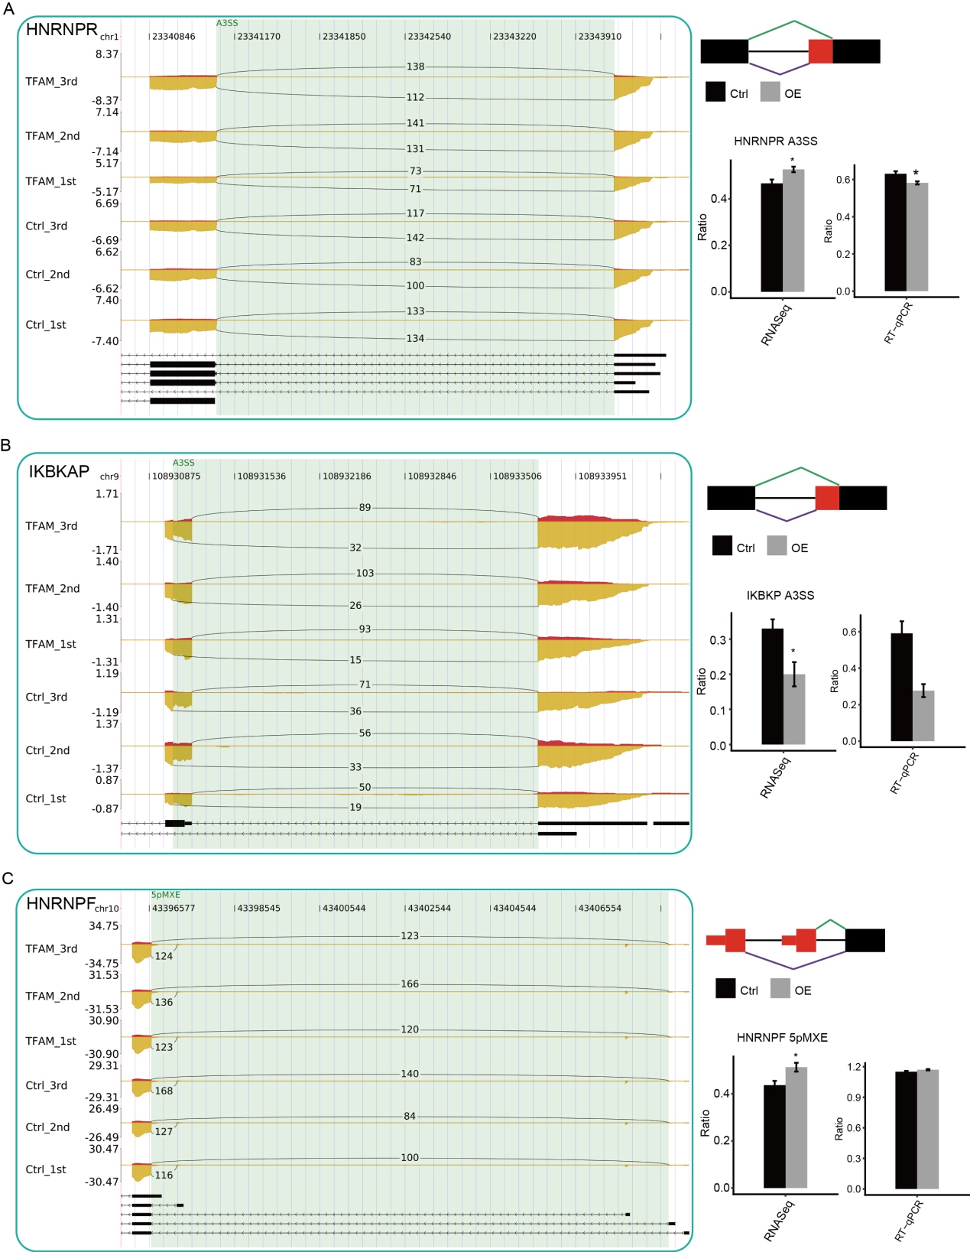
Supplementary Fig. S1 Validation of TFAM-regulated RASEs.
The experiments and presentation of the results are the same as shown in Fig. 4.

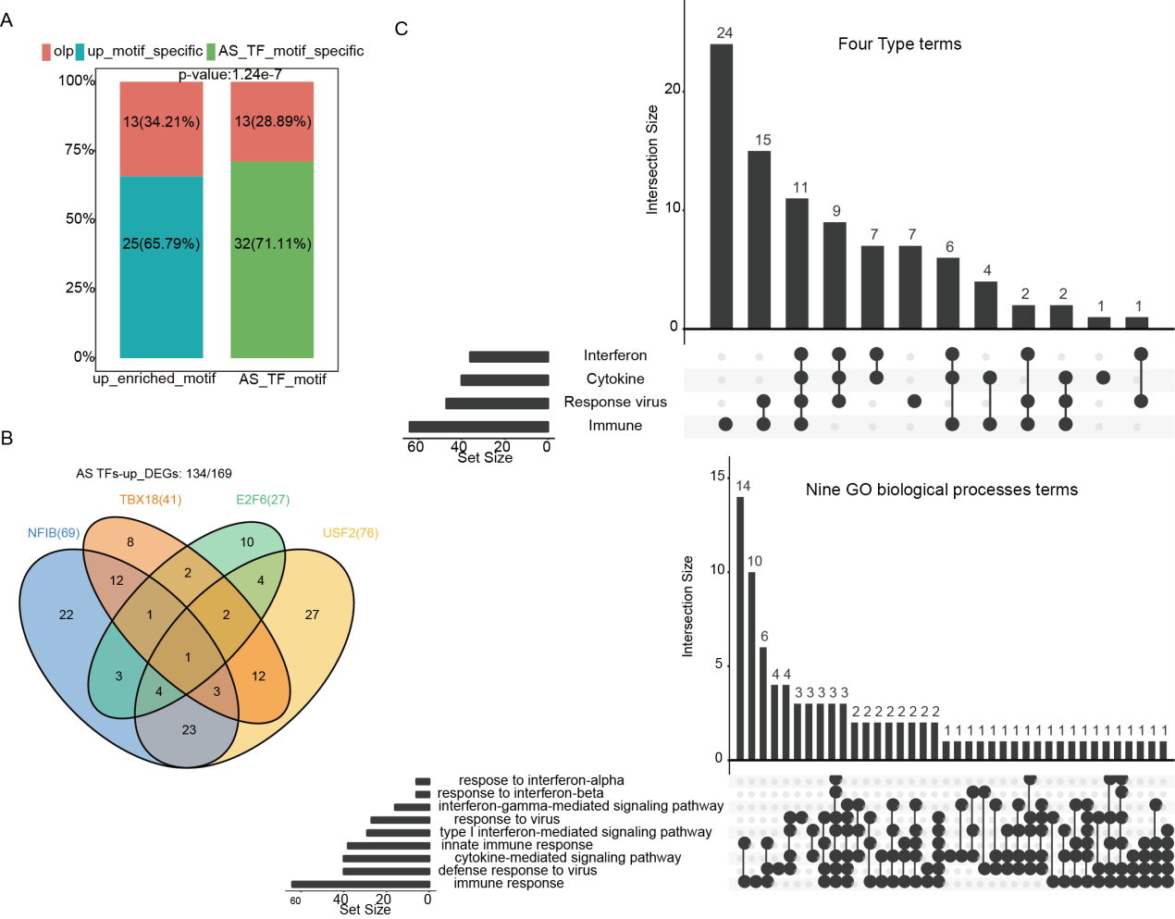
Supplementary Fig. S2 TFAM-regulated alternative splicing of the transcript factors are linked to the TFAM-regulated gene expression.
(A) Overlap of the DNA binding motifs of TFAM-regulated TFs (RASGs) with the DNA motifs enriched in the promoter regions of the TFAM-upregulated genes (DEGs). (B) Venn diagram shows the overlap among the up-DEGs containing the DNA binding motifs for the top four TFs (NFIB, USF2, TBX18, and E2F6 that were ranked by the number of up-DEGs harboring their DNA binding sites. (C) UpSet plot of the overlaps of the TFAM-repressed genes enriched in nine top GO-BP terms. The terms were grouped to four functional groups. The interferon function includes “type I interferon-mediated signaling pathway”, “interferon-gamma-mediated signaling pathway”, “response to interferon-alpha”, and “response to interferon-beta”. The cytokine function includes one term “cytokine-mediated signaling”. The response to virus function includes 2 terms, “response to virus” and “defense response to virus”. The immune function includes “immune response” and “innate immune response”.

