Supplementary information
Precise co-delivery of drug and cytotoxic exosomes using a biomimetic nanorobot for glioma regression and recurrence prevention
Wenyan Hao^{a,1}, Peiying Li^{b,1}, Chuntong Li^{c,1}, Yueyue Fanª, Chen Li^{c}, Mengyu Chenª, Qianqian Liuª, Meiyan Yang^{a,*}, Mengli Chen ^{c,*}, Chunsheng Gao ^{a,*}, Yang Yangª
ªState Key Laboratory of Toxicology and Medical Countermeasures, Beijing Institute of Pharmacology and Toxicology, Beijing, China
^{b}The Department of Pediatric, The Fifth Medical Center of Chinese PLA General Hospital, Beijing, China
^{c} The Department of Pharmacy, Chinese PLA General Hospital, Beijing, China

¹These authors contributed equally to this work.
* To whom correspondence should be addressed.
Corresponding Authors
Meiyan Yang: ymyzi@163.com
Mengli Chen: hellolily301cn@126.com
Chunsheng Gao: gaocs@bmi.ac.cn.

Supplementary figures
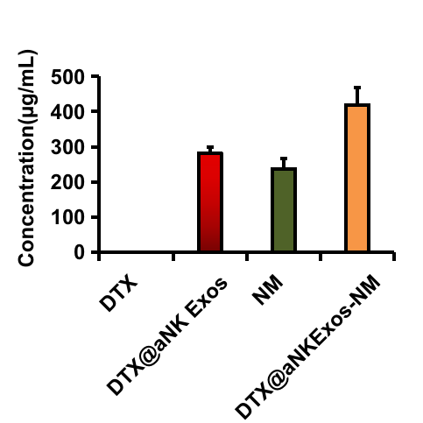
Fig. S1 The total protein contents of different biomimetic nanoparticles (n=3).
Fig. S2 RAW264.7 Macrophage uptake of DTX@ aNK Exos and DTX@aNK Exos.
Fig. S3 Evaluation of cytotoxicity of different DTX formulations on C6 glioma cells (n=6).
Fig. S4 Representative scatter plots of Annexin V/PI analysis of C6 cells with various DTX formulations.
Fig. S5 Levels of serum HSP 70 in serum, a: glioma-bearing mice with radiation treatment, b: glioma-bearing mice (n=3).
Fig. S6 Expression of IL-10 and TNF-α in serum (A, C) and tumor (B, D), a: glioma-bearing mice with radiation treatment, b: glioma-bearing mice (n=3).
Fig. S7 Preliminary safety evaluation. (A) Levels of liver and kidney function markers, including ALT, AST, and UREA. (B) Histological examination of major organs derived from mice after treatment (20× magnification).

