Eye-mimicked neural network composed of photosensitive neural spheroids with human photoreceptors

Authors
Byeongho Park,¹† Seokyoung Bang,^{1,2}† Kyeong Seob Hwang,^{1,3}† Yeon Kyung Cha,⁴† Jisung Kwak,¹ Na Ly Tran,^{1,5} Hyo-Suk Kim,¹ Subeen Park,¹ Seung Ja Oh,^{1,5} Maesoon Im,^{1,5} Yong-Sang Ryu,¹ Sooyoung Chung,¹ Jongbaeg Kim,³ Tai Hyun Park,⁴ Hyun Seok Song,^{1,}* Hong Nam Kim,^{1,3,5,6,}* and Jae Hun Kim^{1,}*
Affiliations
¹Korea Institute of Science and Technology (KIST), Seoul, 02792, Republic of Korea
²Department of Medical Biotechnology, Dongguk University, 32 Dongguk-ro, Ilsandong-gu, Goyang, Gyeonggi, 10326, Republic of Korea
³School of Mechanical Engineering, Yonsei University, Seoul 03722, Republic of Korea
⁴School of Chemical and Biological Engineering, and Institute of Chemical Processes, Seoul National University, Gwanak-gu, Seoul 08826, Republic of Korea
⁵Division of Bio-Medical Science & Technology, KIST School, University of Science and Technology, Seoul 02792, Republic of Korea
⁶Yonsei-KIST Convergence Research Institute, Yonsei University, Seoul 03722, Republic of Korea

† These authors contributed equally to this work.
* Correspondence authors
Email: hssong@kist.re.kr, hongnam.kim@kist.re.kr, jaekim@kist.re.kr

SUPPLEMENTAL MATERIAL
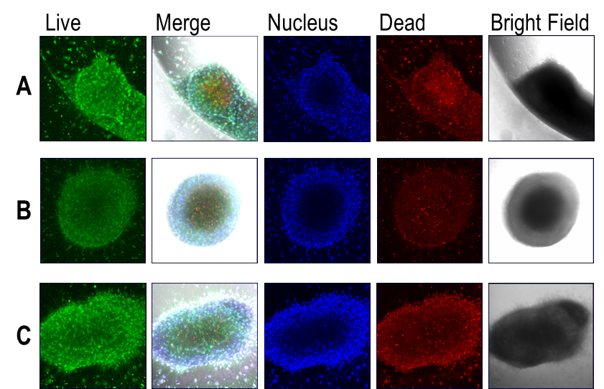

Figure S1. Viability of SW spheroids with and without retinal and light stimulation. Each condition was as follows: (A) Retinal free without light stimulation, (B) retinal added without light stimulation, and (C) retinal added with light stimulation. The photospheroids of each condition were stained by calcein‐AM (green)/Hoechst (blue)/propidium iodide (PI; red). The photospheroids remained viable regardless of retinal and light stimulation.

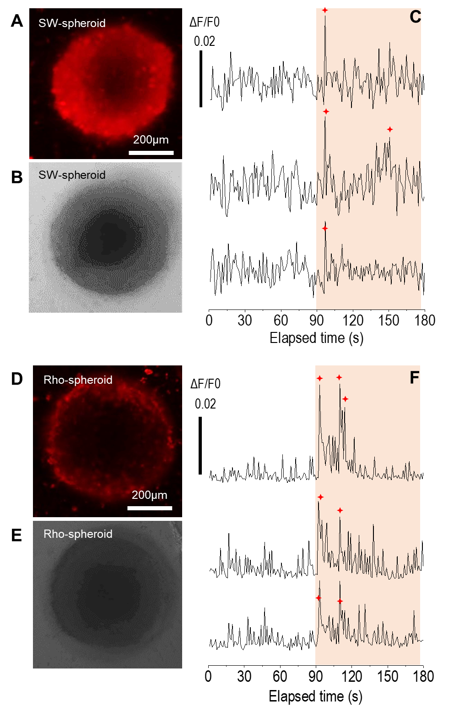
Figure S2. Under light stimulation, the response of photosensitive spheroids, (A-C) SW- and (D-F) Rho spheroid. (A, D) Calcium assay fluorescence images and (B, E) bright-field images of samples. (C, F) The normalized fluorescence intensity extracted from the images that were captured over time. After light stimulation at 90 s, both samples reacted and showed several peaks over a specific threshold of 0.02, which are marked with red stars.
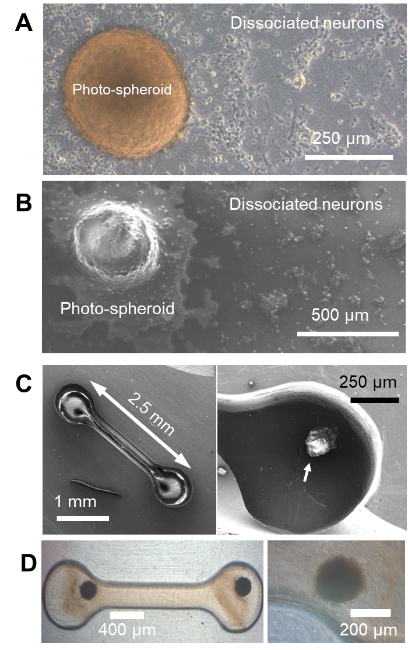
Figure S3. The sample structures. (A) Bright field and (B) SEM images of photospheroid/dissociated neurons. (C) SEM images of photo/intact spheroids. (D) Bright field images of photo/intact spheroid samples with PDMS grooves.

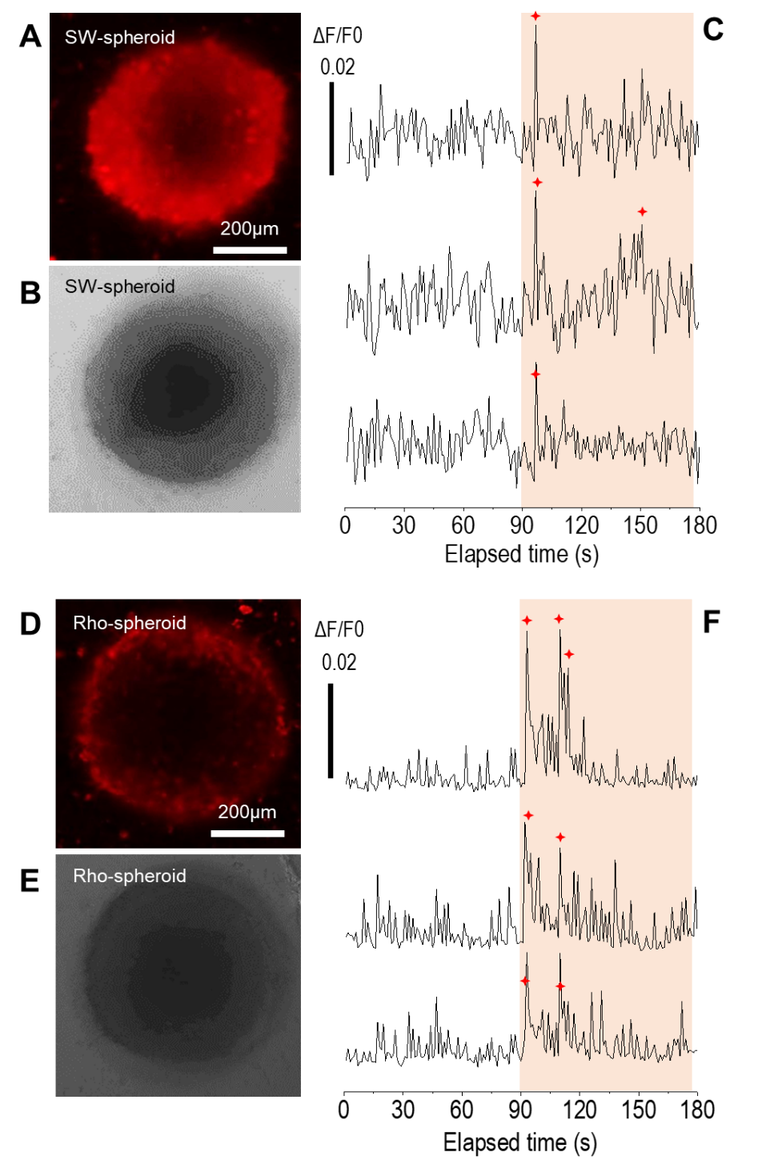
Figure S4. Under light stimulation, the response of dissociated neurons and photosensitive spheroids, (A-C) SW- and (D-F) Rho spheroid. (A, D) Calcium assay fluorescence images and (B, E) bright-field images of samples. (C, F) The normalized fluorescence intensity extracted from the images that were captured over time. After light stimulation at 90 s, both samples reacted and showed several peaks over a specific threshold of 0.03, which are marked with red stars.
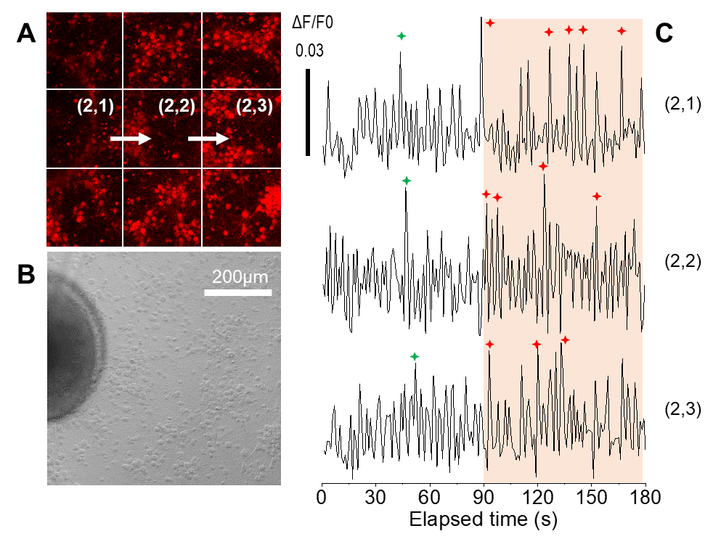

Figure S5. (A) Fluorescence image and (B) bright-field image of SW spheroid and dissociated neurons for intensity tracking. (C) The result of intensity tracking from fluorescence images over time after stimulation at 90 s. The reaction peaks are indicated by the green and red stars.

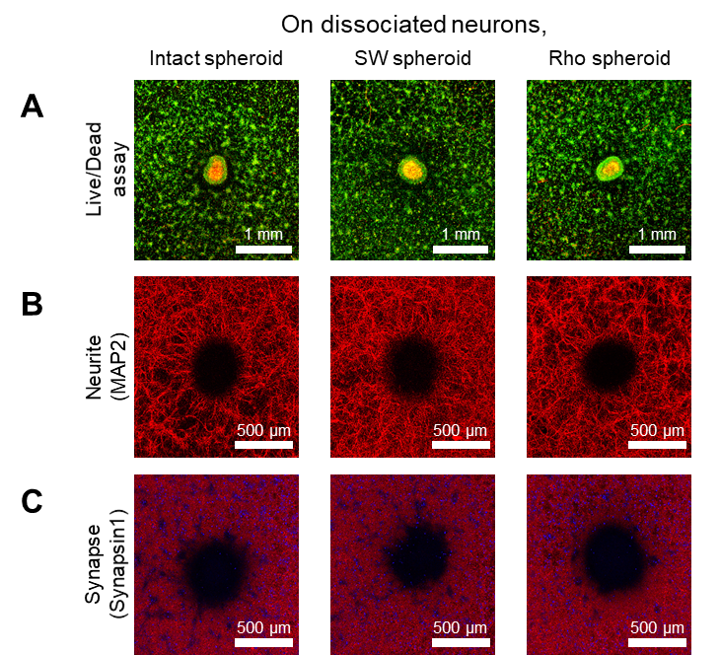
Figure S6. Photoreceptors expressed on neurospheroids do not affect the state of cocultured 2D neural networks. (A-C) Representative images analyzing the status of 2D neural networks cultured with various photospheroid and intact neurospheroid: (A) live/dead assay (green - calcein‐AM/red - propidium iodide), (B) neurite imaging (immunostaining with antibody against MAP2 (red)), (C) synapse imaging (immunostaining with antibody against Synapsin1 (red) and DAPI (blue)).
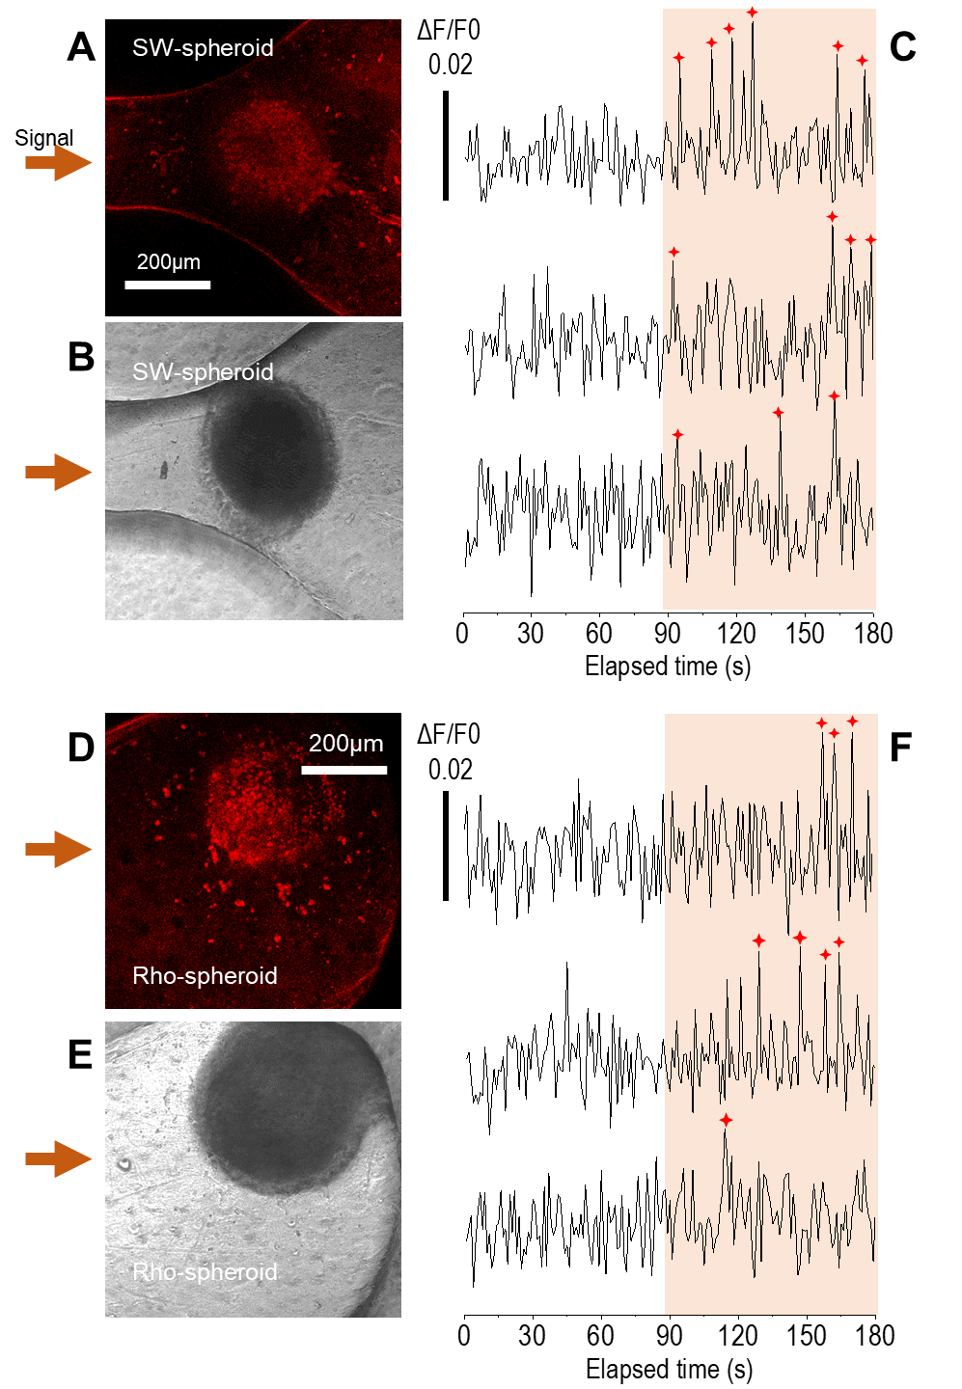
Figure S7. Under light stimulation, the response of photosensitive spheroids with intact spheroids in the eye-to-brain model, (A-C) SW- and (D-F) Rho spheroid. (A, D) Calcium assay fluorescence images and (B, E) bright-field images of samples. (C, F) The normalized fluorescence intensity extracted from the images captured over time. After light stimulation at 90 s, both samples reacted and showed several peaks over a specific threshold of 0.02, which are marked with red stars.
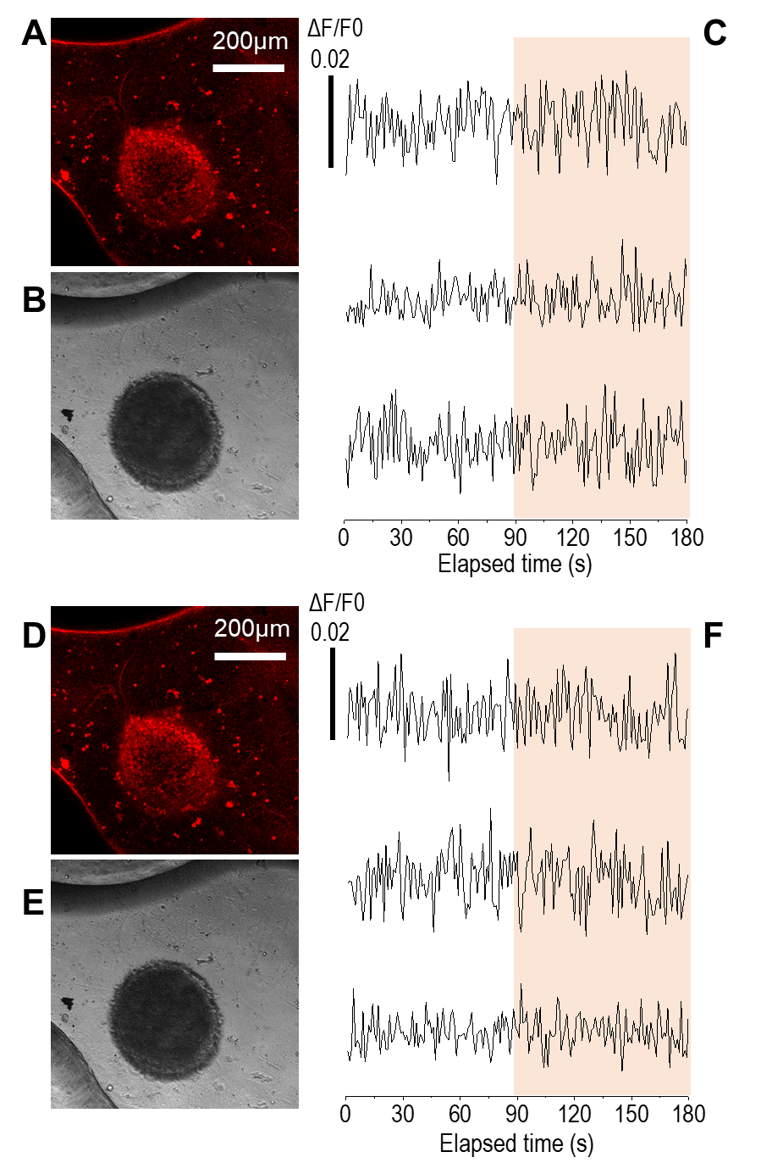
Figure S8. Under light stimulations with different wavelengths, the responses of the two intact spheroids connected each other. (A-C) Blue-light stimulation and (D-F) green-light stimulation. (A, D) Intracellular calcium assay fluorescence images and (b, e) bright-field images of samples. (C, F) The normalized fluorescence intensity extracted from the images captured over time. Although light stimulations were applied from 90 s, the sample did not respond to light stimulation of any wavelength.

