Supporting Information
Ofloxacin-loaded Selenium-tellurium Nanoheterojunctions for Skin Infection and Wound Healing

Ping Gao ª, Meng Sun ^{a, b}, Leijiao Li ^{a, b,} *, Xiangyang Li ª, Bao Wang ª, Yan Xu ª, Jing Sun ^{a,} *, Jiajun Chen ª, Wenliang Li ^{a, c,} *
ª School of Chemistry and Environmental Engineering, Changchun University of Science and Technology, Changchun, 130022, China.
^{b} Zhongshan Institute of Changchun University of Science and Technology, Zhongshan, 528437, China.
^{c} Jilin Medical University, Jilin, 132013, China.

1.1 Photothermal conversion efficiency calculation method
The calculation formula of photothermal conversion efficiency is as follows:
$η=\frac{hS\left(T_{max}-T_{surr}\right)-Q_{0}}{I(1-{10}^{-A808})}$ (1)
Where $h$ is heat transfer coefficient, $S$ is the surface area of the container, $T_{max}$ is the maximum temperature of the liquid, $T_{surr}$ is the ambient temperature, $Q_{0}$ is the heat generated when the water and the container absorb light, and $I$ is the laser power density.
${ Q}_{0}=hS(T_{max，water}-T_{surr}$) (2) $τ_{s}=\frac{m_{d}C_{d}}{hS}$ (3)
$m_{d}$ is the mass of water; $C_{d}$ is the specific heat capacity of water (4.24.2 J·g^{–1}·°C^{–1}), $τ_{s}$ is the sample system constant, which can be calculated as follows:
$t=-τ_{s}ln(θ)$ (4)
$θ=\frac{T_{surr}-T}{T_{surr}-T_{max}}$ (5)
1.2 Bacterial survival rate
The formula for calculating bacterial survival rate is as follows:
$$Survival rate (\%)=\frac{{CFU}_{experimental}}{{CFU}_{PBS}}$$
Where, ${CFU}_{experimental}$ to the number of colonies formed in the experimental group, and${ CFU}_{PBS}$is the number of colonies formed in the PBS treatment group.
1.3. Cell relative activity
The eell relative viability was calculated according to the following formula:
$$Cell viability (\%)=\frac{{OD}_{experimental}}{{OD}_{control}}$$
Where, ${OD}_{experimental}$represent the absorbance of experimental group, ${OD}_{control}$represent the absorbance of control group.
1.4 Hemolysis ratio
The hemolysis percent of RBCs was calculated as below:
$$Hemolysis percent (\%)=\frac{{Abs}_{sample}{-Abs}_{negative}}{{Abs}_{Positive}-{Abs}_{negative}}$$
Where, Where, ${Abs}_{sample}$represent the absorbance of experimental group, ${Abs}_{negative}$ represent the absorbance of negative group, ${Abs}_{Positive}$ represent the absorbance of positive group.

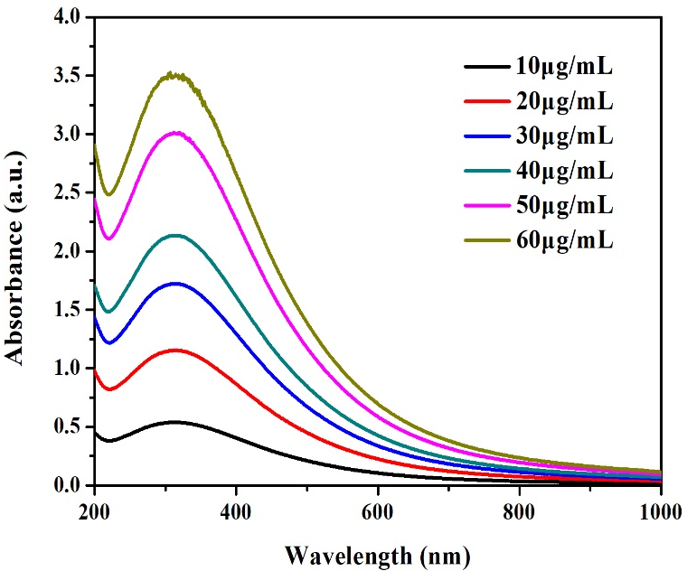
Figure S1. Absorbance spectra of TeSe nanomaterials dispersed in water at different concentrations
Figure S2. Temperature change and temperature elevation of the TeSe with an 808 nm NIR laser at the power density of (a, b) 1 W/cm², (c, d) 2 W/cm², (e, f) 3 W/cm²
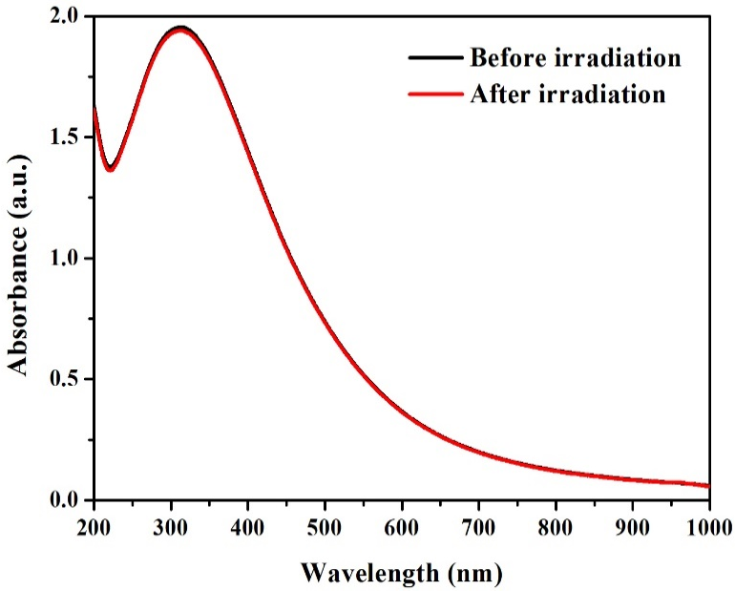
Figure S3. UV-visible absorption spectra of TeSe nanomaterials before and after four cycles of laser on/off.
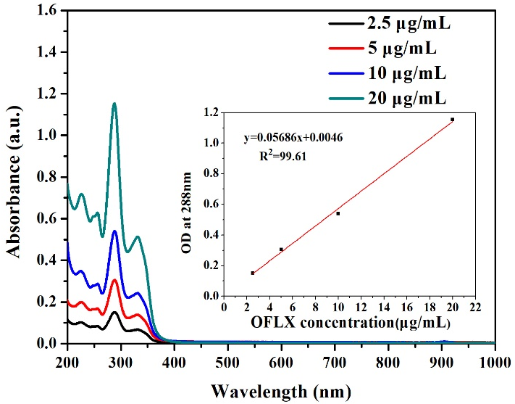
Figure S4. UV-vis absorption spectrum of OFLX at different concentrations, illustrated with fitted standard curves of OFLX.
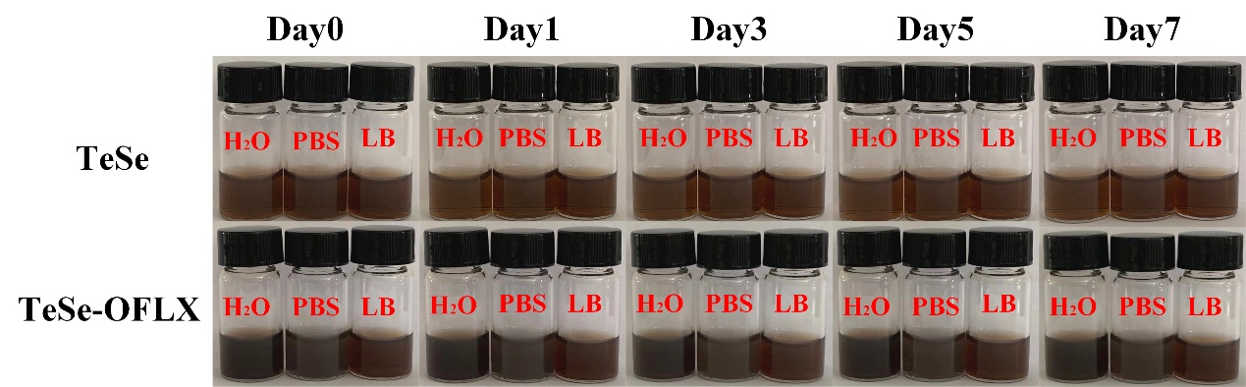
Figure S5. Photos of TeSe, TeSe-OFL in ultrapure water, PBS solution and LB liquid medium for 7 days-standing.
Figure S6. DLS size distribution of TeSe and TeSe-OFLX in (a, b) ultrapure water H₂O, (c, d) PBS solution, and (e, f) LB liquid medium.
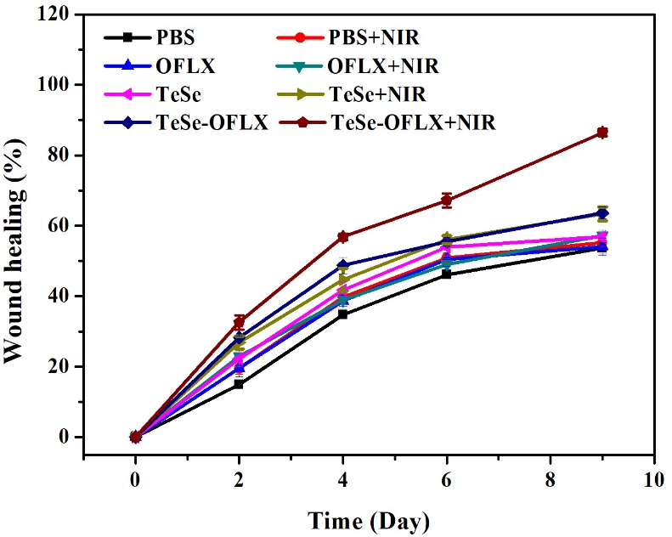
Figure S7. Wound healing rate of mice after infection

Figure S8. (a) In vivo NIR imaging and b) temperature elevation of wound area mice treated with 808 nm laser (1 W/cm²) for 10 min.
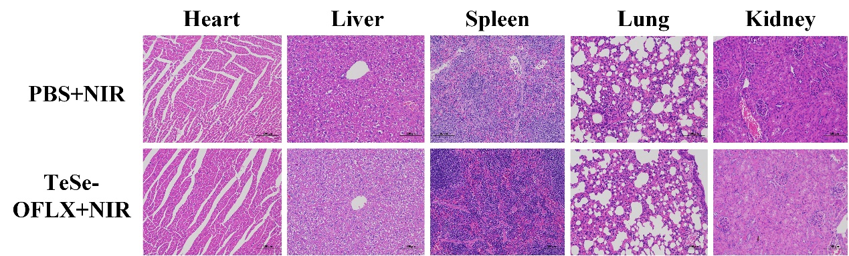
Figure S9. H&E staining of major organs slices including heart, liver, spleen, lung, and kidney of PBS or TeSe-OFLX+NIR mice
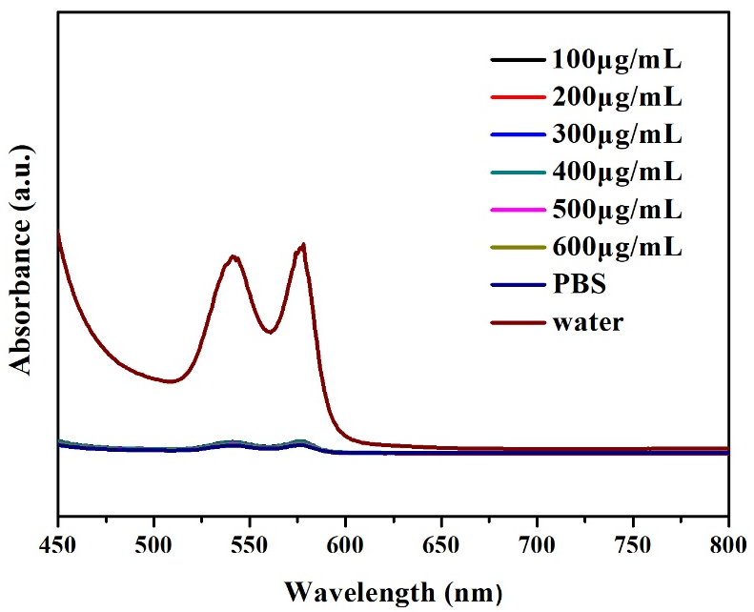
Figure S10. UV−vis adsorption spectra of the supernatant after hemolysis assay.

