Detection of a Pair Density Wave State in UTe2

Qiangqiang Gu, Joseph P. Carroll, Shuqiu Wang, Sheng Ran, Christopher Broyles, Hasan Siddiquee, Nicholas P. Butch, Shanta R. Saha, Johnpierre Paglione, J.C. Séamus Davis and Xiaolong Liu

Materials and Methods

A Visualizing the UTe₂ CDW State

A.1 Normal Tip Differential Conductance Imaging of CDW at T = 4.2 K

At temperature T = 4.2 K and using a non-superconducting scan tip to study the UTe₂ (0-11) surface, we visualize dI/dV($r,V)≡ g(r,E=eV)$ for -$25 mV<V<25 mV.$ Extended data Fig. 1a-d shows $g(r,V)$ images V = -11 mV, -17 mV, -23 mV and -29 mV with Fourier transform $g\left(q,V\right)$ shown as Extended data Figs. 1e-h. Three CDW peaks²⁴ at $Q_{1,2,3}^{}$ occur in all $g(q,V)$ representing incommensurate charge density modulations with a characteristic energy scale up to at least ~30$meV$.

A.2 CDW Visualization at Incommensurate Wavevectors Q_{1,2,3}
From these data, to calculate the amplitude $g_{Q_{i}}\left(r\right)$ of the CDW modulation represented by the peaks at $Q_{i}$ ($i=1,2,3$), we apply a two-dimensional computational lock-in technique. Here $g\left(r\right)$ is multiplied by the term $e^{iQ_{i}∙r}$, and integrated over a Gaussian filter to obtain the lock-in signal¹
$g_{Q_{i}}\left(r\right)=\frac{1}{\sqrt{2π}σ_{r}}\int{dRg\left(R\right)e^{iQ_{i}∙R}e^{\frac{{\left|r-R\right|}^{2}}{2σ_{r}^{2}}}}$ (M1)
where $σ_{r}$ is the cut-off length in the real space. In q-space this lock-in signal is
$g_{Q_{i}}\left(r\right)=F^{-1}g_{Q_{i}}\left(q\right)=F^{-1}[F(g\left(r\right)e^{iQ_{i}∙r})∙\frac{1}{\sqrt{2π}σ_{Q}}e^{-\frac{q^{2}}{2{σ_{Q}}^{2}}}]$ (M2)
where $σ_{Q}$ is the cut-off length in q-space. Here ${σ_{r}=1/σ}_{Q}$. Next, $g_{Q}(r,V)$, the inverse Fourier transform of the combined $Q_{i}$ ($i=1,2,3$) CDWs, is then presented in Figs. 1i-l. These data demonstrate that the spatial modulations and phases of the CDW are primarily independent of energy.

To specify the filtering size of the inverse Fourier transform leading to Main Text Fig. 2e, we show in Extended Data Fig. 2 the evolution of images as a function of the real-space cut-off length $σ_{r}$. The differential conductance map $g_{Q}\left(r, 10 mV\right)$ is displayed at a series of $σ_{r}$ including 10 Å, 12 Å, 14 Å, 18 Å, 24 Å and 35 Å. The distributions of the CDW domains in the filtered $g_{Q}\left(r, 10 mV\right)$ images with a cut-off length of 10 Å, 12 Å, 14 Å, 18 Å, 24 Å are highly similar. While a filter size of 35 Å leads to the vanishing of the domains. The cut-off length used in Main Text Fig. 2e is 14 Å such that the domain of the CDW modulations are resolved, the irrelevant image distortions are excluded, and the inversed image is consistent with the results from other cut-off lengths. It resolves the CDW domain structures without picking up irrelevant contributions from other wavevectors. Same filter size of 14 Å is chosen for all three Q- vectors.

Formally the same inversed Fourier transform analysis is carried out for main text Figs. 4c-d, but with a filter size of 7.9 Å to filter CDW and PDW peaks.

A.3 Simulated UTe₂ Topography
To identify q-space peaks resulting from the (0-11) cleave plane structure of UTe₂ we simulate the topography of the UTe₂ cleave plane and Fourier transform this simulation. Subsequently we are able to distinguish clearly the CDW signal from the structural periodicity of the surface. The simulation is calculated based on the ideal lattice constant of the (0-11) plane of the UTe₂, $a^{*}=4.16$Å and inter-Te-chain distance $b^{*}=7.62$Å. Extended Data Fig. 3a is a simulated T(r) image in FOV of 14.5 nm. The simulated topography T(r) is in a good agreement with experimental T(r) images presented throughout in the paper. The Fourier transform, T(q), of the simulated T(r) in Extended Data Fig. 3b shows six sharp peaks, confirming that they are the primary peaks resulting from the cleave plane structure. Most importantly, the CDW peaks in Fig. 3d are not seen in the simulation. They are therefore not caused by the surface periodicity but instead originate from the electronic structure.

B UTe₂ sample and Nb tip preparation

B.1 Sample preparation
High-quality UTe₂ single crystals were synthesized by chemical vapor transport using iodine as the transport agent. The UTe₂ crystal is mounted on the sample holder such that the (0-11) cleave plane is facing upwards. The sample is cleaved in situ in a cryogenic ultrahigh vacuum environment at ~4.2 K, and immediately inserted into the STM head. STM measurements are performed using a custom-built STM at a base temperature of ~280 mK. The STM is controlled using SPECS Nanonis electronics.

B.2 Tip preparation
Atomic-resolution superconducting Nb tips are formed by field emission of a Nb wire on a Nb single-crystal target. The total gap value of superconducting tip and Nb target is determined at the energy of a sharp coherence peak (middle panel Main Text Fig. 3a). To determine the tip gap value during our experiments, we measure dI/dV spectrum on UTe₂ at 1.5 K (T_{c} = 1.65 K), where the UTe₂ superconducting gap is closed. Thus the tip gap value $|∆_{tip}|$ is taken as ~ 1.37 meV from the energy of the coherence peak (black curve in Extended Data Fig. 4). At a junction resistance of ~1 MΩ, SIS junction current $I$ is given by the convolution of the density-of-states of superconducting tip and superconducting UTe₂, the typical ${\left.dI/dV\right|}_{SIS}$ taken at 280 mK on UTe₂ (the right panel Main Text Fig. 3a) shows the total gap value $\left|∆_{tip}\right|+\left|∆_{UTe_{2}}\right|=1.62 meV$. Therefore we estimate $\left|∆_{UTe_{2}}\right| \sim 0.25 meV$, being consistent with the previous report and the ${\left.dI/dV\right|}_{NIS}$ shown as the left panel in Main Text Fig. 3a.

C Visualizing UTe₂ Electron-Pairing Energy Gap $Δ(r)$

C.1 Nb Coherence-peak Amplified UTe2 Energy Gap
To determine the energy of $E_{+}(r)$ and $E_{-}(r)$ at which the maximum conductance occurs, we fit the peak of the measured ${\left.dI/dV\right|}_{SIS}\left(V\right)$ spectra using a second-order polynomial fit (Equation M3).
${\left.dI/dV\right|}_{SIS}\left(V\right)=aV^{2}+bV+c$ (M3)
The polynomial fits excellently with the experimental data. Extended Data Fig. 5a shows the fitting of a typical ${\left.dI/dV\right|}_{SIS}\left(V\right)$ spectrum, and the evolution of fits ${\left.dI/dV\right|}_{SIS}\left(V\right)$along a representative line is shown in Extended Data Fig. 5b and it demonstrates a clear gap modulation. The fitting quality is defined using the coefficient
$$R^{2}\left(r\right)=1-\frac{\sum_{i=1}^{N}{{\left[g\left(r,V_{i}\right)-{dI}/{dV}|_{SIS}\left(r,V_{i} \right)\right]}^{2} }}{\sum_{i=1}^{N}{[g\left(r,V_{i}\right)-g(r)]}}$$

The statistical histogram of the coefficient $R^{2}$ from the whole field of view can be quantitatively seen in Extended Data Fig. 5c. The mean value ${<R}^{2}>=0.98±0.04$ indicates excellent fitting quality in the gap maps $Δ_{+}(r)$ and $Δ_{-}(r)$.

C.2 Shear correction
To register multiple images to precisely the same field of view, a shear correction technique and the Lawler-Fujita (LF) algorithm² are implemented to the experimental data.
To recover the arbitrary hexagon of the Te lattice, shear correction is applied to correct any image distortions caused by long-range scanning drift. The coordinate system in the experimental data $\tilde{r}$ is transformed to a coordinate system $r$ that has the crystal symmetry of the UTe₂ lattice. The transformation in the x-direction with magnitude p is described as
$\left(\begin{matrix}x \\ y\end{matrix}\right)=S\left(\tilde{\begin{matrix}x \\ \tilde{y}\end{matrix}}\right)$ (M4)
where $S=\left[\begin{matrix}1 & p \\ 0 & 1\end{matrix}\right]$ is the transformation matrix. In q-space, this leads to a transformation of ${\tilde{Q}}_{y}→p{\tilde{Q}}_{x}$. Consider an arbitrary triangular lattice with two adjacent Bragg peaks ${\tilde{Q}}_{1}$ and ${\tilde{Q}}_{2}$ with angles $α$ and $α+1.295$ from the $Q_{x}$-axis, respectively. A shear at an angle $θ$ from the $Q_{x}$-axis will transform ${\tilde{Q}}_{i}$ into the following
$Q_{1}=(\begin{matrix}q_{1}cosα+pq_{1}sinθcos⁡(θ-α) \\ q_{1}sinα+pq_{1}cosθcos⁡(θ-α)\end{matrix})$ (M5)
$Q_{2}=(\begin{matrix}q_{2}cos(α+2.59)+pq_{2}sinθcos⁡(θ-α-2.59) \\ q_{2}sinα(α+2.59)+pq_{2}cosθcos⁡(θ-α-2.59)\end{matrix})$ (M6)
Where $q_{1}=|{\tilde{Q}}_{1}|$, $q_{2}=1.912$*$|{\tilde{Q}}_{2}|$. $p$ and $θ$ are determined by solving Equation M5-6 using measured $Q_{1}$ and $Q_{2}$. The angle coefficient 1.295 and the vector length coefficient 1.912 are estimated from the simulated Fourier transform of an ideal UTe₂ lattice in Extended Data Fig. 2b. Consequently the shear corrected image can be obtained by the transformation $\tilde{T}\left(\tilde{r}\right)=T(r$). Here the two coordinate systems $r$ and $\tilde{r}$ are related by the transformation $\tilde{r}=R^{-1}S^{-1}Rr$.

To obtain the perfectly periodic lattice, we apply the LF algorithm. Let T($\tilde{r}$) represent a topograph of a perfect UTe₂ lattice without any distortion. Three pairs of Bragg peaks $Q_{1}$, $Q_{2}$ and $Q_{3}$ can be obtained from FT of T($\tilde{r}$). Hence T($\tilde{r}$) is expected to take the form
$T\left(\tilde{r}\right)=\sum_{i=1}^{3}{T_{i}\cos\left(Q_{i}∙\tilde{r}+θ_{i}\right)}$, (M7)
The experimentally obtained topography $T'\left(r\right)$ may suffer from a slowly varying position-dependent spatial phase shift $θ_{i}(r)$, which can be given by
$T'\left(r\right)=\sum_{i=1}^{3}{T_{i}\cos\left(Q_{i}∙r+θ_{i}(r)\right)}$, (M8)
To get $θ_{i}(r)$, we employ a computational two-dimensional lock-in technique to the topography
$A_{Q}\left(r\right)=\int{dRT'\left(R\right)e^{iQ∙R}e^{-\frac{{\left(r-R\right)}^{2}}{2σ^{2}}}}$ , (M9)
$A_{Q_{i}}\left(r\right)=F^{-1}A_{Q_{i}}\left(q\right)=F^{-1}[F(T'\left(r\right)e^{iQ_{i}∙r})∙\frac{1}{\sqrt{2π}σ_{Q}}e^{-\frac{q^{2}}{2{σ_{Q}}^{2}}}]$ (M10)

$\left|A_{Q}\left(r\right)\right|=\sqrt{{\left(ReA_{Q}\left(r\right)\right)}^{2}+{\left(ImA_{Q}\left(r\right)\right)}^{2}}$ , (M11)
$θ_{i}(r)=\tan^{-1}\frac{ImA_{Q}\left(r\right)}{ReA_{Q}\left(r\right)}$ . (M12)
where σ is chosen to capture the lattice distortions. In the Lawler-Fujita analysis, we use $σ_{q}=3.8 nm^{-1}$. Mathematically, the relationship between the distorted and the perfect lattice for each $Q_{i}$ is $Q_{i}∙\tilde{r}+θ_{i}=Q_{i}∙r+θ_{i}(r)$. We define another global position-dependent quantity, the displacement field $u\left(r\right)=r-\tilde{r}$, which can be obtained by solving equations
$u\left(r\right)={\left(\begin{aligned}\begin{matrix}Q_{1} \\ Q_{2}\end{matrix} \\ Q_{3}\end{aligned}\right)}^{-1}\left(\begin{aligned}\begin{matrix}θ_{1}-θ_{1}\left(r\right) \\ θ_{2}-θ_{2}\left(r\right)\end{matrix} \\ θ_{3}-θ_{3}\left(r\right)\end{aligned}\right)$. (M13)
Finally, a drift-corrected topography, $T\left(r\right)$ is obtained by
$T\left(r\right)=T'(r-u\left(r\right))$. (M14)
By applying the same correction of $u\left(r\right)$ to the simultaneously taken differential conductance map g’($r$), we can get
$g\left(r\right)=g'(r-u\left(r\right))$. (M15)
where $g\left(r\right)$ is the drift-corrected differential conductance map.

C.3 Lattice Registration of UTe₂ Energy Gap $Δ(r)$
Due to the small junction resistance ~1 MΩ between Nb tip and UTe₂ sample during the ${\left.dI/dV\right|}_{SIS}\left(V\right)$map measurement, if we take the maps at both positive and negative energy sides simultaneously, the flip of bias polarity will immediately change the direction of electric field applied in the tunneling junction, which may affect the stability of the last atom on the STM tip. Hence we make two separate $g(r,V)$ maps separated by several days, and in two overlapping FOVs, with energy ranges -1.67 meV < E < -1.47 meV and 1.5 meV < E < 1.7 meV. Therefore, we obtain two datasets, $T_{1}'(r)$ with the simultaneous $g_{1}'(r,V)$ at positive bias and $T_{2}'(r)$ with the simultaneous $g_{2}'(r,V)$ at negative bias.
After the shear and LF correction are applied, the lattice in the corrected topographs of $T_{1}(r)$ and $T_{2}(r)$ become nearly perfectly periodic. Next, we perform rigid spatial translations to register the two topographs to the exact same FOV with a lateral precision better than 27 pm. Extended Data Figs. 6a-b shows two topographs of registered $T_{1}(r)$ and $T_{2}(r)$. Cross-correlation (XCORR) of two images $I_{1} and I_{2}$, $C(r,I_{1},I_{2})$ at $r$ is obtained by sliding two images $r$ apart and calculate the convolution,
$C\left(r,I_{1},I_{2}\right)= \frac{\int{I_{1}^{*}\left(r_{1}\right)I_{2}\left(r+r_{1}\right)dr_{1}}}{\sqrt{\int{{\left|I_{1}\left(r_{1}\right)\right|}^{2}dr_{1}}\int{{\left|I_{2}\left(r_{2}\right)\right|}^{2}dr_{2}}}}$. (M16)
where the denominator is a normalization factor such that when $I_{1}$ and $I_{2}$ are exactly the same image, we can get $C\left(r=0,I_{1},I_{2}\right)=$ 1 with the maximum centered at (0,0) cross-correlation vector. Extended Data Fig. 6c shows the maximum of XCORR between $T_{1}(r)$ and $T_{2}(r)$ coincides with the (0,0) cross-correlation vector. The offset of the two registered images are within one pixel. The uncertainty of registration is half the size of the single pixel. Thus we prove the precision of the multiple-image registration method is better than 0.5 pixel = 27 pm in the whole FOV. The maxima of the cross-correlation coefficient between the topographs is 0.95, where a coefficient of 1 indicates two identical images. All transformation parameters applied to $T_{1}'(r)$ and $T_{2}'(r)$ to yield $T_{1}(r)$ and $T_{2}(r)$ are subsequently applied to the corresponding ${\left.dI/dV\right|}_{SIS}\left(V\right)$ maps taken at positive and negative voltage.

C.4 Particle-hole Symmetry of UTe₂ Energy Gap $Δ(r)$
The cross-correlation map in Extended Data Fig. 7a provides a two-dimensional measure of agreement between the positive and negative ${\left.dI/dV\right|}_{SIS}\left(V\right)$conductance peak maps. Extended Data Fig. 7b shows a linecut along the trajectory indicated in Extended Data Fig. 7a. It shows a maximum of 0.94 and coincides with the (0,0) cross-correlation vector. The higher value of XCORR indicates the growing similarity between the two images, and XCORR of 1 indicates two identical images. Thus it shows that gap values between positive bias and negative bias are highly correlated, demonstrating the expected particle-hole symmetry of PDW energy gap magnitudes for superconducting UTe₂.

C.5 PDW Visualization at Incommensurate Wavevectors P_{1,2,3}
The inverse Fourier transform analysis for PDW state in Main Text Fig. 4c is implemented using the same technique described in Section A.2. The filter size chosen to visualize the PDW is 7.9 Å such that the domain structures are resolved and irrelevant image distortion is excluded. The inverse Fourier transform of the CDW in Main Text Fig. 4d is calculated using the identical filter size of 7.9 Å.

C.6 Independent PDW Visualization Experiments
To confirm that the PDW phase discovered is present in multiple FOVs we show a typical example of the gap modulation$Δ(r)$ from one different field of view in Extended Data Fig. 8. The $g(r,V)$ map is measured in the voltage region surrounding the positive Nb-UTe₂ coherence peak. The FOV is fitted with a second-order polynomial as in Section C.1 and shear corrected as in C.2. The resulting map, $δ∆_{+}(r)$ is presented in Extended Data Fig. 8b. The Fourier transform of this map, $δ∆_{+}(q)$ is presented in Extended Data Fig. 8c. $δ∆_{+}(q)$ features the same PDW wavevectors, $(P_{1}, P_{2},P_{3})$ observed in the main text.

D Relative phase shift between all CDW: PDW pairs
The analysis of phase difference between PDW and CDW at three different Q-vectors is shown in Extended Data Fig. 9. The Inverse Fourier transforms of each CDW and PDW wavevector demonstrate a clear half-period shift between the two density waves (First and second row in Extended Data Fig. 9). This shift motivates the statistical analysis of the phase difference. The phase map of $g_{Q_{1}}(r,-15 mV)$, $ϕ_{1}^{C}\left(r\right)$, and the phase map of $Δ_{P_{1}}(r)$, $ϕ_{1}^{P}\left(r\right)$, are calculated using Equation M12. The phase difference between two corresponding maps is defined as ${\left|δϕ_{1}\right|=ϕ}_{1}^{C}\left(r\right)-ϕ_{1}^{P}\left(r\right)$ for the $P_{1}:Q_{1}$ wavevectors. The identical procedure is carried out for $P_{2}:Q_{2}$ and $P_{3}:Q_{3}$. The histograms resulting from this procedure show that the statistical distributions of the phase shift $|δϕ_{i}|$ are centered around π. Although the distribution varies, this $π$ phase shift reinforces the observation of the spatial anti-correlation between CDW and PDW.

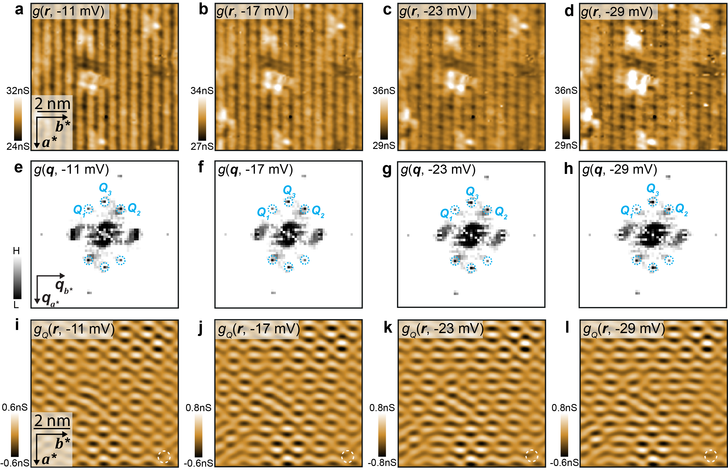

Extended Data Fig. 1 CDW at different voltages in UTe₂. a. Measured $g(r,V)$ images of UTe₂ using non-superconductive STM tips at T = 4.2 K, and at four representative negative sample voltages including -11 mV, -17 mV, -23 mV and -29 mV in the same 10 nm × 10 nm field of view. b. Fourier transform of the $g(r,V)$ images, $g(q,V)$, showing the presence of the three wavevectors corresponding to the CDW order (labelled by dashed blue circles). c. Inverse Fourier transform the CDW peaks (Q₁, Q ₂, Q ₃) at different sample voltages. The CDW pattern is independent from the sample voltages for -29 mV < V < -11 mV. A white dashed circle indicates $σ$ of Gaussian filter used to isolate CDW peaks in real space.

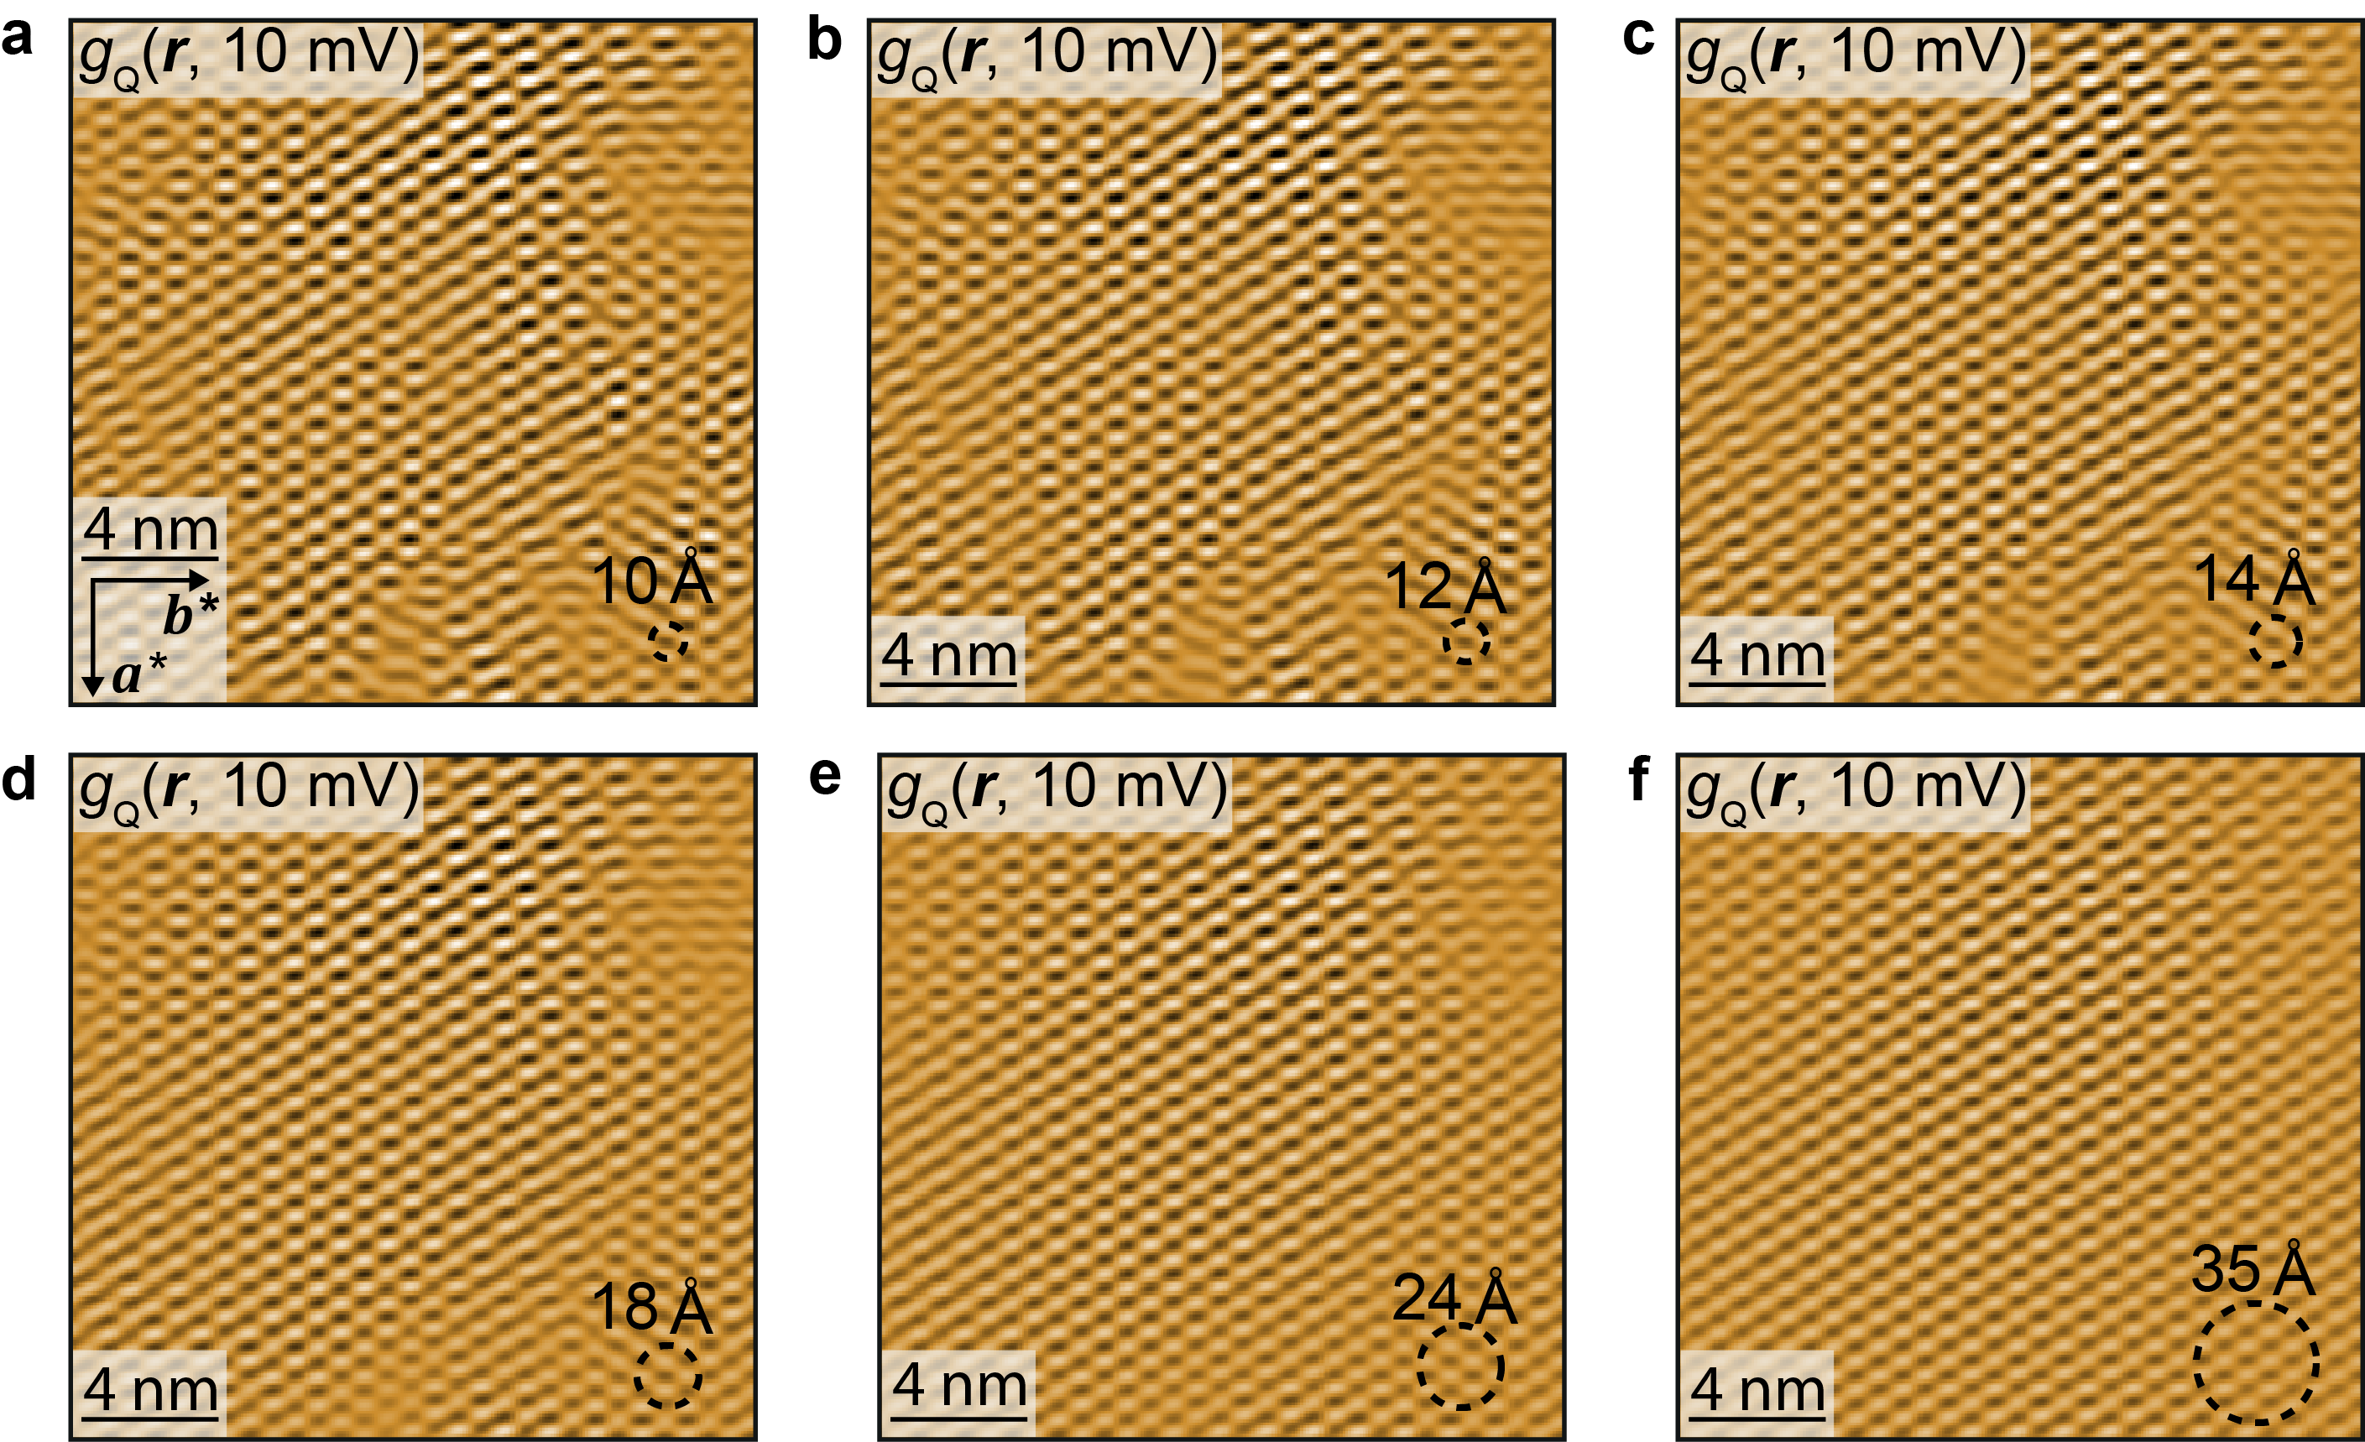

Extended Data Fig. 2. Cut-off dependence of inverse Fourier filtering $g_{Q}\left(r, 10 mV\right)$. Inverse Fourier transform of CDW peaks from $g_{Q}\left(r, 10 mV\right)$ map. The images of $g_{Q}\left(r, 10 mV\right)$ are filtered at different cut-off lengths such as 10 Å, 12 Å, 14 Å, 18 Å, 24 Å and 35 Å. The filter size is indicated as a dashed black circle in the bottom-right corner. Smaller values of $σ_{r}$ introduce more of surrounding noise in the Fourier transform $g_{Q}\left(q, 10 mV\right)$ and lead to less defined domain borders. $σ_{r}$ chosen for main text Fig. 2e is 14 Å.

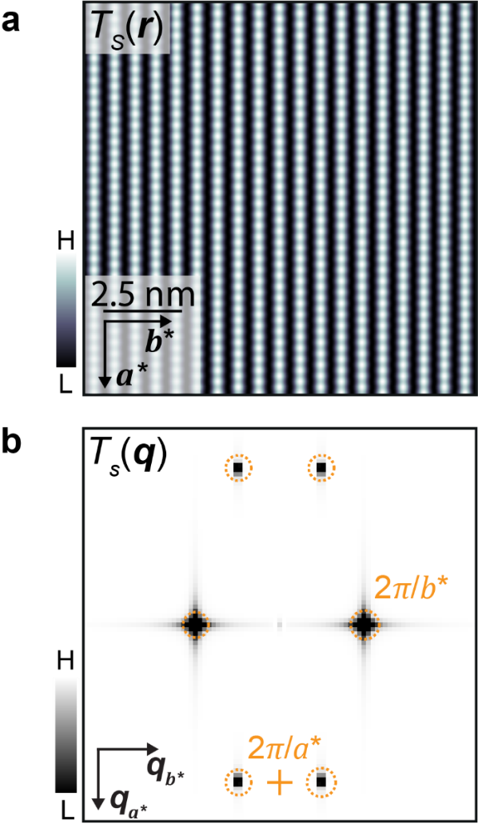

Extended Data Fig.3 Simulated topography of UTe₂ and its Fourier transform. a. Simulated topograph, T_{S}(r) of (0-11) cleave surface of UTe₂. b. Fourier transform of simulated topograph, T_{S}(q). The six primary peaks are signal from the crystal structure of UTe₂. They are observed in the experimental STM data.

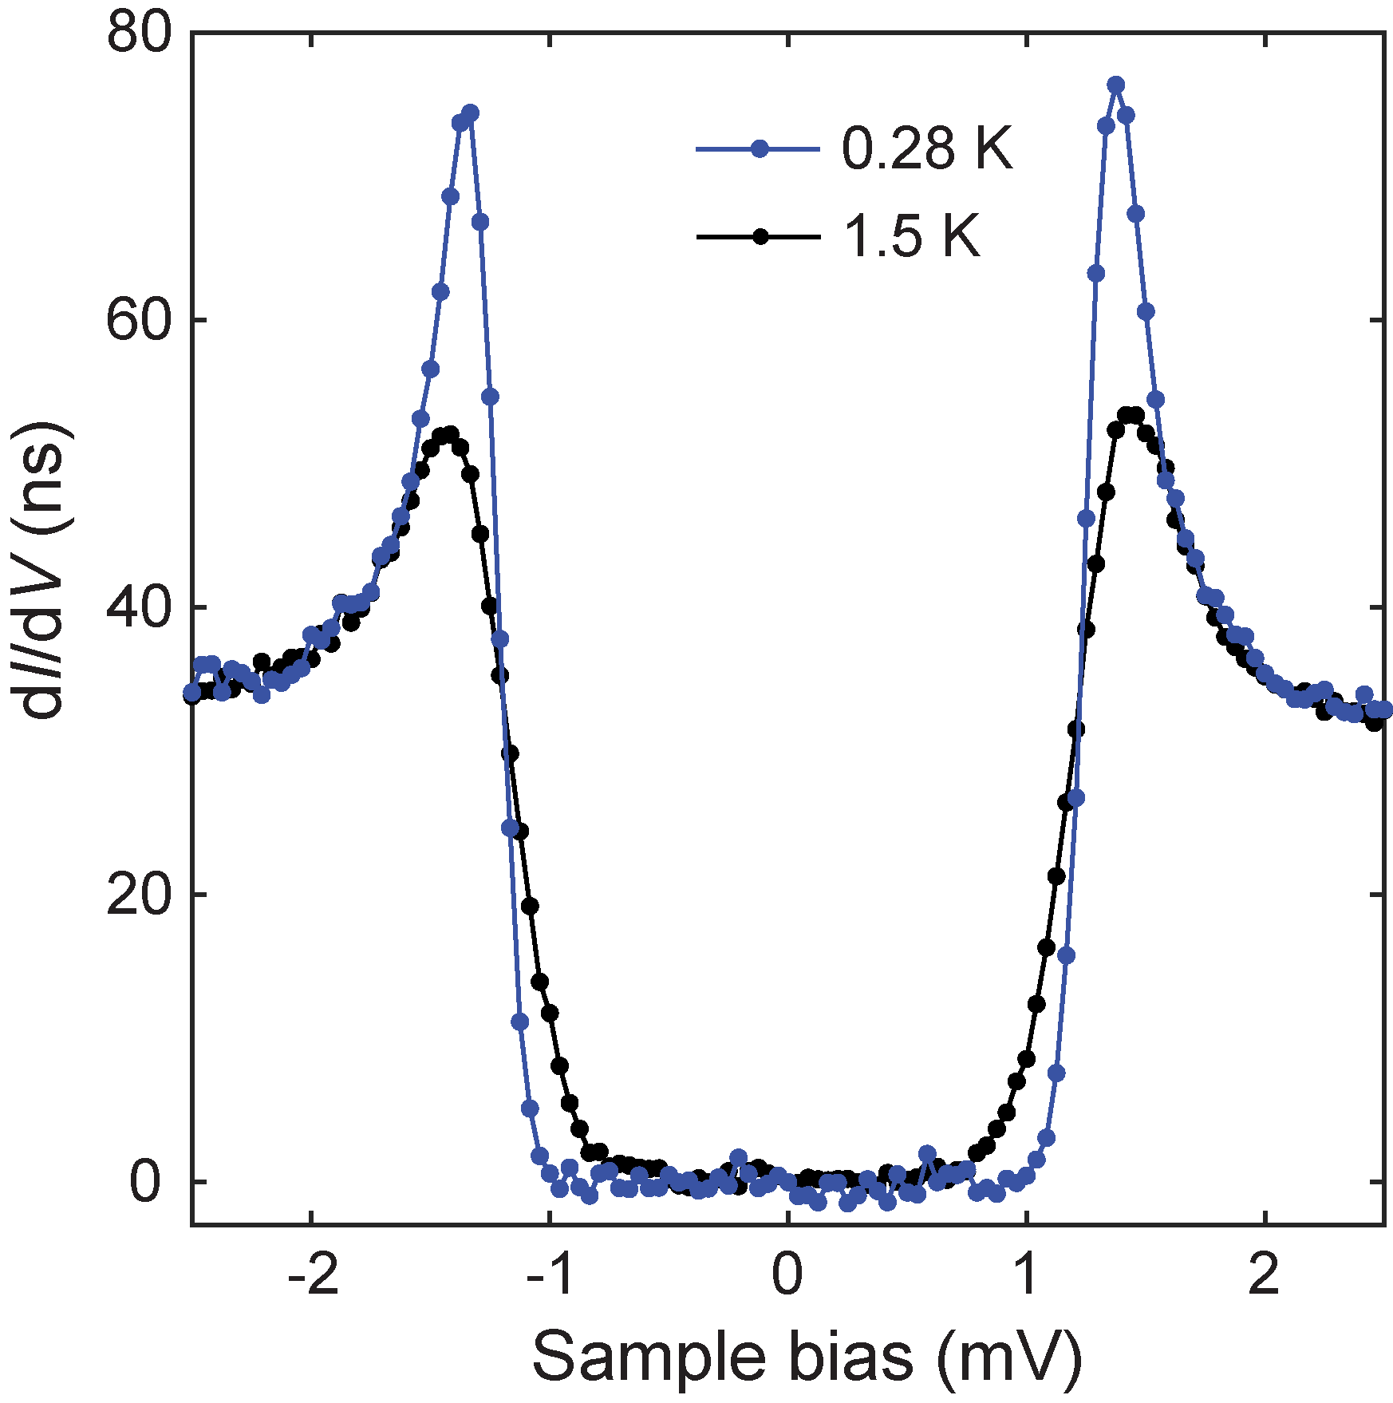

Extended Data Fig. 4. SIS tunneling spectrum measuring the tip gap $Δ_{tip}$. Two typical spectra measured at a large junction resistance 40 MΩ. The tip gap $Δ_{tip}$ is found to be 1.37 meV. The tip gap is unaffected by temperature indicating the negligible contribution of the UTe₂ gap at large junction resistances and the stability of the Nb tip gap.

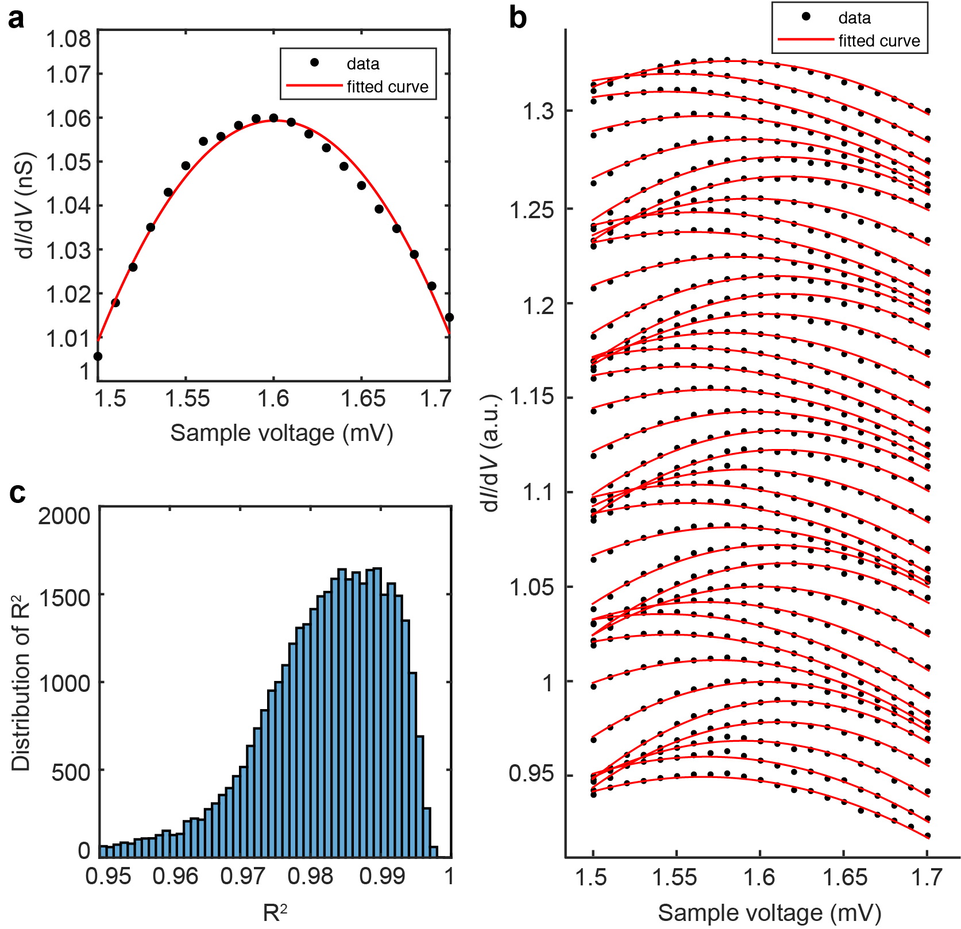

Extended Data Fig. 5 Gap determination and fitting quality. a. Example of polynomial fitting (red line) on $dI/dV$ data (black points) from 1.5 mV to 1.7 mV. The peak energy value is estimated by fitting the second order polynomial ${\left.dI/dV\right|}_{SIS}=aV^{2}+bV+c$ and calculating the first derivative. b. An evolution of fits ${\left.dI/dV\right|}_{SIS}\left(V\right)$along a representative line. c. Histogram of the coefficient of determination $R^{2}$. Averaged value of ${<R}^{2}> =0.976 ±0.043$.

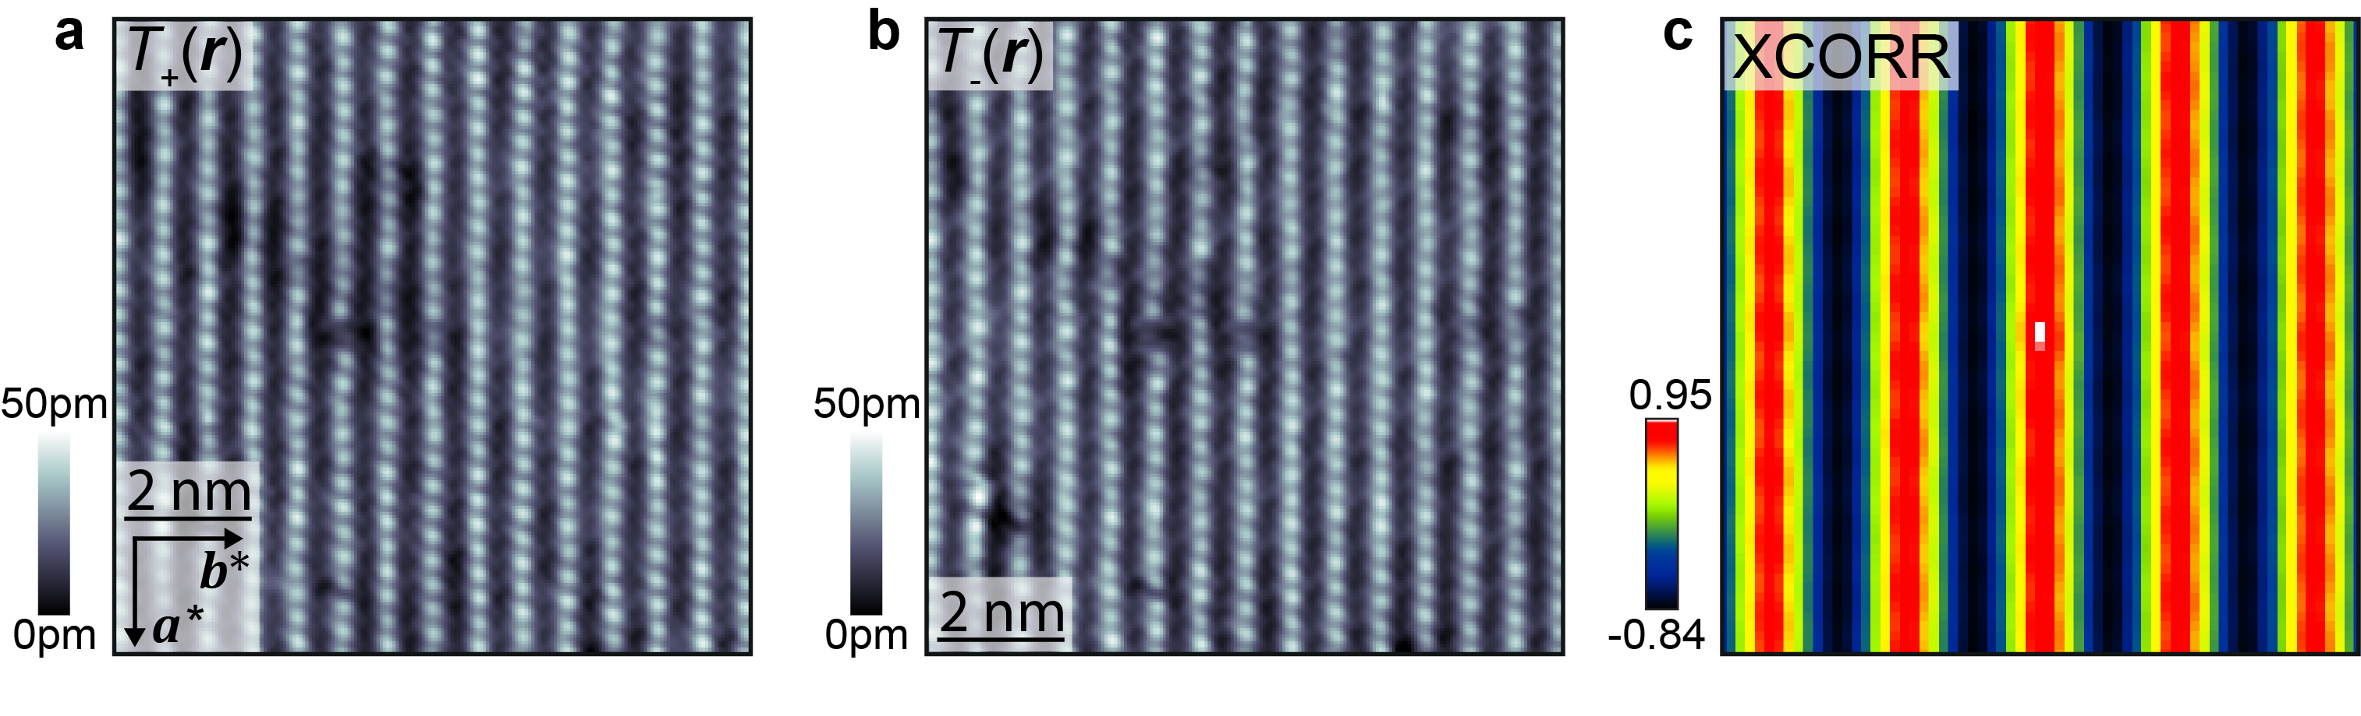

Extended Data Fig. 6 Spatial Registration of topographs. a-b 10 nm × 10 nm topographs after registration. These topographs were obtained concomitantly as $dI/dV$ maps recording positive and negative coherence peaks respectively. c. Cross-correlation (XCORR) map of the registered topographs. The correlation coefficient is 0.95 indicating the two topographs are almost identical. The maxima of the XCORR map is single pixel wide, which suggests a registration precision of 0.5 pixels equivalent to real registration precision of 27 pm.

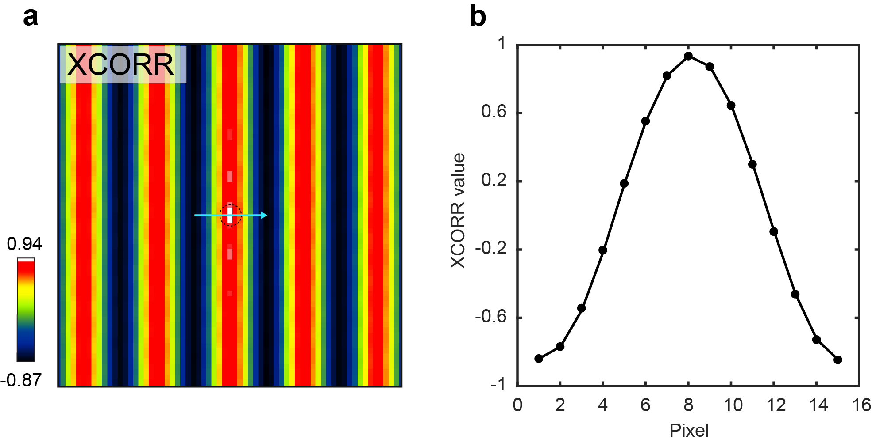

Extended Data Fig. 7. Cross-correlation of gap map $Δ_{+}(r)$ and $Δ_{-}(r)$. a Cross-correlation (XCORR) map providing a two-dimensional measure of correlation between the positive gap map $Δ_{+}(r)$ and negative gap map $Δ_{-}(r)$. b A linecut along the trajectory indicated in a. It shows the maximum is 0.94 and coincides with the (0,0) cross-correlation vector. The strong correlation demonstrates the particle-hole symmetry in UTe₂.

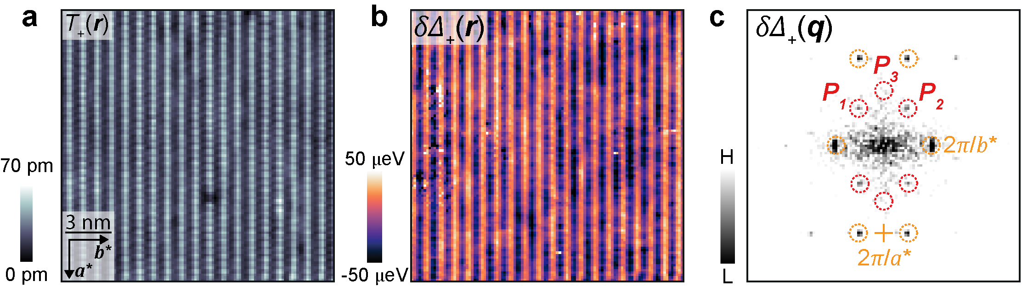
Extended Data Fig. 8 PDW repeatability analysis. a. A topograph recorded in a new FOV away from that seen in Main Text Fig. 3b. The image size is 15 nm $×$ 15nm$(V_{s}=3 mV, I_{s}=2.5 nA)$. b. $δ∆_{+}(r)$ map prepared using the same procedure outlined in Section C revealing the same gap modulations as Main Text Fig. 4a. c. The Fourier transform of $δ∆_{+}(r)$ map, $δ∆_{+}(q)$. $(P_{1}, P_{2}, P_{3})$ PDW peaks are highlighted with dashed red circles and reciprocal lattice vectors highlighted with dashed orange circles.

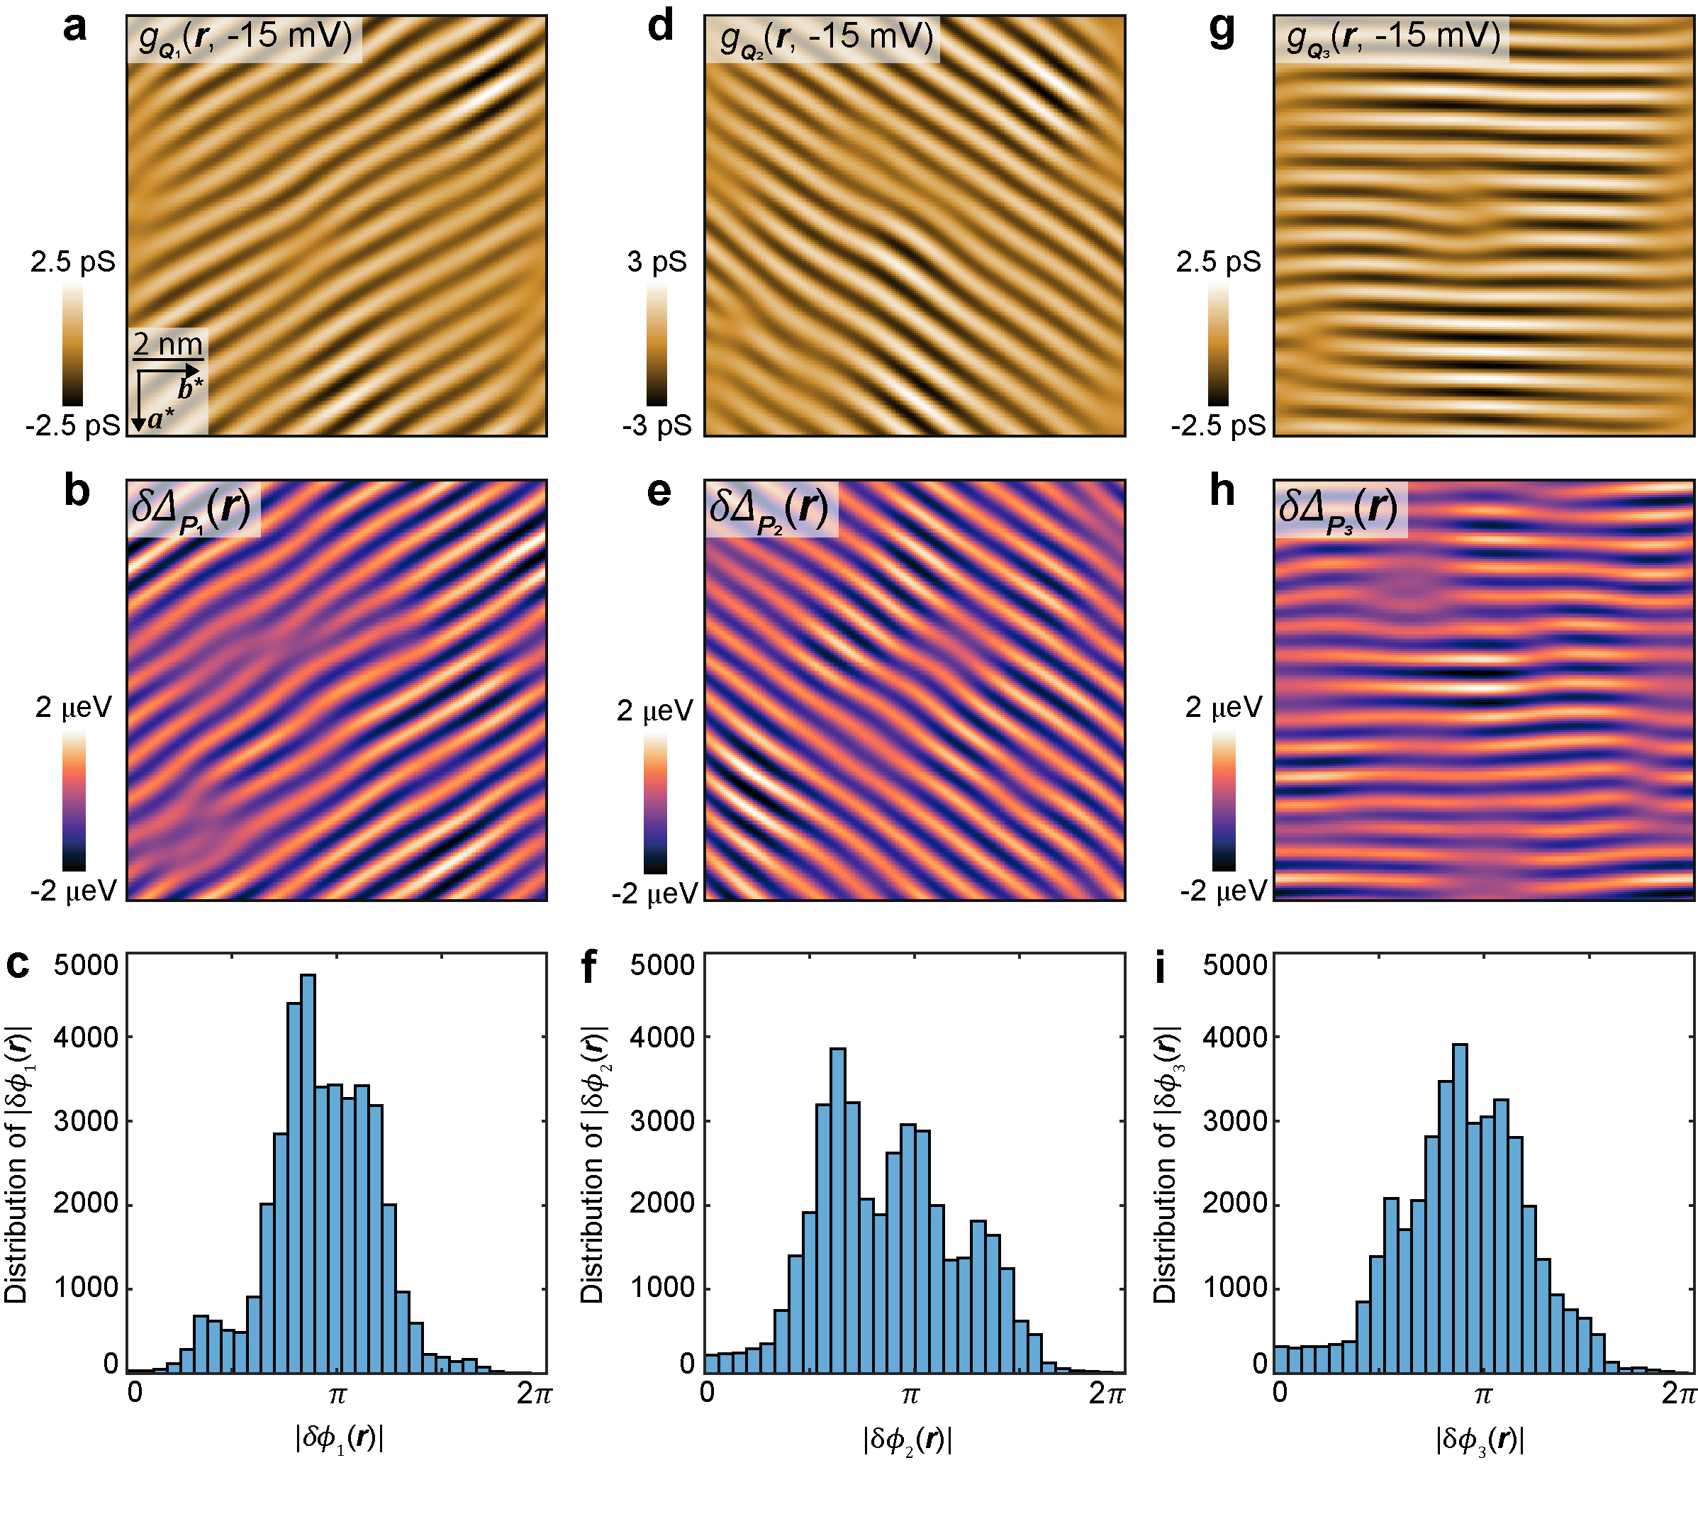
Extended Data Fig. 9 Phase shift between CDW and PDW. (a,d,g) Inverse Fourier transforms of the three CDW wavevectors identified $g_{Q_{i = 1, 2, 3}}(r, -15 mV)$ in the same 10 nm × 10 nm FOV as Main Text Fig. 3b. (b, e, h) Inverse Fourier transforms of the three PDW $δ∆_{P_{i = 1, 2, 3}}$ wavevectors in the same FOV as Main Text Fig. 3b. (c, f, i) Distributions of the relative spatial phase difference $δϕ_{i}(r)$ between $ϕ_{i}^{C}\left(r\right)$ and $ϕ_{i}^{P}\left(r\right)$ from three individual wavevectors. Each histogram is centered around $π$ reinforcing the observation of a general phase difference $|δϕ_{i}|≅π$ between the CDW and PDW.

METHODS REFERENCES:
1. Liu, X., Chong, Y. X. & Sharma, R. Discovery of a Cooper-pair density wave state in a transition-metal dichalcogenide. Science 1452, 1447–1452 (2021).
2. Lawler, M. J. et al. Intra-unit-cell electronic nematicity of the high-T_{c} copper-oxide pseudogap states. Nature 466, 347–351 (2010).

Data Availability Statement
The data that support the findings of this study are available from the corresponding author upon reasonable request.

Extended Data Figure Legends

Extended Data Fig. 1 CDW at different voltages in UTe₂. a. Measured $g(r,V)$ images of UTe₂ using non-superconductive STM tips at T = 4.2 K, and at four representative negative sample voltages including -11 mV, -17 mV, -23 mV and -29 mV in the same 10 nm × 10 nm field of view. b. Fourier transform of the $g(r,V)$ images, $g(q,V)$, showing the presence of the three wavevectors corresponding to the CDW order (labelled by dashed blue circles). c. Inverse Fourier transform the CDW peaks (Q₁, Q ₂, Q ₃) at different sample voltages. The CDW pattern is independent from the sample voltages for -29 mV < V < -11 mV. A white dashed circle indicates $σ$ of Gaussian filter used to isolate CDW peaks in real space.

Extended Data Fig. 2. Cut-off dependence of inverse Fourier filtering $g_{Q}\left(r, 10 mV\right)$. Inverse Fourier transform of CDW peaks from $g_{Q}\left(r, 10 mV\right)$ map. The images of $g_{Q}\left(r, 10 mV\right)$ are filtered at different cut-off lengths such as 10 Å, 12 Å, 14 Å, 18 Å, 24 Å and 35 Å. The filter size is indicated as a dashed black circle in the bottom-right corner. Smaller values of $σ_{r}$ introduce more of surrounding noise in the Fourier transform $g_{Q}\left(q, 10 mV\right)$ and lead to less defined domain borders. $σ_{r}$ chosen for main text Fig. 2e is 14 Å.

Extended Data Fig.3 Simulated topography of UTe₂ and its Fourier transform. a. Simulated topograph, T_{S}(r) of (0-11) cleave surface of UTe₂. b. Fourier transform of simulated topograph, T_{S}(q). The six primary peaks are signal from the crystal structure of UTe₂. They are observed in the experimental STM data.

Extended Data Fig. 4. SIS tunneling spectrum measuring the tip gap $Δ_{tip}$. Two typical spectra measured at a large junction resistance 40 MΩ. The tip gap $Δ_{tip}$ is found to be 1.37 meV. The tip gap is unaffected by temperature indicating the negligible contribution of the UTe₂ gap at large junction resistances and the stability of the Nb tip gap.

Extended Data Fig. 5 Gap determination and fitting quality. a. Example of polynomial fitting (red line) on $dI/dV$ data (black points) from 1.5 mV to 1.7 mV. The peak energy value is estimated by fitting the second order polynomial ${\left.dI/dV\right|}_{SIS}=aV^{2}+bV+c$ and calculating the first derivative. b. An evolution of fits ${\left.dI/dV\right|}_{SIS}\left(V\right)$along a representative line. c. Histogram of the coefficient of determination $R^{2}$. Averaged value of ${<R}^{2}> =0.976 ±0.043$.

Extended Data Fig. 6 Spatial Registration of topographs. a-b 10 nm × 10 nm topographs after registration. These topographs were obtained concomitantly as $dI/dV$ maps recording positive and negative coherence peaks respectively. c. Cross-correlation (XCORR) map of the registered topographs. The correlation coefficient is 0.95 indicating the two topographs are almost identical. The maxima of the XCORR map is single pixel wide, which suggests a registration precision of 0.5 pixels equivalent to real registration precision of 27 pm.

Extended Data Fig. 7. Cross-correlation of gap map $Δ_{+}(r)$ and $Δ_{-}(r)$. a Cross-correlation (XCORR) map providing a two-dimensional measure of correlation between the positive gap map $Δ_{+}(r)$ and negative gap map $Δ_{-}(r)$. b A linecut along the trajectory indicated in a. It shows the maximum is 0.94 and coincides with the (0,0) cross-correlation vector. The strong correlation demonstrates the particle-hole symmetry in UTe₂.
Extended Data Fig. 8 PDW repeatability analysis. a. The topograph in a different FOV. The image size is 15 nm $×$ 15nm$(V_{s}=3 mV, I_{s}=2.5 nA)$. b. $δ∆_{+}(r)$ maps prepared using the same procedure outlined in Section C revealing the same gap modulations as Main Text Fig. 4a. c. The Fourier transform of $δ∆_{+}(r)$ maps, $δ∆_{+}(q)$. $(P_{1}, P_{2})$ PDW peaks are highlighted with dashed red circles and reciprocal lattice vectors highlighted with dashed orange circles.

Extended Data Fig. 9 Phase shift between CDW and PDW. (a,d,g) Inverse Fourier transforms of the three CDW wavevectors identified $g_{Q_{i = 1, 2, 3}}(r, -15 mV)$ in the same 10 nm × 10 nm FOV as Main Text Fig. 3b. (b, e, h) Inverse Fourier transforms of the three PDW $δ∆_{P_{i = 1, 2, 3}}$ wavevectors in the same FOV as Main Text Fig. 3b. (c, f, i) Distributions of the relative spatial phase difference $δϕ_{i}(r)$ between $ϕ_{i}^{C}\left(r\right)$ and $ϕ_{i}^{P}\left(r\right)$ from three individual wavevectors. Each histogram is centered around $π$ reinforcing the observation of a general phase difference $|δϕ_{i}|≅π$ between the CDW and PDW.

