Ca(IO₃)₂ nanoparticles: fabrication and application as an eco-friendly and recyclable catalyst for green synthesis of quinoxalines, pyridopyrazines and 2,3-dicyano pyrazines

Mehdi Kalhor٭, Mahboubeh Shayestefar ª, Mehdi Khalaj*^{b}, Fatemeh Janghorbanª
Department of Chemistry, Payame Noor University, Tehran, 19395-4697, Iran
^{b} Department of Chemistry, Buinzahra Branch, Islamic Azad University, Buinzahra, Iran

Supporting Information
1. Spectral Data of the Compounds ...............................................................................2
2. ¹H, and ¹³C NMR spectra of selective compounds 5a-q ..........................................9

Experimental
Melting points were determined by the use of a Barnstead Electrothermal 9200 apparatus and they may be uncorrected. ¹H NMR and ¹³C NMR spectra were recorded on Bruker spectrophotometer (300 and 500 MHz) in DMSO-d₆, with Me₄Si as internal standard. FT-IR spectra were acquired with a JASCO FT-IR 4200-A spectrophotometer. The mass spectra were recorded on an Agilent model 5975C VL MSD with a Triple-Axis Detector spectrometer at 70 eV. The shape, size and atom type of nano-particles were examined by SEM and EDX images recorded by Philips XL30. Nitrogen adsorption and desorption isotherms (BET analysis) were measured at -196°C by a Japan Belsorb II system after the samples were vacuum dried at 150°C overnight. The progress of reactions was routinely monitored by thin-layer chromatography on silica gel F₂₅₄ aluminium sheets (Merck). All chemicals were used as obtained without further purification.
Preparation of nano- Ca(IO₃)₂
To a 50 ml beaker containing 10 ml of distilled water and Ca(NO₃)₂. 4H₂O, (2.36 gr, 1 mmol) was added an aqueous solution of KIO₃ (4.28 gr, 2 mmol) and the mixture was placed in an ultrasonic bath for 10 minutes. The reaction mixture was stirred for 2 h at room temperature until a white precipitate of calcium iodine salt (3.81 gr, 98%) formed, which was then filtered. The resulting precipitate was washed with water and dried at 110 ℃. The Ca(IO₃)₂ (1 g) was subjected to ultrasonic irradiation for 1 h to provide nano sized particles. The nanocatalyst was then used without further purification.
Typical procedure for preparation of compounds (3a-q)
1,2-Arylenediamine, 1a-d, or 2,3-diaminomaleonitrile, 1e, (0.1 mmol) and the corresponding 1,2-diketones, 2a-d, were dissolved in ethanol with constant stirring. Then, a catalytic amount (3 mol%, 0.005 gr) of Ca(IO₃)₂ was then added to the solution. The reaction mixture was stirred at room temperature for 3-20 minutes (Table 2). The reaction progress was monitored by TLC. After completion of the reaction, the used catalyst was collected by filtration and cold water was added to the filtrate to obtain the product. Afterward, the residue was filtered and washed with cold ethanol/water to yield compounds 3a-q. In this method, pure products were obtained. For further purifications, the crude products were recrystallized from EtOH or MeOH/AcOH mixtures.
Spectroscopic data for selected compounds
2,3-Diphenyl quinoxaline (3a)
White solid, FT-IR (KBr, υ_{max}): 3058 (CH), 1558, 1548 (C=N), 1477, 1440, 1395, 1345, 1247, 1218 (C=C), 1128, 1076, 1057 (C-N), 977, 770, 698, 598, 539 cm⁻¹; ¹H NMR (500 MHz, CDCl₃) δ_{H}: 7.32-7.37 (m, 6H, H-Ar), 7.53 (dd, J = 1.45 Hz, J = 6.26 Hz, 4H, H-Ar), 7.77 (dd, J = 3.45 Hz, J = 3.01 Hz, 2H, H-Ar), 8.19-8.17 (m, 2H, H-Ar) ppm; ¹³C NMR (125 MHz, CDCl₃) δ_{C}: 153.5, 141.2, 139.0, 129.9, 129.8, 129.2, 128.8, 128.3 ppm.
6-Nitro-2,3-dipenylquinoxaline (3b): FT-IR (KBr, υ_{max}):1659 (C=N), 1593, 1315 (NO₂), 1450, 1211 (C=C), 876, 718, 643 cm⁻¹; ¹H NMR (300 MHz, CDCl₃) δ_{H}: 9.07 (br, 1H, H-Ar), 8.53 (dd, J₁ = 2.46 Hz, J₂ =8.11 Hz, 1H, H-Ar), 8.29 (d, J = 9.10 Hz, 1H, H-Ar), 7.36-7.57 (m, 10H, H-Ar) ppm; ¹³C NMR (75 MHz, CDCl₃) δ_{C}: 156.3, 155.7, 147.8, 143.5, 139.9, 138.1, 138.0, 130.7, 129.9, 129.8, 129.7, 129.6, 128.4, 125.6, 123.3 ppm.
6-Methyl-2,3-diphenyl quinoxaline (3c): FT-IR (KBr, υ_{max}): 2916 (CH), 1620 (C=N), 1345 (C=C), 1058, 808, 700 cm⁻¹; ¹H NMR (300 MHz, CDCl₃) δ_{H} 8.08 (d, J = 8.47 Hz, 1H, H-Ar),7.96 (s, 1H, H-Ar),7.60 (dd, J₁ = 1.82 Hz, J₂ = 8.74 Hz, 1H, H-Ar), 7.30-7.53 (m, 10H, H-Ar), 2.62 (s, 3H, CH₃) ppm; ¹³C NMR (75 MHz, CDCl₃) δ_{C}: 153.3, 152.5, 141.3, 140.4, 139.7, 139.2, 132.3, 129.8, 129.8, 128.7, 128.7, 128.6, 128.2, 128.0, 21.9 ppm.
2,3-Bis(4-methoxyphenyl)quinoxaline (3f): FT-IR (KBr, υ_{max}): 2935 (CH), 1604 (C=N), 1510, 1347, 1287 (C=C), 1243, 1172 (C-O), 1026 (C-N), 829, 764, 538 cm⁻¹; ¹H NMR (300 MHz, CDCl₃) δ_{H}: 8.13 (dd, J₁ = 3.60 Hz, J₂ = 2.70 Hz, 2H), 7.72 (dd, J₁ = 3.60 Hz, J₂ = 2.70 Hz, 2H), 7.50 (d, J = 8.70 Hz, 4H), 6.88 (d, J = 8.70 Hz, 4H), 3.83 (s, 6H) ppm; ¹³C NMR (75 MHz, CDCl₃) δ_{C}: 160.1, 153.0, 141.0, 131.5, 131.2, 129.5, 129.0, 113.7, 55.3 ppm.
2,3-Dimethylquinoxaline (3h): FT-IR (KBr, υ_{max}): 2911 (C-H), 1632 (C=N), 1489, 1398, 1317 1210 (C=C), 1163 (C-N), 988, 761, 670, 612, 427 cm⁻¹; ¹H NMR (500 MHz, CDCl₃) δ_{H} : 7.95 (dd, J₁ = 3.45 Hz, J₂ = 2.75 Hz, 2H, H-Ar), 7.64 (dd, J₁ = 3.39 Hz, J₂ = 2.90 Hz, 2H, H-Ar), 2.69 (s, 6H, CH₃) ppm; ¹³C NMR (125 MHz, CDCl₃) δ_{C}: 153.3, 141.0, 128.7, 128.2, 23.1 ppm.
2,3-Diphenyl pyrido[2,3-b]pyrazine (3i): FT-IR (KBr, υ_{max}): 3056 (C-H), 1544 (C=N), 1430, 1384, 1332 (C=C), 1068, 1019, 780, 697 cm⁻¹; ¹H NMR (500 MHz, DMSO-d₆) δ_{H}: 9.15 (d, J = 3.52 Hz, 1H, H-Ar), 8.57 (dd, J = 1.32, 6.90 Hz, 1H, H-Ar), 7.87 (q, J = 4.14 Hz, 1H, H-Ar), 7.49-7.31 (m, 10H, H-Ar) ppm; ¹³C NMR (125 MHz, DMSO-d₆) δ_{C}: 156.5, 155.3, 154.9, 150.0, 139.1, 138.7, 136.5, 130.6, 130.6, 130.0, 129.9, 128.9, 126.8 ppm.
Dibenzo[f,h]pyrido[2,3-b]quinoxaline (3j): FT-IR (KBr, υ_{max}): 1600, 1497 (C=N), 1447, 1359, 1199 (C=C), 1023, 757, 722 cm⁻¹; ¹H NMR (300 MHz, CDCl₃) δ_{H}: 9.56 (d, J = 8.10 Hz, 1H, H-Ar), 9.36-9.31 (t br, 2H, H-Ar), 8.70 (d, J = 8.40 Hz, 1H, H-Ar), 8.58 (d, J = 8.10 Hz, 2H, H-Ar), 7.83-7.72 (m, 5H, H-Ar) ppm; ¹³C NMR (75 MHz, CDCl₃) δ_{C}: 154.6, 149.9, 145.1, 143.8, 138.3, 137.4, 132.5, 132.3, 131.2, 130.9, 129.8, 129.6, 128.2, 128.1, 127.4, 126.5, 124.9, 123.0, 122.9 ppm.
Acenaphtho[1,2-b]pyrido[2,3-e]pyrazine (3k): Light yellow solid, FT-IR (KBr, υ_{max}): 3051 (C-H), 2371 (CN), 1612, 1562 (C=N), 1527, 1489, 1433, 1294, 1212 (C=C), 1097, 1034 (C-N), 827, 772, 426 cm⁻¹; ¹H NMR (300 MHz, CDCl₃) δ_{H}: 7.70-7.74 (m, 1H, H-Ar), 7.83 (q, J = 2.40 Hz, 2H, H-Ar), 8.13 (dd, J = 2.55 Hz, J = 5.70 Hz, 2H, H-Ar), 8.40 (d, J = 6.90 Hz, 1H, H-Ar), 8.52 (t, J = 7.12 Hz, 2H, H-Ar), 9.12 (d, J = 4.20 Hz, 1H, H-Ar) ppm; ¹³C NMR (75 MHz, CDCl₃) δ_{C}: 122.3, 123.3, 124.3, 128.7, 129.9, 130.0, 130.2, 130.9, 131.2, 136.4, 137.2, 150.7, 152.4, 155.0, 157.1 ppm.
2,3-Bis-(4-methoxyphenyl)pyrido[2,3-b]pyrazine (3l): IR (KBr, υ_{max}): 2933 (C-H), 1605, 1513 (C=N), 1447, 1384 (C=C), 1251, 1175 (C-O), 1023 (C-N), 833 cm⁻¹; ¹H NMR (300 MHz, CDCl₃) δ_{H}: 9.12 (dd, J = 1.80, 4.20 Hz, 1H, H-Ar), 8.47 (dd, J = 1.80, 6.60 Hz, 1H, H-Ar), 7.68-7.62 (m, 3H, H-Ar), 7.55 (d, J = 8.40 Hz, 2H, H-Ar), 6.91-6.85 (m, 4H, H-Ar), 3.84 (d, 6H, 2CH₃), ppm; ¹³C NMR (75 MHz, CDCl₃) δ_{C}: 160.7, 155.7, 154.2, 153.5, 149.8, 137.8, 135.8, 131.8, 131.2, 131.1, 130.7, 124.7, 113.9, 113.6, 55.35, 55.30 ppm.
5,6-Diphenylpyrazine-2,3-dicarbonitrile (3m): FT-IR (KBr, υ_{max}): 3067 (CH), 2348 (C≡N), 1660 (C=N), 1375-1579 (C=C), 831 cm⁻¹; ¹H NMR (300 MHz, DMSO- d₆), δ_{H}: 7.20 (d, J = 6.90 Hz, 2H, H-ph), 7.28 (d, J = 7.29 Hz, 2H, H-ph), 7.40-7.59 (m, 4H, H-ph), 7.72 (d, J = 7.42 Hz, 2H, H-ph) ppm; ¹³C NMR (75 MHz, DMSO- d₆) δ_{C}: 129.0, 130.1, 130.5, 131.0, 132.6, 135.9, 155.2 ppm.
2,3-Dicyanodibenzo[f,h]quinoxaline (3n): FT-IR (KBr, υ_{max}): (C≡N), 2220 (C=N), 1603 (C=C) 1509, cm⁻¹; ¹H NMR (300 MHz, DMSO-d₆) δ_{H}: 7.84-7.85 (br d, 4H, H-Ar), 8.76-8.87 (br d, 4H, H-Ar) ppm; MS (m/z, %): 280.1 (M⁺, 100), 176.1 (36), 150.1 (16), 88.0 (22).
Acenaphtho[1,2-b]pyrazine-8,9-dicarbonitrile (3o): FT-IR (KBr, υ_{max}): 2234 (C≡N), 1612 (C=N), 1421 (C=C) cm⁻¹; ¹H NMR (300 MHz, DMSO-d₆) δ_{H}: 6.78-6.88 (br t, 2H, H- Ar), 8.02 (br d, 2H, H-Ar), 8.57 (br, 2H, H-Ar) ppm; MS (m/z, %): 254.2 (M⁺, 100 ), 178.1 (81), 151.1 (28), 127.1 (7), 101.1 (7), 75.1 (10).
5,6-Dimethylpyrazine-2,3-dicarbonitrile (3q): FT-IR (KBr, υ_{max}): 2921 (C-H), 2239 (C≡N), 1717 (C=N), 1536, 1389, 1197 (C=C), 1123 (C-N), 986, 411, 432 cm⁻¹; ¹H NMR (500 MHz, CDCl₃) δ_{H}: 2.70 (s, 6H, 2CH₃) ppm: ¹³C NMR (125 MHz, CDCl₃) δ_{C}: 158.4, 130.7, 113.6, 23.0 ppm.

¹H NMR spectrum of 2,3-diphenyl quinoxaline (3a)

¹³C NMR spectrum of 2,3-diphenyl quinoxaline (3a)
¹H NMR spectrum of 6-nitro-2,3-diphenylquinoxaline (3b)
¹³C NMR spectrum of 6-nitro-2,3-diphenylquinoxaline (3b)
¹H NMR spectrum of 6-Methyl-2,3-diphenyl quinoxaline (3c)
¹³C NMR spectrum of 6-Methyl-2,3-diphenyl quinoxaline (3c)
¹H NMR spectrum of 2,3-bis(4-methoxyphenyl)quinoxaline (3f)
¹³C NMR spectrum of 2,3-bis(4-methoxyphenyl)quinoxaline (3f)
¹H NMR spectrum of 2,3-dimethylquinoxaline (3h)
¹³C NMR spectrum of 2,3-dimethylquinoxaline (3h)
¹H NMR spectrum of 2,3-diphenylpyrido[2,3-b]pyrazine (3i)
¹³C NMR spectrum of 2,3-diphenylpyrido[2,3-b]pyrazine (3i)
¹H NMR spectrum of dibenzo[f,h]pyrido[2,3-b]quinoxaline (3j)
¹³C NMR spectrum of dibenzo[f,h]pyrido[2,3-b]quinoxaline (3j)
¹H NMR spectrum of acenaphtho[1,2-b]pyrido[2,3-e]pyrazine (3k)
¹³C NMR spectrum of acenaphtho[1,2-b]pyrido[2,3-e]pyrazine (3k)
¹H NMR spectrum of 2,3-bis(4-methoxyphenyl)pyrido[2,3-b]pyrazine (3l)
¹³C NMR spectrum of 2,3-bis(4-methoxyphenyl)pyrido[2,3-b]pyrazine (3l)
¹H NMR spectrum of 5,6-Diphenylpyrazine-2,3-dicarbonitrile (3m)
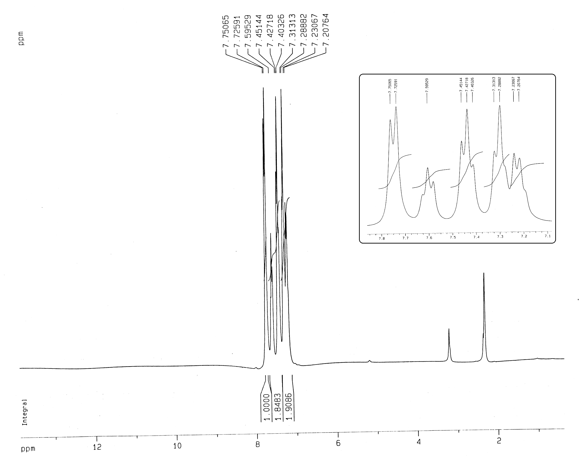

¹³C NMR spectrum of 5,6-Diphenylpyrazine-2,3-dicarbonitrile (3m)
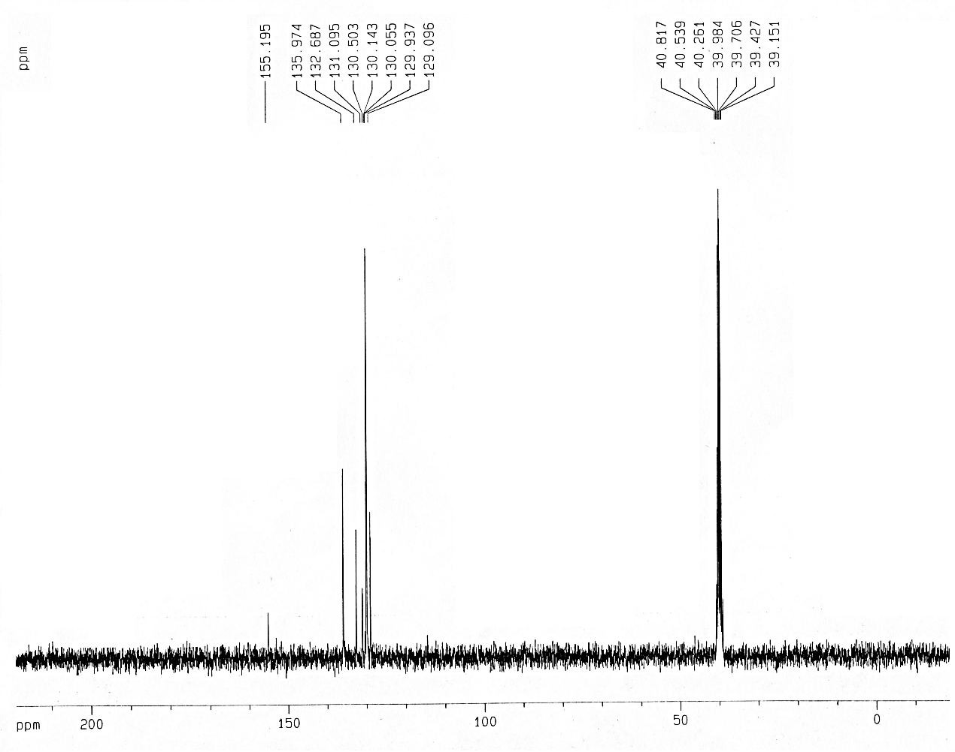
¹H NMR spectrum of 2,3-dihydrodibenzo[f,h]quinoxaline-2,3-dicarbonitrile (3n)
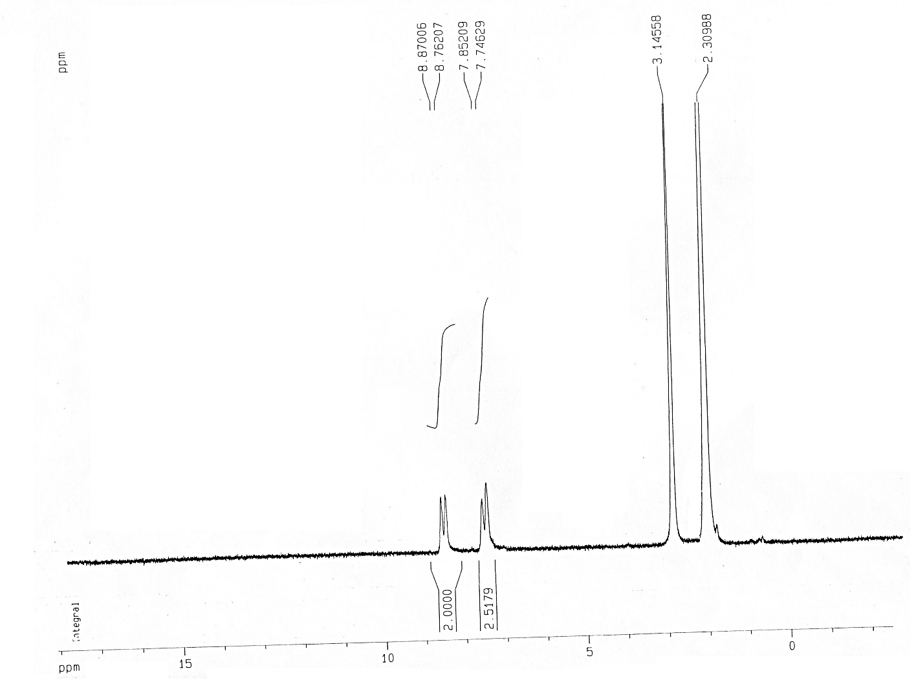

Mass spectrum of 2,3-dihydrodibenzo[f,h]quinoxaline-2,3-dicarbonitrile (3n)
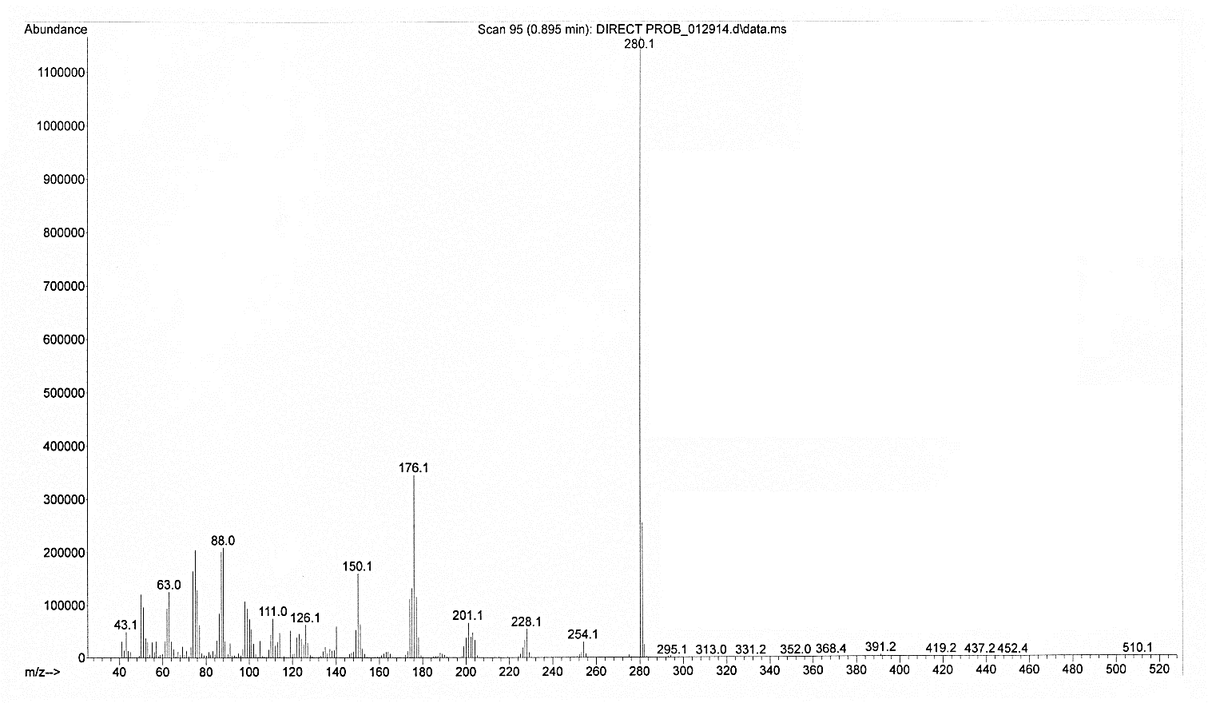

¹H NMR spectrum of Acenaphtho[1,2-b]pyrazine-8,9-dicarbonitrile (3o)
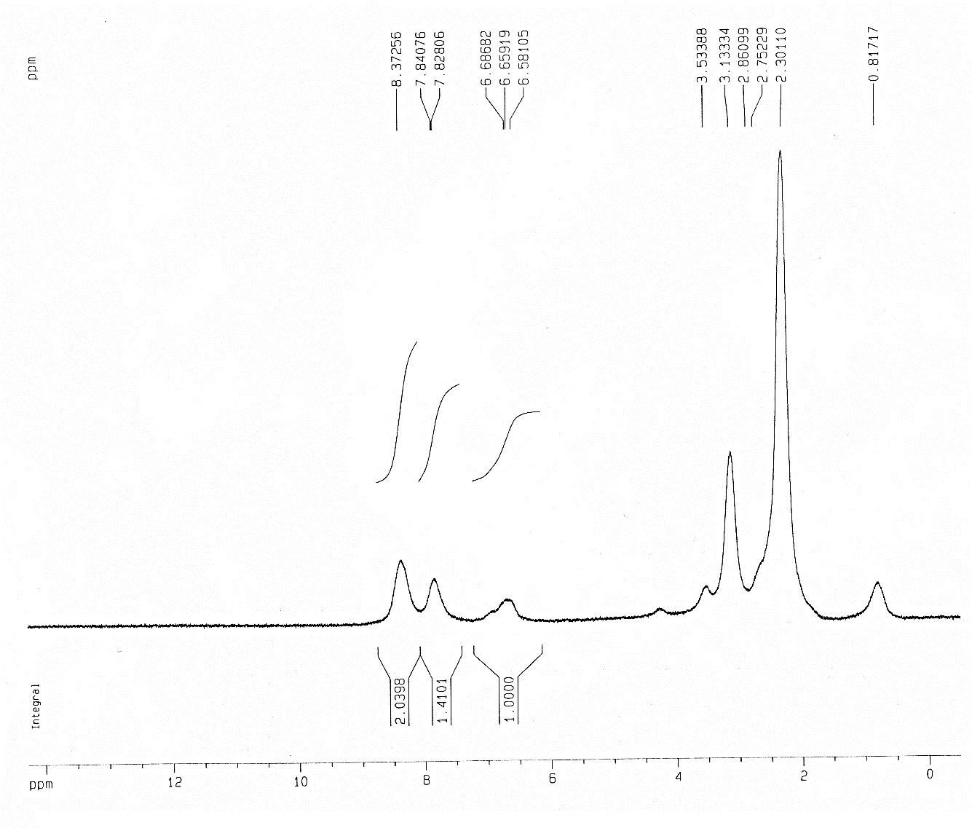
Mass spectrum of Acenaphtho[1,2-b]pyrazine-8,9-dicarbonitrile (3o)
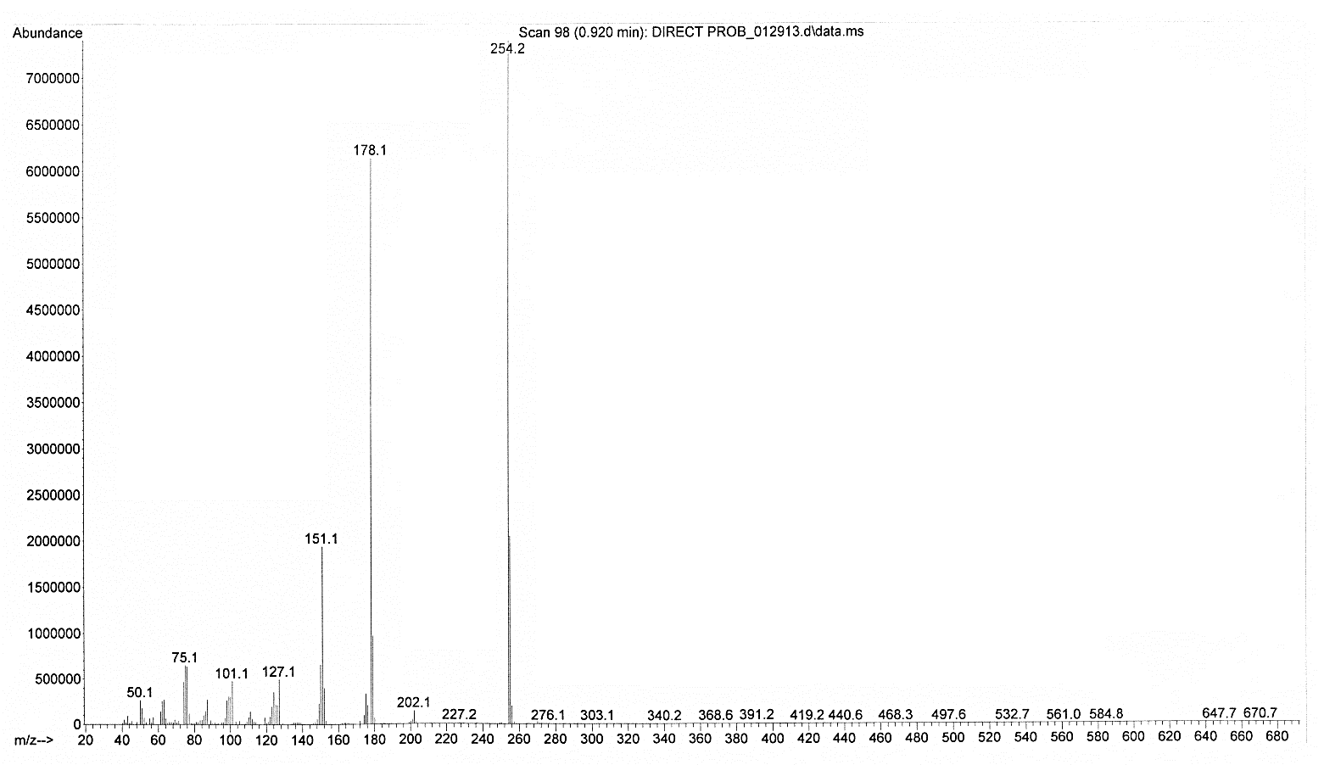
¹H NMR spectrum of 5,6-dimethylpyrazine-2,3-dicarbonitrile (3q)
¹³C NMR spectrum of 5,6-dimethylpyrazine-2,3-dicarbonitrile (3q)

٭Corresponding authors. E-mail addresses: mekalhor@pnu.ac.ir, mekalhor@gmail.com (M. Kalhor), m.khalaj@buiniau.ac.ir (M. Khalaj), Tel and Fax: +98 2537179170

