The dual invasion of Amur honeysuckle and Emerald Ash Borer alters fungal driven decomposition in Midwestern forests
Adam M. Reed¹, Carson Richardson¹, and Megan A. Rúa^{1,2*}
¹Wright State University, Department of Biological Sciences, Dayton, OH, USA
²Wright State University, Environmental Sciences PhD Program, Dayton, OH, USA
*Correspondence: Megan A. Rúa, Department of Biological Sciences, Wright State University, 3640 Colonel Glenn Hwy, Dayton, OH, 45435, USA.
ORCID: 0000-0002-2883-2795
Phone: +001 937 775 2913
Fax: +001 937 775 3320
E-mail: megan.rua@wright.edu

Acknowledgements
The authors thank Lingyan Huang, Justin Moran, Lea Kelty, Michael McKean, Joshua Miller, and Michaela Woods for assistance with fieldwork, culture work, and sample processing in the laboratory and Dr. Donnie Peterson for providing ash leaf litter. We also thank Dr. Don Cipollini, Ashley Julian, Dr. Laura Rouhana, Dr. Molly Simonis and anonymous reviewers for reviewing earlier drafts of the manuscript. Financial support for this work was provided by start-up funds from Wright State University and National Science Foundation grant DEB- 2227331 to M.A.R.

Abstract
Midwestern forests are currently impacted by two prominent invaders, the Emerald Ash Borer (EAB), Agrilus planipennis and Amur honeysuckle, Lonicera maackii. The loss of ash (Fraxinus spp.) trees due to EAB invasion can further facilitate honeysuckle invasion, driving changes in the composition of forest leaf litter. To evaluate the extent to which these changes alter ecosystem function, we conducted litter bag and culture-based decomposition experiments using leaf litter from sugar maple (Acer saccharum), oak (Quercus spp.), black ash (Fraxinus nigra), green ash (Fraxinus pennsylvanica), spicebush (Lindera benzoin), and Amur honeysuckle (Lonicera maackii). To further understand the mechanism driving differences in decay rates, we inoculated six species of decomposing fungi separately onto both single species and multispecies (half honeysuckle and half native species) leaf litter and measured decomposition rate, fungal growth and enzymatic activity in laboratory-based cultures. Honeysuckle leaf litter decomposed faster, had increased fungal growth, and had higher activity for carbon degrading enzymes compared to native species leaf litter. Furthermore, multispecies mixtures followed the same patterns as honeysuckle, suggesting that the addition of honeysuckle to leaf litter will accelerate ecosystem functions related to carbon breakdown. Consequently, forests that experience the invasion of honeysuckle and EAB induced loss of ash are likely to have faster rates of decomposition, potentially resulting in an influx of available nutrients.

Keywords Lonicera maackii, Agrilus planipennis, Fungi, Leaf litter decomposition, Enzyme activities.

Introduction
Forests throughout the world have undergone several major changes that affect entire ecosystems and will have lasting impacts on their overall health. These changes include dominant species loss, habitat destruction and exotic species introductions and invasions, each of which greatly alter ecosystem functioning (Tilman et al. 1994; Pyšek and Richardson 2010). In the Midwestern and Eastern United States, forests are greatly impacted by the introduction of the insect, Agrilus planipennis (emerald ash borer; EAB), which has significantly decreased the abundance of Fraxinus spp. (ash) trees as well as the introduction of the invasive shrub Lonicera maackii (Amur honeysuckle). While the independent roles these two events play in structuring plant communities are widely studied (i.e., (Gould and Gorchov 2000; Collier et al. 2002; Hartman and McCarthy 2004; Schradin and Cipollini 2012), the interactive effects of these events on ecosystem functions such as nutrient cycling and microbial processes are largely unexplored.
Originally from Southeast Asia, EAB is an invasive pest with no natural predators in North America (Muirhead et al. 2006; Herms and McCullough 2014). Since its discovery in 2002 in southeast Michigan, it has spread to 35 states within the United States as well as five neighboring Canadian provinces (http://www.emeraldashborer.info; (Nisbet et al. 2015). With ash mortality rates near 100% in the most infected areas, damages from EAB infestation are estimated to cost over $26 billion (Sydnor et al. 2007; Klooster et al. 2014). Consequently, EAB induced ash mortality has the potential to change ecosystem function and species dynamics in many Midwestern forests (Lovett et al. 2006).
Extreme losses of prominent plant species like ash trees from forests is likely to impact key functions in forest ecosystems like decomposition, leading to significant changes in nutrient availability due to interspecific differences in the quality of leaf litter which drive differences in the decay rates of leaves. For example, European ash (Fraxinus excelsior) leaf litter has higher amounts of nitrogen (N), magnesium and calcium leading to faster decomposition and a higher litter turnover rate than both European beech (Fagus sylvatica) and lime (Tilia cordata Mill. or Tilia platyphyllos; (Langenbruch et al. 2012). In North American forest ecosystems, decomposition of ash leaf litter leads to a lower soil carbon to nitrogen ratio than decomposition of other native species including red oak (Quercus rubra), sugar maple (Acer saccharum), red maple (Acer rubrum), American beech (Fagus grandifolia) and eastern hemlock (Tsuga canadensis; (Finzi et al. 1998). Therefore, losing ash from forest ecosystems can potentially lead to a large change in soil nutrients in forest ecosystems.
The loss of ash from forest ecosystems is also likely to cause increased turnover in plant species composition due to gap formation in the overstory and understory (Klooster et al. 2014). Gaps in the canopy resulting from increased ash mortality will lead to higher light availability in the understory, which could lead to an increase in shrubs and saplings with high light tolerance (Dolan and Kilgore 2018). While replacement of ash by other native species can potentially happen (Smith et al. 2015), replacement by an invasive species such as honeysuckle or autumn olive (Elaegnus umbellata) is more likely since such species are better adapted to higher light availability than native species (McNeish and McEwan 2016; Hoven et al. 2017). Indeed, in an EAB infected forest with high rates of ash mortality, 18% of the remaining cover was from invasive plant species (Hoven et al. 2017).
Amur honeysuckle is an invasive shrub present throughout the understory of Midwestern forests. Since its introduction in southwest Ohio in 1896, honeysuckle has spread to over half of North America (Hutchinson and Vankat 1997). This invasion disrupts forest ecosystems in a variety of ways. When honeysuckle is present, overall plant species richness declined by 53% (Collier et al. 2002). It is also altering nutrient cycling. The leaves of honeysuckle have a higher N content and decompose faster than native species, thus, potentially driving an increase of N in invaded forests (Arthur et al. 2012). There is also evidence that honeysuckle increases decay rates for the litter of native species (Blair and Stowasser 2009). Furthermore, honeysuckle can reduce the growth of native plant species by limiting space and resources, such as light, water and nutrient availability (Arthur et al. 2012; Lieurance and Cipollini 2013). In whole, the combination of increased decomposition rates, reduction in native vegetative growth and introduction of new chemical components from honeysuckle invasion could have a major impact on nutrient cycling in affected forests.
To fully understand the impact losing native ash species and gaining invasive species like honeysuckle is having on nutrient cycling in midwestern forests, experiments which compare leaf litter decay for native and introduced species are needed. Leaf litter decomposition rates are dependent on leaf chemistry with leaves with high N content able to decompose more quickly than recalcitrant leaves that have higher carbon (C) content (Cotrufo et al. 2013). Consequently, honeysuckle should decompose the fastest due to having a low C:N compared to native trees and within native trees, oaks should have a slower decomposition rate than maple or ash species (Howard and Howard 1974; Madritch and Cardinale 2007). When native species are combined with invasive species, decomposition rates of native species are usually accelerated (Ashton et al. 2005; Arthur et al. 2012), but labile litter decomposition can be slower when mixed with native species litter (Grossman et al. 2020). Since leaf litter often consists of mixtures of several plant species and their decomposition dynamics are often not easily predicted based on the decomposition patterns of single species (Gartner and Cardon 2004), decomposition dynamics of different leaf species combinations should be directly evaluated. Since honeysuckle litter is highly labile, mixed species litter combining native and invasive leaves should have a faster decomposition rate than single species litter.
Decomposition is mainly driven by microorganisms whose community composition and function can be altered by invasive plant species (Vitousek et al. 1997). Early work suggests that honeysuckle has a unique community of microbes associated with its leaves that are not present on native ash or Carya spp. (hickory) leaves in Midwestern forests (Arthur et al. 2012). This change in the microbial community may alter microbially driven nutrient cycling by changing the decomposers of plant litter, potentially explaining why invasive species decompose faster and lead to an abundance of soil nutrients (van der Putten et al. 2007).
Fungi in particular are important drivers of decomposition and do so through the secretion of a specialized set of extracellular enzymes that allow for the breakdown of different components of organic matter (Hankin and Anagnostakis 1975). Plant species invasion can lead to increases in enzyme activity, most noticeably for N and P decomposing enzymes (Zhou and Staver 2019), but can also contribute to an increase in C degrading enzymes such as peroxidase and polyphenol oxidase (Woods et al. 2019), potentially as a result of shifts in fungal communities driven by invasive species (Liu et al. 2019; Yang et al. 2019). Consequently, changes in plant composition will drive changes in available leaf litter, potentially altering fungal community composition and function, and thereby changing nutrient availability in invaded ecosystems.
Here we use both field and laboratory-based decomposition experiments to investigate how the addition of honeysuckle to leaf litter changes fungal facilitated decomposition in forests that have also experienced a loss of ash due to EAB. We hypothesized that (1) honeysuckle litter would decompose faster than all native species and (2) this effect would be driven by changing fungal traits, such as increased fungal biomass, hyphal growth rate, and enzyme activities.

Materials and Methods
Study Site
This study utilized material from a relatively undisturbed section of the Runkle Woods at Wright State University (primary woods, which are approximately 127 years old; (DeMars and Runkle 1992) in Dayton, Ohio (39.785253 °N, 84.05424 °W). The overstory of the woods consists primarily of oaks (Oak) and maples (Acer spp.), but also contains other species such as hickory, and American elm (Ulmus americana; (DeMars and Runkle 1992). F. americana (white ash), green ash (F. pennsylvanica) and F. quadrangulata (blue ash) were once present in the woods but have been reduced by EAB such that only blue ash trees remain (Cipollini and Runkle, personal communication). Like other Midwestern forests, the understory has been invaded by and is now primarily composed of honeysuckle, but spicebush (Lindera benzoin) is also present in the shrub layer (Dorning and Cipollini 2006).
Leaf Litter Collection
This study focused on six woody species which are representative of a typical Midwestern forest: sugar maple (A. saccharum), oak (Q. rubra and Q. alba), black ash (F. nigra), green ash (F. pennsylvanica), spicebush (L. benzoin) and honeysuckle (L. maackii). These species vary in decomposition rate and leaf litter chemistry (Petersen and Cummins 1974; Kominoski et al. 2007; Blair and Stowasser 2009; Swan et al. 2009; Arthur et al. 2012; Poulette and Arthur 2012; Nisbet et al. 2015; Jo et al. 2016; Stoler et al. 2017).
Leaves from sugar maple, oak, spicebush and honeysuckle were hand collected in the WSU woods following natural senescence but leaves from black ash, originating from Baileys Nursery in St. Paul, Minnesota, and green ash, originating from the WSU woods, were collected from trees maintained in the WSU greenhouse. These trees were kept in pots with commercial soil outside the WSU greenhouse to prevent EAB infection. All leaves were collected after abscission from September-November 2017 and September-November 2018 from multiple locations and pooled. Following collection, leaf litter was dried in a drying oven at 80 °C for two days. To kill any microbes present, leaf litter was autoclaved for 20 minutes at 121 °C twice within 24 hours. Litter was stored at room temperature until the start of the experiments, approximately seven days.
Litter Bag Decomposition
Experimental Set-up
To evaluate field rates of litter decomposition, we performed a standard litter bag decomposition experiment. We placed 10 g of leaf litter from each of five focal species (sugar maple, oak, black ash, spicebush and honeysuckle) in individual litter bags constructed by folding 300 µm nylon mesh into 8 x 6 inches and stapling all four edges. Decomposition bags with mixed species were created by combining 5 g of native plant leaf litter from sugar maple, oak or spicebush and 5 g of honeysuckle leaf litter. A total of 56 litter bags, (5 single species bags + 3 mixed species bags x 7 replicates), were haphazardly placed in primary forested areas of the Runkle woods for 100 days (17 November 2018 - 25 February 2019). Litter bags were collected after 100 days since previous work indicated honeysuckle leaf litter decomposed completely by this time (McEwan et al. 2012). Leaf litter was removed from litter bags and dried at 80 °C for two days to obtain dry weight to determine final leaf mass. The decomposition rate was calculated in g/year using the exponential decay model (Olson 1963).
Litter Decomposition in Culture
To better understand the role fungi play in driving changes in decomposition rates, we created a culture-based experiment with six species of fungi representing three fungal guilds (white rot, brown rot, ectomycorrhizal fungi) originally collected from the Runkle Woods: Mycena galericulata, Amanita parcivolvata, Schizophyllum commune, Laetiporus sulphureus, Pseudosperma rimosum (aka, Inocybe rimosa), and Marasmius rotula (Table S1). Fungi were isolated and maintained on Modified Melkin-Norkans (MMN) agar for approximately 21 days prior to use. Streptomycin sulfate was added to the plates to prevent bacterial contamination. To obtain enough fungal biomass for the experiment, we first placed 1 cm³ plugs from pure fungal cultures of each species onto 12 plates and incubated them for four weeks at 22 °C. We then inoculated 1 cm³ plugs from these plates onto leaf litter for the experiment.
Experimental Set-up
To isolate the effect of fungi on leaf litter decomposition, we performed a culture-based decomposition experiment using different species of leaf litter and fungi. Cultures consisted of deep plate Petri-dishes (100 mm x 20 mm) filled with 30 ml MMN agar. Each plate received 1 g of a single leaf species (sugar maple, oak, black ash, green ash, spicebush and honeysuckle) or a 1 g combination of 0.5 g of honeysuckle and 0.5 g of the native leaf species (sugar maple, oak or spicebush), which were crushed by hand and homogenized before being placed on each plate. Each fungal species by leaf litter type was replicated 7 times for a total of 378 plates [6 fungal species x (6 single species litter cultures + 3 mixed species litter cultures) x 7 replicates)]; however, some plates were discarded due to contamination resulting in a total of 367 plates (Table S2).
Each plate was inoculated with a single species of fungi. Four 1 cm³ plugs of fungi were removed from four-week-old cultures with a sterilized scalpel blade and placed on top of leaves. After a 100-day incubation period, fungal material was scraped from the leaves and placed into the agar to measure fungal biomass as described below. The remaining leaf litter was collected and weighed to determine rate of decomposition. Approximately 0.25 g of remaining litter was stored at -20 °C until ready for enzyme assays. For logistical purposes, the experiment was performed in two rounds with three different species of fungi in each round.
Fungal Hyphae
To determine the growth rate of fungi in culture, fungal hyphal length was measured from the edge of the initial fungal plug to the end of the hyphae with a caliper twice a week until the hyphae reached the edge of the plate. Hyphal growth rate (mm/day) was calculated by taking the natural log of the difference between initial hyphal length and final hyphal length over the time maximum hyphal length was reached.
Fungal Biomass
To assess total fungal biomass, both the agar and the fungal material that was removed from the leaf litter were melted in a beaker in an autoclave following a procedure outlined by Maynard et al. (2017). Cultures were autoclaved for 20 minutes at 121 °C to separate the fungal material from the agar, then poured through a 45 µm sieve to isolate the fungal material from the agar. Fungal material was further separated from agar by rinsing with ~100 mL of 90 °C DI water. The remaining fungi was placed in a drying oven at 65 °C for 12-24 hours until dry and weighed to determine fungal biomass in mg.
Enzyme Activities
To determine differences in fungal function between leaf species, we tested five enzymatic activities commonly assessed in decomposition. We measured the activities of β-glucosidase (BG), cellobiohydrolase (CBH), leucine aminopeptidase (LAP), peroxidase (PER) and polyphenol oxidase (PPO) following the procedures outlined in Woods et al. (2019). Each enzyme assay was conducted using homogenous leaf slurries made with 13 mg of leaf and 4 ml of 50 mM sodium acetate buffer at a pH of 5.6 and incubated in the dark at 4 °C. For the fluorometric enzymes BG, CBH, and LAP, we measured assay absorbance and fluorescence values using a BioTex Synergy HT microplate reader (BioTek, Winookski, VT, USA). For the colorimetric enzymes, PPO and PER, we measured assay absorbance using a Molecular Devices Corporation SpectraMax 190 microplate reader (Molecular Devices Corporation, Sunnyvale, CA, USA). Incubation times were selected to maximize the potential of each enzymatic activity for leaf litter. Due to a lack of leaf litter, not all of the assays from CBH, PER and LAP could be completed, resulting in sample sizes for CBH, PER, and LAP that are lower than for the other fungal traits (Table S2). For univariate analyses described below, analyses were conducted without these missing values but for multivariate analyses, values were imputed.
Statistical analysis
All statistical analyses were performed in the statistical programming environment R version 4.2.0 (R Core Team 2022). All results were visualized using ggplot2 (Wickham 2016) unless otherwise noted. Significant interactions for all models were tested with ANOVA and post hoc analysis using the emmeans package with adjustment for Tukey HSD (Lenth 2022).
To understand how litter decay rates differed among plant species in the field, decay rate was tested as a function of plant species using a linear model created with the lm function from the stats package (R Core Team 2022) and one-way ANOVA. Separate models were created with data from the mixed species bag and the two single species bags that made up those mixes to assess differences in decay rates for natives when honeysuckle is present. A linear model was also used to examine differences in decay rates for each species between laboratory and field experiments.
To evaluate the extent to which fungi drive differences in decay rate, we tested decay rate as a function of either hyphal growth rate, fungal biomass or enzyme activity with an interaction for plant species using a linear mixed effects model from the package nlme (Pinheiro et al., 2019) and a random effect for experimental round. We used principal component analysis (PCA) to condense enzyme activities into two linear principal components using prcomp from the stats package. PERMANOVA using the adonis2 function in the vegan package with 1000 permutations was then used to determine significant differences in enzyme activities based on decay rates (Oksanen et al. 2022). Prior to multivariate analyses, missing data for CBH (n = 13), PER (n = 20), and LAP (n = 1) was interpolated using the na.approx function from the zoo package (Zeileis and Grothendieck 2005).
Partial least squares path modeling (PLS-PM) was conducted using the package plspm to assess the direct and indirect effects of fungal hyphal growth rate, fungal biomass and enzyme activities (CBH, PER, PPO, LAP, BG) on decomposition rates (Sanchez et al. 2015). As with the PCA, interpolated values were used for missing CBH, PER, and LAP data. An a priori model was constructed to include all possible paths among these factors (Fig. S1). Estimates of path coefficients, coefficients of determination (R²) and goodness-of-fit (GoF) values were validated using 999 bootstraps on the path model. The GoF statistic was used to assess the reliability of the models. Independent models were created for each plant species and plant species combinations to compare differences in decomposition drivers.

Results
Plant Species Identity and Decay
Litter Bag Decay Rates
For single species litter bags, litter decay rate significantly varied by plant species (F_{4,30} = 83.51, P < 0.0001, Fig. 1A). Honeysuckle leaf litter decayed ~100% faster than spicebush and black ash, ~200% faster than sugar maple and ~250% faster than oak (Fig. 1A). In multispecies mixtures, decay rates were intermediate between honeysuckle and its associated native species (Fig. 1B-D). Honeysuckle + spicebush mixtures decayed ~43% faster than spicebush alone (F_{2,18} = 19.82, P < 0.0001, Fig. 1B), honeysuckle + sugar maple mixtures decayed ~90% faster than sugar maple alone (F_{2,18} = 62.57, P < 0.0001, Fig. 1C) and honeysuckle + oak mixtures decayed ~90% faster than oak alone (F_{2,18} = 63.41, P < 0.0001, Fig. 1D).
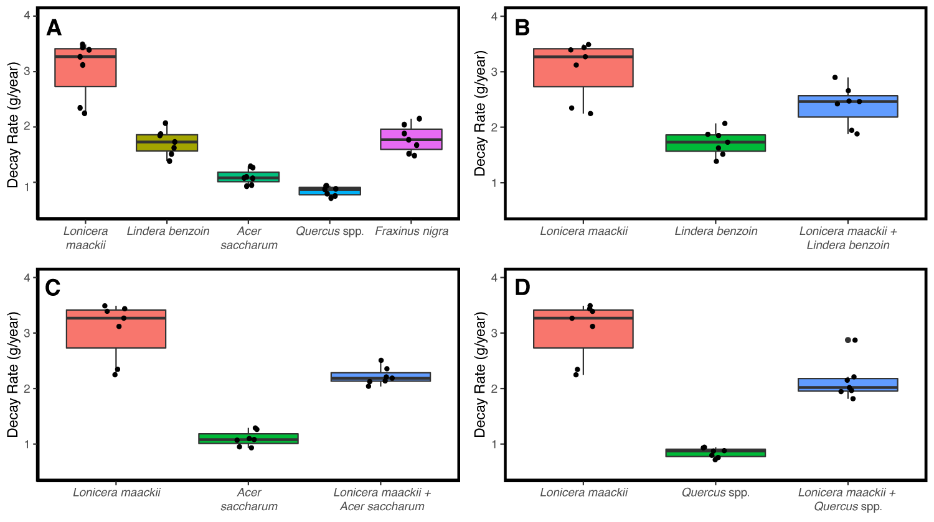
Fig. 1. Plant species identity drives decay rates in litter bag mixtures in A) in single species litter bags (P < 0.0001), and for mixed species litter bags of B) spicebush (P < 0.0001), C) sugar maple (P < 0.0001) and D) oak (P < 0.0001). Decay rate was highest for honeysuckle, lowest for the native species and intermediate for the multispecies litter bags. Letters indicate significant differences based on the ANOVA and Tukey tests. The same letters indicate that differences in decay rates between litter species were not significant.
Culture Based Decay Rates
For cultures with a single plant species, litter decay rate significantly varied by plant species (F_{5,238} = 27.2, P < 0.0001, Fig. 2). Honeysuckle leaf litter decayed ~65% faster than spicebush and black ash, 75% faster than green ash and ~80% faster than sugar maple and oak (Figure #). In multispecies mixtures, decay rates were intermediate between honeysuckle and its associated native species (Fig. 2B-D). Honeysuckle + spicebush mixtures decayed ~37% faster than spicebush alone (F_{2,118} = 54.52, P < 0.0001, Fig. 2B), honeysuckle + sugar maple mixtures decayed 49% faster than sugar maple alone (F_{2,120} = 62.08, P < 0.0001, Fig. 2C) and honeysuckle + oak mixtures decayed 52% faster than oak alone (F_{2,130} = 95.1, P < 0.0001, Fig. 3D).
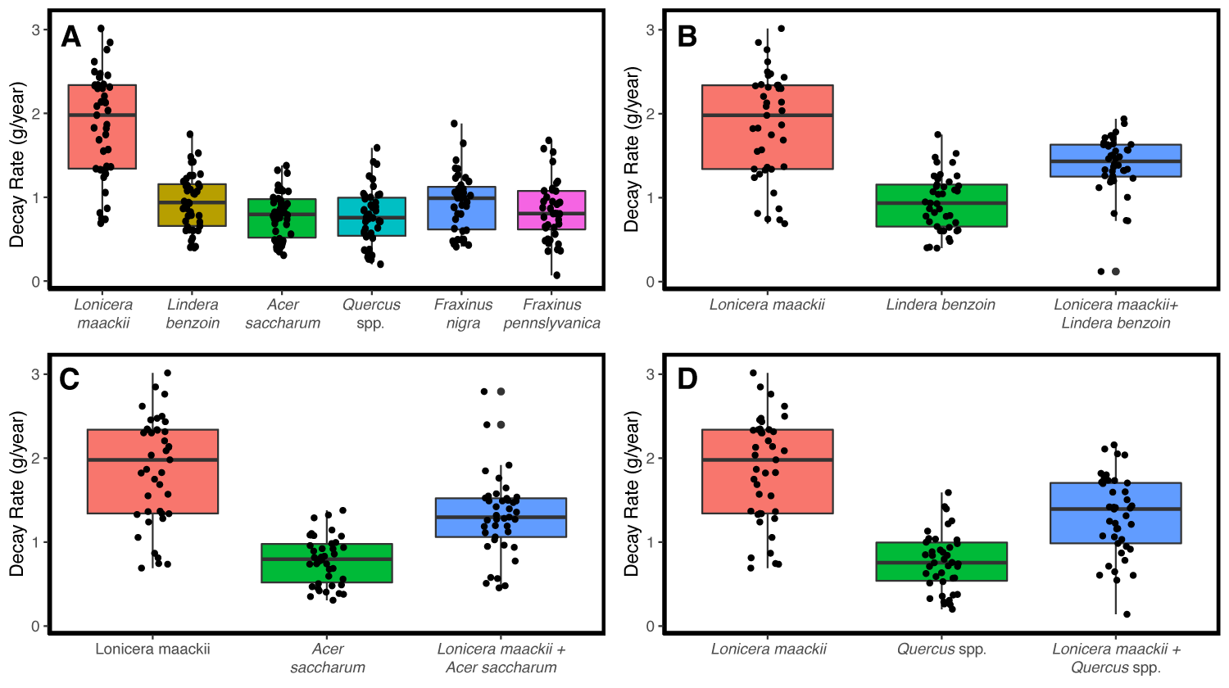
Fig. 2. Plant species identity drives decay rates in cultures for A) single species cultures (P < 0.0001), and for mixed species cultures of B) spicebush (P < 0.0001), C) sugar maple (P < 0.0001) and D) oak (P < 0.0001). Decay rate was highest for honeysuckle, lowest for the native species and intermediate for the multispecies litter bags. Letters indicate significant differences based on the ANOVA and Tukey tests. The same letters indicate that differences in decay rates between litter species were not significant.
Lab vs. Field Decay Rates
Litter decay rates were significantly different between the lab and field for most plant species combinations (F_{7,367} = 4.936, P < 0.0001, Fig. S2). Decay rates on average were higher for the field than in the lab for most single species litter: Honeysuckle litter decayed ~70% faster; spicebush litter decayed ~85% faster; and black ash litter decayed ~ 95% faster (Fig. S2). However, decay rates for sugar maple and oak did not significantly differ between lab and field experiments (P>0.05). Multispecies litter also decayed faster in the field than in the lab: honeysuckle + spicebush mixtures decayed ~100% faster; honeysuckle + sugar maple mixtures decayed ~90% faster; and honeysuckle + oak mixtures decayed ~ 65% faster (Fig. S2).
Culture Based Litter Decay Rates
Role of Hyphal Growth Rate and Plant Species Identity on Decay Rates
The interaction of hyphal growth rate and plant species identity significantly explained leaf litter decay rates in single species litter cultures (F_{5,232} = 8.467, P < 0.0001). Honeysuckle, green ash, oak and black ash litter decayed slower with increased hyphal growth rate, but decay rates increased with an increase in hyphal growth rate for spicebush and sugar maple litter (Fig. 3A).
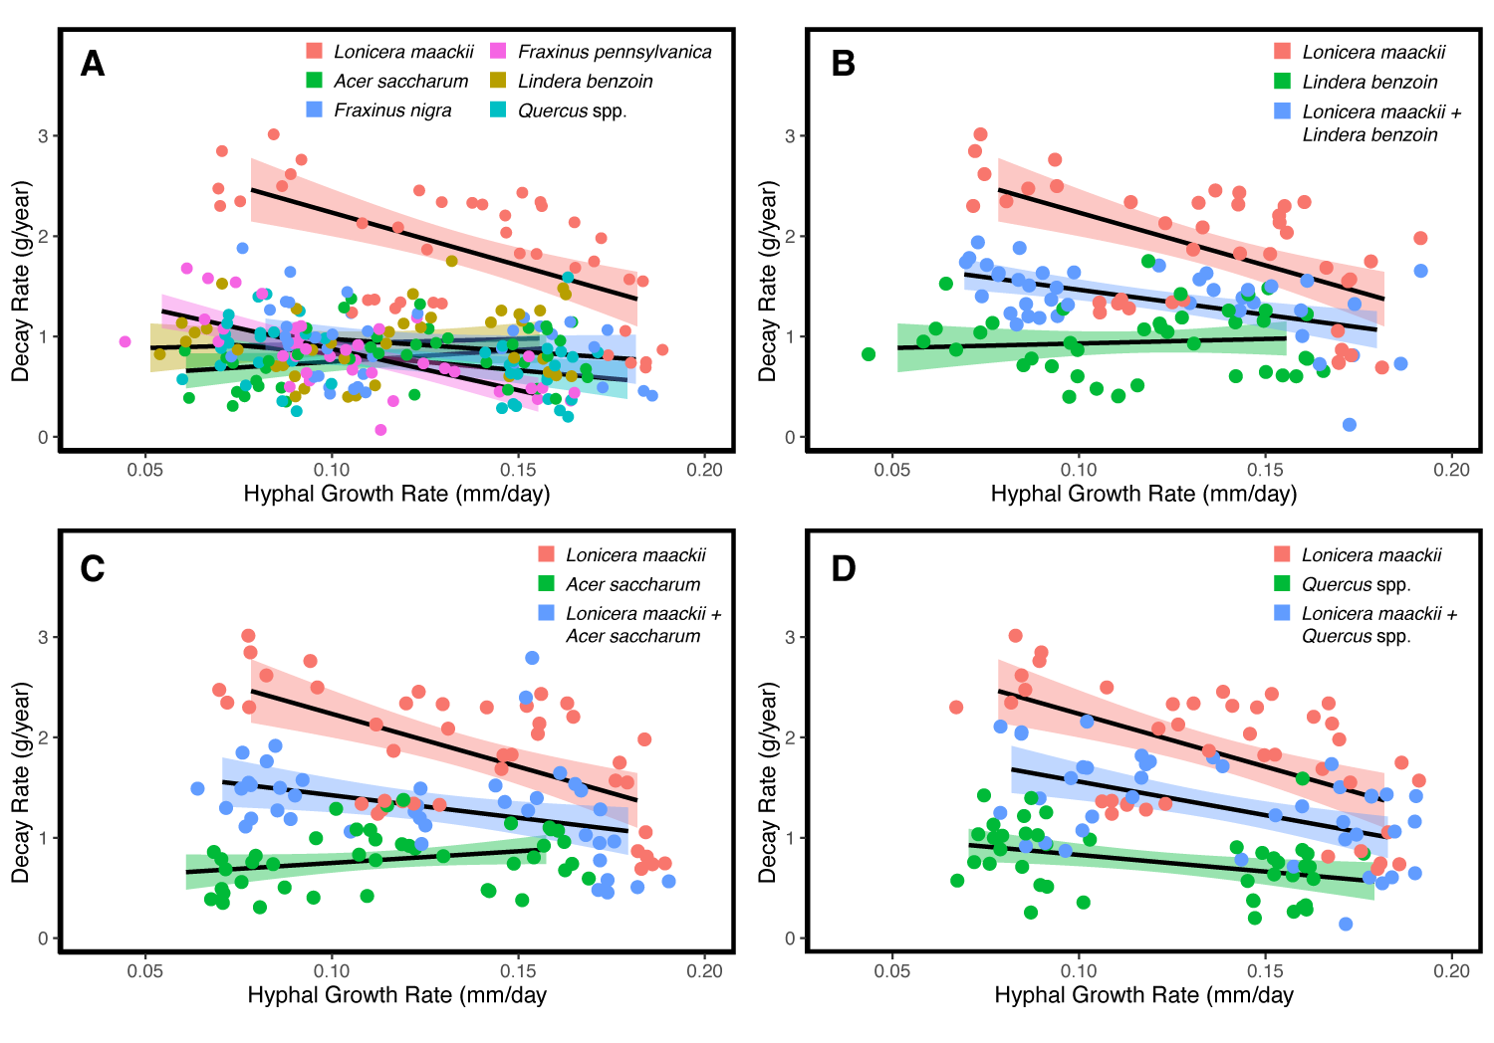
Fig. 3. Hyphal growth rate, plant species identity and fungal guild drive litter decay rate for A) single species cultures (P < 0.0001), B) spicebush (P < 0.0001), C) maple (P < 0.0001), and D) oak (P = 0.0196). All plant species had decreased decay with increasing hyphal growth rate except for spicebush and sugar maple. Decay rates for multispecies cultures followed similar patterns to honeysuckle with decreasing decay rates with increased hyphal growth rate. Shaded regions represent 95% confidence intervals for honeysuckle (pink), spicebush (brown)¸ sugar maple (green), oak (light blue), black ash (dark blue), and green ash (purple) in single species cultures and honeysuckle (pink), native species (green) and mixtures (blue) in multispecies cultures.
Patterns for decay rate as a function of fungal hyphal growth rate and plant species identity for multispecies mixtures consistently fell between patterns for honeysuckle and the relevant single species culture (Fig. 3B-D). Each multispecies culture followed similar trends to honeysuckle litter such that decay rates decreased with increasing hyphal growth rate: honeysuckle + spicebush (F_{2,115} = 14.03, P <0.0001, Fig. 3B), honeysuckle + maple (F_{2,117} = 11.89, P <0.0001, Fig. 3C) and honeysuckle + oak (F_{2,117} = 4.068, P = 0.0196, Fig. 3D).
Role of Fungal Biomass and Plant Species Identity on Decay Rates
In single species models, litter decay rate increased with increasing fungal biomass (F_{1,232} = 25.15, P < 0.0001) but this was not affected by plant species identity (F_{5,232} = 1.375, P = 0.2343). In multispecies cultures, litter decay rates decreased with increasing fungal biomass for honeysuckle + spicebush (F_{2,115} = 4.065, P = 0.0197, Fig. 4A) and honeysuckle + maple (F_{2,117} = 4.004, P = 0.0208, Fig. 4B) models. However, fungal biomass did not significantly predict decay rate as an interaction with plant species in honeysuckle + oak mixed models (F_{2,117} = 1.769, P = 0.1750).
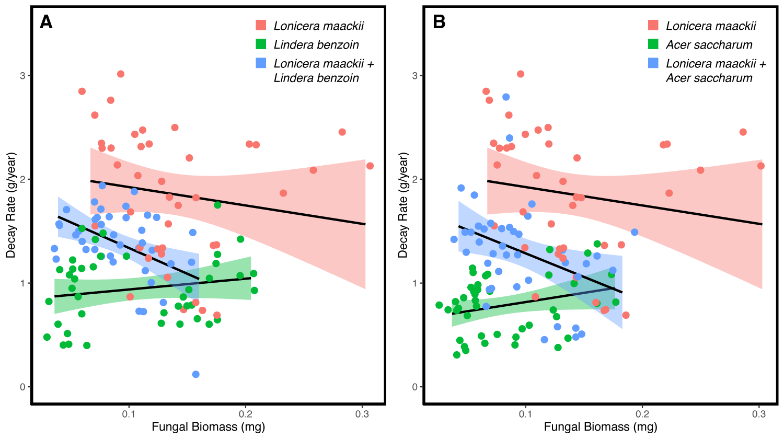
Fig. 4. Fungal biomass and plant species identity drive litter decay rate in multispecies cultures for A) spicebush (P = 0.0197) and B) maple (P = 0.0208). Similar to honeysuckle, in multispecies litter cultures, decay rates decreased with increasing fungal biomass compared to native single species litter where decay rates increased with increasing fungal biomass. Shaded regions represent 95% confidence intervals for honeysuckle (pink), native species (green) and mixtures (blue).
Role of Enzyme Activities and Plant Species Identity on Decay Rates
Individual enzyme activities and plant species identity predicted litter decay rate for single species cultures for CBH (F_{5,221} = 2.211, P = 0.0542), PPO (F_{5,232} = 6.151, P < 0.0001), LAP (F_{5,231} = 4.753, P = 0.0004) and PER (F_{5,218} = 2.242, P = 0.0512). Decay rates increased with increasing CBH activity for all plant species except for spicebush litter (Fig. 5A). Decay rates increased with increasing PPO activity for honeysuckle, spicebush, oak, and black ash but decreased with increasing PPO activity for maple and green ash (Fig. 5B). Decay rates increased with increasing LAP activity for honeysuckle and oaks, but decreased for spicebush, maple, black ash and Green ash (Fig. 5C). Finally, decay rates decreased with increasing PER activity for honeysuckle, oak, and green ash and increased for black ash but had no relationship for spicebush and maple (Fig. 5D).
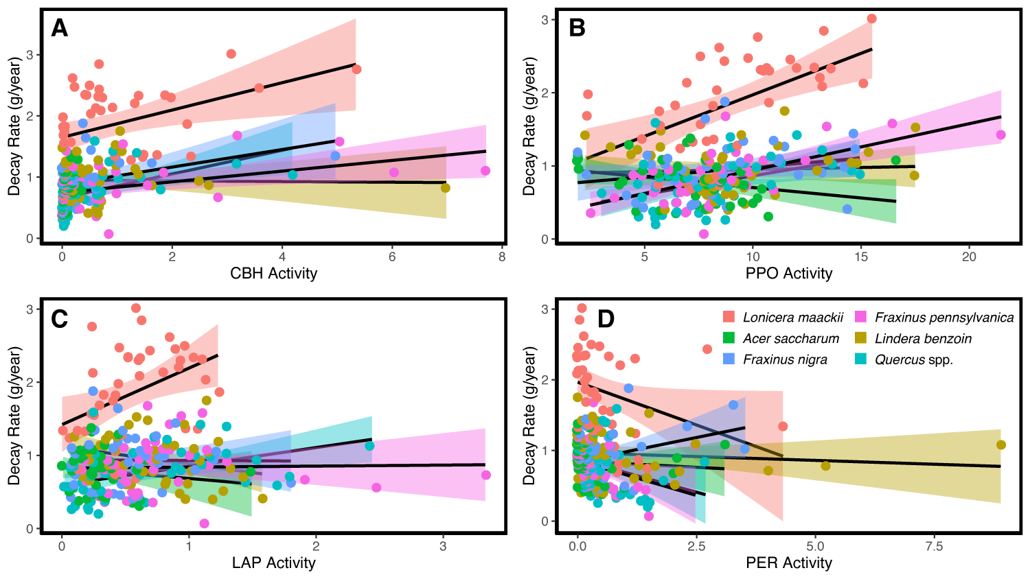
Fig. 5. Enzyme activity and plant species identity interacted to drive decay rate in single species cultures for A) cellobiohydrolase (CBH) activity (P < 0.0001), B) leucine aminopeptidase (LAP) activity (P = 0.0004), C) polyphenol oxidase (PPO) activity (P < 0.0001), and D) peroxidase (PER) activity (P = 0.0512). Shaded regions represent 95% confidence intervals for honeysuckle (pink), spicebush (brown)¸ maple (green), oak (light blue), black ash (dark blue), and green ash (purple).
Decay rate increased with increasing BG activity (F_{1,232} = 42.10, P < 0.0001) but this did not interact with plant species identity (F_{1,232} = 0.8883, P = 0.4896).
Multispecies Cultures
Spicebush
Decay rates increased with increasing enzyme activity for honeysuckle, spicebush, and their mixed litter for CBH activity (F_{2,114} = 4.358, P = 0.0150; Fig. 6A) and PPO activity (F_{2,115} = 5.582, P = 0.0049; Fig. 6B). The relationship between decay rates and LAP activity varied such that increasing LAP activity increased decay rates of honeysuckle litter, decreased decay rates of spicebush litter and increased decay rates for mixed litter (F_{2,115} = 8.584, P < 0.0001; Fig. 6C). Enzyme activity failed to predict decay rates as a function of plant species identity in honeysuckle + maple cultures for BG activity (F_{2,115} = 0.7934, P = 0.4548) and PER activity (F_{2,111} = 1.557, P = 0.2154).
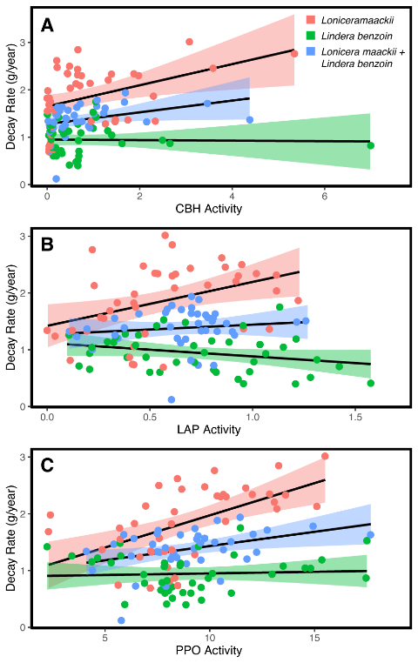
Fig 6. The relationship between decay rates and enzyme activity with plant species identity varied for A) cellobiohydrolase (CBH) activity (P = 0.0150), B) polyphenol oxidase (PPO) activity (P = 0.0049) and C) leucine aminopeptidase (LAP) activity (P < 0.0001). Shaded regions represent 95% confidence intervals for honeysuckle (pink), spicebush (green) and honeysuckle + spicebush mixtures (blue).
Maple
Decay rates increased with increasing PPO activity for for both honeysuckle litter and maple + honeysuckle mixed litter but decreased for maple litter alone (F_{2,117} = 7.528, P < 0.0001; Fig. 7A). In contrast, decay rates increased with increasing LAP activity for honeysuckle litter, decreased with increasing LAP activity for maple + honeysuckle mixed litter and no effect for maple litter alone (F_{2,116} = 10.41, P = 0.0001; Fig. 7B). Enzyme activity failed to predict decay rates as a function of plant species identity in honeysuckle + maple cultures for BG activity (F_{2,117} = 0.6995, P = 0.4989), CBH activity (F_{2,110} = 0.9211, P = 0.4011), PER activity (F_{2,107} = 0.8731, P = 0.4206).
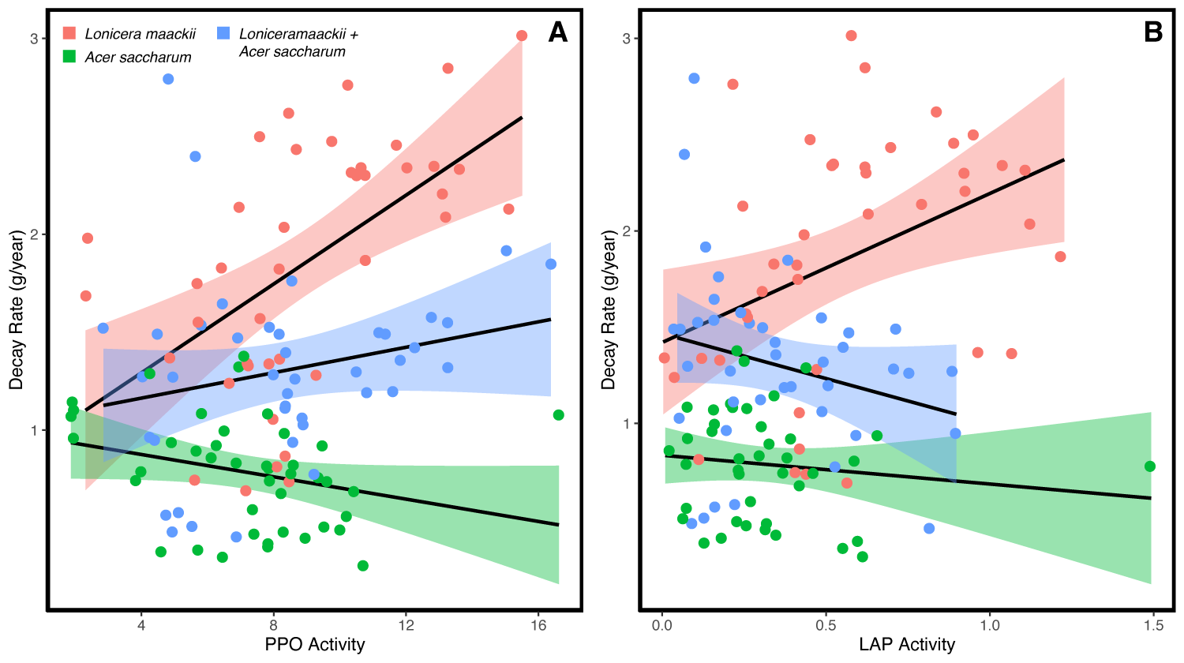
Fig. 7. A) Polyphenol oxidase (PPO) activity and B) leucine aminopeptidase (LAP) activity drives litter decay rates as a function of plant species identity. Litter decay rates in mixed honeysuckle-maple cultures increased with increased PPO activity but decreased with increased LAP activity for the mixes compared to the single species litter. Shaded regions represent 95% confidence intervals.
Oak
Decay rates increased with increasing PPO activity for honeysuckle litter, oak litter, and mixed honeysuckle-oak litter (F_{2,117} = 3.355, P = 0.0383, Fig. S3). Enzyme activity failed to predict decay rates as a function of plant species identity in honeysuckle + maple cultures for BG activity (F_{2,117} = 1.244, P = 0.2920), CBH activity (F_{2,116} = 1.425, P = 0.2448), LAP activity (F_{2,117} = 2.618, P = 0.0772), PER activity (F_{2,112} = 0.3474, P = 0.7073).
Role of Hyphal Growth Rate, Fungal Biomass and Enzyme Activities on Decay Rates
Independent of litter species identity, hyphal growth rate did not significantly predict litter decay rates (F_{1,364} = 0.0611, P = 0.8049) but fungal biomass did such that decay rates increased with increasing fungal biomass (F_{1,364} = 6.701, P = 0.01).
The relationship between decay rate and enzyme activities across litter species identity varied by enzyme. Decay rate increased with increasing BG activity (F_{1,364} = 28.87, P < 0.0001, Fig. 8A), CBH activity (F_{1,351} = 23.26, P < 0.0001, Fig. 8B), PPO activity (F_{1,364} = 18.02, P < 0.0001, Fig. 8C), and LAP activity (F_{1,363} = 5.94, P = 0.0153, Fig. 8D) but decay rate decreased with increasing PER activity (F_{1,344} = 4.138, P = 0.0427, Fig. 8E). PERMANOVA results suggest decay rate significantly affects enzymes activities (R² = 0.08, F1,364=29.735, P=0.001) but separation appeared weak (Fig. 8F).
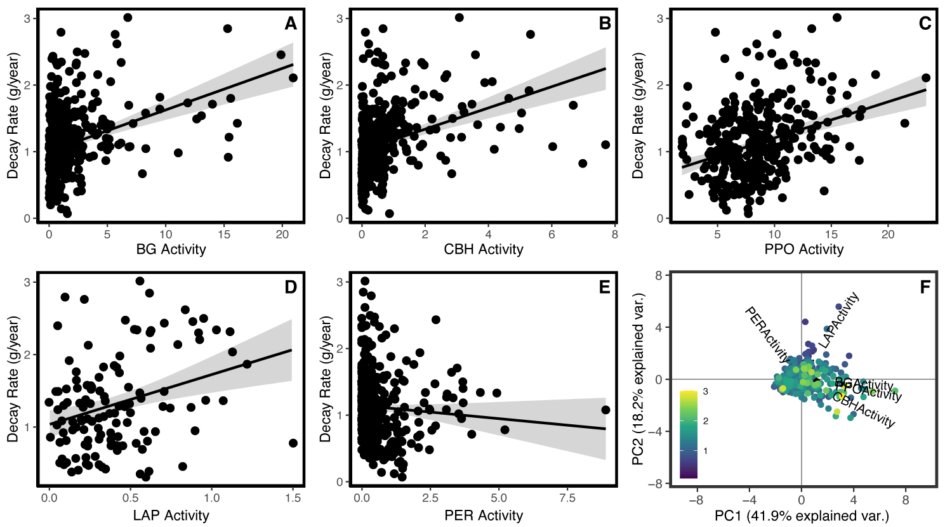
Fig. 8. Decay rate as a function of enzyme activities. Decay rate increased with A) β-glucosidase (BG) activity (P < 0.0001), B) cellobiohydrolase (CBH) activity (P < 0.0001), C) polyphenol oxidase (PPO) activity (P < 0.0001), and D) leucine aminopeptidase (LAP activity) (P = 0.0153) but decreased with E) peroxidase (PER) activity (P = 0.0427). When condensed into two axes (F), decay rate significantly affects enzyme activities (P=0.001).
Fungal Traits as drivers of decay rates
Structural equation modeling was used to compare the relative importance of the different fungal traits on decomposition rates for each litter species. PLS-PM analysis explained XX% of total variance in decay rates. In models with only the single species cultures, goodness of fit (GOF) values ranged from 0.35 for spicebush and sugar maple to 0.46 for oak, honeysuckle, and green ash (Fig. 9). Oak, honeysuckle, black ash, and green ash PLS-PM models all had similar outputs such that enzyme activities and fungal biomass jointly regulated decay rates, of which enzyme activities showed stronger direct and total impacts (Fig. 9A,C-E). The PLS-PM model for sugar maple also showed that enzyme activities have strong direct and total impacts on decay rates (Fig. 9B). In contrast, in spicebush PLS-PM models, the moderator variable fungal traits, of which fungal biomass and enzyme activities loaded most strongly, had the strongest effect on decay rates while fungal hyphal growth rate also had a significant effect on decay rate despite not mapping onto the fungal traits variable (Fig. 9F).
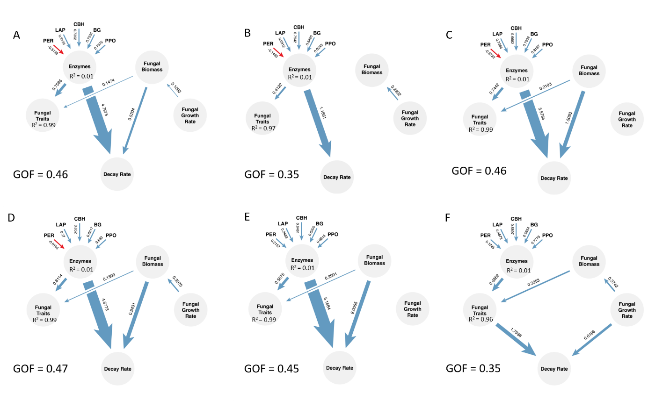
Figure 9. Directed graph of the partial least squares path model (PLS-PM) analysis for decay rates for A) honeysuckle, B) sugar maple, C) oak, D), green ash, E) black ash, and F) spicebush. Each circle represents the observed (Fungal Biomass, Fungal Growth Rate) or latent variables (Enzymes, Fungal Traits). The latent variable Enzymes is created by the enzyme activities for β-glucosidase (BG), cellobiohydrolase (CBH), leucine aminopeptidase (LAP), peroxidase (PER) and polyphenol oxidase (PPO). The latent variable Fungal Traits is created from the latent variable Enzymes, Fungal Biomass and Fungal Growth Rate. Path coefficients and explained variability (R²) are reflected in the width of the arrow were calculated after 1000 bootstraps. Blue and red arrows represent positive and negative effects. Goodness of fit (GOF) values represent model fit. Only significant paths (P<0.05) are represented.
Models with mixed species cultures revealed interesting patterns. In honeysuckle single species models, decay rate was regulated by both fungal biomass and most strongly, enzyme activities, but in sugar maple single species models, only enzyme activities regulated decay rates (Fig. 9A,C). For sugar maple + honeysuckle PLS-PM models, decay rate was jointly and strongly regulated by enzyme activities and fungal biomass (Fig. 10A).
Oak and honeysuckle single species PLS-PM models all had similar outputs such that decay rates were regulated by fungal biomass, and most strongly, enzyme activities (Fig. 9A,B). However, in mixed species PLS-PM models with oak + honeysuckle, decay rates were regulated by fungal traits as represented by fungal biomass and enzyme activities and fungal growth rate (Fig. 10B).
Finally, decay rates were regulated differently for honeysuckle and spicebush single species PLS-PM models such that enzyme activities and fungal biomass regulated decay rates for honeysuckle while the moderator variable fungal traits as represented by fungal biomass and enzyme activities, had the strongest effect on decay rates, while fungal hyphal growth rate also had a significant effect on decay rate despite not mapping onto the fungal traits variable for spicebush (Fig. 9A,F). In mixed species PLS-PM models with honeysuckle + spicebush, enzyme activities strongly and directly regulated decay rates, but no other variables had an impact on decay rate (Fig. 10C).
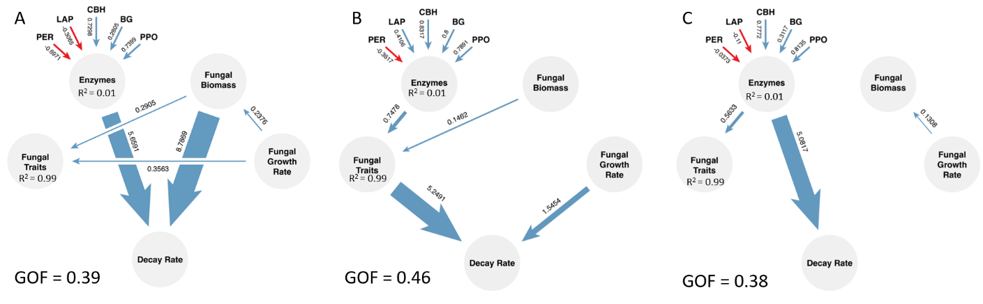
Figure 10. Directed graph of the partial least squares path model (PLS-PM) analysis for decay rates for A) honeysuckle + sugar maple, B) honeysuckle + oak and C) honeysuckle + spicebush. Each circle represents the observed (Fungal Biomass, Fungal Growth Rate) or latent variables (Enzymes, Fungal Traits). The latent variable Enzymes is created by the enzyme activities for β-glucosidase (BG), cellobiohydrolase (CBH), leucine aminopeptidase (LAP), peroxidase (PER) and polyphenol oxidase (PPO). The latent variable Fungal Traits is created from the latent variable Enzymes, Fungal Biomass and Fungal Growth Rate. Path coefficients and explained variability (R²) are reflected in the width of the arrow were calculated after 1000 bootstraps. Blue and red arrows represent positive and negative effects. Goodness of fit (GOF) values represent model fit. Only significant paths (P<0.05) are represented.
Discussion
Invasive species are detrimental to forests by causing habitat degradation, altering plant community structure, and impacting ecosystem functions (Tilman et al. 1994; Pyšek and Richardson 2010). The invasion of honeysuckle and EAB both independently disrupt ecosystem functions, but their interactive effect on ecosystems is relatively unknown. One of the most obvious changes caused by these concurring invaders is declines in plant species richness (Hartman and McCarthy 2008; Hoven et al. 2017), but understanding their long-term impacts on ecosystem functions like nutrient cycling requires further research. Here, we found that the addition of honeysuckle litter not only increased decomposition rates when combined with native species litter, but also altered fungal biomass and enzyme activities, all of which contributed to increased decomposition rates. The addition of honeysuckle further increased enzyme activity for several key enzymes important for nutrient cycling, particularly C associated enzymes. Across all native species, litter from both species of ash decayed the fastest and had higher CBH, LAP and PPO activities compared to the other native species. Taken together, these results suggest that forests incurring both a loss of ash and an invasion of honeysuckle may further increase the rate that C is broken down by fungi, thus potentially increasing the C nutrient pools in invaded forests. They also suggest decomposition rates in forests which lose ash from EAB invasion but do not experience honeysuckle invasion will generally decline if sugar maple and/or oaks fill the void.
In general, invasive species leaf litter decomposes faster than native species leaf litter in both field and lab studies (Arthur et al. 2012; Nisbet et al. 2015; Jo et al. 2016). In this study, honeysuckle litter decomposed the fastest among the six leaf litter species for both in situ litter bag and laboratory culture experiments. The accelerated decomposition of honeysuckle litter compared to that of the native species supports the general finding that invasive species litter is more labile with faster decomposition rates than native species (Ehrenfeld 2003; Ashton et al. 2005; Arthur et al. 2012). Furthermore, mixing honeysuckle and individual native species leaf litter increased decay rates compared to native species decay alone in both litter bags and lab cultures. This may reflect “priming effects” which can occur when labile C additions accelerate microorganism decomposition of recalcitrant C sources (Rousk et al. 2015). In previous studies, the addition of a non-native labile leaf litter to recalcitrant native litter has led to mixed results for the direction of change in decomposition rates for the native leaf litter. Some studies have reported an overall increase in decomposition rate, which could be the result of increased N (Ashton et al. 2005; Arthur et al. 2012). Other studies have reported a decrease in decomposition rate, which may be driven by an increase in litter with diverse chemical traits (Zhang et al. 2014; Grossman et al. 2020). Our results support an overall increase in litter decomposition due to the addition of honeysuckle, which potentially reduces fungal N limitation during decay since its litter is so labile.
Invasive species can alter fungal growth and performance and thus act as primary drivers of changes in decomposition (Vitousek et al. 1997). In this study, fungi inoculated on honeysuckle litter grew faster and had higher biomass than on native species litter; however, increased hyphal growth rates and fungal biomass were both associated with slower decay rates for honeysuckle, green ash, black ash, and oaks. This pattern suggests that fungi did not invest nutrients acquired from decomposition into new growth but instead invested in other avenues. One possible avenue is spore production, which we did not measure, but can be important in the breakdown of labile litter components (van der Wal et al. 2013). Another possible avenue for fungi to invest nutrients during the decomposition process is investment in degradative enzyme production (Sinsabaugh 1994; Hättenschwiler et al. 2005). This seems likely in our experiment as evidenced by the strong relationship between decay rates and individual enzymes and enzymes as part of PLS-PM models.
The primary way fungi facilitate decomposition is through the release of extracellular enzymes (Hankin and Anagnostakis 1975). Here, enzymatic activity levels were key drivers of decay rates both as a member of a conglomerate variable for fungal traits and independently. Additionally, their effects on decay rate differed by litter species such that enzymatic activities related to C and N breakdown increased decay rates more for species associated with labile litter compared to species associated with recalcitrant litter. Specifically, LAP, CBH and PPO had higher activities on honeysuckle leaf litter compared to native species leaf litter. Higher enzyme activity for enzymes associated with N on honeysuckle supports previous studies with invasive plants which suggests an increase in activity levels due to a larger amount of nutrient input (Liao et al. 2008; Vilà et al. 2011; Zhou and Staver 2019). However, the results presented here with C associated enzymes do reflect previous studies that demonstrated increased C enzyme activity for C associated enzymes such as PPO (Liao et al. 2008; Woods et al. 2019), potentially due to C limitation during decay due to the loss of ash.
Ash litter decomposed slower than honeysuckle litter but decomposed faster than other native species. This finding supports ash litter being more labile than other native species, but less so than honeysuckle (Nisbet et al. 2015). Just as with honeysuckle, decomposition rates are driven by fungal traits. Similar to honeysuckle, decay rates decreased with increasing hyphal growth rates and tracked with enzyme activities. Ash litter had higher LAP, CBH, and PPO activities compared to litter from the other native species. This trend was particularly prominent for green ash, which had the overall highest enzyme activities compared to the other plant species. In total, these results support previous research that ash have an outsized effect on soil nutrient availability in forests where they are present (Langenbruch et al. 2012).
With greater decomposition, there is increased nutrient availability in forest soils (Sinsabaugh and Moorhead 1994). Increased nutrient availability can lead microorganisms to allocate greater enzymatic activity towards C degradation instead of N and P degradation, leading to increased C cycling (Allison and Vitousek 2004). In this system, multispecies litter with honeysuckle decomposed faster than the native litter alone for all tested species, suggesting that forest systems where honeysuckle is invading would cycle C faster than uninvaded ecosystems. This effect may be counterbalanced in systems also experiencing EAB induced loss of ash since ash potentially represent a large C source (Flower et al. 2013). Therefore, the dual invasion of EAB and honeysuckle potentially leads to no net change in soil C despite the loss of soil C from the loss of ash. In forest systems which have experienced EAB induced loss of ash but where honeysuckle is not invading, we expect to see lower rates of C cycling since natives like sugar maple and oaks which are expected to replace ash in these systems have lower decomposition rates and consequently less C availability (Arthur et al. 2012; Marshall 2020).
In summary, the addition of honeysuckle litter is altering litter decomposition through several fungal traits: increased hyphal growth rates, increased fungal biomass, increases in activities of enzymes associated with C and decreases in activities of enzymes associated with both N and P. Forests that previously had abundant ash populations are increasingly becoming overtaken by invasive shrubs (Hoven et al. 2017). The consequent changes to the leaf litter layer are likely to have lasting impacts on overall soil nutrient cycling. This study represents an important first step in understanding how fungal driven responses to this changing litter layer will change in response to the alteration in leaf litter from the transition of ash to honeysuckle in Midwestern US forests.
References
Allison SD, Vitousek PM (2004) Extracellular Enzyme Activities and Carbon Chemistry as Drivers of Tropical Plant Litter Decomposition. Biotropica 36:285–296. https://doi.org/10.1111/j.1744-7429.2004.tb00321.x
Arthur MA, Bray SR, Kuchle CR, McEwan RW (2012) The influence of the invasive shrub, Lonicera maackii, on leaf decomposition and microbial community dynamics. Plant Ecology 213:1571–1582. https://doi.org/10.1007/s11258-012-0112-7
Ashton IW, Hyatt LA, Howe KM, et al (2005) Invasive species accelerate decomposition and litter nitrogen loss in a mixed deciduous forest. Ecological Applications 15:1263–1272. https://doi.org/10.1890/04-0741
Blair BC, Stowasser A (2009) Impact of Lonicera maackii on Decomposition Rates of Native Leaf Litter in a Southwestern Ohio Woodland. 109:43–47
Collier MH, Vankat JL, Hughes MR (2002) Diminished Plant Richness and Abundance Below Lonicera maackii, an Invasive Shrub. amid 147:60–71. https://doi.org/10.1674/0003-0031(2002)147[0060:DPRAAB]2.0.CO;2
Cotrufo MF, Wallenstein MD, Boot CM, et al (2013) The Microbial Efficiency-Matrix Stabilization (MEMS) framework integrates plant litter decomposition with soil organic matter stabilization: do labile plant inputs form stable soil organic matter? Global Change Biology 19:988–995. https://doi.org/10.1111/gcb.12113
DeMars BG, Runkle JR (1992) Groundlayer Vegetation Ordination and Site-Factor Analysis of the Wright State University Woods (Greene County, Ohio). The Ohio Journal of science 92:98–106
Dolan B, Kilgore J (2018) Forest Regeneration Following Emerald Ash Borer (Agrilus planipennis Fairemaire) Enhances Mesophication in Eastern Hardwood Forests. Forests 9:353. https://doi.org/10.3390/f9060353
Dorning M, Cipollini D (2006) Leaf and root extracts of the invasive shrub, Lonicera maackii, inhibit seed germination of three herbs with no autotoxic effects. Plant Ecol 184:287–296. https://doi.org/10.1007/s11258-005-9073-4
Ehrenfeld JG (2003) Effects of Exotic Plant Invasions on Soil Nutrient Cycling Processes. Ecosystems 6:503–523. https://doi.org/10.1007/s10021-002-0151-3
Finzi AC, Van Breemen N, Canham CD (1998) Canopy Tree–Soil Interactions Within Temperate Forests: Species Effects on Soil Carbon and Nitrogen. Ecological Applications 8:440–446. https://doi.org/10.1890/1051-0761(1998)008[0440:CTSIWT]2.0.CO;2
Flower CE, Knight KS, Gonzalez-Meler MA (2013) Impacts of the emerald ash borer (Agrilus planipennis Fairmaire) induced ash (Fraxinus spp.) mortality on forest carbon cycling and successional dynamics in the eastern United States. Biol Invasions 15:931–944. https://doi.org/10.1007/s10530-012-0341-7
Gartner TB, Cardon ZG (2004) Decomposition dynamics in mixed-species leaf litter. Oikos 104:230–246. https://doi.org/10.1111/j.0030-1299.2004.12738.x
Gould AMA, Gorchov DL (2000) Effects of the Exotic Invasive Shrub Lonicera maackii on the Survival and Fecundity of Three Species of Native Annuals. amid 144:36–50. https://doi.org/10.1674/0003-0031(2000)144[0036:EOTEIS]2.0.CO;2
Grossman JJ, Cavender-Bares J, Hobbie SE (2020) Functional diversity of leaf litter mixtures slows decomposition of labile but not recalcitrant carbon over two years. Ecological Monographs 90:e01407. https://doi.org/10.1002/ecm.1407
Hankin L, Anagnostakis SL (1975) The Use of Solid Media for Detection of Enzyme Production by Fungi. Mycologia 67:597–607. https://doi.org/10.1080/00275514.1975.12019782
Hartman KM, McCarthy BC (2004) Restoration of a Forest Understory After the Removal of an Invasive Shrub, Amur Honeysuckle (Lonicera maackii). Restoration Ecology 12:154–165. https://doi.org/10.1111/j.1061-2971.2004.00368.x
Hartman KM, McCarthy BC (2008) Changes in Forest Structure and Species Composition following Invasion by a Non-Indigenous Shrub, Amur Honeysuckle (Lonicera maackii). The Journal of the Torrey Botanical Society 135:245–259
Hättenschwiler S, Tiunov AV, Scheu S (2005) Biodiversity and Litter Decomposition in Terrestrial Ecosystems. Annual Review of Ecology, Evolution, and Systematics 36:191–218
Herms DA, McCullough DG (2014) Emerald Ash Borer Invasion of North America: History, Biology, Ecology, Impacts, and Management. Annu Rev Entomol 59:13–30. https://doi.org/10.1146/annurev-ento-011613-162051
Hoven BM, Gorchov DL, Knight KS, Peters VE (2017) The effect of emerald ash borer-caused tree mortality on the invasive shrub Amur honeysuckle and their combined effects on tree and shrub seedlings. Biological Invasions. https://doi.org/10.1007/s10530-017-1485-2
Howard P, Howard DM (1974) Microbial Decomposition of Tree and Shrub Leaf Litter. 1. Weight Loss and Chemical Composition of Decomposing Litter. 341–352. https://doi.org/10.2307/3543954
Hutchinson TF, Vankat JL (1997) Invasibility and Effects of Amur Honeysuckle in Southwestern Ohio Forests. Conservation Biology 11:1117–1124. https://doi.org/10.1046/j.1523-1739.1997.96001.x
Jo I, Fridley JD, Frank DA (2016) More of the same? In situ leaf and root decomposition rates do not vary between 80 native and nonnative deciduous forest species. New Phytologist 209:115–122. https://doi.org/10.1111/nph.13619
Klooster WS, Herms DA, Knight KS, et al (2014) Ash (Fraxinus spp.) mortality, regeneration, and seed bank dynamics in mixed hardwood forests following invasion by emerald ash borer (Agrilus planipennis). Biological Invasions 16:859–873. https://doi.org/10.1007/s10530-013-0543-7
Kominoski JS, Pringle CM, Ball BA, et al (2007) Nonadditive Effects of Leaf Litter Species Diversity on Breakdown Dynamics in a Detritus-Based Stream. Ecology 88:1167–1176. https://doi.org/10.1890/06-0674
Langenbruch C, Helfrich M, Flessa H (2012) Effects of beech (Fagus sylvatica), ash (Fraxinus excelsior) and lime (Tilia spec.) on soil chemical properties in a mixed deciduous forest. Plant Soil 352:389–403. https://doi.org/10.1007/s11104-011-1004-7
Lenth RV (2022) emmeans: Estimated Marginal Means, aka Least-Squares Means. R package version 1.7.5
Liao C, Peng R, Luo Y, et al (2008) Altered ecosystem carbon and nitrogen cycles by plant invasion: a meta-analysis. New Phytologist 177:706–714. https://doi.org/10.1111/j.1469-8137.2007.02290.x
Lieurance D, Cipollini D (2013) Environmental influences on growth and defence responses of the invasive shrub, Lonicera maackii, to simulated and real herbivory in the juvenile stage. Annals of Botany 112:741–749. https://doi.org/10.1093/aob/mct070
Liu X, Siemann E, Cui C, et al (2019) Moso bamboo (Phyllostachys edulis) invasion effects on litter, soil and microbial PLFA characteristics depend on sites and invaded forests. Plant Soil 438:85–99. https://doi.org/10.1007/s11104-019-04010-3
Lovett GM, Canham CD, Arthur MA, et al (2006) Forest Ecosystem Responses to Exotic Pests and Pathogens in Eastern North America. BioScience 56:395–405. https://doi.org/10.1641/0006-3568(2006)056[0395:FERTEP]2.0.CO;2
Madritch MD, Cardinale BJ (2007) Impacts of tree species diversity on litter decomposition in northern temperate forests of Wisconsin, USA: a multi-site experiment along a latitudinal gradient. Plant Soil 292:147–159. https://doi.org/10.1007/s11104-007-9209-5
Marshall JM (2020) Forest Compositional Changes after a Decade of Emerald Ash Borer. Forests 11:949. https://doi.org/10.3390/f11090949
Maynard DS, Bradford MA, Lindner DL, et al (2017) Diversity begets diversity in competition for space. Nature Ecology & Evolution 1:0156. https://doi.org/10.1038/s41559-017-0156
McEwan RW, Arthur MA, Alverson SE (2012) Throughfall Chemistry and Soil Nutrient Effects of the Invasive Shrub Lonicera maackii in Deciduous Forests. The American Midland Naturalist 168:43–55. https://doi.org/10.1674/0003-0031-168.1.43
McNeish RE, McEwan RW (2016) A review on the invasion ecology of Amur honeysuckle (Lonicera maackii, Caprifoliaceae) a case study of ecological impacts at multiple scales. The Journal of the Torrey Botanical Society 143:367–385. https://doi.org/10.3159/TORREY-D-15-00049.1
Muirhead JR, Leung B, van Overdijk C, et al (2006) Modelling local and long-distance dispersal of invasive emerald ash borer Agrilus planipennis (Coleoptera) in North America. Diversity and Distributions 12:71–79. https://doi.org/10.1111/j.1366-9516.2006.00218.x
Nisbet D, Kreutzweiser D, Sibley P, Scarr T (2015) Ecological risks posed by emerald ash borer to riparian forest habitats: A review and problem formulation with management implications. Forest Ecology and Management 358:165–173. https://doi.org/10.1016/j.foreco.2015.08.030
Oksanen J, Simpson, Gavin, Blanchet FG, et al (2022) vegan: Community Ecology Package. R package version 2.6-2:
Petersen RC, Cummins KW (1974) Leaf processing in a woodland stream*. Freshwater Biology 4:343–368. https://doi.org/10.1111/j.1365-2427.1974.tb00103.x
Poulette MM, Arthur MA (2012) The impact of the invasive shrub Lonicera maackii on the decomposition dynamics of a native plant community. Ecological Applications 22:412–424. https://doi.org/10.1890/11-1105.1
Pyšek P, Richardson DM (2010) Invasive Species, Environmental Change and Management, and Health. Annu Rev Environ Resour 35:25–55. https://doi.org/10.1146/annurev-environ-033009-095548
R Core Team (2022) R: A language and environment for statistical computing. R Foundation for Statistical Computing, Vienna, Austria
Rousk J, Hill PW, Jones DL (2015) Priming of the decomposition of ageing soil organic matter: concentration dependence and microbial control. Functional Ecology 29:285–296. https://doi.org/10.1111/1365-2435.12377
Sanchez G, Trinchera L, Russolillo G (2015) plspm: Tools for Partial Least Squares Path Modeling (PLS-PM), R package version 0.4.9
Schradin K, Cipollini D (2012) The Sign and Strength of Plant-Soil Feedback for the Invasive Shrub, Lonicera maackii, Varies in Different Soils. Forests 3:903
Sinsabaugh RL, Moorhead DL (1994) Resource allocation to extracellular enzyme production: A model for nitrogen and phosphorus control of litter decomposition. Soil Biology and Biochemistry 26:1305–1311. https://doi.org/10.1016/0038-0717(94)90211-9
Sinsabaugh RS (1994) Enzymic analysis of microbial pattern and process. Biology and Fertility of Soils 17:69–74. https://doi.org/10.1007/bf00418675
Smith A, Herms DA, Long RP, Gandhi KJK (2015) Community composition and structure had no effect on forest susceptibility to invasion by the emerald ash borer (Coleoptera: Buprestidae). The Canadian Entomologist 147:318–328. https://doi.org/10.4039/tce.2015.8
Stoler AB, Mattes BM, Hintz WD, et al (2017) Effects of a common insecticide on wetland communities with varying quality of leaf litter inputs. Environ Pollut 226:452–462. https://doi.org/10.1016/j.envpol.2017.04.019
Swan CM, Gluth MA, Horne CL (2009) Leaf litter species evenness influences nonadditive breakdown in a headwater stream. Ecology 90:1650–1658. https://doi.org/10.1890/08-0329.1
Sydnor TD, Bumgardner M, Todd A (2007) The Potential Economic Impacts of Emerald Ash Borer (Agrilus planipennis) on Ohio, U.S., Communities. AUF 33:48–54. https://doi.org/10.48044/jauf.2007.006
Tilman D, May RM, Lehman CL, Nowak MA (1994) Habitat destruction and the extinction debt. Nature 371:65–66. https://doi.org/10.1038/371065a0
van der Putten WH, Klironomos JN, Wardle DA (2007) Microbial ecology of biological invasions. ISME J 1:28–37
van der Wal A, Geydan TD, Kuyper TW, de Boer W (2013) A thready affair: linking fungal diversity and community dynamics to terrestrial decomposition processes. FEMS Microbiology Reviews 37:477–494. https://doi.org/10.1111/1574-6976.12001
Vilà M, Espinar JL, Hejda M, et al (2011) Ecological impacts of invasive alien plants: a meta-analysis of their effects on species, communities and ecosystems. Ecol Lett 14:702–708. https://doi.org/10.1111/j.1461-0248.2011.01628.x
Vitousek PM, D’Antonio CM, Loope LL, et al (1997) Introduced species: a significant component of human-caused global change. New Zealand Journal of Ecology 1–16
Wickham H (2016) ggplot2: Elegant Graphics for Data Analysis. Springer-Verlag, New York
Woods MJ, Roberson E, Cipollini D, Rúa MA (2019) White-tailed deer and an invasive shrub facilitate faster carbon cycling in a forest ecosystem. Forest Ecology and Management 448:104–111. https://doi.org/10.1016/j.foreco.2019.05.068
Yang W, Zhang D, Cai X, et al (2019) Significant alterations in soil fungal communities along a chronosequence of Spartina alterniflora invasion in a Chinese Yellow Sea coastal wetland. Science of The Total Environment 693:133548. https://doi.org/10.1016/j.scitotenv.2019.07.354
Zeileis A, Grothendieck G (2005) zoo: S3 Infrastructure for Regular and Irregular Time Series. Journal of Statistical Software 14:1–27. https://doi.org/10.18637/jss.v014.i06
Zhang L, Zhang Y, Zou J, Siemann E (2014) Decomposition of Phragmites australis litter retarded by invasive Solidago canadensis in mixtures: an antagonistic non-additive effect. Sci Rep 4:5488. https://doi.org/10.1038/srep05488
Zhou Y, Staver AC (2019) Enhanced activity of soil nutrient-releasing enzymes after plant invasion: a meta-analysis. Ecology 100:e02830. https://doi.org/10.1002/ecy.2830
Statements and Declarations
Funding: This work was supported by start-up funds from Wright State University to M.A.R.
Competing Interests: The authors have no relevant financial or non-financial interests to disclose.
Author Contributions: All authors contributed to the study conception and design. Material preparation, data collection and initial data analyses were performed by A.M.R. with input from M.A.R. Subsequent data analyses were performed by M.A.R. C.R. supported A.M.R. in data collection. The first draft of the manuscript was written by A.M.R. with subsequent drafts written by M.A.R. All authors commented on previous versions of the manuscript and read and approved the final manuscript
Availability of data and material
The datasets generated in this study and R code used to analyze that data have been uploaded to the Environmental Data Initiative Data Repository (https://doi.org/10.6073/pasta/e87910d2313e269c3e2124b85dc03011).
Supplementary Material
Table S1. Fungal guilds and associated fungal species. Dates included are for the initial collection of fungi in woods, date the fungal species was inoculated on leaf litter and the date the cultures were collected. ‘n’ represents the total number of plates per fungal species.
Round  (1 or 2) | Fungal Guild | Fungal Species | Date Collected (Fungi) | n  (Single Species) | n  (Mixed Species) | Date Inoculated | Date Collected (Cultures)
1 | Brown rot | Mycena galericulata | 14 August 2017 | 42 | 21 | 21 June 2018 | 30 September 2018
1 | Ectomycorrhizal fungi | Amanita parcivolvata | 5 July 2017 | 42 | 21 | 20 June 2018 | 29 September 2018
1 | White rot | Schizophyllum commune | 6 September 2017 | 42 | 21 | 21 June 2018 | 30 September 2018
2 | Brown rot | Laetiporus sulphureus | 15 June 2017 | 38 | 17 | 2 April 2019 | 11 July 2019
2 | Ectomycorrhizal fungi | Inocybe rimosa | 20 September 2017 | 42 | 21 | 15 March 2019 | 23 June 2019
2 | White rot | Marasmius rotula | 13 September 2017 | 41 | 21 | 18 March 2019 | 26 June 2019

Table S2. Final sample size by litter treatment and fungal species. ‘n’ represents the total number of plates per fungal species.
Litter Treatment | Common Name | Fungal Species | n | CBH  n | PER  n | LAP  n
Acer saccharum | Sugar maple | Amanita parcivolvata | 7 | 0 | 0 | 6
 |  | Inocybe rimosa | 7 | 7 | 7 | 7
 |  | Laetiporus sulphureus | 7 | 7 | 7 | 7
 |  | Marasmius rotula | 7 | 7 | 7 | 7
 |  | Mycena galericulata | 7 | 7 | 7 | 7
 |  | Schizophyllum commune | 7 | 7 | 7 | 7
Fraxinus nigra | Black ash | Amanita parcivolvata | 7 | 5 | 6 | 7
 |  | Inocybe rimosa | 7 | 7 | 7 | 7
 |  | Laetiporus sulphureus | 5 | 5 | 5 | 5
 |  | Marasmius rotula | 7 | 7 | 7 | 7
 |  | Mycena galericulata | 6 | 5 | 5 | 6
 |  | Schizophyllum commune | 7 | 7 | 7 | 7
Fraxinus pennsylvanica | Green ash | Amanita parcivolvata | 7 | 6 | 3 | 7
 |  | Inocybe rimosa | 7 | 7 | 7 | 7
 |  | Laetiporus sulphureus | 6 | 6 | 6 | 6
 |  | Marasmius rotula | 7 | 7 | 7 | 7
 |  | Mycena galericulata | 6 | 6 | 6 | 6
 |  | Schizophyllum commune | 7 | 7 | 7 | 7
Lindera benzoin | Spicebush | Amanita parcivolvata | 7 | 7 | 7 | 7
 |  | Inocybe rimosa | 7 | 7 | 7 | 7
 |  | Laetiporus sulphureus | 7 | 7 | 7 | 7
 |  | Marasmius rotula | 6 | 6 | 6 | 6
 |  | Mycena galericulata | 7 | 7 | 7 | 7
 |  | Schizophyllum commune | 7 | 7 | 7 | 7
Lonicera maackii | Honeysuckle | Amanita parcivolvata | 7 | 7 | 5 | 7
 |  | Inocybe rimosa | 7 | 7 | 7 | 7
 |  | Laetiporus sulphureus | 6 | 6 | 6 | 6
 |  | Marasmius rotula | 7 | 7 | 7 | 7
 |  | Mycena galericulata | 7 | 7 | 7 | 7
 |  | Schizophyllum commune | 7 | 7 | 7 | 7
Quercus spp. | Oaks | Amanita parcivolvata | 7 | 7 | 7 | 7
 |  | Inocybe rimosa | 7 | 7 | 7 | 7
 |  | Laetiporus sulphureus | 7 | 7 | 7 | 7
 |  | Marasmius rotula | 7 | 7 | 7 | 7
 |  | Mycena galericulata | 7 | 7 | 7 | 7
 |  | Schizophyllum commune | 7 | 7 | 7 | 7
Lonicera maackii + Acer saccharum | Honeysuckle + Sugar maple | Amanita parcivolvata | 7 | 7 | 6 | 7
 |  | Inocybe rimosa | 7 | 7 | 7 | 7
 |  | Laetiporus sulphureus | 6 | 6 | 6 | 6
 |  | Marasmius rotula | 7 | 7 | 7 | 7
 |  | Mycena galericulata | 7 | 7 | 7 | 7
 |  | Schizophyllum commune | 7 | 7 | 7 | 7
Lonicera maackii + Lindera benzoin | Honeysuckle + Spicebush | Amanita parcivolvata | 7 | 6 | 5 | 7
 |  | Inocybe rimosa | 7 | 7 | 7 | 7
 |  | Laetiporus sulphureus | 5 | 5 | 5 | 5
 |  | Marasmius rotula | 7 | 7 | 7 | 7
 |  | Mycena galericulata | 7 | 7 | 7 | 7
 |  | Schizophyllum commune | 7 | 7 | 7 | 7
Lonicera maackii + Quercus spp. | Honeysuckle + Oaks | Amanita parcivolvata | 7 | 6 | 6 | 7
 |  | Inocybe rimosa | 7 | 7 | 7 | 7
 |  | Laetiporus sulphureus | 6 | 6 | 6 | 6
 |  | Marasmius rotula | 7 | 7 | 7 | 7
 |  | Mycena galericulata | 7 | 7 | 6 | 7
 |  | Schizophyllum commune | 7 | 7 | 7 | 7

Figure S1. Conceptual partial least squares path model (PLS-PM) analysis for decay rates. Each circle represents the observed (Fungal Biomass, Fungal Growth Rate) or latent variables (Enzymes, Fungal Traits). The latent variable Enzymes is created by the enzyme activities for β-glucosidase (BG), cellobiohydrolase (CBH), leucine aminopeptidase (LAP), peroxidase (PER) and polyphenol oxidase (PPO). The latent variable Fungal Traits is created from the latent variable Enzymes, Fungal Biomass and Fungal Growth Rate.
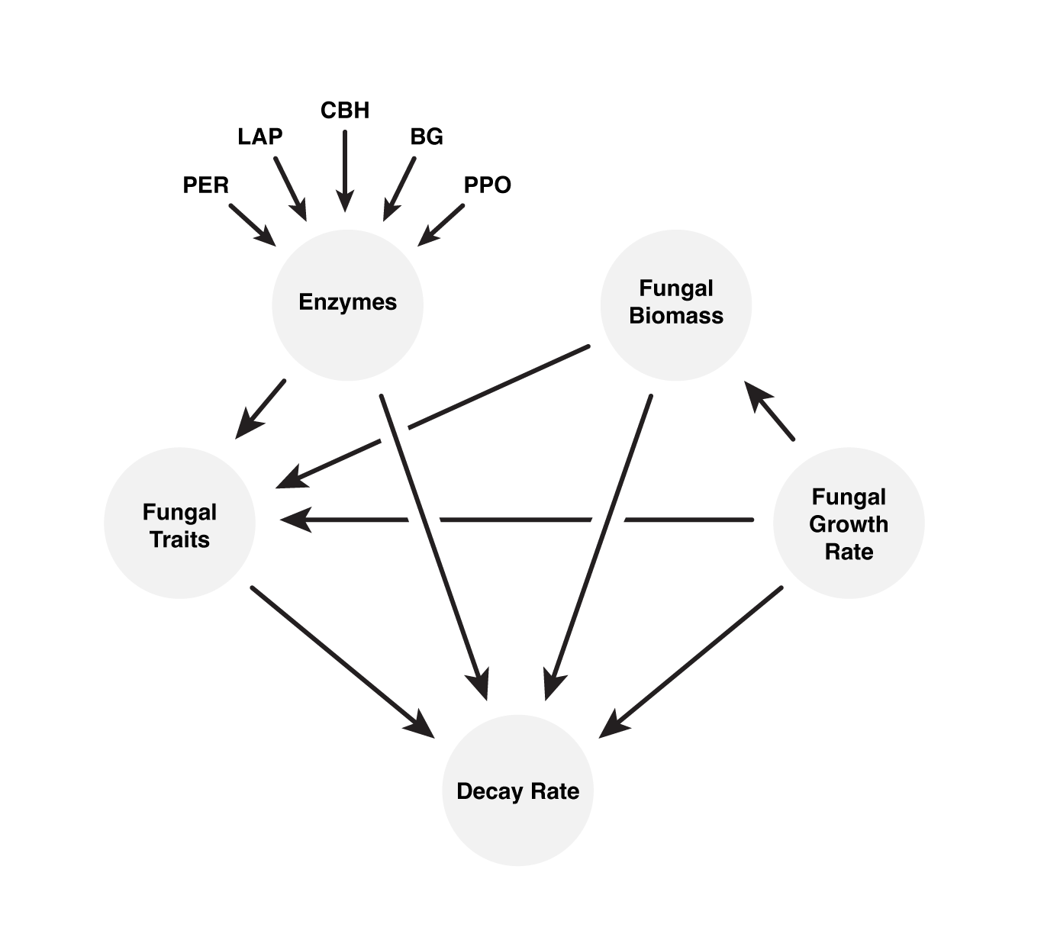

Figure S2. Experiment type (field vs lab) drives decay rates for most plant species. Decay rate was higher in the field than the lab for most plant species (P < 0.0001) except for sugar maple and oak litter which did not significantly differ. Colored boxes represent experiment type [field (pink), lab (blue) while stars denote significant differences based on pairwise comparisons (**** P < 0.0001).
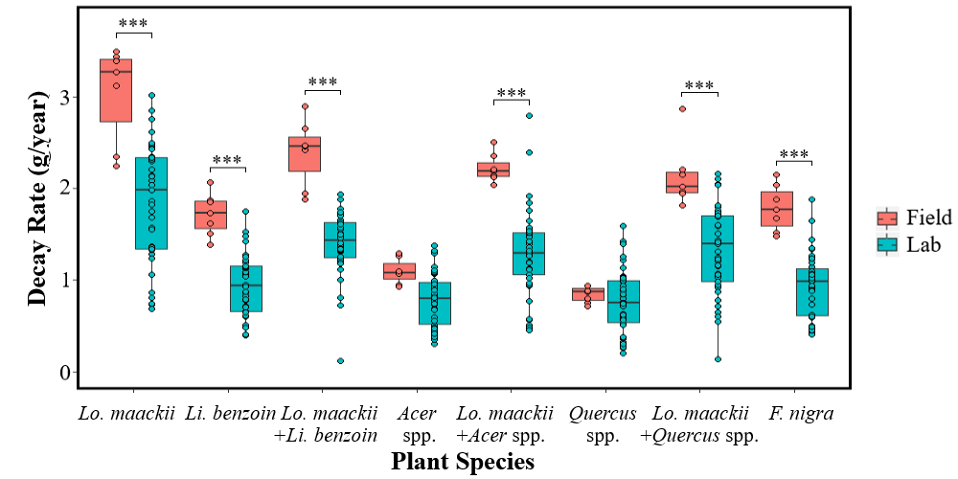

Figure S3. Decay rates increased with increasing polyphenol oxidase (PPO) activity for honeysuckle litter, oak litter, and litter consisting of their mixture (P = 0.0383). Shaded regions represent 95% confidence intervals for honeysuckle (pink), oak (green) and honeysuckle + oak (blue) litter.
