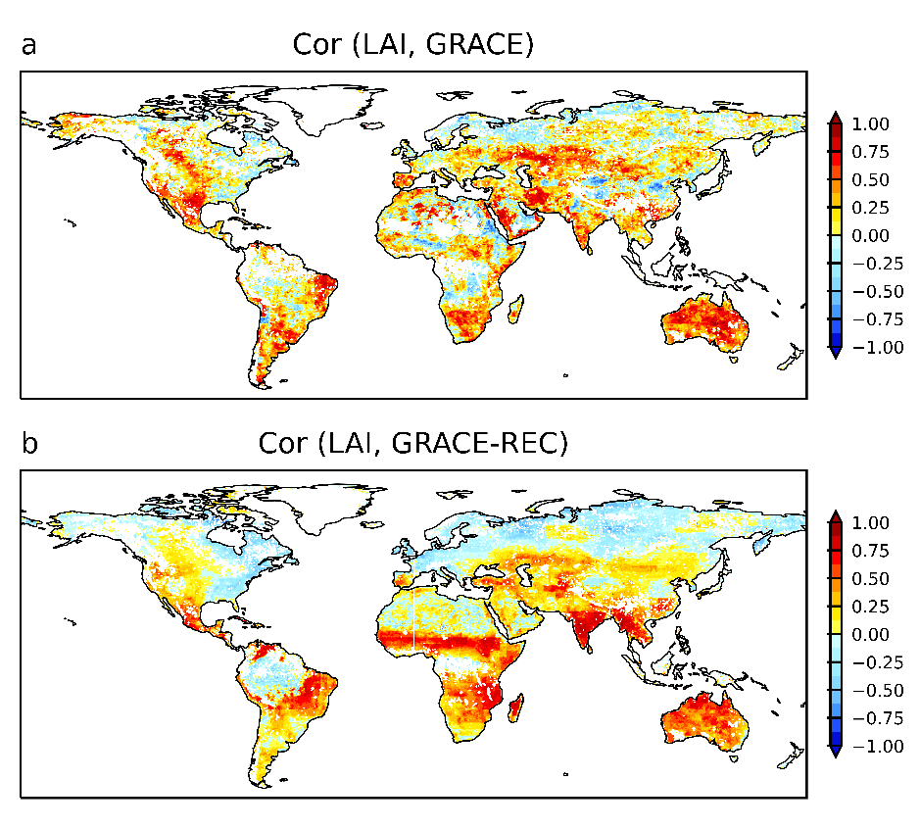
Supplemental Fig 1. Spatial patterns of correlation between monthly terrestrial water storage and leaf area index, (a) for GRACE of 2002-2016 period, (b) for GRACE-REC of 1982-2016 period.

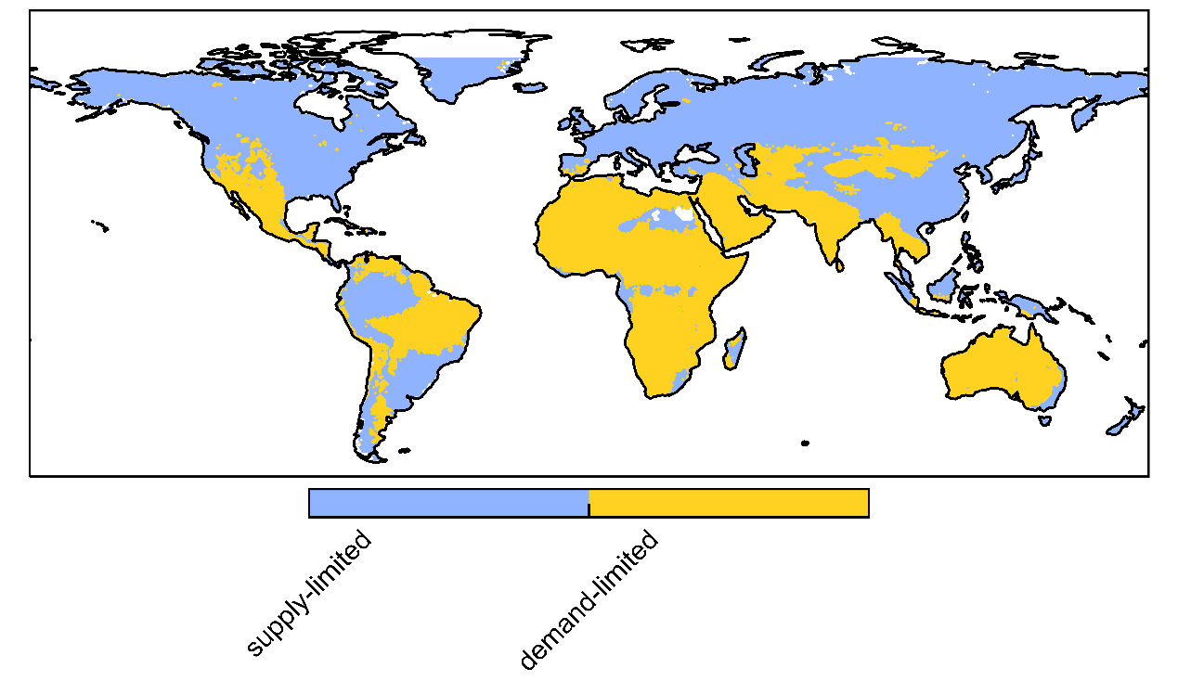

Supplemental Fig 2. Map of demand-limited (blue), supply-limited (yellow) regions.

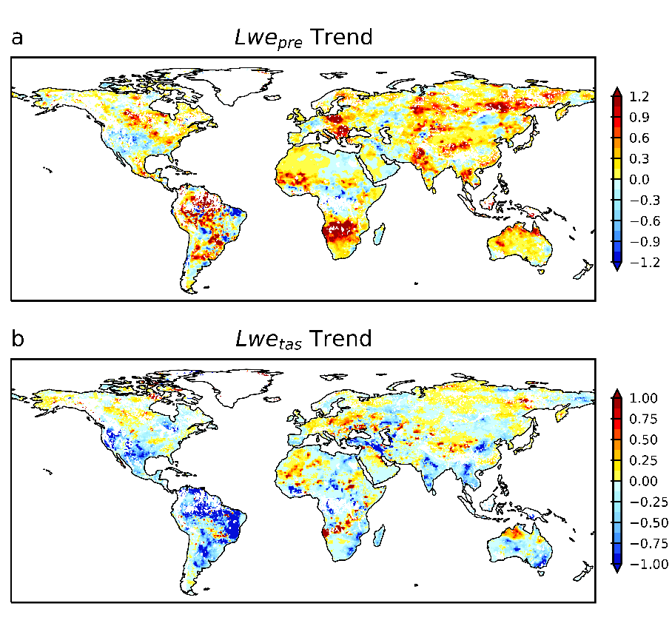
Supplemental Fig 3. Spatial pattern of precipitation-related TWS trend (a), temperature-related TWS trend (b), computed of TWS trend associated with long-term trends in precipitation, temperature, TWS are using GRACE-REC data.

