Supplementary Information
Natural Dihydroisobenzofuran Derivatives as a Template for Promising Radical Scavengers: Theoretical Insights into Structure-Activity Relationships, Thermochemistry and Kinetics
Maciej Spiegel* and Zbigniew Sroka
Department of Pharmacognosy and Herbal Medicines, Wroclaw Medical University, Borowska 211A, 50-556 Wroclaw, Poland

ORCiD: 0000-0002-8012-1026 (Maciej Spiegel)
0000-0001-6618-017X (Zbigniew Sroka)
* Author to whom correspondence should be addressed: Maciej Spiegel
e-mail: maciej.spiegel@student.umed.wroc.pl +48 71 784 02 16

Table of Contents
SMILES Codes: 2
Table S1. Theoretical deprotonation constants, expected dissociation route and distribution diagrams of the investigated species, in water at pH=7.4 2
Table S2. Lewis-type Interactions and Their Energies, Found in M₁ Species Computed in water at pH 7.4 Using Second Order Perturbation Theory Analysis of the Fock Matrix in NBO Basis. Values are restricted to threshold of 10kcal/mol 2
Table S3. Gibbs Free Energies of Reaction (ΔG°) for the •OH, •OCH₃ and •OOH Radical Scavenging Pathways in the Pentyl Ethanoate and Water Solvent by M1 Species, in kcal/mol 3
Table S4. Gibbs Free Energies of Reaction (ΔG°) for the •OH, •OCH₃ and •OOH Radical Scavenging Pathways in the Pentyl Ethanoate and Water Solvent by M2 Species. [kcal/mol] 4
Table S5. Gibbs Free Energies of Reaction (ΔG°) for the •OH, •OCH₃ and •OOH Radical Scavenging Pathways in the Pentyl Ethanoate and Water Solvent by M3 Species. [kcal/mol] 4
Table S6. Activation Energies (ΔG≠, in kcal/mol), Apparent Rate Constants (k_{app}, in 1/M×s), Total Reaction Rate (k_{total}, in 1/M×s), Overall Reaction Rate (k_{overall}, in 1/M×s) and Branching Ratios (Γ, %) at 298.15K for the M1 species. The parentheses provide the molar fraction of each water species. 5
Table S7. Activation Energies (ΔG≠, in kcal/mol), Apparent Rate Constants (k_{app}, in 1/M×s), Total Reaction Rate (k_{total}, in 1/M×s), Overall Reaction Rate (k_{overall}, in 1/M×s) and Branching Ratios (Γ, %) at 298.15K for the M2 species. The parentheses provide the molar fraction of each water species. 6
Table S8. Activation Energies (ΔG≠, in kcal/mol), Apparent Rate Constants (kapp, in 1/M×s), Total Reaction Rate (ktotal, in 1/M×s), Overall Reaction Rate (koverall, in 1/M×s) and Branching Ratios (Γ, %) at 298.15K for the M3 species. The parentheses provide the molar fraction of each water species. 7

SMILES Codes:
M₁: CC1=C(O)C(O)=C(O)C2=C1C(O)OC2=O
M₂: CC1=C(O)C(O)=C(O)C2=C1C(=O)OC2
M₃: COC1=C(O)C2=C(COC2)C(C)=C1O

Table S1. Theoretical deprotonation constants, expected dissociation route and distribution diagrams of the investigated species, in water at pH=7.4
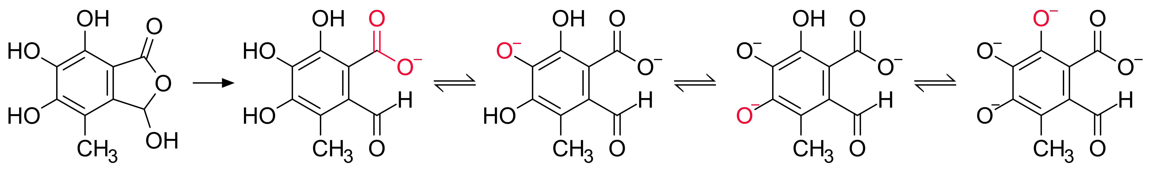 |  |  |  |  |  |  |  |  |  | 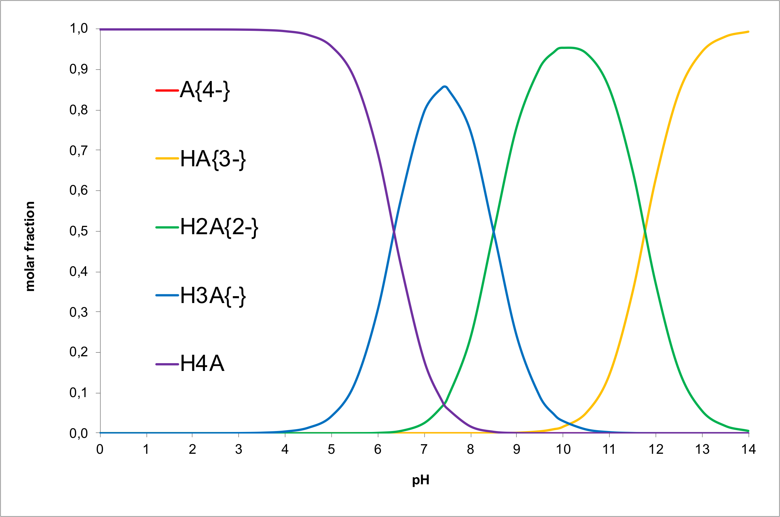
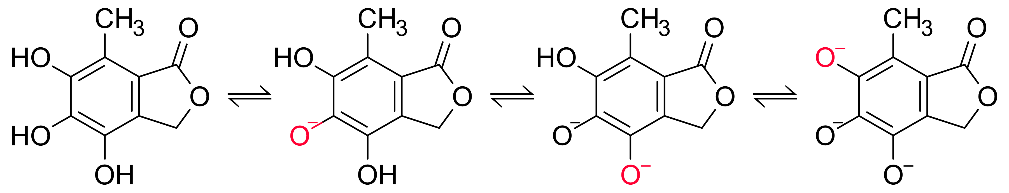 |  |  |  |  |  |  |  |  |  | 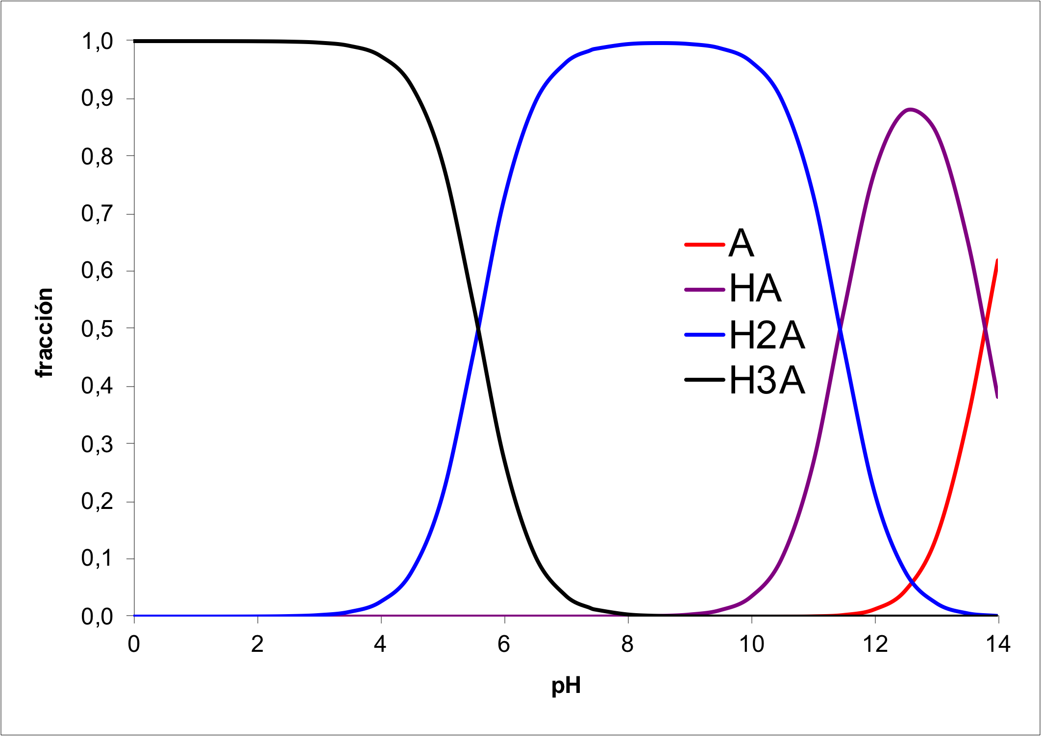
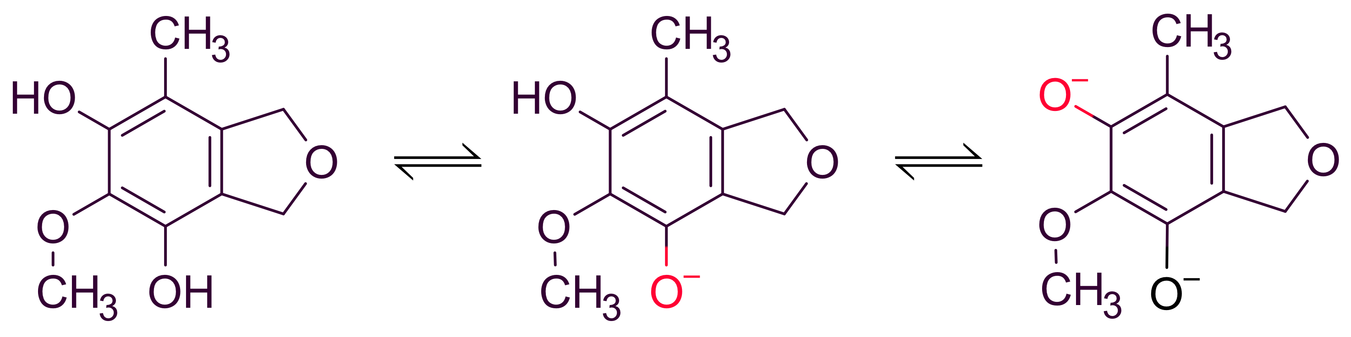 |  |  |  |  |  |  |  |  |  | 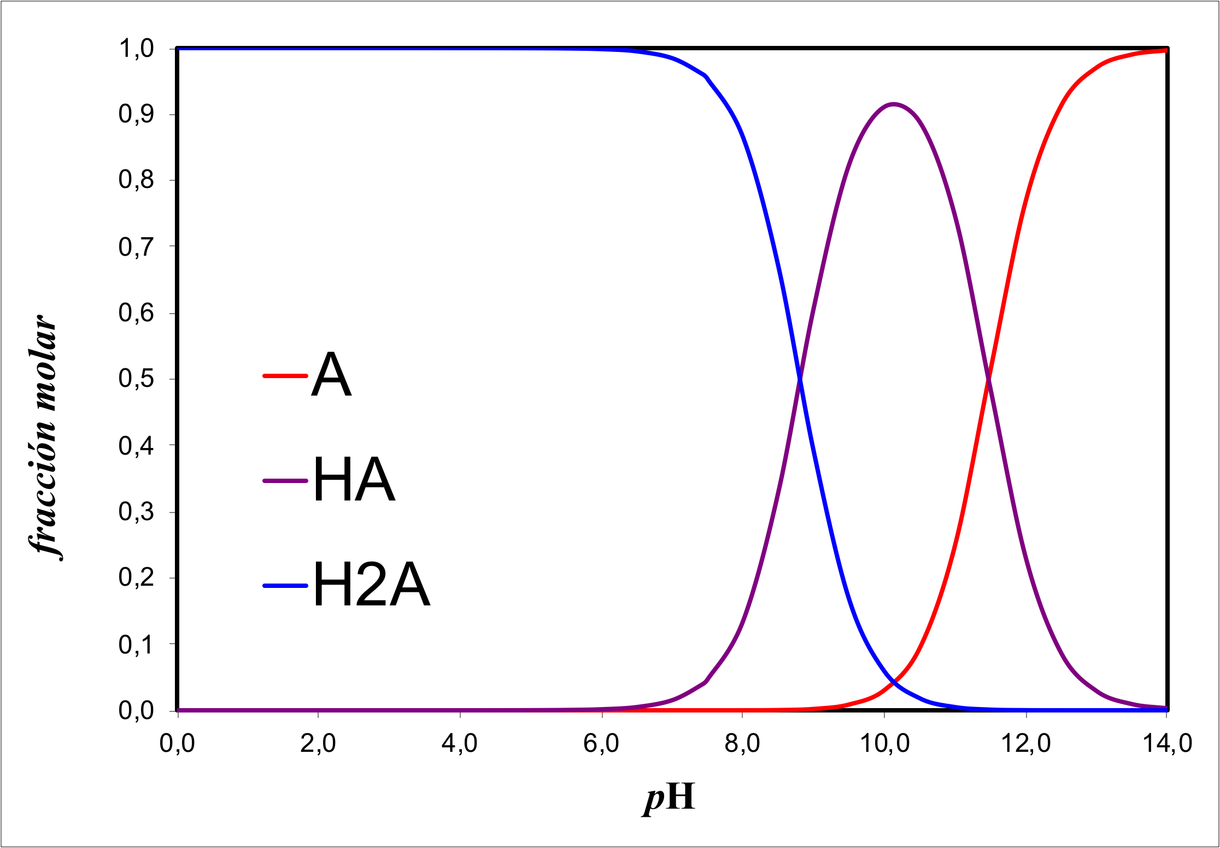
 | ^{M}f | pKa | ^{M}f₁₋ | pKa₁₋ | ^{M}f₂ | pKa₂₋ | ^{M}f₃ | pKa₃₋ | ^{M}f₄
M₁ | 7.8% | 6.36 | 85.5% | 8.50 | 6.7% | 11.77 | 0.0% | 13.53 | 0.0%
M₂ | 1.5% | 5.58 | 98.5% | 11.45 | 0.0% | 13.79 | 0.0%
M₃ | 96.2% | 8.80 | 3.8% | 11.47 | 0.0%

Table S2. Lewis-type Interactions and Their Energies, Found in M₁ Species Computed in water at pH 7.4 Using Second Order Perturbation Theory Analysis of the Fock Matrix in NBO Basis. Values are restricted to threshold of 10kcal/mol
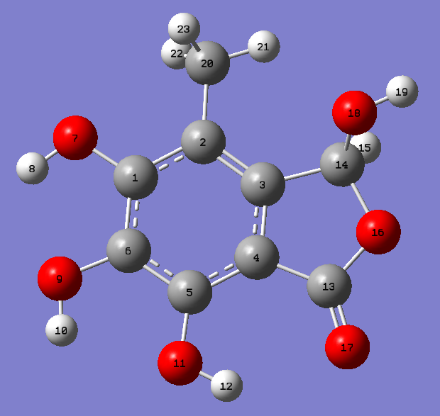 | 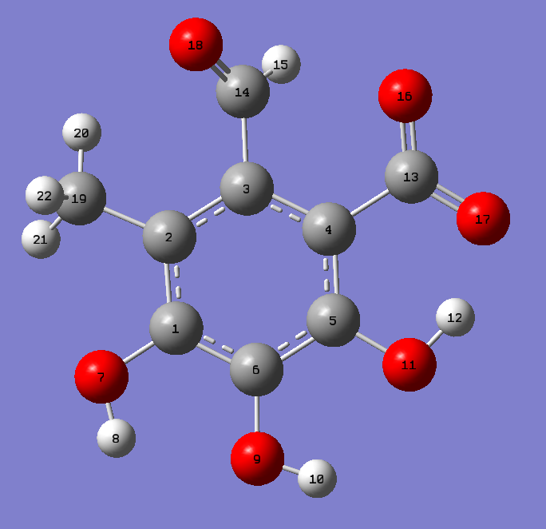 | 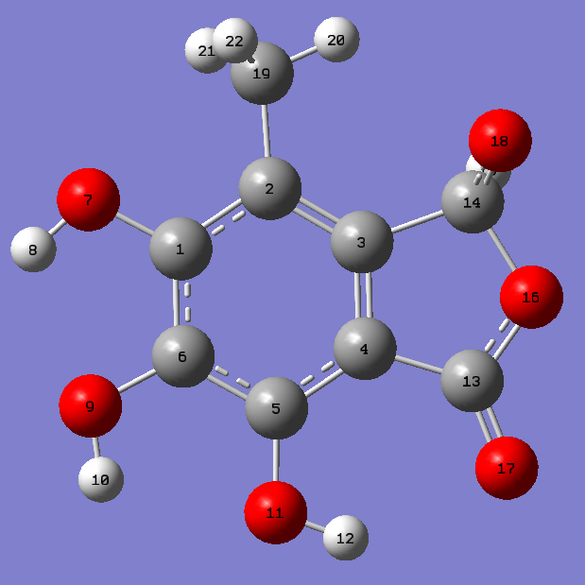
M₁ | M_{1–} | M_{1–frozen}
BD ( 2) C 1 - C 6 /355. BD*( 2) C 2 - C 3 17.99  BD ( 2) C 1 - C 6 /360. BD*( 2) C 4 - C 5 34.39  BD ( 2) C 2 - C 3 /352. BD*( 2) C 1 - C 6 30.15  BD ( 2) C 2 - C 3 /360. BD*( 2) C 4 - C 5 23.89  BD ( 1) C 2 - C 20 /349. RY*( 5) H 23 17.99  BD ( 1) C 2 - C 20 /357. BD*( 1) C 3 - C 4 10.64  11. BD ( 2) C 4 - C 5 /352. BD*( 2) C 1 - C 6 20.88  11. BD ( 2) C 4 - C 5 /370. BD*( 2) C 13 - O 17 29.56  12. BD ( 1) C 4 - C 13 /354. BD*( 1) C 2 - C 3 10.14  12. BD ( 1) C 4 - C 13 /377. BD*( 1) C 20 - H 23 10.78  26. BD ( 1) C 20 - H 21 /349. RY*( 5) H 23 23.81  26. BD ( 1) C 20 - H 21 /377. BD*( 1) C 20 - H 23 11.44  27. BD ( 1) C 20 - H 22 /349. RY*( 5) H 23 43.60  27. BD ( 1) C 20 - H 22 /355. BD*( 2) C 2 - C 3 10.82  27. BD ( 1) C 20 - H 22 /377. BD*( 1) C 20 - H 23 19.40  28. BD ( 1) C 20 - H 23 /349. RY*( 5) H 23 70.36  28. BD ( 1) C 20 - H 23 /377. BD*( 1) C 20 - H 23 37.01  43. CR ( 1) C 20 /348. RY*( 4) H 23 16.15  43. CR ( 1) C 20 /349. RY*( 5) H 23 274.99  43. CR ( 1) C 20 /357. BD*( 1) C 3 - C 4 19.58  43. CR ( 1) C 20 /359. BD*( 1) C 4 - C 5 11.79  43. CR ( 1) C 20 /377. BD*( 1) C 20 - H 23 197.21  45. LP ( 2) O 7 /352. BD*( 2) C 1 - C 6 34.15  47. LP ( 2) O 9 /352. BD*( 2) C 1 - C 6 26.46  49. LP ( 2) O 11 /360. BD*( 2) C 4 - C 5 34.70  51. LP ( 2) O 16 /370. BD*( 2) C 13 - O 17 52.28  52. LP ( 1) O 17 /224. RY*( 1) C 13 18.70  53. LP ( 2) O 17 /361. BD*( 1) C 4 - C 13 18.46  53. LP ( 2) O 17 /368. BD*( 1) C 13 - O 16 37.75  55. LP ( 2) O 18 /372. BD*( 1) C 14 - O 16 20.91  352. BD*( 2) C 1 - C 6 /355. BD*( 2) C 2 - C 3 58.10  355. BD*( 2) C 2 - C 3 /377. BD*( 1) C 20 - H 23 17.62  360. BD*( 2) C 4 - C 5 /355. BD*( 2) C 2 - C 3 51.12 | 3. BD ( 2) C 1 - C 6 / 41. LP ( 1) C 2 52.02  3. BD ( 2) C 1 - C 6 / 42. LP*( 1) C 5 68.55  6. BD ( 1) C 2 - C 19 /346. RY*( 5) H 22 22.37  6. BD ( 1) C 2 - C 19 /351. BD*( 1) C 2 - C 3 10.58  6. BD ( 1) C 2 - C 19 /371. BD*( 1) C 19 - H 22 18.18  8. BD ( 2) C 3 - C 4 / 41. LP ( 1) C 2 55.01  8. BD ( 2) C 3 - C 4 / 42. LP*( 1) C 5 70.26  8. BD ( 2) C 3 - C 4 / 49. LP*( 1) C 13 37.61  23. BD ( 1) C 19 - H 20 /346. RY*( 5) H 22 34.06  23. BD ( 1) C 19 - H 20 /371. BD*( 1) C 19 - H 22 23.73  24. BD ( 1) C 19 - H 21 /346. RY*( 5) H 22 44.68  24. BD ( 1) C 19 - H 21 /351. BD*( 1) C 2 - C 3 16.12  24. BD ( 1) C 19 - H 21 /371. BD*( 1) C 19 - H 22 30.57  25. BD ( 1) C 19 - H 22 /346. RY*( 5) H 22 82.76  25. BD ( 1) C 19 - H 22 /351. BD*( 1) C 2 - C 3 16.46  25. BD ( 1) C 19 - H 22 /353. BD*( 1) C 3 - C 4 12.76  25. BD ( 1) C 19 - H 22 /371. BD*( 1) C 19 - H 22 57.35  40. CR ( 1) C 19 /324. RY*( 10) C 19 14.33  40. CR ( 1) C 19 /325. RY*( 11) C 19 12.31  40. CR ( 1) C 19 /326. RY*( 12) C 19 12.96  40. CR ( 1) C 19 /331. RY*( 17) C 19 12.24  40. CR ( 1) C 19 /345. RY*( 4) H 22 12.60  40. CR ( 1) C 19 /346. RY*( 5) H 22 345.78  40. CR ( 1) C 19 /348. BD*( 1) C 1 - C 6 14.05  40. CR ( 1) C 19 /350. BD*( 1) C 1 - O 7 12.58  40. CR ( 1) C 19 /351. BD*( 1) C 2 - C 3 26.50  40. CR ( 1) C 19 /353. BD*( 1) C 3 - C 4 23.17  40. CR ( 1) C 19 /370. BD*( 1) C 19 - H 21 11.25  40. CR ( 1) C 19 /371. BD*( 1) C 19 - H 22 293.31  41. LP ( 1) C 2 /349. BD*( 2) C 1 - C 6 80.31  41. LP ( 1) C 2 /354. BD*( 2) C 3 - C 4 120.57  42. LP*( 1) C 5 /349. BD*( 2) C 1 - C 6 73.69  42. LP*( 1) C 5 /354. BD*( 2) C 3 - C 4 90.24  44. LP ( 2) O 7 /349. BD*( 2) C 1 - C 6 33.65  46. LP ( 2) O 9 /349. BD*( 2) C 1 - C 6 25.63  48. LP ( 2) O 11 / 42. LP*( 1) C 5 60.53  49. LP*( 1) C 13 /354. BD*( 2) C 3 - C 4 43.09  50. LP ( 1) O 16 /225. RY*( 1) C 13 11.71  51. LP ( 2) O 16 /357. BD*( 1) C 4 - C 13 16.42  51. LP ( 2) O 16 /365. BD*( 1) C 13 - O 17 24.70  52. LP ( 3) O 16 / 49. LP*( 1) C 13 222.41  54. LP ( 2) O 17 /363. BD*( 1) O 11 - H 12 38.57  54. LP ( 2) O 17 /364. BD*( 1) C 13 - O 16 20.30  55. LP ( 3) O 17 / 49. LP*( 1) C 13 170.04  56. LP ( 1) O 18 /242. RY*( 1) C 14 14.49  57. LP ( 2) O 18 /355. BD*( 1) C 3 - C 14 19.44  57. LP ( 2) O 18 /366. BD*( 1) C 14 - H 15 22.46  354. BD*( 2) C 3 - C 4 /368. BD*( 2) C 14 - O 18 24.44 | 3. BD ( 2) C 1 - C 6 /351. BD*( 2) C 2 - C 3 20.54  3. BD ( 2) C 1 - C 6 /356. BD*( 2) C 4 - C 5 34.73  6. BD ( 2) C 2 - C 3 /348. BD*( 2) C 1 - C 6 33.73  6. BD ( 2) C 2 - C 3 /356. BD*( 2) C 4 - C 5 24.43  11. BD ( 2) C 4 - C 5 /348. BD*( 2) C 1 - C 6 21.72  11. BD ( 2) C 4 - C 5 /351. BD*( 2) C 2 - C 3 32.16  11. BD ( 2) C 4 - C 5 /366. BD*( 2) C 13 - O 17 29.76  44. LP ( 2) O 7 /348. BD*( 2) C 1 - C 6 33.24  46. LP ( 2) O 9 /348. BD*( 2) C 1 - C 6 25.24  48. LP ( 2) O 11 /356. BD*( 2) C 4 - C 5 33.21  50. LP ( 2) O 16 /366. BD*( 2) C 13 - O 17 61.94  51. LP ( 1) O 17 /224. RY*( 1) C 13 18.38  52. LP ( 2) O 17 /357. BD*( 1) C 4 - C 13 17.98  52. LP ( 2) O 17 /364. BD*( 1) C 13 - O 16 34.54  53. LP ( 1) O 18 /241. RY*( 1) C 14 12.42  54. LP ( 2) O 18 /354. BD*( 1) C 3 - C 14 11.79  54. LP ( 2) O 18 /367. BD*( 1) C 14 - H 15 14.36  55. LP ( 3) O 18 /368. BD*( 1) C 14 - O 16 34.97  348. BD*( 2) C 1 - C 6 /351. BD*( 2) C 2 - C 3 109.72  356. BD*( 2) C 4 - C 5 /351. BD*( 2) C 2 - C 3 144.02

Table S3. Gibbs Free Energies of Reaction (ΔG°) for the •OH, •OCH₃ and •OOH Radical Scavenging Pathways in the Pentyl Ethanoate and Water Solvent by M1 Species, in kcal/mol
mechanism  position | pentyl ethanoate |  |  |  | water
mechanism  position | M1
mechanism  position | •OH | •OCH3 | •OOH |  | •OH | •OCH3 | •OOH
f-HAT
C3 | -10.1 | 3.2 | 18.1 |  | -15.0 | 3.3 | 22.7
C5 | -27.4 | -14.1 | 0.8 |  | -34.7 | -16.5 | 2.9
C6 | -33.6 | -20.3 | -5.4 |  | -40.4 | -22.2 | -2.8
C7 | -29.3 | -16.0 | -1.1 |  | -37.7 | -19.5 | 0.0
RAF
C3a | -5.3 | 7.3 | 20.7 |  | -12.9 | 4.8 | 16.0
C4 | -1.9 | 11.3 | 25.8 |  | -9.2 | 8.1 | 19.2
C5 | -8.6 | 4.2 | 18.6 |  | -14.9 | 4.1 | 14.6
C6 | -8.7 | 2.7 | 17.8 |  | -14.1 | 2.5 | 14.0
C7 | -8.3 | 3.2 | 17.9 |  | -15.3 | 1.7 | 13.8
C7a | 3.6 | 15.0 | 28.9 |  | -1.9 | 14.8 | 26.0
SET
 | 29.6 | 77.2 | 51.6 |  | 50.7 | 31.2 | 70.1
mechanism  position | water |  |  |  | water
mechanism  position | M1– |  |  |  | M1^{2–}
mechanism  position | •OH | •OCH3 | •OOH |  | •OH | •OCH3 | •OOH
f-HAT
C5 | -37.1 | -18.9 | 0.5 |  | -49.6 | -31.4 | -11.9
C6 | -42.8 | -24.6 | -5.2 |  | — | — | —
C7 | -34.6 | -16.4 | 3.0 |  | -47.7 | -29.5 | -10.0
RAF
C3a | -16.7 | 3.3 | 13.6 |  | -22.5 | -2.4 | 6.4
C4 | -18.4 | -0.8 | 7.6 |  | -15.3 | 3.3 | 12.4
C5 | -14.7 | 3.3 | 14.5 |  | -21.0 | -4.3 | 5.8
C6 | -19.5 | -5.6 | 9.2 |  | -15.3 | 1.3 | 9.7
C7 | -11.7 | 4.9 | 15.4 |  | -20.0 | -2.5 | 7.0
C7a | -15.5 | 5.4 | 12.9 |  | -17.3 | 3.3 | 12.0
SET
 | 33.3 | 13.7 | 52.7 |  | 14.5 | -5.0 | 33.9

Table S4. Gibbs Free Energies of Reaction (ΔG°) for the •OH, •OCH₃ and •OOH Radical Scavenging Pathways in the Pentyl Ethanoate and Water Solvent by M2 Species. [kcal/mol]
mechanism  position | pentyl ethanoate |  |  |  | water
mechanism  position | M2
mechanism  position | •OH | •OCH3 | •OOH |  | •OH | •OCH3 | •OOH
f-HAT
C4 | -38.4 | -25.1 | -10.3 |  | -41.8 | -23.5 | -4.1
C5 | -40.7 | -27.4 | -12.5 |  | -43.1 | -24.9 | -5.5
C6 | -37.6 | -24.3 | -9.4 |  | -41.4 | -23.2 | -3.8
RAF
C3a | -5.3 | 6.2 | 20.5 |  | -13.3 | 3.9 | 14.9
C4 | -11.2 | 1.1 | 14.6 |  | -15.6 | 1.8 | 14.6
C5 | -13.5 | -0.3 | 12.2 |  | -18.0 | -1.3 | 10.9
C6 | -9.1 | 3.7 | 16.6 |  | -13.9 | 3.2 | 16.2
C7 | -8.9 | 4.2 | 18.5 |  | -17.2 | 0.1 | 12.0
C7a | 0.3 | 12.6 | 29.2 |  | -3.3 | 15.0 | 26.2
SET
 | 26.5 | 74.1 | 48.5 |  | 48.9 | 29.3 | 68.3
mechanism  position | water
mechanism  position | M2–
mechanism  position | •OH | •OCH3 | •OOH
f-HAT
C4 | -46.3 | -28.1 | -8.7
C6 | -45.7 | -27.5 | -8.1
RAF
C3a | -9.1 | 7.4 | 16.7
C4 | -17.4 | 0.6 | 10.9
C5 | -10.4 | 5.5 | 15.1
C6 | -15.4 | 1.4 | 11.5
C7 | -13.3 | 4.3 | 13.6
C7a | -5.2 | 11.8 | 21.6
SET
 | 24.0 | 4.5 | 43.4

Table S5. Gibbs Free Energies of Reaction (ΔG°) for the •OH, •OCH₃ and •OOH Radical Scavenging Pathways in the Pentyl Ethanoate and Water Solvent by M3 Species. [kcal/mol]
mechanism  position | pentyl ethanoate |  |  |  | water
mechanism  position | M3
mechanism  position | •OH | •OCH3 | •OOH |  | •OH | •OCH3 | •OOH
f-HAT
C4 | -34.7 | -21.4 | -6.5 |  | -39.7 | -21.5 | -2.0
C6 | -29.8 | -16.5 | -1.6 |  | -38.5 | -20.3 | -0.9
RAF
C3a | -6.4 | 7.6 | 18.1 |  | -10.5 | 5.7 | 15.0
C4 | -11.2 | 2.6 | 17.7 |  | -13.7 | 3.2 | 14.2
C5 | -15.8 | -1.2 | 16.1 |  | -20.7 | -2.1 | 10.9
C6 | -8.5 | 5.8 | 19.2 |  | -14.7 | 5.3 | 16.1
C7 | -5.6 | 9.2 | 20.7 |  | -11.3 | 6.4 | 16.3
C7a | -4.5 | 8.0 | 21.1 |  | -9.7 | 6.9 | 16.9
SET
 | 13.8 | 61.4 | 35.9 |  | 44.1 | 24.6 | 63.5
mechanism  position | water
mechanism  position | M3–
mechanism  position | •OH | •OCH3 | •OOH
f-HAT
C6 | -44.3 | -26.1 | -6.7
RAF
C3a | -15.2 | 1.4 | 10.5
C4 | -7.7 | 9.4 | 18.2
C5 | -24.5 | -5.3 | 3.0
C6 | -13.4 | 5.9 | 15.1
C7 | -14.2 | 3.6 | 11.9
C7a | -9.5 | 8.0 | 16.3
SET
 | 16.7 | -2.8 | 36.1

Table S6. Activation Energies (ΔG≠, in kcal/mol), Apparent Rate Constants (k_{app}, in 1/M×s), Total Reaction Rate (k_{total}, in 1/M×s), Overall Reaction Rate (k_{overall}, in 1/M×s) and Branching Ratios (Γ, %) at 298.15K for the M1 species. The parentheses provide the molar fraction of each water species.
mechanism |  | •OCH₃ |  |  |  |  |  | •OH |  |  |  |  |  | •OOH
 |  | pentyl ethanoate |  |  | water |  |  | pentyl ethanoate |  |  | water |  |  | pentyl ethanoate |  |  | water
 |  | ΔG≠ | k_{app} | Γ | ΔG≠ | k_{app} | Γ | ΔG≠ | k_{app} | Γ | ΔG≠ | k_{app} | Γ | ΔG≠ | k_{app} | Γ | ΔG≠ | k_{app} | Γ
M1 (7.8%)
f–HAT | C3 | 18.9 | 2.21×10¹ | 0.0 | 0ª | 2.59×10⁹ | 25.0 | 14.2 | 3.65×10⁴ | 0.0 | 0ª | 2.93×10⁹ | 14.4
f–HAT | C5 | 15.2 | 1.10×10³ | 0.1 | 0ª | 2.59×10⁹ | 25.0 | 12.8 | 1.40×10⁵ | 0.0 | 0ª | 2.93×10⁹ | 14.4 | 24.2 | 2.59×10^{–3} | 0.0 | 0ª | 2.75×10⁹ | 33.3
f–HAT | C6 | 11.3 | 7.92×10⁵ | 99.2 | 0ª | 2.59×10⁹ | 25.0 | 0ª | 2.93×10⁹ | 99.6 | 0ª | 2.93×10⁹ | 14.4 | 21.8 | 9.37×10⁰ | 99.8 | 0ª | 2.75×10⁹ | 33.3
f–HAT | C7 | 14.3 | 5.01×10³ | 0.6 | 0ª | 2.59×10⁹ | 25.0 | 13.8 | 2.11×10⁵ | 0.0 | 0ª | 2.93×10⁹ | 14.4 | 26.5 | 1.41×10^{–2} | 0.2 | 0ª | 2.75×10⁹ | 33.3
RAF | C3a | 22.2 | 1.12×10^{–2} | 0.0 | 20.0 | 4.29×10^{–1} | 0.0 | 12.7 | 8.05×10⁴ | 0.0 | 6.1 | 1.64×10⁹ | 8.1
RAF | C4 |  |  |  | 19.7 | 6.95×10^{–1} | 0.0 | 13.5 | 2.24×10⁴ | 0.0 | 6.6 | 1.15×10⁹ | 5.7
RAF | C5 | 28.1 | 4.30×10^{–7} | 0.0 | 19.2 | 1.67×10⁰ | 0.0 | 13.1 | 4.25×10⁴ | 0.0 | 5.6 | 2.01×10⁹ | 9.9
RAF | C6 | 15.9 | 3.36×10² | 0.0 | 17.1 | 4.44×10¹ | 0.0 | 9.7 | 1.17×10⁷ | 0.4 | 2.7 | 2.60×10⁹ | 12.8
RAF | C7 | 21.3 | 5.30×10^{–2} | 0.0 | 18.6 | 4.45×10⁰ | 0.0 | 12.5 | 1.15×10⁵ | 0.0 | 7.2 | 6.10×10⁸ | 3.0
RAF | C7a |  |  |  |  |  |  | 13.0 | 4.94×10 ⁴ | 0.0 | 6.5 | 5.80×10⁸ | 2.9
k_{total} |  |  | 7.98×10⁵ |  |  | 1.04×10¹⁰ |  |  | 2.94×10⁹ |  |  | 2.03×10¹⁰ |  |  | 9.39×10⁰ |  |  | 8.26×10⁹
M1– (85.5%)
f–HAT | C5 |  |  |  | 14.0 | 8.31×10³ | 0.0 |  |  |  | 0ª | 2.96×10⁹ | 12.1 |  |  |  | 7.9 | 7.34×10² | 0.0
f–HAT | C6 |  |  |  | 0ª | 2.62×10⁹ | 100.0 |  |  |  | 0ª | 2.96×10⁹ | 12.1 |  |  |  | 4.7 | 9.71×10⁴ | 0.0
f–HAT | C7 |  |  |  | 16.4 | 1.50×10² | 0.0 |  |  |  | 0ª | 2.96×10⁹ | 12.1 |  |  |  | 0ª | 2.78×10⁹ | 100.0
RAF | C3a |  |  |  | 15.5 | 6.61×10² | 0.0 |  |  |  | 5.0 | 2.31×10⁹ | 9.5
RAF | C4 |  |  |  | 17.7 | 1.47×10¹ | 0.0 |  |  |  | 4.4 | 2.90×10⁹ | 11.9 |  |  |  | 21.4 | 3.82×10^{–2} | 0.0
RAF | C5 |  |  |  | 18.1 | 8.21×10^{–1} | 0.0 |  |  |  | 4.8 | 2.44×10⁹ | 10.0
RAF | C6 |  |  |  | 13.0 | 4.49×10⁴ | 0.0 |  |  |  | 1.6 | 2.82×10⁹ | 11.6 |  |  |  | 18.4 | 6.38×10⁰ | 0.0
RAF | C7 |  |  |  | 17.7 | 1.90×10¹ | 0.0 |  |  |  | 4.4 | 2.41×10⁹ | 9.9
RAF | C7a |  |  |  | 16.3 | 1.71×10² | 0.0 |  |  |  | 2.4 | 2.63×10⁹ | 10.8
k_{total} |  |  |  |  |  | 2.62×10⁹ |  |  |  |  |  | 2.44×10¹⁰ |  |  |  |  |  | 2.78×10⁹
M1^{2–} (6.7%)
f–HAT | C5 |  |  |  | 0ª | 2.63×10⁹ | 16.4 |  |  |  | 0ª | 2.97×10⁹ | 14.2 |  |  |  | 0ª | 2.79×10⁹ | 50.0
f–HAT | C7 |  |  |  | 0ª | 2.63×10⁹ | 16.4 |  |  |  | 0ª | 2.97×10⁹ | 14.2 |  |  |  | 0ª | 2.79×10⁹ | 50.0
RAF | C3a |  |  |  | 0ª | 2.02×10⁹ | 12.6 |  |  |  | 0ª | 2.56×10⁹ | 12.2 |  |  |  | 13.6 | 1.66×10⁴ | 0.0
RAF | C4 |  |  |  | 16.3 | 1.71×10² | 0.0 |  |  |  | 2.5 | 2.35×10⁹ | 11.2
RAF | C5 |  |  |  | 7.4 | 4.46×10⁸ | 2.8 |  |  |  | 0ª | 2.41×10⁹ | 11.5 |  |  |  | 11.3 | 8.86×10⁵ | 0.0
RAF | C6 |  |  |  | 7.9 | 2.19×10⁸ | 1.4 |  |  |  | 0ª | 2.32×10⁹ | 11.1 |  |  |  | 11.4 | 7.29×10⁵ | 0.0
RAF | C7 |  |  |  | 7.4 | 4.46×10⁸ | 2.8 |  |  |  | 0ª | 2.38×10⁹ | 11.4 |  |  |  | 11.9 | 3.16×10⁵ | 0.0
RAF | C7a |  |  |  | 12.6 | 8.82×10⁴ | 0.0 |  |  |  | 0ª | 2.97×10⁹ | 14.2
SET |  |  |  |  | 0.6 | 7.69×10⁹ | 47.8
k_{total} |  |  |  |  |  | 1.61×10¹⁰ |  |  |  |  |  | 2.09×10¹⁰ |  |  |  |  |  | 5.58×10⁹
k_{overall} |  | 7.98×10⁵ |  |  | 4.13×10⁹ |  |  | 2.94×10⁹ |  |  | 2.38×10¹⁰ |  |  | 9.39×10⁰ |  |  | 3.39×10⁹
ª the reaction has been found to be barrierless (explanation in the main text).

Table S7. Activation Energies (ΔG≠, in kcal/mol), Apparent Rate Constants (k_{app}, in 1/M×s), Total Reaction Rate (k_{total}, in 1/M×s), Overall Reaction Rate (k_{overall}, in 1/M×s) and Branching Ratios (Γ, %) at 298.15K for the M2 species. The parentheses provide the molar fraction of each water species.
mechanism |  | •OCH₃ |  |  |  |  |  | •OH |  |  |  |  |  | •OOH
 |  | pentyl ethanoate |  |  | water |  |  | pentyl ethanoate |  |  | water |  |  | pentyl ethanoate |  |  | water
 |  | ΔG≠ | k_{app} | Γ | ΔG≠ | k_{app} | Γ | ΔG≠ | k_{app} | Γ | ΔG≠ | k_{app} | Γ | ΔG≠ | k_{app} | Γ | ΔG≠ | k_{app} | Γ
M2 (1.5%)
f–HAT | C4 | 7.4 | 4.65×10⁸ | 37.4 | 9.9 | 8.38×10⁶ | 15.4 | 7.5 | 4.13×10⁸ | 15.0 | 0ª | 2.61×10⁹ | 11.6 | 18.7 | 5.15×10² | 34.5 | 0ª | 2.78×10⁹ | 50.0
f–HAT | C5 | 7.0 | 7.77×10⁸ | 62.5 | 9.6 | 1.39×10⁷ | 25.6 | 8.5 | 8.67×10⁷ | 3.1 | 0ª | 2.61×10⁹ | 11.6 | 18.8 | 5.60×10² | 37.5 | 0ª | 2.78×10⁹ | 50.0
f–HAT | C6 | 13.3 | 2.71×10⁴ | 0.0 | 9.1 | 3.20×10⁷ | 58.9 | 6.5 | 1.36×10⁹ | 49.3 | 0ª | 2.61×10⁹ | 11.6 | 18.8 | 4.19×10² | 28.0 | 13.6 | 6.07×10⁵ | 0.0
RAF | C3a | 21.2 | 5.79×10^{–2} | 0.0 | 17.1 | 4.88×10⁰ | 0.0 | 13.5 | 2.16×10⁴ | 0.0 | 5.3 | 2.26×10⁹ | 10.1
RAF | C4 | 19.0 | 2.35×10⁰ | 0.0 | 13.0 | 4.49×10⁴ | 0.1 | 10.7 | 2.18×10⁶ | 0.1 | 4.2 | 2.43×10⁹ | 10.8
RAF | C5 | 11.7 | 4.03×10⁵ | 0.0 | 16.4 | 1.45×10² | 0.0 | 6.9 | 8.80×10⁸ | 31.9 | 2.5 | 2.53×10⁹ | 11.3
RAF | C6 | 18.8 | 3.32×10⁰ | 0.0 | 17.0 | 5.25×10¹ | 0.0 | 9.6 | 1.39×10⁷ | 0.5 | 2.6 | 2.56×10⁹ | 11.4
RAF | C7 | 21.0 | 8.17×10^{–2} | 0.0 | 17.0 | 5.25×10¹ | 0.0 | 12.2 | 3.64×10⁴ | 0.0 | 3.8 | 2.67×10⁹ | 11.9
RAF | C7a |  |  |  |  |  |  | 11.8 | 3.40×10⁵ | 0.0 | 4.6 | 2.19×10⁹ | 9.7
k_{total} |  |  | 1.24×10⁹ |  |  | 5.43×10⁷ |  |  | 2.76×10⁹ |  |  | 2.25×10¹⁰ |  |  | 1.49×10³ |  |  | 5.56×10⁹
M2– (98.5%)
f–HAT | C4 |  |  |  | 0ª | 2.61×10⁹ | 36.6 |  |  |  | 0ª | 2.95×10⁹ | 14.5 |  |  |  | 0ª | 2.78×10⁹ | 50.0
f–HAT | C6 |  |  |  | 0ª | 2.61×10⁹ | 36.6 |  |  |  | 0ª | 2.95×10⁹ | 14.5 |  |  |  | 0ª | 2.78×10⁹ | 50.0
RAF | C3a |  |  |  | 17.3 | 3.69×10¹ | 0.0 |  |  |  | 4.3 | 2.30×10⁹ | 11.3
RAF | C4 |  |  |  | 10.5 | 3.32×10⁶ | 0.0 |  |  |  | 0ª | 2.63×10⁹ | 12.9
RAF | C5 |  |  |  | 11.1 | 1.20×10⁶ | 0.0 |  |  |  | 0ª | 2.33×10⁹ | 11.4
RAF | C6 |  |  |  | 11.1 | 1.19×10⁶ | 0.0 |  |  |  | 0ª | 2.63×10⁹ | 12.9
RAF | C7 |  |  |  | 16.1 | 2.74×10² | 0.0 |  |  |  | 2.9 | 2.40×10⁹ | 11.8
RAF | C7a |  |  |  |  |  |  |  |  |  | 0ª | 2.20×10⁹ | 10.8
SET |  |  |  |  | 4.6 | 1.91×10⁹ | 26.8
k_{total} |  |  |  |  |  | 7.14×10⁹ |  |  |  |  |  | 2.04×10¹⁰ |  |  |  |  |  | 5.56×10⁹
k_{overall} |  | 1.24×10⁹ |  |  | 7.03×10⁹ |  |  | 2.76×10⁹ |  |  | 2.04×10¹⁰ |  |  | 1.49×10³ |  |  | 5.56×10⁹
ª the reaction has been found to be barrierless (explanation in the main text).

Table S8. Activation Energies (ΔG≠, in kcal/mol), Apparent Rate Constants (kapp, in 1/M×s), Total Reaction Rate (ktotal, in 1/M×s), Overall Reaction Rate (koverall, in 1/M×s) and Branching Ratios (Γ, %) at 298.15K for the M3 species. The parentheses provide the molar fraction of each water species.
mechanism |  | •OCH₃ |  |  |  |  |  | •OH |  |  |  |  |  | •OOH
 |  | pentyl ethanoate |  |  | water |  |  | pentyl ethanoate |  |  | water |  |  | pentyl ethanoate |  |  | water
 |  | ΔG≠ | k_{app} | Γ | ΔG≠ | k_{app} | Γ | ΔG≠ | k_{app} | Γ | ΔG≠ | k_{app} | Γ | ΔG≠ | k_{app} | Γ | ΔG≠ | k_{app} | Γ
M3 (96.2%)
f–HAT | C4 | 12.7 | 1.65×10⁶ | 85.8 | 0ª | 2.57×10⁹ | 100.0 | 12.0 | 3.55×10⁵ | 0.1 | 6.9 | 1.02×10⁹ | 5.3 | 17.9 | 5.42×10¹ | 87.0 | 16.0 | 2.11×10⁴ | 94.9
f–HAT | C6 | 12.9 | 2.78×10⁵ | 14.2 | 13.0 | 7.31×10⁴ | 0.0 | 9.9 | 5.44×10⁸ | 92.5 | 0ª | 2.91×10⁹ | 15.3 | 19.4 | 8.10×10⁰ | 13.0 | 17.8 | 1.13×10³ | 5.1
RAF | C3a | 19.6 | 7.82×10^{–1} | 0.0 | 15.9 | 3.83×10² | 0.0 | 9.3 | 2.34×10⁷ | 4.0 | 1.8 | 2.67×10⁹ | 14.0
RAF | C5 | 21.4 | 4.02×10^{–2} | 0.0 | 19.2 | 1.63×10⁰ | 0.0 | 10.2 | 5.64×10⁶ | 1.0 | 5.4 | 2.11×10⁹ | 11.1
RAF | C5 | 18.8 | 3.09×10⁰ | 0.0 | 12.5 | 1.14×10⁵ | 0.0 | 10.3 | 4.61×10⁶ | 0.8 | 1.7 | 2.65×10⁹ | 13.9
RAF | C6 | 21.1 | 6.54×10^{–2} | 0.0 | 18.0 | 1.15×10¹ | 0.0 | 10.5 | 3.26×10⁶ | 0.6 | 3.5 | 2.68×10⁹ | 14.1
RAF | C7 | 20.6 | 1.47×10^{–1} | 0.0 | 16.6 | 1.18×10² | 0.0 | 10.1 | 6.24×10⁶ | 1.1 | 1.6 | 2.65×10⁹ | 13.9
RAF | C7a | 21.8 | 2.07×10^{–2} | 0.0 | 19.0 | 2.26×10⁰ | 0.0 | 11.5 | 6.35 ×10⁵ | 0.1 | 4.2 | 2.38×10⁹ | 12.5
k_{total} |  |  | 1.96×10⁶ |  |  | 2.57×10⁹ |  |  | 5.88×10⁸ |  |  | 1.91×10¹⁰ |  |  | 6.23×10¹ |  |  | 2.22×10⁴
M3– (3.8%)
f–HAT | C6 |  |  |  | 0ª | 2.59×10⁹ | 22.3 |  |  |  | 0ª | 2.93×10⁹ | 17.3 |  |  |  | 0ª | 2.78×10⁹ | 100.0
RAF | C3a |  |  |  | 8.2 | 1.48×10⁸ | 1.3 |  |  |  | 0ª | 2.34×10⁹ | 13.8
RAF | C5 |  |  |  | 12.8 | 6.89×10⁴ | 0.0 |  |  |  | 0ª | 2.19×10⁹ | 12.9
RAF | C5 |  |  |  | 6.6 | 1.07×10⁹ | 9.2 |  |  |  | 0ª | 2.65×10⁹ | 15.6 |  |  |  | 12.0 | 2.65×10⁵ | 0.0
RAF | C6 |  |  |  | 16.0 | 3.21×10² | 0.0 |  |  |  | 0ª | 2.29×10⁹ | 13.5
RAF | C7 |  |  |  | 8.8 | 5.54×10⁷ | 0.5 |  |  |  | 0ª | 2.24×10⁹ | 13.2
RAF | C7a |  |  |  | 17.2 | 5.62×10⁰ | 0.0 |  |  |  | 1.7 | 2.31×10⁹ | 13.6
SET |  |  |  |  | 0.0 | 7.76×10⁹ | 66.8
k_{total} |  |  |  |  |  | 1.16×10¹⁰ |  |  |  |  |  | 1.70×10¹⁰ |  |  |  |  |  | 2.78×10⁹
k_{overall} |  | 1.96×10⁶ |  |  | 2.91×10⁹ |  |  | 5.88×10⁸ |  |  | 1.90×10¹⁰ |  |  | 6.23×10¹ |  |  | 1.05×10⁸
ª the reaction has been found to be barrierless (explanation in the main text).

