Bio-Composite Materials of Porous Hydroxyapatite and Collagen from Eggshell Membrane and Oreochromis niloticus Fish Skin as Tissue Engineering
Nutchaya Ingwattanapokª, Yosita Sakunrakª, Nuchnapa Tangboriboon^{a*}
^{a*} Materials Engineering Department, Faculty of Engineering, Kasetsart University, Bangkok, 10900,
Thailand

Graphical Abstract
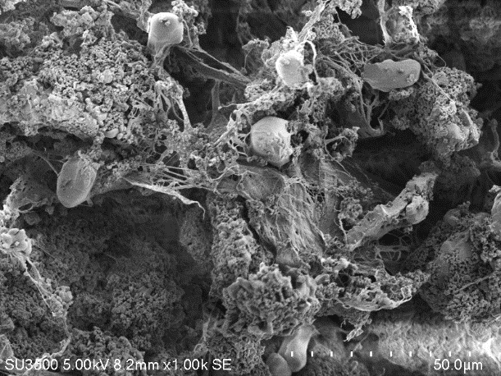
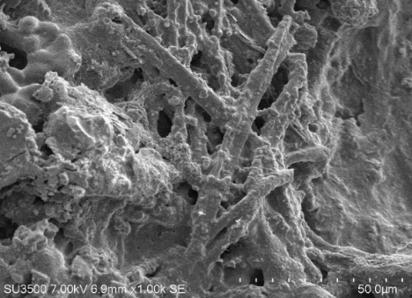
1000×
50 μm
1000×
50 μm

HA in collagen from fish skin
HA in collagen from eggshell

