Supporting Information
Highly Transparent Ultrahigh-Molecular-Weight Polyethylene/MXene Films with Efficient UV Absorption for Light Conversion and Energy Savings
Xianhu Liu^{1,2,5}, Xin Zhang^{1,5}, Zhengui Zhou^{3,5}, Wenrui Zhang^{1,5}, Chunfeng Wang^{2,4}, Yamin Pan^{1,*}, Bin Hu^{3,*}, Chuntai Liu^{1, *}, Caofeng Pan^{2,*}, Changyu Shen¹
¹ National Engineering Research Center for Advanced Polymer Processing Technology, College of Materials Science and Engineering, Key Laboratory of Advanced Material Processing & Mold (Ministry of Education), Zhengzhou University, Zhengzhou, 450002, P. R. China
² Beijing Institute of Nanoenergy and Nanosystems, Chinese Academy of Sciences, Beijing 100140, P. R. China
³ Wuhan National Laboratory for Optoelectronics, Huazhong University of Science and Technology, Wuhan 430074, P. R. China
⁴ College of Physics and Optoelectronic Engineering, Shenzhen University, Shenzhen 518060, P. R. China

Supplementary Note 1. Detailed steps for the measurement of Haze
Haze is the percentage of the intensity of transmitted light deviated from the incident light at an angle of 2.5° or above in the total transmitted light intensity. The greater the haze means that the film luster and transparency decrease. According to this principle, four-step method was used to measure the film haze. The first step is to correct the background by placing a white plate in the reflectance port; the second step is to place the film at the transmission port while keeping the position of the white plate unchanged to measure the total luminous transmittance; the third step is to remove the white plate and measure the light scattering rate of the sample and instrument; finally, the film and the white plate are removed to obtain the scattering of the instrument. The haze of the film can be obtained by calculation of the value obtained from the above four steps. The whole testing process and data processing are carried out by the machine to eliminate external interference. A concise step-by-step description of the measurement is summarized in Table 2.

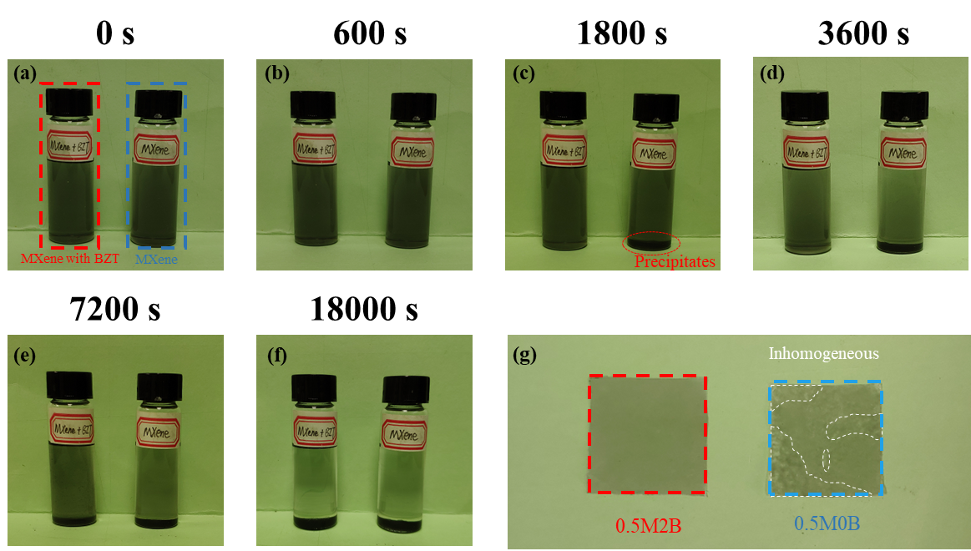
Supplementary Fig. 1 Dispersion of MXene with or without BZT. (a)-(f) Photographs of dispersion of MXene alone (right) in xylene and after addition of BZT (left). (g) Photograph of the composite film before compression of 0.5M2B and 0.5M0B.

Supplementary Fig. 2 FTIR spectra of UHMWPE film with 0.3 wt.% MXene and different contents of BZT.

Supplementary Fig. 3 The DTG curves of UHMWPE and MXene@BZT/UHMWPE films with 2 wt.% BZT and different contents of MXene.

Supplementary Fig. 4 Thermal stability of films with 0.3 wt.% MXene and different contents of BZT. The TGA (a) and DTG (b) curves of UHMWPE and composite films with 0.3 wt.% MXene and different contents of BZT.

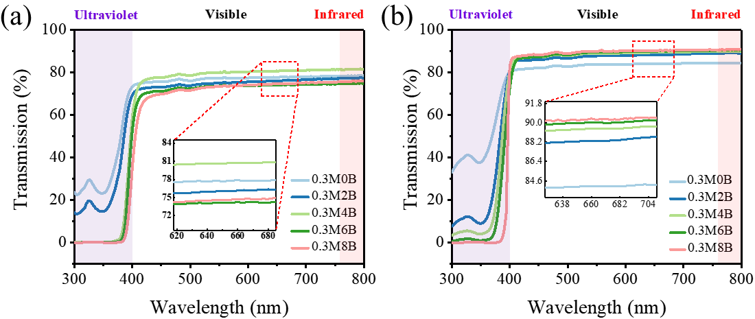
Supplementary Fig. 5 Optical properties of films with 0.3 wt.% MXene and different contents of BZT. Transmission spectra of composite films with 0.3 wt.% MXene and different contents of BZT before (a) and after (b) being pressed.

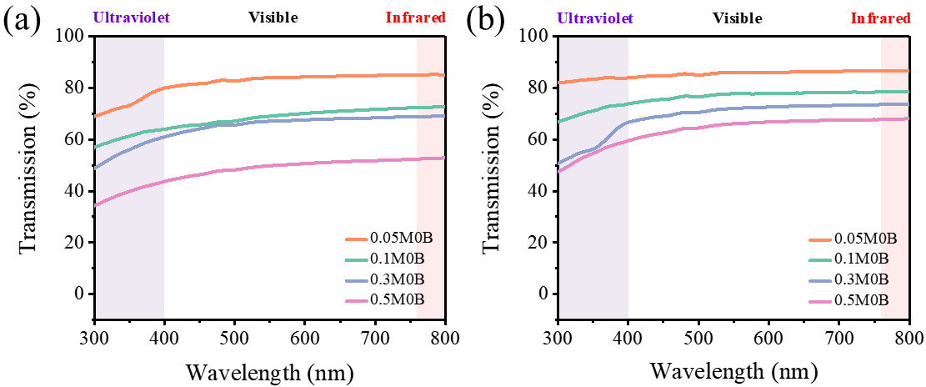
Supplementary Fig. 6 Optical properties of films containing MXene alone. Transmission spectra of composite films with MXene alone before (a) and after (b) being pressed.

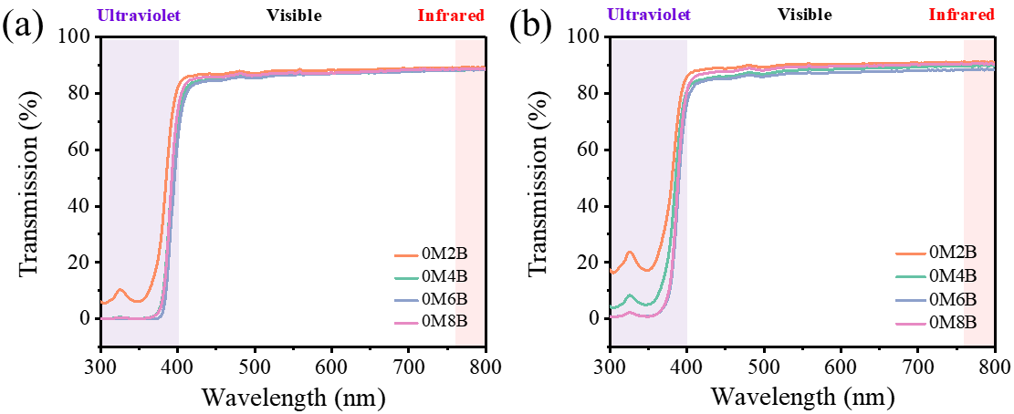
Supplementary Fig. 7 Optical properties of films containing BZT alone. Transmission spectra of composite films with BZT alone before (a) and after (b) being pressed.

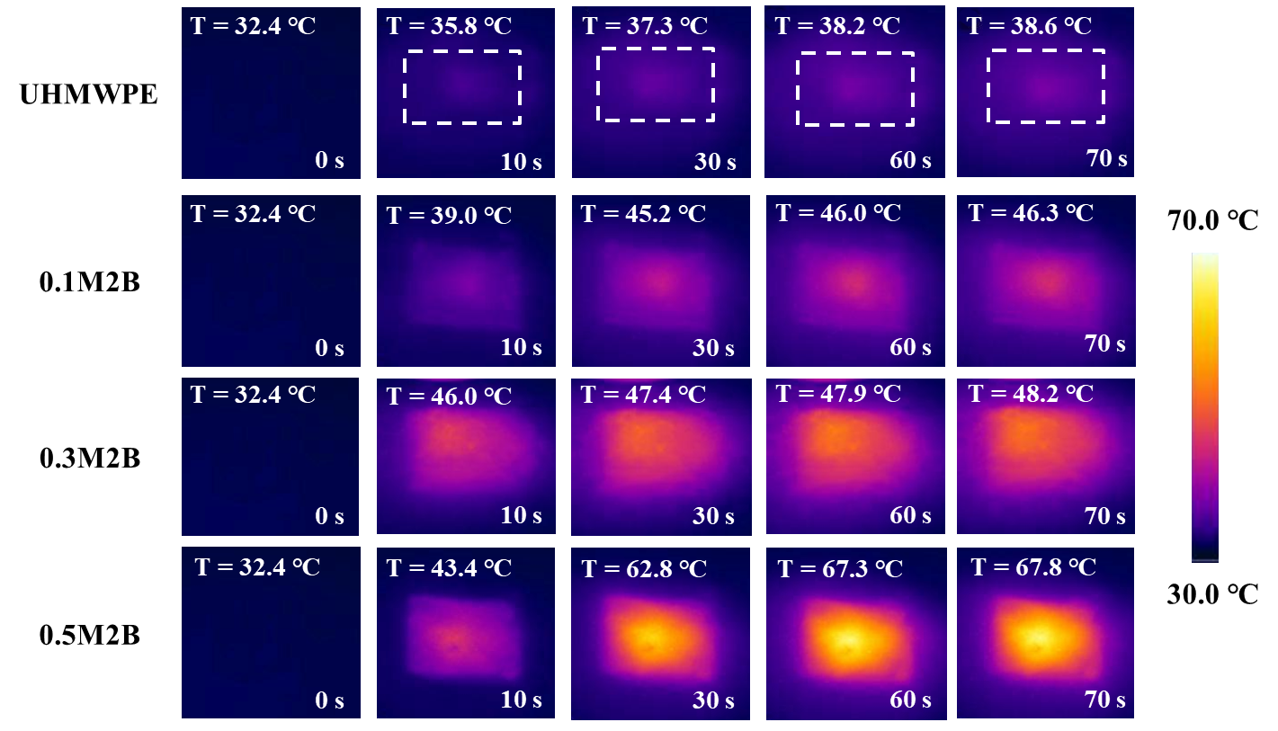
Supplementary Fig. 8 IR images of UHMWPE films with 2 wt.% BZT and different MXene contents irradiated under 400 mW cm⁻².

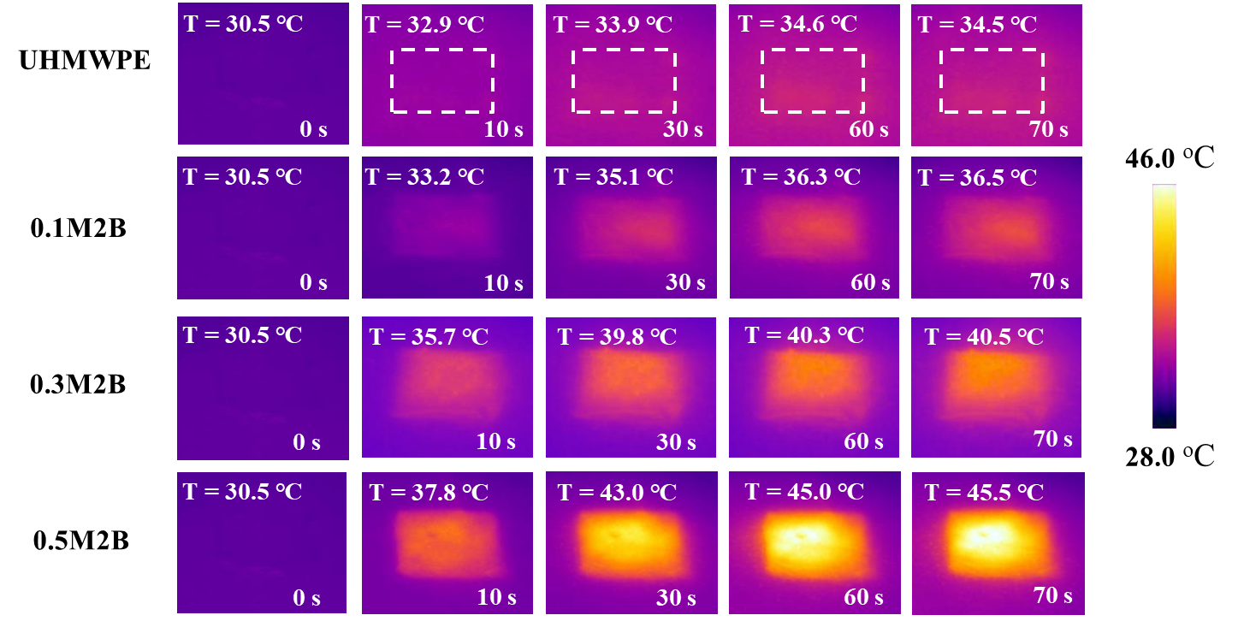
Supplementary Fig. 9 IR images of UHMWPE films with 2 wt.% BZT and different MXene contents irradiated under 100 mW cm⁻².

Supplementary Fig. 10 Temperature-time curve of composites films with 0.3 wt.% MXene and different content of BZT under light irradiation of 100 mW cm⁻².
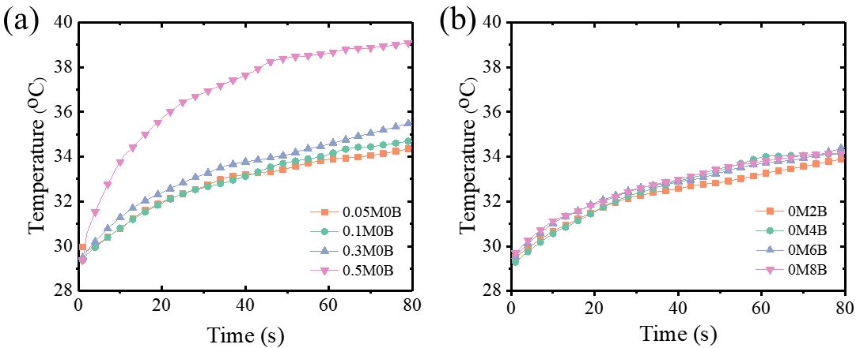 Supplementary Fig. 11 Photothermal conversion of film in control group. Temperature-time curve of composites films with different content of MXene (a) and different content of BZT (b) under 100 mW cm⁻².

Supplementary Fig. 12 Variation of illumination over time inside a cube container in Zhengzhou, China.
Supplementary Fig. 13 The annual cooling energy consumption of building models using these four types of windows based on weather data from 11 cities.
Supplementary Fig. 14 The annual cooling energy savings and percentage of building models using UHMWPE film based on weather data from 12 cities.
Supplementary Fig. 15 The annual cooling energy savings and percentage of building models using 0.1M2B film based on weather data from 12 cities.

Supplementary Fig. 16 The annual cooling energy savings and percentage of building models using 0.3M2B film based on weather data from 12 cities.

Supplementary Table 1 The thickness of UHMWPE and MXene@BZT/UHMWPE films before and after pressing.
Sample |  | UHMWPE | 0.05M2B | 0.1M2B | 0.3M2B | 0.5M2B | 0.3M0B | 0.3M4B | 0.3M6B | 0.3M8B
Film  Thickness (μm) | Before | 38 | 35 | 41 | 35 | 33 | 35 | 36 | 36 | 38
Film  Thickness (μm) | After | 20 | 21 | 24 | 22 | 18 | 21 | 22 | 19 | 22

Supplementary Table 2 Four-step method for measuring haze
Step | Description | Purpose
1 | No sample, white plate in reflectance port | Background calibration
2 | Sample in transmittance position, white plate in reflectance port | Total luminous transmittance
3 | Sample in position, light trap in reflectance port | Sample and instrument scatter
4 | No sample, no white plate | Instrument scatter

Supplementary Table 3 The transmittance and haze of the composite film are compared with other polyethylene-based composite materials.
Composites | Transmission (%) | Haze (%) | Thickness (μm) | Years | Ref
Green LDPE | 52.0 ± 5.2 | 67.9 ± 0.5 | 150 | 2020 | 1
Green LDPE/0.1 wt.% GC | 48.9 ± 1.9 | 78.8 ± 0.4 | 150 | 2020 | 1
Green LDPE/0.3 wt.% GC | 46.5 ± 4.0 | 89.2 ± 1.6 | 150 | 2020 | 1
Green LDPE/0.5 wt% GC | 41.5 ± 1.7 | 95.4 ± 0.6 | 150 | 2020 | 1
20% LLDPE/80% HDPE | ~91 | ~26.8 | 100 | 2020 | 2
40% LLDPE/60% HDPE | ~91.5 | ~25 | 100 | 2020 | 2
10% PP/30% LLDPE/60% HDPE | ~91.5 | ~23.7 | 100 | 2020 | 2
UHMWPE-undraw | ~70 | ~91 | / | 2019 | 3
UHMWPE-20x | ~80 | ~64 | / | 2019 | 3
UHMWPE-60x | ~81 | ~50 | / | 2019 | 3
PE/5 wt.% CNF | ~80 | ~53 | 130 | 2017 | 4
PE/10 wt.% CNF | ~75 | ~68 | 130 | 2017 | 4
PE/20 wt.% CNF | ~70 | ~80 | 130 | 2017 | 4
PE/30 wt.% CNF | ~53 | ~95 | 130 | 2017 | 4
PE/5 wt.% EMAA | ~88 | ~40 | 112 | 2019 | 5
PE/10 wt.% EMAA | ~89 | ~37.5 | 82 | 2019 | 5
PE/20 wt.% EMAA | ~89.5 | ~53 | 44 | 2019 | 5
PE/30 wt.% EMAA | ~89.8 | ~67.5 | 28 | 2019 | 5
This work | 85~92 | 12~30 | 19~24 | This work
Green LDPE/GC: green low-density polyethylene/glassy carbon; LLDPE/HDPE: linear low-density polyethylene/high-density polyethylene; PE/CNF: polyethylene/cellulose nanofibril; EMAA: ethylene/methacrylic acid

Supplementary Table 4 Geographical coordinates and climate types of 12 cities

City | Geographical coordinates | Climatic zones | Climatic types
Beijing (China) | 39º48′N, 116º28′E | Temperate zone | Monsoon climate of medium latitudes
Turpan (China) | 42º55′N, 89º12′E | Temperate zone | Temperate continental climate
Canberra (Australian) | 35º18′S, 149º10′E | Temperate zone | Temperate oceanic climate
Wuhan (China) | 30º37′N, 114º7′E | Subtropical zone | Subtropical monsoon climate
Rome (Italy) | 41 º 48′N, 12º13′E | Subtropical zone | Mediterranean climate
Athens (Greece) | 34º54′N, 27º43′E | Subtropical zone | Mediterranean climate
Atlanta (USA) | 33º37′N, 84º25′W | Subtropical zone | Subtropical monsoon climate
Mexico City (Mexico) | 19º25′N, 99º4′W | Subtropical zone | Subtropical plateau climate
Johannesburg  (South Africa) | 26º7′S, 28º13′E | Subtropical zone | Subtropical plateau climate
Singapore City  (Singapore) | 1º1′N, 103º3′E | Tropical zone | Tropical rainy climate
New Delhi (India) | 28º34′N, 77º12′E | Tropical zone | Tropical monsoon climate
Phoenix (USA) | 33º27′N, 111º58′W | Tropical zone | Tropical desert climate

REFERENCES
1 Oyama, I. C. et al. A new eco-friendly green composite for antistatic packaging: Green low-density polyethylene/glassy carbon. Polym. Compos. 41, 2744-2752 (2020).
2 Wu, W., Wang, Y. Modified high-density polyethylene films: preparation, composition and their physical properties. Bull. Mat. Sci. 43, 143 (2020).
3 Lozano L. M. et al. Optical engineering of polymer materials and composites for simultaneous color and thermal management. Opt. Mater. Express 9, 1990-2005 (2019).
4 Maia T. H. S. et al. Polyethylene cellulose nanofibrils nanocomposites Carbohydr. Polym. 173, 50-56 (2017).
5 Ali S. et al. Preparation of Polyethylene and Ethylene/Methacrylic Acid Copolymer Blend Films with Tunable Surface Properties through Manipulating Processing Parameters during Film Blowing. Polymers 11, 1565 (2019).

⁵These authors contributed equally: Xianhu Liu, Xin Zhang, Zhengui Zhou and Wenrui Zhang. *Corresponding authors. E-mail: yamin.pan@zzu.edu.cn; bin.hu@hust.edu.cn; ctliu@zzu.edu.cn; cfpan@binn.cas.cn

