Title:
Cost effectiveness, nitrogen and phosphorus removal in field-based woodchip bioreactors treating agricultural drainage water

SUPPLEMENTARY INFORMATION
Table S1 Air temperature and precipitation during the hydrological years.
Facility | Hydrological year | Air Temperature | Precipitation
 |  | mean (°C) | sum (mm)
Gyldenholm | 2018-2019 | 9.9 | 569
 | 2019-2020 | 10 | 657
Hofmansgave | 2018-2019 | 9.7 | 544
 | 2019-2020 | 9.7 | 812
Egsmarken | 2018-2019 | 9.8 | 617
 | 2019-2020 | 9.7 | 893
Dundelum | 2018-2019 | 9.7 | 706
 | 2019-2020 | 9.7 | 1135
Serupgård | 2018-2019 | 9.2 | 809
 | 2019-2020 | 9.1 | 1083

Table S2 Standard costs used by the Danish Agricultural Agency.
Item | Base price (DKK) | Additional costs DKK pr. m²
Obligatory parts (incl. bio material). | 105,000 | 350
Pump | 69,000 | 45
Path | 8,000 | -
Advisory costs | 13,250 | -
Permissions | 6,200 | -
Archaeological examinations | 11,800 | 2.5
Additional biomaterial | - | DKK 145 m³
Source: Agricultural Agency (2020)

Table S3 Basic data for the four bioreactors analysed.
Name of reactor | Serupgård | Egsmarken | Dundelum | Gyldenholm | Average
Size of reactor (m³) | 271 | 526 | 652 | 1431 | 720
Complete catchment area (ha) | 80 | 57 | 53 | 120 | 78
Size of reactor compared to complete area (%) | 0.03 | 0.09 | 0.12 | 0.12 | 0.09
Effective catchment area (ha)* | 10.4 | 11.4 | 17.49 | 68.4 | 26.9
Effective catchment, a (%) of the complete catchment** | 13 | 20 | 33 | 57 | 34
Size of reactor compared to effective area (%) | 0.26 | 0.46 | 0.37 | 0.21 | 0.33
Area taken out of production (reactor x2) (ha) | 0.04 | 0.1 | 0.1 | 0.3 | 0.1
Height of biomaterial at the beginning (m) | 1.7 | 1.7 | 1.7 | 1.7 | 1.7
Height of additional biomaterial (m) | 0.5 | 0.5 | 0.5 | 0.5 | 0.5
Biomaterial initial (m³) | 466 | 889 | 1,140 | 2,485 | 1,245
Biomaterial (DKK/m³) | 130 | 144 | 150 | 110 | 134
Cost of area taken out of production (DKK/ha) | 1,883 | 1,883 | 1,883 | 1,883 | 1,883
Source: Pers. comm. Finn Plauborg, 2020, and own calculations. For Dundelum, an average was used (45+60 ha)/2. *The effective catchment area is a percent of the complete catchment area. **The percent effective catchment is equal to the relative amount of drainage water treated, cf. Table 1.

Table S4 The base investment in the bioreactors (DKK)
Name of reactor | Serup-gård | Egsmarken | Dundelum | Gyldenholm | Share of total cost
Establishing the work area/??site | 52,500 | 95,000 | 100,000 | 326,260 | 12%
Moving soil | 110,676 | 260,597 | 196,994 | 358,055 | 19%
Electricity | 52,044 | 69,575 | 90,250 | 156,215 | 7%
Wells | 85,000 | 70,000 | 92,500 | 409,000 | 13%
Base investment | 300,219 | 495,172 | 479,744 | 1,249,530 | 51%
Biomaterial initial | 60,580 | 128,016 | 171,000 | 273,500 | 13%
Additional well | 10,271 | 14,152 | 0 | 0 | 10%
Additional pump | 0 | 0 | 0 | 496,107 | 4%
Biomaterial (yr. 6, 12 and 18) | 42,050 | 90,407 | 116,733 | 187,883 | 9%
Consultant | 161,947 | 143,123 | 143,123 | 404,000 | 17%
Other* | 0 | 0 | 0 | 0 | 0%
Total | 575,067 | 870,870 | 910,600 | 2,611,020 | 100%
Note : *No additional costs for identification of sites were included as this is assumed to be a task carried out by the catchment officers. Paths, archaeological digs and permissions are not encumbered with costs.

Table S5 Comparison of key figures between bioreactors and the N catalogue*) based on a standard size reactor of 2,000 m² (0.2 ha).
 | N catalogue  500 m² | N catalogue  2500 m² | Serupgård | Egsmarken | Dundelum | Gyldenholm
Size of reactor at outset (m²) | 500 | 2500 | 209 | 526 | 652 | 1431
Scaling factor | 4,0 | 0,8 | 7,4 | 3,8 | 3,1 | 1,4
Annual costs:
Bioreactor and initial biomaterial | 59,233 | 59,233 | 146,635 | 152,704 | 130,906 | 153,556
Additional well | 0 | 0 | 5,578 | 3,959 | 0 | 0
Additional pump | 26,931 | 10,684 | 0 | 0 | 0 | 51,019
Additional biomaterial | 36,276 | 36,276 | 32,897 | 35,816 | 38,597 | 28,127
Archaeological digs | 1,236 | 1,236 | 0 | 0 | 0 | 0
Electricity etc. | 0 | 0 | 0 | 0 | 0 | 27,952
Establishing a path | 589 | 589 | 0 | 0 | 0 | 0
Cleaning pipes | 0 | 0 | 11,070 | 5,703 | 1,500 | 1,000
Loss of income | 753 | 753 | 753 | 753 | 753 | 753
-Archaeological digs | 1,236 | 1,236 | 0 | 0 | 0 | 0
Path and permissions | 1,045 | 1,045 | 0 | 0 | 0 | 0
Consultant | 975 | 975 | 11,916 | 10,531 | 10,531 | 29,727
Total costs | 128,274 | 112,027 | 208,849 | 209,467 | 182,287 | 292,135
Total costs without pump | 101,343 | 101,343 | 208,849 | 209,467 | 182,287 | 241,115
Cost efficiency:
N reduction (kg N/yr) | 600 | 750 | 908 | 617 | 817 | 855
Cost efficiency (DKK/kg N) | 214 | 149 | 230 | 340 | 223 | 342
Cost efficiency (DKK/kg N) without pump | 169 | 135 | 230 | 340 | 223 | 282
The costs are scaled to 0.2 ha (see scaling factor).
Additional economic support: For area in rotation: DKK 35,000 per ha biofilter or DKK 7,000 per 0.2 ha and maintenance DKK 24,000 0.2 ha for 10 years.
*) The nitrogen catalogue is an overview on potential measures to reduce nitrogen losses to the sea.
Source: Eriksen et al. (2020).

Photos of the sites
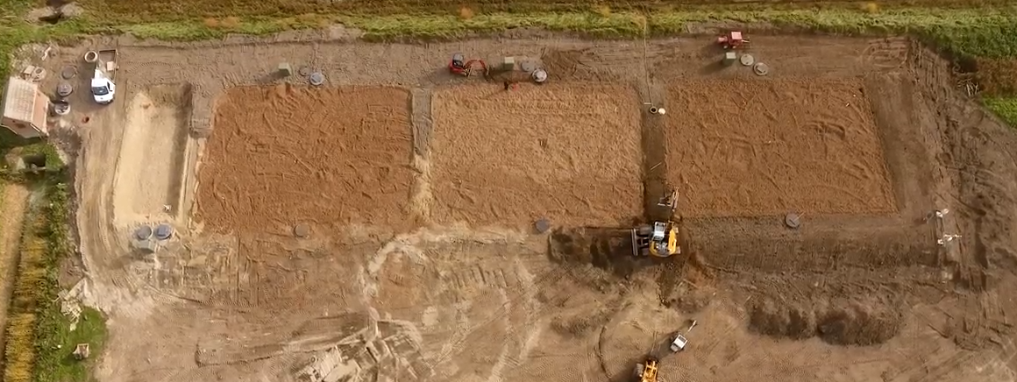
Fig. S1 The bioreactor facility at Hofmansgave. The sedimentation pond at the left and the three bioreactors A. B and C from left to right can be seen. Picture taken shortly before opening of the drains. Credit: SEGES.

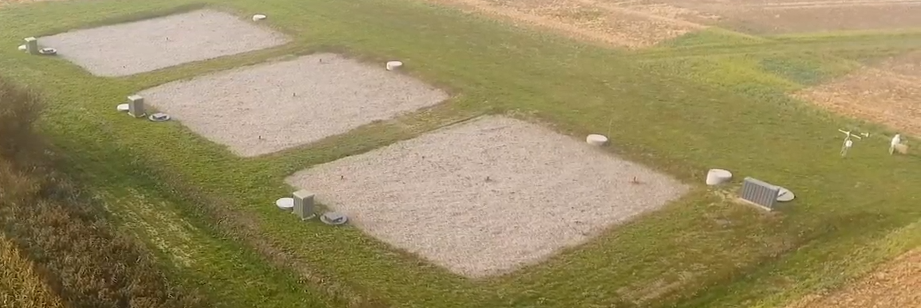
Fig. S2 The bioreactor facility at Gyldenholm. The three bioreactors A. B and C (left to right) can be seen. Credit: SEGES.

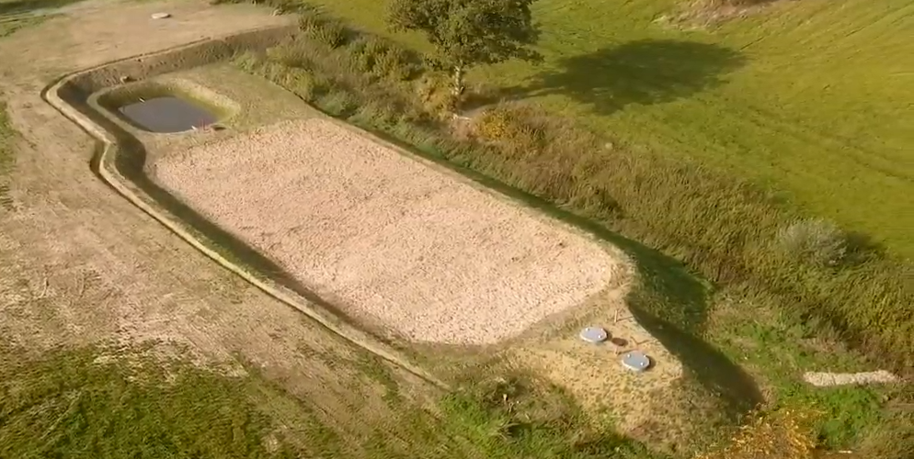
Fig. S3 The bioreactor facility at Egsmarken. Credit: SEGES.
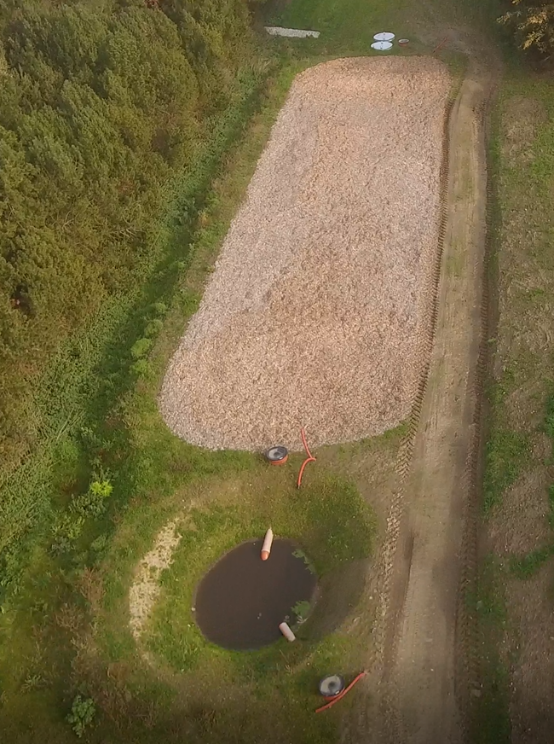
Fig. S4 The bioreactor facility at Serupgård. Credit: SEGES.

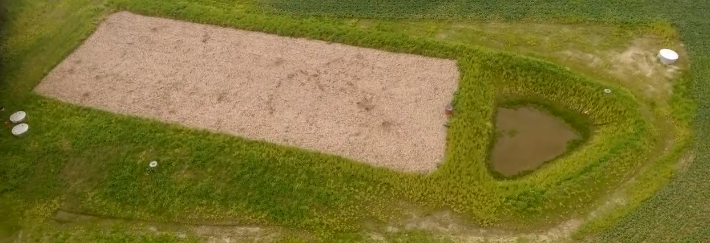
Fig. S5 The bioreactor facility at Dundelum. Credit: SEGES.

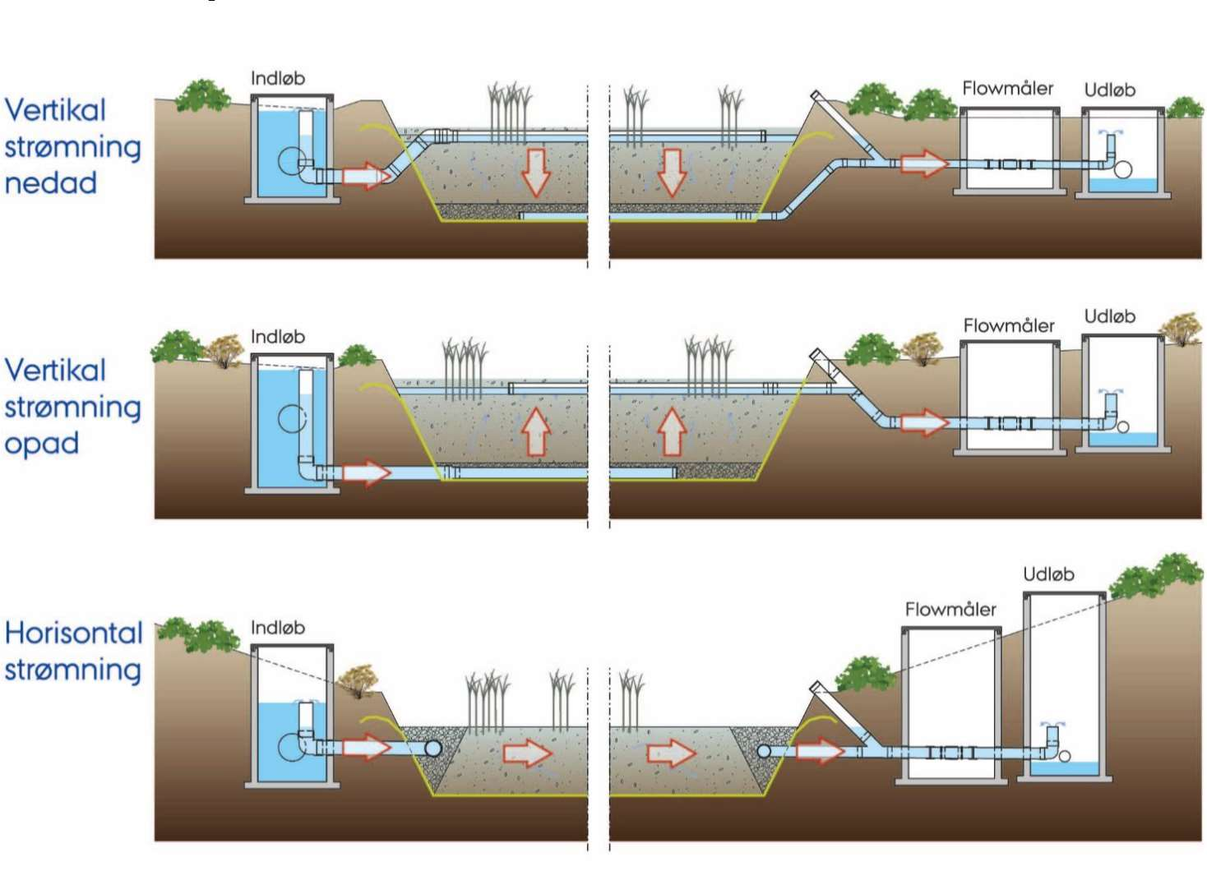
Inlet
Flow unit

Fig. S6. Woodchip bioreactor with a horizontal flow regime with inlet and outlet (Hoffmann et al., 2019).

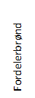
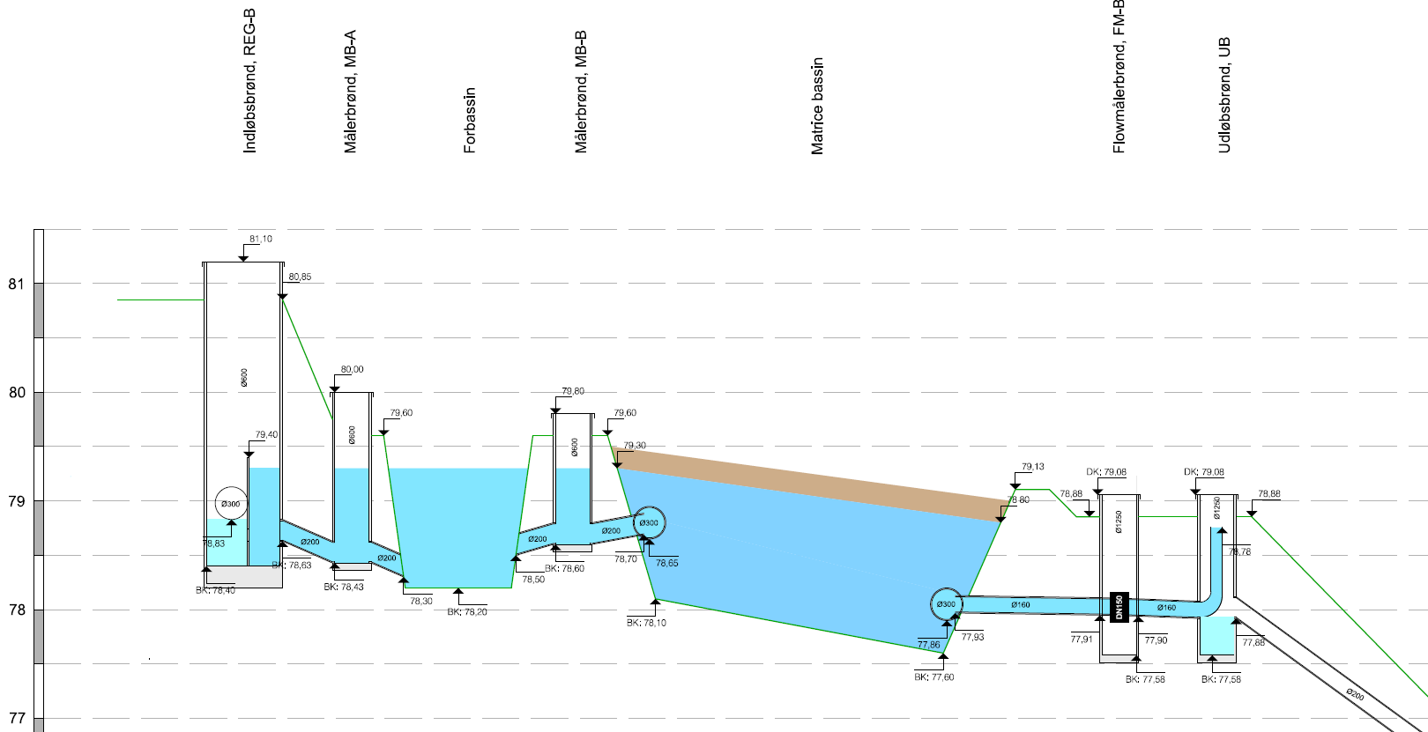
B
A
C
Fig. S7 Technical drawing of the hydraulics for the plant at Egsmarken on Funen. The red arrows A, B and C mark wells established for sampling and research. These do not have to be established in practice (source: WSP).
B
C
A

--
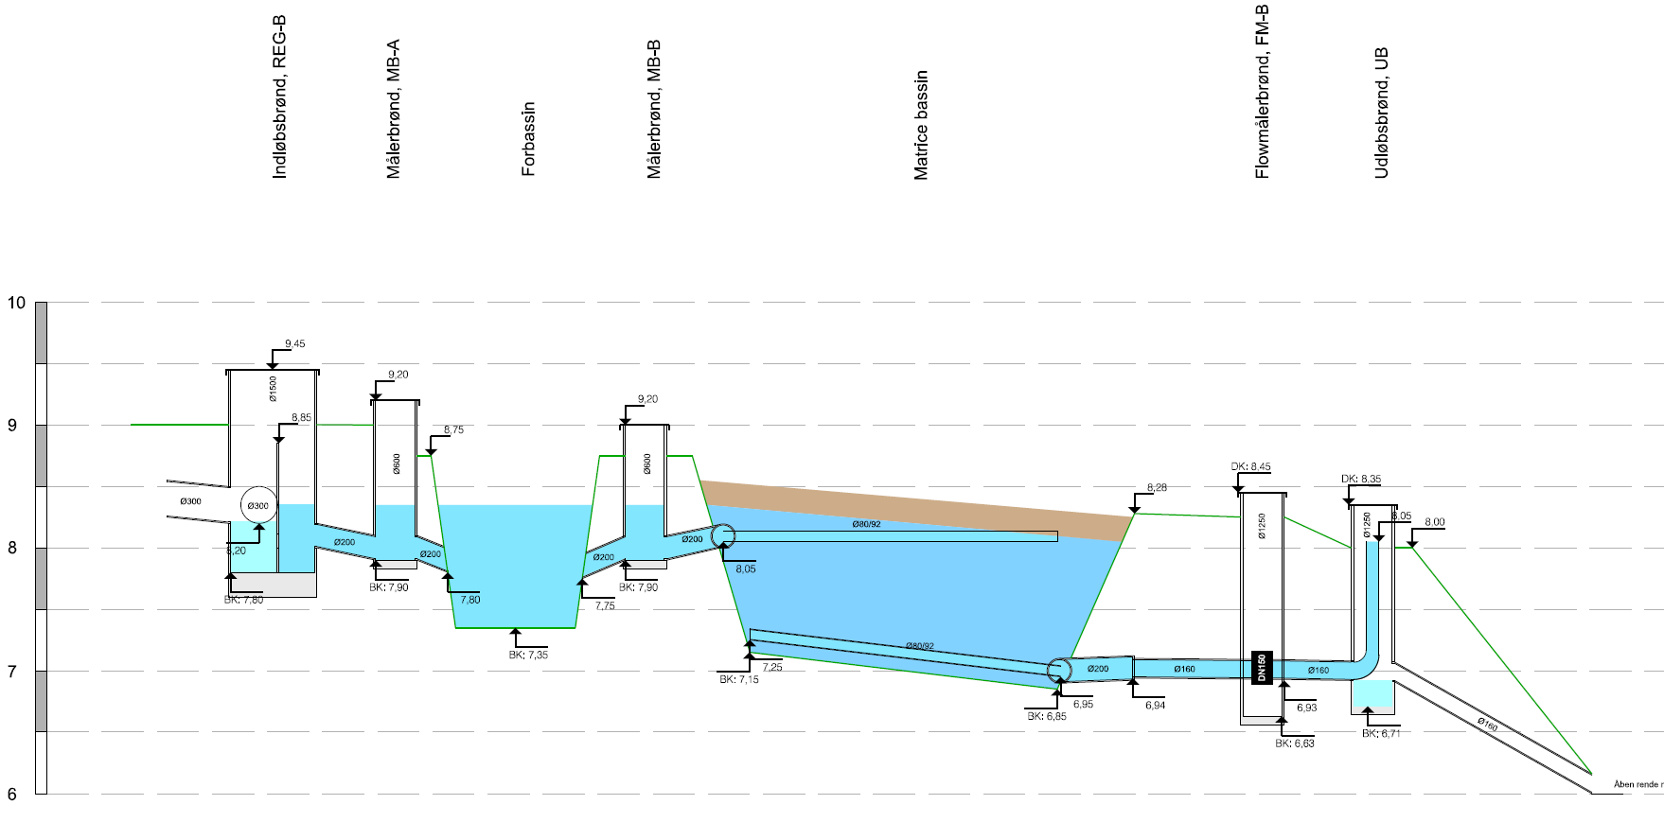
C
B
A
Fig. S8 Technical drawing of the hydraulics for the plant at Dundelum near Haderslev. The red arrows A, B and C mark wells established for sampling and research. These do not have to be established in practice. The level of the three drainage pipes at the top and bottom in the entire longitudinal direction of the basin is shown (source: WSP).

