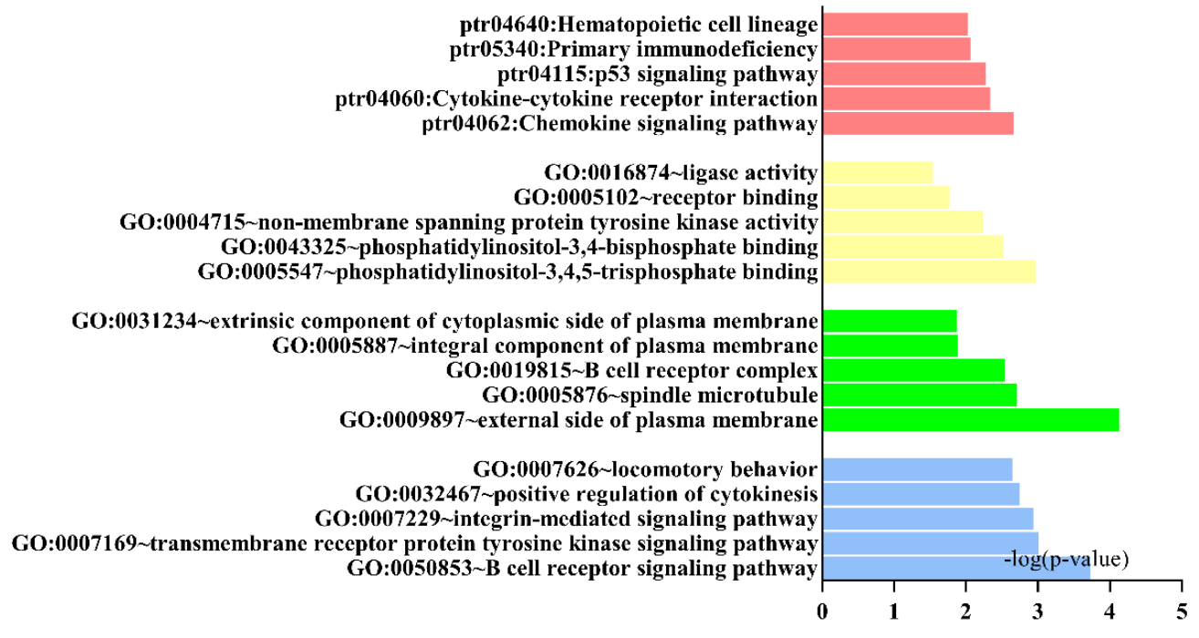
Supplemental Fig.1 Results of gene ontology (GO) and Kyoto Encyclopedia of genes and genome (KEGG).

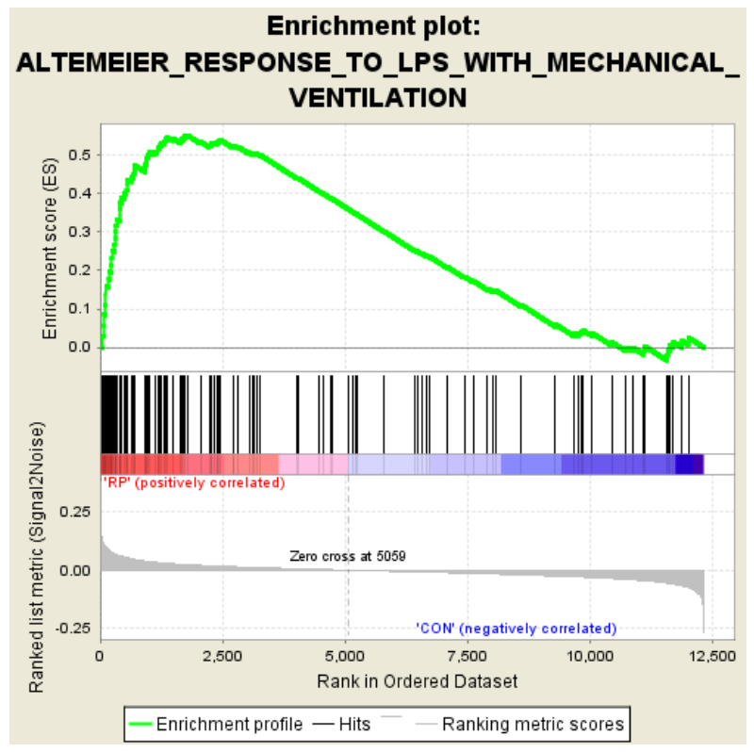
Supplemental Fig.2 Results of Gene Set Enrichment Analysis indicated abnormal regulation of mechanical ventilation pathways in radiation pneumonia

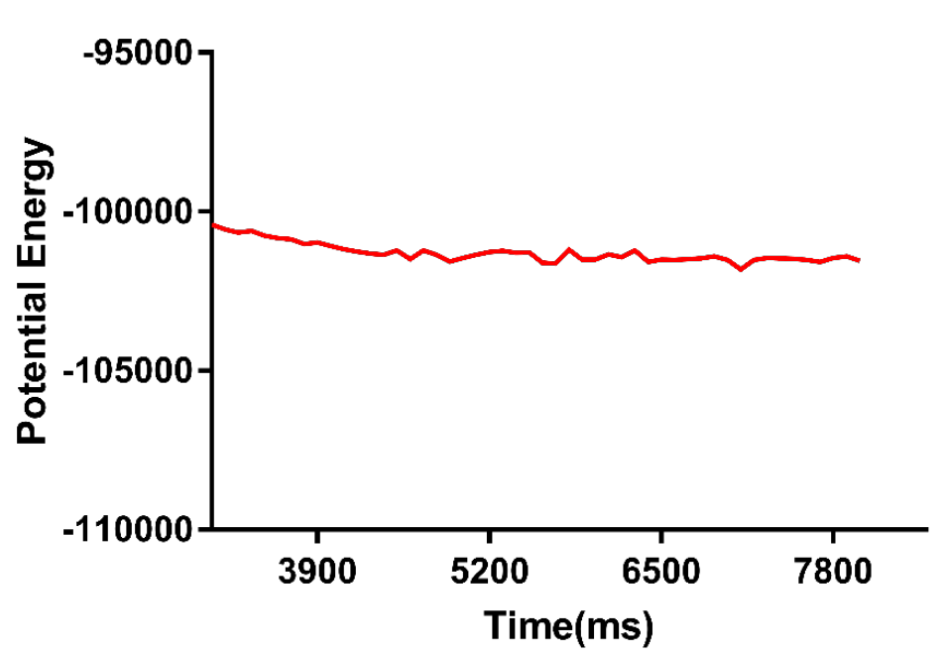
Supplemental Fig.4 Potential energy between ZINC43131420 and SYK transcriptional protein

