Comparative transcriptome analysis of Saposhnikovia divaricata to
reveal drought and rehydration adaption strategies

Youla Su, Miaomiao Jiao, Huan Guan, Guilin Chen*

Key Laboratory of Herbage & Endemic Crop Biology, Ministry of Education,
Inner Mongolia University, Hohhot 010020, China
School of Life Sciences, Inner Mongolia University, Hohhot 010020, China
The Good Agriculture Practice Engineering Technology Research Center of Chinese and Mongolian Medicine in Inner Mongolia, Hohhot 010020, China
*Email address: guilinchen61@163.com

Supplementary information
Table S1 RT-qPCR gene primer sequences
Gene ID | Description | Primers (5’-3’)
TRINITY_DN106620_c2_g5 | auxin transporter-like protein 2 | F: TGCTCTTCAAATCAGGTGGCT
TRINITY_DN106620_c2_g5 | auxin transporter-like protein 2 | R: TGTGCAGTTGAATGCCAAGC
TRINITY_DN108592_c0_g2 | protein phosphatase 2C 37 | F: GCTGCTCACATGTTGCGATG
TRINITY_DN108592_c0_g2 | protein phosphatase 2C 37 | R: CGCAGCGACAGTTAGGACTT
TRINITY_DN103837_c1_g2 | gibberellin receptor GID1B-like | F: CAGCGAAGCGAAGAGAGTTGT
TRINITY_DN103837_c1_g2 | gibberellin receptor GID1B-like | R: GTTGGGAGGGACTTTGCGTT
TRINITY_DN100914_c0_g3 | peroxidase 5-like | F: CACAGTCATGTTGGATGGCAG
TRINITY_DN100914_c0_g3 | peroxidase 5-like | R: AGATGCATCACAGCCCCTAA
TRINITY_DN101775_c0_g3 | 9-cis-epoxycarotenoid dioxygenase NCED3 | F: CGCGTTTCGGTGTATTGGAC
TRINITY_DN101775_c0_g3 | 9-cis-epoxycarotenoid dioxygenase NCED3 | R: AATGATTGCCCTACGGGTCG
TRINITY_DN106905_c0_g1 | L-ascorbate peroxidase 6, chloroplastic isoform X1 | F: TCGTCAGGAAAGAGAGAGC
TRINITY_DN106905_c0_g1 | L-ascorbate peroxidase 6, chloroplastic isoform X1 | R: CGCACTAAGTACCAAGACCAT
TRINITY_DN98637_c1_g1 | phospholipid hydroperoxide glutathione peroxidase | F: CCTCTCAGCATCGAGAAGGATG
TRINITY_DN98637_c1_g1 | phospholipid hydroperoxide glutathione peroxidase | R: CAGATTGCCAGTGCAACAGC
TRINITY_DN109575_c0_g1 | superoxide dismutase [Cu-Zn] 2-like | F: GAGGGTGTGACAGGAACACT
TRINITY_DN109575_c0_g1 | superoxide dismutase [Cu-Zn] 2-like | R: TGACATGAGTAGGACCATCAGC
TRINITY_DN97004_c0_g1 | 1-deoxy-D-xylulose-5-phosphate synthase 2 | F: TGGAAATCTCAAGTGGAGGGC
TRINITY_DN97004_c0_g1 | 1-deoxy-D-xylulose-5-phosphate synthase 2 | R: GGTGAAGGCTGTCCCTAGAC
TRINITY_DN106571_c1_g2 | sesquiterpene synthase 2-like | F: GCTGGGTCATATTACAAGGTGG
TRINITY_DN106571_c1_g2 | sesquiterpene synthase 2-like | R: GGCATAATGCGGCTCAAAGT
TRINITY_DN101101_c3_g2 | 4-hydroxy-3-methylbut-2-enyl diphosphate reductase | F: GAAGAACATGGCAGAAGCAACA
TRINITY_DN101101_c3_g2 | 4-hydroxy-3-methylbut-2-enyl diphosphate reductase | R: TGGACCCGTCAAGTTGTCCT
TRINITY_DN91698_c0_g1 | terpene synthase 10-like | F: ACACACTGCCAGTTCTCAGG
TRINITY_DN91698_c0_g1 | terpene synthase 10-like | R: CCGTCCTTTGAAACGTTCAATCTTA
TRINITY_DN97004_c0_g1 | 1-deoxy-D-xylulose-5-phosphate synthase 2 | F: TGGAAATCTCAAGTGGAGGGC
TRINITY_DN97004_c0_g1 | 1-deoxy-D-xylulose-5-phosphate synthase 2 | R: GGTGAAGGCTGTCCCTAGAC

Table S2 Summary of RNA-Seq data
Sample | Raw reads | Clean reads | Clean bases | Error rate (%) | Q20 (%) | Q30 (%) | GC content (%)
CK1 | 47233242 | 46777674 | 7368872898 | 0.027 | 97.50 | 92.08 | 43.59
CK2 | 49586084 | 49051984 | 7214329784 | 0.027 | 97.43 | 92.19 | 43.9
CK3 | 59507148 | 58868226 | 7511650200 | 0.026 | 97.57 | 92.68 | 43.92
DS8-1 | 47721914 | 47281158 | 7074926316 | 0.026 | 97.55 | 92.67 | 44.28
DS8-2 | 67340706 | 66740562 | 9973307433 | 0.027 | 97.47 | 92.49 | 44.24
DS8-3 | 52550386 | 51965404 | 7761591601 | 0.027 | 97.35 | 92.23 | 44.04
DS12-1 | 50691080 | 50107088 | 7486380506 | 0.027 | 97.35 | 92.22 | 44.31
DS12-2 | 49003818 | 48497854 | 7241611359 | 0.027 | 97.32 | 92.14 | 44.24
DS12-3 | 48326250 | 47787036 | 7138601563 | 0.027 | 97.35 | 92.23 | 44.67
DS16-1 | 48484718 | 48046554 | 7186813498 | 0.027 | 97.52 | 92.61 | 43.81
DS16-2 | 49796570 | 49310124 | 7369664976 | 0.027 | 97.41 | 92.36 | 43.93
DS16-3 | 48608890 | 48140572 | 7198291045 | 0.026 | 97.60 | 92.79 | 44.2
RW8-1 | 58799014 | 58286268 | 8714307063 | 0.026 | 97.62 | 92.84 | 44.15
RW8-2 | 58049186 | 57552772 | 8609767153 | 0.026 | 97.63 | 92.86 | 43.53
RW8-3 | 59401678 | 58896386 | 8809345670 | 0.026 | 97.68 | 92.96 | 43.96

The control (0 day) and drought treated (8 days, 12 days, 16 days) and rehydration treated (8 days) were generated and referred to as CK, DS8, DS12, DS16 and RW8. Each condition had three biological repetitions.
Table S3 Statistics of transcriptome assembly
Assembly statistics
Total unigenes number | 167447
Maximum length | 14945 bp
Minimum length | 201 bp
Average length | 807.49 bp
N50 | 1253 bp
GC% | 39.33
Length 0-1000 bp | 135268
Length 1001-2000 bp | 21059
Length 2001-3000 bp | 7367
Length 3001-4000 bp | 2507
Length > 4000 bp | 1246

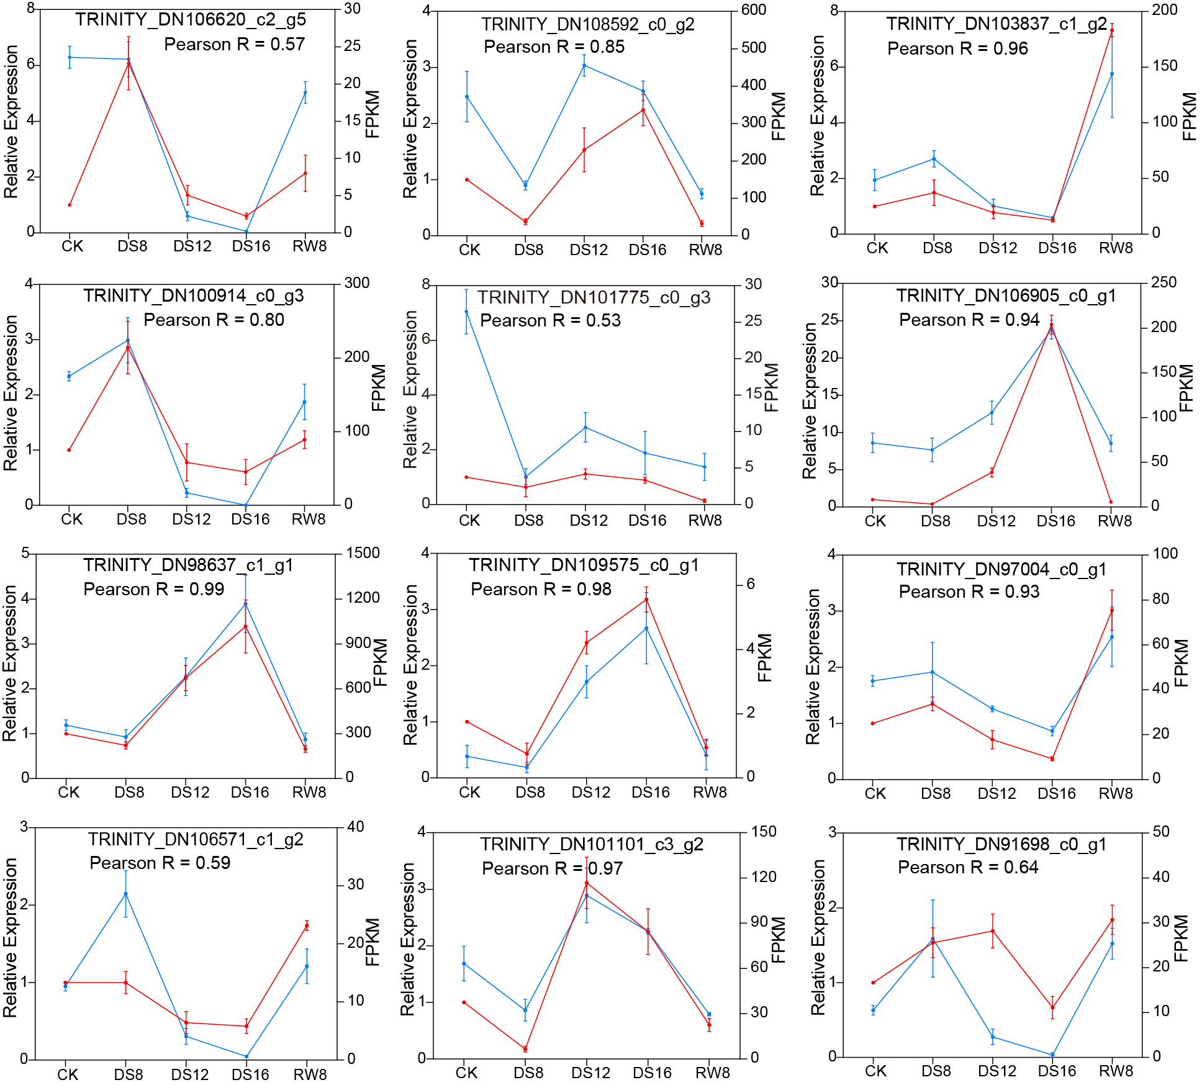
Fig.S1 Validation of RNA-sequencing results by RT-qPCR. Relative expression values are showed as the mean ± SD of three biological replicates and the bars represent standard deviation.

