Improvement of RNA in situ hybridization for grapevine fruit and ovule

Jin Yao^{1, 2†}, Xingmei Li^{1, 2†}, Na Wu^{1, 2}, Songlin Zhang^{1,2}, Min Gao^{1,2*}, Xiping Wang^{1,2*}

1 State Key Laboratory of Crop Stress Biology in Arid Areas, College of Horticulture, Northwest A&F University, Yangling, Shaanxi 712100, China
2 Key Laboratory of Horticultural Plant Biology and Germplasm Innovation in Northwest China, Ministry of Agriculture, Northwest A&F University, Yangling, Shaanxi 712100, China
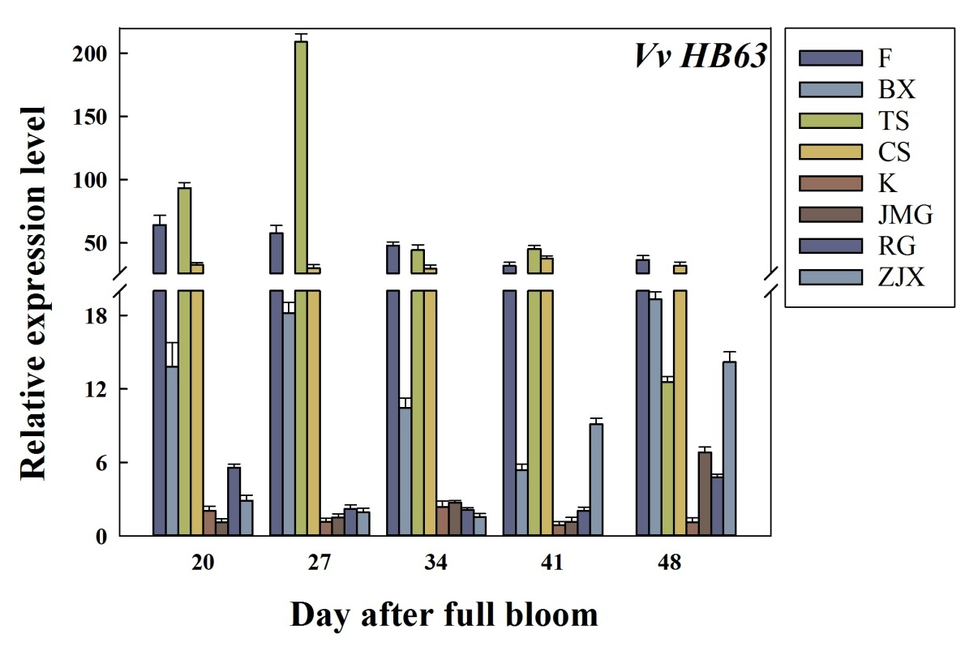

Fig. S1. Expression patterns of grape VvHB63 in ovules from eight grape cultivars. Seedless cultivars: Flame Seedless (F), Bi Xiang Seedless (BX), Thompson Seedless (TS), Crimson Seedless (CS), Seeded cultivars: Kyoho (K), Ju Mei Gui (JMG), Red Globe (RG), Zui Jin Xiang (ZJX). Using VvGAPDH and VvEF1-a genes followed by geometric averaging for determining a normalization factor.

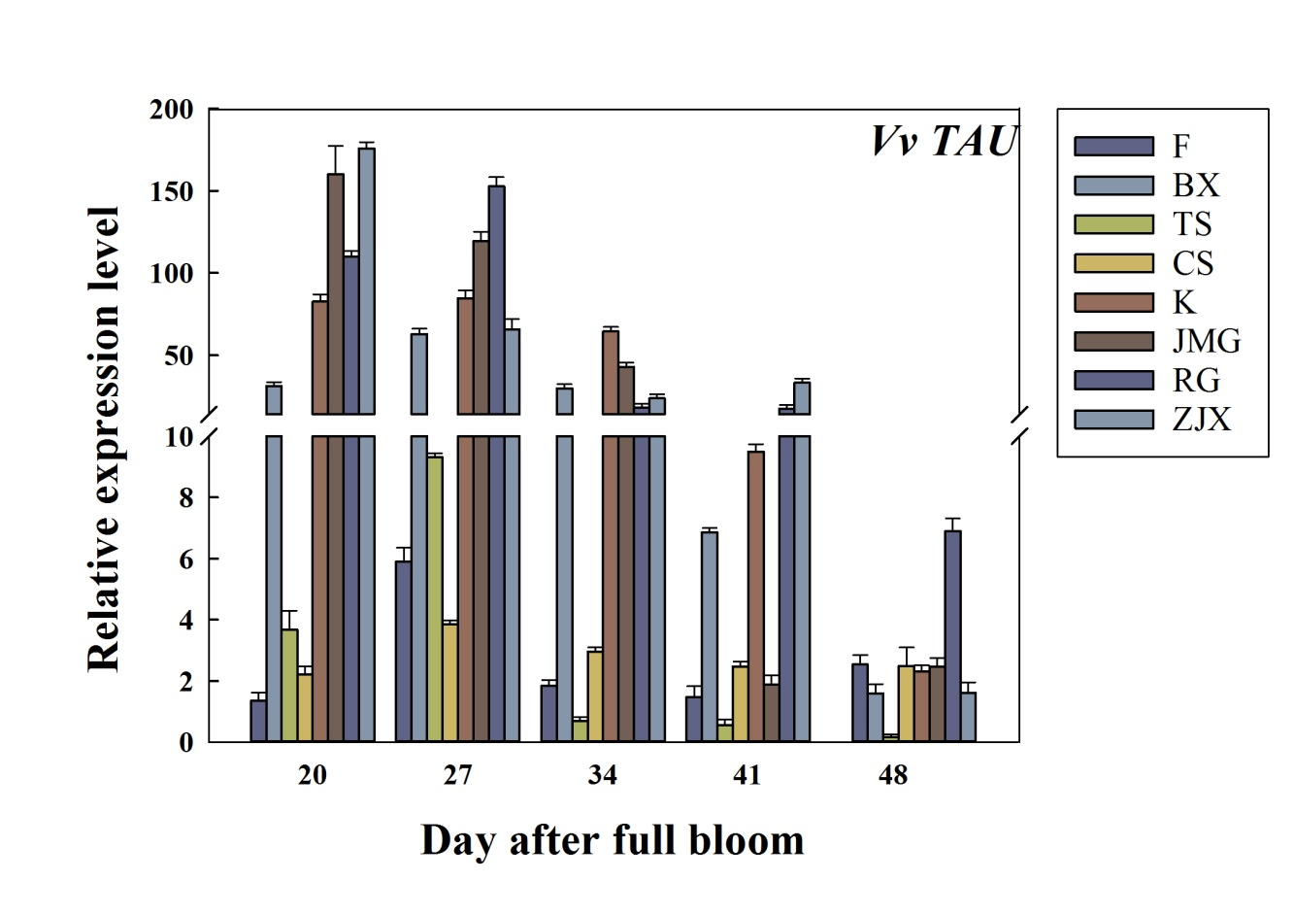

Fig. S2. Expression patterns of grape VvTAU in ovules from eight grape cultivars. Seedless cultivars: Flame Seedless (F), Bi Xiang Seedless (BX), Thompson Seedless (TS), Crimson Seedless (CS), Seeded cultivars: Kyoho (K), Ju Mei Gui (JMG), Red Globe (RG), Zui Jin Xiang (ZJX). Using VvGAPDH and VvEF1-a genes followed by geometric averaging for determining a normalization factor.

Fig. S3. Semi-quantitative analysis of VvTAU probe by dot blot hybridization.

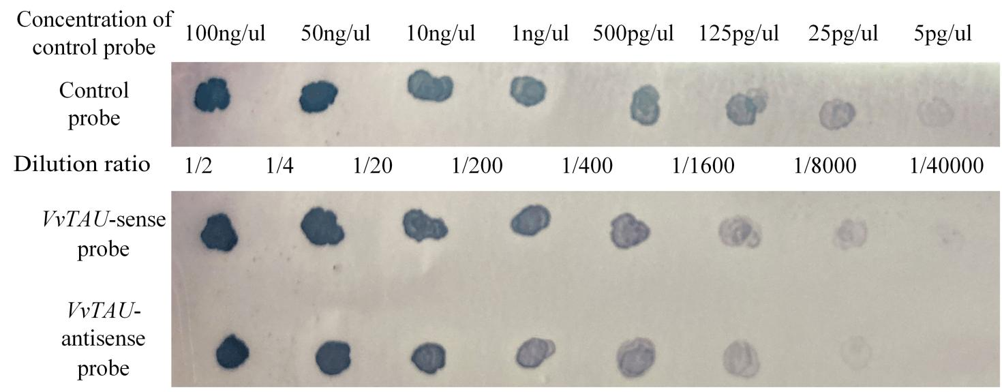
Fig. S4. Semi-quantitative analysis of VvHB63probe by dot blot hybridization.

Table S1: Reagent configuration method

Reagent name | component
2×carbonate buffer | 32ul 1M NaHCO₃, 48ul 的 1M NaCO_{3;} 320ul DEPC-H₂O
10×PBS | 1.3M NaCL; 70mM Na₂HPO₄; 30mM NaH₂PO₄; DEPC-H₂O
10×TBS | 1M Tris-HCl pH7.5; 1.5M NaCl
20×SSC | 3M NaCl; 300mM Na citrate
5×NTE | 2.5M NaCl; 50mM Tris pH 8; 5mM EDTA; DEPC-H₂O
Buffer C | 100mM Tris-HCl pH9.5; 50mM MgCl₂; 100mM NaCl
1% Blocking buffer | 1% in 1×TBS
10x proteinase K buffer | 100mM Tris pH8; 50mM EDTA
Acetic anhydride solution | 3ml in 600ml 0.1M triethanolamine-HCl, pH 8 (11.142g, 600ml H₂O, 3ml 10M NaOH for the pH)
4% paraformaldehyde | 4% in 1×PBS
10× in situ salts | 3M NaCl ; 100mM Tris-HCl pH8; 100mM Na phosphate, pH 6.8; 50mM EDTA;  DEPC H₂O to 10ml; Store at -20C
hybridization buffer | 0.3 M NaCl; 10mM Tris-HCl pH 6.8; 10mM NaHPO₄ pH 6.8; 5mM EDTA;  50% formamide; 10% dextran sulfate; 1xDernhardts (0.02% each:Ficoll; PVP; BSA); 1mg/ml tRNA

