Supporting information
Title：Fine Mapping of CscpFtsY, a Gene Conferring the Yellow Leaf Phenotype in Cucumber (Cucumis sativus L.)
Gaohui Zha¹ · Juan Yin¹ · Feng Cheng¹ · Mengfei Song¹ · Mengru Zhang¹ · Hesbon Ochieng Obel¹ · Yi Wang¹ · Jinfeng Chen¹ · Qunfeng Lou*
¹ State Key Laboratory of Crop Genetics and Germplasm Enhancement, College of Horticulture, Nanjing Agricultural University, Weigang Street No.1, Nanjing 210095, China

*Corresponding author: Qunfeng Lou (qflou@njau.edu.cn)
Author
Gaohui Zha 2020104064@stu.njau.edu.cn
Juan Yin 2020104065@stu.njau.edu.cn
Feng Cheng 2018204019@njau.edu.cn
Mengfei Song 2017204016@njau.edu.cn
Mengru Zhang 2019204035@njau.edu.cn
Hesbon Ochieng Obel 2019204059@njau.edu.cn
Yi Wang wangyi@stu.njau.edu.cn
Jinfeng Chen jfchen@njau.edu.cn
Qunfeng Lou qflou@njau.edu.cn

Fig. S1 The delta SNP manhattan plot of BSA-seq

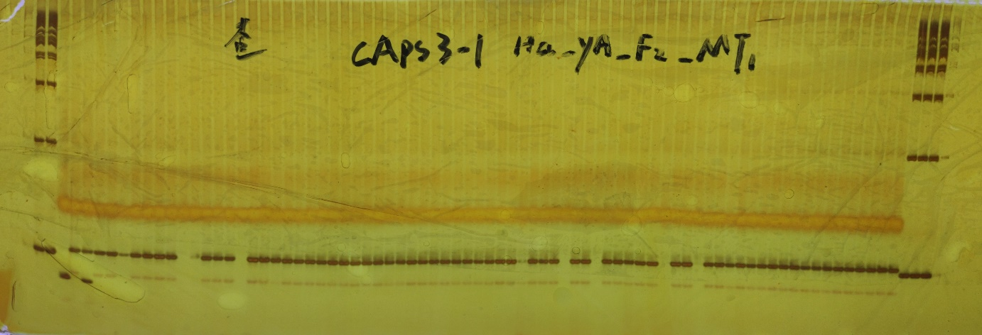
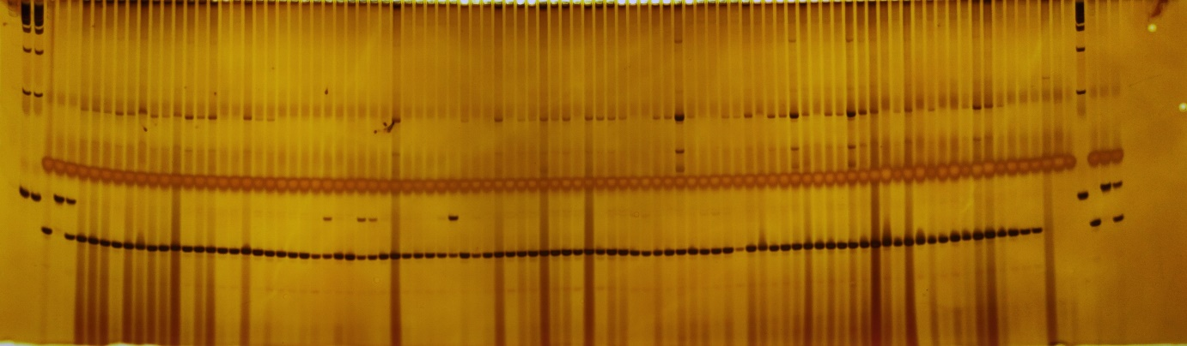
Fig S2 Linkage analysis and allelism test by dCAPS3-1 based on candidate SNP
a
b
c
WT
yl
F₁
WT
F₁
yl
22
25
26
33

Fig S2. a, Genotype identification by dCAPS3-1 in MT individuals b, Allelism test by dCAPS3-1 in 80 cucumber inbred lines (Should note that 22nd, 25th, 26th, and 33rd these four bonds exhibited F₁ bond, but their genotypes were the same as WT based on sequencing result, which was shown in c).

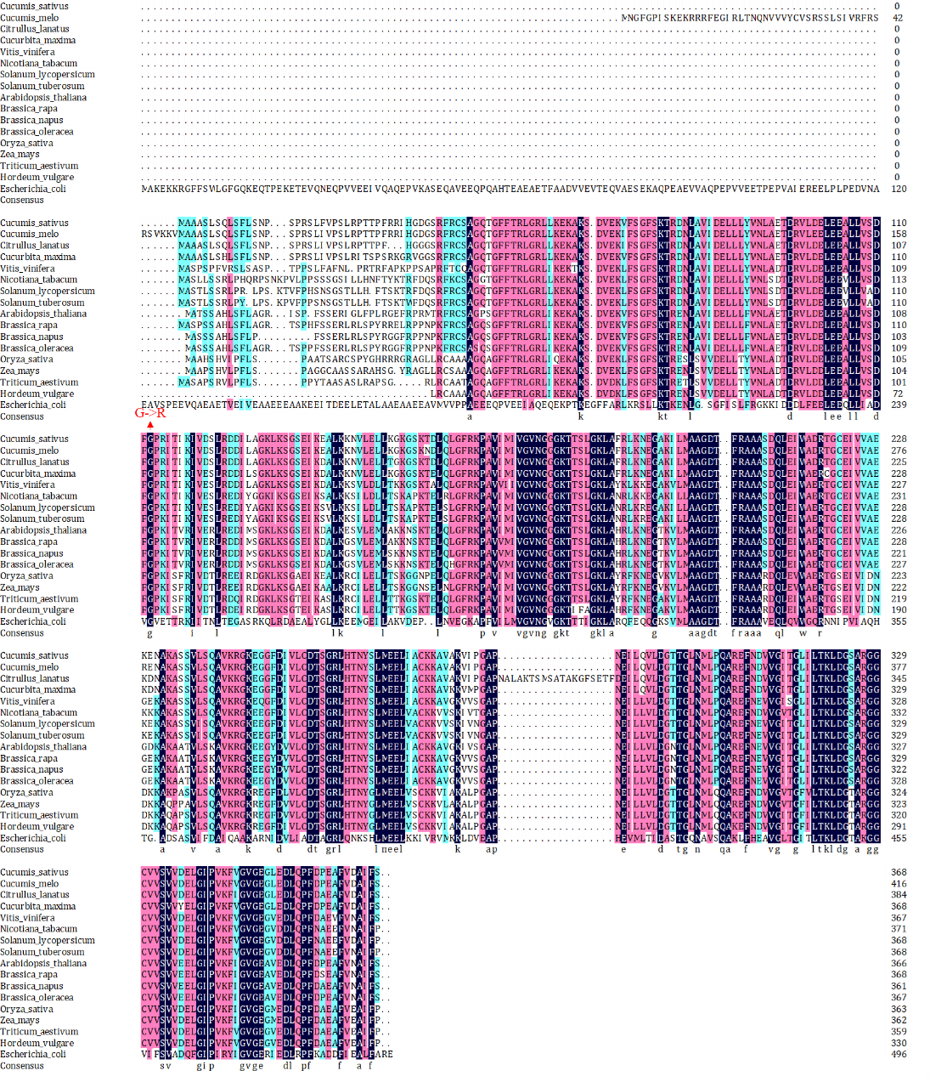
Fig S3 Multiple sequences alignment of CscpFtsY

Table S1 The information of cucumber leaf color mutants
Leaf Color | Mutation | Inherited Pattern | Locus | Gene ID | Gene Annotation | Chr
Golden leaf | EMS | Single nuclear recessive | yp | CsChlⅠ | CHLI subunit of cucumber Mg-chelatase | 6
Virescent leaf | Spontaneous | Single nuclear recessive | v-1 | CsaCNGCs | cyclic-nucleotide-gated ion channel protein | 6
Green-Yellow-White variegation | EMS | Single nuclear recessive | csvl | Csa6G405290 | chorismate synthase | 6
virescent yellow | EMS | Single nuclear recessive | vyl | Csa4G637110 | DnaJ-like zinc finger protein | 4
Yellow-Green | Spontaneous | Single nuclear recessive | ygl1 | Csa4M286960  Csa4M287550  Csa4M288070  Csa4M288080 | lipoxygenase isoenzymes | 4
Yellowing | Spontaneous | Single nuclear recessive | yf | Cucsa.099260.1 | cpSRP43 | 7
Yellowing | EMS | Single nuclear recessive | yl-2 | Csa6G385090 | Chlorophyllide a oxygenase | 6
Yellow-Young | EMS | Single nuclear recessive | yyl-1 | Csa3G836480 | HD domain-containing protein | 3
Virescent |  | Single nuclear recessive | v-2 | Csa3G890020 | auxin F-box protein | 3
Yellow | EMS | Single nuclear recessive | yl2.1 | Csa2G263900 | plastid isoform of triose phosphate isomerase | 2
Yellow | Tnt1 Transposon | Single nuclear recessive | yl-5 | Csa3G588450 | chloroplast 30S ribosomal protein S21 | 3
albino | EMS | Single nuclear recessive | al | Not Mentioned |  | 7

Table S2
All primers’ information used in this study
Primer ID | Application | 9930V3.0_Pos | Forward primer 5'-3' | Reverse prime5'-3' | Note
CsACTIN2 | qPCR |  | ATTGTTCTCAGTGGTGGTTCTAC | CCTTTGAGATCCACATCTGCT | Reference gene
qCscpFtsY | qPCR |  | GAAACCGATAGAGTTCTCGACG | ACTACCAGATTTAAGCTTCCCAG | Candidate gene
pG-1 | Subcellular localization |  | atctagaggatccccATGGCCGCGGCCTCAC | cggccggtggatcccTGAAAATATGGCATCAACAAAGGC
Ind3-27 | Mapping | 324948 | CTTTTTCCACACGTTTCTTT | CCCCTAGCTCCTTAATAGAT | InDel
Ind3-28 | Mapping | 1277740 | TGTTTCTCCTAACATTTTGC | TGAATTTAGCCTATGCATTC | InDel
AInd3-3 | Mapping | 2656159 | TGATATTGAGATGGGTTGTC | TATAAGGGTTGGTTAGGTCT | InDel
AInd3-4 | Mapping | 3739510 | GACAATATGAATGAAACCCC | AAATTCACATCTAAGAACGC | InDel
AInd3-6 | Mapping | 5524418 | AAACTCATATTGTGGAGTCC | TTCTATTTTGAAGGGTCACT | InDel
AInd3-7 | Mapping | 6023890 | GTATTTACAGTTCAGTGTATAAC | TCTTACACCTCTATTTGATACA | InDel
yb-Indel3-2 | Mapping | 6968518 | TTTTGTAGTTTCACATTGGC | CTGTACCTGTTGCATCAGAG | InDel
AInd3-12 | Mapping | 7067545 | AAAATGGCACCTTGAGATTC | TGTTTGGACCATGAAAATCC | InDel
AInd3-14 | Mapping | 7270205 | TTTCGCTGTCACTTTCAAAT | AGATGATCATGGTTCCTAGC | InDel
AInd3-15 | Mapping | 7365867 | TGTCCATTACTTGATGCAAG | AGAAAGGAGAAGGTACACTG | InDel
AInd3-21 | Mapping | 7426209 | GTGTTTCGTTTGGATCTATT | CCTGCTGATAGAATAAACTG | InDel
AInd3-22 | Mapping | 7471383 | ACGAGCATCTATCACTTATAG | CATACACCGTTTACAAAGAT | InDel
AInd3-16 | Mapping | 7474497 | TTTCTTGTCAAATCCATTGA | CAAAATATCTCTCGAAAAAGAC | InDel
dCAPS3-1 | Allelism test | 7561767 | CTTAATGGTGATCCTTGGCT | ATTTCGGGAGATTGGAGTC | dCAPS,TaqⅠ
AInd3-24 | Mapping | 7573226 | TCAGATGATAAACATGCGT | ATGATGACATTTGTTTCGTG | InDel
AInd3-18 | Mapping | 7648036 | GATTTTATCGGTCATGTAAATC | CTCAAGGAGAAAACGAGAAT | InDel
AInd3-19 | Mapping | 7802738 | TCCTAACTCTCTCAAAGCTT | AGTAATCGACTAGAATGAACT | InDel
yb-Indel3-3 | Mapping | 7857562 | TTTTGCGAAGTCGATGTAGG | AGATCATTGAATCTCAGCCG | InDel
Ind3-35 | Mapping | 9170070 | CAGAGCAAAAGAATCAGAAG | TTTCCTTAGCTTGCTTCAT | InDel
Ind3-36 | Mapping | 10189337 | ACATAAAGTCAGAATAACCAC | TAAATCTAGCAAAAGCGAAG | InDel
yb-Indel3-6 | Mapping | 10922249 | TGAACTCTAGGAAACAAAAT | TTCCATAGGACTAACTATTT | InDel

Table S3 The annotations of 20 Genes in the fine mapping region
Gene ID | Annotation
CsaV3_3G009010.1 | Remorin family protein
CsaV3_3G009020.1 | MYB transcription factor
CsaV3_3G009030.1 | ATP-dependent RNA helicase
CsaV3_3G009040.1 | Transmembrane protein, putative
CsaV3_3G009050.1 | Cleavage and polyadenylation specificity factor subunit 5
CsaV3_3G009060.1 | ABC transporter substrate-binding protein
CsaV3_3G009070.1 | LIM domain-containing protein
CsaV3_3G009080.1 | Unknown protein
CsaV3_3G009090.1 | K(+) efflux antiporter 2, chloroplastic-like
CsaV3_3G009100.1 | Bifunctional protein FolD
CsaV3_3G009110.1 | Threonine aspartase, putative
CsaV3_3G009120.1 | LIM domain-containing protein
CsaV3_3G009130.1 | digalactosyldiacylglycerol synthase 2, chloroplastic
CsaV3_3G009140.1 | acyl-coenzyme A thioesterase 13
CsaV3_3G009150.1 | Signal-recognition particle receptor FtsY
CsaV3_3G009160.1 | BON1-associated protein 2-like
CsaV3_3G009170.1 | Unknown protein
CsaV3_3G009180.1 | BON1-associated protein 2-like
CsaV3_3G009190.1 | BON1-associated protein 2-like
CsaV3_3G009200.1 | E3 ubiquitin-protein ligase

Table S4 SNPs in the fine mapping region
Mutation site |  | Gene | INFO | CCMC | F₂-MT | F₂-WT
upstream;  downstream |  | CsaV3_3G009040;  CsaV3_3G009050 | GT:AD:DP:GQ:PL | 1/1:0,11:11:27:354,27,0 | 1/1:0,22:22:66:880,66,0 | 1/1:0,19:19:57:760,57,0
exonic |  | CsaV3_3G009090 | GT:AD:DP:GQ:PL | 1/1:0,11:11:33:430,33,0 | 1/1:0,17:17:51:670,51,0 | 1/1:0,27:27:72:939,72,0
intronic |  | CsaV3_3G009090 | GT:AD:DP:GQ:PL | 0/1:5,3:8:38:38,0,179 | 0/1:9,5:14:99:158,0,308 | 0/1:14,5:19:75:75,0,440
exonic |  | CsaV3_3G009150 | GT:AD:DP:GQ:PL | 0/0:10,0:10:30:0,30,400 | 1/1:0,16:17:45:600,45,0 | 0/1:13,9:22:99:297,0,411
intergenic |  | CsaV3_3G009160(dist=1339),  CsaV3_3G009170(dist=1006) | GT:AD:DP:GQ:PL | 0/1:1,5:6:22:161,0,22 | 0/1:4,17:21:99:580,0,100 | 0/1:3,17:20:31:565,0,31
exonic |  | CsaV3_3G009170 | GT:AD:DP:GQ:PL | 1/1:0,9:9:24:325,24,0 | 1/1:0,26:26:78:1040,78,0 | 1/1:0,25:25:75:1000,75,0
upstream |  | CsaV3_3G009170 | GT:AD:DP:GQ:PL | 1/1:0,14:14:42:539,42,0 | 1/1:0,26:26:69:920,69,0 | 1/1:0,15:15:45:600,45,0
upstream |  | CsaV3_3G009180 | GT:AD:DP:GQ:PL | 1/1:0,7:7:21:270,21,0 | 1/1:0,21:21:63:830,63,0 | 1/1:0,18:18:54:720,54,0
upstream |  | CsaV3_3G009180 | GT:AD:DP:GQ:PL | 1/1:0,9:9:24:320,24,0 | 1/1:0,23:23:63:845,63,0 | 1/1:0,17:17:45:605,45,0
Should note that 0/0 (example: 0/0:10,0:10:30:0,30,400) means sharing the same genotype as reference sequence and homozygous, 1/1 means different genotype from reference sequences and homozygous, 0/1 means containing the reference sequence but heterozygous. Only the SNP residing CsaV3_3G009150 was polymorphism between CCMC and F₂-MT, which can be predicted as the candidate SNP in the fine mapping region.

