Supporting Information
Plastic Nanoparticles Cause Proteome Stress and Aggregation by Compromising Cellular Protein Homeostasis ex vivo and in vivo.

Biao Jing^{1,2,3}, Wang Wan^{1,3}, Bo Hu², Wenhan Jin¹, Zhenduo Zhang^{1,2} Congcong Peng^{1,2}, Mengdie Wang¹, Xuepeng Dong², Zhenming Gao^{2*}, Yu Liu^{1*}
1. CAS Key Laboratory of Separation Science for Analytical Chemistry, Dalian Institute of Chemical Physics, Chinese Academy of Sciences, 457 Zhongshan Road, Dalian 116023, China.
2. The Second Hospital of Dalian Medical University, 467 Zhongshan Road, Dalian, 116023, China.
3.These authors contributed equally to this work.
*E-mail: liuyu@dicp.ac.cn, gaozhenmingdl@outlook.com

Abstract: Decomposition of plastic materials into minuscule particles and their long-term uptake pose increasing concerns on environmental sustainability and biosafety. Besides common cell viability and cytotoxicity evaluations, how plastic nanoparticles interfere with different stress response pathways and affect cellular fitness has been less explored. Here, we provided the first piece of evidence to demonstrate plastic nanoparticles potentially can deteriorate proteome stability, compromise cellular protein homeostasis, and consequently cause global proteome misfolding and aggregation. Polystyrene (PS) nanoparticles of different sizes and surface charges were exploited as model plastic materials. In cell lysate and human blood plasma, naked PS nanoparticles with hydrophobic surface deteriorated proteome thermodynamic stability and exaggerated its aggregation propensity. While no cell viability ablation was observed in cells treated with PS nanoparticles up to 200 μg·mL⁻¹, global proteome stress was detected by a selective proteome aggregation sensor. Further proteomics analysis revealed how protein homeostasis network was remodeled by positively charged PS nanoparticles via differential expression of key proteins to counteract proteome stress. In mice model, size-dependent liver accumulation of positively charged PS nanoparticles induced hepatocellular proteome aggregation that was invisible to standard ALT/AST liver function assay. Meanwhile, long-term liver accumulation of plastic nanoparticles saturated protein homeostasis network capacity and compromised liver detoxification of overdosed acetaminophen. This work highlighted the impact of nanoplastics on cellular proteome integrity and cellular fitness that are invisible to current biochemical assays and clinical tests.

Table of Contents
1. Supplementary Figures S3
2. Supplementary Tables S12
3. Experimental Procedures S17
3.1 Morphological evaluations by dynamic light scattering (DLS) and scanning electron microscope (SEM). S17
3.2 Thermal shift assay to quantify the impact on proteome stability and aggregation propensity. S17
3.3 Cytotoxicity of plastic nanoparticles S18
3.4 Fluorescence imaging of agregated proteome by AggStain probe S18
3.5 Confocal imaging of agregated proteome by AggStain probe S19
3.6 Proteomics analysis. S19
3.7 Fluorescent labeling of amino polystyrene nanoparticles with Cy7-NHS S21
3.8 Biodistribution and clearance of plastic nanoparticles in mice. S21
3.9 Hepatotoxicity of PS-NH₂-1 in mice S22
3.10 Hematoxylin and Eosin (H&E) staining S23
3.11 Histochemistry of liver tissue treated with plastic nanoparticles S24
4. References S25

1. Supplementary Figures
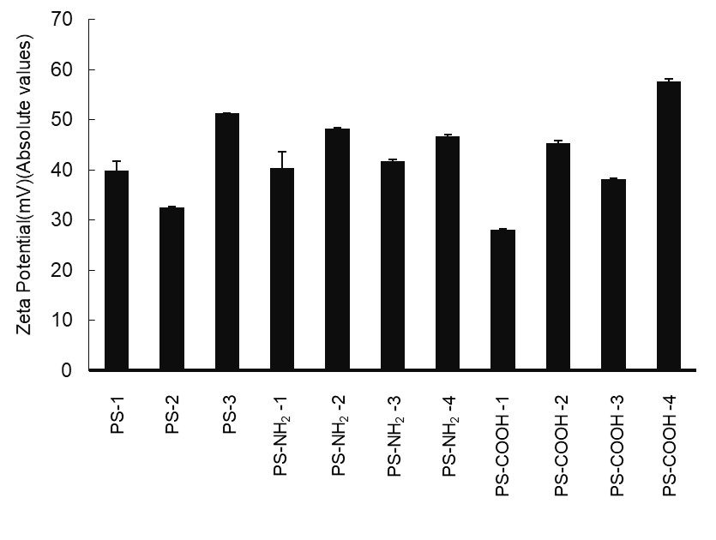Figure S1. Zeta potential (absolute values) of all polystyrene nano-/micro-plastics dispersed in deionized water.

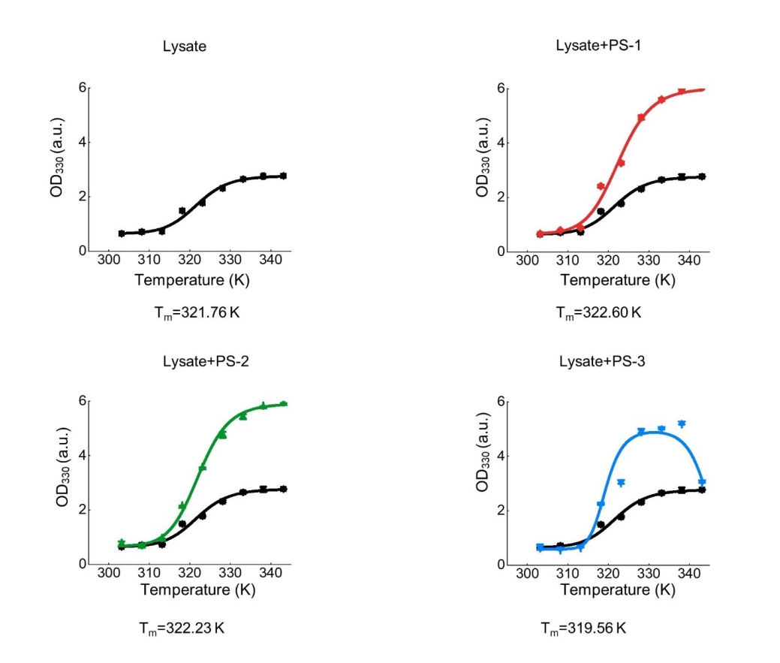
Figure S2. Thermal shift assay quantitatively determines the thermodynamic stability and aggregation propensity of E. coli lysate proteome upon heat induced protein aggregation in presence of naked polystyrene nanoparticles (PS-1 to PS-3). The lysate of E. coli was chosen as model proteome mixture to evaluate the influence on thermal stability caused by PS-1 to PS-3. The measurement and calculation of thermal shift assay was specifically described in Experimental Methods 1.2. Error bars: standard error, n = 3. (Refer to Fig. 3b)

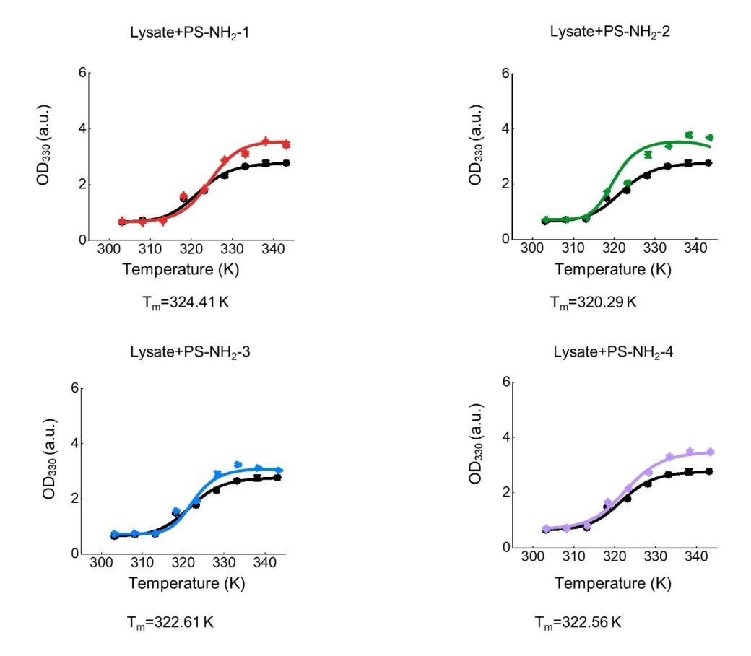
Figure S3. Thermal shift assay quantitatively determines the thermodynamic stability and aggregation propensity of E. coli lysate proteome upon heat induced protein aggregation in presence of amino-modified polystyrene nanoparticles (PS-NH₂-1 to PS-NH₂-4). The lysate of E. coli was chosen as model proteome mixture to evaluate the influence on thermal stability caused by PS-NH₂-1 to PS-NH₂-4. The measurement and calculation of thermal shift assay was specifically described in Experimental Methods 1.2. Error bars: standard error, n = 3. (Refer to Fig. 3b)

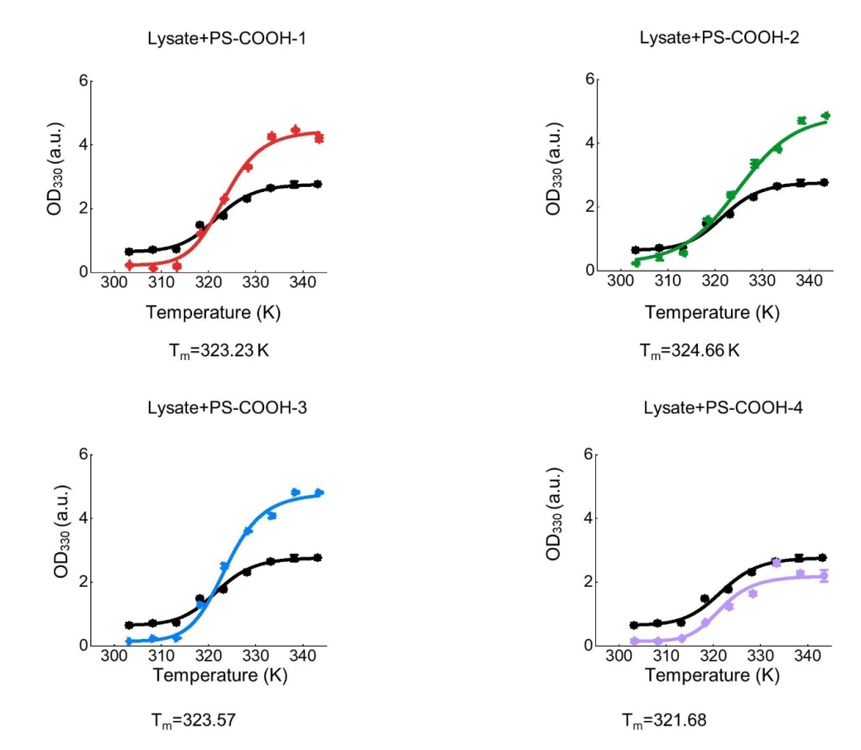
Figure S4. Thermal shift assay quantitatively determines the thermodynamic stability and aggregation propensity of E. coli lysate proteome upon heat induced protein aggregation in presence of carboxy-modified polystyrene nanoparticles (PS-COOH-1 to PS-COOH-4). The lysate of E. coli was chosen as model proteome mixture to evaluate the influence on thermal stability caused by PS-COOH-1 to PS-COOH-4. The measurement and calculation of thermal shift assay was specifically described in Experimental Methods 1.2. Error bars: standard error, n = 3 (Refer to Fig. 3b)

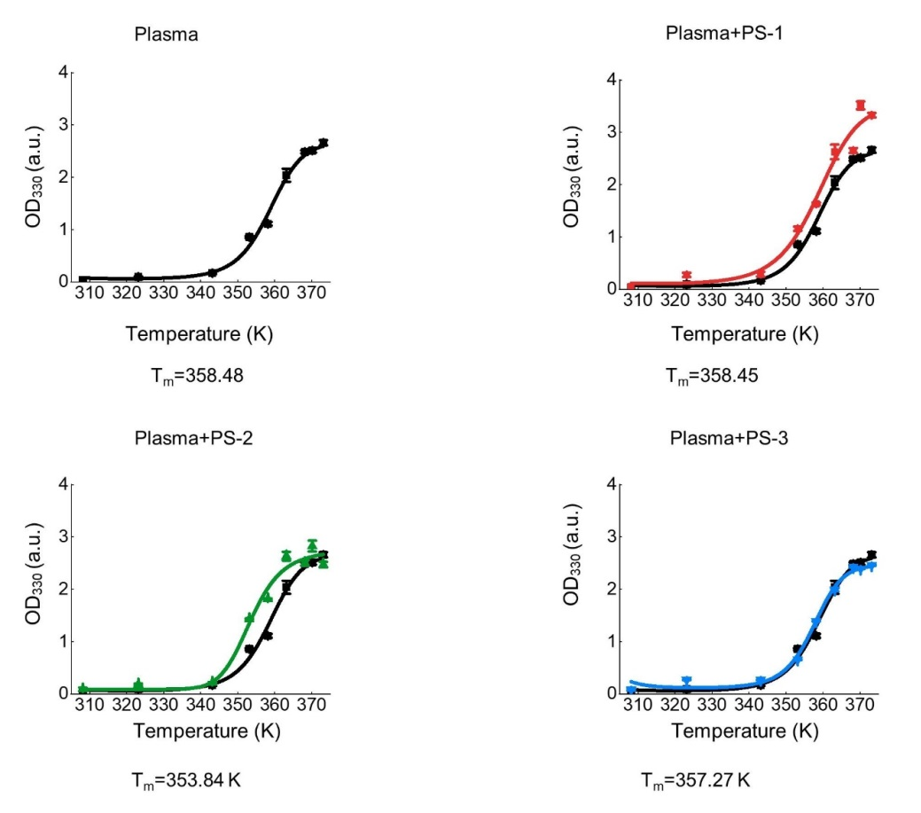
Figure S5. Thermal shift assay quantitatively determines the thermodynamic stability and aggregation propensity of human blood plasma proteome upon heat induced protein aggregation in presence of naked polystyrene nanoparticles (PS-1 to PS-3). The human blood plasma was chosen as model proteome mixture to evaluate the influence on thermal stability caused by PS-1 to PS-3. The measurement and calculation of thermal shift assay was specifically described in Experimental Methods 1.2. Error bars: standard error, n = 3 (Refer to Fig. 3f)

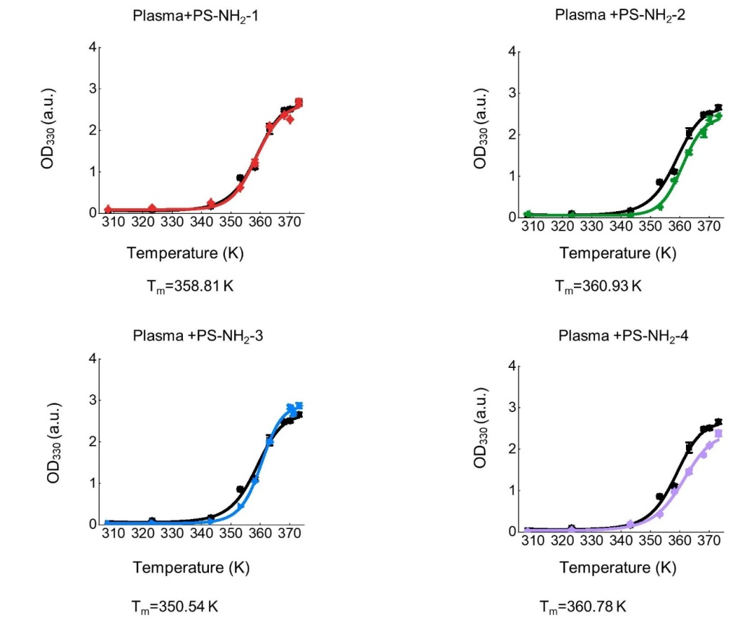
Figure S6. Thermal shift assay quantitatively determines the thermodynamic stability and aggregation propensity of human blood plasma proteome upon heat induced protein aggregation in presence of amino-modified polystyrene nanoparticles (PS-NH₂-1 to PS-NH₂-4). Human blood plasma was chosen as model proteome mixture to evaluate the influence on thermal stability caused by PS-NH₂-1 to PS-NH₂-4. The measurement and calculation of thermal shift assay was specifically described in Experimental Methods 1.2. Error bars: standard error, n = 3 (Refer to Fig. 3f)

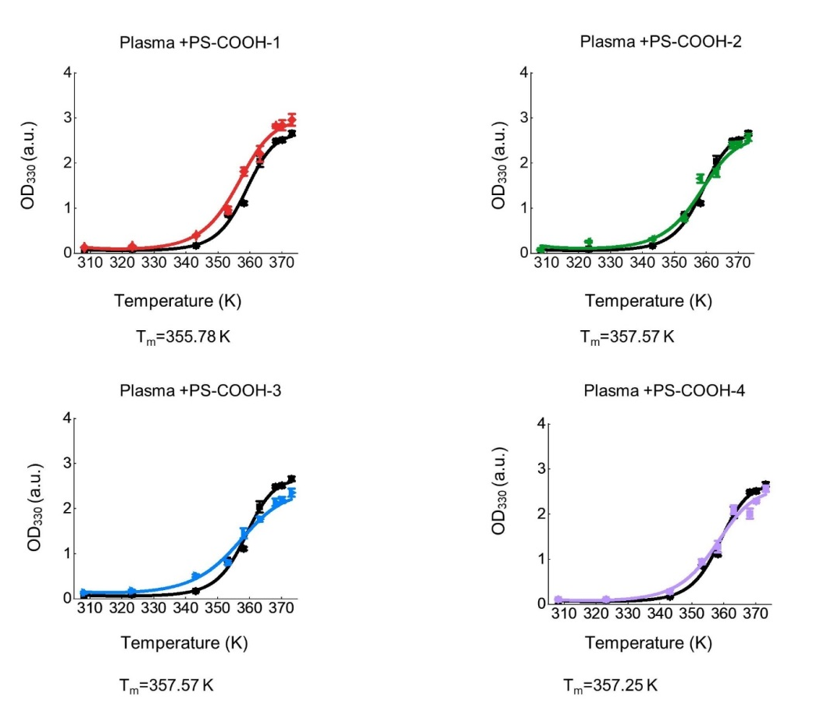
Figure S7. Thermal shift assay quantitatively determines the thermodynamic stability and aggregation propensity of human blood plasma proteome upon heat induced protein aggregation in presence of carboxy-modified polystyrene nanoparticles (PS-COOH-1 to PS-COOH-4). Human blood plasma was chosen as model proteome mixture to evaluate the influence on thermal stability caused by PS-COOH-1 to PS-COOH-4. The measurement and calculation of thermal shift assay was specifically described in Experimental Methods 1.2. Error bars: standard error, n = 3 (Refer to Fig. 3f)

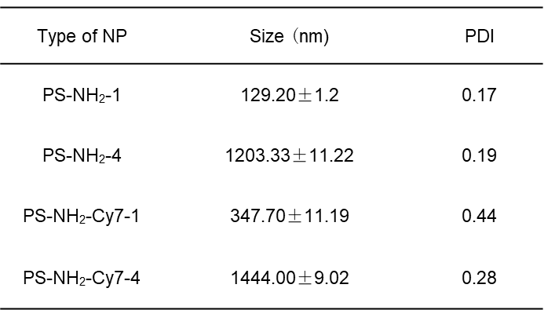
Figure S8. Comparison of particle size before and after amino-modified nanoparticles were labeled with Cy7-NHS through NHS chemistry. Particle size and PDI were slightly increased upon modification.

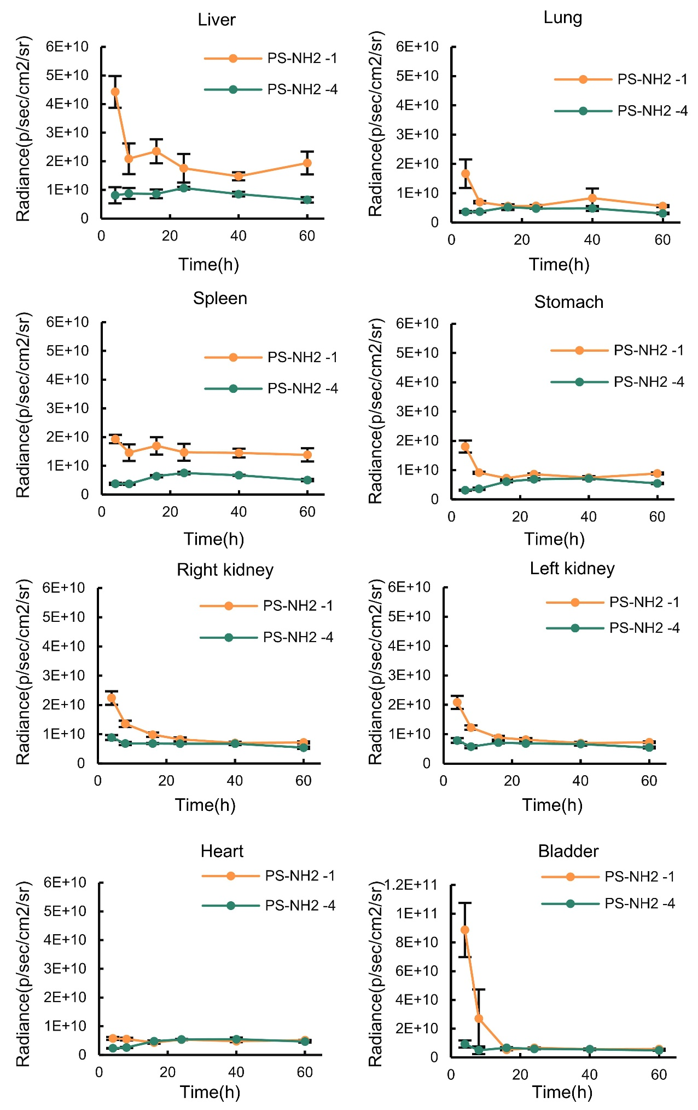
Figure S9. Biodistribution of Cy7 fluorescently labeled amino-modified polystyrene nanoparticles of two different sizes in mice (n = 6). Error bars: standard errors. Refer to Fig. 6b.
Table S1. Differentially expressed proteins in cells treated with PS-NH₂-4.

Table S2. Functional classifications of differentially expressed and up-regulated proteins in cells treated with the PS-NH₂-4.

Table S3. Differentially expressed and down-regulated proteins in cells treated with PS-NH₂-4.

Table S4. Functional classifications of proteins related to cellular metabolisms and differentially expressed in cells treated with PS-NH₂-4.

3. Experimental Procedures
3.1. Morphological evaluations by dynamic light scattering (DLS) and scanning electron microscope (SEM).
The nanoparticles were diluted into deionized water at 0.1 μM for dynamic light scattering (DLS) measurement. The size distribution and zeta potential of each type of nanoparticles were measured by Malvern Zetasizer Nano ZS90 instrument. The measurement of each types of nanoparticle was repeated three times (n = 3).
The sample was glued directly to the conductive adhesive and sprayed with gold for 45 s using an Oxford Quorum SC7620 sputter coater at 10 mA; the sample was then photographed using a ZEISS GeminiSEM 300 scanning electron microscope with an accelerating voltage of 3 kV for the morphology.
Plastic nanoparticles were purchased from Macklin as suspension in ddH2O and Store at 4°C.
3.2. Thermal shift assay to quantify the impact on proteome stability and aggregation propensity.
The protein concentration of lysate samples were measured by bicinchoninic acid assay (BCA assay). The lysate of E.coli (BL21 DE3) (1.0 mg·mL⁻¹) or human plasma (1.0 mg·mL⁻¹) was incubated with nanoparticles (5 μg·mL⁻¹) in acidic aggregation buffer (NaOAc 200 mM, KCl 100 mM, acidified by AcOH to pH = 6.23) under different temperatures for 5 min. The incubated mixture was pipetted into quartz cuvette to measure optical density at 330 nm (OD₃₃₀)¹.
The melting temperatures (T_{m}) were obtained through non-linear curve fitting of optical density readings at different incubation temperatures using the program OriginPro 2018:
$$F(T) = F(post)+ \frac{[F\left(pre\right)-F\left(post\right)]}{1+exp⁡\{\frac{-△H_{u}}{R}\left(\frac{1}{T}-\frac{1}{T_{m}}\right)+\frac{△C_{pu}}{R}\left[\ln\left(\frac{T}{T_{m}}\right)+ \frac{T}{T_{m}}-1\right]\} }$$
in which F(T) is the OD₃₃₀ signal at temperature T; T_{m} is the melting temperature of the protein aggregation transition, F(pre) and F(post) are the initial and ending transitional OD₃₃₀ signal, respectively, R is the gas constant, ∆H_{u} is the enthalpy of protein aggregation, and ∆C_{pu} is the heat capacity change upon protein aggregation.
3.3. Cytotoxicity of plastic nanoparticles
HepG2 cells (hepatocellular carcinoma) were grown in RPMI 1640 medium with 10 % FBS and 1 % antibiotics (penicillin-streptomycin) at 37 °C in a humidified environment of 5 % CO₂. Then, the cells were harvested and seeded in 96-well plates (1 × 10⁴ /well in 200 μL media), and incubated at 60 % confluency. Subsequently, the medium was replaced with the fresh medium containing different concentrations of polystyrenes (PS) nano-/micro-plastics. After further incubation for 24 h, the medium was replaced with 100 μL fresh RPMI 1640 media (containing 10% CCK-8) and then incubated for another 1 h in the dark. Next, the absorbance of the products was measured at 450 nm by the Tecan Spark Fluorescence Plate Reader. The control set was identical as abovementioned without addition of PSs. The relative cell viability was calculated according to the following formula: Cell viability (%) = (OD_{sample} - OD_{background})/(OD_{control} - OD_{background}) × 100%.
3.4. Fluorescence imaging of agregated proteome by AggStain probe
The HepG2 cells were seeded at 70 % confluency 12 h prior to nanoplastics treatment in 24-well NEST flat bottom cell culture plate (polystyrene, non-pyrogenic, sterile). Cells were grown in RPMI-1640 media supplemented with 10 % FBS and 1 % Penicillin-Streptomycin antibiotics until they reached 70 % confluency.
Experimental set: Nanoparticle (10.0 μg·mL⁻¹) and AggStain probe (2.5 μM) were introduced into the media and incubated for 24 h. Positive control: The cells were incubated with proteasome inhibitor MG132 (1.0 μM) and AggStain probe² (2.5 μM) for 24 h. Negative control: Only AggStain probe (2.5 μM) was added into cells to incubate for 24 h.
Fluorescence images of all samples were taken after staining with Hoechst 33342 for 30 min. Fluorescence images were taken using Olympus® IX73 Research Inverted Microscope. Nuclear staining fluorescence was visualized using ultroviolet light channel (BP 340-390 nm). The fluorescence of aggregated proteome in cellular milieu was visualized using blue light channel (460-495 nm).
3.5. Confocal imaging of agregated proteome by AggStain probe
The HepG2 cells were seeded at 70 % confluency 12 h prior to nanoparticles treatment in 20 mm NEST glass bottom cell culture dishes (polystyrene, non-pyrogenic, sterile). Cells were grown in RPMI-1640 media supplemented with 10 % FBS and 1 % Penicillin-Streptomycin antibiotics until they reached 70 % confluency.
Experimental set: Nanoparticle (10.0 μg·mL⁻¹) and AggStain probe (2.5 μM) were introduced into the media and incubated for 24 h. Positive control: The cells were incubated with proteasome inhibitor MG132 (1.0 μM) and AggStain probe (2.5 μM) for 24 h. Negative control: Only AggStain probe (2.5 μM) was added into cells for 24 h incubation. Images of all samples were taken after staining with Hoechst 33342 for 30 min. Fluorescence images were taken using Olympus® IX73 Research Inverted Microscope. Nuclear staining fluorescence was visualized using ultroviolet light laser (405 nm). The fluorescence of aggregated proteome in cellular milieu was visualized using green HeNe laser (543 nm).
3.6. Proteomics analysis.
Preparation of Cell Culture:
The HepG2 cells were seeded at 80 % confluency in two sets of 75 cm² culture flask with RPMI-1640 media. The PS-NH₂-4 (200 μg·mL⁻¹) was added into culture flask, and then incubated in RPMI-1640 media supplemented with 10 % FBS and 1 % Penicillin-Streptomycin antibiotics for 24 h at 37 °C under 5 % CO₂ condition. For each set, cells were dissociated via 0.25 % trypsin, and then re-suspendded in 1.0 mL PBS buffer. The total amount of cell was collected as 3 × 10⁷. The collected cells were centrifuged, the supernatant buffer was removed and re-suspended with PBS buffer. This washing procedure was repeated three times to obtain cell samples.
Preparation of Proteomics Analysis Sample:
Sample was lysed three times on ice using a high intensity ultrasonic processor in lysis buffer (8 M urea, 1 % v/v protease inhibitor cocktail). The remaining debris was removed by centrifugation at 12,000 × g at 4 °C for 10 min. Finally, the supernatant was collected and the protein concentration was determined with bicinchoninic acid (BCA) assay kit (Bio-Rad, Hercules, CA, USA) according to the manufacturer’s instructions. Tryptic peptides were firstly dissolved in 0.5 M tetraethylammonium bromide (TEAB). Each channel of peptide was labeled with their respective tandem mass tag (TMT) reagent, and incubated for 2 hours at room temperature. 5.0 μL of each sample were pooled, desalted and analyzed by MS to check labeling efficiency. After labeling efficiency check, samples were quenched by adding 5 % hydroxylamine. The pooled samples were then desalted with Strata X C18 SPE column and dried by vacuum centrifugation. The sample was fractionated into fractions by high pH reverse-phase HPLC using Agilent 300 Extend C18 column (5 μm particles, 4.6 mm ID, 250 mm length). Briefly, peptides were separated with a gradient of 2 % to 60 % acetonitrile in 10 mM ammonium bicarbonate pH 10 over 80 min into 80 fractions. Then, the peptides were combined into 9 fractions and dried by vacuum centrifuging.
Mass Spectrometry Analysis
The tryptic peptides were dissolved in solvent A (0.1% formic acid, 2% acetonitrile/ in water), directly loaded onto a home-made reversed-phase analytical column (25-cm length, 75 μm i.d.). Peptides were separated with a gradient from 5% to 25% solvent B (0.1% formic acid in 90% acetonitrile) over 60 min, 25% to 35% in 22 min and climbing to 80% in 4 min then holding at 80% for the last 4 min, all at a constant flowrate of 450 nL/min on an EASY-nLC 1200 UPLC system. The separated peptides were analyzed in Q ExactiveTM HF-X (ThermoFisher Scientific) with a nano-electrospray ion source. The electrospray voltage applied was 2.0 kV. The full MS scan resolution was set to 60,000 for a scan range of 350–1600 m/z. Up to 20 most abundant precursors were then selected for further MS/MS analyses with 30 s dynamic exclusion. The HCD fragmentation was performed at a normalized collision energy (NCE) of 28%. The fragments were detected in the Orbitrap at a resolution of 30,000. Fixed first mass was set as 100 m/z. Automatic gain control (AGC) target was set at 1E5, with an intensity threshold of 3.3E4 and a maximum injection time of 60 ms.
Database Searching
The resulting MS/MS data were processed using MaxQuant search engine (v.1.6.15.0). Tandem mass spectra were searched against the human SwissProt database (20422 entries) concatenated with reverse decoy database. Trypsin/P was specified as cleavage enzyme allowing up to 2 missing cleavages. The mass tolerance for precursor ions was set as 20 ppm in first search and 5 ppm in main search, and the mass tolerance for fragment ions was set as 0.02 Da. Carbamidomethyl on Cys was specified as fixed modification, and acetylation on protein N-terminal and oxidation on Met were specified as variable modifications. FDR was adjusted to < 1%. Preparation of proteomics analysis sample, mass spectrometry analysis, and database searching were performed by Jingjie PTM BioLab(HangZhou) company.
3.7. Fluorescent labeling of amino polystyrene nanoparticles with Cy7-NHS.
1.0 mL PS-NH₂ (25 mg·mL⁻¹) was mixed with 1.0 mL phosphate buffer (10.0 mM sodium phosphates, 100.0 mM KCl, 1.0 mM EDTA, acidified by HCl to pH = 7.40), and then added 50.0 μM Cy7-NHS. The mixture was stirred at room temperature for 12 h, and then dialyzed twice for 6 h at 4°C (7000 MWCO) to obtain fluorescently labeled PS-NH₂-Cy7.
3.8. Biodistribution and clearance of plastic nanoparticles in mice.
6-8 weeks female Balb/C mice purchased from Liaoning Changsheng Biotechnology Co., Ltd. The mice were utilized and anesthetized by inhalation of sevoflurane. Cy7 labeled PS nanoparticles (PS-NH₂-1-Cy7 and PS-NH₂-4-Cy7) were intravenously injected via tail. For each type of PS nanoplastic particles, the injected mice were isolated into 6 groups (6 mice for each group), and these groups of mice were sacrificed at 4, 8, 16, 24, 40, 60 h respectively. Major organs (heart, liver, kidney, spleen, lung and bladder) were dissected and visualized by VISQUE InVivo Smart-LF bio-imaging system. For PS-NH₂-1 and PS-NH₂-4: The fluorescence images were collected using 750-790 nm as excitation channel and using 810-860 nm as emission channel. The exposure time for fluorescence imaging was selected as 0.5 second.
Ethical claims: All animal studies were approved by the Institute Animal Care and Use Committee (IACUC) of Dalian Medical University (No. AAE21110) and carried out in accordance with established institutional guidelines and approved protocols.
3.9. Hepatotoxicity of PS-NH₂-1 in mice
Repeated administration of PS-NH₂-1
6-8 weeks female Balb/C mice were purchased from Liaoning Changsheng Biotechnology Co., Ltd. The mice were anesthetized by inhalation of sevoflurane. The administration of nanoparticle was tail intravenous injection. The mice were divided into two control groups and two experimental groups. For the first experimental group (repeated administration): 0.2 mL solution of PS-NH₂-1-Cy7 (1.0 mg·mL⁻¹) was injected every 24 h for 4 times (++++); For the other experimental group (one administration): 0.2 mL solution of PS-NH₂-1-Cy7 (1.0 mg·mL⁻¹) was injected into anesthetized mice at 72 h (+); For the negative control group: 0.2 mL saline was injected at 0 h. Mice of all these groups were sacrificed at 96 h. For the positive control group: mice were treated by intraperitoneal injection of acetaminophen (APAP) at a dose of 500 mg/kg. Mice were sacrificed at 12 h as acute liver injury model. Major organs, including heart, liver, kidneys, spleen, lung, bladder, were dissected from the mice, and the fluorescence signal was visualized by VISQUE InVivo Smart-LF bio-imaging system. The fluorescence signal of mice was measured using 750-790 nm as excitation channel and using 810-860 nm channel to collect fluorescence emission.
Long-term accumulation exaggerated liver damage of acetaminophen (APAP)
6-8 weeks female Balb/C mice were purchased from Liaoning Changsheng Biotechnology Co., Ltd. The mice were injected with PS-NH2-1 once as (+) group or 4 times once a day as (++++) group to saturate liver detoxification capacity. Next, an overdose of APAP (500 mg/kg) was injected intraperitoneally. The mice were imaged and sacrificed 4 h after APAP injection. Major organs, including heart, liver, kidneys, spleen, lung, bladder, were dissected from the mice, and the fluorescence signal was visualized by VISQUE InVivo Smart-LF bio-imaging system. The fluorescence signal of mice was measured using 750-790 nm as excitation channel and using 810-860 nm channel to collect fluorescence emission.
Aspartate aminotransferase (AST) and alanine aminotransferase (ALT) assay
The measurement of blood concentration of AST or ALT was performed using AST/GOT or ALT/GOT kit (Nanjing Jiancheng Bioeng. Inst.). The blood was collected from tail vein. The blood sample was placed into promoting coagulating tube, and then centrifuged (1,500 × g) for 15 min. The supernatant was separated as serum. Control set: 0.5 mL AST or ALT reagent solutions were incubated at 37 °C for 30 min. 0.5 mL 2, 4-dinitrophenylhydrazine and 0.1 mL serum were added into testing sample, and then the obtained testing sample mixture was incubated in 37 °C water bath for another 20 min. Next, 5.0 mL NaOH (0.4 M) was introduced and kept under ambient temperature for 5 min. The absorption at 505 nm (OD₅₀₅) was measured as background. Experimental set: 0.1 mL serum and 0.5 mL 37 °C pre-heated AST or ALT reagent solutions were mixed, and then incubated at 37 °C for 30 min. 0.5 mL 2, 4-dinitrophenylhydrazine was added into testing sample mixture and incubated in 37 °C water bath for another 20 min. Next, 5.0 mL NaOH (0.4 M) was introduced and kept under ambient temperature for 5 min. The absorption at 505 nm (OD₅₀₅) was measured and then deducted OD₅₀₅ of control set as the optical density of the color generated by deamination (ΔOD). AST/GOT and ALT/GOT values were calculated from standard curve using ΔOD values of experimental sets.
3.10. Hematoxylin and Eosin (H&E) staining
The freshly dissected liver tissue was embedded with optimal cutting temperature compound (OCT). The tissue was then sliced into 6 μm histologic sections via LEICA CM1950 clinic cryostat. The histologic sections were placed into Coplin jar containing 4 °C acetone 10 min for fixation. Remove the slides from the acetone and completely air-dry them for 20–30 min at room temperature. First, hematoxylin drops were kept in the tissue sections for 2 min. Next the tissue sections were placed in flowing water with running water to reverse blue for 10 min. Further eosin staining was added dropwise to the tissue sections for 1 min, and then placed in running water to flush for 2 min, followed by dehydration in different gradients of ethanol (75%, 80%, 95%, 100%) and transparent treatment in xylene. Finally, neutral resin was added dropwise on the tissue sections to seal them. Bright-field images were taken using the Olympus FV1000 FluoView™ confocal microscope.
3.11. Histochemistry of liver tissue treated with plastic nanoparticles
The freshly dissected liver tissue was embedded with optimal cutting temperature compound (OCT). The tissue was then sliced into 6 μm histologic sections via LEICA CM1950 clinic cryostat. The histologic sections were placed into Coplin jar containing 4 °C acetone 10 min for fixation, and then removed the slides from the acetone and completely air-dried for 20–30 min at room temperature. The slides were rinsed three times with PBS buffer for 5 min. All slides were removed from the PBS buffer and placed on an Eppendorf flipper rack and target area was circled by PAP pen. AggStain (5.0 μM) solution was applied to fully stain target area for 1 h, and then rinsed with PBS buffer. Next, the section further stained with Hoechst 33342 (2.0 μg·mL⁻¹) for 15 min and then rinsed with PBS buffer. The finely stained tissue slides were sealed in antifade mounting medium. The fluorescence images of tissue sections were collected via Olympus FV1000 FluoView™ confocal microscope. Nuclear staining fluorescence was visualized using violet laser (405 nm). The fluorescence of aggregated proteome stained by AggStain probe in cellular milieu was visualized using green HeNe laser (543 nm) ³.

3. Reference.
1.Y. Huang, et al. Common Pitfalls and Recommendations for Using a Turbidity Assay to Study Protein Phase Separation Biochemistry 60, 2447-2456 (2021)
2.W. Wan, et al. Monitoring the Dynamics of Proteome Aggregation in Live Cells Using a Solubilized and Noncovalent Analogue of Fluorescent Protein Chromophores Anal. Chem. 93, 1717-1724 (2021)
3.N. P. Withana, et al. Labeling of active proteases in fresh-frozen tissues by topical application of quenched activity-based probes Nat. Protoc. 11, 184-91 (2016)

