Supplementary Information
Predicting the secondary metabolic potential of microbiomes from marker genes using PSMPA

Bin Wei ^{1, 2, #}, Zhen-Yi Zhou ^{1, #}, Cong Lai ¹, Ao-Qi Du ¹, Gang-Ao Hu ¹, Wen-Chao Yu ¹, Yan-Lei Yu ¹, Jian-Wei Chen ¹, Hua-Wei Zhang ¹, Qi-Hao Wu ^{1,3}, Xue-Wei Xu ^{2, *}, Qi Xuan ^{4, *}, Hong Wang ^{1, *}

¹ College of Pharmaceutical Science & Collaborative Innovation Center of Yangtze River Delta Region Green Pharmaceuticals, Zhejiang University of Technology, Hangzhou 310014, China
² Key Laboratory of Marine Ecosystem and Biogeochemistry, Ministry of Natural Resources & Second Institute of Oceanography, Ministry of Natural Resources, Hangzhou 310012, China
³ Current address: Departments of Chemistry; Institute of Biomolecular Design & Discovery, Yale University, West Haven, CT 06516, United States.
⁴ Institute of Cyberspace Security, College of Information Engineering, Zhejiang University of Technology, Hangzhou 310023, China

*Correspondence author:
Tel: 86-571-8832-0622;
E-mail: hongw@zjut.edu.cn (H. W.); xuanqi@zjut.edu.cn (Q. X.); xuxw@sio.org.cn (X. X.)
# Bin Wei and Zhen-Yi Zhou contributed equally to this article.
16S rRNA gene and BGC database processing for psmpa1
The PSMPA pipeline provides two algorithms to predict the BGC profiles of microbiomes using 16S rRNA gene sequences. The first one (psmpa1) uses the same algorithm provided by PICRUSt2, which contains a reference tree consisting of 20,000 unique full-length 16S rRNA genes [1]. The corresponding bacterial genomes of these 16S rRNA sequences were collected according to the IMG genome ids provided in https://github.com/gavinmdouglas/picrust2_manuscript. Notably, a few genomes were replaced by those with the same lineage because they were not available in the IMG or NCBI database. All acquired genome sequences were analyzed by antiSMASH (v5.2.0) [2], and the numbers of each class of BGCs in each genome were extracted using a custom Python script to prepare the traits of BGCs for all the 20,000 full-length 16S rRNA genes in the database.
16S rRNA gene and BGC database processing for psmpa2
The second algorithm (psmpa2) uses BLASTn to predict the BGC profiles for each input sequence by comparing the sequence identity against a 16S rRNA gene database. The psmpa2 collected all bacterial genomes (220,524 in total) from NCBI RefSeq Assembly Database (https://ftp.ncbi.nlm.nih.gov/genomes/refseq) on July 2021. The 16S rRNA sequences were extracted from the genomic FASTA files based on the keyword 16S ribosomal RNA in the annotation using a custom Python script. A total of 676,967 16S rRNA gene sequences were extracted from these genomes. To reduce the redundancy of the 16S rRNA gene database, we selected the longest 16S rRNA gene sequence in each genome and then used SeqKit (v0.16.1) to remove the duplicate sequences [3]. For some genomes whose 16S rRNA sequences could not be successfully extracted, we used Prokka (v1.14.6) to annotate the genomes and then extract the 16S rRNA sequences [4]. For the collection of taxonomic information, we used TaxonKit (v0.8.0) to obtain specific taxonomic lineage based on the taxonomy id of the genome [5]. Finally, there were 75,564 entries of 16S rRNA gene sequences in the database of psmpa2.
Then, genomes lacking 16S rRNA gene or complete taxonomic lineage were removed and the remaining 216,408 genomes were analyzed by antiSMASH (v5.2.0). The numbers of each class of BGCs were extracted as described above. Since some genomes with identical 16S rRNA sequences may contain a different composition of BGCs, we used four different methods (mean_float, mean_int, median_float, median_int) to prepare the BGC database for all the 75,564 entries in 16S rRNA gene database. As the names of these methods indicate, the number of each class of BGCs for each entry were obtained by calculating the mean or median number (retaining floats or integers) of BGCs in strains with the identical 16S rRNA genes.
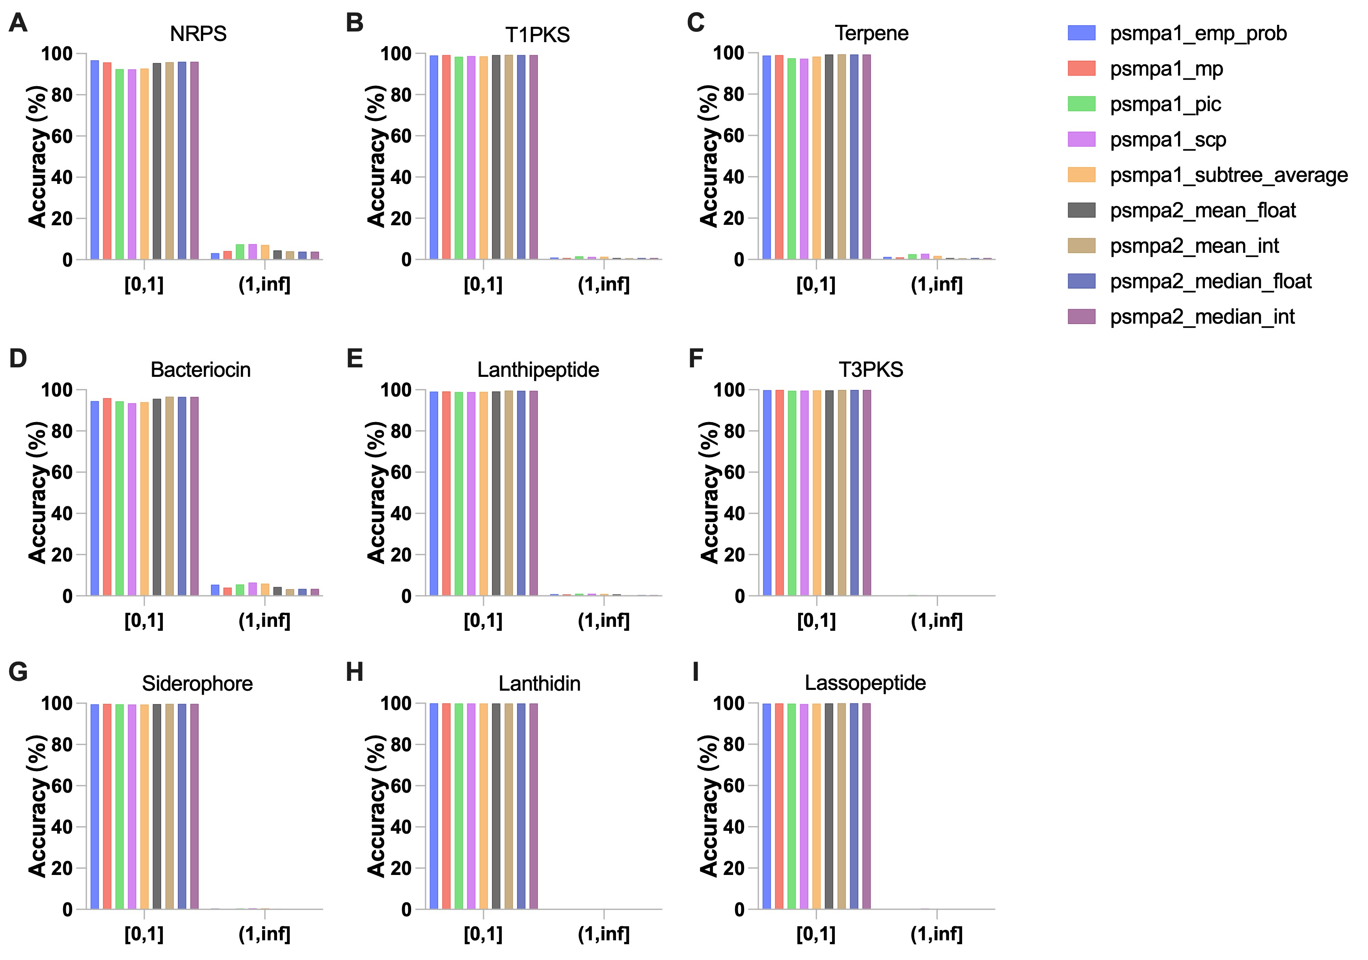
Supplementary Figure 1. Accuracy of PSMPA under different parameters in the prediction of BGC counts in 5,000 bacterial genomes. Bias of the number of (A) NRPS, (B) T1PKS, (C) Terpene, (D) Bacteriocin, (E) Lanthipeptide, (F) T3PKS, (G) Siderophore, (H) Lanthidin, and (I) Lassopeptide BGCs using the V3-V4 region of 16S rRNA genes.

References
- Douglas, G.M., Maffei, V.J., Zaneveld, J.R., Yurgel, S.N., Brown, J.R., Taylor, C.M., Huttenhower, C. and Langille, M.G. PICRUSt2 for prediction of metagenome functions. Nat. Biotechnol. 2020; 38(6): 685-688.
- Blin, K., Shaw, S., Steinke, K., Villebro, R., Ziemert, N., Lee, S.Y., Medema, M.H. and Weber, T. (2019) antiSMASH 5.0: updates to the secondary metabolite genome mining pipeline. Nucleic Acids Res. 2019; 47(W1): W81-W87.
- Shen, W., Le, S., Li, Y. and Hu, F. SeqKit: a cross-platform and ultrafast toolkit for FASTA/Q file manipulation. PLoS One. 2016; 11(10): e0163962.
- Seemann, T. Prokka: rapid prokaryotic genome annotation. Bioinformatics. 2014; 30(14): 2068-2069.
- Shen, W. and Ren, H. TaxonKit: a practical and efficient NCBI taxonomy toolkit. J Genet Genomics. 2021; 48(9): 844-850.

