Synthesis, structure,Hirshfeld surface analysisand computational studies of 2-amino-5-nitropyridine-2,4-dinitrophenol cocrystal
Shanmugam Sivaraman^{1,2}•Chellakarungu Balakrishnan^{1,3}•Palusamy Suppuraj³•
Subbiah Meenakshisundaram¹*
¹Department of Chemistry, Annamalai University, Annamalainagar-608002, Tamil Nadu, India.
²Department of Chemistry, IndraGanesan College of Engineering, Manikandam, Tiruchirapalli -620012, TamilNadu, India.
³ Department of Chemistry, Erode Sengunthar Engineering College, Erode - 638057, Tamil Nadu, India.

*Corresponding author:
Dr. SP. Meenakshisundaram
CSIR Emeritus Scientist
Department of Chemistry
Annamalai University
Annamalainagar - 608 002
Tamil Nadu, India
Tel: +91 94430 91274
E-mail: aumats2009@gmail.com

Supporting information
Supplementary Figures
Fig. S1FT-IR spectra of (a) 2-amino-5-nitropyridine (b) 2,4-dinirophenol and (c) ANDP
Fig. S2 Percentage contributions to the Hirshfeld surface areas for the various close intermolecular contacts for ANDP
Fig. S3(a) Mulliken atomic charge distribution and (b) Mulliken plot of ANDP
Fig. S4 Electron density surface maps

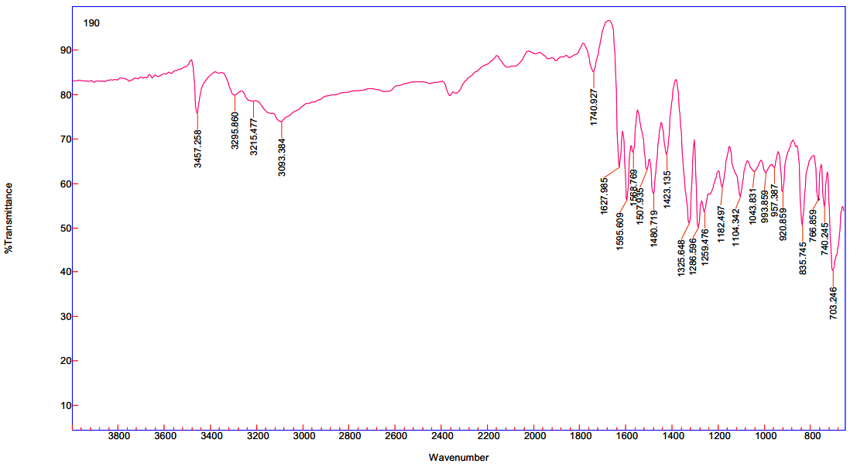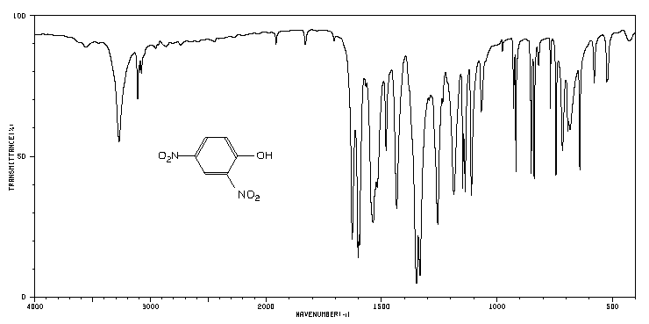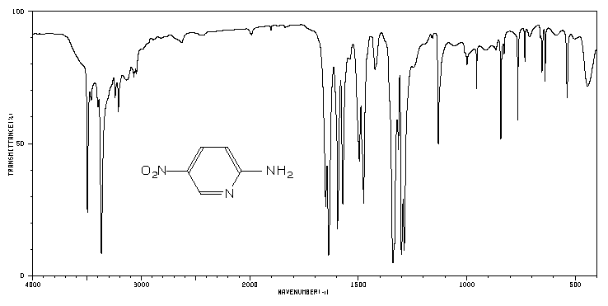
Fig. S1 FT-IR spectra of (a) 2-amino-5-nitropyridine (b) 2,4-dinirophenol and (c) ANDP
(SDBS No: 2390)
(SDBS No: 4210)
b
a
c

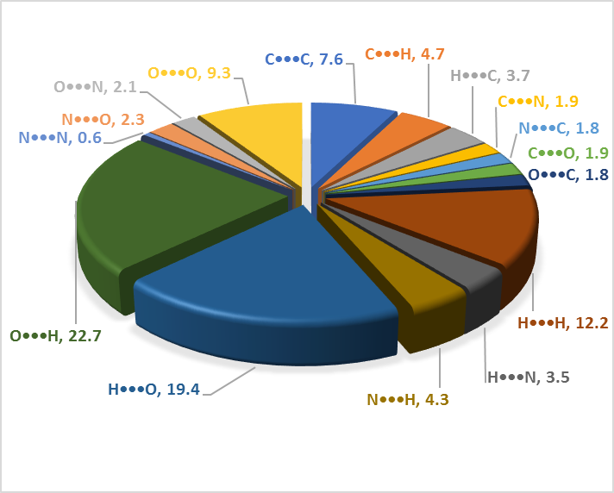
Fig. S2 Percentage contributions to the Hirshfeld surface areas for the variousclose intermolecular contacts for ANDP

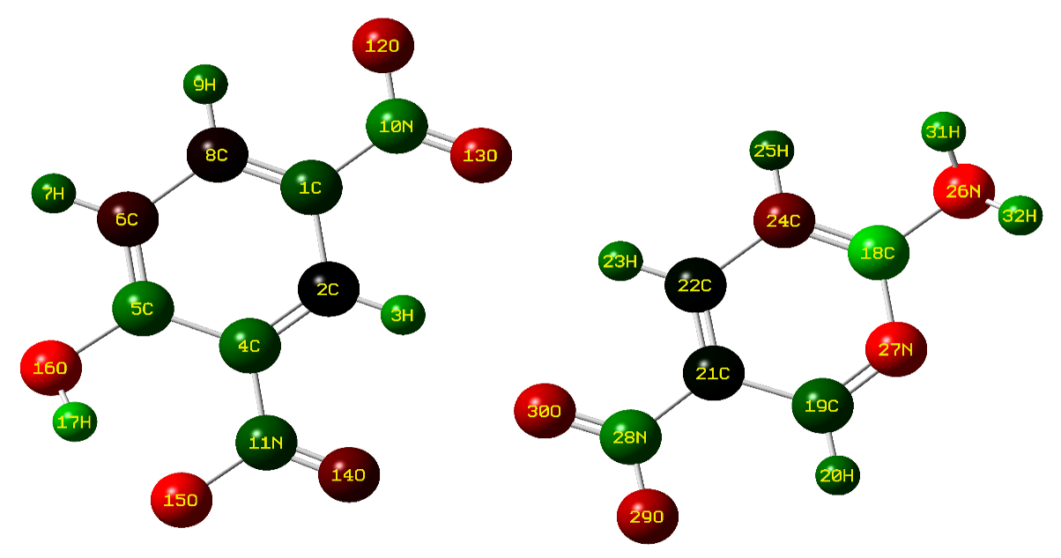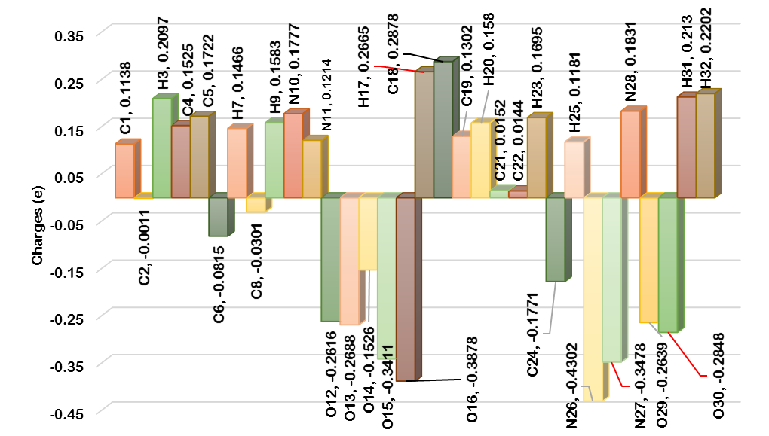
Fig. S3 (a) Mulliken atomic charge distribution and (b) Mulliken plot of ANDP
b
a

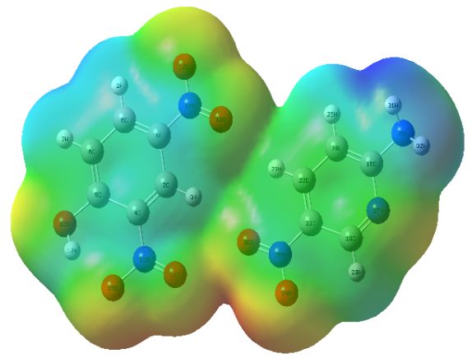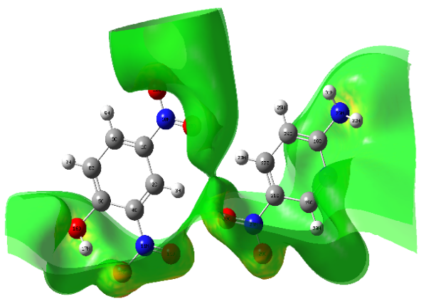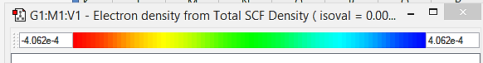
Fig.S4 Electron density surface maps
-1.191e-2
1.191e-2

-5.729e-2
5.729e-2

