Supplementary information
A novel inverse membrane bioreactor for efficient bioconversion from methane gas to liquid methanol using a microbial gas-phase reaction
Yan-Yu Chen¹, Masahito Ishikawa¹, Katsutoshi Hori^{1,*}

¹ Department of Biotechnology, Graduate School of Engineering, Nagoya University, Furo-cho, Chikusa-ku, Nagoya 464-8603, Japan.

*Corresponding authors: Katsutoshi Hori
Department of Biomolecular Engineering, Graduate School of Engineering, Nagoya University, Furo-cho, Chikusa-ku, Nagoya 464-8603, Japan
Tel.: +81-52-789-3339; Fax: +81-52-789-3218
E-mail address: khori@chembio.nagoya-u.ac.jp

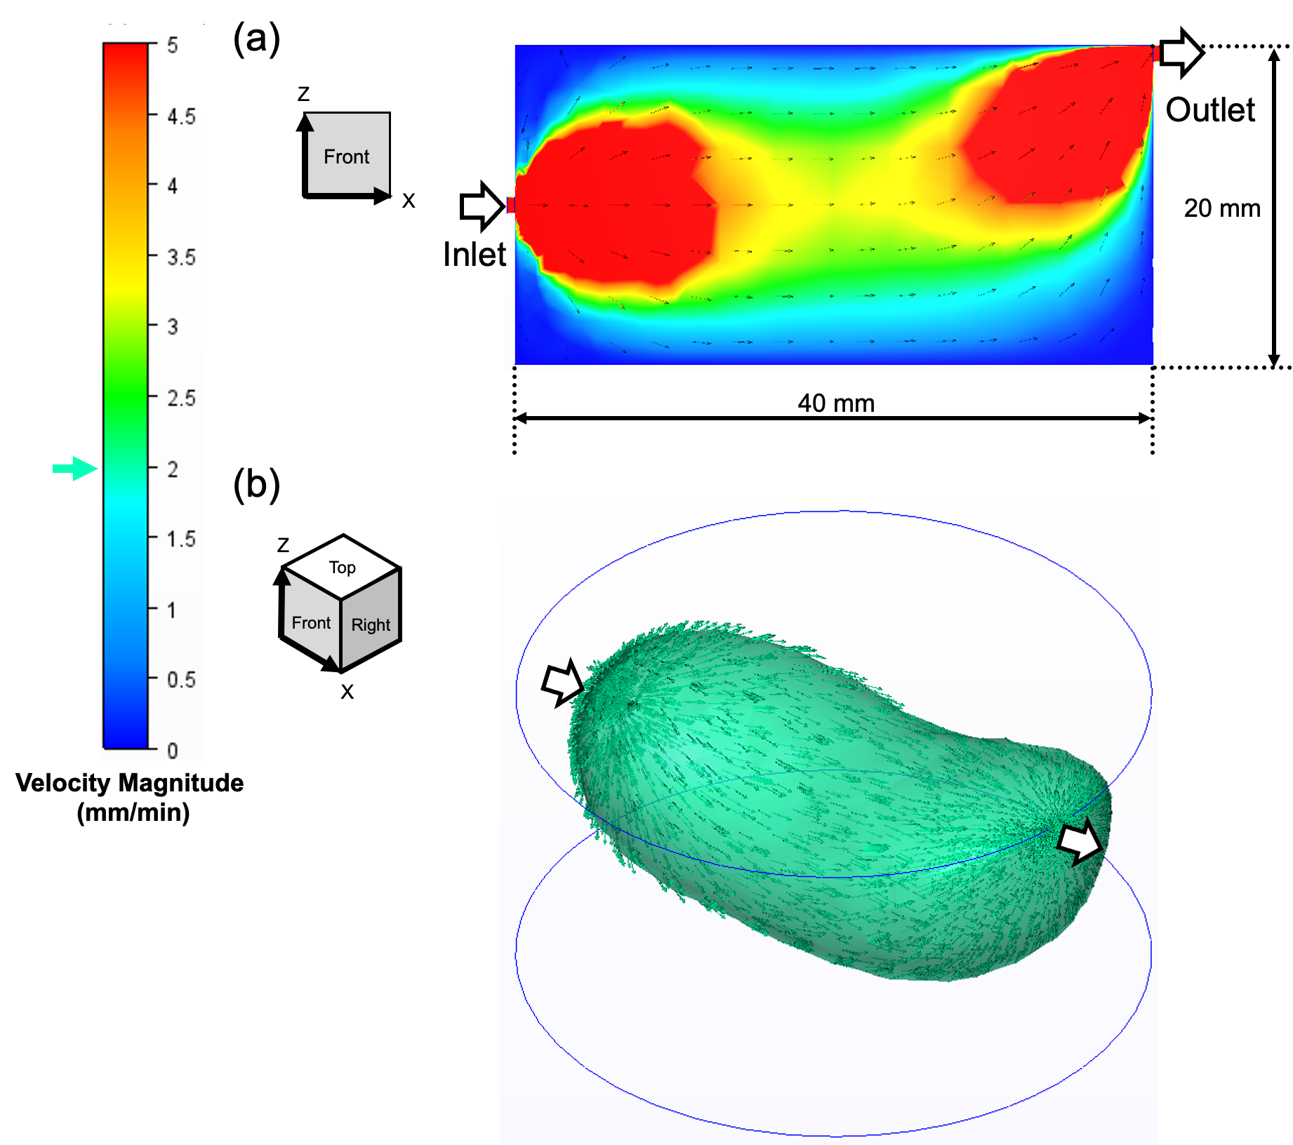
Additional file 2. Computational flow dynamic analysis in a 25 mL gas chamber; (a) the profile of velocity magnitude on the XZ plane; and (b) the 3-D profile of the gas flow when the velocity magnitude is higher than 2 mm min⁻¹. The arrows are velocity vectors indicating the direction of the gas flow.

