Additional materials

Additional File 1. Flow chart of LSTM model

Additional File 2. Time series decomposition of ILI%, influenza positive rate and ILI% * influenza positive rate
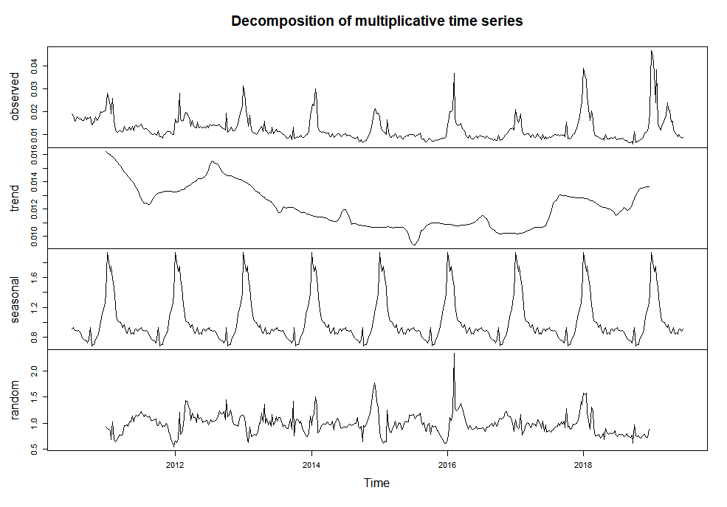
A. Time series decomposition of ILI%

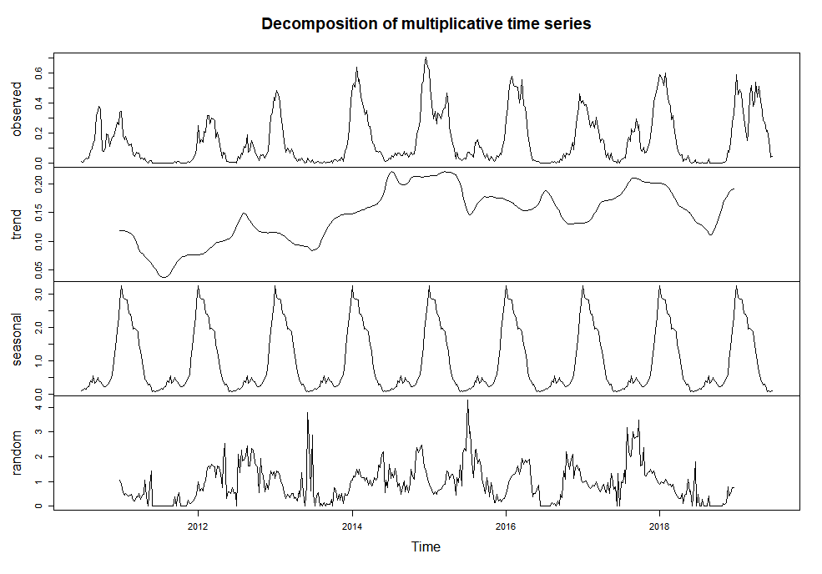
B. Time series decomposition of influenza positive rate

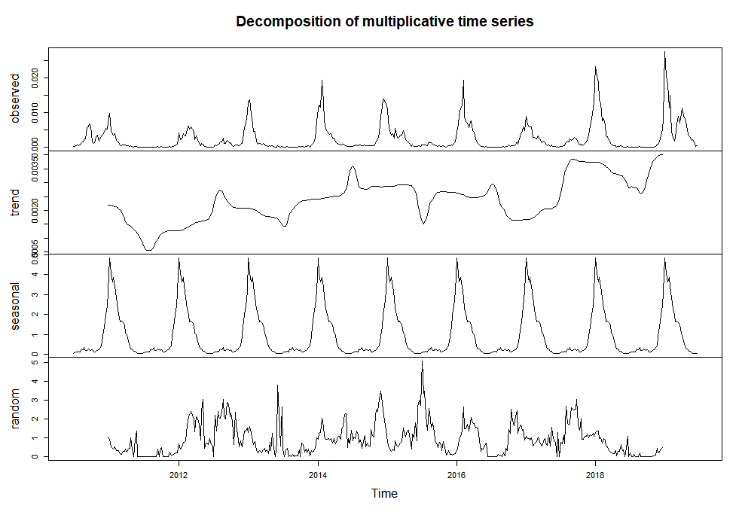
C. Time series decomposition of ILI% * influenza positive rate

Additional File 3. Auto-correlation function (ACF) and partial auto-correlation function (PACF).

Additional File 4. Comparison of different prediction periods of SARIMA and hybrid LSTM models
Predict  weeks | ILI% |  |  |  | Influenza positive rate |  |  |  | ILI%*Influenza positive rate
Predict  weeks | SARIMA |  | Hybrid LSTM |  | SARIMA |  | Hybrid LSTM |  | SARIMA |  | Hybrid LSTM
Predict  weeks | EX | R2 | EX | R2 | EX | R2 | EX | R2 | EX | R2 | EX | R2
1 | 0.681 | 0.680 | 0.828 | 0.823 | 0.906 | 0.906 | 0.972 | 0.972 | 0.855 | 0.854 | 0.957 | 0.957
2 | 0.681 | 0.681 | 0.829 | 0.823 | 0.907 | 0.906 | 0.972 | 0.972 | 0.855 | 0.855 | 0.956 | 0.956
3 | 0.655 | 0.654 | 0.801 | 0.798 | 0.907 | 0.906 | 0.973 | 0.972 | 0.817 | 0.816 | 0.920 | 0.920
4 | 0.634 | 0.632 | 0.817 | 0.815 | 0.907 | 0.907 | 0.969 | 0.968 | 0.804 | 0.802 | 0.919 | 0.918
5 | 0.623 | 0.620 | 0.825 | 0.823 | 0.908 | 0.907 | 0.968 | 0.967 | 0.795 | 0.793 | 0.908 | 0.908
6 | 0.626 | 0.623 | 0.817 | 0.814 | 0.908 | 0.908 | 0.966 | 0.966 | 0.797 | 0.795 | 0.879 | 0.879
7 | 0.616 | 0.613 | 0.810 | 0.807 | 0.909 | 0.908 | 0.964 | 0.964 | 0.794 | 0.791 | 0.881 | 0.881
8 | 0.616 | 0.612 | 0.802 | 0.799 | 0.909 | 0.908 | 0.963 | 0.962 | 0.793 | 0.790 | 0.879 | 0.879
9 | 0.616 | 0.612 | 0.802 | 0.799 | 0.908 | 0.907 | 0.962 | 0.962 | 0.792 | 0.790 | 0.878 | 0.878
10 | 0.616 | 0.612 | 0.802 | 0.799 | 0.905 | 0.905 | 0.961 | 0.961 | 0.790 | 0.788 | 0.878 | 0.878
11 | 0.616 | 0.612 | 0.801 | 0.798 | 0.905 | 0.905 | 0.961 | 0.961 | 0.790 | 0.788 | 0.878 | 0.878
12 | 0.616 | 0.612 | 0.801 | 0.798 | 0.903 | 0.903 | 0.955 | 0.954 | 0.790 | 0.788 | 0.876 | 0.876
13 | 0.615 | 0.611 | 0.800 | 0.797 | 0.899 | 0.899 | 0.950 | 0.950 | 0.788 | 0.786 | 0.873 | 0.873
14 | 0.613 | 0.609 | 0.795 | 0.793 | 0.899 | 0.898 | 0.950 | 0.950 | 0.787 | 0.785 | 0.873 | 0.873
15 | 0.606 | 0.601 | 0.784 | 0.782 | 0.897 | 0.896 | 0.950 | 0.950 | 0.783 | 0.780 | 0.869 | 0.869
16 | 0.603 | 0.598 | 0.784 | 0.782 | 0.889 | 0.888 | 0.947 | 0.947 | 0.775 | 0.772 | 0.868 | 0.868
17 | 0.599 | 0.593 | 0.783 | 0.782 | 0.883 | 0.881 | 0.947 | 0.947 | 0.770 | 0.766 | 0.869 | 0.869
18 | 0.598 | 0.591 | 0.783 | 0.782 | 0.871 | 0.869 | 0.946 | 0.946 | 0.766 | 0.761 | 0.869 | 0.869
19 | 0.597 | 0.590 | 0.782 | 0.781 | 0.862 | 0.860 | 0.946 | 0.946 | 0.762 | 0.758 | 0.868 | 0.868
20 | 0.597 | 0.590 | 0.782 | 0.781 | 0.854 | 0.852 | 0.946 | 0.946 | 0.761 | 0.756 | 0.868 | 0.868
21 | 0.597 | 0.590 | 0.782 | 0.781 | 0.850 | 0.847 | 0.946 | 0.946 | 0.760 | 0.755 | 0.868 | 0.868
22 | 0.597 | 0.590 | 0.782 | 0.781 | 0.846 | 0.843 | 0.946 | 0.946 | 0.760 | 0.755 | 0.868 | 0.868
23 | 0.597 | 0.590 | 0.782 | 0.781 | 0.844 | 0.841 | 0.946 | 0.946 | 0.760 | 0.755 | 0.868 | 0.868
24 | 0.597 | 0.590 | 0.782 | 0.781 | 0.841 | 0.837 | 0.946 | 0.946 | 0.760 | 0.754 | 0.868 | 0.868
25 | 0.596 | 0.590 | 0.782 | 0.781 | 0.840 | 0.836 | 0.946 | 0.946 | 0.760 | 0.754 | 0.868 | 0.868
26 | 0.596 | 0.590 | 0.782 | 0.781 | 0.840 | 0.836 | 0.945 | 0.945 | 0.760 | 0.754 | 0.868 | 0.868
Note: EX, expected variance.

