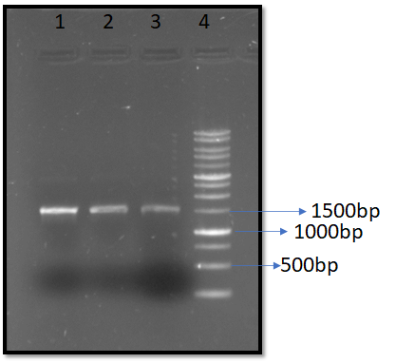
Fig S1 Agarose gel electrophoresis analysis of 16S rRNA amplified from a bacterial isolate. PCR amplified products were run on 1% agarose gel. Lane 4 – 1Kbp DNA ladder; Lane 1,2, and 3- PCR product of bacterial isolate.

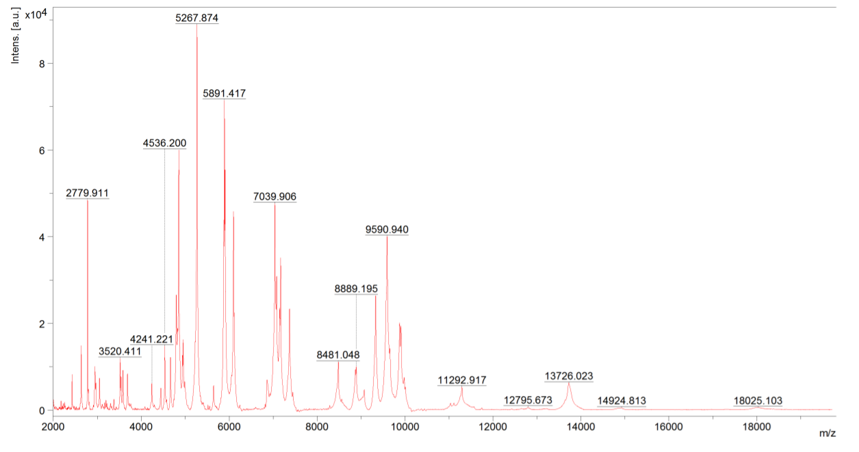
Fig S2 MS profiles of bacterial isolates showing spectra with specific peaks. Intense [a.u] Intensity arbitrary units; (m/z) mass-to-charge ratio.

Fig S3 The determination of metal tolerance of the bacterial isolates grown on metal incorporated media.
a)
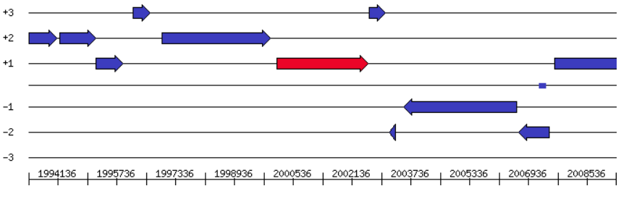
b)
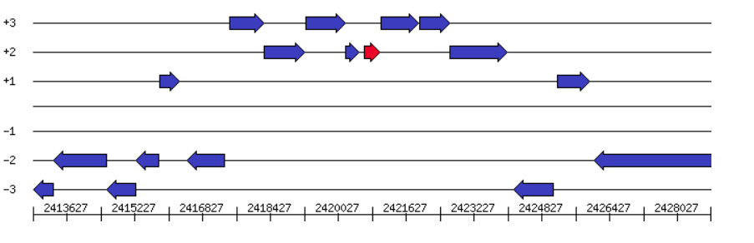
c)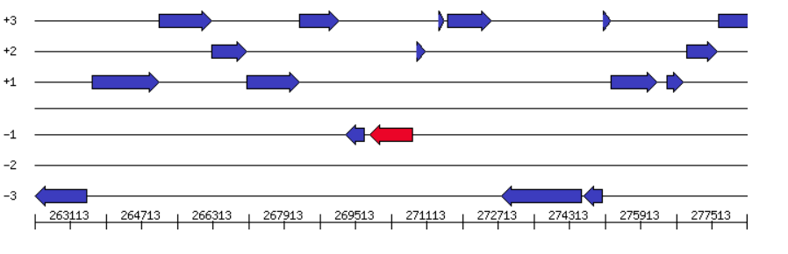
Fig S4: The annotation of heavy metal resistant genes on the genome of strain NWUAB01 and their location on the genome (a) Lead, cadmium, zinc and mercury transporting ATPase (b) Copper resistance protein C (c) cobalt–zinc–cadmium resistance protein (CzcD)

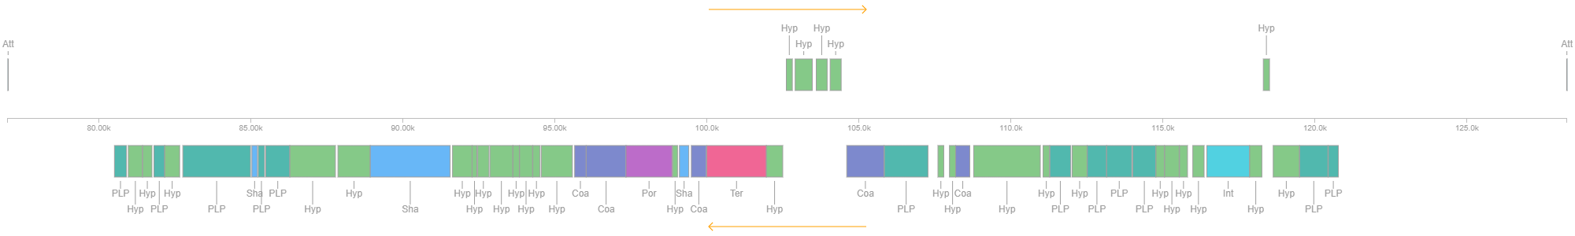
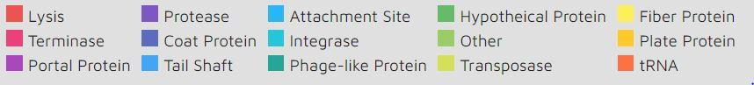
Fig S5: From the complete genome sequencing of S. maltophilia SRM01, bacteriophage remnants were found. To show their potential roles, the boxes are color-coded, and the legend is pasted beneath the figure.

