Supplementary Information 2

Recurrence intervals for M>7 Miyagi-ken-Oki earthquakes during an M~9 earthquake cycle
Ryoko Nakata1
Corresponding author
Email: rnakata@eps.s.u-tokyo.ac.jp

Naoki Uchida2,3
Email: naoki.uchida.b6@tohoku.ac.jp

Takane Hori4
Email: horit@jamstec.go.jp

Ryota Hino2
Email: hino@tohoku.ac.jp

(Institutional addresses)
¹ Graduate School of Science, The University of Tokyo, 7-3-1 Hongo, Bunkyo-ku, Tokyo 113-0033, Japan
² Graduate School of Science, Tohoku University, 6-6, Aramaki-aza-aoba, Aoba-ku, Sendai 980-8578, Japan
³ Earthquake Research Institute, The University of Tokyo, 1-1-1 Yayoi, Bunkyo-ku, Tokyo 113-0032, Japan
⁴ Research and Development Center for Earthquake and Tsunami Forecasting (FEAT), Research Institute for Marine Geodynamics (IMG), Japan Agency for Marine-Earth Science and Technology (JAMSTEC), 3173-25 Showa-machi, Kanazawa-ku, Yokohama 236-0001, Japan

Supplementary Figures

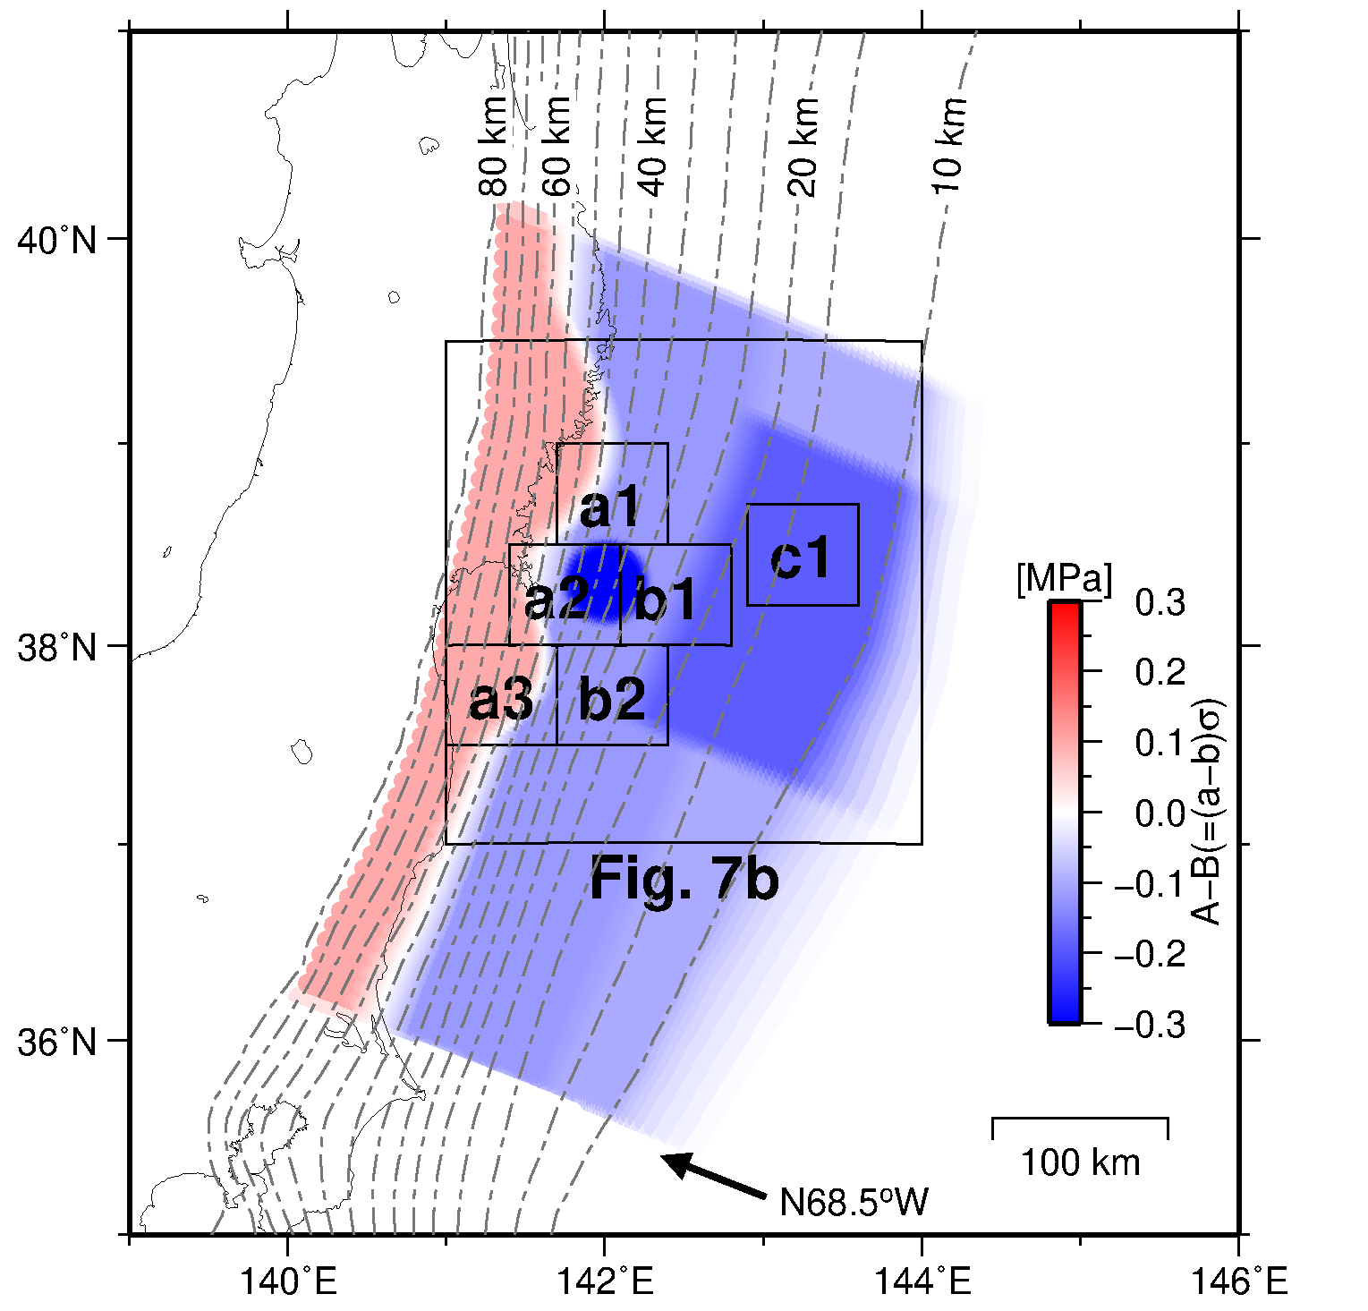
Supplementary Figure 1. Position of the squares used in Figure 7 in the main text and the frictional parameters (A–B). Contours indicate the depth (km) to the upper surface of the descending plate (Baba et al., 2006).

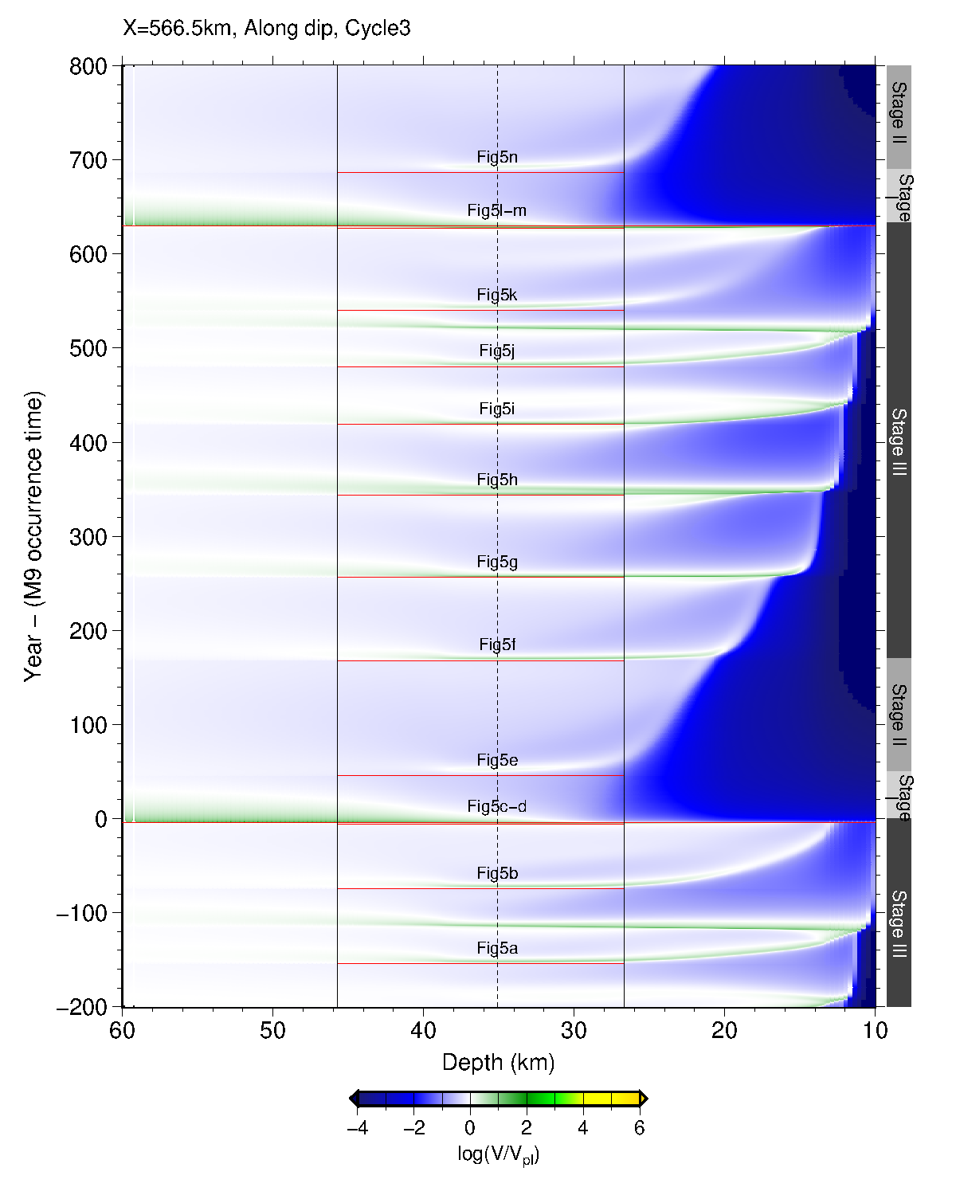
Supplementary Figure 2. Time development of simulated slip velocity during Cycle 3. Similar to Figure 8 in the main text, but for A–A’, approximately 55 km northward from C–C’.

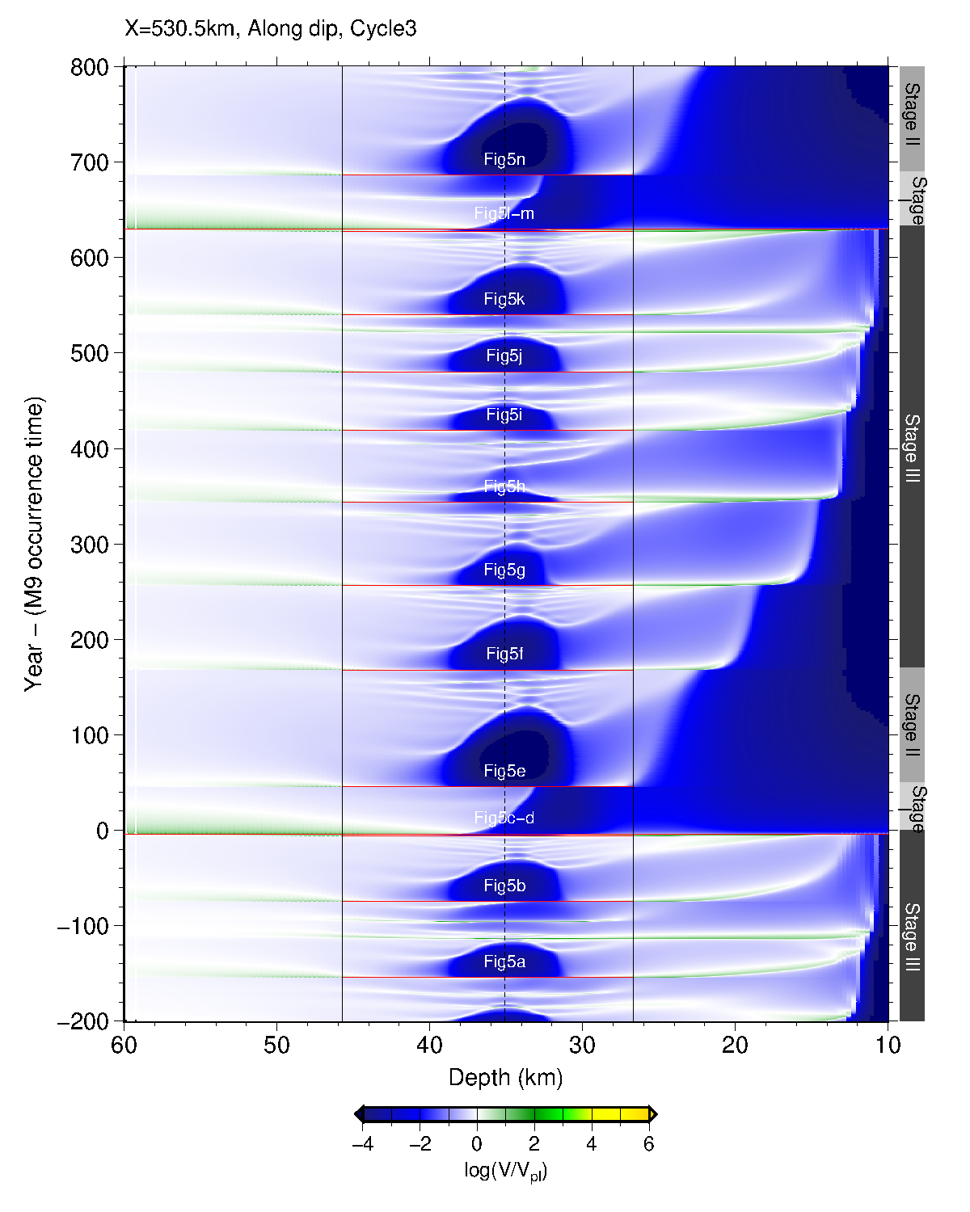
Supplementary Figure 3. Time development of simulated slip velocity during Cycle 3. Similar to Figure 8 in the main text, but for B–B’, approximately 15 km northward from the center of the Miyagi-ken-Oki (MYG) patch (radius of 23 km), that is, within the MYG patch.

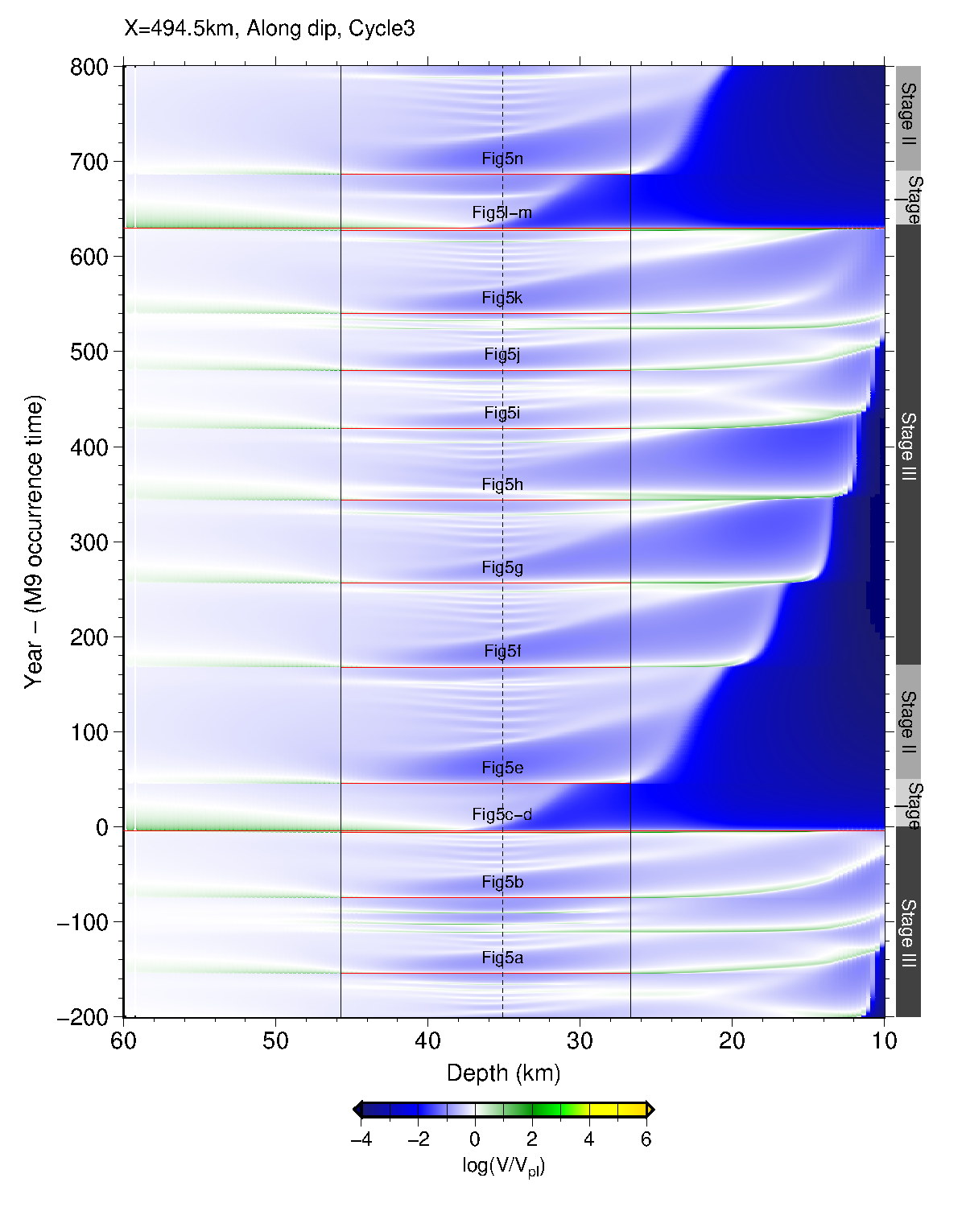
Supplementary Figure 4. Time development of simulated slip velocity during Cycle 3. Similar to Figure 8 in the main text, but for D–D’, approximately 20 km southward from the center of the MYG patch (radius of 23 km), that is, the edge of the MYG patch.

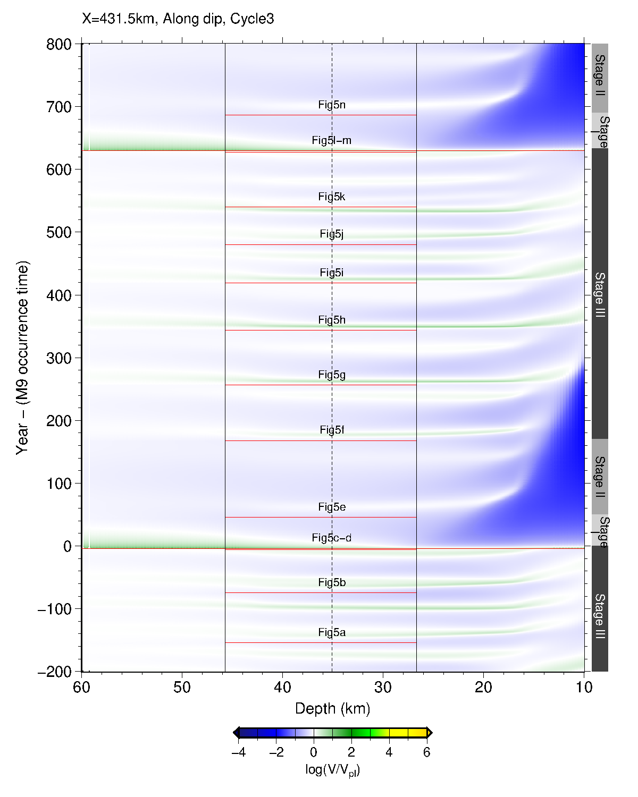
Supplementary Figure 5. Time development of simulated slip velocity during Cycle 3. Similar to Figure 8 in the main text, but for E–E’, approximately 80 km southward from C–C’.

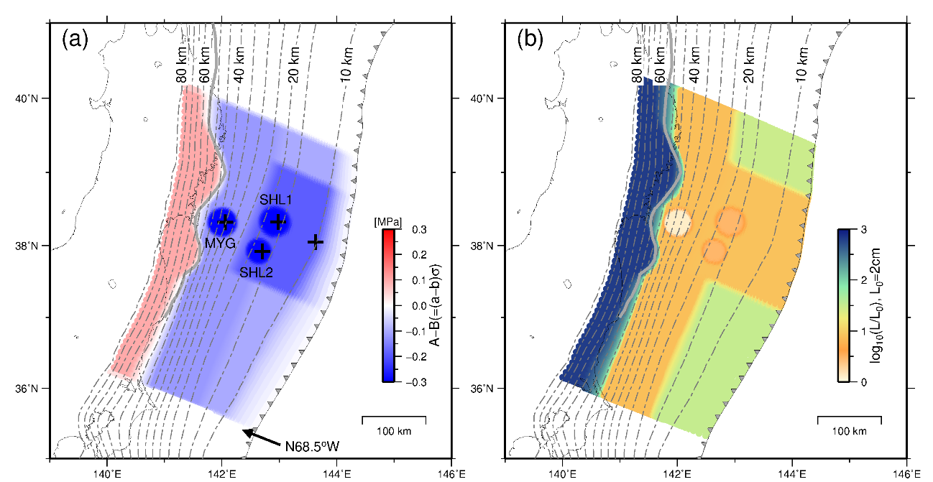
Supplementary Figure 6. Distribution of frictional parameters. (a) Spatial distribution on the plate interface of (A–B) (MPa). Contours indicate the depth (km) to the upper surface of the descending plate (Baba et al., 2006). Gray solid curve indicates the down-dip limit of the interplate earthquake distribution (Igarashi et al., 2001). Black crosses show locations used in Supplementary Figure 7. Barbed line indicates the trench axis. MYG, Miyagi-ken-Oki. (b) Spatial distribution of the characteristic slip distance (L).

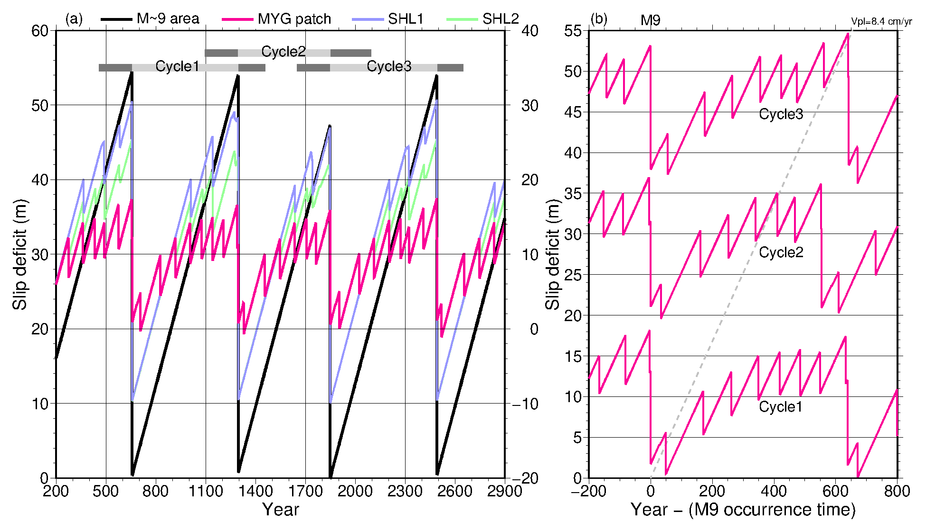
Supplementary Figure 7. Temporal distribution of slip deficits obtained using the friction model shown in Supplementary Figure 6. (a) Temporal distribution of simulated slip deficits over 2700 years at a point within the M~9 source area (black), Miyagi-ken-Oki (MYG) source area (magenta), and shallower patches (SHL1 and SHL2; light purple and light green) at the locations of the crosses shown in Supplementary Figure 6. Cycles 1–3 written with light gray lines represent the time period from one M~9 earthquake to the next M~9 earthquake. The slip deficit in the M~9 area was set to zero when the first M~9 earthquake of Cycle 3 occurred (T=1848.8 year) and the vertical axis is on the left. The slip deficit in the MYG area was set to zero when the MYG earthquake occurred at T=1904.2 year and the vertical axis is on the right. Slip deficits at the shallower patches (SHL1 and SHL2) were set to 10.0 when the first M~9 earthquake of Cycle 3 occurred (T=1848.8 year) and the vertical axis is on the left. (b) Temporal distribution of the slip deficit at the center point within the MYG patch for 1000 years from 200 years before the occurrence time of each M~9 earthquake in Cycles 1–3. In this figure, the time when the slip deficit is zero is different from that in (a), and the slip deficit is a relative value for ease of viewing. The period in this figure combines the dark gray lines and the light gray line in (a). The horizontal axis is indicated as 0 year at the time of the M~9 earthquake, which is the start of each cycle.

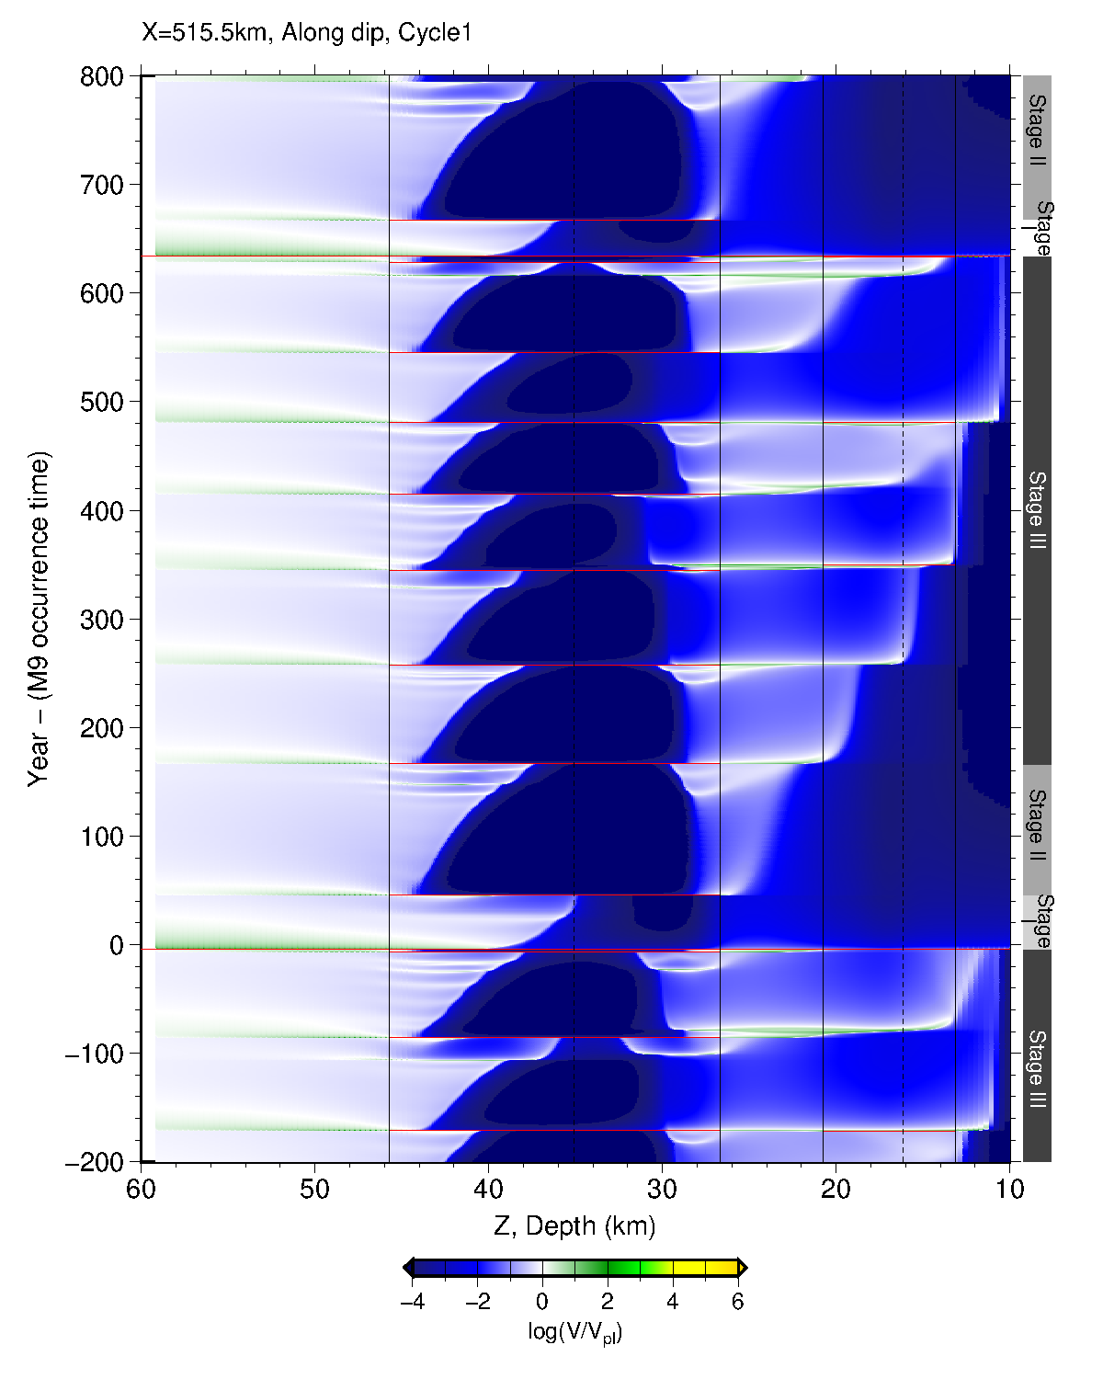
Supplementary Figure 8. Time development of simulated slip velocity. Similar to Figure 8 in the main text, but for Cycle 1 obtained using the frictional parameters shown in Supplementary Figure 6. Black dashed and solid vertical lines indicate the center of the MYG patch and a radius of 23 km from it, respectively. The vertical lines around 15 km depth indicate the area of the SHL1 patch. Red horizontal lines indicate the timing of MYG, SHL1, or an M~9 earthquake. Compared to that in Figure 8 in the main text, the shallow area is strongly locked in this figure. However, the appearance of Supplementary Figure 7 is relatively similar to Figure 3 in the main text.

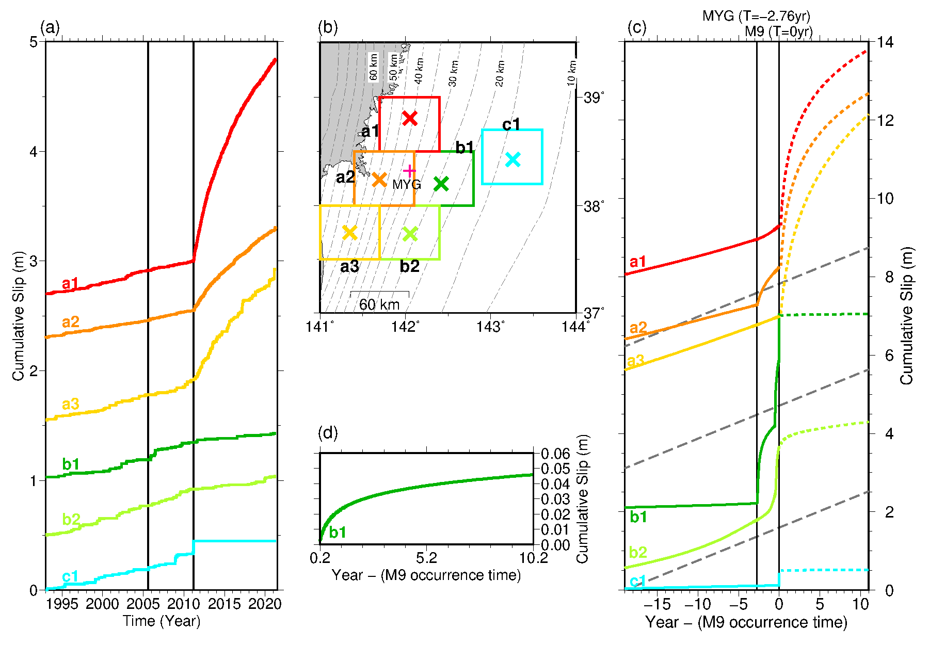
Supplementary Figure 9. Cumulative slip in the middle segment before and after an M~9 earthquake. (a)–(b) Similar to Figure 7(a)–(b) in the main text. (c) Simulated cumulative slip time series over 30 years (from T’=−19 years to T’ = 11 years) in Supplementary Figure 7, Cycle 1. An M=7.43 earthquake occurred at the SHL1 patch (near the point c1) ats T’=−55 hours. (d) Enlarged view of (c) at point b1.

Supplementary Table 2 Parameters for the northern, middle, southern, and deep segments and the MYG, SHL1, and SHL2 patches.
Segments | Parameters | Values | Sources / Segments | Parameters | Values
Northern | A–B (MPa) | −0.10 | MYG | A–B (MPa) | −0.320
Northern | b–a | 0.0020 | MYG | b–a | 0.0064
Northern | L (m) | 0.60 | MYG | L (m) | 0.026
Northern | Rb = (b–a) / b | 0.118 | MYG | Rb = (b–a) / b | 0.299
Northern | Ru | 0.271 | MYG | Ru | 14.2
Northern | Length (km) *2 | 65 (*1) | MYG | Radius (km) | 23
Middle | A–B (MPa) | −0.19 | SHL1 | A–B (MPa) | −0.300
Middle | b–a | 0.0038 | SHL1 | b–a | 0.0060
Middle | L (m) | 0.16 | SHL1 | L (m) | 0.060
Middle | Rb = (b–a) / b | 0.202 | SHL1 | Rb = (b–a) / b | 0.286
Middle | Ru | 5.047 | SHL1 | Ru | 6.0
Middle | Length (km) *2 | 170 | SHL1 | Radius (km) | 24
Southern | A–B (MPa) | −0.10 | SHL2 | A–B (MPa) | −0.295
Southern | b–a | 0.0020 | SHL2 | b–a | 0.0059
Southern | L (m) | 0.65 | SHL2 | L (m) | 0.060
Southern | Rb = (b–a) / b | 0.118 | SHL2 | Rb = (b–a) / b | 0.282
Southern | Ru | 0.865 | SHL2 | Ru | 4.9
Southern | Length (km) *2 | 225 (*1) | SHL2 | Radius (km) | 20
Deep | A–B (MPa) | −0.12 | Deep | A–B (MPa) | 0.10
Deep | b–a | 0.0024 | Deep | b–a | -0.0020
Deep | L (m) | 0.15 | Deep | L (m) | 13.0
Deep | Rb = (b–a) / b | 0.138 | Deep
Deep | Ru | 9.6 | Deep
Deep | Length (km) *2 | 480 | Deep | Length (km) *2 | 480
*1: Transition between the middle and northern/southern segments is 10 km.
*2: Length along the strike direction.

Supplementary References 2
Baba T, Ito A, Kaneda Y, Hayakawa T, Furumura T (2006) 3-D seismic wave velocity structures in the Nankai and Japan Trench subduction zones derived from marine seismic surveys. Abstract S111-006 presented at the JpGU Meeting 2006, Makuhari, Japan, 14-18 May 2006. https://www2.jpgu.org/meeting/2006/pdf/S111/S111-006_e.pdf. Accessed 1 July 2022.
Igarashi T, Matsuzawa T, Umino N, Hasegawa A (2001) Spatial distribution of focal mechanisms for interplate and intraplate earthquakes associated with the subducting Pacific plate beneath the northeastern Japan arc: A triple-planed deep seismic zone. J Geophys Res 106:2177–2191.

