Supporting Information
External and Internal Dual-controls: Tunable Cavity and Ru-O-Co Bond Bridge Synergistically Accelerate the RuCoCu-MOF/CF Nanorods for Urea-assisted Energy-saving Hydrogen Production
Yilin Wang¹, Yunmei Du*², Ziqi Fu¹, Mengmeng Wang², Yunlei Fu¹, Bin Li³ and Lei Wang*^{1,2}
¹ College of Chemistry and Molecular Engineering, Qingdao University of Science and Technology, Key Laboratory of Eco-chemical Engineering, Key Laboratory of Optic-electric Sensing and Analytical Chemistry of Life Science, Taishan Scholar Advantage and Characteristic Discipline Team of Eco Chemical Process and Technology, Qingdao 266042, P. R. China.
² College of Environment and Safety Engineering, Qingdao University of Science and Technology, Shandong Engineering Research Center for Marine Environment Corrosion and Safety Protection, Qingdao 266042, P. R. China
³ College of Materials Science and Engineering, Qingdao University of Science and Technology, Qingdao, 266042 China.

*E-mail: duyunmeiqust@163.com (Yunmei Du); inorchemwl@126.com (Lei Wang)

Figures and Tables
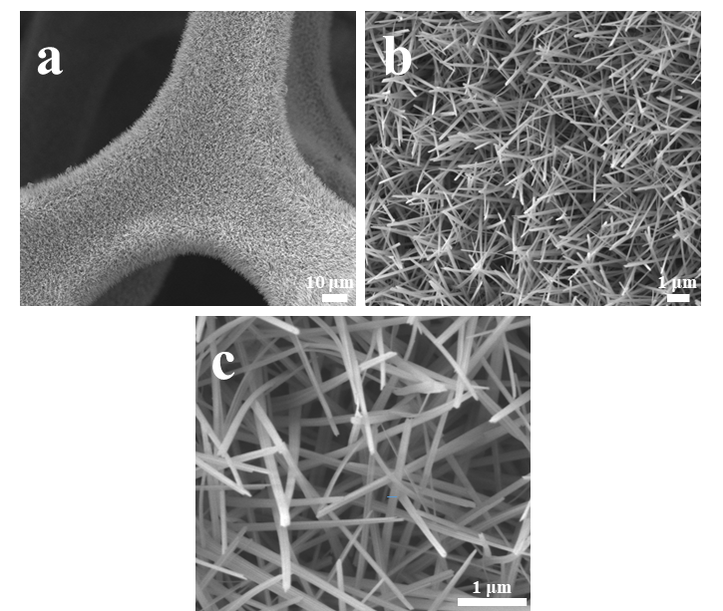
Figure S1 (a-c) SEM images of Cu (OH)₂/CF.

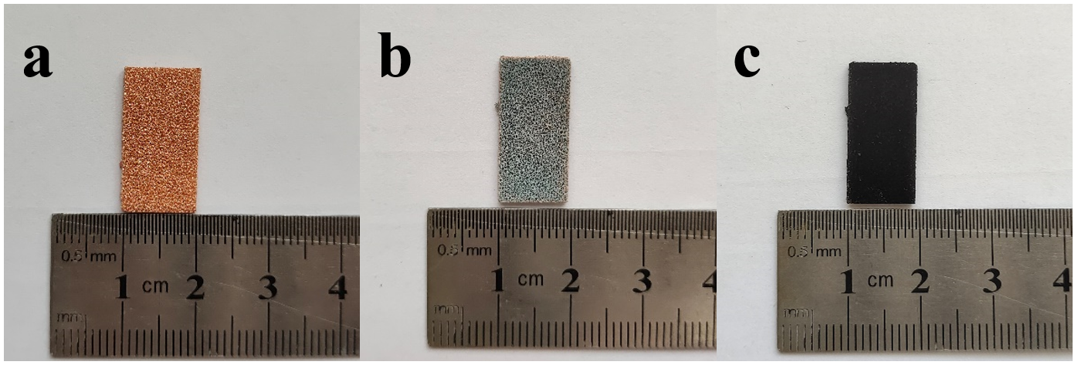
Figure S2 Photos of (a) CF, (b) Cu(OH)₂/CF, and (c) RuCoCu-MOF/CF.

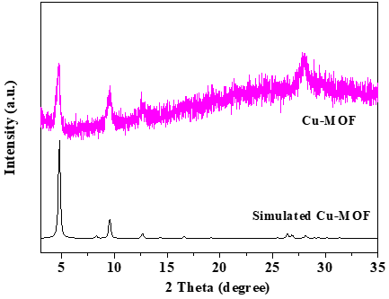
Figure S3 XRD image of Cu-MOF and simulated Cu-MOF.

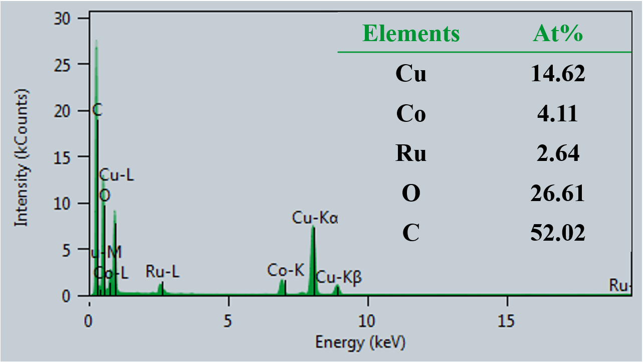
Figure S4 EDX of RuCo-MOF/CF catalyst.

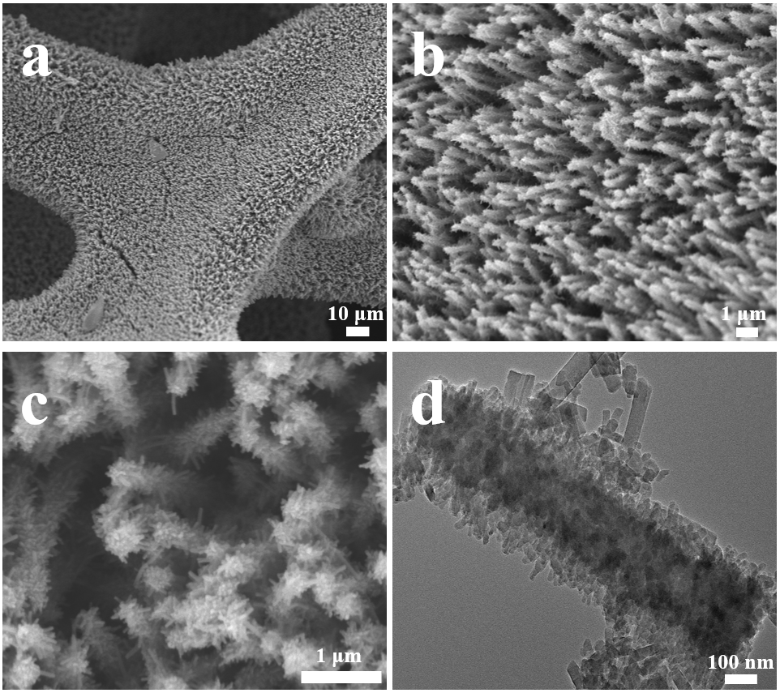
Figure S5 (a-c) SEM images and (d) TEM image of Cu-MOF/CF.

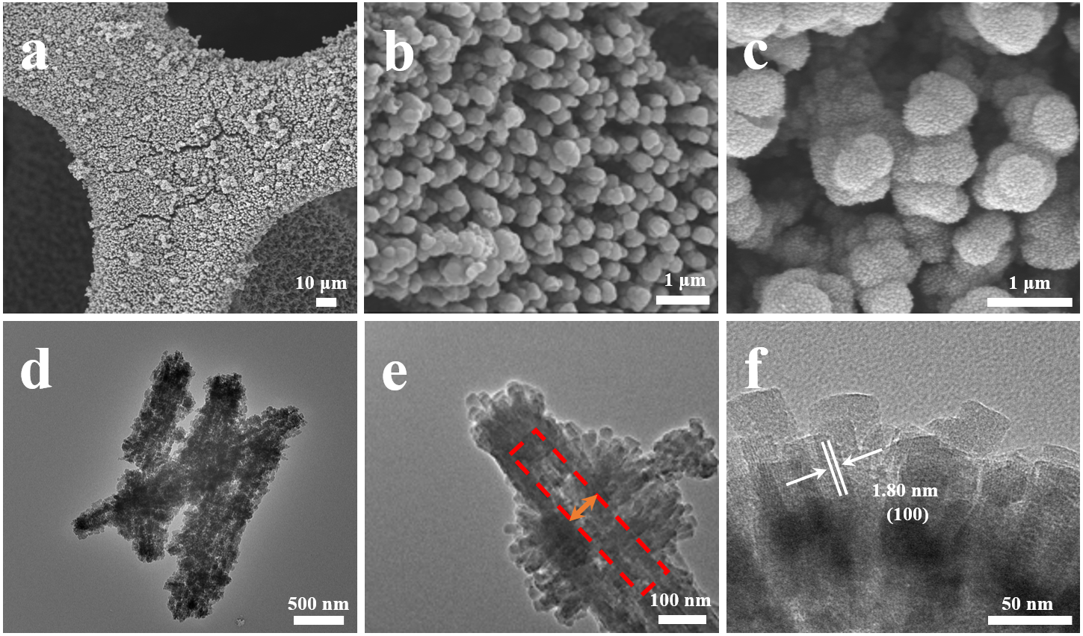
Figure S6 (a-c) SEM images and (d-f) TEM image of CoCu-MOF/CF.

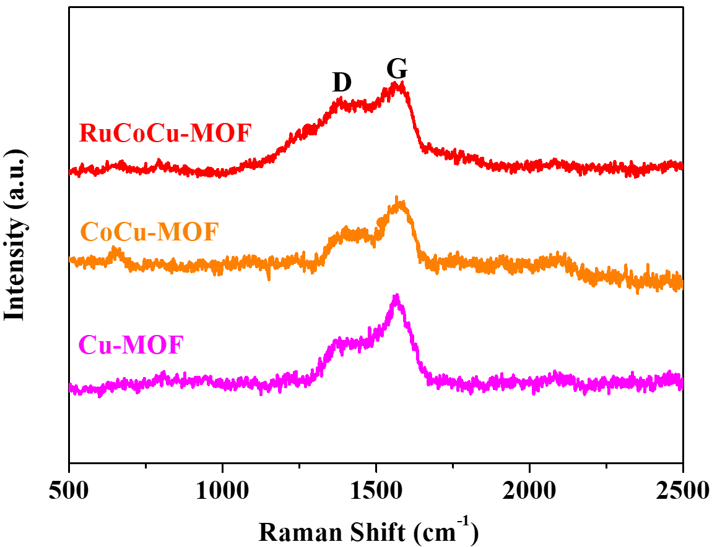
Figure S7 Raman spectraum of RuCoCu-MOF, CoCu-MOF, and Cu-MOF.

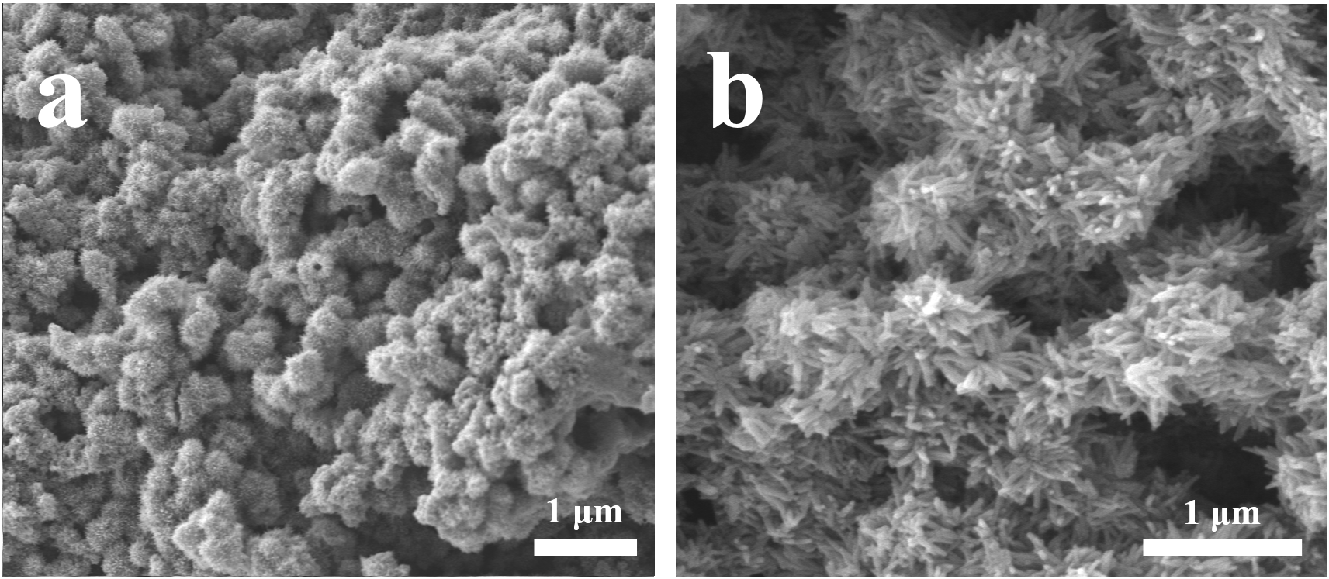
Figure S8 (a-b) SEM images of RuCoCu-MOF/CF-5.

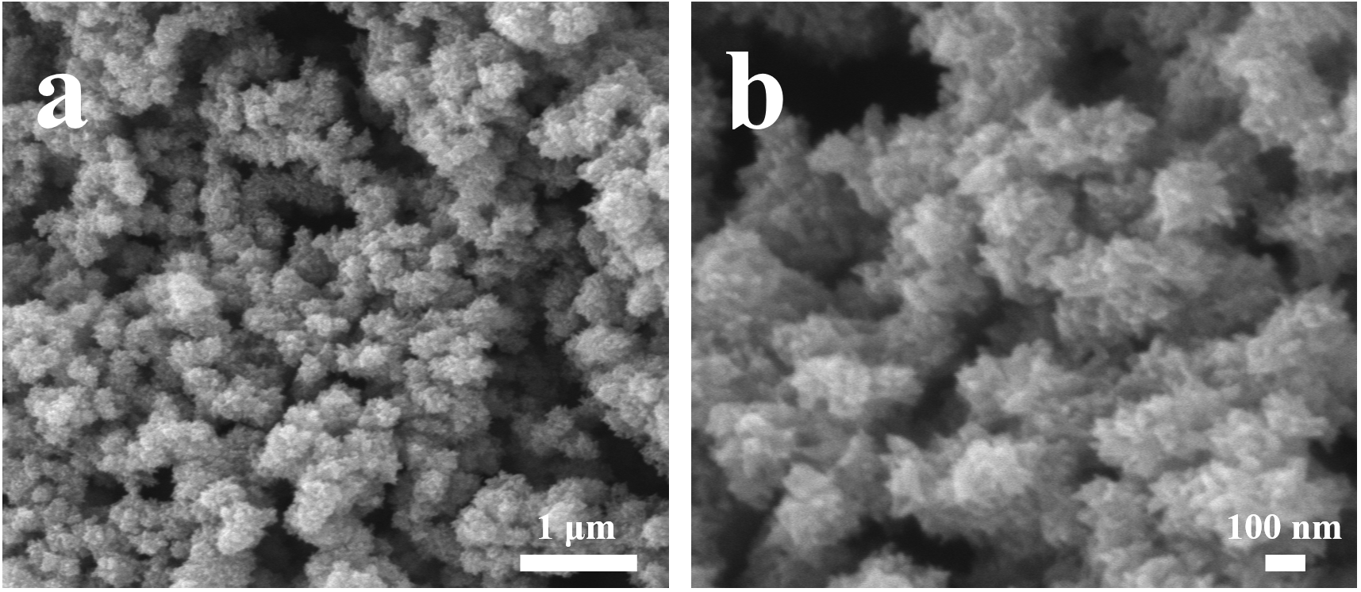
Figure S9 (a-b) SEM images of RuCoCu-MOF/CF-15.

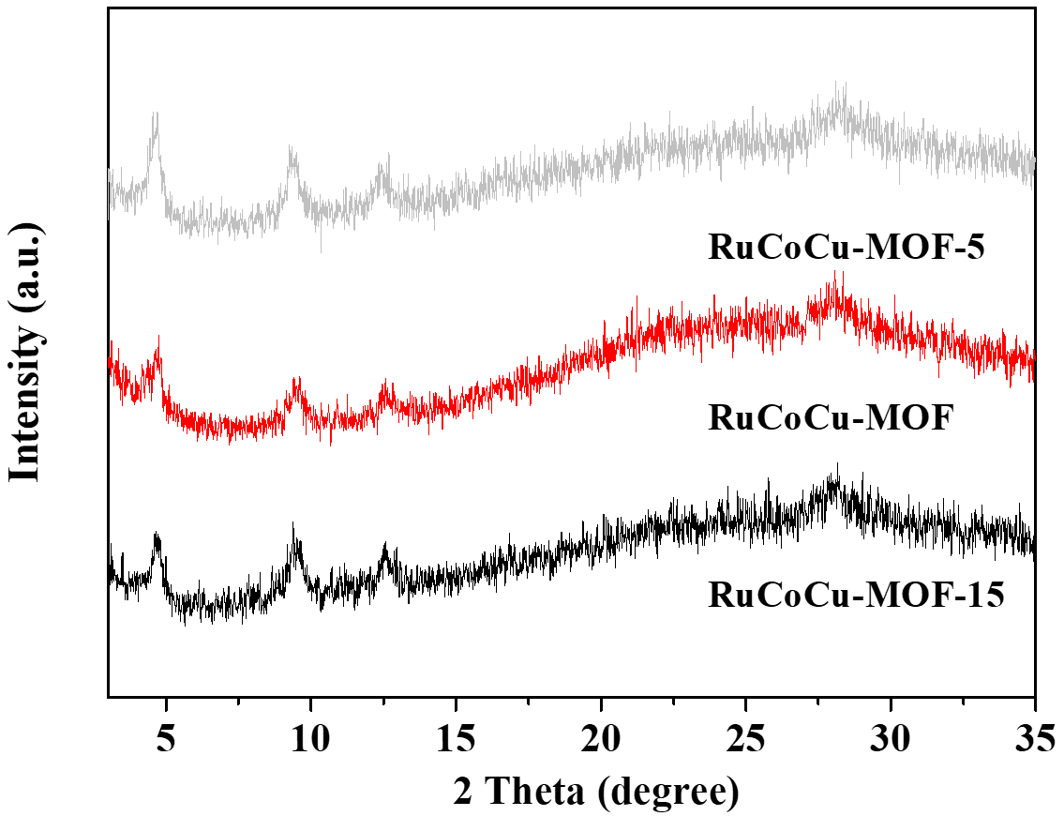
Figure S10 XRD image of RuCoCu-MOF-X (X=5, 10, 15).

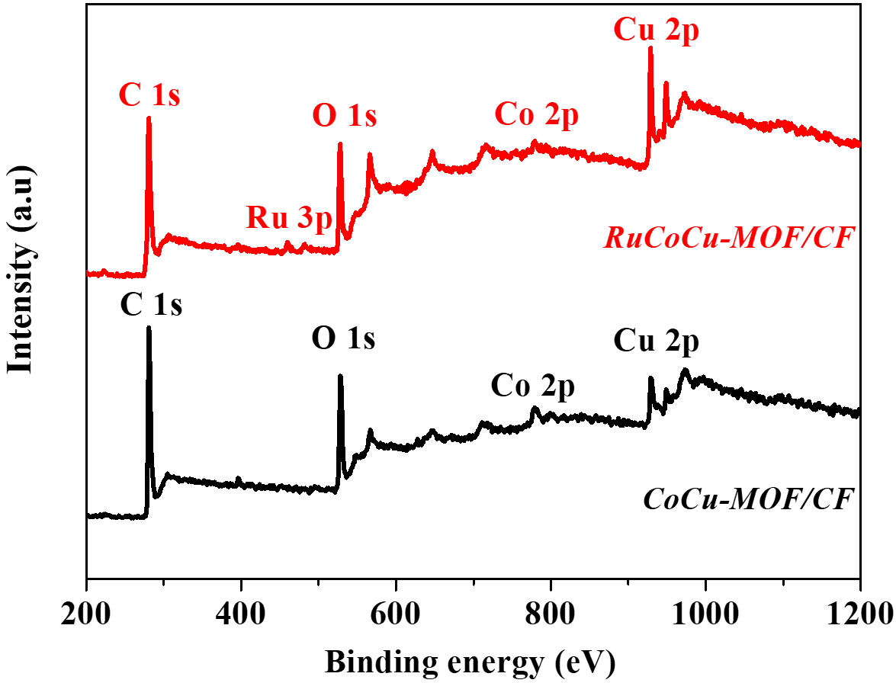
Figure S11 XPS survey spectra of RuCoCu-MOF/CF and CoCu-MOF/CF.
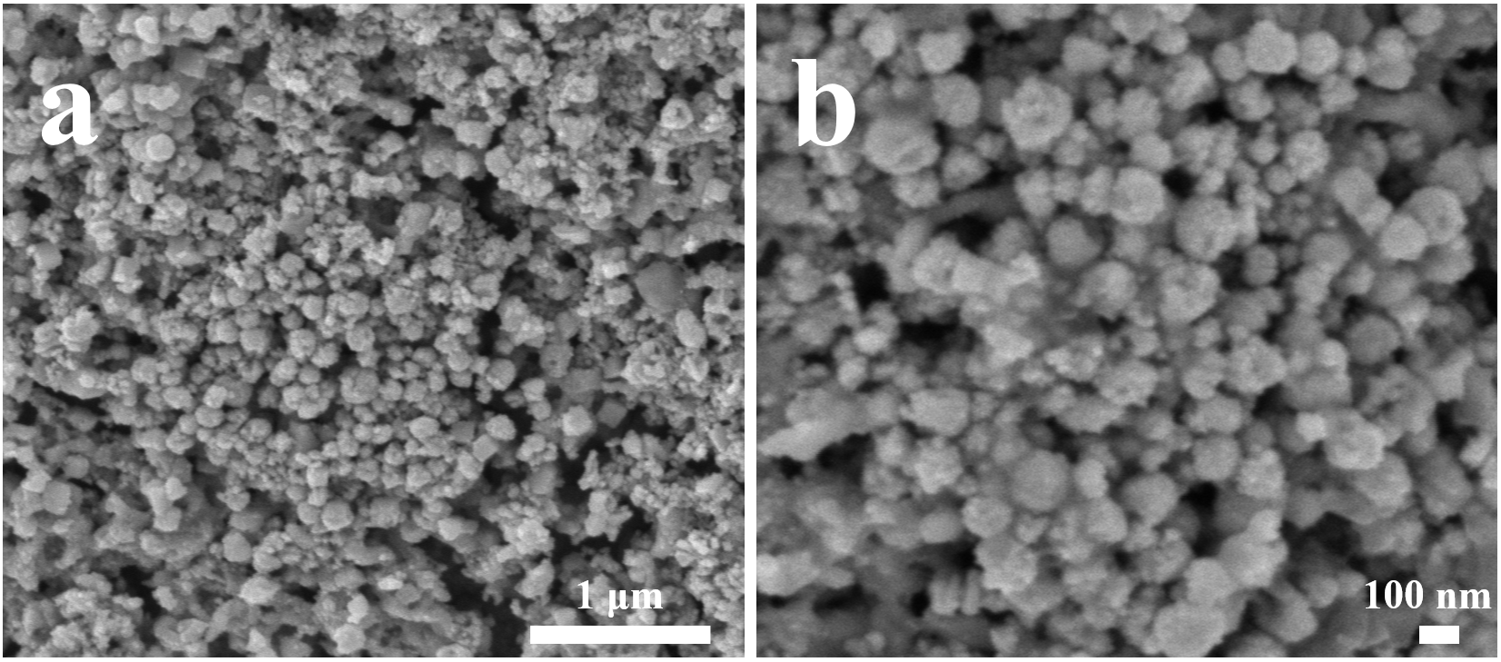
Figure S12 (a-b) SEM images of RuCu-MOF/CF.

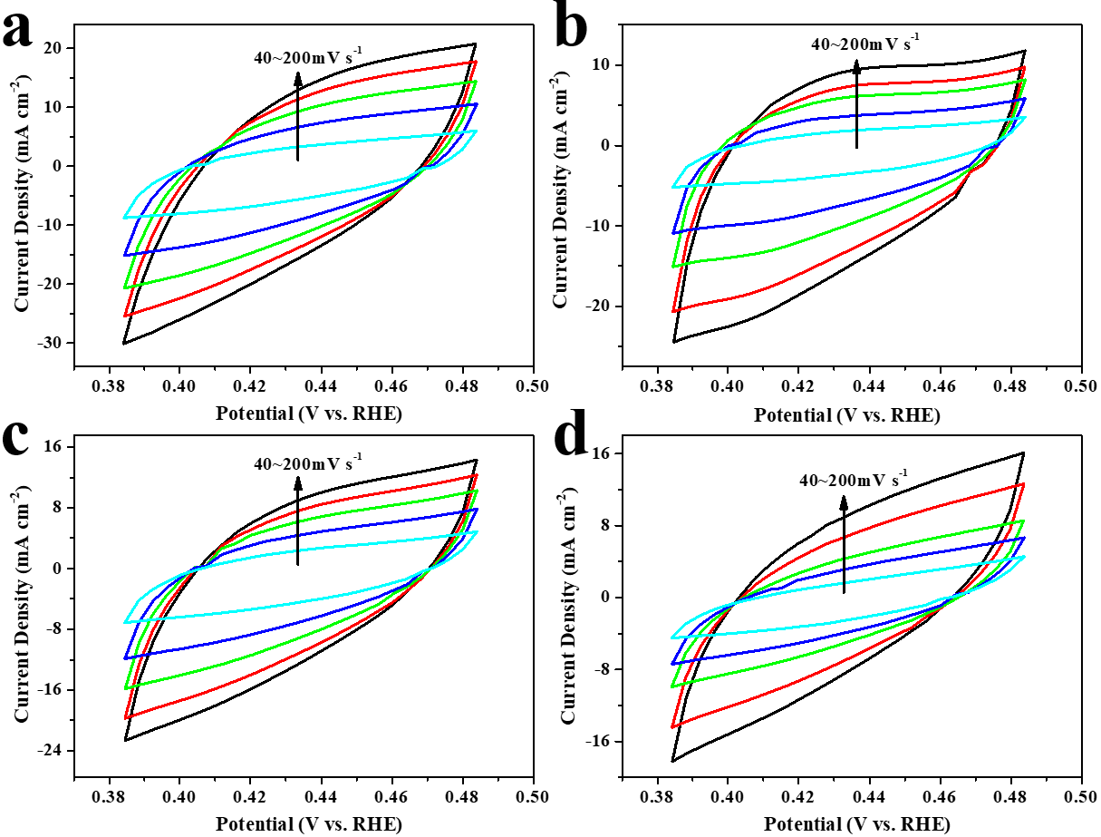
Figure S13 Cyclic voltammetry curves at 0.384~0.484V vs RHE for (a) RuCoCu-MOF/CF, (b) CoCu-MOF/CF, (c) RuCu-MOF/CF, and (d) Cu-MOF/CF with different scan rates from 40 to 200 mV s⁻¹.

Figure S14 ECSA-normalized HER polarization curves of RuCoCu-MOF/CF, CoCu-MOF/CF, RuCu-MOF/CF, and Cu-MOF/CF.

Figure S15 (a) HER polarization curves and corresponding (b) Nyquist plots of the RuCoCu-MOF/CF-X catalysts (X = 1, 2, 3).
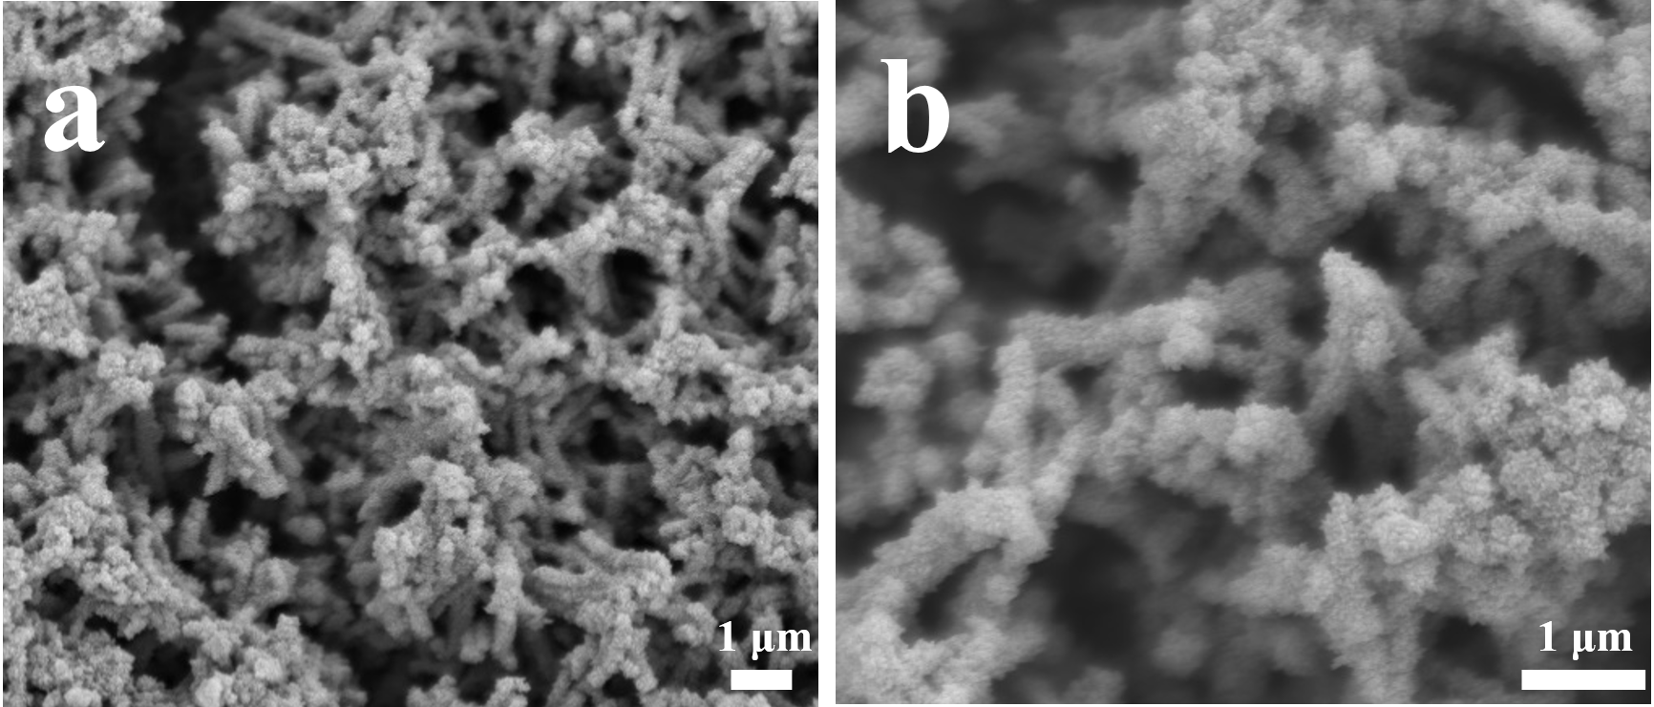
Figure S16 SEM images of Ru@FeCoP (a-b) after HER.
Figure S17 XPS spectra of the RuCoCu-MOF/CF after HER stability test: (a) Cu 2p, (b) Co 2p, (c) Ru 3p, and (d) O 1s spectrum.

Figure S18 (a) UOR polarization curves and corresponding (b) Nyquist plots of the RuCoCu-MOF/CF-X catalysts (X = 1, 2, 3).

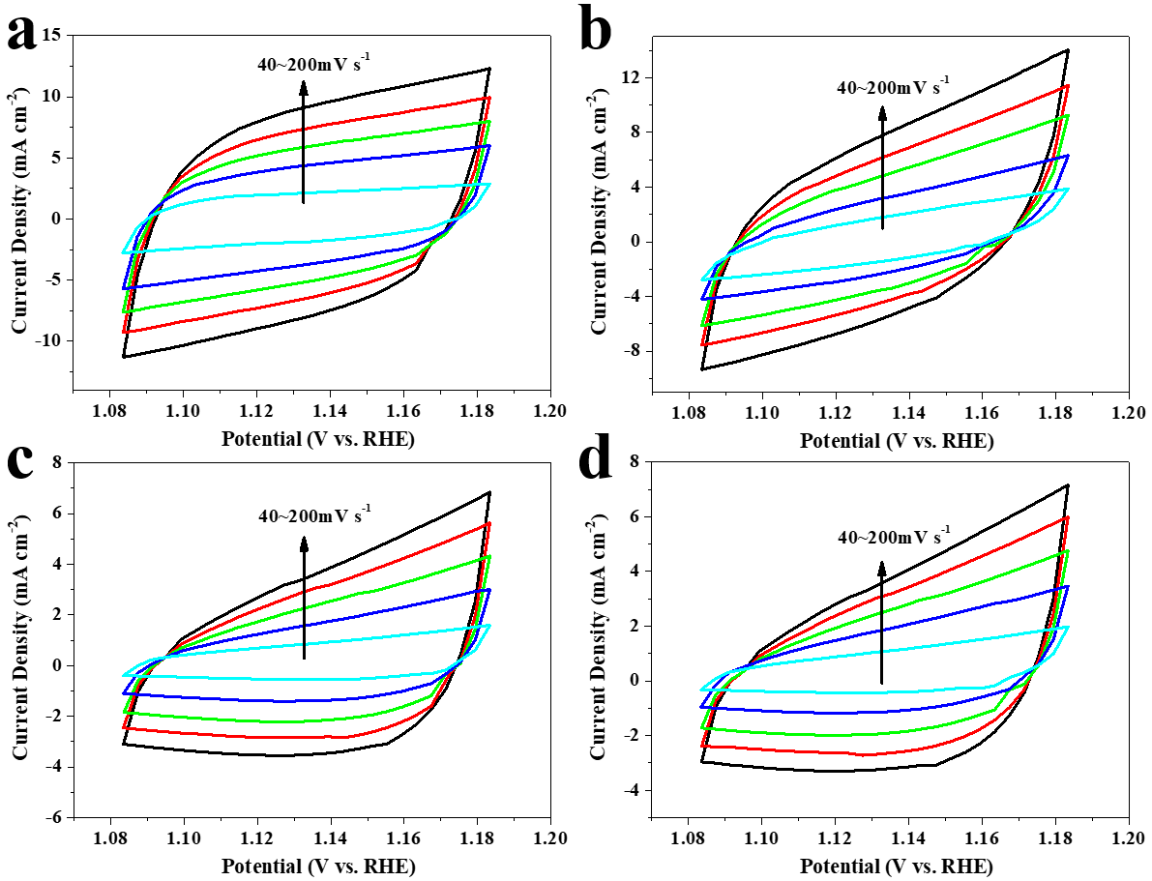
Figure S19 Cyclic voltammetry curves at 1.084~1.184 V vs. RHE for (a) RuCoCu-MOF/CF, (b) CoCu-MOF/CF, (c) RuCu-MOF/CF, and (d) Cu-MOF/CF with different scan rates from 40 to 200 mV s⁻¹.

Figure S20 ECSA-normalized UOR polarization curves of RuCoCu-MOF/CF, CoCu-MOF/CF, RuCu-MOF/CF, and Cu-MOF/CF.

Figure S21 Nyquist plots of RuCoCu-MOF/CF, CoCu-MOF/CF, RuCu-MOF/CF, Cu-MOF/CF, and Cu (OH)₂/CF for UOR.

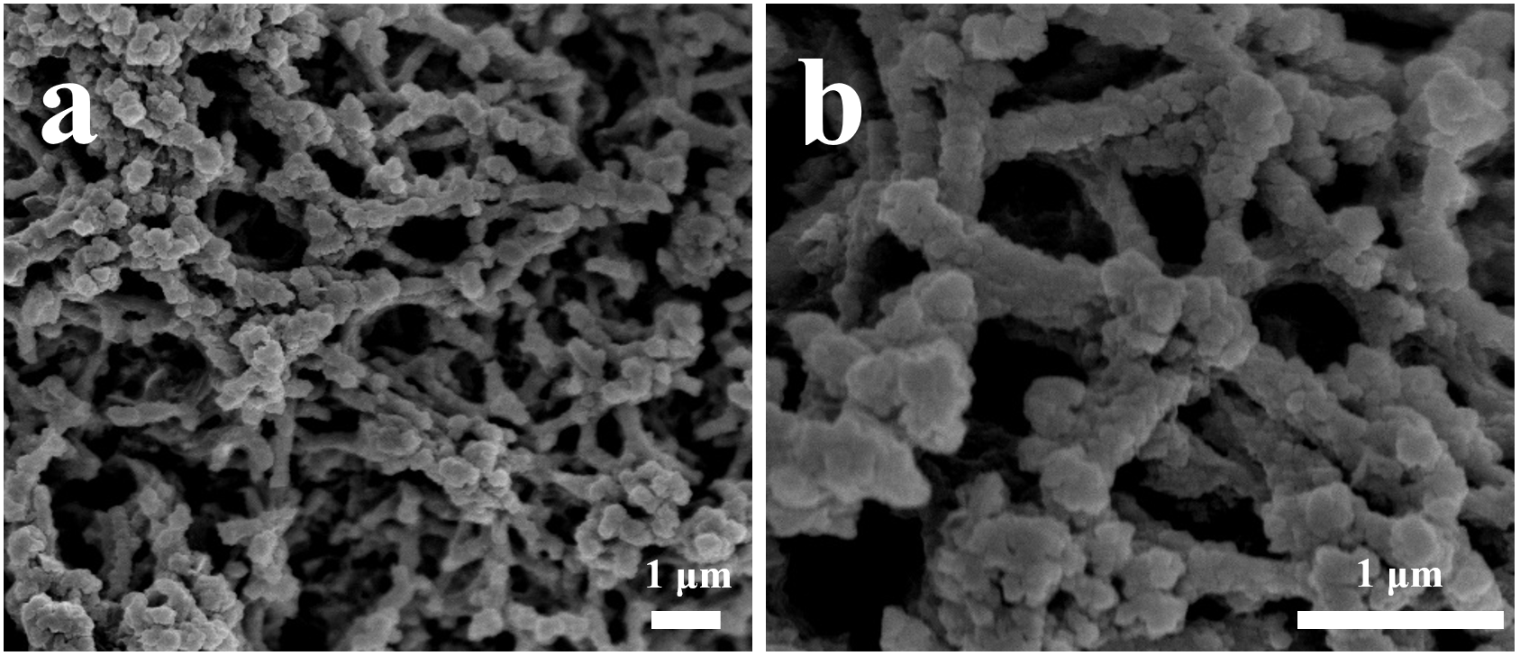
Figure S22 SEM images of Ru@FeCoP (a-b) after UOR.

Figure S23 XPS spectra of the RuCoCu-MOF/CF after UOR stability test: (a) Cu 2p, (b) Co 2p, (c) Ru 3p, and (d) O 1s spectrum.
Figure S24 HER//UOR polarization curves of the RuCoCu-MOF/CF-X (X = 1, 2, 3) catalysts.
Figure S25 The color chart for the concentration degradation of urea at 1.55 V.

Table S1 ICP-AES data of RuCoCu-MOF/CF.

Elements | Mass Fraction  wt.%
Ru | 4.5793
Co | 5.2984
Cu | 11.9282

Table S2 Comparison of HER activity of RuCoCu-MOF/CF with other catalysts reported.

Electrocatalysts | J  (mA cm⁻²) | Ƞ  (mV) | Electrolyte  solution | Refs.
RuCoCu-MOF/CF | 10 | 11.6 | 1.0 M KOH | This work
Ru-MoO₂@PC/rGO | 10 | 126 | 1.0 M KOH | 1
Ru-NiFe-③/NF | 10 | 90 | 1.0 M KOH | 2
RuO₂/Co₃O4 | 10 | 89 | 1.0 M KOH | 3
MNF-MOFs/NF | 10 | 79 | 1.0 M KOH | 4
Ru-Co₂P/N-C/NF | 10 | 65 | 1.0 M KOH | 5
Ru-doped-NiFeP/NF | 10 | 56 | 1.0 M KOH | 6
NiRu-MOF/NF | 10 | 51 | 1.0 M KOH | 7
Ru-Co₃O₄-NiO-NF | 10 | 44 | 1.0 M KOH | 8
Ru-NiCoP/NF | 10 | 44 | 1.0 M KOH | 9
Ru-MnFeP/NF | 10 | 35 | 1.0 M KOH | 10
Ru₁Ni₁-NC NFs | 10 | 35 | 1.0 M KOH | 11
M-Co NPs@Ru SAc/NC | 10 | 34 | 1.0 M KOH | 12
NiRu_{0.13}-BDC | 10 | 34 | 1.0 M KOH | 13
Ru-Cu-2 | 10 | 33 | 1.0 M KOH | 14
Ru-Ni@Ni₂P HNRs | 10 | 31 | 1.0 M KOH | 15
Mo@Ru-3 | 10 | 30.5 | 1.0 M KOH | 16
Ru-MoO₂ | 10 | 29 | 1.0 M KOH | 17
MIL-53(Ru-NiFe) @NF | 10 | 27 | 1.0 M KOH | 18
(Ru-Co) O_{x} | 10 | 25 | 1.0 M KOH | 19
Ru@Ni-MOF | 10 | 22 | 1.0 M KOH | 20
CoNiRu-NT | 10 | 22 | 1.0 M KOH | 21
Ru-Cu@C | 10 | 20 | 1.0 M KOH | 22
RuP(L-RP) | 10 | 19 | 1.0 M KOH | 23
Ru@P-Co₃HHTP₂-3.2% | 10 | 19 | 1.0 M KOH | 24
Ru/MWCNT | 10 | 17 | 1.0 M KOH | 25
Ru-NPs@N-TC | 10 | 14 | 1.0 M KOH | 26
RuNi/CQDS | 10 | 13 | 1.0 M KOH | 27
Ru/OMSNNC | 10 | 13 | 1.0 M KOH | 28
MIL-(IrNiFe)@NF | 10 | 12 | 1.0 M KOH | 29

Table S3 Comparison of UOR activity of RuCoCu-MOF/CF with other catalysts reported.
Electrocatalysts | J  (mA cm⁻²) | Ƞ  (V) | Electrolyte  solution | Refs.
RuCoCu-MOF/CF | 10 | 1.35 | 1.0 M KOH+  0.5 M urea | This work
Ni/C | 10 | 1.60 | 1.0 M KOH+  0.33 M urea | 30
CoS₂ NA/Ti | 10 | 1.59 | 1.0 M KOH+  0.3 M urea | 31
NiCo alloy | 10 | 1.50 | 1.0 M KOH+  0.33 M urea | 32
Ru-NiFe-③/NF | 10 | 1.47 | 1.0 M KOH+  0.33 M urea | 2
CFP-NiMn₄ | 10 | 1.46 | 1.0 M KOH+  0.5 M urea | 33
Ni_{0.9}Fe_{0.1}O | 10 | 1.455 | 1.0 M KOH+  0.33 M urea | 34
Ni₃N NA/CC | 10 | 1.44 | 1.0 M KOH+  0.33 M urea | 35
Ni (OH)₂-NMs | 10 | 1.44 | 1.0 M KOH+  0.33 M urea | 36
Ni-Mo nanotude | 10 | 1.43 | 1.0 M KOH+  0.5 M urea | 37
Ni-RGO | 10 | 1.43 | 1.0 M KOH+  0.33 M urea | 38
NP-Ni_{0.70}Fe_{0.30}-GC | 10 | 1.43 | 1.0 M KOH+  0.33 M urea | 39
Ni-CoP/HPFs | 10 | 1.43 | 1.0 M KOH+  0.5 M urea | 40
Ni-G-5 | 10 | 1.42 | 1.0 M KOH+  0.33 M urea | 41
Ni (OH)₂ | 10 | 1.42 | 1.0 M KOH+  0.33 M urea | 42
NF-G-Mn | 10 | 1.41 | 1.0 M KOH+  0.5 M urea | 43
Ni₃Se₄ | 10 | 1.38 | 1.0 M KOH+  0.5 M urea | 44
Ni (OH)₂ nanoflakes | 10 | 1.38 | 1.0 M KOH+  0.33 M urea | 45
Ni@NCNT-3 | 10 | 1.38 | 1.0 M KOH+  0.5 M urea | 46
Zn_{0.08}Co_{0.92}P/TM | 10 | 1.38 | 1.0 M KOH+  0.5 M urea | 47
Ni/FeOOH | 10 | 1.373 | 1.0 M KOH+  0.5 M urea | 48
NF/NiMoO-Ar | 10 | 1.37 | 1.0 M KOH+  0.5 M urea | 49
MnO₂ | 10 | 1.37 | 1.0 M KOH+  0.5 M urea | 43
Ni-MOF | 10 | 1.36 | 1.0 M KOH+  0.33 M urea | 50
NiMo alloy | 10 | 1.36 | 1.0 M KOH+  0.1 M urea | 51
Ni₂P/Fe₂P | 10 | 1.36 | 1.0 M KOH+  0.5 M urea | 52
Ni-MOF nanowires | 10 | 1.36 | 1.0 M KOH+  0.5 M urea | 53
Ni-WO_{x} | 10 | 1.36 | 1.0 M KOH+  0.33 M urea | 54
Ni@C | 10 | 1.35 | 1.0 M KOH+  0.5 M urea | 55
Ni/Ni_{0.2}Mo_{0.8}N/MnO3 | 10 | 1.348 | 1.0 M KOH+  0.33 M urea | 56

Table S4 Comparison of overall water splitting activity of RuCoCu-MOF/CF with other MOF-based/derived electrochemical catalysts.
Electrocatalysts | J  (mA cm⁻²) | Ƞ  (V) | Electrolyte  solution | Refs.
RuCoCu-MOF/CF | 10 | 1.402 | 1.0 M KOH+  0.5 M urea | This work
CoS_{x}/Co-MOF | 10 | 1.480 | 1.0 M KOH+  0.5 M urea | 57
Fc-NiCo-BDC | 10 | 1.490 | 1.0 M KOH+  0.33 M urea | 58
MFN-MOFs (2:1)/NF | 10 | 1.495 | 1.0 M KOH | 59
D-Ni-MOF | 10 | 1.500 | 1.0 M KOH | 60
NiCo₂X₄/CP, X=O,S,Se | 10 | 1.510 | 1.0 M KOH | 61
IrO₂@Ir-MOF | 10 | 1.530 | 1.0 M KOH | 62
NG-NiFe@MoC₂-2 | 10 | 1.530 | 1.0 M KOH | 63
CC-NC-NiFeP | 10 | 1.540 | 1.0 M KOH | 64
Ni-ZIF/Ni-B@NF | 10 | 1.540 | 1.0 M KOH | 65
Co@N-CS/N-HCP@CC | 10 | 1.545 | 1.0 M KOH | 66
Co-NC@Ni₂Fe-LDH | 10 | 1.550 | 1.0 M KOH | 67
NiFe-MOF | 10 | 1.550 | 1.0 M KOH | 68
Fe₂Ni-MIL-88B/NF | 10 | 1.560 | 1.0 M KOH | 69
Ni₂P/CoN-pcp | 10 | 1.580 | 1.0 M KOH | 70
Fe-CoP HTPAs | 10 | 1.590 | 1.0 M KOH | 71
Fe-Co-Ni MOF | 10 | 1.600 | 1.0 M KOH | 72
Co₉S₈-NSC@Mo₂C | 10 | 1.610 | 1.0 M KOH | 73
Co-MOF/H₂ | 10 | 1.619 | 1.0 M KOH | 74
Co-NCNTFs//NF | 10 | 1.620 | 1.0 M KOH | 75

References
- Han JY, Cai SH, Zhu JY, Yang S, Li JS. MOF-derived ruthenium-doped amorphous molybdenum dioxide hybrid for highly efficient hydrogen evolution reaction in alkaline media. Chem Comm 2022; 58: 100-103. https://doi.org/10.1039/D1CC05683B.
- Wang Y, Wang C, Shang H, Yuan M, Wu Z, Li J, Du Y. Self-driven Ru-modified NiFe MOF nanosheet as multifunctional electrocatalyst for boosting water and urea electrolysis. J Colloid Interface Sci 2022; 605: 779-789. https://doi.org/10.1016/j.jcis.2021.07.124.
- Liu H, Xia G, Zhang R, Jiang P, Chen J, Chen Q. MOF-derived RuO₂/Co₃O₄ heterojunctions as highly efficient bifunctional electrocatalysts for HER and OER in alkaline solutions. Rsc Adv 2017; 7: 3686-3694. https://doi.org/10.1039/C6RA25810G.
- Raja DS, Lin HW, Lu SY. Synergistically well-mixed MOFs grown on nickel foam as highly efficient durable bifunctional electrocatalysts for overall water splitting at high current densities. Nano Energy 2019; 57: 1-13. https://doi.org/10.1016/j.nanoen.2018.12.018.
- Xu Y, Ren T, Ren K, Yu S, Liu M, Wang Z, Li X, Wang L, Wang H. Metal-organic frameworks-derived Ru-doped Co₂P/N-doped carbon composite nanosheet arrays as bifunctional electrocatalysts for hydrogen evolution and urea oxidation. Chem Eng J 2021; 408: 127308. https://doi.org/10.1016/j.cej.2020.127308.
- Lin Y, Zhang M, Zhao L, Wang L, Cao D, Gong Y. Ru doped bimetallic phosphide derived from 2D metal organic framework as active and robust electrocatalyst for water splitting. Appl Surf Sci 2021; 536: 147952. https://doi.org/10.1016/j.apsusc.2020.147952.
- Xu Y, Yu S, Ren T, Liu S, Wang Z, Li X, Wang L, Wang H. Hydrophilic/aerophobic hydrogen-evolving electrode: NiRu-based metal-organic framework nanosheets in situ grown on conductive substrates. ACS Appl Mater Interfaces 2020; 12: 34728-34735. https://doi.org/10.1021/acsami.0c03333.
- Zhang H, Guo H, Ren J, Jin X, Li X, Song R. Synergistic engineering of morphology and electronic structure in constructing metal-organic framework-derived Ru doped cobalt-nickel oxide heterostructure towards efficient alkaline hydrogen evolution reaction. Chem Eng J 2021; 426: 131300. https://doi.org/10.1016/j.cej.2021.131300.
- Chen D, Lu R, Pu Z, Zhu J, Li HW, Liu F, Hu S, Luo X, Wu J, Zhao Y, Mu S. Ru-doped 3D flower-like bimetallic phosphide with a climbing effect on overall water splitting. Appl Catal B Environ 2020; 279: 119396. https://doi.org/10.1016/j.apcatb.2020.119396.
- Chen D, Pu Z, Lu R, Ji P, Wang P, Zhu J, Lin C, Li HW, Zhou X, Hu Z, Xia F, Wu J, Mu S. Ultralow Ru loading transition metal phosphides as high‐efficient bifunctional electrocatalyst for a solar‐to‐hydrogen generation system. Adv Energy Mater 2020; 10: 2000814. https://doi.org/10.1002/aenm.202000814.
- Li M, Wang H, Zhu W, Li W, Wang C, Lu X. RuNi nanoparticles embedded in N-doped carbon nanofibers as a robust bifunctional catalyst for efficient overall water splitting. Adv Sci 2019; 7: 1901833. https://doi.org/10.1002/advs.201901833.
- Zhang H, Su H, A Soldatov M, Li Y, Zhao X, Liu M, Zhou W, Zhang X, Sun X, Xu Y, Yao P, Wei S, Liu Q. Dynamic Co Ru bond shrinkage at atomically dispersed Ru sites for alkaline hydrogen evolution reaction. Small 2021; 17: 2105231. https://doi.org/10.1002/smll.202105231.
- Sun Y, Xue Z, Liu Q, Jia Y, Li Y, Liu K, Lin Y, Liu M, Li G, Su CY. Modulating electronic structure of metal-organic frameworks by introducing atomically dispersed Ru for efficient hydrogen evolution. Nat commun 2021; 12: 1-8. https://doi.org/10.1038/s41467-021-21595-5.
- Huang H, Jung H, Li S, Kim S, Han JW, Lee J. Activation of inert copper for significantly enhanced hydrogen evolution behaviors by trace ruthenium doping. Nano Energy 2022; 92: 106763. https://doi.org/10.1016/j.nanoen.2021.106763.
- Liu Y, Liu S, Wang Y, Zhang Q, Gu L, Zhao S, Xu D, Li Y, Bao J, Dai Z. Ru modulation effects in the synthesis of unique rod-like Ni@ Ni₂P-Ru heterostructures and their remarkable electrocatalytic hydrogen evolution performance. J Am Chem Soc 2018; 140: 2731-2734. https://doi.org/10.1021/jacs.7b12615.
- Zhang Z, Li P, Wang Q, Feng Q, Tao Y, Xu J, Jiang C, Lu X, Fan J, Gu M, Li H, Wang H. Mo modulation effect on the hydrogen binding energy of hexagonal-close-packed Ru for hydrogen evolution. J Mater Chem A 2019; 7: 2780-2786. https://doi.org/10.1039/C8TA11251G.
- Jiang P, Yang Y, Shi R, Xia G, Chen J, Su J, Chen Q. Pt-like electrocatalytic behavior of Ru-MoO₂ nanocomposites for the hydrogen evolution reaction. J Mater Chem A 2017; 5: 5475-5485. https://doi.org/10.1039/C6TA09994G.
- Zhao M, Li H, Li W, Li J, Yi L, Hu W, Li CM. Ru‐doping enhanced electrocatalysis of metal-organic framework nanosheets toward overall water splitting. Chem Eur J 2020; 26: 17091-17096. https://doi.org/10.1002/chem.202002072.
- Wang C, Qi L. Heterostructured inter‐doped ruthenium-cobalt oxide hollow nanosheet arrays for highly efficient overall water splitting. Angew Chem Int Ed 2020; 132: 17372-17377. https://doi.org/10.1002/anie.202005436.
- Deng L, Hu F, Ma M, Huang SC, Xion Yg, Chen HY, Li L, Peng S. Electronic modulation caused by interfacial Ni‐O‐M (M= Ru, Ir, Pd) bonding for accelerating hydrogen evolution kinetics. Angew Chem Int Ed 2021; 133: 22450-22456. https://doi.org/10.1002/anie.202110374.
- Wang Y, Wang S, Ma ZL, Yan LT, Zhao XB, Xue YY, Huo JM, Yuan X, Li SN, Zhai QG. Competitive coordination‐oriented monodispersed ruthenium sites in conductive MOF/LDH heteronanotree catalysts for efficient overall water splitting in alkaline media. Adv Mater 2022; 34: 2107488. https://doi.org/10.1002/adma.202107488.
- Yang M, Jiao L, Dong H, Zhou L, Teng C, Yan D, Ye TN, Chen X, Yi Liu, Jiang HL. Conversion of bimetallic MOF to Ru-doped Cu electrocatalysts for efficient hydrogen evolution in alkaline media. Sci Bull 2021; 66: 257-264. https://doi.org/10.1016/j.scib.2020.06.036.
- Yu J, Guo Y, She S, Miao S, Ni M, Zhou W, Liu M, Shao Z. Bigger is surprisingly better: agglomerates of larger RuP nanoparticles outperform benchmark Pt nanocatalysts for the hydrogen evolution reaction. Adv Mater 2018; 30: 1800047. https://doi.org/10.1002/adma.201800047.
- Wu X, Xu W, Wang Z, Li H, Wang M, Zhang D, Lai J, Wang L. Rapid microwave synthesis of Ru-supported partially carbonized conductive metal-organic framework for efficient hydrogen evolution. Chem Eng J 2022; 431: 133247. https://doi.org/10.1016/j.cej.2021.133247.
- Kweon DH, Okyay MS, Kim SJ, Jeon JP, Noh HJ, Park N, Mahmood J, Baek JB. Ruthenium anchored on carbon nanotube electrocatalyst for hydrogen production with enhanced Faradaic efficiency. Nat commun 2020; 11: 1-10. https://doi.org/10.1038/s41467-020-15069-3.
- Yan B, Liu D, Feng X, Shao M, Zhang Y. Ru species supported on MOF‐derived N‐doped TiO₂/C hybrids as efficient electrocatalytic/photocatalytic hydrogen evolution reaction catalysts. Adv Funct Mater 2020; 30: 2003007. https://doi.org/10.1002/adfm.202003007.
- Liu Y, Li X, Zhang Q, Li W, Xie Y, Liu H, Shang L, Liu Z, Chen Z, Gu L, Tang Z, Zhang T, Lu S. A general route to prepare low‐ruthenium‐content bimetallic electrocatalysts for pH‐universal hydrogen evolution reaction by using carbon quantum dots. Angew Chem Int Ed 2020; 59: 1718-1726. https://doi.org/10.1002/anie.201913910.
- Wu YL, Li X, Wei YS, Fu Z, Wei W, Wu XT, Zhu QL, Xu Q. Ordered macroporous superstructure of nitrogen‐doped nanoporous carbon implanted with ultrafine Ru nanoclusters for efficient pH‐universal hydrogen evolution reaction. Adv Mater 2021; 33: 2006965. https://doi.org/10.1002/adma.202006965.
- Zhai X, Yu Q, Liu G, Bi J, Zhang Y, Chi J, Lai J, Yang B, Wang L. Hierarchical microsphere MOF arrays with ultralow Ir doping for efficient hydrogen evolution coupled with hydrazine oxidation in seawater. J Mater Chem A 2021; 9: 27424-27433. https://doi.org/10.1039/D1TA07328A.
- Wang L, Ren L, Wang X, Feng X, Zhou J, Wang B. Multivariate MOF-templated pomegranate-like Ni/C as efficient bifunctional electrocatalyst for hydrogen evolution and urea oxidation. ACS Appl Mater Interfaces 2018; 10: 4750-4756. https://doi.org/10.1021/acsami.7b18650.
- Wei S, Wang X, Wang J, Sun X, Cui L, Yang W, Zheng Y, Liu J. CoS₂ nanoneedle array on Ti mesh: A stable and efficient bifunctional electrocatalyst for urea-assisted electrolytic hydrogen production. Electrochim Acta 2017; 246: 776-782. https://doi.org/10.1016/j.electacta.2017.06.068.
- Xu W, Zhang H, Li G, Wu Z. Nickel-cobalt bimetallic anode catalysts for direct urea fuel cell. Sci Rep 2014; 4: 1-6. https://doi.org/10.1038/srep05863.
- Meng J, Chernev P, Mohammadi M R, Klingan K, Loos S, Pasquini C, Kubella P, Jiang S, Yang X, Cui Z, Zhu S, Li Z, Liang Y, Dau H. Self-supported Ni (OH)₂/MnO₂ on CFP as a flexible anode towards electrocatalytic urea conversion: The role of composition on activity redox states and reaction dynamics. Electrochim Acta 2019; 318: 32-41. https://doi.org/10.1016/j.electacta.2019.06.013.
- Wu F, Ou G, Yang J, Li H, Gao Y, Chen F, Wang Y, Shi Y. Bifunctional nickel oxide-based nanosheets for highly efficient overall urea splitting. Chem Comm 2019; 55: 6555-6558. https://doi.org/10.1039/C9CC02507C.
- Liu Q, Xie L, Qu F, Liu Z, Du G, Asiri AM, Sun X. A porous Ni₃N nanosheet array as a high-performance non-noble-metal catalyst for urea-assisted electrochemical hydrogen production. Inorg Chem Front 2017; 4: 1120-1124. https://doi.org/10.1039/C7QI00185A.
- Ding Y, Li Y, Xue Y, Miao B, Li S, Jiang Y, Liu X, Chen Y. Atomically thick Ni (OH)₂ nanomeshes for urea electrooxidation. Nanoscale 2019; 11: 1058-1064. https://doi.org/10.1039/C8NR08104B.
- Zhang JY, He T, Wang M, Qi R, Yan Y, Dong Z, Liu H, Wang H, Xia BY. Energy-saving hydrogen production coupling urea oxidation over a bifunctional nickel-molybdenum nanotube array. Nano Energy 2019; 60: 894-902. https://doi.org/10.1016/j.nanoen.2019.04.035.
- Wang D, Yan W, Vijapur S H, Botte GG. Electrochemically reduced graphene oxide–nickel nanocomposites for urea electrolysis. Electrochim Acta 2013; 89: 732-736. https://doi.org/10.1016/j.electacta.2012.11.046.
- Cao Z, Zhou T, Ma X, Shen Y, Deng Q, Zhang W, Zhao Y. Hydrogen production from urea sewage on NiFe-based porous electrocatalysts. ACS Sustain Chem Eng 2020; 8: 11007-11015. https://doi.org/10.1021/acssuschemeng.0c04049.
- Pan Y., Sun K, Lin Y, Cao X, Cheng Y, Liu S, Zeng L, Cheong WC, Zhao D, Wu K, Liu Z, Liu Y, Wang D, Peng Q, Chen C, Li Y. Electronic structure and d-band center control engineering over M-doped CoP (M= Ni, Mn, Fe) hollow polyhedron frames for boosting hydrogen production. Nano Energy 2019; 56: 411-419. https://doi.org/10.1016/j.nanoen.2018.11.034.
- Urbańczyk E, Maciej A, Stolarczyk A, Basiaga M, Simka W. The electrocatalytic oxidation of urea on nickel-graphene and nickel-graphene oxide composite electrodes. Electrochim Acta 2019; 305: 256-263. https://doi.org/10.1016/j.electacta.2019.03.045.
- Zhu X, Dou X, Dai J, An X, Guo Y, Zhang L, Tao S, Zhao J, Chu W, Zeng XC, Wu C, Xie Y. Metallic nickel hydroxide nanosheets give superior electrocatalytic oxidation of urea for fuel cells. Angew Chem Int Ed 2016; 55: 12465-12469. https://doi.org/10.1002/anie.201606313.
- Chen S, Duan J, Vasileff A, Qiao SZ. Size fractionation of two‐dimensional sub‐nanometer thin manganese dioxide crystals towards superior urea electrocatalytic conversion. Angew Chem Int Ed 2016; 55: 3804-3808. https://doi.org/10.1002/anie.201600387.
- Zhang JY, Tian X, He T, Zaman S, Miao M, Yan Y, Qi K, Dong Z, Liu H, Xia B Y. In situ formation of Ni₃Se₄ nanorod arrays as versatile electrocatalysts for electrochemical oxidation reactions in hybrid water electrolysis. J Mater Chem A 2018; 6: 15653-15658. https://doi.org/10.1039/C8TA06361C.
- Yang W, Yang X, Hou C, Li B, Gao H, Lin J, Luo X. Rapid room-temperature fabrication of ultrathin Ni (OH)₂ nanoflakes with abundant edge sites for efficient urea oxidation. Appl Catal B Environ 2019; 259: 118020. https://doi.org/10.1016/j.apcatb.2019.118020.
- Zhang Q, Kazim F MD, Ma S, Qu K, Li M, Wang Y, Hu H, Cai H, Yang Z. Nitrogen dopants in nickel nanoparticles embedded carbon nanotubes promote overall urea oxidation. Appl Catal B Environ 2021; 280: 119436. https://doi.org/10.1016/j.apcatb.2020.119436.
- Liu T, Liu D, Qu F, Wang D, Zhang L, Ge R, Hao S, Ma Y, Du G, Asiri AM, Chen L, Sun X. Enhanced electrocatalysis for energy‐efficient hydrogen production over CoP catalyst with nonelectroactive Zn as a promoter Adv Energy Mater 2017; 7: 1700020. https://doi.org/10.1002/aenm.201700020.
- Zhang JJ, Bao WW, Li MY, Yang CM, Zhang NN. Ultrafast formation of an FeOOH electrocatalyst on Ni for efficient alkaline water and urea oxidation. Chem Comm 2020; 56: 14713-14716. https://doi.org/10.1039/D0CC05592A.
- Yu ZY, Lang CC, Gao MR, Chen Y, Fu QQ, Duan Y, Yu SH. Ni-Mo-O nanorod-derived composite catalysts for efficient alkaline water-to-hydrogen conversion via urea electrolysis. Energy Environ Sci 2018; 11: 1890-1897. https://doi.org/10.1039/C8EE00521D.
- Zhu D, Guo C, Liu J, Wang L, Du Y, Qiao SZ. Two-dimensional metal-organic frameworks with high oxidation states for efficient electrocatalytic urea oxidation. Chem Comm 2017; 53: 10906-10909. https://doi.org/10.1039/C7CC06378D.
- Zhang JY, He T, Wang M, Qi R, Yan Y, Dong Z, Liu H, Wang H, Yu XB. Energy-saving hydrogen production coupling urea oxidation over a bifunctional nickel-molybdenum nanotube array. Nano Energy 2019; 60: 894-902. https://doi.org/10.1016/j.nanoen.2019.04.035.
- Yan L, Sun Y, Hu E, Ning J, Zhong Y, Zhang Z, Hu Y. Facile in-situ growth of Ni₂P/Fe₂P nanohybrids on Ni foam for highly efficient urea electrolysis. J Colloid Interf Sci 2019; 541: 279-286. https://doi.org/10.1016/j.jcis.2019.01.096.
- Yuan M, Wang R, Sun Z, Lin L, Yang H, Li H, Nan C, Sun G, Ma S. Morphology-controlled synthesis of Ni-MOFs with highly enhanced electrocatalytic performance for urea oxidation. Inorg Chem 2019; 58: 11449-11457. https://doi.org/10.1021/acs.inorgchem.9b01124.
- Wang L, Zhu Y, Wen Y, Li S, Cui S, Ni F, Liu Y, Lin H, Li Y, Peng H, Zhang B. Regulating the local charge distribution of Ni active sites for the urea oxidation reaction. Angew Chem Int Ed 2021; 133: 10671-10676. https://doi.org/10.1002/anie.202100610.
- Wang J, Zhao Z, Shen C, Liu H, Pang X, Gao M, Mu J, Cao F, G. Li G. Ni/NiO heterostructures encapsulated in oxygen-doped graphene as multifunctional electrocatalysts for the HER, UOR and HMF oxidation reaction. Catal Sci Technol 2021: 11: 2480-2490. https://doi.org/10.1039/D0CY02333G.
- Cao Z, Zhou T, Ma X, Shen Y, Deng Q, Zhang W, Zhao Y. Hydrogen production from urea sewage on NiFe-based porous electrocatalysts. ACS Sustain Chem Eng 2020 8: 11007-11015. https://doi.org/10.1021/acssuschemeng.0c04049.
- Xu H, Ye K, Zhu K, Yin J, Wang G, Cao D (2020) Template-directed assembly of urchin-like CoS_{x}/Co-MOF as an efficient bifunctional electrocatalyst for overall water and urea electrolysis. Inorg Chem Front 7: 2602-2610. https://doi.org/10.1039/D0QI00408A
- Li M, Sun H, Yang J, Humayun M, Li L, Xu X, Xue X, Yangjeh AH, Temst K, Wang C (2022) Mono-coordinated metallocene ligands endow metal-organic frameworks with highly efficient oxygen evolution and urea electrolysis. Chem Eng J 430: 132733. https://doi.org/10.1016/j.cej.2021.132733
- Raja DS, Lin HW, Lu SY (2019) Synergistically well-mixed MOFs grown on nickel foam as highly efficient durable bifunctional electrocatalysts for overall water splitting at high current densities. Nano Energy 57: 1-13. https://doi.org/10.1016/j.nanoen.2018.12.018
- Zhou J, Dou Y, Wu XQ, Zhou A, Shu L, Li JR (2020) Alkali‐Etched Ni (II)‐Based Metal–Organic Framework Nanosheet Arrays for Electrocatalytic Overall Water Splitting. Small 16: 1906564. https://doi.org/10.1002/smll.201906564
- Zhou J, Dou Y, He T, Zhou A, Kong XJ, Wu XQ, Liu T, Li JR (2021) Revealing the effect of anion-tuning in bimetallic chalcogenides on electrocatalytic overall water splitting. Nano Res 14: 4548-4555. https://doi.org/10.1007/s12274-021-3370-7
- Li L, Li G, Zhang Y, Ouyang W, Zhang H, Dong F, Gao X, Lin Z (2020) Fabricating nano-IrO₂@ amorphous Ir-MOF composites for efficient overall water splitting: a one-pot solvothermal approach. J Mater Chem A 8: 25687-25695. https://doi.org/10.1039/D0TA09168E
- Hu Q, Liu X, Zhu B, Fan L, Chai X, Zhang Q, Liu J, He C, Lin Z (2018) Crafting MoC₂-doped bimetallic alloy nanoparticles encapsulated within N-doped graphene as roust bifunctional electrocatalysts for overall water splitting. Nano Energy 50: 212-219. https://doi.org/10.1016/j.nanoen.2018.05.033
- Bian J, Song Z, Li X, Zhang Y, Cheng C (2020) Nickel iron phosphide ultrathin nanosheets anchored on nitrogen-doped carbon nanoflake arrays as a bifunctional catalyst for efficient overall water splitting. Nanoscale 12: 8443-8452. https://doi.org/10.1039/C9NR10471B
- Xu H, Fei B, Cai G, Ha Y, Liu J, Jia H, Zhang J, Liu M, Wu R (2020) Boronization‐induced ultrathin 2D nanosheets with abundant crystalline–amorphous phase boundary supported on nickel foam toward efficient water splitting. Adv Energy Mater 10: 1902714. https://doi.org/10.1002/aenm.201902714
- Chen Z, Ha Y, Jia H, Yan X, Chen M, Liu M, Wu R (2019) Oriented Transformation of Co-LDH into 2D/3D ZIF-67 to Achieve Co-N-C Hybrids for Efficient Overall Water Splitting. Adv Energy Mater 9: 1803918. https://doi.org/10.1002/aenm.201803918
- Guo T, Chen L, Li Y, Shen K (2022) Controllable Synthesis of Ultrathin Defect‐Rich LDH Nanoarrays Coupled with MOF‐Derived Co‐NC Microarrays for Efficient Overall Water Splitting. Small 18: 2107739. https://doi.org/10.1002/smll.202107739
- Duan J, Chen S, Zhao C (2017) Ultrathin metal-organic framework array for efficient electrocatalytic water splitting. Nat commun 8: 1-7. https://doi.org/10.1038/ncomms15341
- Senthil Raja D, Chuah XF, Lu SY. In situ grown bimetallic MOF‐based composite as highly efficient bifunctional electrocatalyst for overall water splitting with ultrastability at high current densities. Adv Energy Mater 8: 1801065. https://doi.org/10.1002/aenm.201801065
- Sun T, Zhang S, Xu L, Wang D, Li Y (2018) An efficient multifunctional hybrid electrocatalyst: Ni₂P nanoparticles on MOF-derived Co, N-doped porous carbon polyhedrons for oxygen reduction and water splitting. Chem Commun 54: 12101-12104. https://doi.org/10.1039/C8CC06566G
- Hu E, Ning J, Zhao D, Xu C, Lin Y, Zhong Y, Zhang Z, Wang Y, Hu Y (2018) A room-temperature postsynthetic ligand exchange strategy to construct mesoporous Fe-doped CoP hollow triangle plate arrays for efficient electrocatalytic water splitting. Small 14: 1704233. https://doi.org/10.1002/smll.201704233
- Shahbazi Farahani F, Rahmanifar MS, Noori A, El-Kady MF, Hassani N, Neek-Amal M, Kaner RB, Mousavi MF (2022) Trilayer Metal-Organic Frameworks as Multifunctional Electrocatalysts for Energy Conversion and Storage Applications. Journal Am Chem Soc 144: 3411-3428. https://doi.org/10.1021/jacs.1c10963
- Luo X, Zhou Q, Du S, Li J, Zhong J, Deng X, Liu Y (2018) Porous Co₉S₈/nitrogen, sulfur-doped carbon@ Mo₂C dual catalyst for efficient water splitting. ACS Appl Mater Interfaces 10: 22291-22302. https://doi.org/10.1021/acsami.8b06166
- Xia Q, Liu H, Jin M, Lai L, Qiu Y, Zhai H, Li H, Liu X (2020) Catalysts confined inside CNTs derived from 2D meta-organic frameworks for electrolysis. Nanoscale 12: 8969-8974. https://doi.org/10.1039/D0NR00992J
- Yuan Q, Yu Y, Gong Y, Bi Y (2019) Three-dimensional N-doped carbon nanotube frameworks on Ni foam derived from a metal-organic framework as a bifunctional electrocatalyst for overall water splitting. ACS Appl Mater Interfaces 12: 3592-3602. https://doi.org/10.1021/acsami.9b18961

