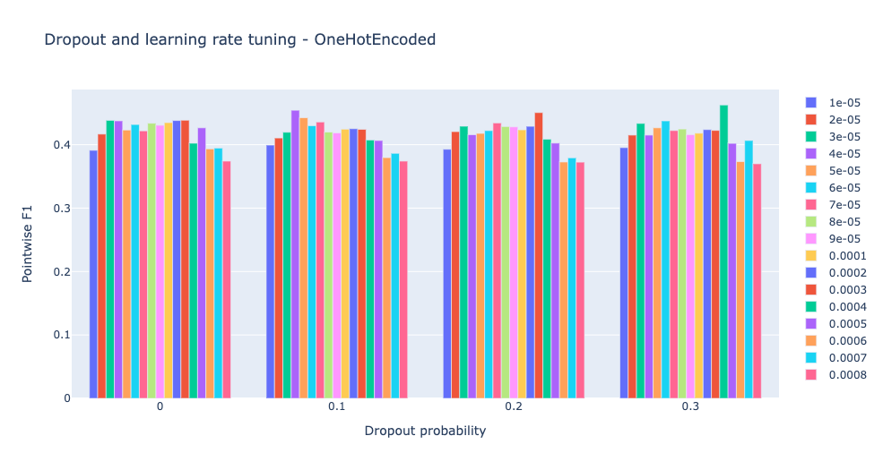
Supplementary figure 1. Residue-wise performance evaluation for hyperparameter tuning. From the models with ALBERT-based sequence embedding (in Figure 2), we replaced the sequence embeddings with simple one-hot encoded vectors of amino acids and repeated the performance evaluation on the same training and validation data. The best F1-score was found to be 0.4626 with dropout probability of 0.3 and initial learning rate of 0.0004, suggesting that higher dropout rate and learning rate are needed when ALBERT-based embedding is missing, and that the embedding helps improve the predictive power of the model.

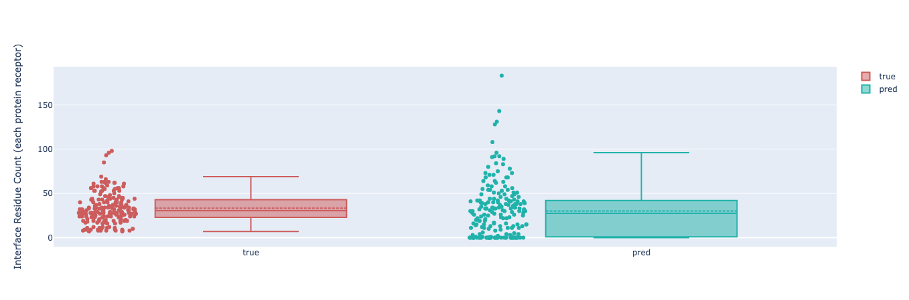
Supplementary figure 2. True and predicted interface residue counts for randomly sampled positive receptor-ligand pairs in test set. Each dot represents a receptor. The number of interface residues on y-axis, and colors indicate ground truth and predictions.

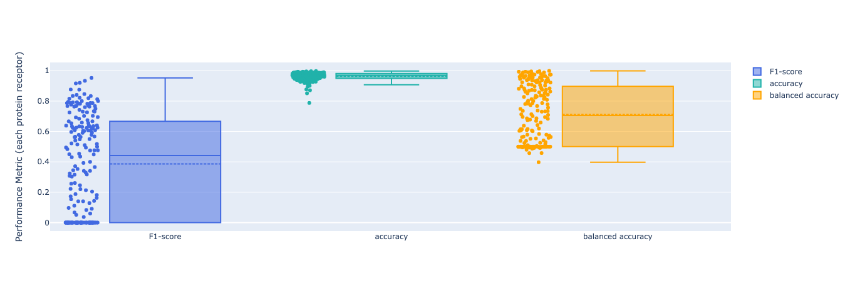
Supplementary figure 3. Pointwise predictive performance for randomly sampled positive receptor-ligand pairs in test set. Each dot represents a receptor. For each receptor in the pairs, the three pointwise performance metrics shown: F1-score, accuracy and balanced accuracy.

Supplementary figure 4. Point cloud visualizations with true and predicted interface residues. Blue and red meshes represent receptors and ligands, respectively. Yellow and red circles indicate true and predicted interface residues on the receptors; thus, red circles with a yellow halo are true positive predictions. A. Examples with high F1 scores showing that the model correctly identified most interface residues. B. Examples with low F1 scores showing that the model makes mixture of false positives and false negatives.

