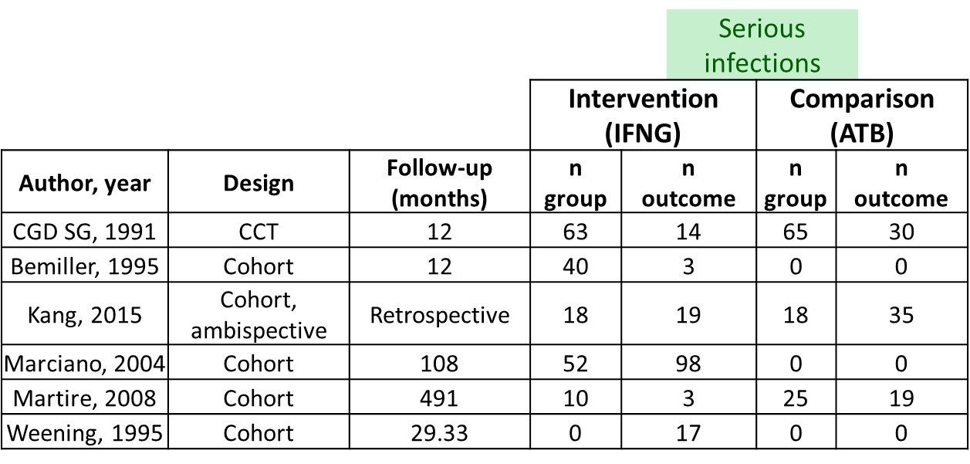

Table 1. Included studies outcomes for serious infections in the intervention and comparison groups.
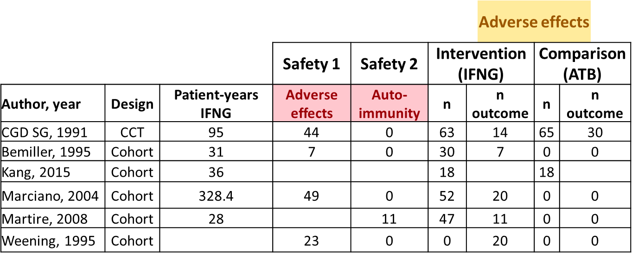
Table 2. Outcomes for Adverse effects and Auto-immune complications in the included studies, for intervention and control groups.

