ANNEXES

Color coded wright map
- Observing.- 1, 5, 9, 13, 17, 21, 25, 29, 30, 33, 37, 39.
(# of items = 12)
- Describing.- 2, 6, 10, 14, 18, 22, 26, 34.
(# of items = 8)
- Acting with awareness.- 3, 7, 11, 15, 19, 23, 27, 31, 35, 38.
(# of items = 10)
- Accepting (or allowing) without judgment.- 4, 8, 12, 16, 20, 24, 28, 32, 36
(# of items = 9)
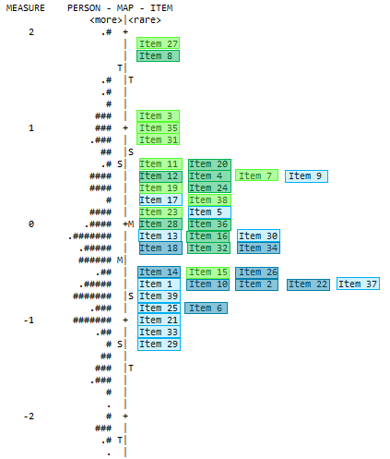

Recoded Fit Statistics
