Table 1. Item Fit Statistics
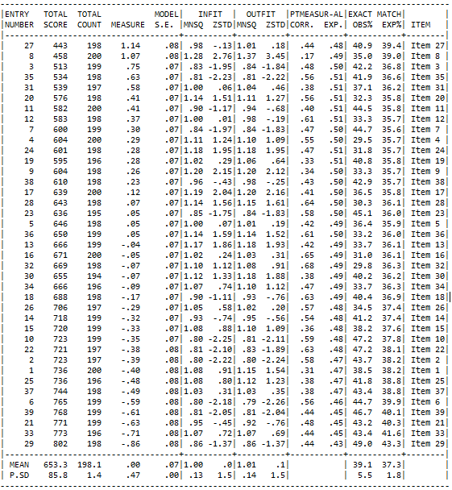

Table 2. Summary of category structure
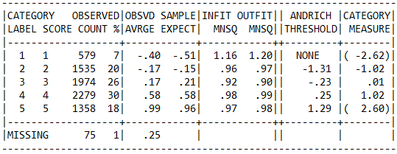

Table 3. Recoded summary of category structure
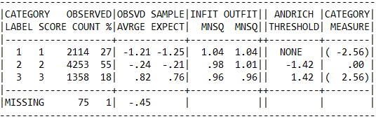

Table 4 Distractor Frequencies
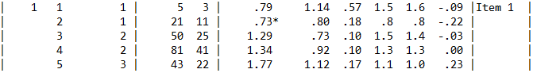
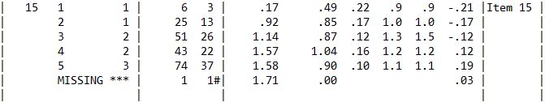
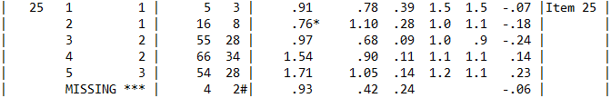
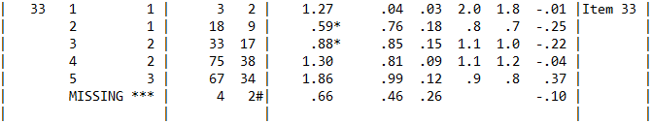

Table 5 Distractor Frequencies with less than 10 observations
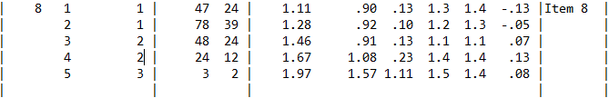
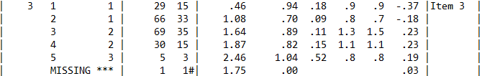
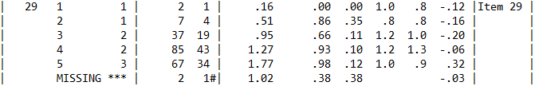

Table 6. Summary of measured items
