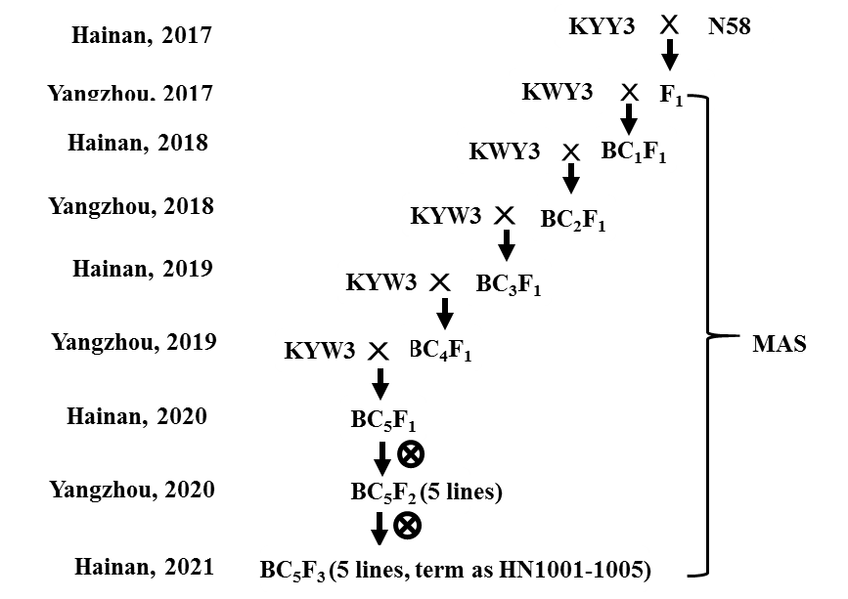
Supplemental Fig. 1 Breeding scheme of the NILs (near-isogenic lines) in the KWY3 (‘Kangwuyujing3’) genetic background.

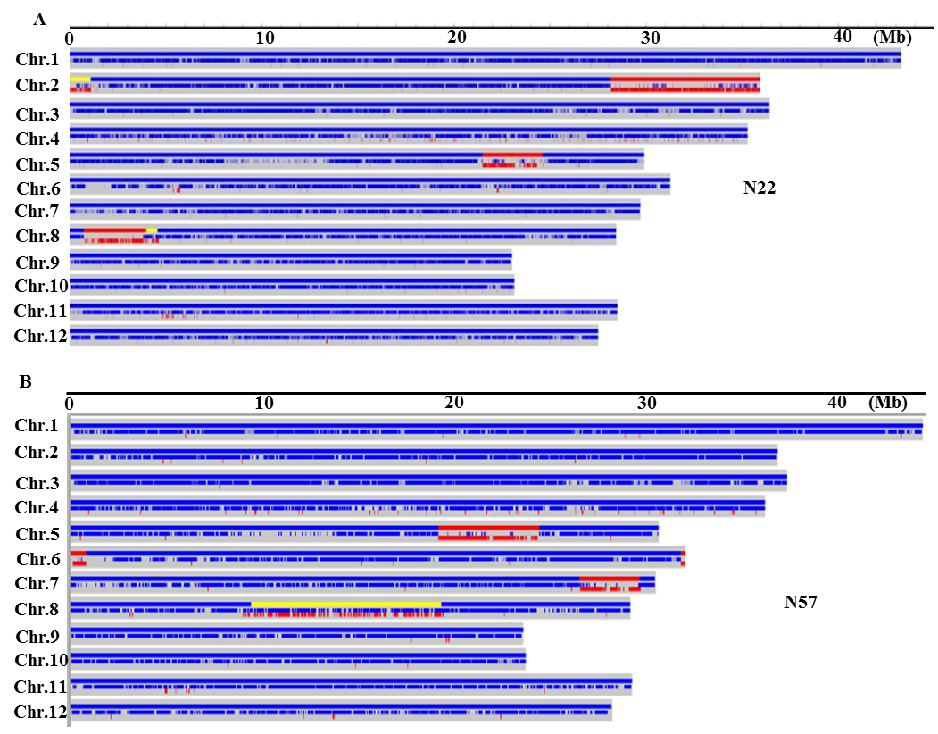
Supplemental Fig. 2 Graphical genotypes of CSSLs N22 and N57. The positions of the introgressed chromosomal segments from the donor indica cultivar ‘9311’ are shown in red and yellow on the blue ‘Nipponbare’ genomic background.

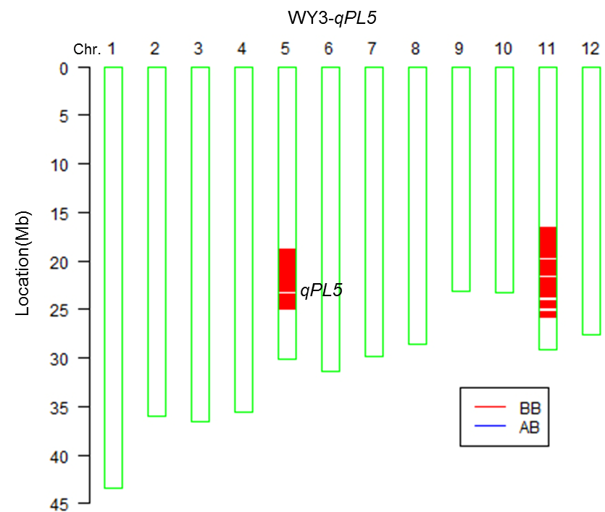
Supplemental Fig. 3 Graphical genotype of rice line KWY3-qPL5. The red rectangles represent introgressed chromosomal regions that are homozygous for the ‘9311’ genotype.

