Supplementary Information (Baumann et al., Earliest evidence for hunter-gatherer impacts on raven diet and ecology in the Gravettian of Southern Moravia, Nature Ecology & Evolution)

Part Ia: Contextual information
SI Syn: Synanthropism
Klegarth¹ defines synanthropic species as “wild or free-ranging plants or animals that benefit from a shared ecology with human beings.” In contrast to antanthropes who tend to avoid human-influenced environments, synanthropes thrive on the affordances and ecosystem services provided by human neighborhoods^{2–4}. Synanthropes frequently inhabit, and to some extent exemplify, “feral ecologies” as defined by the Feral Atlas⁵ – ecologies encouraged by human projects yet have “developed and spread beyond [direct] human control”. There are three main types of synanthropes: 1) commensal species derive food improvements and subsistence benefits from direct associations with humans; 2) edificarian or domiciliary species live in, on, or close to human built structures; and 3) environmental synanthropes, finally, take advantage of landscapes with a sustained anthropogenic ecological fingerprint².
Synanthropic and other co-evolutionary relationships at the human-animal interface have recently drawn considerable attention as expansive urbanization and an increasingly anthropogenic biosphere subvert ecological dynamics, frame “novel” habitats, environments and ecosystems^{6,7} including so-called “Anthromes” and “Anthroecologies”^{8,9} and in this way alter the behavioral trajectories of the involved species, often with substantial long-term consequences for human-environment systems. Synanthropic behavior, especially commensalism, has been implicated in the domestication of wolves^{10,11}, cats¹², possibly foxes¹³ and boar ¹⁴, and many birds in particular have been noted to successfully adapt to human-associated ecologies ^{2,3,15–19}.
SI PavSites: Pavlovian sites in relation to raven foraging patterns
The intraspecific variability of dietary profiles recorded in the sample of Pavlovian common raven deserves closer attention here as the elevated mammoth intake of raven individuals from Pavlov I is possibly emergent rather than coincidental. The local human settlement landscape in the Pavlovian Hill area during the Mid Upper Palaeolithic is highly differentiated and comprises both single and recurrent multiphase occupations as well as near-permanent, apparently year-round habitation localities ^{20,21}.
Pavlov I is an extensive, artifact-dense (>1 million lithic artefacts) and long-term occupation site (base camp) with hearths, various kettle-shaped “boiling pits”, larger stationary objects, circular features^{22,23}, a male burial (Pa1) covered by a mammoth shoulder blade underneath a small mammoth bone structure²⁰, and the so far only discovered deeper storage pit (K14) comparable to Eastern European analogues²⁴. Pavlov I yielded zooarchaeological evidence for all stages of animal processing and the importation of whole animal carcasses to the site²⁵. In comparison to other Pavlovian sites, mammoth remains are less abundant, while carnivore remains (wolves and foxes) are extremely frequent (>30% MNI) and the faunal spectrum is generally diversified²⁵. Pavlov I has been interpreted as reflecting a winter occupation emphasis due to possible traces of frozen meat working²⁶ and the focus on fur-bearing species²⁷ (cf. ²⁸ for winter procurement of arctic fox at the later Gravettian site of Kraków Spadzista). A small mammoth bone deposition has recently been discovered at the western slope of the site²⁴.
Dolní Věstonice I is a large and complex open-air site with intensive human occupations²⁹, uniquely thick and extensive ash lenses indicating special and recurrent use, several hearths (one with stone alignment), built bone structures and a rich assemblage of zoomorphic and anthropomorphic figurines including many undiagnostic fragments of fired clay²⁰. The site includes several mammoth bone depositions and is flanked by a massive 45 x 12 m mammoth bone concentration implicating ca. 40-80 elephant individuals adjacent to the DV3 female burial²⁰. Mammoth bone frequency is markedly higher at Dolní Věstonice I, but carnivores also contribute a substantial part of the faunal assemblage (>40% NISP)³⁰.
Předmostí I, by contrast, consists of a large burial area centered on the Skalka rock and peripheral to the primary settlement areas with hearths and macro-tools such as the iconic marlstone disc³¹, where Pavlovian domestic activity seems to be less intensive and structured than at Pavlov I and Dolní Věstonice I. The mean estimates of mammoth meat contribution to raven diets might reflect this differential nature of Pavlovian sites: the highest estimates are associated with the Pavlov I “megasite” where carcass import and substantial animal body part processing are documented, while Předmostí I with its more task-specific and slight ambiguous occupational signature scores the lowest mean values. The ravens from Dolní Věstonice I broadly occupy an intermediate position and this may in part reflect the distinct settlement profile of the site with more emphasis placed on ritual activity and especially clay transformation, object baking and figurine burial³². This being said, however, one should be cautious not to over-interpret these patterns and more evidence is needed to assess possible relationships between raven diets and site-specific human activities.

Part Ib: Data tables
SI Table 1a. Obtained niche metrics for common ravens compared to Pavlovian humans, other large carnivores and Artic foxes.
 | Pavlovian humans | Large carnivores | Arctic foxes | Ravens
n | 10 | 11 | 4 | 12
TA [‰²] | 0.95 | 2.31 | 0.20 | 5.68
SEA [‰²] | 0.45 | 1.22 | 0.25 | 2.51
SEAc [‰²] | 0.51 | 1.36 | 0.38 | 2.76

SI Table 1b. Obtained niche metrics for local and non-local ravens compared to Pavlovian humans, other large carnivores and Artic foxes.
 | Pavlovian humans | High δ³⁴S ravens | Local ravens | Large carnivores | Arctic foxes
n | 10 | 4 | 6 | 11 | 4
TA [‰²] | 0.95 | 0.61 | 3.02 | 2.31 | 0.20
SEA [‰²] | 0.45 | 0.67 | 2.43 | 1.22 | 0.25
SEAc [‰²] | 0.51 | 1.01 | 3.03 | 1.36 | 0.38

SI Table 2. Nitrogen, carbon and sulfur isotope values of consumers used for niche calculations, dietary reconstructions, and mobility estimates.
Lab-ID | Site | Taxon | δ¹³C | δ¹⁵N | δ³⁴S | Reference
PRDM-70 | Předmostí | Human | -19.4 | 12.6 |  | ³³
Hu-Brno | Brno | Human | -19.0 | 12.3 |  | ^{34,35}
Hu-Doln | Dolní Věstonice | Human | -18.8 | 12.3 |  | ³⁵
PRDM-7 | Předmostí | Cave lion | -18.6 | 9.4 | 1.9 | ³³
PRDM-8 | Předmostí | Cave lion | -18.6 | 8.1 | 0.3 | ³³
PRDM-12 | Předmostí | Wolverine | -19.3 | 8.8 |  | ³³
PRDM-14 | Předmostí | Wolverine | -19.4 | 7.4 |  | ³³
PRDM-16 | Předmostí | Wolverine | -18.9 | 9.0 | -1.3 | ³³
PRDM-23 | Předmostí | Arctic fox | -19.5 | 6.4 | 1.0 | ³³
PRDM-24 | Předmostí | Arctic fox | -19.8 | 8.0 | 6.3 | ³³
PRDM-26 | Předmostí | Arctic fox | -19.6 | 7.0 |  | ³³
PRDM-27 | Předmostí | Arctic fox | -19.7 | 6.2 | 6.3 | ³³
PRDM-49 | Předmostí | Wolf | -18.7 | 7.8 |  | ³³
PRDM-53 | Předmostí | Wolf | -18.3 | 8.9 |  | ³³
PRDM-55 | Předmostí | Wolf | -19.5 | 9.0 | 3.2 | ³³
PRDM-58 | Předmostí | Wolf | -19.4 | 9.9 |  | ³³
PRDM-61 | Předmostí | Wolf | -18.7 | 8.9 |  | ³³
PRDM-63 | Předmostí | Wolf | -19.5 | 10.7 |  | ³³
Pav-1 | Pavlov | Human | -19.5 | 13.6 |  | ³⁶
DV-13 | Dolní Věstonice | Human | -19.3 | 12.9 |  | ³⁶
DV-14 | Dolní Věstonice | Human | -20.3 | 13.3 |  | ³⁶
DV-15 | Dolní Věstonice | Human | -19.4 | 12.6 |  | ³⁶
DV-16 | Dolní Věstonice | Human | -19.7 | 12.5 |  | ³⁶
DV-42 | Dolní Věstonice | Human | -19.8 | 12.7 |  | ³⁶
DV-43 | Dolní Věstonice | Human | -19.6 | 12.6 |  | ³⁶
MCP-1 | Předmostí | Common raven | -19.3 | 8.6 | 3.6 | this study
MCP-2 | Předmostí | Common raven | -19.8 | 8.3 | -1.2 | this study
MCP-3 | Předmostí | Common raven | -19.9 | 8.1 | 3.9 | this study
MCP-4 | Předmostí | Common raven | -18.4 | 7.8 | 4.7 | this study
MCP-6 | Předmostí | Common raven | -19.7 | 8.1 | 1.7 | this study
MCP-8 | Předmostí | Common raven | -19.5 | 8.1 | 2.3 | this study
MCP-9 | Předmostí | Common raven | -18.6 | 10.6 | 1.6 | this study
MCP-13 | Dolní Věstonice | Common raven | -19.6 | 9.4 | 0.7 | this study
MCP-14 | Dolní Věstonice | Common raven | -19.3 | 10.7 | 1.9 | this study
MCP-15 | Dolní Věstonice | Common raven | -19.1 | 7.7 | 4.4 | this study
MCP-16 | Pavlov | Common raven | -21.0 | 8.5 | 2.9 | this study
MCP-17 | Pavlov | Common raven | -20.6 | 10.2 | -1.2 | this study

SI Table 3. Estimated dietary composition of artic foxes based on their position in the integrated Pavlovian isospace and in relation to the three inferred primary prey groups. (
 | Lab ID | Prey group | 5% | 25% | 50% | 75% | 95%
Arctic foxes | PRDM-23 | Reindeer | 0.8% | 3.6% | 9.9% | 23.0% | 45.0%
Arctic foxes | PRDM-23 | Large Herbivores | 3.8% | 20.5% | 48.1% | 71.1% | 89.9%
Arctic foxes | PRDM-23 | Mammoth | 5.7% | 17.7% | 33.8% | 56.9% | 84.9%
Arctic foxes | PRDM-24 | Reindeer | 0.7% | 3.5% | 8.1% | 17.1% | 33.4%
Arctic foxes | PRDM-24 | Large Herbivores | 3.2% | 16.2% | 37.9% | 62.5% | 86.0%
Arctic foxes | PRDM-24 | Mammoth | 9.0% | 27.9% | 48.1% | 68.1% | 89.3%
Arctic foxes | PRDM-26 | Reindeer | 0.7% | 3.6% | 9.5% | 20.4% | 39.9%
Arctic foxes | PRDM-26 | Large Herbivores | 3.6% | 20.2% | 46.0% | 67.7% | 87.3%
Arctic foxes | PRDM-26 | Mammoth | 6.9% | 21.3% | 37.9% | 59.8% | 85.7%
Arctic foxes | PRDM-27 | Reindeer | 0.7% | 3.2% | 8.2% | 17.6% | 38.5%
Arctic foxes | PRDM-27 | Large Herbivores | 2.9% | 18.2% | 49.7% | 73.3% | 89.6%
Arctic foxes | PRDM-27 | Mammoth | 5.6% | 17.0% | 36.3% | 63.1% | 88.0%

SI Table 4. Estimated dietary composition of Homo sapiens based on their position in the integrated Pavlovian isospace and in relation to the three inferred primary prey groups.
 | Lab ID | Prey group | 5% | 25% | 50% | 75% | 95%
Pavlovian humans | DV-13 | Reindeer | 2.2% | 6.8% | 10.9% | 15.5% | 23.1%
Pavlovian humans | DV-13 | Large Herbivores | 8.2% | 20.5% | 31.4% | 43.4% | 62.3%
Pavlovian humans | DV-13 | Mammoth | 31.9% | 47.1% | 56.8% | 65.0% | 76.4%
Pavlovian humans | DV-14 | Reindeer | 0.5% | 1.8% | 4.0% | 7.5% | 15.7%
Pavlovian humans | DV-14 | Large Herbivores | 1.4% | 5.5% | 12.1% | 22.8% | 48.6%
Pavlovian humans | DV-14 | Mammoth | 47.1% | 70.8% | 81.4% | 89.1% | 95.7%
Pavlovian humans | DV-15 | Reindeer | 0.6% | 2.9% | 6.2% | 12.2% | 24.9%
Pavlovian humans | DV-15 | Large Herbivores | 2.1% | 8.8% | 18.1% | 32.6% | 67.4%
Pavlovian humans | DV-15 | Mammoth | 28.0% | 57.5% | 70.4% | 82.1% | 92.9%
Pavlovian humans | DV-16 | Reindeer | 0.6% | 2.5% | 5.7% | 10.9% | 23.0%
Pavlovian humans | DV-16 | Large Herbivores | 1.9% | 8.1% | 17.0% | 31.6% | 62.4%
Pavlovian humans | DV-16 | Mammoth | 32.3% | 59.4% | 73.1% | 83.8% | 93.8%
Pavlovian humans | DV-42 | Reindeer | 0.5% | 2.3% | 5.3% | 10.2% | 21.2%
Pavlovian humans | DV-42 | Large Herbivores | 1.8% | 7.2% | 15.7% | 29.7% | 60.7%
Pavlovian humans | DV-42 | Mammoth | 35.1% | 61.7% | 75.2% | 85.5% | 94.4%
Pavlovian humans | DV-43 | Reindeer | 0.6% | 2.5% | 5.7% | 11.7% | 23.4%
Pavlovian humans | DV-43 | Large Herbivores | 2.0% | 8.0% | 17.3% | 32.1% | 64.8%
Pavlovian humans | DV-43 | Mammoth | 29.8% | 59.2% | 72.5% | 83.6% | 93.7%
Pavlovian humans | HuBrno | Reindeer | 0.7% | 3.1% | 7.3% | 15.0% | 31.3%
Pavlovian humans | HuBrno | Large Herbivores | 2.4% | 9.0% | 20.3% | 37.8% | 72.0%
Pavlovian humans | HuBrno | Mammoth | 21.6% | 50.8% | 66.3% | 79.0% | 92.2%
Pavlovian humans | HuDoln | Reindeer | 0.7% | 3.2% | 7.3% | 15.8% | 32.8%
Pavlovian humans | HuDoln | Large Herbivores | 2.3% | 9.0% | 19.9% | 38.4% | 76.6%
Pavlovian humans | HuDoln | Mammoth | 17.1% | 48.7% | 65.0% | 79.1% | 92.2%
Pavlovian humans | Pav-1 | Reindeer | 0.6% | 2.2% | 5.0% | 10.3% | 21.7%
Pavlovian humans | Pav-1 | Large Herbivores | 1.7% | 6.6% | 13.9% | 25.8% | 51.4%
Pavlovian humans | Pav-1 | Mammoth | 41.3% | 65.6% | 77.1% | 86.2% | 94.7%
Pavlovian humans | PRDM-70 | Reindeer | 0.6% | 2.6% | 6.3% | 12.7% | 25.3%
Pavlovian humans | PRDM-70 | Large Herbivores | 2.1% | 8.6% | 17.9% | 32.4% | 63.9%
Pavlovian humans | PRDM-70 | Mammoth | 29.8% | 57.8% | 71.2% | 82.2% | 93.2%

SI Table 5. Estimated dietary composition of large non-human carnivores based on their position in the integrated Pavlovian isospace and in relation to the three inferred primary prey groups.
 | Taxon | Lab ID | Prey group | 5% | 25% | 50% | 75% | 95%
Large Carnivores | Wolverines | PRDM-12 | Reindeer | 0.8% | 4.5% | 11.8% | 24.2% | 43.6%
Large Carnivores | Wolverines | PRDM-12 | Large Herbivores | 3.3% | 17.3% | 36.1% | 57.2% | 82.1%
Large Carnivores | Wolverines | PRDM-12 | Mammoth | 11.7% | 29.1% | 44.3% | 60.8% | 84.1%
Large Carnivores | Wolverines | PRDM-14 | Reindeer | 0.8% | 4.2% | 11.3% | 25.3% | 45.8%
Large Carnivores | Wolverines | PRDM-14 | Large Herbivores | 4.0% | 18.6% | 41.4% | 63.8% | 86.5%
Large Carnivores | Wolverines | PRDM-14 | Mammoth | 7.8% | 22.9% | 39.3% | 57.6% | 83.8%
Large Carnivores | Wolverines | PRDM-16 | Reindeer | 0.8% | 5.5% | 16.4% | 31.9% | 51.5%
Large Carnivores | Wolverines | PRDM-16 | Large Herbivores | 4.2% | 17.8% | 36.0% | 56.3% | 83.0%
Large Carnivores | Wolverines | PRDM-16 | Mammoth | 9.7% | 26.0% | 39.7% | 54.4% | 79.3%
Large Carnivores | Wolves | PRDM-49 | Reindeer | 0.8% | 7.1% | 22.5% | 42.2% | 63.1%
Large Carnivores | Wolves | PRDM-49 | Large Herbivores | 4.0% | 17.8% | 38.5% | 61.5% | 86.9%
Large Carnivores | Wolves | PRDM-49 | Mammoth | 6.5% | 18.0% | 29.8% | 43.9% | 73.3%
Large Carnivores | Wolves | PRDM-53 | Reindeer | 0.9% | 6.8% | 23.6% | 48.1% | 69.6%
Large Carnivores | Wolves | PRDM-53 | Large Herbivores | 2.9% | 14.6% | 34.5% | 61.9% | 87.1%
Large Carnivores | Wolves | PRDM-53 | Mammoth | 6.6% | 17.0% | 27.9% | 43.5% | 76.1%
Large Carnivores | Wolves | PRDM-55 | Reindeer | 0.7% | 3.9% | 9.7% | 19.7% | 37.7%
Large Carnivores | Wolves | PRDM-55 | Large Herbivores | 3.3% | 17.8% | 35.9% | 56.2% | 81.9%
Large Carnivores | Wolves | PRDM-55 | Mammoth | 11.9% | 31.9% | 48.1% | 65.4% | 86.4%
Large Carnivores | Wolves | PRDM-58 | Reindeer | 0.7% | 3.8% | 9.9% | 19.9% | 36.7%
Large Carnivores | Wolves | PRDM-58 | Large Herbivores | 3.4% | 15.0% | 31.0% | 51.3% | 77.5%
Large Carnivores | Wolves | PRDM-58 | Mammoth | 15.6% | 36.4% | 52.4% | 68.2% | 87.4%
Large Carnivores | Wolves | PRDM-61 | Reindeer | 0.9% | 5.6% | 18.8% | 36.6% | 57.5%
Large Carnivores | Wolves | PRDM-61 | Large Herbivores | 3.7% | 17.7% | 36.8% | 58.9% | 84.4%
Large Carnivores | Wolves | PRDM-61 | Mammoth | 9.1% | 22.8% | 35.4% | 50.0% | 76.5%
Large Carnivores | Wolves | PRDM-63 | Reindeer | 0.7% | 3.3% | 7.7% | 15.5% | 32.0%
Large Carnivores | Wolves | PRDM-63 | Large Herbivores | 2.5% | 12.2% | 27.4% | 46.8% | 74.8%
Large Carnivores | Wolves | PRDM-63 | Mammoth | 17.9% | 42.8% | 59.3% | 74.3% | 90.2%
Large Carnivores | Cave lions | PRDM-7 | Reindeer | 0.8% | 5.3% | 17.0% | 35.9% | 58.3%
Large Carnivores | Cave lions | PRDM-7 | Large Herbivores | 3.2% | 15.1% | 34.5% | 58.1% | 82.8%
Large Carnivores | Cave lions | PRDM-7 | Mammoth | 9.6% | 23.9% | 36.9% | 53.0% | 80.7%
Large Carnivores | Cave lions | PRDM-8 | Reindeer | 0.8% | 6.8% | 23.6% | 43.4% | 65.1%
Large Carnivores | Cave lions | PRDM-8 | Large Herbivores | 3.9% | 17.0% | 37.7% | 62.7% | 87.1%
Large Carnivores | Cave lions | PRDM-8 | Mammoth | 6.8% | 17.9% | 28.9% | 43.2% | 72.8%

SI Table 6. Published comparative sulfur isotope values from animal taxa dated to the pre-LGM of Central and Western Europe.
Site | Region | Taxon | δ³⁴S | Reference
Goyet | Central Belgium | Cave lion | -2.1 | ³⁷
Goyet | Central Belgium | Cave lion | 0.6 | ³⁷
Goyet | Central Belgium | Hyena | 1.4 | ³⁷
Goyet | Central Belgium | Hyena | 1.4 | ³⁷
Goyet | Central Belgium | Hyena | 4.5 | ³⁷
Goyet | Central Belgium | Hyena | 2.6 | ³⁷
Goyet | Central Belgium | Hyena | 4.3 | ³⁷
Scladina | Central Belgium | Hyena | 4.3 | ³⁷
Scladina | Central Belgium | Hyena | 1.1 | ³⁷
Scladina | Central Belgium | Hyena | 0.1 | ³⁷
Goyet | Central Belgium | Wolf | 1.7 | ³⁷
Goyet | Central Belgium | Wolf | 2.9 | ³⁷
Scladina | Central Belgium | Wolf | 11.8 | ³⁷
Goyet | Central Belgium | Cave bear | -5.0 | ³⁷
Goyet | Central Belgium | Cave bear | -6.6 | ³⁷
Goyet | Central Belgium | Cave bear | -1.5 | ³⁷
Goyet | Central Belgium | Cave bear | -1.7 | ³⁷
Scladina | Central Belgium | Cave bear | 0.1 | ³⁷
Scladina | Central Belgium | Cave bear | -2.1 | ³⁷
Scladina | Central Belgium | Cave bear | 3.4 | ³⁷
Scladina | Central Belgium | Cave bear | -17.0 | ³⁷
Scladina | Central Belgium | Cave bear | -5.4 | ³⁷
Scladina | Central Belgium | Cave bear | -4.2 | ³⁷
Goyet | Central Belgium | Mammoth | -2.6 | ³⁷
Goyet | Central Belgium | Mammoth | 4.1 | ³⁷
Goyet | Central Belgium | Mammoth | 8.4 | ³⁷
Scladina | Central Belgium | Mammoth | 6.0 | ³⁷
Scladina | Central Belgium | Mammoth | 6.6 | ³⁷
Scladina | Central Belgium | Mammoth | 4.5 | ³⁷
Goyet | Central Belgium | Wooly rhino | -0.1 | ³⁷
Scladina | Central Belgium | Wooly rhino | 6.9 | ³⁷
Scladina | Central Belgium | Wooly rhino | 1.9 | ³⁷
Scladina | Central Belgium | Wooly rhino | 4.6 | ³⁷
Scladina | Central Belgium | Wooly rhino | 2.5 | ³⁷
Goyet | Central Belgium | Horse | 0.6 | ³⁷
Goyet | Central Belgium | Horse | 1.0 | ³⁷
Goyet | Central Belgium | Horse | -0.7 | ³⁷
Scladina | Central Belgium | Horse | 5.7 | ³⁷
Scladina | Central Belgium | Horse | 2.0 | ³⁷
Scladina | Central Belgium | Horse | 6.2 | ³⁷
Spy | Central Belgium | Horse | 5.5 | ³⁷
Goyet | Central Belgium | Bison | -2.8 | ³⁷
Goyet | Central Belgium | Bison | 4.9 | ³⁷
Scladina | Central Belgium | Bison | 4.1 | ³⁷
Scladina | Central Belgium | Bison | 8.4 | ³⁷
Scladina | Central Belgium | Bison | 4.5 | ³⁷
Goyet | Central Belgium | Reindeer | 7.2 | ³⁷
Goyet | Central Belgium | Reindeer | 6.2 | ³⁷
Goyet | Central Belgium | Reindeer | 5.1 | ³⁷
Goyet | Central Belgium | Reindeer | 6.8 | ³⁷
Goyet | Central Belgium | Reindeer | -7.2 | ³⁷
Scladina | Central Belgium | Reindeer | 8.3 | ³⁷
Scladina | Central Belgium | Reindeer | 7.5 | ³⁷
Scladina | Central Belgium | Reindeer | 8.5 | ³⁷
Scladina | Central Belgium | Reindeer | 10.5 | ³⁷
Scladina | Central Belgium | Reindeer | 4.5 | ³⁷
Scladina | Central Belgium | Reindeer | 13.1 | ³⁷
Lommersum | Rhine Valley | Reindeer | 1.4 | ³⁷
Lommersum | Rhine Valley | Reindeer | 4.2 | ³⁷
Lommersum | Rhine Valley | Reindeer | 4.7 | ³⁷
Lommersum | Rhine Valley | Reindeer | 2.6 | ³⁷
Lommersum | Rhine Valley | Reindeer | 5.6 | ³⁷
Lommersum | Rhine Valley | Horse | 2.0 | ³⁷
Lommersum | Rhine Valley | Horse | 3.5 | ³⁷
Geißenklösterle | Swabian Jura | Mammoth | -1.8 | ³⁸
Geißenklösterle | Swabian Jura | Mammoth | -2.2 | ³⁸
Geißenklösterle | Swabian Jura | Mammoth | 1.9 | ³⁸
Geißenklösterle | Swabian Jura | Reindeer | -1.4 | ³⁸
Geißenklösterle | Swabian Jura | Reindeer | 11.9 | ³⁸
Geißenklösterle | Swabian Jura | Horse | 0.8 | ³⁸
Geißenklösterle | Swabian Jura | Horse | 3.6 | ³⁸
Geißenklösterle | Swabian Jura | Horse | -0.4 | ³⁸
Geißenklösterle | Swabian Jura | Horse | 1.4 | ³⁸
Abri Pataud | Dordogne | Mammoth | 11.9 | ³⁸
Abri Pataud | Dordogne | Mammoth | 12.2 | ³⁸
Abri Pataud | Dordogne | Mammoth | 11.5 | ³⁸
Abri Pataud | Dordogne | Mammoth | 13.6 | ³⁸
Abri Pataud | Dordogne | Mammoth | 12.7 | ³⁸
Abri Pataud | Dordogne | Mammoth | 7.1 | ³⁸
Abri Pataud | Dordogne | Mammoth | 11.1 | ³⁸
Abri Pataud | Dordogne | Mammoth | 2.6 | ³⁸
Abri Pataud | Dordogne | Reindeer | 7.8 | ³⁸
Abri Pataud | Dordogne | Reindeer | 15.2 | ³⁸
Abri Pataud | Dordogne | Reindeer | 8.8 | ³⁸
Abri Pataud | Dordogne | Reindeer | 8.8 | ³⁸
Abri Pataud | Dordogne | Reindeer | 6.2 | ³⁸
Abri Pataud | Dordogne | Horse | 11.7 | ³⁸
Abri Pataud | Dordogne | Horse | 12.7 | ³⁸

SI Table 7. Published comparative carbon, nitrogen and sulfur isotope abundances from animal taxa from the Pavlovian of Předmostí I, Czech Republic, and their assigned source groups (cf. Results and Materials & Methods).
Lab-ID | Site | Taxon | δ¹³C | δ¹⁵N | δ³⁴S | Reference | Source group
PRDM-1 | Předmostí I | Reindeer | -18.9 | 2.8 | -0.4 | ³³ | Reindeer
PRDM-2 | Předmostí I | Reindeer | -19.3 | 2.7 |  | ³³ | Reindeer
PRDM-3 | Předmostí I | Reindeer | -18.8 | 2.6 | 0.8 | ³³ | Reindeer
PRDM-4 | Předmostí I | Reindeer | -18.9 | 3.9 |  | ³³ | Large Herbivores
PRDM-17 | Předmostí I | Horse | -21.0 | 5.6 |  | ³³ | Large Herbivores
PRDM-18 | Předmostí I | Horse | -20.8 | 5.2 |  | ³³ | Large Herbivores
PRDM-19 | Předmostí I | Horse | -20.4 | 5.1 |  | ³³ | Large Herbivores
PRDM-20 | Předmostí I | Horse | -20.8 | 3.7 |  | ³³ | Large Herbivores
PRDM-21 | Předmostí I | Horse | -20.7 | 5 |  | ³³ | Large Herbivores
PRDM-30 | Předmostí I | Wooly rhino | -20.5 | 3.9 |  | ³³ | Large Herbivores
PRDM-31 | Předmostí I | Wooly rhino | -20.3 | 5 |  | ³³ | Large Herbivores
PRDM-32 | Předmostí I | Bison | -20.7 | 3.3 | 2.8 | ³³ | Large Herbivores
PRDM-33 | Předmostí I | Bison | -19.6 | 3.3 |  | ³³ | Large Herbivores
PRDM-34 | Předmostí I | Bison | -19.6 | 4.2 |  | ³³ | Large Herbivores
PRDM-35 | Předmostí I | Bison | -20.2 | 6.8 | 3.7 | ³³ | Mammoth
PRDM-36 | Předmostí I | Bison | -20.3 | 5.3 |  | ³³ | Large Herbivores
PRDM-37 | Předmostí I | Red deer | -20.9 | 2.7 | 0.2 | ³³ | Large Herbivores
PRDM-38 | Předmostí I | Muskox | -19.1 | 1.6 |  | ³³ | Reindeer
PRDM-39 | Předmostí I | Muskox | -18.7 | 1.3 |  | ³³ | Reindeer
PRDM-42 | Předmostí I | Mammoth | -21.5 | 8.0 |  | ³³ | Mammoth
PRDM-43 | Předmostí I | Mammoth | -21.1 | 7.7 |  | ³³ | Mammoth
PRDM-46 | Předmostí I | Mammoth | -21.2 | 7.3 |  | ³³ | Mammoth
TSK-II-1 | Předmostí I | Mammoth | -20.9 | 9.6 |  | ³³ | Mammoth
TSK-II-3 | Předmostí I | Mammoth | -20.7 | 9.8 | 3.5 | ³³ | Mammoth
TSK-II-7 | Předmostí I | Mammoth | -21.8 | 8.2 |  | ³³ | Mammoth

SI Table 8. Published ¹⁴C data from Pavlov I, Předmostí I and Dolní Věstonice I used for comparison with the newly dated raven remains.
Site | LabNr | Uncal. 14C age | Dev. | Archaeological context | Rejected ages | Literature
Předmostí Ib | GrN-6801 | 26.870 | 250 | Pavlovian |  | ³¹
Předmostí Ib | GrN-6852 | 26.320 | 240 | Pavlovian |  | ³¹
Předmostí Ib | GrA-32583 | 26.780 | 140 | Lower layer - Pavlovian |  | ³¹
Předmostí Ib | GrA-32641 | 24.340 | 120 | Upper layer - Willendorf-Kostenkian | Too young, discarded | ³¹
Dolní Věstonice I | GrN-6859 | 27.790 | 370 |  |  | ³⁹
Dolní Věstonice I | GrN-10524 | 26.430 | 190 |  |  | ³⁹
Dolní Věstonice I | GrN-18189 | 25.950 | 630 |  |  | ³⁹
Dolní Věstonice I | GrN-1286 | 25.820 | 170 |  |  | ³⁹
Dolní Věstonice I | GrN-6875 | 25.790 | 320 |  |  | ³⁹
Dolní Věstonice I | OxA-8292 | 22.840 | 200 |  | Too young, discarded | ³⁹
Pavlov 1 SE | GrN-4812 | 26.730 | 250 | Klima 1952-1972 |  | ⁴⁰
Pavlov 1 SE | GrN-19539 | 26.650 | 230 | Klima 1952-1972 |  | ⁴⁰
Pavlov 1 SE | GrN-1272 | 26.620 | 230 | Klima 1952-1972 |  | ⁴⁰
Pavlov 1 SE | KN-1286 | 26.580 | 460 | Klima 1952-1972 |  | ⁴⁰
Pavlov 1 SE | GrN-22303 | 26.400 | 310 | Klima 1952-1972 |  | ⁴⁰
Pavlov 1 SE | GrN-22305 | 25.840 | 290 | Klima 1952-1972 |  | ⁴⁰
Pavlov 1 SE | GrA-192 | 25.530 | 110 | Klima 1952-1972 |  | ⁴⁰
Pavlov 1 SE | GrN-22304 | 25.160 | 170 | Klima 1952-1972 |  | ⁴⁰
Pavlov 1 SE | GrN-1325 | 25.020 | 150 | Klima 1952-1972 |  | ⁴⁰
Pavlov 1 NW | GrN-20391 | 26.170 | 450 | Klima 1952-1972 |  | ⁴⁰
Pavlov 1 C | GIN-104 | 26.000 | 350 | Klima 1952-1972 |  | ⁴⁰
Pavlov 1 SW/A | Beta 359288 | 25.810 | 130 | Svoboda 2013-2014 |  | ⁴⁰
Pavlov 1 SW/A | Beta 359287 | 26.400 | 140 | Svoboda 2013-2014 |  | ⁴⁰
Pavlov 1 SW/A | Beta 359285 | 27520 | 150 | Svoboda 2013-2014 |  | ⁴⁰
Pavlov 1 SW/A | Beta 359286 | 28860 | 170 | Svoboda 2013-2014 |  | ⁴⁰
Pavlov I SW/B | Beta 359289 | 27050 | 130 | Svoboda 2013-2014 |  | ⁴⁰
Pavlov I SW/D | Beta 359291 | 26340 | 140 | Svoboda 2013-2014 |  | ⁴⁰
Pavlov I SW/D | Beta 359292 | 28630 | 170 | Svoboda 2013-2014 |  | ⁴⁰
Pavlov I SW/D | Beta 359293 | 28560 | 160 | Svoboda 2013-2014 |  | ⁴⁰
Pavlov I SW/D | Beta 359294 | 32540 | 240 |  | Too old, discarded | ⁴⁰
Pavlov I SW/E | Beta 388397 | 26920 | 130 | Svoboda 2013-2014 |  | ⁴⁰
Pavlov I SW/E | Beta 388398 | 28580 | 140 | Svoboda 2013-2014 |  | ⁴⁰
Pavlov I SW/E | Beta 388399 | 33230 | 220 |  | Too old, discarded | ⁴⁰
Pavlov I SE/unit S1 | Beta 388403 | 26420 | 120 | Svoboda 2013-2014 |  | ⁴⁰
Pavlov I SE/unit S1 | Beta 388404 | 28710 | 120 | Svoboda 2013-2014 |  | ⁴⁰
Pavlov I SE/unit S1 | Beta 388405 | 27570 | 120 |  | Described as problematic, discarded | ⁴⁰
Pavlov I SE/unit S1 | Beta 388406 | 27410 | 120 |  | Described as problematic, discarded | ⁴⁰
Pavlov I SE/pit S2 | Beta 388400 | 26180 | 110 | Svoboda 2013-2014 |  | ⁴⁰
Pavlov I SE/pit S2 | Beta 388401 | 27660 | 130 | Svoboda 2013-2014 |  | ⁴⁰
Pavlov I SE/pit S2 | Beta 388402 | 26990 | 120 | Svoboda 2013-2014 |  | ⁴⁰

References
1. Klegarth, A. R. Synanthropy. in The International Encyclopedia of Primatology (eds. Bezanson, M. et al.) 1–5 (John Wiley & Sons, Inc., 2017). doi:10.1002/9781119179313.wbprim0448.
2. O’Connor, T. Animals as neighbors: the past and present of commensal species. (Michigan State University Press, 2013).
3. Johnston, R. F. Synanthropic birds of North America. in Avian Ecology and Conservation in an Urbanizing World (eds. Marzluff, J. M., Bowman, R. & Donnelly, R.) 49–67 (Springer US, 2001). doi:10.1007/978-1-4615-1531-9_3.
4. Marchesini, R. ANIMALS OF THE CITY. Angelaki 21, 79–91 (2016).
5. Tsing, A. L., Deger, J., Saxena, A. K. & Zhou, F. Feral Atlas: The More-Than-Human Anthropocene. (Stanford University Press, 2020). doi:10.21627/2020fa.
6. Hobbs, R. J., Higgs, E. & Harris, J. A. Novel ecosystems: implications for conservation and restoration. Trends Ecol. Evol. 24, 599–605 (2009).
7. Morse, N. B. et al. Novel ecosystems in the Anthropocene: a revision of the novel ecosystem concept for pragmatic applications. Ecol. Soc. 19, art12 (2014).
8. Ellis, E. C. Ecology in an anthropogenic biosphere. Ecol. Monogr. 85, 287–331 (2015).
9. Ellis, E. C., Beusen, A. H. W. & Goldewijk, K. K. Anthropogenic Biomes: 10,000 BCE to 2015 CE. Land 9, 129 (2020).
10. Baumann, C. et al. A refined proposal for the origin of dogs: the case study of Gnirshöhle, a Magdalenian cave site. Sci. Rep. 11, 5137 (2021).
11. Serpell, J. A. Commensalism or Cross-Species Adoption? A Critical Review of Theories of Wolf Domestication. Front. Vet. Sci. 8, 662370 (2021).
12. Krajcarz, M. et al. Ancestors of domestic cats in Neolithic Central Europe: Isotopic evidence of a synanthropic diet. Proc. Natl. Acad. Sci. 117, 17710–17719 (2020).
13. Grandal-d’Anglade, A. et al. Dogs and foxes in Early-Middle Bronze Age funerary structures in the northeast of the Iberian Peninsula: human control of canid diet at the sites of Can Roqueta (Barcelona) and Minferri (Lleida). Archaeol. Anthropol. Sci. 11, 3949–3978 (2019).
14. Vigne, J.-D. et al. Pre-Neolithic wild boar management and introduction to Cyprus more than 11,400 years ago. Proc. Natl. Acad. Sci. 106, 16135–16138 (2009).
15. Alberti, M., Marzluff, J. & Hunt, V. M. Urban driven phenotypic changes: empirical observations and theoretical implications for eco-evolutionary feedback. Philos. Trans. R. Soc. B Biol. Sci. 372, 20160029 (2017).
16. Clucas, B. & Marzluff, J. M. Coupled Relationships between Humans and other Organisms in Urban Areas. in Urban Ecology (eds. Breuste, J. H., Elmqvist, T., Guntenspergen, G., James, P. & McIntyre, N. E.) 135–147 (Oxford University Press, 2011). doi:10.1093/acprof:oso/9780199563562.003.0017.
17. Ravinet, M. et al. Signatures of human-commensalism in the house sparrow genome. Proc. R. Soc. B Biol. Sci. 285, 20181246 (2018).
18. Baldaccini, N. E. The synanthropic status of wild rock doves (Columba livia) and their contribution to feral pigeon populations. Riv. Ital. Ornitol. 90, (2020).
19. Kumar, N. et al. Habitat selection by an avian top predator in the tropical megacity of Delhi: human activities and socio-religious practices as prey-facilitating tools. Urban Ecosyst. (2017) doi:10.1007/s11252-017-0716-8.
20. Svoboda, J. Dolní Věstonice--Pavlov: explaining Paleolithic settlements in central Europe. (Texas A&M University Press, 2020).
21. Svoboda, J. The Gravettian of Moravia: Landscape, settlement, and dwellings. (Archaeopress, 2003).
22. Pavlov I Southeast: a window into the Gravettian lifestyles. (Academy of Sciences of the Czech Republic, Institute of Archaeology, 2005).
23. Novák, M. Pavlov I - Southeast: Review of spatial distributions. vol. D (Archeologický ústav AVČR Brno, 2005).
24. Svoboda, J., Novák, M., Sázelová, S. & Demek, J. Pavlov I: A large Gravettian site in space and time. Quat. Int. 406, 95–105 (2016).
25. Wojtal, P., Wilczyński, J., Bocheński, Z. M. & Svoboda, J. A. The scene of spectacular feasts: Animal remains from Pavlov I south-east, the Czech Republic. Quat. Int. 252, 122–141 (2012).
26. Tomášková, S. Use-wear analysis and its spatial interpretation. in Pavlov I, Excavations 1952–1953 35–47 (1994).
27. Musil, R. Hunting Game of the Culture layer of Pavlov. V, (1994).
28. Pryor, A. J. E. et al. Mobility and season of death of the Arctic foxes killed by Gravettian hunters at Kraków Spadzista, Poland. J. Archaeol. Sci. Rep. 33, 102520 (2020).
29. Svoboda, J. A. The Gravettian on the Middle Danube. Paléo 203–220 (2007) doi:10.4000/paleo.607.
30. Wilczyński, J., Wojtal, P., Robličková, M. & Oliva, M. Dolní Věstonice I (Pavlovian, the Czech Republic) – Results of zooarchaeological studies of the animal remains discovered on the campsite (excavation 1924–52). Quat. Int. 379, 58–70 (2015).
31. A. Svoboda, J. The Upper Paleolithic burial area at Předmostí: ritual and taphonomy. J. Hum. Evol. 54, 15–33 (2008).
32. Verpoorte, A. Places of art, traces of fire. A contextual approach to anthropomorphic figurines in the Pavlovian. (Archaeological Studies Leiden University, 2000).
33. Bocherens, H. et al. Reconstruction of the Gravettian food-web at Předmostí I using multi-isotopic tracking (13C, 15N, 34S) of bone collagen. Quat. Int. 359–360, 211–228 (2015).
34. Pettitt, P. & Trinkaus, E. Direct radiocarbon dating of the Brno 2 Gravettian human remains. Anthropologie 38, 149–50 (2000).
35. Richards, M. P., Pettitt, P. B., Stiner, M. C. & Trinkaus, E. Stable isotope evidence for increasing dietary breadth in the European mid-Upper Paleolithic. Proc. Natl. Acad. Sci. 98, 6528–6532 (2001).
36. Fewlass, H. et al. Direct radiocarbon dates of mid Upper Palaeolithic human remains from Dolní Věstonice II and Pavlov I, Czech Republic. J. Archaeol. Sci. Rep. 27, 102000 (2019).
37. Wißing, C. et al. Stable isotopes reveal patterns of diet and mobility in the last Neandertals and first modern humans in Europe. Sci. Rep. 9, 4433 (2019).
38. Drucker, D. G. et al. Tracking possible decline of woolly mammoth during the Gravettian in Dordogne (France) and the Ach Valley (Germany) using multi-isotope tracking (13C, 14C, 15N, 34S, 18O). Quat. Int. 359–360, 304–317 (2015).
39. Svoboda, J. A. Gravettian art of Pavlov I and VI: an aggregation site and an episodic site compared. in L’art pléistocène dans le monde / Pleistocene art of the world / Arte pleistoceno en el mundo 1461–1469 (2012).
40. Svoboda, J., Novák, M., Sázelová, S. & Demek, J. Pavlov I: A large Gravettian site in space and time. Quat. Int. 406, 95–105 (2016).

Part II: Detailed bone sample information
SI Table 9. Overview of samples taken at the Moravian Museum, Brno, Czech Republic, including weight information and Foto IDs (MCP = Moravian Corvid Project).
Species/Taxon | Bone element | Site | ID | Total bone weight (g) | Sample weight (g) | Foto ID | Comment(s)
Corvus corax | Left Ulna | Předmostí I | MCP-1 | 0.91 | 0.91 | MCP 01
Corvus corax | Left Ulna | Předmostí I | MCP-2 | 1.03 | 1.03 | MCP 02
Corvus corax | Left Ulna | Předmostí I | MCP-3 | 1.81 | 0.78 | MCP 03
Corvus corax | Left Ulna | Předmostí I | MPC-4 | 3.01 | 1.15 | MCP 04 | A lot of sediment still enclosed (weight skewed)
Corvus corax | Left Ulna | Předmostí I | MPC-5 | 2.62 | 0.98 | MCP 05 | A lot of sediment still enclosed (weight skewed)
Corvus corax | Left Ulna | Předmostí I | MPC-6 | 2.28 | 1.02 | MCP 06 | A lot of sediment still enclosed (weight skewed)
Corvus corax | Left Ulna | Předmostí I | MCP-7 | 2.28 | 0.81 | MCP 07
Corvus corax | Left Ulna | Předmostí I | MPC-8 | 3.00 | 1.02 | MCP 08 | Weight skewed (enclosed sediment)
Corvus corax | Left Ulna | Předmostí I | MCP-9 | 2.91 | 0.89 | MCP 09 | Weight skewed (enclosed sediment)
Corvus corax | Left Ulna | Předmostí I | MCP-10 | 4.32 | 1.07 | MCP 10 | Included a wooden stick glued to the inside of the bone (weighted without stick)
Nyctea nivea | Scapula | Předmostí I | MCP-11 | 1.44 | 0.73 | MCP 11
Gyps fulvus | Humerus | Předmostí I | MCP-12 | 35.91 | 0.99 | MCP 12 | Sintercrust
Corvus corax | Left Ulna | Dolní Věstonice I | MCP-13 | 1.07 | 0.83 | MCP 13
Corvus corax | Left Femur | Dolní Věstonice I | MCP-14 | 0.61 | 0.61 | MCP 14
Corvus corax | Left Femur | Dolní Věstonice I | MCP-15 | 1.51 | 0.70 | MCP 15
Corvus corax | Left Ulna | Pavlov | MCP-16 | 2.29 | 0.75 | MCP 16
Corvus corax | Left Tibia | Pavlov | MCP-17 | 1.95 | 0.88 | MCP 17

Photographs of selected bird bones prior to sampling:
SI MCP 01
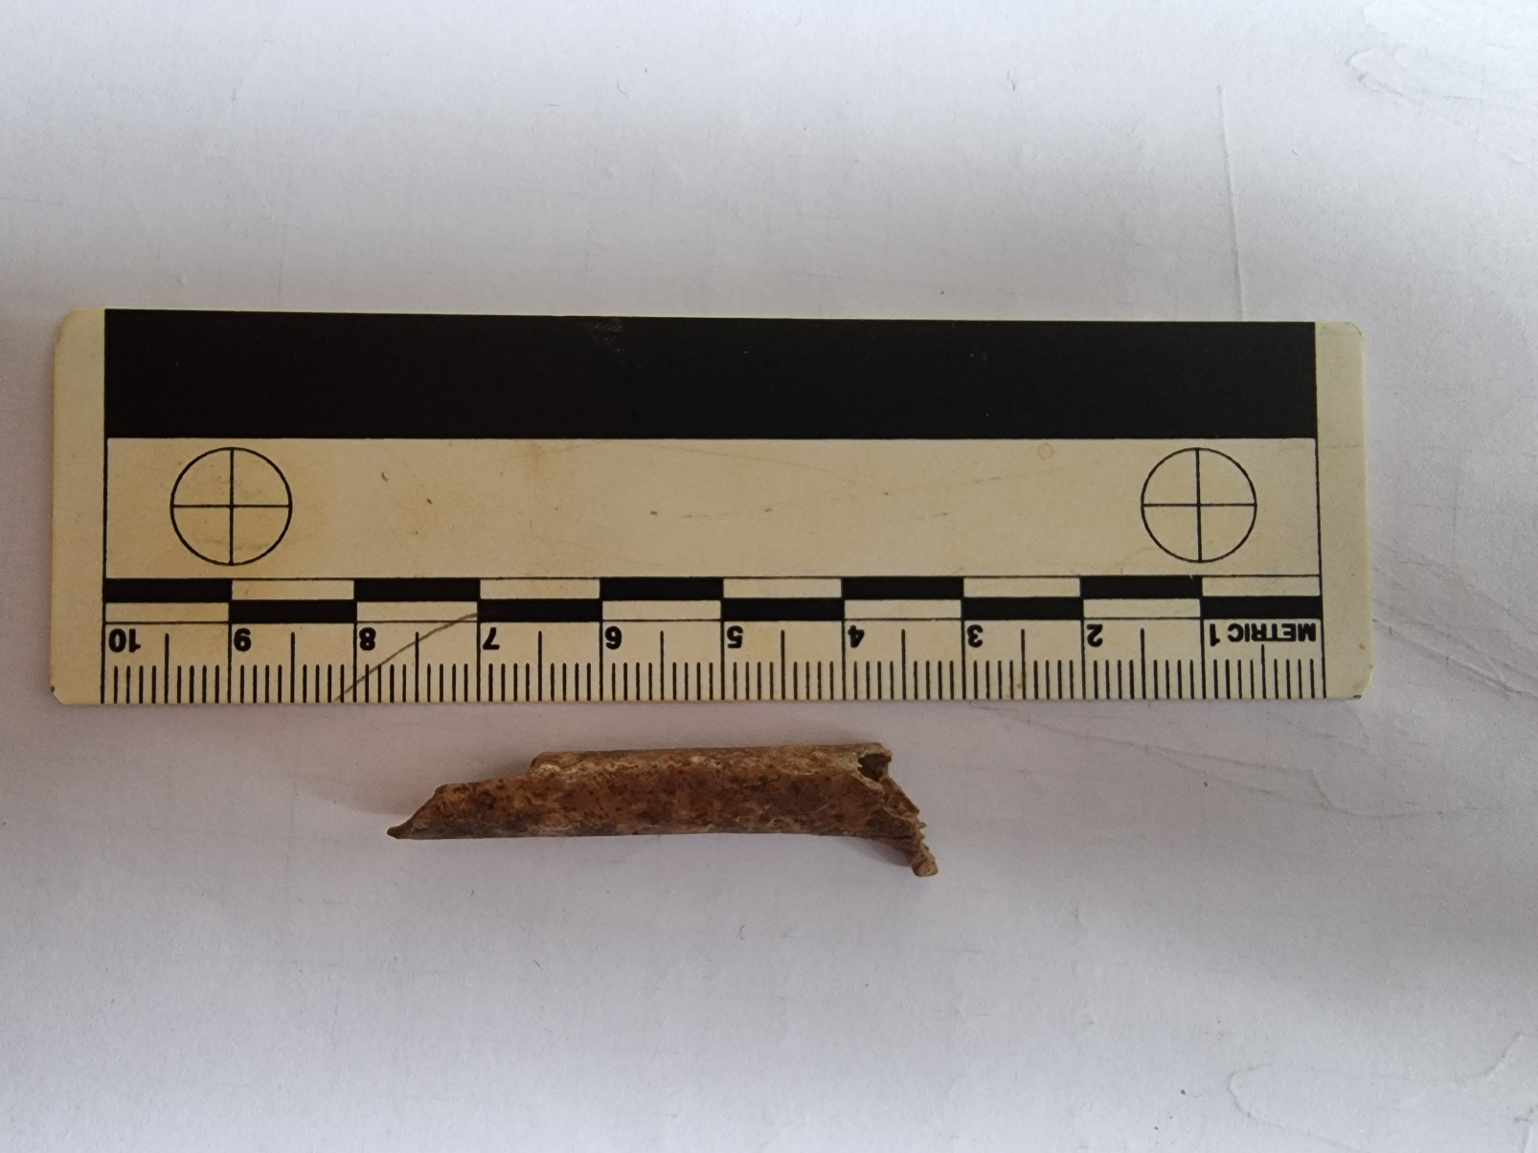

SI MCP 02
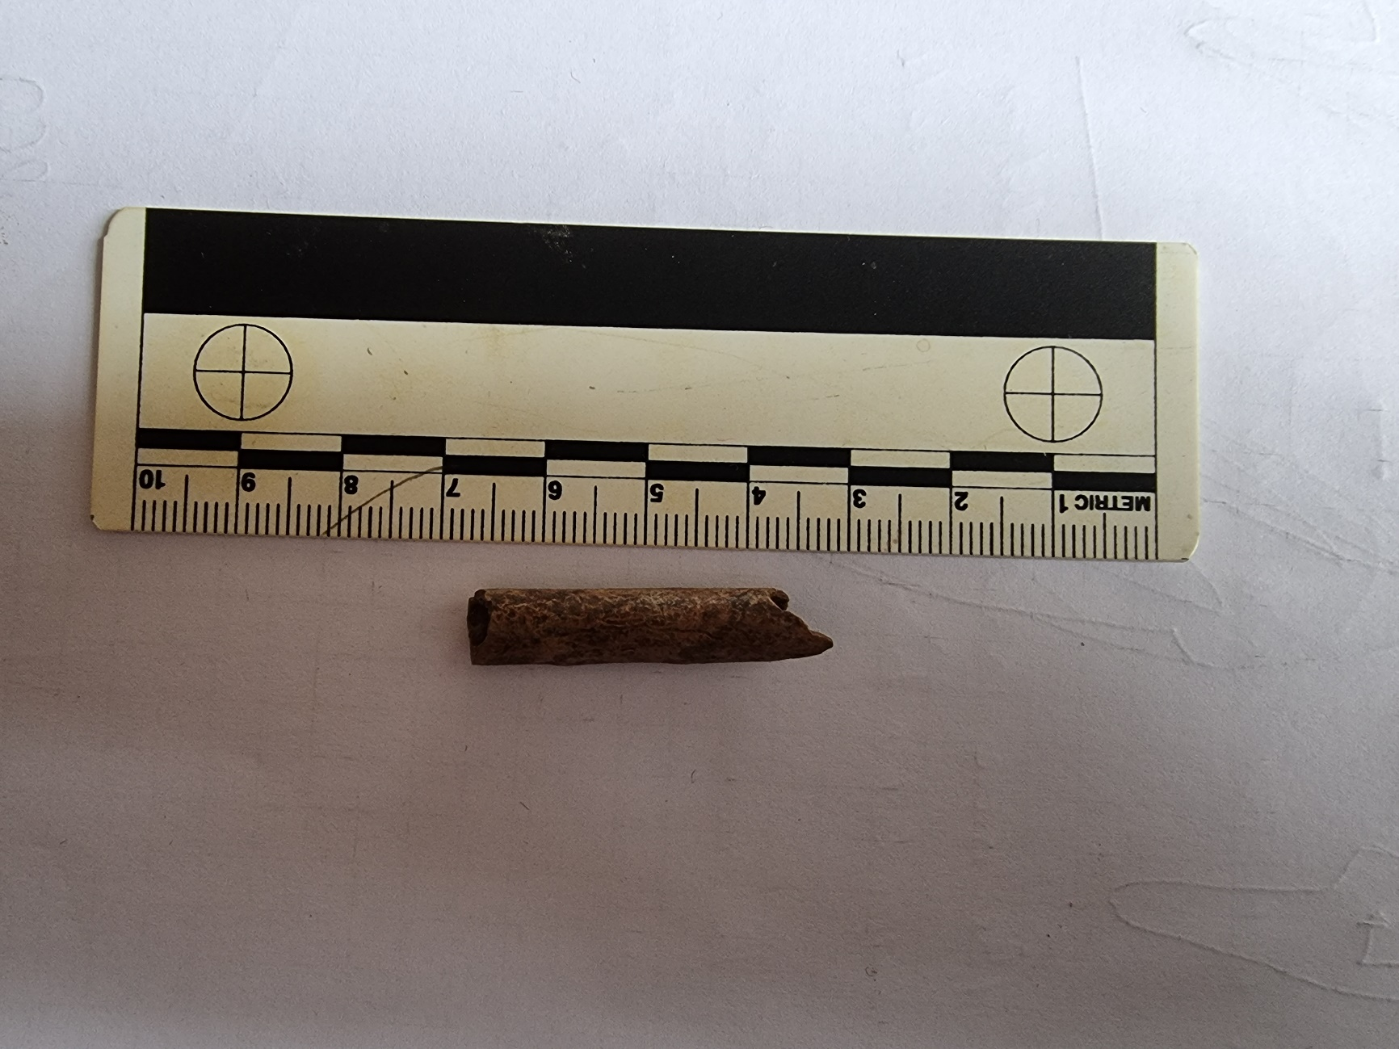

SI MCP 03
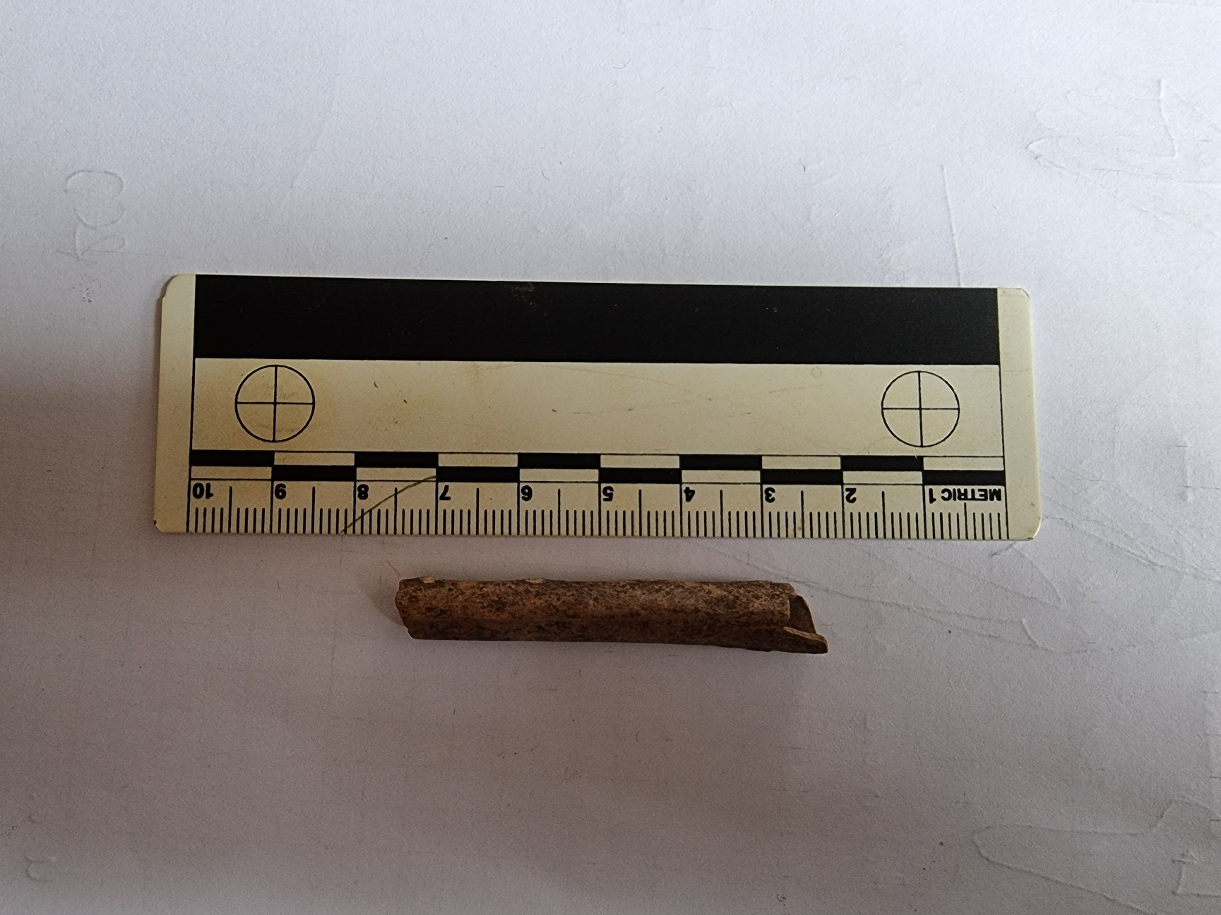

SI MCP 04
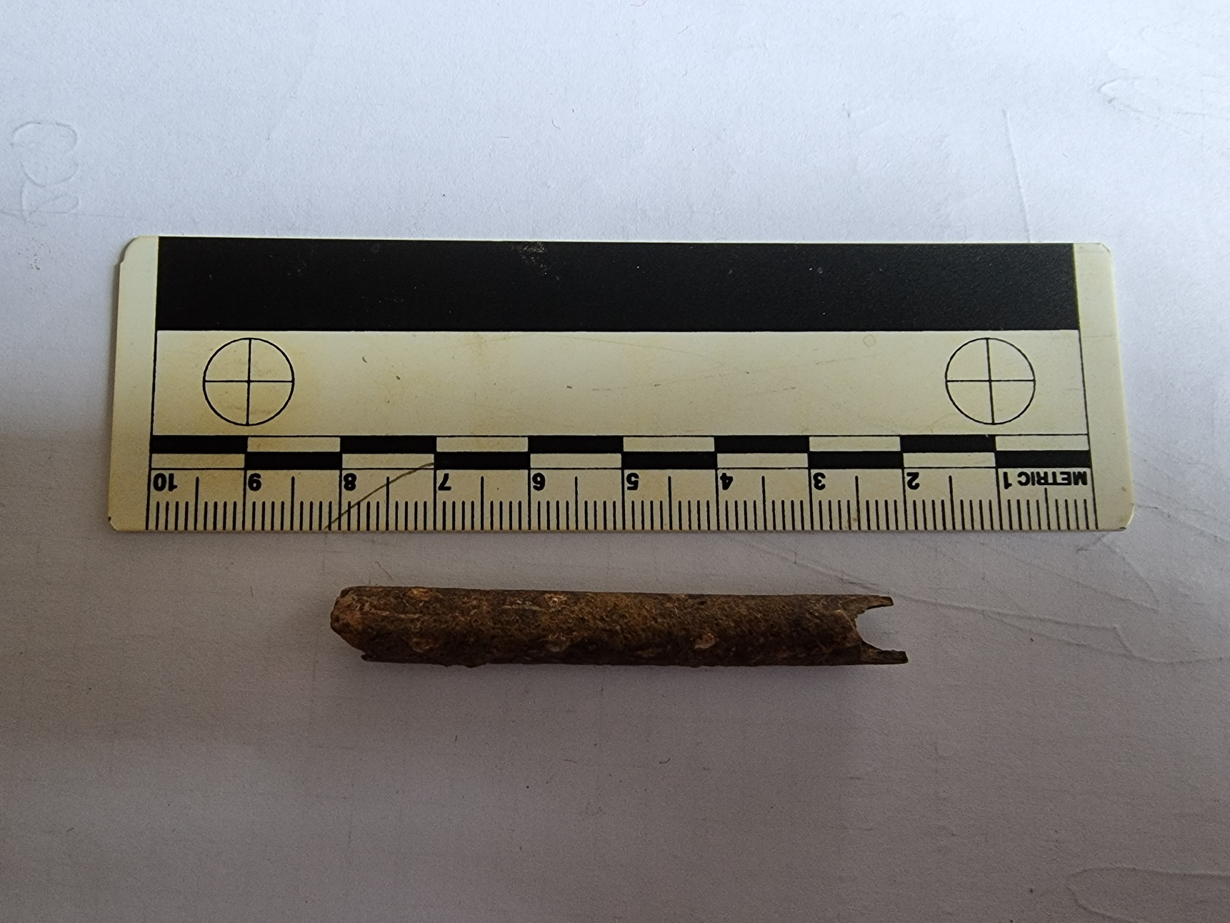

SI MCP 05
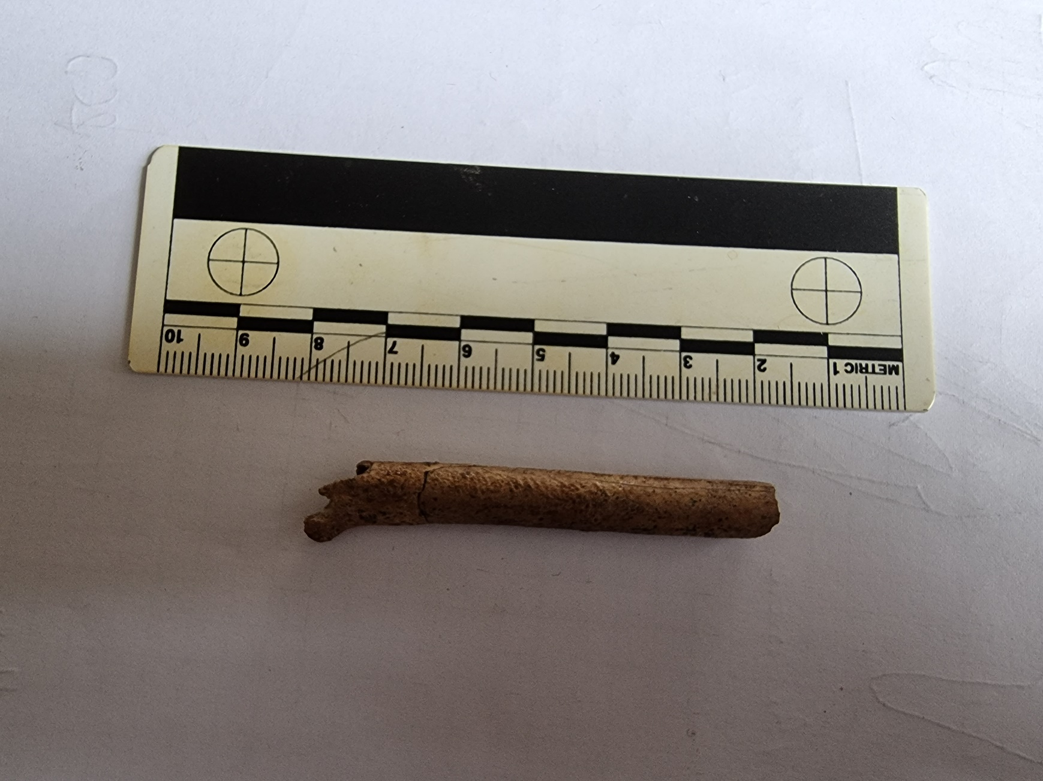

SI MCP 06
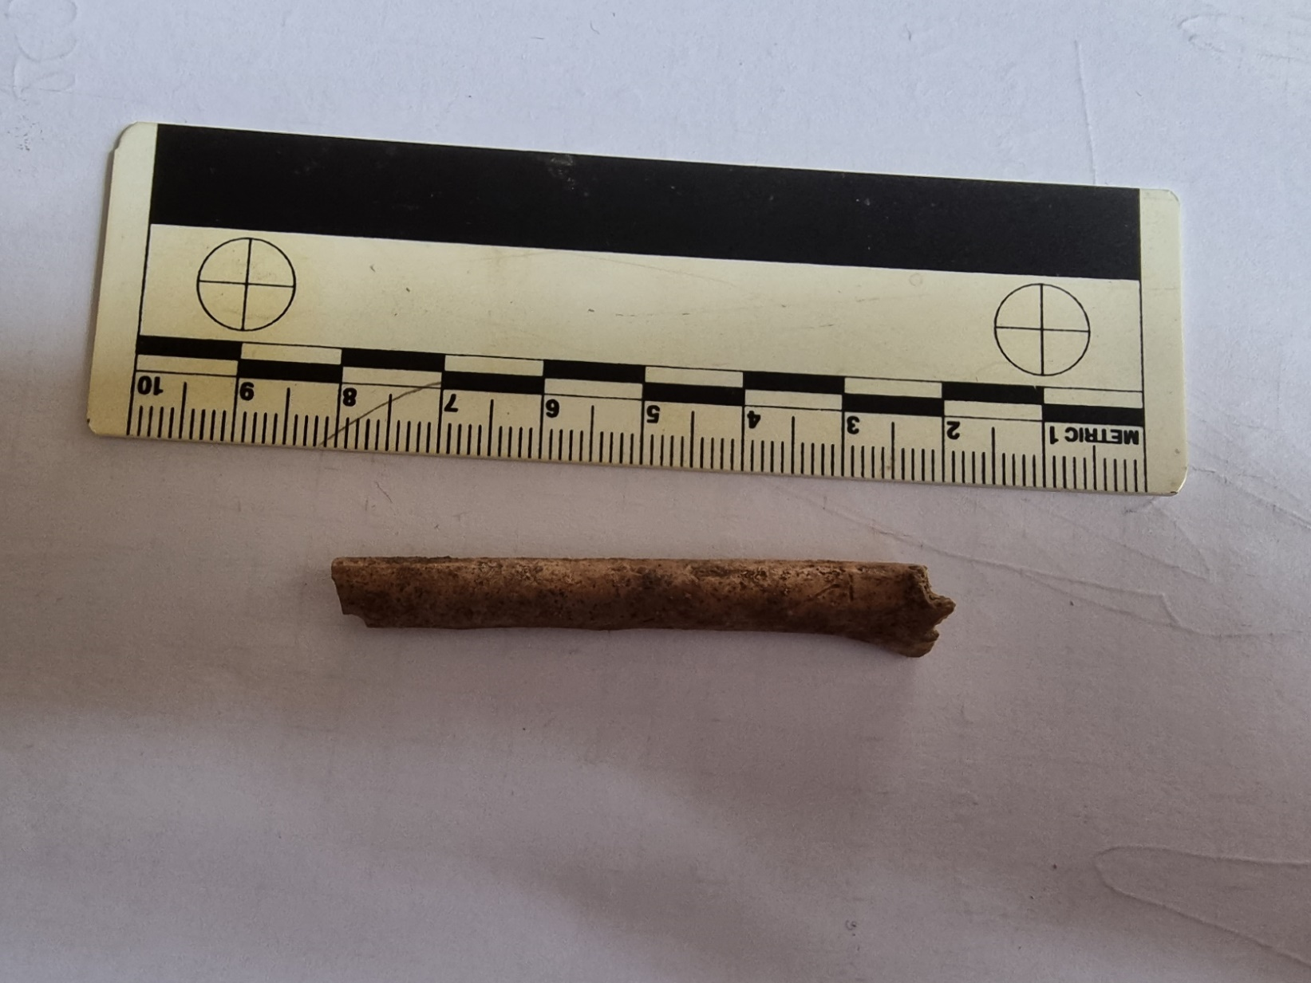

SI MCP 07
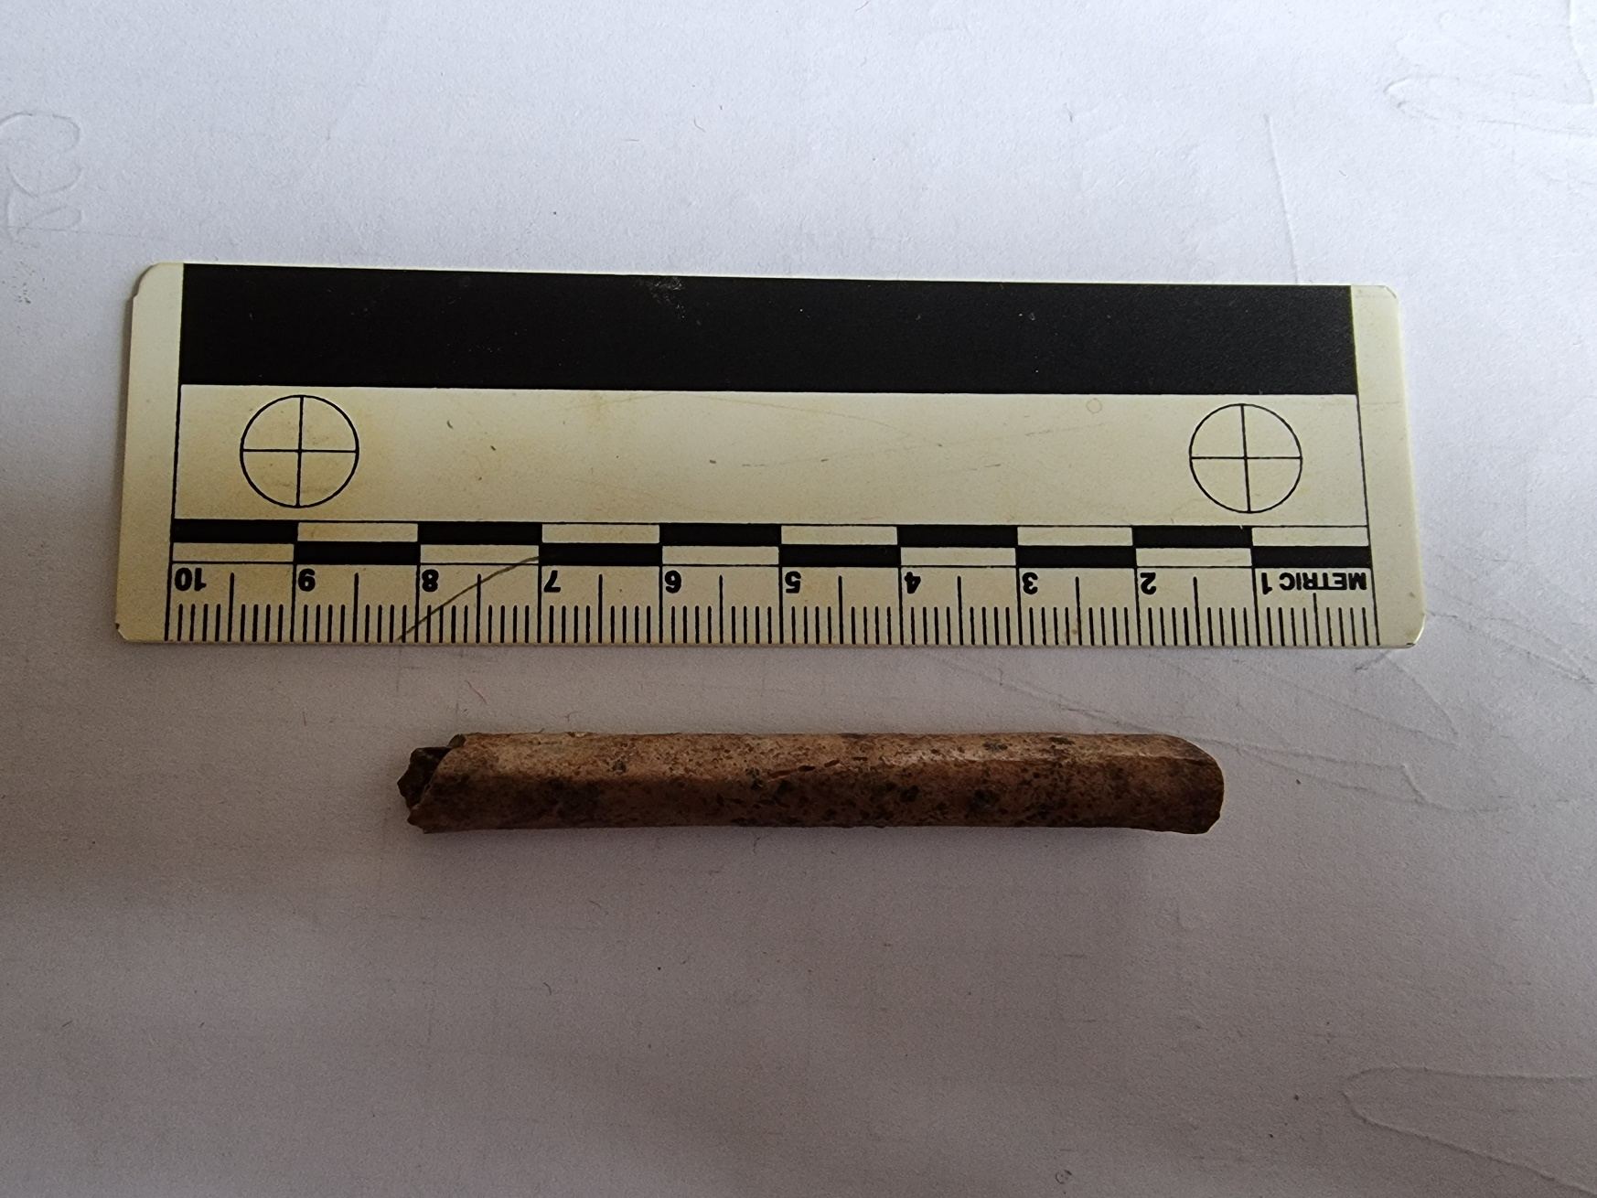

SI MCP 08
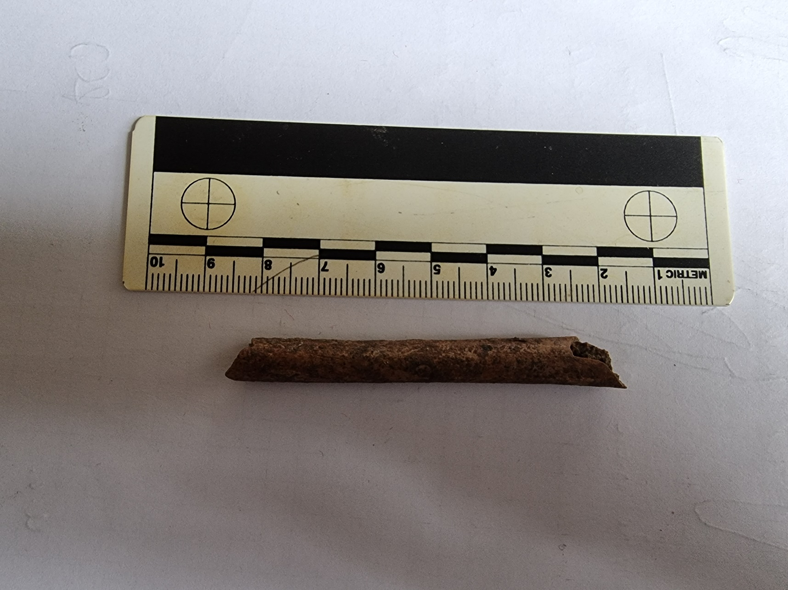

SI MCP 09
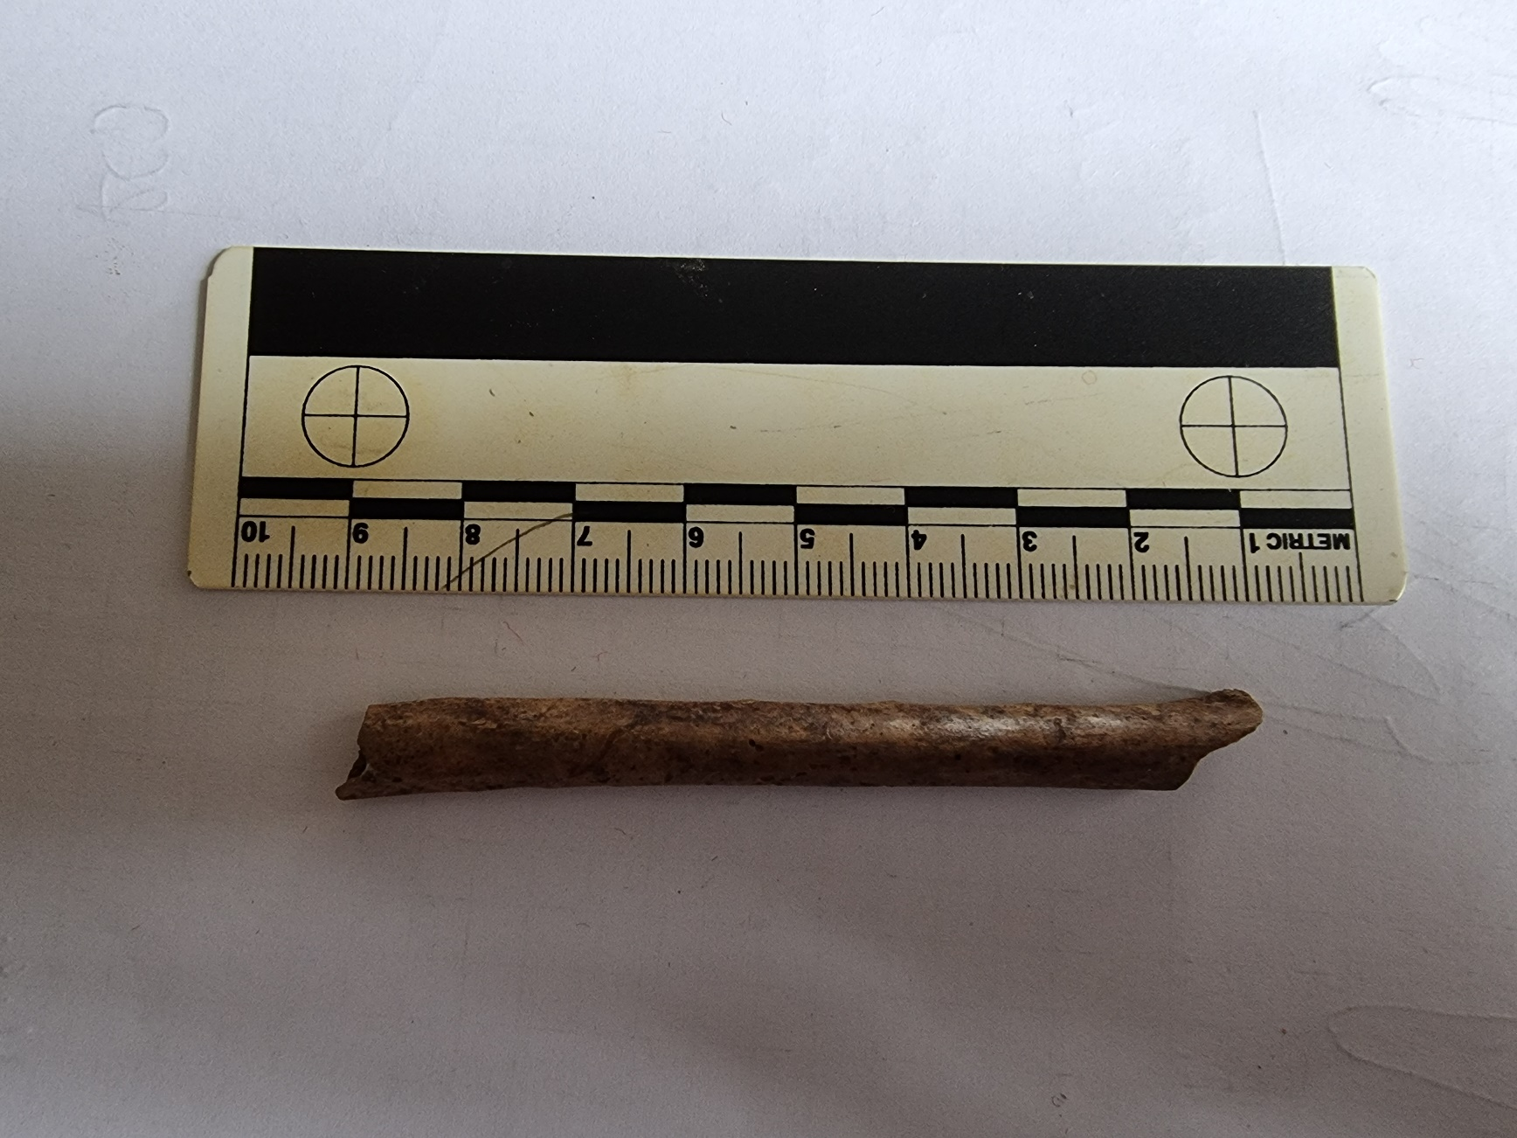

SI MCP 10
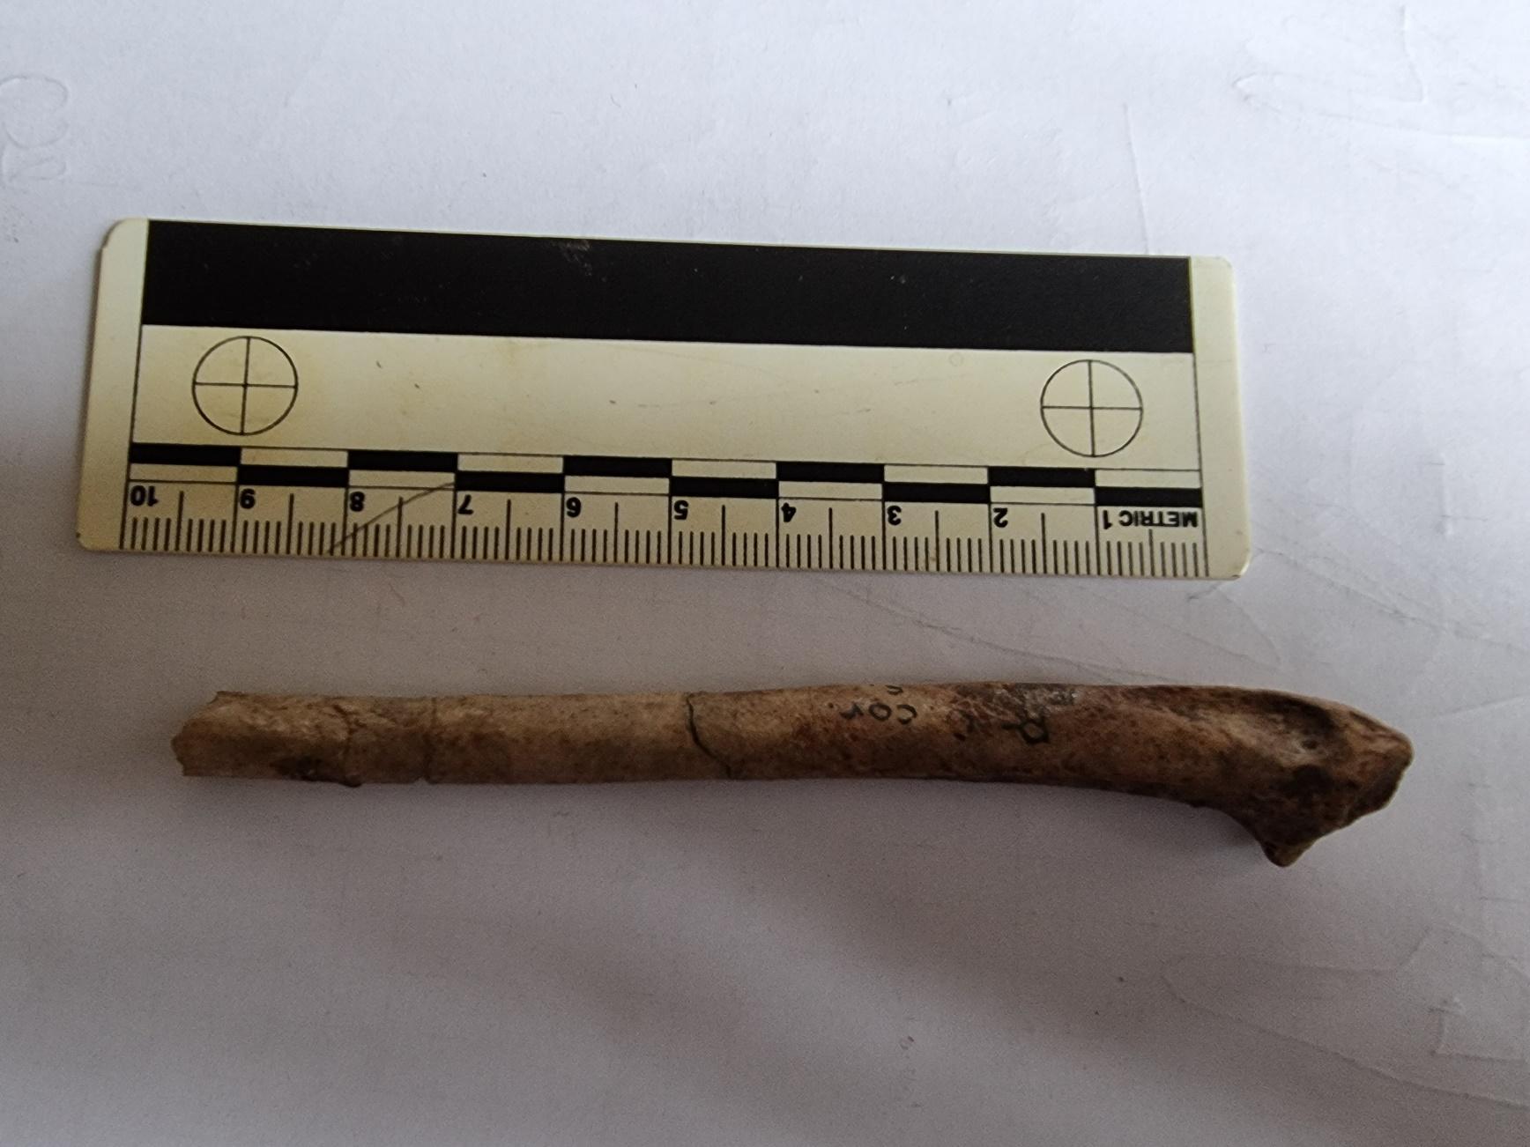

SI MCP 11
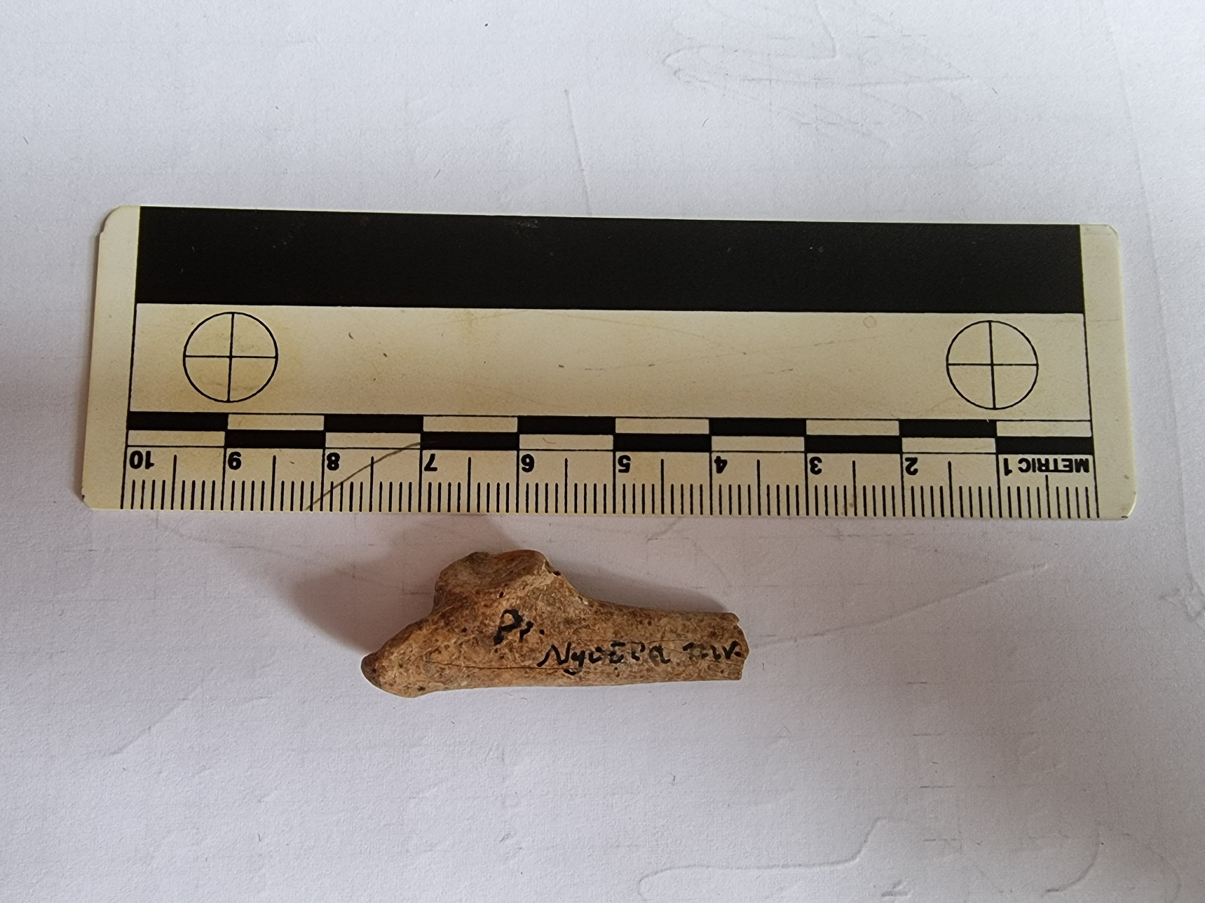

SI MCP 12
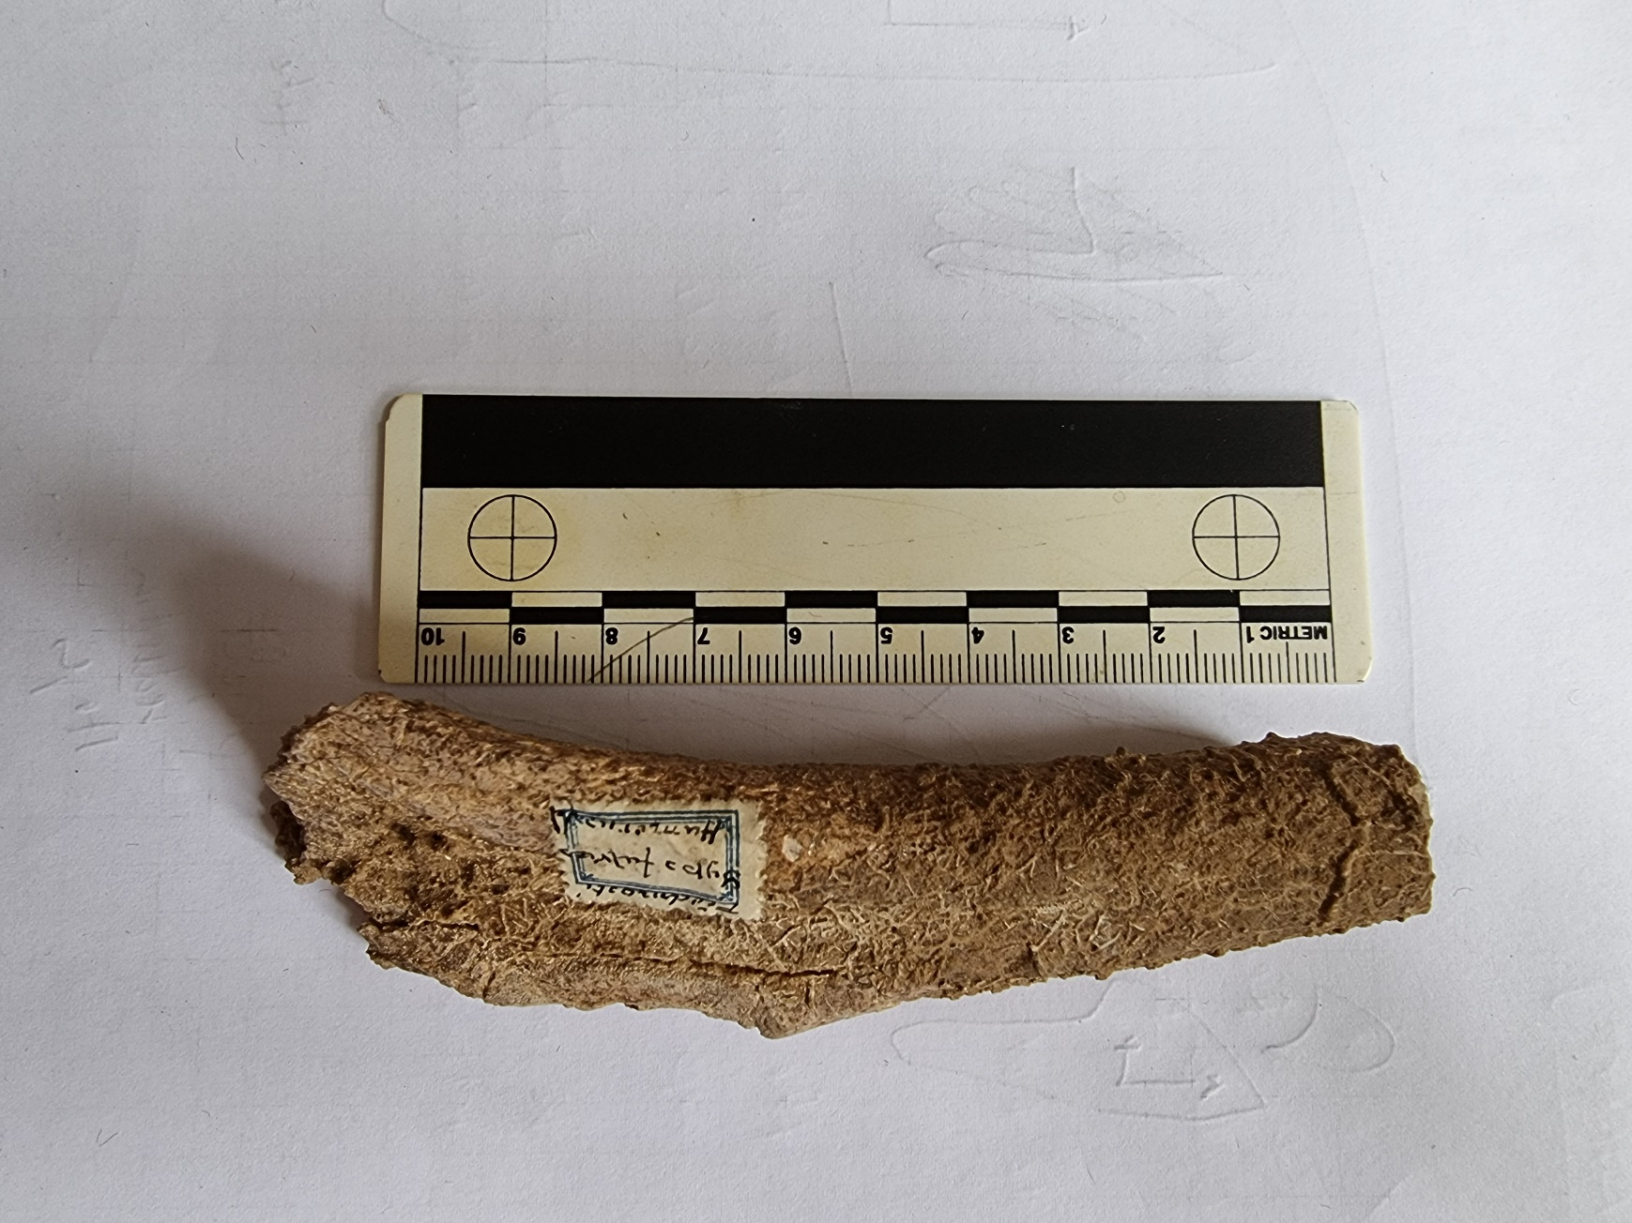

SI MCP 13
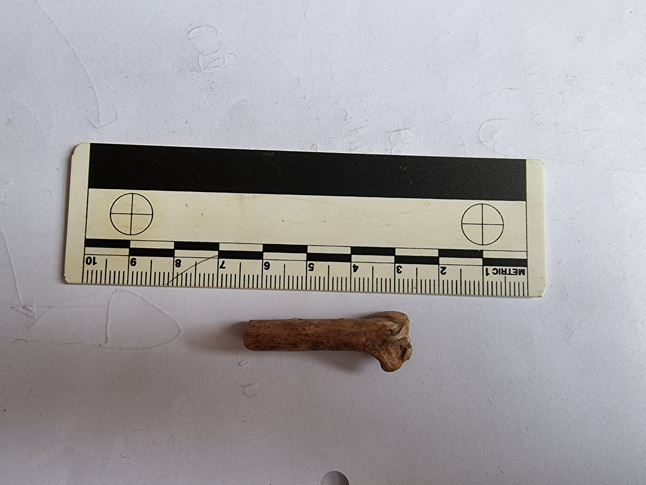

SI MCP 14
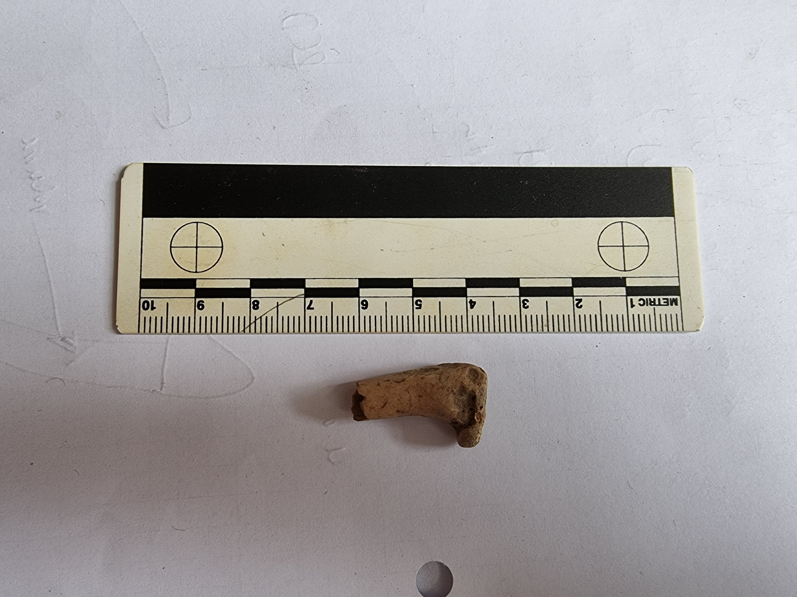

SI MCP 15
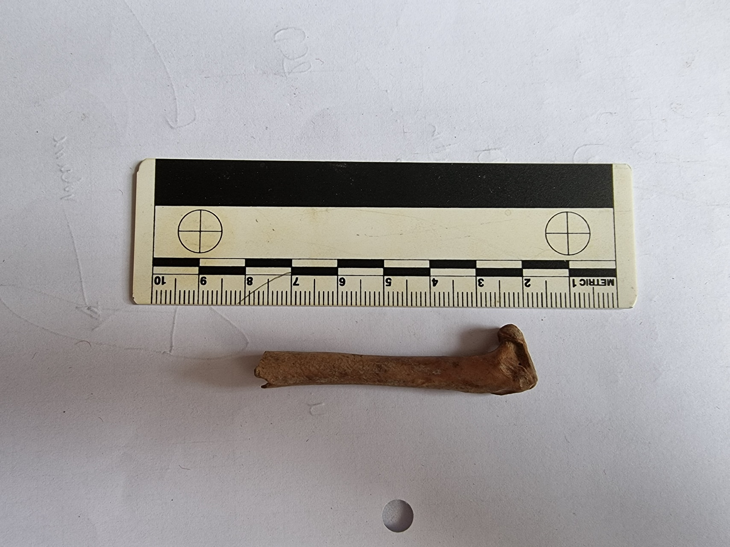

SI MCP 16
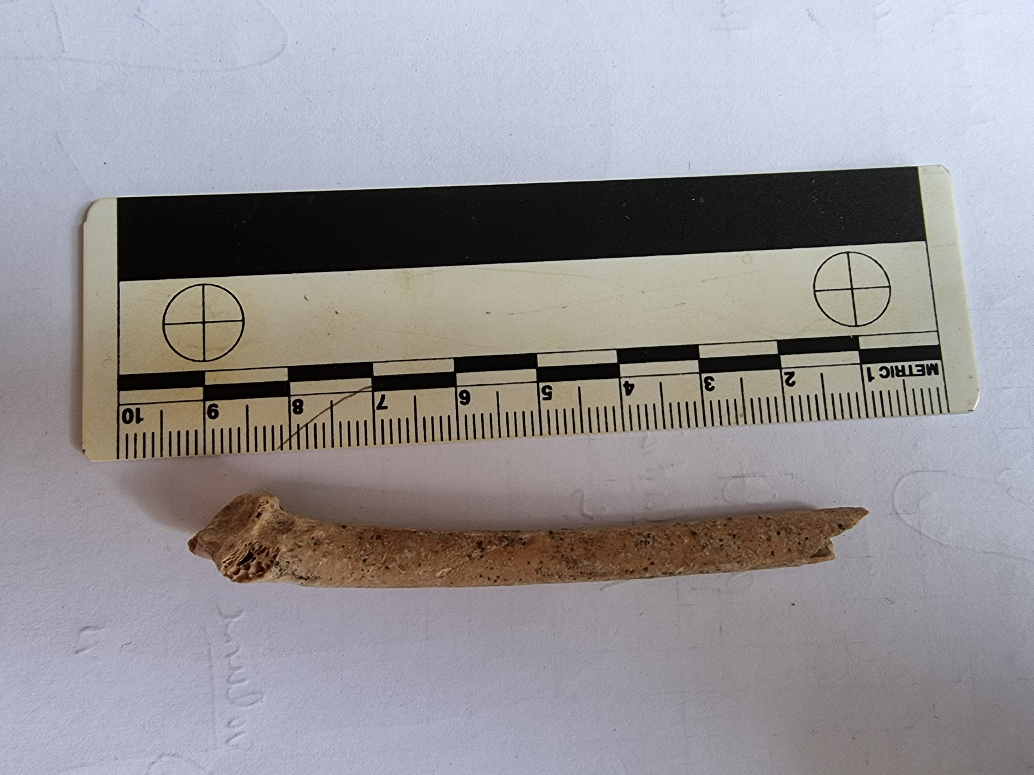

SI MCP 17
