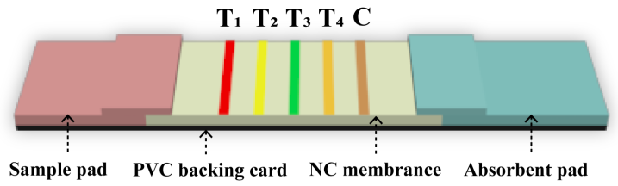
Fig. S1 Schematic illustration of the QB-based mICA

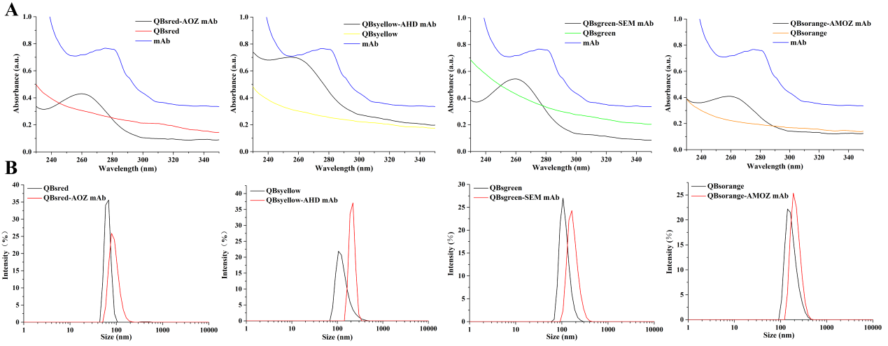
Fig. S2 (A) UV-Vis absorption spectra of mAb, QBs and QB-mAb probes. (B) DLS analysis of QBs and QB-mAb probes

Table S1 Linear equations based on mICA analysis for the nitrofuran metabolites
Analyte | Standard curve | R²
AOZ | y= - 0.350 logx + 0.636 | 0.970
AHD | y= - 0.247 logx + 0.478 | 0.984
SEM | y= - 0.182 logx + 0.377 | 0.979
AMOZ | y= - 0.164 logx + 0.333 | 0.990

Table S2 Assay performances comparison of the published methods
Analytes | Methods | Samples | LOD | References
AHD | SERS | Sea cucumber | 5 ng/g | Fan et al., 2021
AHD | ELISA | Water | 0.2 ppb | Liu et al., 2007
AOZ | Immunoassay | Milk powder/Shrimp | 0.43 ng/mL | Su et al., 2021
AMOZ | ELISA | Shrimps | 0.16 μg/kg | Pimpitak et al., 2009
AMOZ | Immunosensor | Food samples | 1 ng/mL | Jin et al., 2011
SEM | HPLC | Food matrices | 0.4 μg/kg | Li et al., 2014
AOZ | Multiplex ICA | Red drum/Grass carp/Shrimp/ Scallop | 0.198 ng/mL | This work
AHD | Multiplex ICA | Red drum/Grass carp/Shrimp/ Scallop | 0.138 ng/mL | This work
SEM | Multiplex ICA | Red drum/Grass carp/Shrimp/ Scallop | 0.071 ng/mL | This work
AMOZ | Multiplex ICA | Red drum/Grass carp/Shrimp/ Scallop | 0.157 ng/mL | This work

Table S3 Recoveries of QB-based mICA strip for the detection of nitrofuran metabolites
Sample | Spiked (ng/mL) | Measured (ng/mL) | Recovery (%) | RSD (%)
AOZ | 0.5 | 0.43 | 86.2 | 5.86
AOZ | 5 | 4.67 | 93.3 | 0.49
AOZ | 50 | 40.99 | 82.0 | 8.84
AHD | 0.5 | 0.44 | 88.6 | 6.71
AHD | 5 | 4.61 | 92.2 | 3.84
AHD | 50 | 42.12 | 84.2 | 9.33
SEM | 0.5 | 0.46 | 92.0 | 3.69
SEM | 5 | 4.44 | 88.7 | 1.21
SEM | 50 | 42.43 | 84.9 | 5.64
AMOZ | 0.5 | 0.46 | 91.9 | 7.52
AMOZ | 5 | 4.52 | 90.3 | 2.13
AMOZ | 50 | 46.49 | 93.0 | 5.40

Table S4 Application of QB-based mICA strip to detect nitrofuran metabolites in different samples
sample | AOZ |  | AHD |  | SEM |  | AMOZ
sample | Spiked  （μg/kg） | mICA | Spiked  （μg/kg） | mICA | Spiked  （μg/kg） | mICA | Spiked  （μg/kg） | mICA | mICA  images
Red drum | 0.5 | +,+,+ª | 0.5 | +,+,+ | 0.5 | +,+,+ | 0.5 | +,+,+ | 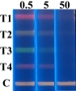
Red drum | 5 | ±,±,±^{b} | 5 | ±,±,± | 5 | ±,±,± | 5 | ±,±,±
Red drum | 50 | -,-,-^{c} | 50 | -,-,- | 50 | -,-,- | 50 | -,-,-
Grass carp | 0.5 | +,+,+ | 0.5 | +,+,+ | 0.5 | +,+,+ | 0.5 | +,+,+ | 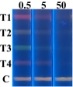
Grass carp | 5 | ±,±,± | 5 | ±,±,± | 5 | ±,±,± | 5 | ±,±,±
Grass carp | 50 | -,-,- | 50 | -,-,- | 50 | -,-,- | 50 | -,-,-
shrimp | 0.5 | +,+,+ | 0.5 | +,+,+ | 0.5 | +,+,+ | 0.5 | +,+,+ | 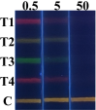
shrimp | 5 | ±,±,± | 5 | ±,±,± | 5 | ±,±,± | 5 | ±,±,±
shrimp | 50 | -,-,- | 50 | -,-,- | 50 | -,-,- | 50 | -,-,-
scallop | 0.5 | +,+,+ | 0.5 | +,+,+ | 0.5 | +,+,+ | 0.5 | +,+,+
scallop | 5 | ±,±,± | 5 | ±,±,± | 5 | ±,±,± | 5 | ±,±,±
scallop | 50 | -,-,- | 50 | -,-,- | 50 | -,-,- | 50 | -,-,-
ª Negative result. An obvious fluorescence band was observed.
^{b} Weakly positive result. The fluorescence band was light.
^{c} Positive result. No fluorescence band was observed.

