Supplementary Figure 1

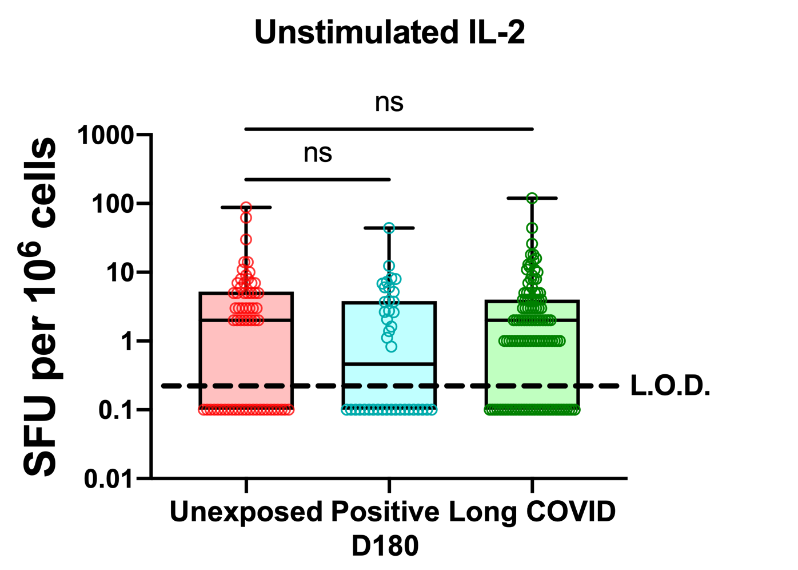

Figure S1: Spontaneous IL-2 release from the PBMCs of Long COVID patients is no different from controls. Data shown is from the same experiment as Figure 1c, having analysed PBMCs from unexposed (red), acutely infected and recovered by D180 (cyan) and Long COVID patients (green). IFN-y and IL-2 were analysed on the same plates and although a change was seen for IFN-y, no such change was observed for IL-2. IL-2 release was quantified as spot forming units per million PBMCs. Each donor was run in duplicate and zero results were set as 0.1 to allow their inclusion on a log scale. L.O.D. = limit of detection. Significance calculated by Kruskal-Wallis ANOVA, **p>0.01, ****p>0.0001.

Supplementary Figure 2

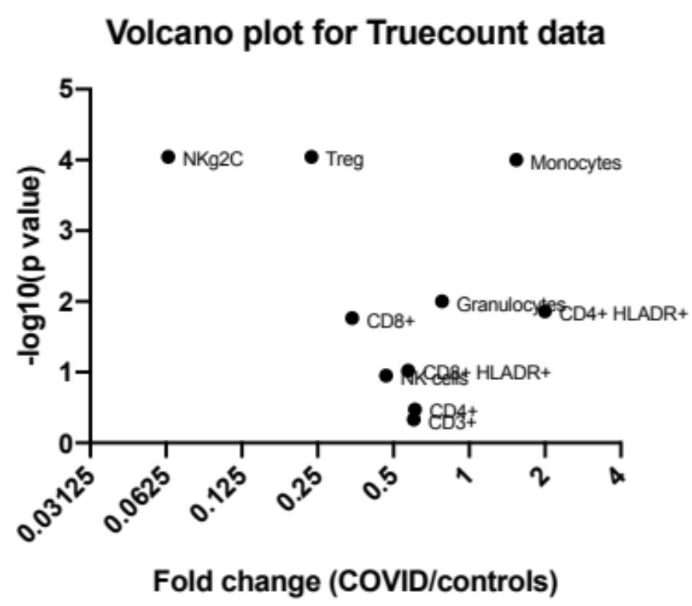

Figure S2: impact of Long COVID on immune cell composition. EDTA treated whole blood was stained with a panel of phenotyping antibodies in order to enumerate T cell, granulocyte, monocyte and NK cell subsets. 18 Long COVID and 26 controls (collected before 2019) were analysed. Data is shown as a volcano plot of fold change in Long COVID patients against healthy controls vs inverse logs of p values, as calculated by multiple Mann-Whitney U tests with Bonferroni-Dunn correction for multiple tests.

Supplementary Figure 3

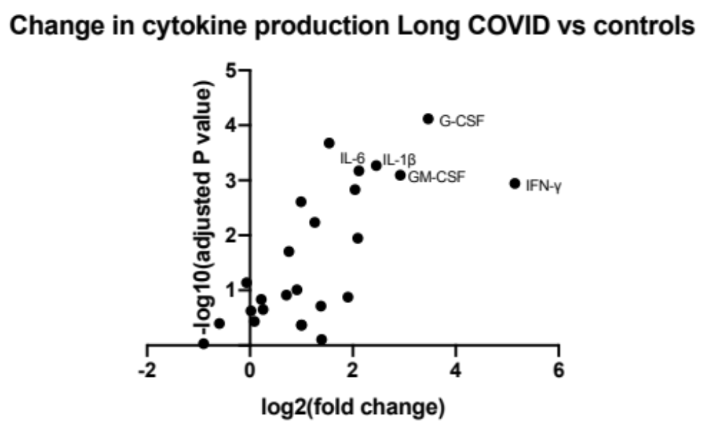
Figure S3: PBMCs from Long COVID spontaneously produce more pro-inflammatory cytokines. PBMCs from patients with Long COVID (n=14) or healthy controls, either unexposed (n=5) or those recovered from acute COVID-19 (n=5), were incubated for 48 hours without exogenous peptide stimulation. Media was collected and cytokine production measured by LEGENDplex assay (Biolegend). Data shown as fold change in cytokine production against p value for each cytokine, calculated by multiple Mann-Whitney U tests with Bonferroni-Dunn correction for multiple tests.

Supplementary Figure 4

Supplementary Figure 4. Representative dot plots from 1 donor are shown illustrating the gating strategy for generating the absolute count data. First the trucount bead population was identified (FITC vs APC) and then the trucount bead negative population (i.e. cells) were analysed by gating for single cells (FSC-A vs FSC-H), then CD45^{hi} lymphocytes (Non-Granulocytes) and Granulocytes were gated (CD45 vs SSC-A). Next, a Monocytes gate and Lymphocytes gate were discriminated by size and granularity (FSC-A vs SSC-A) and monocytes were gated by eliminating CD16hi cells (monos (non-gran gate on CD16 vs CD45 plot), the CD3 and CD19 negatives (CD3 vs CD19 plot) and finally the CD14+ monocyte population identified (CD14 vs SSC-A). From the lymphocytes gate CD3+ T cells, NK cells and B cells were identified (CD3 vs CD19 plot), the NK cells were then gated for CD56+, CD56+CD16+ and CD56-CD16+ populations as All NK (CD16 vs CD56) and the proportion of NK cells expressing NKG2C was enumerated (CD56 vs NKG2C). The CD3+ T cells were gated from the NKT cells (CD56+ by CD56 vs CD3 plot), then the CD4+ and CD8+ expressing cells and double positive (DP) T cells and double negative (DN) T cells were identified. T regulatory (Treg) CD4+ T cells were identified as CD127lo and CD25hi (CD25 vs CD127 plot). Lastly both the CD4+ and CD8+ T cell populations were further subdivided into 4 memory populations defined by expression of CD27 and CD45RA, 4 differentiation populations defined by expression of CD57 and CD28 and HLA-DR expressing activated cells were identified (HLA-DR vs CD45RA plot). All gate and quadrant positions were identified using the FMO controls, the formula used to calculate the absolute cell counts from the event numbers in each gate or quadrant is illustrated.

Supplementary Figure 5
The gating strategy used to identify CD4+ and CD8+ T cells is shown (A) with representative plots from 1 donor sample. First a Time vs Side scatter gate was drawn, to identify the main flow of cells, then these cells were gated for forward scatter single cells (Forward scatter area (FSC-A) vs Forward scatter height (FSC-H)), side scatter single cells (Side scatter area (SSC-A) vs Side scatter height (SSC-H)), live B cell negative cells (SSC-W vs Live Dead Aqua dye & CD19 BV510), then lymphocytes were gated (FSC-A vs SSC-A (log scale)). CD3 positive cells were identified (CD3 BV650 vs CD14 FITC) and then CD8+ and CD4+ T cells gated (CD4 BV605 vs CD8 BV570). Representative plots showing IFNγ staining from CD3+ T cells, CD8+ and CD4+ T cell subsets from unstimulated and stimulated (polyclonal positive control) of a Healthy control (B) and long covid patient (C) are shown. This illustrates the increased production of IFNgamma in ex vivo long covid patient T cells compared to the healthy control volunteer.

Table S1: Long COVID symptoms distribution post vaccination

 | Long COVID patients | Non-hospitalised | Hospitalised | SARS-CoV-2 antibody positive (negative) | IFN-γ status pre-vaccination (post vaccination) (above upper quartile unexposed control)
Age categories
31-45 | 5 | 5 | 0 | 1 (4) | 5 (4)
46-60 | 6 | 6 | 0 | 1 (5) | 5 (0)
>60 | 6 | 2 | 4 | 2 (4) | 6 (4)
Gender
Female | 10 | 9 | 3 | 1 (9) | 10 (4)
Male | 7 | 4 | 3 | 2 (1) | 6 (4)

Table S2: Absolute count antibody panel
Antigen | Fluorochrome | Clone | Isotype | Cat. No. | Supplier
CD19 | BUV395 | SJ25C1 | IgG1 κ | 563549 | BD BioSciences
CD45 | VioBlue | REA747 | rh IgG1 | 130-110-637 | Miltenyi Biotec
CD3 | VioGreen | REA613 | rh IgG1 | 130-113-142 | Miltenyi Biotec
CD8 | BV570 | RPA-T8 | IgG1 κ | 301038 | BioLegend
CD4 | BV605 | OKT4 | IgG2b κ | 317438 | BioLegend
CD16 | BV650 | 3G8 | IgG1 κ | 302042 | BioLegend
CD56 | BV785 | 5.1H11 | IgG1 κ | 362550 | BioLegend
CD45RA | FITC | HI100 | IgG2b κ | 304106 | BioLegend
CD14 | PerCP-Cy5.5 | M5E2 | IgG2a κ | 301824 | BioLegend
NKG2C | PE | REA205 | rh IgG1 | 130-119-776 | Miltenyi Biotec
CD57 | PE-Dz594 | HNK-1 | IgM κ | 359620 | BioLegend
HLA-DR | PE-Cy5 | L243 | IgG2a κ | 307608 | BioLegend
CD127 | PE-Cy7 | A019D5 | IgG1 κ | 351320 | BioLegend
CD25 | APC | BC96 | IgG1 κ | 302610 | BioLegend
CD28 | AxF700 | CD28.2 | IgG1 κ | 302920 | BioLegend
CD27 | APC-Cy7 | O323 | IgG1 κ | 302816 | BioLegend
Abbrv: BV = Brilliant Violet; BUV = Brilliant UV; Dz = Dazzle; AxF = Alexa Fluor

Table S3: IFN-γ secretion Flow cytometry panel

Antigen | Fluorochrome | Clone | Isotype | Cat. No. | Supplier
CD14 | FITC | M5E2 | IgG2a κ | 301804 | BioLegend
CD19 | BV510 | HIB19 | IgG1 κ | 302242 | BioLegend
CD3 | BV650 | OKT3 | IgG2a κ | 317324 | BioLegend
CD69 | Pacific Blue | FN50 | IgG1 κ | 310920 | BioLegend
CD8 | BV570 | RPA-T8 | IgG1 κ | 301038 | BioLegend
CD4 | BV605 | OKT4 | IgG2b κ | 317438 | BioLegend
IFNγ | BV786 | 4S.B3 | IgG1 κ | 563731 | BD Biosciences
CD134 (OX-40) | PE | Ber-Act35 | IgG1 κ | 350004 | BioLegend
CD137 (4-1BB) | PE-Cy5 | 4B4-1 | IgG1 κ | 309808 | BioLegend
CD40L | PerCP-Cy5.5 | 24-31 | IgG1 κ | 310834 | BioLegend

