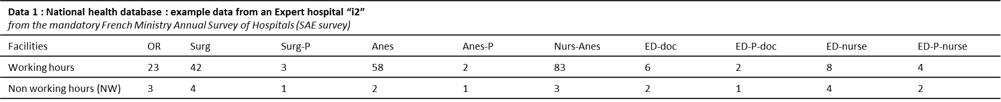
Table 2 : Example of hospital MassCare capacity profile calculation
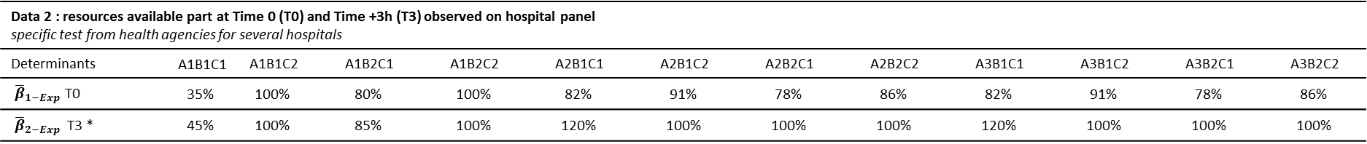
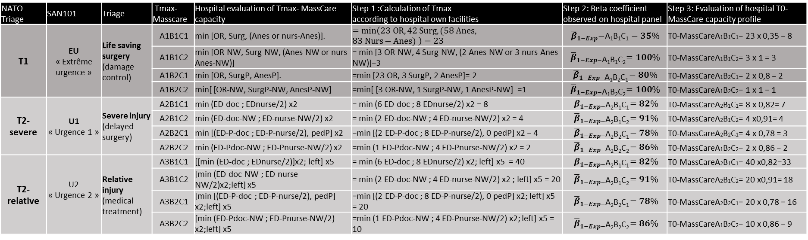
Determinants of MassCare capacity:
- Primary care unit (1. operating room, 2. ED for severe victims, 3. ED for relative victims, 4. on-site care)
- Type of patient (1. adult, 2. child)
- Period of care (1. Working hours, 2. Nonworking hours: night and weekend).
For each hospital, the primary MassCare capacity is symbolized by the MassCare-A_{X}B_{X}C_{X} index. For example, MassCare-A₁B₂C₂ represents the hospital MassCare surgery capacity for pediatric patients during the night or weekend.

Capacity assessment for all hospitals is carried out by 3 steps:
- Step 1: maximum capacities (Tmax) for each, using national administrative databases for personnel and equipment.
- Step 2: National surveys of hospital panels record the resources available at Time 0 (T0) and Time +3h (T3) and at different hours of the day. These data determine the mean percentage of expected resources available β=(T0/Tmax)
- Step 3: For each hospital, real available capacity is determined by is own Tmax, and national β mean observed coefficient : For MassCareA₁B₁C₁ : T0 = Tmax x β = min (23 OR, 42 Surg, (58 Anes, 83 Nurs-Anes)) x 0.35 = 8
For this hospital, the total number of its personnel and materials, and the percentage of resources available from national surveys determine that its capacity would be 8 adult surgical victims
OR: operating room, Surg: surgeon, Anes: anesthesiologist, nurs-Anes: anesthesia nurse, P:pediatric, NW: Night or week end (practitioner on call or present in no working hour), ED-doc: Emergency department doctor

