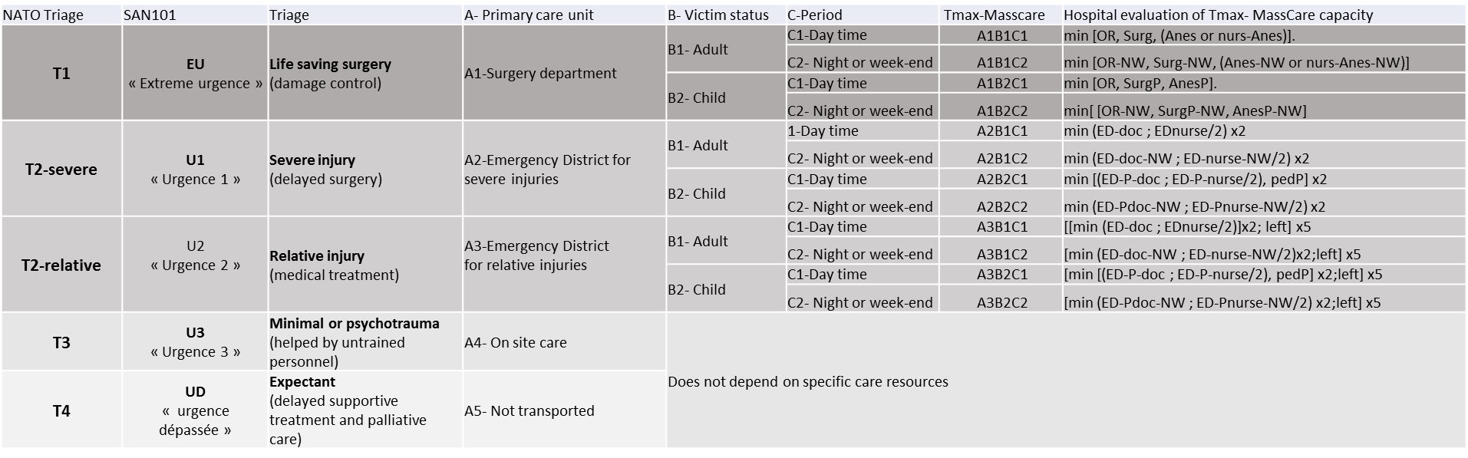
Table 1 : Calculation of Tmax-MassCare
For each NATO triage category, MassCare capacity corresponds to the hospital's own capacities with regard to available personnel and equipment (OR: operating room, Surg: surgeon, Anes: anesthesiologist, nurs-Anes: anesthesia nurse, P:pediatric, NW: Night or week end (practitioner on call or present in no working hour), ED-doc: Emergency department doctor). To estimate the maximum simultaneous care capacities, we consider one person present for each full-time employee during working hours and one for each on-call role at night and on weekends (-NW). This information is found in national administrative resource databases.

For example, in a mass casualty incidents, each patient sent to the operating room requires the presence of these three minimum resources to be managed. In practice, these factors set the benchmark of the maximum theoretical capacity to manage several simultaneous patients for each hospital if all of its material and human resources are available.
The Tmax-MassCare for surgery (A₁) for adults (B₁) is given by:
$In working hours \left(C1\right): Tmax-MassCare-A1B1C1 = min\left[OR, Surg, \left(nurs-Anes+Anes\right), nurs-OR\right] (E3)$
$In nonworking hours \left(C2\right): Tmax-MassCare-A1B1C2 = min\left[{OR}_{NW}, {Surg}_{NW}, \left({nurs-Anes}_{NW}+{Anes}_{NW}\right), nurs{OR}_{NW}\right] (E4)$

