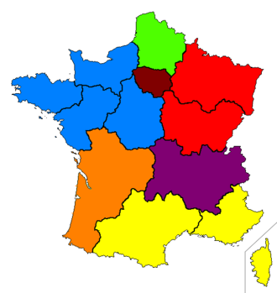
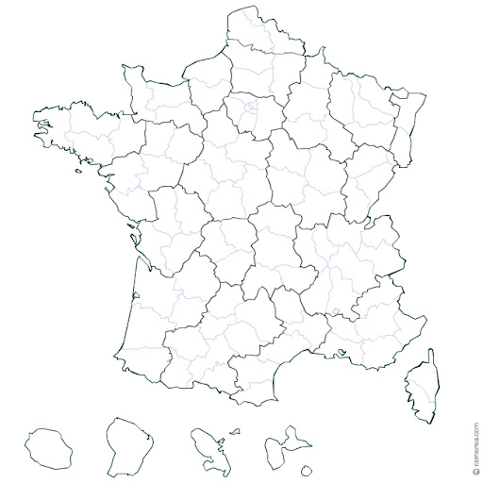
Figure S1 : Health administration areas in France, with 13 Regional Agencies (RHA), grouped into 7 Zonal Defense Areas (ZDA), and 6 overseas territories
1
2
3
4
5
6
7
8
9
10
11
12
13
18
16
15
14
 | Regional Health Agencies : |  |  |  |  |  |  |  | Zonal Defense Areas : | ZDA legend
In mainland France | 1. North of France |  |  |  |  |  |  |  | Northern Defense zone
In mainland France | 2. Paris region |  |  |  |  |  |  |  | Paris defense zone
In mainland France | 3. Normandy |  |  |  |  |  |  |  | Western Defense Zone
In mainland France | 4. Brittany |  |  |  |  |  |  |  | Western Defense Zone
In mainland France | 5. Loire river area |  |  |  |  |  |  |  | Western Defense Zone
In mainland France | 6. Center and and basin of Loire river |  |  |  |  |  |  |  | Western Defense Zone
In mainland France | 7. Great East |  |  |  |  |  |  |  | Eastern Defense Zone
In mainland France | 8. Bourgogne and Franche-Comté |  |  |  |  |  |  |  | Eastern Defense Zone
In mainland France | 9. Auvergne-Rhône and Alpes |  |  |  |  |  |  |  | South-East Defense Zone
In mainland France | 10. New-Aquitaine |  |  |  |  |  |  |  | South-Western Defense Zone
In mainland France | 11. Occitania |  |  |  |  |  |  |  | South Defense Zone
In mainland France | 12. Provence-Alpes and Côte d'Azur |  |  |  |  |  |  |  | South Defense Zone
In mainland France | 13. Corsica |  |  |  |  |  |  |  | South Defense Zone
In French overseas territories : | 14. Guadeloupe |  |  |  |  |  |  |  | French West Indies Defense Zone
In French overseas territories : | 15. Martinique |  |  |  |  |  |  |  | French West Indies Defense Zone
In French overseas territories : | 16. Guyana |  |  |  |  |  |  |  | Guyane defense zone
In French overseas territories : | 17. Mayotte |  |  |  |  |  |  |  | Southern indian ocean defense zone
In French overseas territories : | 18. Reunion Island |  |  |  |  |  |  |  | Southern indian ocean defense zone
In French overseas territories : | 19. Wallis and Futuna* |  |  |  |  |  |  |  | Specific security plans
In French overseas territories : | 20. Saint Pierre and Miquelon* |  |  |  |  |  |  |  | Specific security plans

Legend: In metropolitan France, the health administration is managed by 13 regional agencies, grouped into 7 defense zones. For example, the regions of Occitania (11), Provence-Alpes-Côtes d'Azur (12) and Corsica (13) each have a regional health agency (RHA), administered by the southern zonal defense zone (ZDA). The French islands of the Pacific, South America and the Indian Ocean have their own health agencies. *”Wallis and Futuna” and “Saint Pierre and Miquelon” are specific territorial health administration

