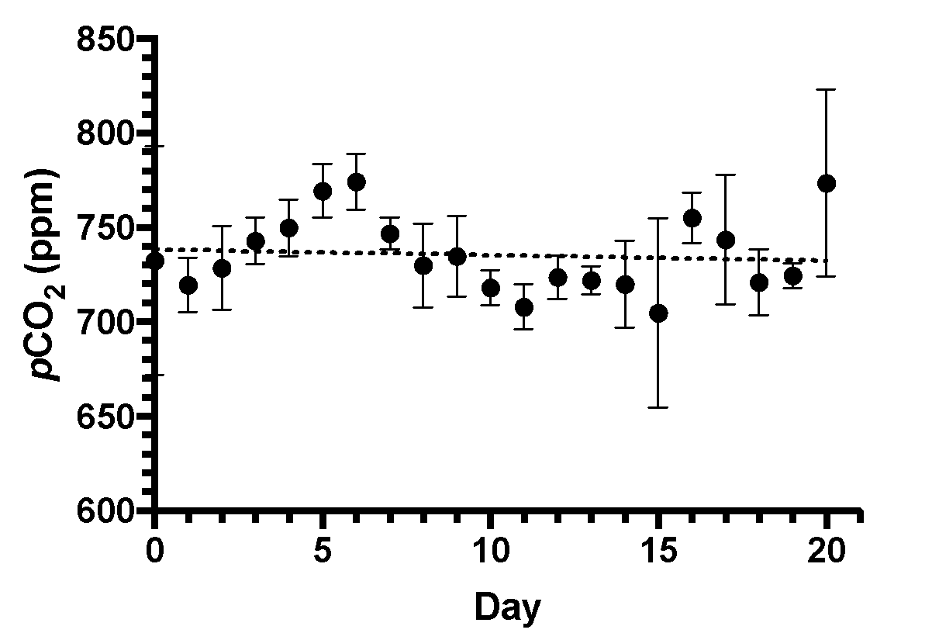

Supplementary Figure 1. Daily CO₂ concentrations (ppm) measured in microcosms supplied with elevated pCO₂. Linear regression (dotted line) shows the average CO₂ concentrations. Values are the average of triplicate incubations ± standard error.

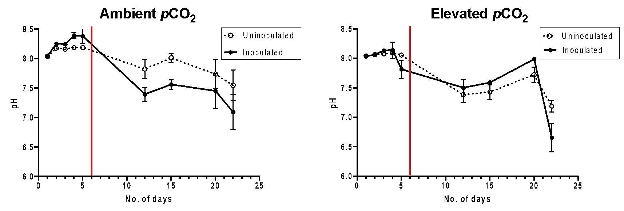

Supplementary Figure 2. pH levels of seawater in microcosms inoculated with (open circles) or without (closed circles) non-axenic E. huxleyi under ambient (400 ppm) and elevated (750 ppm) CO₂ concentrations. Red line indicates the addition of crude oil to microcosms, with the sampling point at day 5 taken just prior to oil addition. Values are the average of triplicate incubations ± standard error.

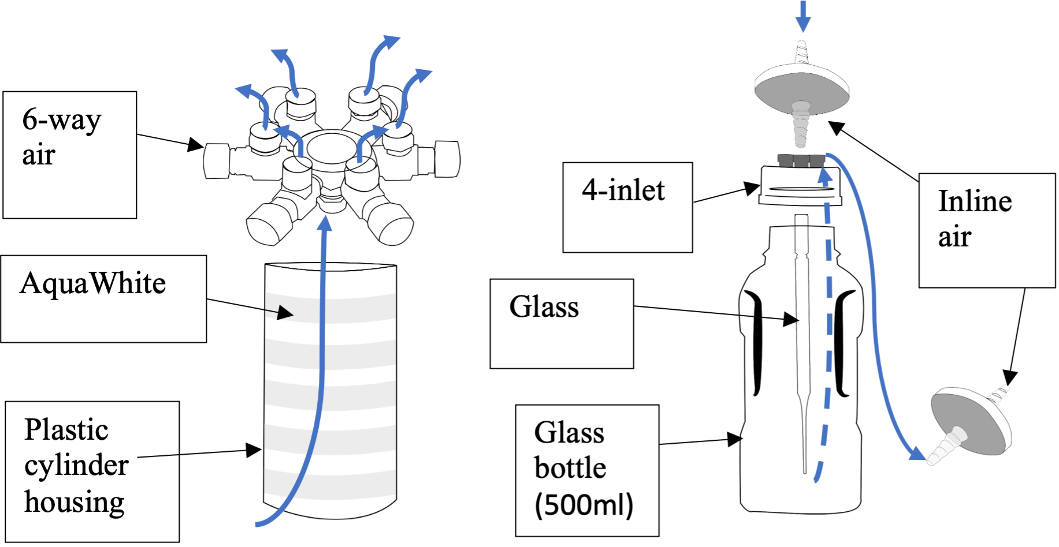

Supplementary Figure 3. Microcosm setup consisting of light and air supply component (left), and culturing vessel (right). Blue solid arrows indicate air flow connected to materials via airline tubing, while blue disconnected line shows air flow without tubing.

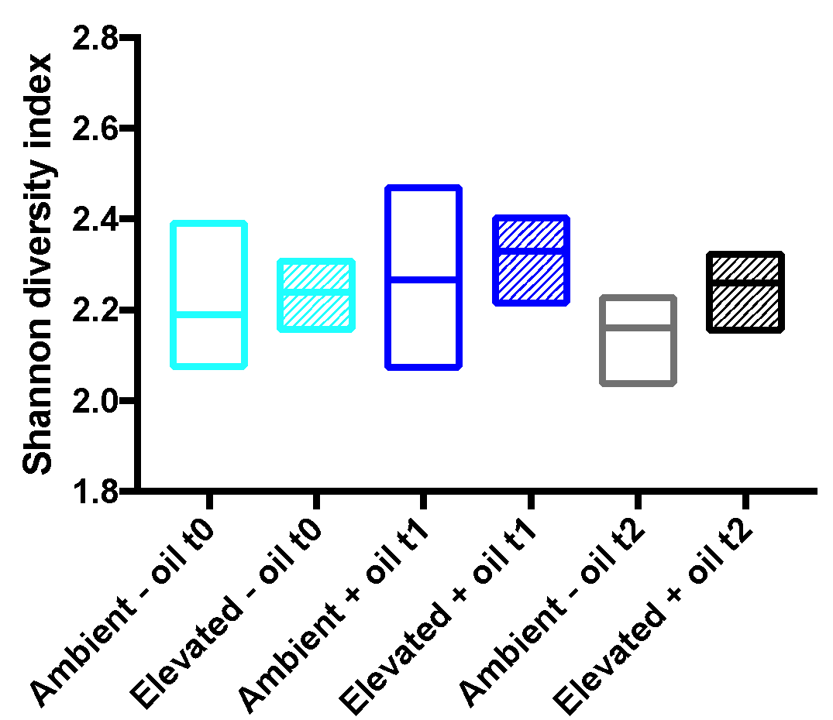

Supplementary Figure 4. Variance of OTU’s between treatments were analysed using Shannon diversity indices shown in floating bar plot. Line shows median value of Shannon diversity, with minimum and maximum values as borders of each bar plot. Clear bars indicate samples treated with ambient conditions at different timepoints, while cross-hatched bars represent microcosms treated with elevated CO₂. Timepoints: t₀ represents day 5 since the start of the incubations and just prior to oil enrichment, t₁ represent day 12 since the start of the incubations or 7 days after oil enrichment, and t₂ represents day 19 since the start of the incubations or 14 days after oil enrichment. - oil (no oil added); + oil (oil added).

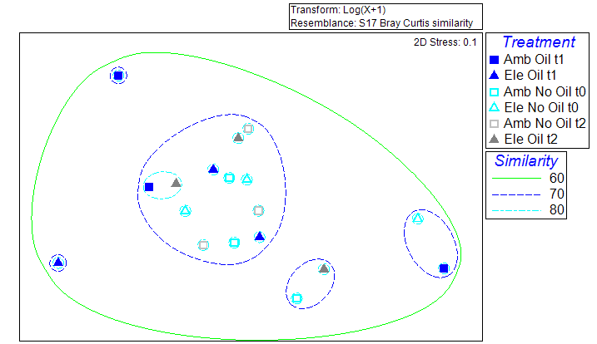

Supplementary Figure 5. nMDS plot based on Bray Curtis similarity index of the bacterial community associated with E. huxleyi in microcosms treated with ambient or elevated CO₂. Clusters based on log (X + 1) Bray-Curtis similarity index (%) are indicated by coloured ellipses. Timepoints: t₀ represents day 5 since the start of the incubations and just prior to oil enrichment, t₁ represent day 12 since the start of the incubations or 7 days after oil enrichment, and t₂ represents day 19 since the start of the incubations or 14 days after oil enrichment. Amb (ambient CO₂ conditions); Ele (elevated CO₂ conditions).

Supplementary Table 1. Percentage relative abundance (± standard error from triplicate incubations) of the bacterial community associated with E. huxleyi in microcosms incubated under ambient (400 ppm) or elevated (750 ppm) CO₂ in the presence (+) or absence (-) of crude oil. Phylogenetic identification was assigned to the highest rank when possible. Timepoints: t₀ represents day 5 since the start of the incubations and just prior to oil enrichment, t₁ represent day 12 since the start of the incubations or 7 days after oil enrichment, and t₂ represents day 19 since the start of the incubations or 14 days after oil enrichment.

Timepoint | T0 |  | T1 |  | T2
CO₂ | 400 ppm | 750 ppm | 400 ppm | 750 ppm | 400 ppm | 750 ppm
Oil enrichment | - | - | + | + | - | +
Unclassified Bacteria | 6 ± 3 | 13± 8 | 18 ± 9 | 9 ± 6 | 16 ± 10 | 8 ± 2
Actinobacteria (Phyla)
Corynebacterium | 1 ± 1 | 2 ± 1 | 4 ± 2 | 2 ± 1 | 2 ± 2 | 4 ± 1
Bacteroidetes (Phyla)
Prevotella | 2 ± 0 | 1 ± 1 | 1 ± 1 | 8 ± 7 | 0 ± 0 | 0 ± 0
Balneola | 4 ± 1 | 5 ± 1 | 3 ± 1 | 3 ± 2 | 5 ± 2 | 3 ± 0
Gracilimonas | 2 ± 0 | 0 ± 0 | 0 ± 0 | 4 ± 2 | 1 ± 1 | 0 ± 0
Firmicutes (Phyla)
Streptococcus | 3 ± 1 | 1 ± 1 | 0 ± 0 | 7 ± 4 | 1 ± 1 | 1 ± 0
Veillonella | 1 ± 1 | 0 ± 0 | 0 ± 0 | 5 ± 3 | 2 ± 0 | 1 ± 1
Unclassified Veillonellaceae | 0 ± 0 | 0 ± 0 | 0 ± 0 | 3 ± 2 | 0 ± 0 | 0 ± 0
Fusobacteria (Phyla)
Fusobacterium | 0 ± 0 | 1 ± 1 | 0 ± 0 | 3 ± 2 | 0 ± 0 | 1 ± 1
Proteobacteria (Phyla)
Alphaproteobacteria (Class)
Unclassified Alphaproteobacteria | 6 ± 2 | 4 ± 1 | 8 ± 5 | 3 ± 1 | 4 ± 1 | 5 ± 3
Maricaulis | 4 ± 1 | 4 ± 1 | 2 ± 1 | 4 ± 2 | 4 ± 2 | 2 ± 1
Methylobacterium | 8 ± 2 | 11 ± 4 | 11 ± 4 | 6 ± 3 | 10 ± 3 | 6 ± 0
Celeribacter | 2 ± 0 | 2 ± 1 | 2 ± 1 | 1 ± 0 | 3 ± 1 | 2 ± 0
Unclassified Rhodobacteraceae | 4 ± 1 | 5 ± 4 | 7 ± 1 | 3 ± 1 | 5± 4 | 4 ± 3
Stappia | 0 ± 0 | 0 ± 0 | 1 ± 0 | 3 ± 2 | 1 ± 1 | 1 ± 1

Timepoint | T0 |  | T1 |  | T2
CO₂ | 400 ppm | 750 ppm | 400 ppm | 750 ppm | 400 ppm | 750 ppm
Oil enrichment | - | - | + | + | - | +
No. of OTU’s | 89 ± 21 | 59 ± 25 | 45 ± 14 | 95 ± 32 | 52 ± 39 | 85±20
Sulfitobacter | 3 ± 1 | 1 ± 1 | 2 ± 1 | 4 ± 2 | 4 ± 1 | 3 ± 1
Sphingomonas | 5 ± 1 | 8 ± 2 | 6 ± 2 | 4 ± 1 | 6 ± 2 | 3 ± 1
Gammaproteobacteria (Class)
Unclassified Alteromonadaceae | 3 ± 3 | 4 ± 3 | 2 ± 2 | 2 ± 2 | <1 ± <1 | 3 ± 3
Alteromonas | 2 ± 0 | 3 ± 2 | 2 ± 1 | 1 ± <1 | 2 ± <1 | 3 ± 1
Marinobacter | 29 ± 1 | 15 ± 4 | 15 ± 3 | 24 ± 8 | 20 ± 4 | 22 ± 5
Unclassified Gammaproteobacteria | 11 ± 5 | 4 ± 1 | 5 ± 2 | 7 ± 3 | 8 ± 5 | 8 ± 4
Unclassified Halomonadaceae | 0 ± 0 | 6 ± 6 | 5 ± 5 | 0 ± 0 | 0 ± 0 | 5 ± 5
Halomonas | 2 ± <1 | 5 ± 2 | 3 ± 1 | 1 ± <1 | 2 ± 1 | 3 ± 1
Methylophaga | 2 ± <1 | 4 ± 1 | 4 ± 2 | 2 ± 1 | 4 ± 1 | 3 ± 1
Epsilonproteobacteria (Class)
Campylobacter | 0 ± 0 | 0 ± 0 | <1 ± <1 | 2 ± 2 | 1 ± 1 | 0 ± 0

