Table S1 Baseline Patient Characteristics
 | Surgery
 | Chemotherapy | Chemotherapy
 | Radiotherapy | Radiotherapy | Chemotherapy | Radiotherapy | No Treatment
Characteristics | N = 6 | N = 91 | N = 13 | N = 63 | N = 39 | P Value
Year of diagnosis |  |  |  |  |  | 0.906
2010-2014 | 4 ( 66.7) | 69 (75.8) | 10 (76.9) | 46 (73.0) | 27 (69.2)
2015-2019 | 2 ( 33.3) | 22 (24.2) | 3 (23.1) | 17 (27.0) | 12 (30.8)
Age |  |  |  |  |  | 0.204
＜60 | 5 ( 83.3) | 40 (44.0) | 4 (30.8) | 20 (31.7) | 11 (28.2)
60-79 | 1 ( 16.7) | 48 (52.7) | 8 (61.5) | 39 (61.9) | 25 (64.1)
≥80 | 0 ( 0.0) | 3 ( 3.3) | 1 ( 7.7) | 4 ( 6.3) | 3 ( 7.7)
Sex |  |  |  |  |  | 0.250
Male | 6 (100.0) | 48 (52.7) | 7 (53.8) | 37 (58.7) | 22 (56.4)
Female | 0 ( 0.0) | 43 (47.3) | 6 (46.2) | 26 (41.3) | 17 (43.6)
Race |  |  |  |  |  | 0.954
White | 5 ( 83.3) | 72 (79.1) | 12 (92.3) | 52 (82.5) | 34 (87.2)
Black | 1 ( 16.7) | 13 (14.3) | 1 ( 7.7) | 9 (14.3) | 4 (10.3)
Other | 0 ( 0.0) | 6 ( 6.6) | 0 ( 0.0) | 2 ( 3.2) | 1 ( 2.6)
Marital status |  |  |  |  |  | 0.669
Married | 4 ( 66.7) | 50 (54.9) | 6 (46.2) | 28 (44.4) | 19 (48.7)
Single | 2 ( 33.3) | 41 (45.1) | 7 (53.8) | 35 (55.6) | 20 (51.3)
Median household income |  |  |  |  |  | 0.419
<$55,000 | 3 ( 50.0) | 35 (38.5) | 4 (30.8) | 28 (44.4) | 9 (23.1)
$55,000 - $74,999 | 1 ( 16.7) | 43 (47.3) | 6 (46.2) | 26 (41.3) | 23 (59.0)
$75,000+ | 2 ( 33.3) | 13 (14.3) | 3 (23.1) | 9 (14.3) | 7 (17.9)
Primary Site |  |  |  |  |  | 0.378
Main bronchus | 0 ( 0.0) | 3 ( 3.3) | 0 ( 0.0) | 6 ( 9.5) | 0 ( 0.0)
Upper lobe | 6 (100.0) | 54 (59.3) | 9 (69.2) | 35 (55.6) | 21 (53.8)
Middle lobe | 0 ( 0.0) | 1 ( 1.1) | 1 ( 7.7) | 2 ( 3.2) | 1 ( 2.6)
Lower lobe | 0 ( 0.0) | 24 (26.4) | 3 (23.1) | 12 (19.0) | 12 (30.8)
Unspecific | 0 ( 0.0) | 9 ( 9.9) | 0 ( 0.0) | 8 (12.7) | 5 (12.8)
Laterality |  |  |  |  |  | 0.923
Left | 3 ( 50.0) | 42 (46.2) | 7 (53.8) | 25 (39.7) | 18 (46.2)
Right | 3 ( 50.0) | 48 (52.7) | 6 (46.2) | 36 (57.1) | 21 (53.8)
Bilateral | 0 ( 0.0) | 1 ( 1.1) | 0 ( 0.0) | 2 ( 3.2) | 0 ( 0.0)
Grade |  |  |  |  |  | 0.027
III | 3 ( 50.0) | 23 (25.3) | 9 (69.2) | 18 (28.6) | 14 (35.9)
IV | 3 ( 50.0) | 23 (25.3) | 2 (15.4) | 19 (30.2) | 7 (17.9)
Unknown | 0 ( 0.0) | 45 (49.5) | 2 (15.4) | 26 (41.3) | 18 (46.2)
T stage |  |  |  |  |  | 0.529
T1 | 3 ( 50.0) | 18 (19.8) | 2 (15.4) | 10 (15.9) | 9 (23.1)
T2 | 3 ( 50.0) | 27 (29.7) | 4 (30.8) | 14 (22.2) | 7 (17.9)
T3 | 0 ( 0.0) | 35 (38.5) | 4 (30.8) | 32 (50.8) | 17 (43.6)
T4 | 0 ( 0.0) | 1 ( 1.1) | 0 ( 0.0) | 1 ( 1.6) | 0 ( 0.0)
T0 | 0 ( 0.0) | 10 (11.0) | 3 (23.1) | 6 ( 9.5) | 6 (15.4)
N stage |  |  |  |  |  | 0.006
N0 | 6 (100.0) | 22 (24.2) | 2 (15.4) | 14 (22.2) | 9 (23.1)
N1 | 0 ( 0.0) | 11 (12.1) | 0 ( 0.0) | 4 ( 6.3) | 6 (15.4)
N2 | 0 ( 0.0) | 39 (42.9) | 7 (53.8) | 34 (54.0) | 21 (53.8)
N3 | 0 ( 0.0) | 19 (20.9) | 4 (30.8) | 11 (17.5) | 3 ( 7.7)
Bone metastases |  |  |  |  |  | 0.151
No | 6 (100.0) | 59 (64.8) | 6 (46.2) | 40 (63.5) | 29 (74.4)
Yes | 0 ( 0.0) | 32 (35.2) | 7 (53.8) | 23 (36.5) | 10 (25.6)
Liver metastases |  |  |  |  |  | 0.550
No | 6 (100.0) | 77 (84.6) | 10 (76.9) | 49 (77.8) | 30 (76.9)
Yes | 0 ( 0.0) | 14 (15.4) | 3 (23.1) | 14 (22.2) | 9 (23.1)
Lung metastases |  |  |  |  |  | 0.861
No | 6 (100.0) | 73 (80.2) | 10 (76.9) | 50 (79.4) | 30 (76.9)
Yes | 0 ( 0.0) | 18 (19.8) | 3 (23.1) | 13 (20.6) | 9 (23.1)
Abbreviations: T, Tumor; N, Node.

Table S2 Baseline Patient Characteristics
 | Before PSM |  |  | After PSM (1:2)
 |  | Chemotherapy |  |  | Chemotherapy
 | Chemotherapy | Radiotherapy |  | Chemotherapy | Radiotherapy
Characteristics | N = 13 | N = 91 | P Value | N = 13 | N = 26 | P Value
Year of diagnosis |  |  | 0.931 |  |  | 1
2010-2014 | 10 (76.92) | 69 (75.82) |  | 10 (76.92) | 20 (76.92)
2015-2019 | 3 (23.08) | 22 (24.18) |  | 3 (23.08) | 6 (23.08)
Age |  |  | 0.5482 |  |  | 0.8737
＜60 | 4 (30.77) | 40 (43.96) |  | 4 (30.77) | 8 (30.77)
60-79 | 8 (61.54) | 48 (52.75) |  | 8 (61.54) | 17 (65.38)
≥80 | 1 (7.69) | 3 (3.30) |  | 1 (7.69) | 1 (3.85)
Sex |  |  | 0.941 |  |  | 0.9084
Male | 7 (53.85) | 48 (52.75) |  | 7 (53.85) | 16 (61.54)
Female | 6 (46.15) | 43 (47.25) |  | 6 (46.15) | 10 (38.46)
Race |  |  | 0.4797 |  |  | 0.709
White | 12 (92.31) | 72 (79.12) |  | 12 (92.31) | 23 (88.46)
Black | 1 (7.69) | 13 (14.29) |  | 1 (7.69) | 3 (11.54)
Other | 0 (0.00) | 6 (6.59) |  | 0 (0.00) | 0 (0.00)
Marital status |  |  | 0.7662 |  |  | 1
Married | 6 (46.15) | 50 (54.95) |  | 6 (46.15) | 12 (46.15)
Single | 7 (53.85) | 41 (45.05) |  | 7 (53.85) | 14 (53.85)
Median household income |  |  | 0.686 |  |  | 0.6997
<$55,000 | 4 (30.77) | 35 (38.46) |  | 4 (30.77) | 5 (19.23)
$55,000 - $74,999 | 6 (46.15) | 43 (47.25) |  | 6 (46.15) | 15 (57.69)
$75,000+ | 3 (23.08) | 13 (14.29) |  | 3 (23.08) | 6 (23.08)
Primary Site |  |  | 0.3405 |  |  | 0.3951
Main bronchus | 0 (0.00) | 3 (3.30) |  | 0 (0.00) | 1 (3.85)
Upper lobe | 9 (69.23) | 54 (59.34) |  | 9 (69.23) | 17 (65.38)
Middle lobe | 1 (7.69) | 1 (1.10) |  | 1 (7.69) | 0 (0.00)
Lower lobe | 3 (23.08) | 24 (26.37) |  | 3 (23.08) | 5 (19.23)
Unspecific | 0 (0.00) | 9 (9.89) |  | 0 (0.00) | 3 (11.54)
Laterality |  |  | 0.8266 |  |  | 0.7292
Left | 7 (53.85) | 42 (46.15) |  | 7 (53.85) | 12 (46.15)
Right | 6 (46.15) | 48 (52.75) |  | 6 (46.15) | 13 (50.00)
Bilateral | 0 (0.00) | 1 (1.10) |  | 0 (0.00) | 1 (3.85)
Grade |  |  | 0.0052 |  |  | 0.7753
III | 9 (69.23) | 23 (25.27) |  | 9 (69.23) | 15 (57.69)
IV | 2 (15.38) | 23 (25.27) |  | 2 (15.38) | 5 (19.23)
Unknown | 2 (15.38) | 45 (49.45) |  | 2 (15.38) | 6 (23.08)
T stage |  |  | 0.7778 |  |  | 0.6174
T1 | 3 (23.08) | 10 (10.99) |  | 3 (23.08) | 3 (11.54)
T2 | 2 (15.38) | 18 (19.78) |  | 2 (15.38) | 8 (30.77)
T3 | 4 (30.77) | 27 (29.67) |  | 4 (30.77) | 9 (34.62)
T4 | 4 (30.77) | 35 (38.46) |  | 4 (30.77) | 6 (23.08)
T0 | 0 (0.00) | 1 (1.10) |  | 0 (0.00) | 0 (0.00)
N stage |  |  | 0.4291 |  |  | 0.6494
N0 | 2 (15.38) | 22 (24.18) |  | 2 (15.38) | 6 (23.08)
N1 | 0 (0.00) | 11 (12.09) |  | 0 (0.00) | 0 (0.00)
N2 | 7 (53.85) | 39 (42.86) |  | 7 (53.85) | 10 (38.46)
N3 | 4 (30.77) | 19 (20.88) |  | 4 (30.77) | 10 (38.46)
Bone metastases |  |  | 0.3196 |  |  | 1
No | 6 (46.15) | 59 (64.84) |  | 6 (46.15) | 12 (46.15)
Yes | 7 (53.85) | 32 (35.16) |  | 7 (53.85) | 14 (53.85)
Liver metastases |  |  | 0.7637 |  |  | 0.779
No | 10 (76.92) | 77 (84.62) |  | 10 (76.92) | 21 (80.77)
Yes | 3 (23.08) | 14 (15.38) |  | 3 (23.08) | 5 (19.23)
Lung metastases |  |  | 0.782 |  |  | 0.795
No | 10 (76.92) | 73 (80.22) |  | 10 (76.92) | 19 (73.08)
Yes | 3 (23.08) | 18 (19.78) |  | 3 (23.08) | 7 (26.92)
Abbreviations: PSM, Propensity-score matching; T, Tumor; N, Node.

Table S3 Baseline Patient Characteristics
 | Before PSM |  |  | After PSM (1:1)
 | Radiotherapy | No Treatment |  | Radiotherapy | No Treatment
Characteristics | N = 13 | N = 91 | P Value | N = 13 | N = 26 | P Value
Year of diagnosis |  |  | 0.8525 |  |  | 0.808
2010-2014 | 27 (69.23) | 46 (73.02) |  | 27 (69.23) | 26 (66.67)
2015-2019 | 12 (30.77) | 17 (26.98) |  | 12 (30.77) | 13 (33.33)
Age |  |  | 0.9134 |  |  | 0.8825
＜60 | 11 (28.21) | 20 (31.75) |  | 11 (28.21) | 13 (33.33)
60-79 | 25 (64.10) | 39 (61.90) |  | 25 (64.10) | 23 (58.97)
≥80 | 3 (7.69) | 4 (6.35) |  | 3 (7.69) | 3 (7.69)
Sex |  |  | 0.9806 |  |  | 0.8179
Male | 22 (56.41) | 37 (58.73) |  | 22 (56.41) | 24 (61.54)
Female | 17 (43.59) | 26 (41.27) |  | 17 (43.59) | 15 (38.46)
Race |  |  | 0.8192 |  |  | 0.9243
White | 34 (87.18) | 52 (82.54) |  | 34 (87.18) | 35 (89.74)
Black | 4 (10.26) | 9 (14.29) |  | 4 (10.26) | 3 (7.69)
Other | 1 (2.56) | 2 (3.17) |  | 1 (2.56) | 1 (2.56)
Marital status |  |  | 0.8287 |  |  | 0.821
Married | 19 (48.72) | 28 (44.44) |  | 19 (48.72) | 18 (46.15)
Single | 20 (51.28) | 35 (55.56) |  | 20 (51.28) | 21 (53.85)
Median household income |  |  | 0.0903 |  |  | 0.3581
<$55,000 | 9 (23.08) | 28 (44.44) |  | 9 (23.08) | 14 (35.90)
$55,000 - $74,999 | 23 (58.97) | 26 (41.27) |  | 23 (58.97) | 17 (43.59)
$75,000+ | 7 (17.95) | 9 (14.29) |  | 7 (17.95) | 8 (20.51)
Primary Site |  |  | 0.2708 |  |  | 0.5984
Main bronchus | 0 (0.00) | 6 (9.52) |  | 0 (0.00) | 2 (5.13)
Upper lobe | 21 (53.85) | 35 (55.56) |  | 21 (53.85) | 21 (53.85)
Middle lobe | 1 (2.56) | 2 (3.17) |  | 1 (2.56) | 2 (5.13)
Lower lobe | 12 (30.77) | 12 (19.05) |  | 12 (30.77) | 9 (23.08)
Unspecific | 5 (12.82) | 8 (12.70) |  | 5 (12.82) | 5 (12.82)
Laterality |  |  | 0.4667 |  |  | 0.5979
Left | 18 (46.15) | 25 (39.68) |  | 18 (46.15) | 17 (43.59)
Right | 21 (53.85) | 36 (57.14) |  | 21 (53.85) | 21 (53.85)
Bilateral | 0 (0.00) | 2 (3.17) |  | 0 (0.00) | 1 (2.56)
Grade |  |  | 0.3764 |  |  | 0.9685
III | 14 (35.90) | 18 (28.57) |  | 14 (35.90) | 13 (33.33)
IV | 7 (17.95) | 19 (30.16) |  | 7 (17.95) | 7 (17.95)
Unknown | 18 (46.15) | 26 (41.27) |  | 18 (46.15) | 19 (48.72)
T stage |  |  | 0.6505 |  |  | 0.5933
T1 | 6 (15.38) | 6 (9.52) |  | 6 (15.38) | 5 (12.82)
T2 | 9 (23.08) | 10 (15.87) |  | 9 (23.08) | 5 (12.82)
T3 | 7 (17.95) | 14 (22.22) |  | 7 (17.95) | 10 (25.64)
T4 | 17 (43.59) | 32 (50.79) |  | 17 (43.59) | 18 (46.15)
T0 | 0 (0.00) | 1 (1.59) |  | 0 (0.00) | 1 (2.56)
N stage |  |  | 0.2972 |  |  | 0.7051
N0 | 9 (23.08) | 14 (22.22) |  | 9 (23.08) | 8 (20.51)
N1 | 6 (15.38) | 4 (6.35) |  | 6 (15.38) | 3 (7.69)
N2 | 21 (53.85) | 34 (53.97) |  | 21 (53.85) | 24 (61.54)
N3 | 3 (7.69) | 11 (17.46) |  | 3 (7.69) | 4 (10.26)
Bone metastases |  |  | 0.3564 |  |  | 1
No | 29 (74.36) | 40 (63.49) |  | 29 (74.36) | 29 (74.36)
Yes | 10 (25.64) | 23 (36.51) |  | 10 (25.64) | 10 (25.64)
Liver metastases |  |  | 0.92 |  |  | 1
No | 30 (76.92) | 49 (77.78) |  | 30 (76.92) | 30 (76.92)
Yes | 9 (23.08) | 14 (22.22) |  | 9 (23.08) | 9 (23.08)
Lung metastases |  |  | 0.9651 |  |  | 0.792
No | 30 (76.92) | 50 (79.37) |  | 30 (76.92) | 29 (74.36)
Yes | 9 (23.08) | 13 (20.63) |  | 9 (23.08) | 10 (25.64)
Abbreviations: PSM, Propensity-score matching; T, Tumor; N, Node.

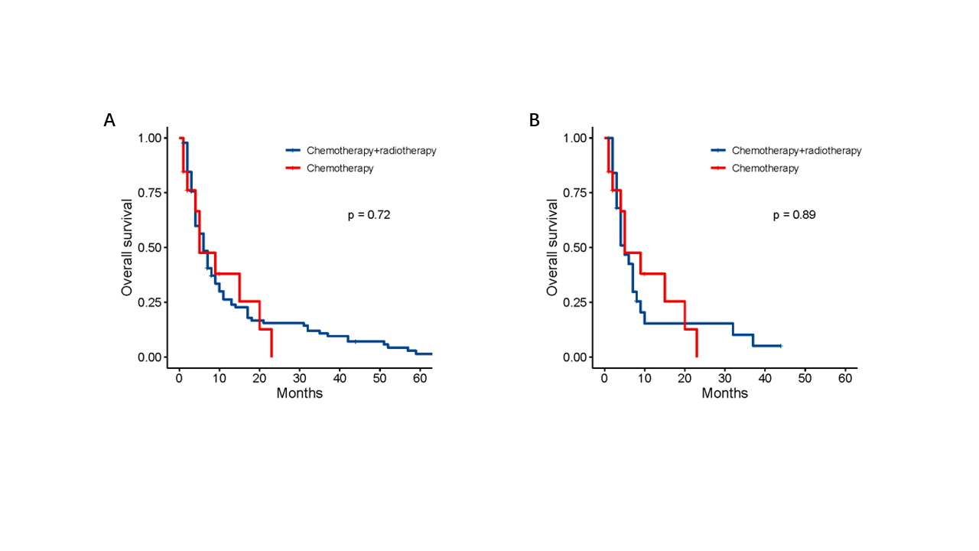
FIGURE S1 Kaplan–Meier curves of LCC patients with SBM receiving chemotherapy and radiotherapy vs radiotherapy before PSM (A) and after 1:2 PSM (B). LCC, large cell carcinoma; SBM, synchronous brain metastases; PSM, propensity score matching.

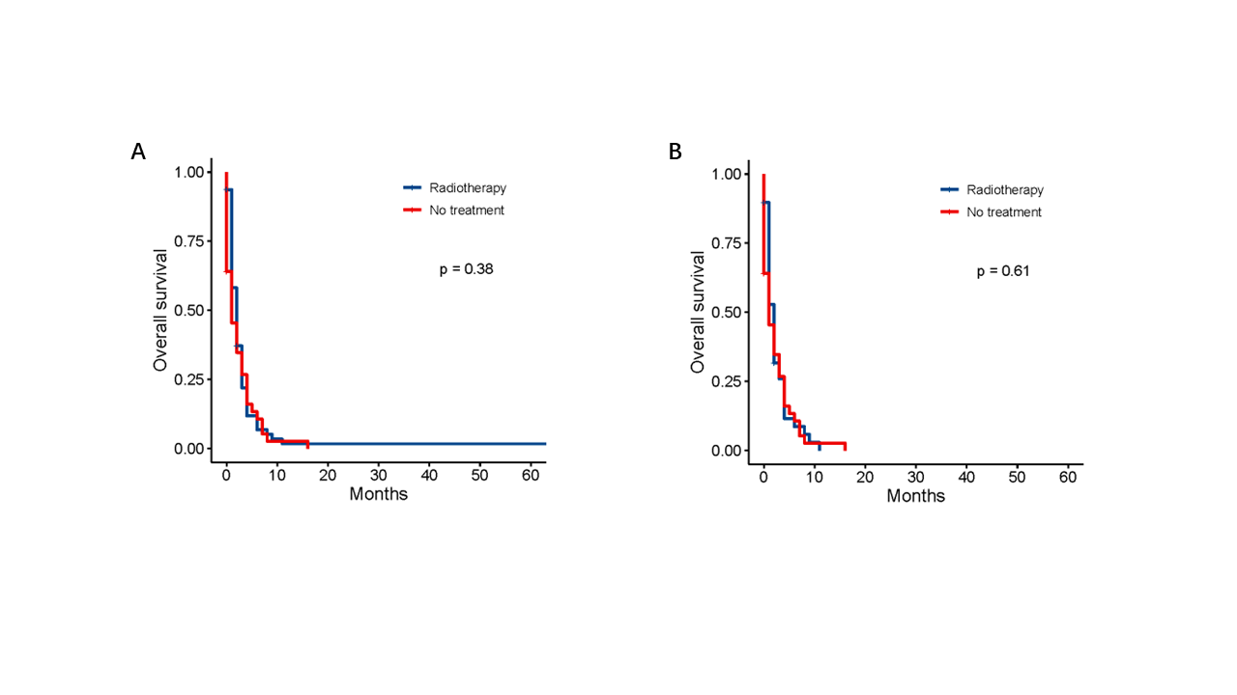
FIGURE S2 Kaplan–Meier curves of LCC patients with SBM receiving radiotherapy vs No treatment before PSM (A) and after 1:1 PSM (B). LCC, large cell carcinoma; SBM, synchronous brain metastases; PSM, propensity score matching.

