Supplementary Information
Dark-Current-Shunting Method to Realize Nearly-Zero Dark Current and Ultrahigh Signal-to-Noise Ratio Perovskite X-ray Detector and Image Array
Peng Jin ¹†, Yingjie Tang^{2,3}†, Dingwei Li^{2,3}, Yan Wang^{2,3}, Peng Ran¹, Ye Yuan⁴, Wenjuan Zhu^{1,5}, Cuifang Kuang¹, Xu Liu¹, Bowen Zhu²* & Yang (Michael) Yang¹*
†Those authors contributed equally to this work.
¹State Key Laboratory of Modern Optical Instrumentation, College of Optical Science and Engineering, Zhejiang University, Hangzhou 310007, Zhejiang, China.
²Key Laboratory of 3D Micro/Nano Fabrication and Characterization of Zhejiang Province, School of Engineering, Westlake University, Hangzhou 310024, Zhejiang, China.
³Zhejiang University, Hangzhou 310007, Zhejiang, China.
⁴State Key Laboratory of Advanced Technology for Materials Synthesis and Processing, Wuhan University of Technology, Wuhan 430070, PR China
⁵College of Electronic and Optical Engineering, and College of Flexible Electronics (Future Technology), Nanjing University of Posts and Telecommunications, Nanjing 210023, P. R. China

Corresponding Author:
Email:yangyang15@zju.edu.cn¹
Email:zhubowen@westlake.edu.cn²

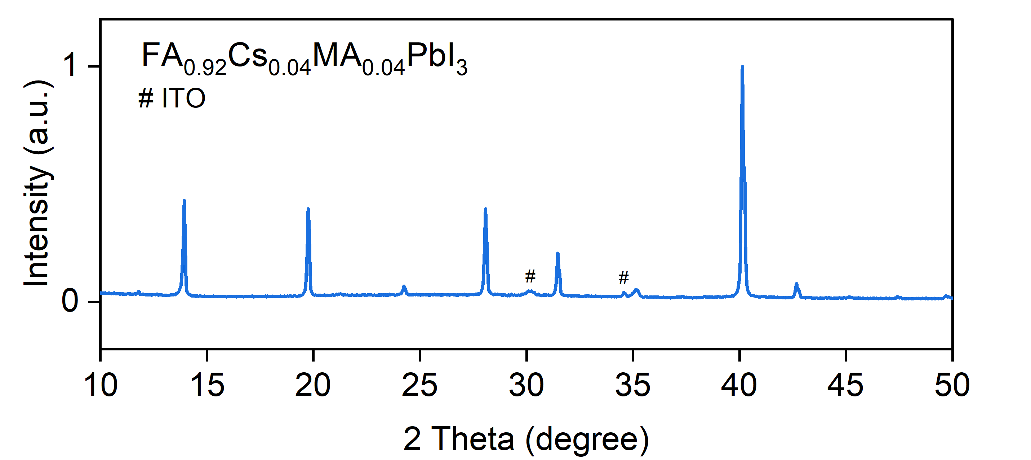
Figure S1. XRD of FA_{0.92}Cs_{0.04}MA_{0.04}PbI₃.
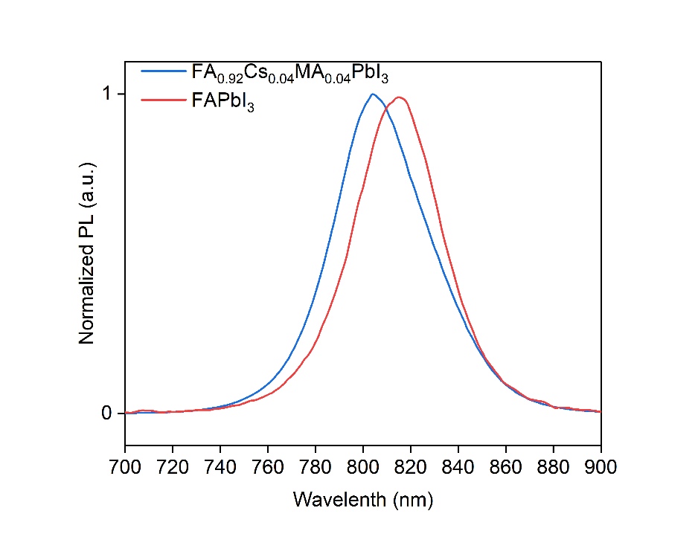
Figure S2. Photoluminescence (PL) of FA_{0.92}Cs_{0.04}MA_{0.04}PbI₃ and pure FAPbI₃.

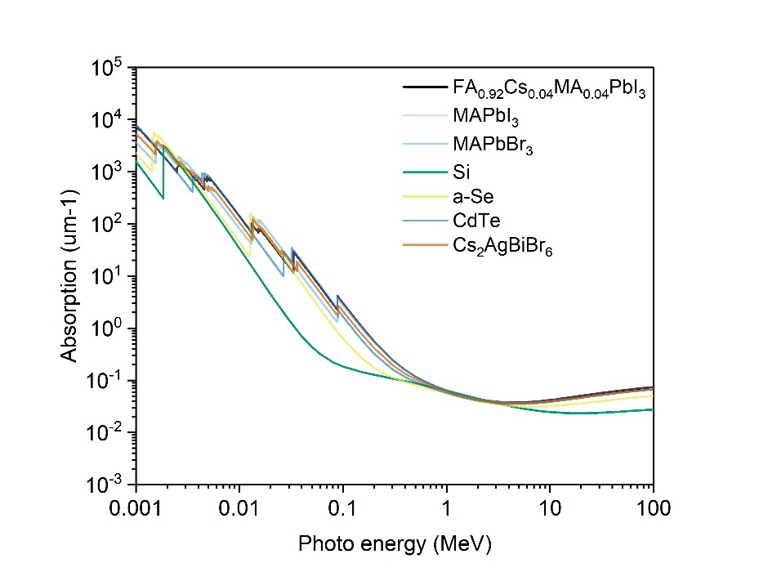
Figure S3. Absorption coefficient of FA_{0.92}Cs_{0.04}MA_{0.04}PbI₃ as a function of photon energy.

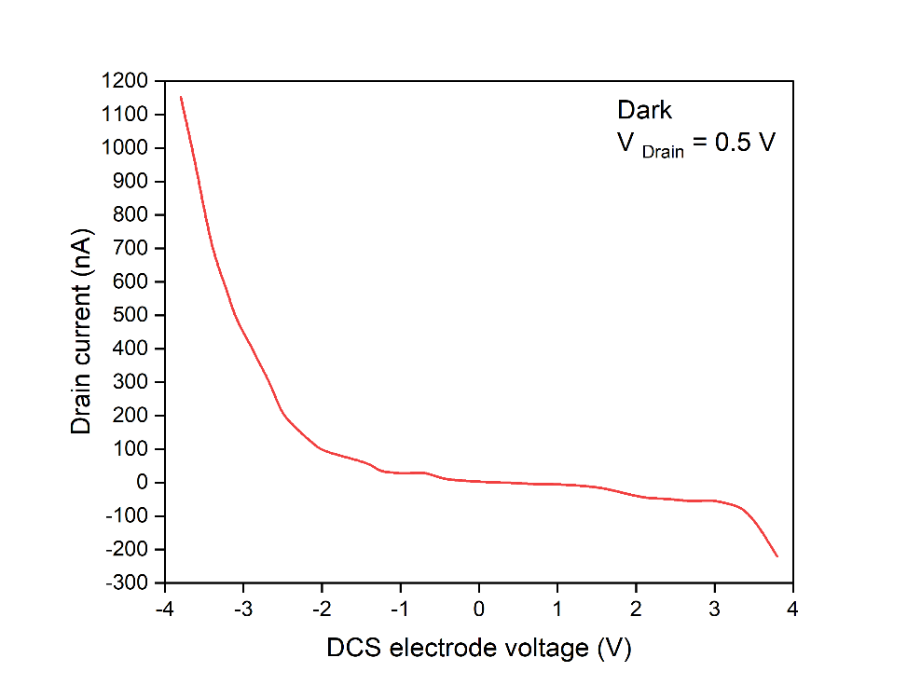
Figure S4. Current-voltage curves with respect to the DCS electrode voltage and the drain current. There is no gate regulation effect with this very thin PMMA spacing layer.

The sensitivity can be calculated by:
$$S=\frac{q}{D}=Q/AD't$$
where q is the charge density, D is the X-ray exposure dose at the detector, Q is the total charge induced by X-rays, A is the exposure area, D′ is the dose rate of X-rays, and t is the X-ray exposure time.

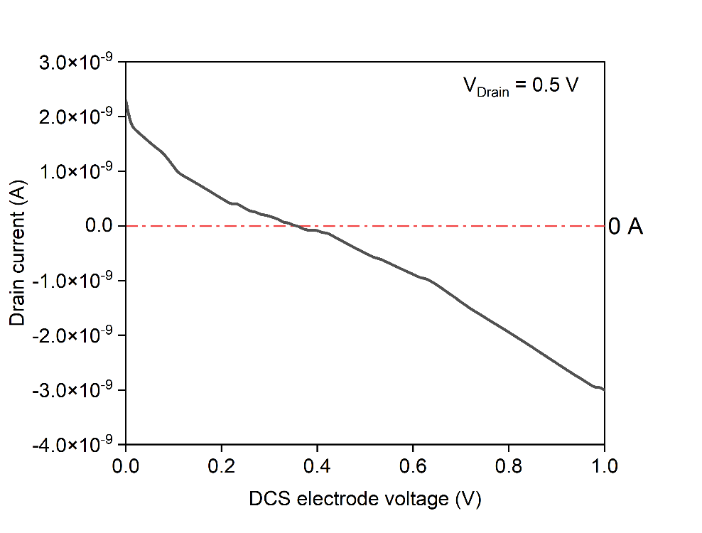
Figure S5. Current-voltage curves of the device without PMMA in terms of DCS electrode voltage and drain current at dark condition. The dark current can be diminished to zero while the DCS electrode is applied 0.4 V bias.

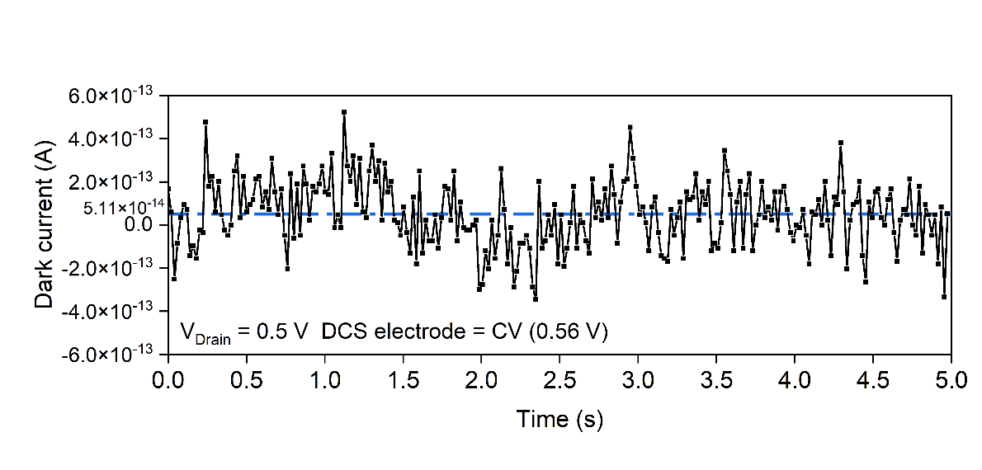
Figure S6. Truly measured dark current. The average dark current and noise current are 51.1 fA and 152 fA, respectively.

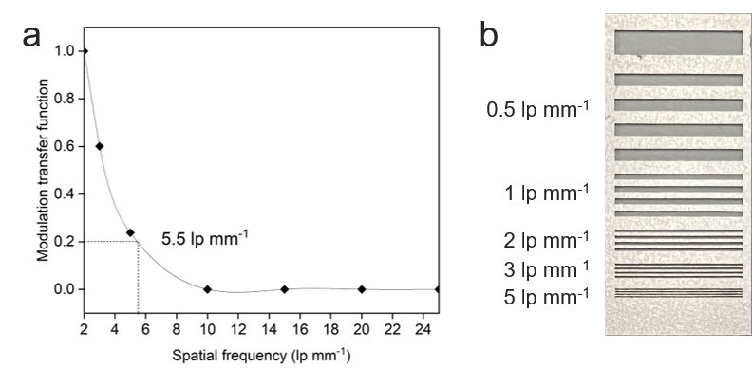
Figure S7. a, Modulation transfer function (MTF) of a single device. The minimum resolved line pair is 5.5 lp mm⁻¹. b, The used line pair mask plate
The MTF was calculated by:
M$TF= \frac{I_{max}-I_{min}}{I_{max}+I_{min}}$
where I_{max} is the maximun current intensity and I_{min} is the minimum current intensity when detecting the line pairs.
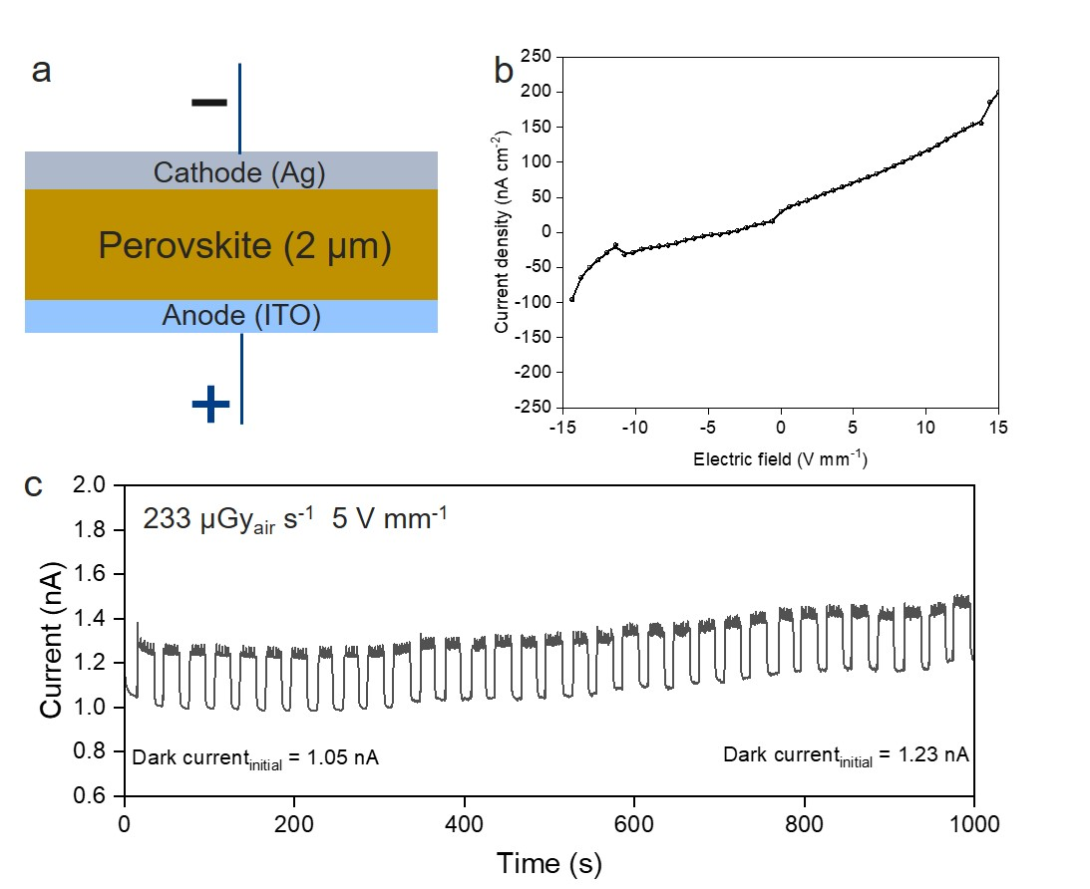
Figure S8. Optoelectronic properties of photoconduction detector. a, Illustration schematic of photoconductive (PCD) detector with a same material and a same thickness. b, Current-voltage curves of the PCD device. The dark current density is 72 nA cm⁻² under the same electrical field with our DCS detector (5 V mm⁻¹). It is more than a thousand time higher than our DCS device. c, Pulse-trains of the PCD device under the exposure of the X-ray with a dose rate of 233 μGy_{air} s⁻¹. The dark current gradually shifts from 1.05 nA to 1.23 nA and the SNR is very poor.

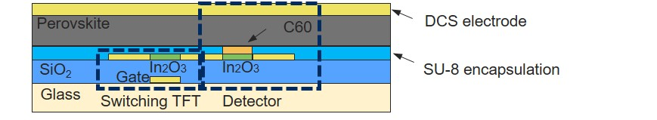
Figure S9. Sectional view of a single-pixel in the array. The DCS detector is in series with a switching TFT to control the on/off of a single-pixel.

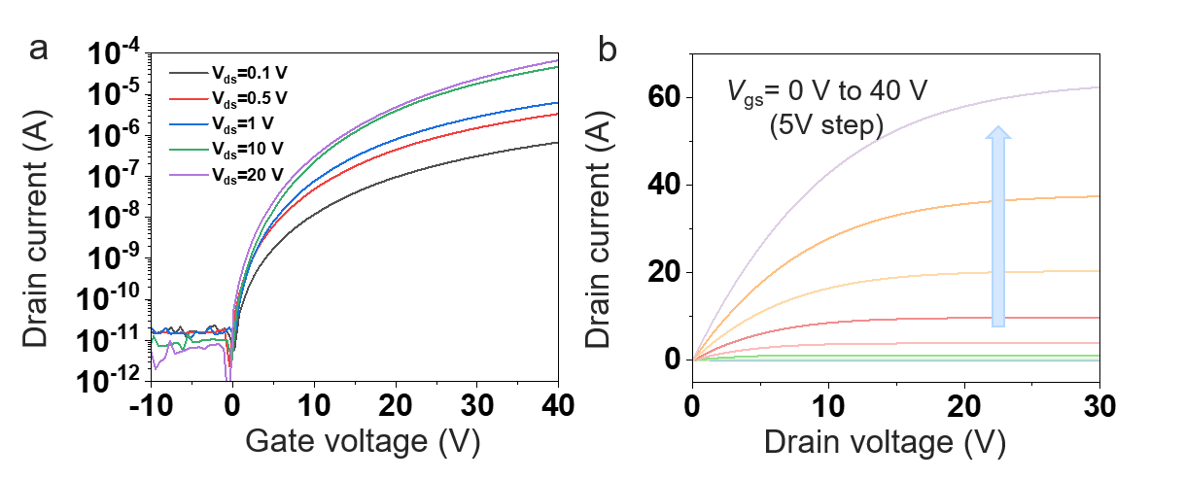
Figure S10. a, Transfer curves of a single transistor in the array. b, Output curves of a single transistor in the array.
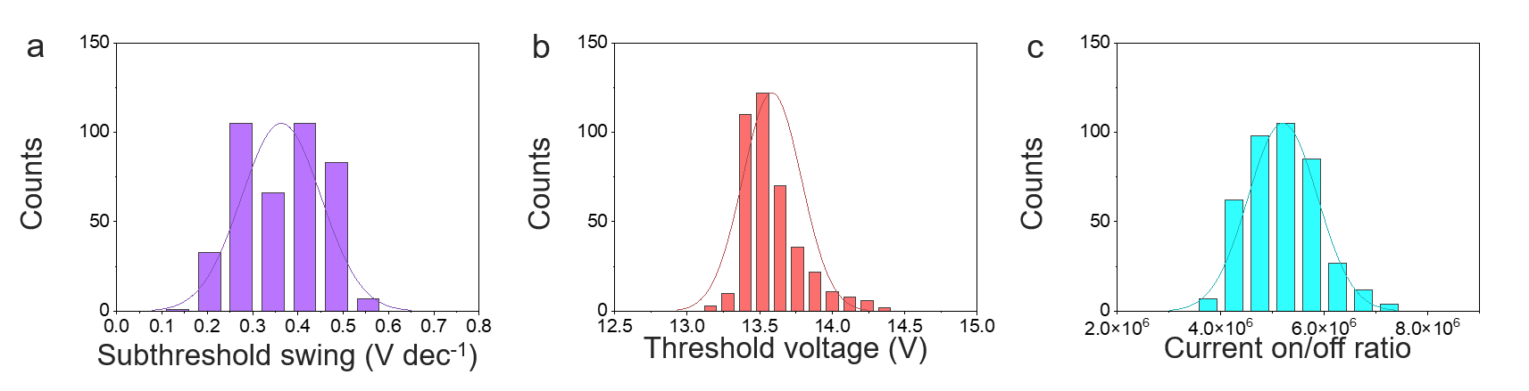
Figure S11. a, The subthreshold swing distribution of the 400 randomly selected pixels from the DCS detector array is demonstrated. b, The threshold voltage distribution of the 400 randomly selected pixels from the DCS detector array is demonstrated. c, The Current on/off ratio distribution of the 400 randomly selected pixels from the DCS detector array is demonstrated.
Where the linear mobility was calculated by:
$μ_{lin}=\frac{{dI}_{ds}}{{dV}_{g}}×\frac{L}{W}×\frac{1}{C_{g}×V_{d}}$ (1)
where dI_{ds}/dV_{g} is the slope of the linear region in the transfer curve, L/W is the channel length-width ratio, C_{g} is the dielectric capacitance and V_{d} is the drain electrode bias.
The S.S was calculated by:
$S.S= \frac{∂V_{GS}}{∂(\log_{10}{I_{DS}})}$ (2)
where V_{GS} is the gate electrode bias and I_{DS} is the current of drain electrode.

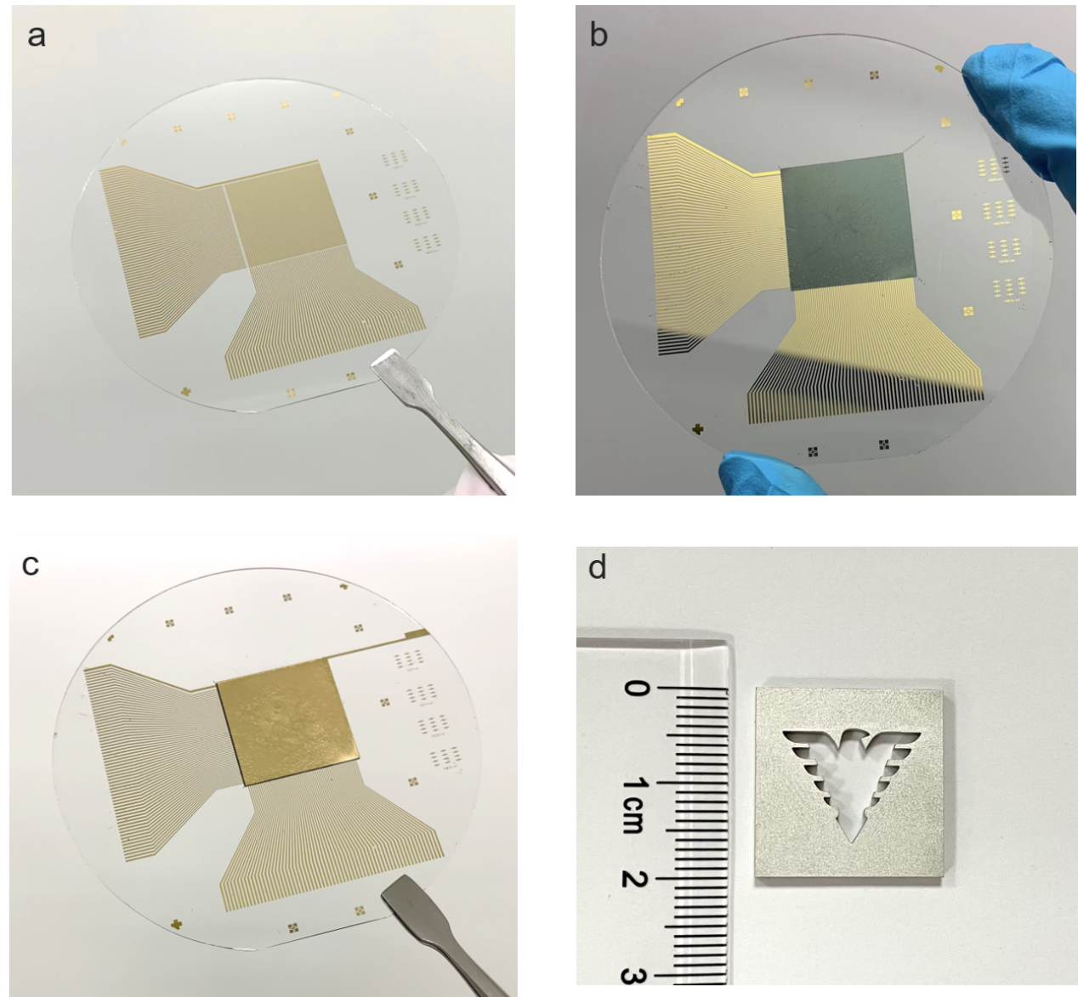
Figure S12. Intermediate process of DCS X-ray detectors array and mask plate. a, 64 х 64 matrix In₂O₃ TFTs back panel. Its pixel density is as high as 1024 per square centimeter. b, A 50 nm layer of C₆₀ was first evaporated on the back panel and then a 2 um layer of perovskite was spin-coated above the area of the detector array. c, With a layer of DCS electrode evaporated onto the area of the detector array, the fabrication of the DCS detector array completed. d, Image of the 2 mm thick stainless steel mask plate with a hollowed-out figure of ‘Qiushi Eagle’.

