Supplementary Information for
An On-demand Photonic Ising Machine with Simplified Hamiltonian Calculation by Phase-encoding and Intensity Detection
Jiayi Ouyang¹, Yuxuan Liao¹, Zhiyao Ma¹, Deyang Kong¹, Xue Feng¹*, Xiang Zhang², Xiaowen Dong², Kaiyu Cui¹, Fang Liu¹, Wei Zhang¹, and Yidong Huang¹*

¹Department of Electronic Engineering, Tsinghua University, Beijing 100084, China
²Central Research Institute, Huawei Technologies Co. Ltd., Shenzhen, 518129, China
*Correspondence: x-feng@tsinghua.edu.cn; yidonghuang@tsinghua.edu.cn

This file includes:
Supplementary Notes
Figs. S1 to S8
References

Supplementary Note 1: Detailed deduction of pretreatment of adjacent interaction matrix
At first, we would like to briefly introduce the principle of solving an Ising ground state problem with the proposed PEIDIA. For a given $N$-dimensional Ising model, the interaction matrix $J$ is real symmetric and can be decomposed with eigen-decomposition¹,
$$\begin{aligned}J=Q^{T}DQ, \#\left(S1\right)\end{aligned}$$
where the $D=diag\left(λ_{1}, λ_{2},…,λ_{N}\right)$ is the diagonal eigenvalue matrix with $N$ eigenvalues $λ_{1}, λ_{2},…,λ_{N}$ and the $Q$ is the corresponding normalized orthogonal eigenvector matrix. Thus, $J$ can be further transformed by introducing $A=\sqrt{D}Q$:
$$\begin{aligned}J=Q^{T}\sqrt{D}\sqrt{D}Q=A^{T}A.\#\left(S2\right)\end{aligned}$$
With such decomposition, the Ising Hamiltonian can be written as
$$\begin{aligned}H\left(σ\right)=-\frac{1}{2}\sum_{1≤i,j≤N}{J_{ij}}σ_{i}σ_{j}=-\frac{1}{2}σ^{T}Jσ=-\frac{1}{2}{\left(Aσ\right)}^{T}\left(Aσ\right). \#\left(S3\right)\end{aligned}$$
In Eq. (S3), the Hamiltonian is the product of the transformed spin vector $Aσ$ and its transpose. It should be mentioned that the eigenvalues $λ_{1}, λ_{2},…,λ_{N}$ may be negative. For convenience, suppose that $J$ has $k$ negative eigenvalues that satisfies $λ_{1}≤λ_{2}≤…≤λ_{k}<0≤λ_{k+1}≤…≤ λ_{N}$. Thus the square root of the diagonal eigenvalue matrix $D$ can be expressed as $\sqrt{D}=diag(i\sqrt{-λ_{1}}, i\sqrt{{-λ}_{2}},…i\sqrt{{-λ}_{k}},\sqrt{λ_{k+1}},…,\sqrt{λ_{N}})$. As $Q=\{q_{ij}\}$ is a real matrix, the transformation matrix $A$ has the following form
$$\begin{aligned}A=\left[\begin{matrix}i{\sqrt{{-λ}_{1}}q}_{11} & … & i{\sqrt{{-λ}_{1}}q}_{k1} & i{\sqrt{-λ_{1}}q}_{1,k+1} & … & i{\sqrt{{-λ}_{1}}q}_{1N} \\ ⋮ & ⋱ & ⋮ & ⋮ & ⋱ & ⋮ \\ i\sqrt{{-λ}_{k}}q_{k1} & … & i\sqrt{-λ_{k}}q_{k,k} & i\sqrt{{-λ}_{k}}q_{k,k+1} & … & i\sqrt{-λ_{k}}q_{kN} \\ \sqrt{λ_{k+1}}q_{k+1,1} & … & \sqrt{λ_{k+1}}q_{k+1,k} & \sqrt{λ_{k+1}}q_{k+1,k+1} & … & \sqrt{λ_{k+1}}q_{k+1,N} \\ ⋮ & ⋱ & ⋮ & ⋮ & ⋱ & ⋮ \\ \sqrt{λ_{N}}q_{N,1} & … & \sqrt{λ_{N}}q_{N,k} & \sqrt{λ_{N}}q_{N,k+1} & … & \sqrt{λ_{N}}q_{N,N}\end{matrix}\right], \#\left(S4\right)\end{aligned}$$
where the first $k$ rows are imaginary, while the rest $(N-k)$ rows are real. Similarly, since the spin vector is also real, the first $k$ elements of the transformed spin vector $E=Aσ$ are imaginary while the rest elements are real. Thus it can be written as $E=Aσ={\left[\begin{matrix}ie_{1} & … & ie_{k} & e_{k+1} & … & e_{N}\end{matrix}\right]}^{T}$. However, only the intensity of the light field can be detected,
$$\begin{aligned}I=E^{*}⊙E={\left[\begin{matrix}e_{1}^{2} & … & e_{k}^{2} & e_{k+1}^{2} & … & e_{N}^{2}\end{matrix}\right]}^{T}={\left[\begin{matrix}I_{1} & … & I_{k} & I_{k+1} & … & I_{N}\end{matrix}\right]}^{T},\#\left(S5\right)\end{aligned}$$
where $⊙$ denotes element-wise multiplication, Thus Eq. (S3) can be further rewritten as
$$\begin{aligned}H\left(σ\right)=-\frac{1}{2}E^{T}E=\left(-I_{1}-…-I_{k}+I_{k+1}+…+I_{N}\right)/2, \#\left(S6\right)\end{aligned}$$
Then the relation between the measured intensities and the corresponding Hamiltonian is
$$\begin{aligned}H=-\frac{1}{2}σ^{T}Jσ=-\frac{1}{2}\left(\sum_{i, λ_{i}>0 }{I_{i}}-\sum_{i, λ_{i}<0 }{I_{i}}\right). \#\left(S7\right)\end{aligned}$$
Therefore, in the pretreatment stage, the required transformation matrix $A$ is obtained by the eigen-decomposition of the Ising interaction matrix $J$ and the Hamiltonian can be calculated by employing the optical vector-matrix multiplication (OVMM) system according to $A$. In the main text, the 20-spin antiferromagnetic Möbius-Ladder model (model 1) and two randomly generated spin-glass models (model 2 and 3 with 20 and 30 spins respectively) are demonstrated, and their interaction matrices and corresponding transformation matrices are shown in Supplementary Fig. 1 respectively.
Supplementary Figure 1. (a)-(c) The Ising interaction matrix of model 1-3 respectively. (d)-(f) The target transformation matrix $A$ of model 1-3 respectively.
Supplementary Note 2: Full operation process of PEIDIA
The operation principle of PEIDIA is modified from the simulated annealing algorithm^{2,3} and inspired by the fast simulated annealing algorithm⁴. The process of each run is:
Input: Ising interaction matrix $J$, number of spins $N$, transformation matrix $A$, initial random spin vector $σ^{(0)}$, initial Hamiltonian $H^{(0)}$, initial annealing temperature $T_{0}$, iteration per temperature $n_{iter}$, number of the temperature stages $n_{temp}$, annealing factor $λ$, Cauchy scaling coefficient $α$.
Output: $P_{o}$
Initialization: annealing temperature: $T←T_{0}$, Hamiltonian: $H←+∞$, spin vector: $σ←σ^{(0)}$, patterns on SLMs: calibrated patterns corresponding to $A$.
For $i=1$ to $n_{temp}$ do
For $j=1$ to $n_{iter}$ do
Generate a Cauchy random variable $x\sim C(x;0,αT)$ until $m=round\left(\left|x\right|\right)<N$
If $m=0$
$m←1$
Else if $m>N/2$
$m←N-m$
End if
Generate the spin state $σ_{next}$ by randomly flip $m$ spins from $σ$
Update SLM1 according to $σ_{next}$
Calculate $H_{next}$ according to the measured beam intensities
If $H_{next}<H$
$σ←σ_{next}$
$H←H_{next}$
Else
If rand(0,1)<$\exp\left(-\frac{H_{next}-H}{T}\right)$
$σ←σ_{next}$
$H←H_{next}$
End if
End if
End for
$T←λT$
End for
Return $σ$
Supplementary Note 3: Experimental demonstration of PEIDIA
The experimental setup is illustrated in Supplementary Fig. 2. The operating wavelength of the laser (ORION 1550nm Laser Module) is 1550nm. Each employed reflective phase-only SLM (HOLOEYE PLUTO-2.1-TELCO-013) has 1920×1080 pixels with the pixel pitch of 8μm. The distance between SLM0 and SLM1 is $L_{01}=0.820m$. The distance between SLM1 and SLM2 is $L_{12}=0.754m$. The distance between SLM2 and pinhole is $L_{2p}=0.373m$. The final output field is measured by the Hamamatsu InGaAs C12741-03 camera. To weaken the influence of the detection noise, the measured image of each sample is the average of 3 frames for model 1-3 respectively. Supplementary Fig. 3 shows the experimentally utilized SLM patterns for model 2 as an example. 20 beam-splitting and beam-recombining circular regions are shown in Supplementary Fig. 3(b) and (c) respectively with the diameter of each region is 2.35mm. Supplementary Fig. 4 shows the SLM1 pattern used in the experiment of model 3, which contains 30 beam-splitting regions with radius of 0.95mm.
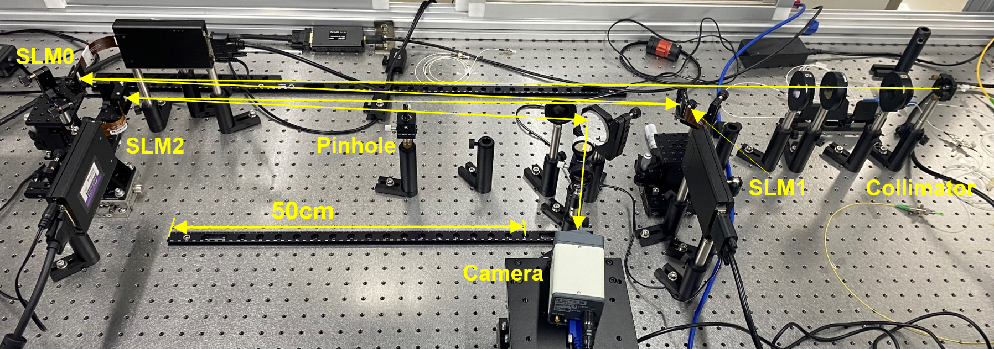
Supplementary Figure 2. The experimental setup of PEIDIA.
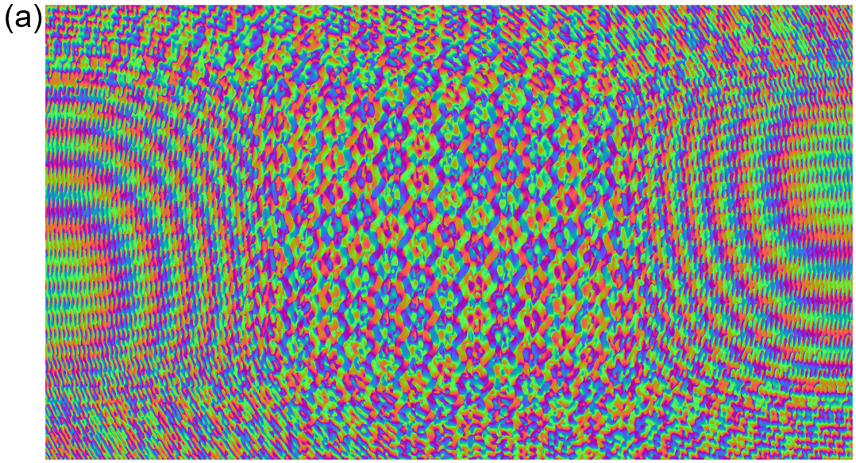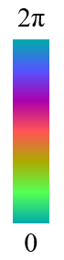
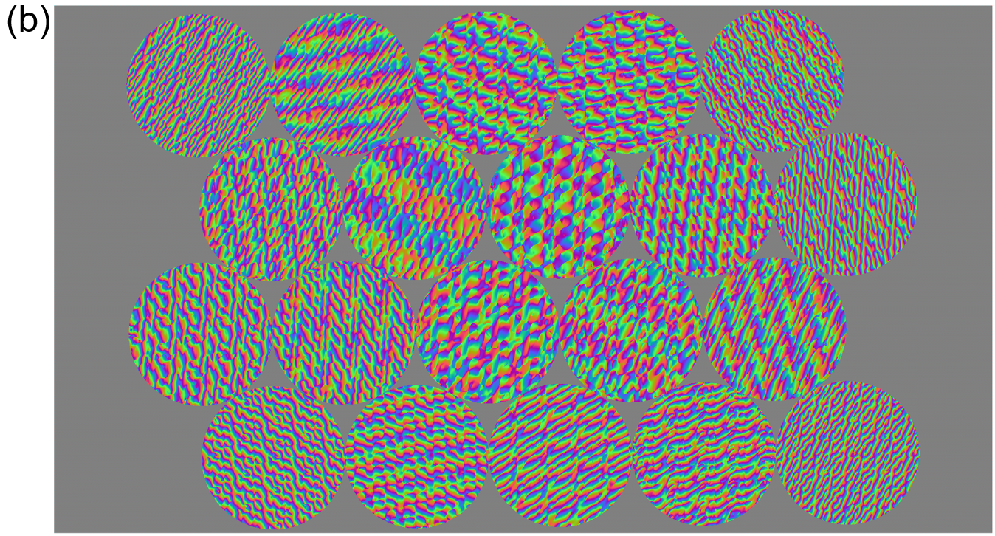
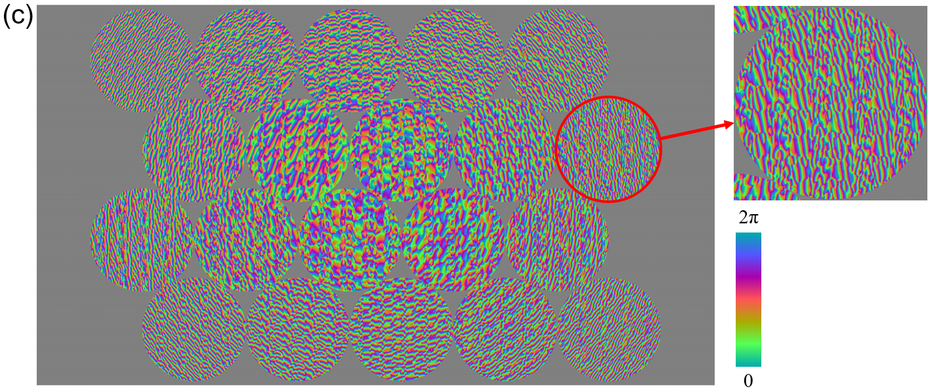
Supplementary Figure 3. Experimentally utilized SLM phase patterns for model 2 (not superposed with the global blazed grating). The color bar indicates the phase value. (a) The beam-splitting pattern on SLM0. (b) The beam-splitting pattern on SLM1. (c) The beam-recombining pattern on SLM2. The inset shows a detailed beam-recombining region denoted by the red circle.
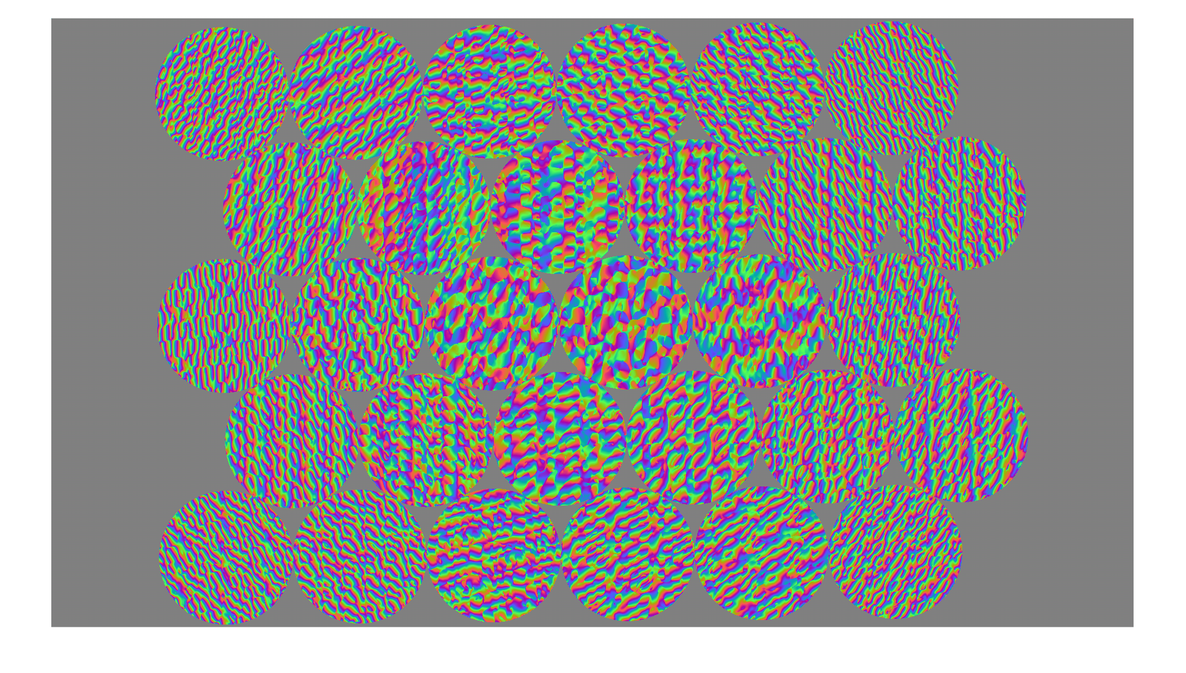
Supplementary Figure 4. Experimentally utilized SLM1 phase patterns for model 3 (not superposed with the global blazed grating). The color bar indicates the phase value.
The method of generating phase patterns on SLMs. In our previous work^{5,6}, the method of generating the phase patterns on SLMs has been presented and the main procedure are described as follows. As mentioned in the main text, three SLMs are employed to generate the required beams, indexed SLM0, SLM1 and SLM2 respectively. SLM0 splits the incident beam into $N$ beams, while SLM1 and SLM2 split and interweave the beams to perform multiplication and addition operations. The pixels outside the circular regions are filled with alternating $0$ and $π$ phase modulation according to the checkerboard method. Besides, as the employed SLMs are reflective, an additional global blazed grating with the period of 4 pixels is applied to each SLM pattern in order to concentrate the optical intensity in the first diffraction order. The beam from the collimator is centered at coordinate [0, 0] in the transverse $xy$ plane. Then the beam is split and projected to $N$ different circular regions on SLM1, as shown in Supplementary Fig. 3(b) and 4. The ideal modulation function of SLM0 is the superposition of a series of blazed gratings^{5,6}:
$$\begin{aligned}H_{SLM0, ideal}\left(r\right)=\sum_{n}^{N}{α_{n}\exp\left(\frac{-ik}{L_{01}}r_{n}∙r\right)}, \#\left(S8\right)\end{aligned}$$
where $r$ is the position vector in the $xy$ plane, $k$ is the wavenumber, $r_{n}$ is the position vector of the center of the $n$th region of SLM1, $α_{n}$ is the element of the input vector.
The ideal modulation function of $n$th circular region on SLM1 comprises two parts: a spin-encoding pattern and a beam-splitting pattern. The spin-encoding pattern just applies a phase delay of $0$ or $π$ to the beam according to its corresponding spin $σ_{n}=±1$ and the beam-splitting pattern is a superposition of a lens mask and $N$ blazed gratings^{5,6}:
$$\begin{aligned}H_{SLM1,ideal,n}\left(r\right)=σ_{n}\sum_{m=1}^{N}{β_{mn}\exp\left[-ik\left(\frac{{R_{m}-r}_{n}}{L_{12}}-\frac{r_{n}}{L_{01}}\right)∙\left(r-r_{n}\right)+θ_{mn}\right]} \\ ∙H_{lens}\left(r-r_{n},f_{1}\right), \#\left(S9\right)\end{aligned}$$
$$\begin{aligned}H_{lens}\left(r-r_{n},f_{1}\right)=\exp\left(i\frac{k{\left|r-r_{n}\right|}^{2}}{2f_{1}}\right), \#\left(S10\right)\end{aligned}$$
where $β_{mn}$ is the element of the beam-splitting matrix, $R_{m}$ is the position vector of the center of the $m$th region of SLM2, $θ_{mn}$ is the phase compensation term due to different optical path, and $H_{lens}$ is the phase modulation function of a lens. The lens with the focus $f_{1}$ adjusts the location of the beam waist to the middle of SLM1 and SLM2.
Each region on SLM2 recombines the $N$ beams deflected by each region on SLM1 and a pinhole is set to filter out undesired light. The ideal modulation function of $m$th region on SLM2 is^{5,6}
$$\begin{aligned}H_{SLM2,ideal,m}\left(r\right)=\sum_{n=1}^{N}{γ_{mn}\exp\left[-ik\left(\frac{{-r}_{n}}{L_{2p}}-\frac{{R_{m}-r}_{n}}{L_{12}}\right)∙\left(r-R_{m}\right)\right]} \\ ∙H_{lens}\left(r-R_{m},f_{2}\right), \#\left(S11\right)\end{aligned}$$
where $γ_{mn}$ is the element of the beam-recombining matrix. The lens with the focus $f_{2}$ adjusts the location of the beam waist to the pinhole.
There is an evident caveat, however, that the ideal modulation functions above are not pure-phase, thus unattainable with the SLMs employed in our experiments. To address this issue, our previous work maps the value to a point on unit circle with the same argument^{5,6}:
$$\begin{aligned}H_{SLM}\left(r\right)=\exp\left\{i\arg{[H_{SLM,ideal}\left(r\right)}]\right\}\#\left(S12\right)\end{aligned}$$
for it is the closest pure-phase solution to the original function in the sense of least squares. It is worth pointing out that this practice is empirical, and the errors for both the light field and the matrix elements would increase drastically with the dimensionality.
In this work, an improved iterative algorithm is employed to obtain the optimal phase-only patterns, which produce the light field distribution on the target plane approximating to an ideal distribution. The fundamental theory here is gradient descent. The main issue is how to optimize a real criterion function depending on complex-valued parameters. According to ref. ⁷, the optimizing theorems are handy to us.
- Preparations
The first step of optimization is to discretize the problem so that the computer processing can be performed. Consider a continuous model of light field propagation: light field given two parallel planes with aligned transverse coordinates, the propagation of the light field $u\left(x,y,0\right)$ on the first plane to the field $u\left(x^{'},y^{'},z_{0}\right)$ on the second plane can be described as⁸
$$\begin{aligned}u\left(x^{'},y^{'},z_{0}\right)=-u\left(x,y,0\right)⋆\frac{1}{2π}\frac{∂}{∂z^{'}}{\left[\frac{e^{-ikr}}{r}\right]}_{z=z_{0}}=IFT\left\{FT\left\{u\left(x,y,0\right)\right\}×FT\left\{-\frac{1}{2π}\frac{∂}{∂z^{'}}{\left[\frac{e^{-ikr}}{r}\right]}_{z=z_{0}}\right\}\right\}, \#\left(S13\right)\end{aligned}$$
where $r=\sqrt{{\left(x-x^{'}\right)}^{2}+{\left(y-y^{'}\right)}^{2}+z^{2}}$, $⋆$ denotes the convolution, and Fourier transform (FT) is utilized to compute the convolution.
Then the fields are sampled, and the Fourier transform and convolution are replaced with their discrete counterparts. For the sake of simplicity, the light fields are uniformly sampled in a rectangular area, aligned with both axes, and centered on the origin.
Let $H_{z_{0}}∈C^{3L_{x}×3L_{y}}$ denote the 2D-DFT of the respond $-\frac{1}{2π}\frac{∂}{∂z^{'}}{\left[\frac{e^{-ikr}}{r}\right]}_{z=z_{0}}$, and $U,U^{'}∈C^{L_{x}×L_{y}}$ denote the sampling of light fields at $z=0$ and $z=z_{0}$, respectively. Noting the non-overlapping condition and the alignment of discrete convolution, the response has to be sampled from an area of double length in each dimension, then applied with $3L_{x}×3L_{y}$ 2D-DFT and finally clips the result to match the shape of $U^{'}$. To formulate it:
$$\begin{aligned}U^{'}=clip\left(IDFT_{3L_{x},3L_{y}}\left(DFT_{3L_{x},3L_{y}}\left(U\right)⊙H_{z_{0}}\right)ΔxΔy\right), \#\left(S14\right)\end{aligned}$$
where $⊙$ denotes element-wise multiplication, $Δx$ and $Δy$ denote the sampling interval along each axis, and $clip\left(∙\right)$ clips extra zeros from the result matrix.
Now consider a surface at $z=0$, such as an SLM, and assume that each pixel independently produces a wavefront (rectangular, for example) proportional to their complex modulation coefficient. Let $M∈C^{3L_{x}×3L_{y}}$ denotes the 2D-DFT of the wavefront and $P∈C^{L_{x}×L_{y}}$ denotes the coefficient matrix of the hologram. Now
$$\begin{aligned}U^{'}=clip\left({IDFT}_{3L_{x},3L_{y}}\left({DFT}_{3L_{x},3L_{y}}\left(P⊙U\right)⊙H_{z_{0}}⊙M\right)ΔxΔy\right)=T_{z_{0}}\left(P⊙U\right). \#\left(S15\right)\end{aligned}$$
Note that the composited operations are defined as $T_{z_{0}}\left(∙\right)$, which is the discrete form of light field propagation function we desire.
- Generate target light field
After discretization, a target light field is needed for each SLM to be optimized. A convenient approach is to treat the light field produced by ideal patterns as target. As well the initial values of optimization are such set with ideal patterns. To formulate it:
$$\begin{aligned}U_{T}=T_{z_{0}}\left(H_{SLM,ideal}⊙U_{I}\right), \#\left(S16\right)\end{aligned}$$
$$\begin{aligned}P_{0}=H_{SLM,ideal}. \#\left(S17\right)\end{aligned}$$
- Optimization steps
Given a target light field $U_{T}$ at $z=z_{0}$, an incident light field $U_{I}$ at $z=0$, and a hyperparameter $δ$, optimize phase pattern $P$ in the sense (Huber Loss):
$${argmin}_{P} L\left(P;U_{T},U_{I},z_{0},δ\right)=\sum_{i,j}{\left\{\begin{aligned}&\frac{1}{2}{\left|T_{z_{0}}\left(\frac{P}{\left|P\right|}⊙U_{I}\right)-U_{T}\right|}_{ij}^{2}, { \left|T_{z_{0}}\left(\frac{P}{\left|P\right|}⊙U_{I}\right)-U_{T}\right|}_{i,j}≤δ \\ &δ{\left|T_{z_{0}}\left(\frac{P}{\left|P\right|}⊙U_{I}\right)-U_{T}\right|}_{i,j}-\frac{1}{2}δ^{2}, otherwise\end{aligned}\right.}$$
$$\begin{aligned}=l\left(T_{z_{0}}\left(N\left(P\right)\right)\right), \#\left(S18\right)\end{aligned}$$
where $T_{z}\left(∙\right)$ is previously defined, $\left\{\begin{aligned}∙ \\ ∙\end{aligned}\right.$ selects from two values and $\sum{∙}$ sums them up. Other operations here are all element-wise. Note that $l\left(∙\right)$ contracts the loss function and $N(P)=\frac{P}{\left|P\right|}$ gives a phase-only hologram, which is what we eventually need.
Following the procedures described in ref. ⁷, we finally derive the gradient of $L$ with respect to $P$, which is:
$$\begin{aligned}\frac{∂}{∂P^{*}}L=\frac{1}{2}U_{I}⊙\left(-\frac{\left|P\right|}{{\left(P^{*}\right)}^{2}}⊙{T_{z_{0}}^{'}}^{*}\left(\frac{∂}{∂T_{z_{0}}^{*}}l\right)+\frac{1}{\left|P\right|}⊙T_{z_{0}}^{'}\left(\frac{∂}{∂T_{z_{0}}^{*}}l\right)\right), \#\left(S19\right)\end{aligned}$$
where
$$\begin{aligned}T_{z_{0}}^{'}\left(Z\right)=clip\left({IDFT}_{3L_{x},3L_{y}}\left({DFT}_{3L_{x},3L_{y}}\left(Z\right)⊙H_{z_{0}}^{*}⊙M^{*}\right)ΔxΔy\right). \#\left(S20\right)\end{aligned}$$
Finally, the gradient-descent-based algorithm is conducted to optimize the target phase-only hologram. Here is a sketch of the algorithm:
Input: target light field: $U_{T}$, incident light field: $U_{I}$, hyperparameter: $δ$, initial phase pattern: $P$, iteration limit $iter$.
Output: $P_{o}$.
Initialization: optimizer: $O←O_{RAdam}$ (Rectified Adam Optimizer⁹ is employed in our demonstration), loss function$l$: Huber loss.
$P_{0}=P$
For $i=1$ to $iter$ do
Compute $\frac{∂}{∂P_{i-1}^{*}}L$
$P_{i}=O.step\left(\frac{∂}{∂P_{i-1}^{*}}L\right)$
End for
Return $P_{o}=\frac{P_{T}}{\left|P_{T}\right|}$
Calibration method of the OVMM. Before the experiments, the whole system should be calibrated to achieve high fidelity of the implemented matrix transformation. In the calibration stage, both the phase and amplitude terms are considered. The phase calibration method is improved from that used in our previous work¹⁰.
Phase calibration. First, as mentioned above, the phase patterns of SLM1 and SLM2 are generated and set according to the all-one matrix. To measure the phase difference among the elements of the beam-splitting matrix, four output intensity matrices $M_{1}$, $M_{2}$, $M_{3}$ and $M_{4}$ have to be measured. In this section, each column of the input matrix would serve as the input vector one by one and the output matrix consists of the corresponding output vectors.
At first, the input matrix $m_{in}$ of SLM0 is defined as an $N×(N-1)$ matrix with each column including two non-zero elements 1:
$$\begin{aligned}m_{in}=\left[\begin{matrix}1 & 1 & 1 & … & 1 \\ 1 & 0 & 0 & … & 0 \\ 0 & 1 & 0 & … & 0 \\ 0 & 0 & 1 & … & 0 \\ ⋮ & ⋮ & ⋮ & ⋱ & ⋮ \\ 0 & 0 & 0 & … & 1\end{matrix}\right]. \#\left(S21\right)\end{aligned}$$
The process of phase calibration can be described as follows:
Initialization: input matrix: $m_{in}$, matrix on SLM1: all-one matrix, matrix on SLM2: all-one matrix.
For $i=1$ to $N-1$ do
Update SLM0 according to the column $i$ of $m_{in}$
Measure the column $i$ output intensity matrix $M_{1}$
Deactivate the region $i+1$ of SLM1
Measure the column $i$ output intensity matrix $M_{3}$
Reset the SLM1 pattern
Deactivate the region $1$ of SLM1
Measure the column $i$ output intensity matrix $M_{4}$
Reset the SLM1 pattern
Add the phase delay of $π/2$ to the region $i+1$ of SLM1
Measure the column $i$ output intensity matrix $M_{2}$
End for
Here, the operation “deactivate” means that replacing the region with a “mirror” pattern in order to erase the incident beam. Next how to use these matrices to conduct the phase calibration is introduced.
According to the process above, the interference intensities between the first and one of the rest of the beams have been measured as $M_{1}$. Since none of the SLM patterns are calibrated, the actual input matrix can only be written as
$$\begin{aligned}m_{in}^{'}=\left[\begin{matrix}b_{11} & b_{12} & b_{13} & … & b_{1,N-1} \\ b_{21} & 0 & 0 & … & 0 \\ 0 & b_{32} & 0 & … & 0 \\ 0 & 0 & b_{43} & … & 0 \\ ⋮ & ⋮ & ⋮ & ⋱ & ⋮ \\ 0 & 0 & 0 & … & b_{N,N-1}\end{matrix}\right] \#\left(S22\right)\end{aligned}$$
The actual transformation matrix is denoted as $A_{ij}^{'}=a_{ij}\exp\left(iφ_{ij}\right)$ so that the output amplitude matrix $m_{1}=A^{'}m_{in}^{'}$ is
$$\begin{aligned}{\left(m_{1}\right)}_{ij}=a_{i1}b_{1j}\exp\left(iφ_{i1}\right)+a_{i,j+1}b_{j+1,j}\exp\left(iφ_{i,j+1}\right) \#\left(S23\right)\end{aligned}$$
and the corresponding measured output intensity matrix $M_{1}$ is
$$\begin{aligned}{\left(M_{1}\right)}_{ij}={\left(m_{1}\right)}_{ij}^{*}{\left(m_{1}\right)}_{ij}=a_{i1}^{2}b_{1j}^{2}+a_{i,j+1}^{2}b_{j+1,j}^{2}+2a_{i1}b_{1j}a_{i,j+1}b_{j+1,j}\cos\left(φ_{i1}-φ_{i,j+1}\right). \#\left(S24\right)\end{aligned}$$
Similarly, the output amplitude matrix $m_{2}$ is
$$\begin{aligned}{\left(m_{2}\right)}_{ij}=a_{i1}b_{1j}\exp\left(iφ_{i1}\right)+a_{i,j+1}b_{j+1,j}\exp\left[i{(φ}_{i,j+1}+π/2)\right] \#\left(S25\right)\end{aligned}$$
and the corresponding measured output intensity matrix $M_{2}$ is
$$\begin{aligned}{\left(M_{2}\right)}_{ij}={\left(m_{2}\right)}_{ij}^{*}{\left(m_{2}\right)}_{ij}=a_{i1}^{2}b_{1j}^{2}+a_{i,j+1}^{2}b_{j+1,j}^{2}+2a_{i1}b_{1j}a_{i,j+1}b_{j+1,j}\sin\left(φ_{i1}-φ_{i,j+1}\right). \#\left(S26\right)\end{aligned}$$
Obviously, ${\left(M_{3}\right)}_{ij}=a_{i1}^{2}b_{1j}^{2}$ and ${\left(M_{4}\right)}_{ij}=a_{i,j+1}^{2}b_{j+1,j}^{2}$.
Therefore, the actual phase difference could be calculated according to
$$\begin{aligned}Δφ_{ij}=φ_{i1}-φ_{i,j+1}=\left\{\begin{aligned}\arccos\left[\frac{{\left(M_{1}\right)}_{ij}-{\left(M_{3}\right)}_{ij}-{\left(M_{4}\right)}_{ij}}{2\sqrt{{\left(M_{3}\right)}_{ij}{\left(M_{4}\right)}_{ij}}}\right], {\left(M_{2}\right)}_{ij}-{\left(M_{3}\right)}_{ij}-{\left(M_{4}\right)}_{ij}≥0 \\ -\arccos\left[\frac{{\left(M_{1}\right)}_{ij}-{\left(M_{3}\right)}_{ij}-{\left(M_{4}\right)}_{ij}}{2\sqrt{{\left(M_{3}\right)}_{ij}{\left(M_{4}\right)}_{ij}}}\right],{\left(M_{2}\right)}_{ij}-{\left(M_{3}\right)}_{ij}-{\left(M_{4}\right)}_{ij}<0\end{aligned}\right.. \#\left(S27\right)\end{aligned}$$
It should be mentioned that Eq. (S27) can only calculate the phase differences among the elements in the same row. But this does not matter since the phase difference among different columns will not affect the output optical intensities. Finally, the phase-calibration matrix $Δφ$ is obtained, and the input beam-splitting matrix of SLM1 is modified to $A_{ij}\exp{(iΔφ_{ij})}$. It should be mentioned that such $Δφ$ is independent to the transformation matrix and only determined by the optical setup so that it could be directly applied on other transformations.
Amplitude calibration. The process of the calibration of SLM1 can be described as follows.
Initialization: Input matrix: identity matrix, target transformation matrix: $A$, beam-splitting matrix on SLM1: ${\left(A_{SLM1}\right)}_{ij}←A_{ij}\exp{(iΔφ_{ij})}$, pattern on SLM2: the same as that in phase calibration stage, repetition times: $n_{amp}$.
For $i_{rep}=1$ to $n_{amp,1}$ do
Measure the output intensity matrix $C$
${\left(A_{SLM1}\right)}_{ij}←{\left(A_{SLM1}\right)}_{ij}\left|A_{ij}\right|/\sqrt{C_{ij}}$
Generate and update the new phase pattern on SLM1 pattern according to $A_{SLM1}$
End for
In the 20-D transformation, $n_{amp,1}=3\sim 4$ is enough to obtain high fidelity. It should be mentioned that due to the phase-only operation, the SLM1 could only split the incident beams. Thus, the input vector of SLM0 has to be modified to compensate the difference between the beam-splitting matrix of SLM1 and the target matrix. Here, the actual contribution of each split beam from SLM0 to the output mode has to be measured. This can be achieved by activating each region of the calibrated SLM1 pattern successively (other regions are “deactivated” as mentioned above). The process is described as follows.
Initialization: target transformation matrix: $A$, input vector of SLM0: ${\left(E_{in}\right)}_{j}←\max_{i}\left(\left|A_{ij}\right|\right)/\sqrt{\max_{i}\left(C_{ij}\right)}$ ($C$ is the last output intensity matrix in the amplitude calibration of SLM1), pattern on SLM1: calibrated pattern, SLM2 pattern: the same as that in phase calibration stage, repetition times $n_{amp,2}$.
For $i_{rep}=1$ to $n_{amp,2}$ do
For $j=1$ to $N$ do
Deactivate all regions except region $j$ of SLM1
Measure the output intensity vector $F_{j}$
$${\left(E_{in}\right)}_{j}←{\left(E_{in}\right)}_{j}\max_{i}\left(\left|A_{ij}\right|\right)/\sqrt{\max_{i}{{\left(F_{j}\right)}_{i}}}.$$
End for
Generate and update the new SLM0 pattern according to $E_{in}$
End for
In the 20-D condition, $n_{amp,2}=3\sim 4$ is enough to obtain high fidelity.
In the end of this section, the 20-D Discrete Fourier Transform (DFT) matrix is set as the target transformation to evaluate the calibration accuracy:
$$\begin{aligned}W=\frac{1}{\sqrt{N}}\left[\begin{matrix}1 & 1 & 1 & ⋯ & 1 \\ 1 & ω & ω^{2} & ⋯ & ω^{N-1} \\ 1 & ω^{2} & ω^{4} & ⋯ & ω^{2\left(N-1\right)} \\ ⋮ & ⋮ & ⋮ & ⋱ & ⋮ \\ 1 & ω^{N-1} & ω^{2\left(N-1\right)} & ⋯ & ω^{\left(N-1\right)\left(N-1\right)}\end{matrix}\right], ω=e^{-i\frac{2π}{N}}. \#\left(S28\right)\end{aligned}$$
Since the elements of both the DFT matrix and its inverse matrix have the same norms and only differ in arguments, it is very sensitive to the phase term. After the amplitude calibration of SLM1, the output intensity matrix corresponding to the input identity matrix is shown in Supplementary Fig. 5(a). It can be seen that each beam is equally split by SLM1, but the intensities in different columns are different. Then after the amplitude calibration of SLM0, the matrix $F$ is shown as Supplementary Fig. 5(b), where the matrix elements are much closer to each other than that in Supplementary Fig. 5(a).
In order to evaluate the accuracy of the calibration, the input matrix is set as the inverse matrix of the DFT matrix, which is also the conjugate transpose. The output matrix should be the 20-dimensional identity matrix. Obviously, the input vector can be simply achieved by adding phase masks to each SLM1 region according to the arguments of the elements of the target input vector. The measured CCD images are shown in Supplementary Fig. 5(d), where only one bright spot at different locations is observed in each image with similar intensities and high contrast. The output intensity matrix is shown as Supplementary Fig. 5(c) with the intensity concentrating on the main diagonal elements. Here the fidelity $f_{mat}$ is employed to evaluate the accuracy of the matrix transformation:
$$\begin{aligned}f_{mat}=\frac{\sum_{ij}{{\left(I_{t}\right)}_{ij}{\left(I_{e}\right)}_{ij}}}{\sqrt{\sum_{ij}{{\left(I_{t}\right)}_{ij}^{2}}}\sqrt{\sum_{ij}{{\left(I_{e}\right)}_{ij}^{2}}}}, f_{mat}∈\left[0,1\right] \#\left(S29\right)\end{aligned}$$
where $I_{t}$ is the theoretical output intensity matrix and $I_{e}$ is the experimentally measured intensity matrix. $f_{mat}$ is normalized within [0, 1]. In this demonstration, the value of $f_{mat}$ is as high as 0.99994.
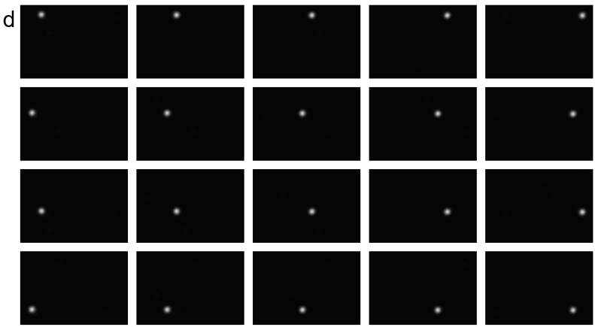
Supplementary Figure 5. (a) The output intensity matrix after the calibration of SLM1. (b) The output intensity matrix after the calibration of SLM0. (c) The output intensity matrix of the calibrated DFT matrix with the input matrix of its inverse matrix. (d) The measured CCD images (rotated for readability) when the input matrix is the conjugate transpose of the DFT matrix.
Supplementary Note 4: The fidelities of different transformation matrices
In Supplementary Note 3, the results of the 20-D DFT matrix has verified the validity of our OVMM system. In this section the fidelities of the three matrix transformations of model 1-3 are discussed. Since their inverse matrices usually do not consist of the column vectors with equal norms like DFT matrices, here the output intensity matrices corresponding to the calibrated input identity matrices (like Supplementary Fig. 5(b)) are used to evaluate the transformation fidelities. The results are shown in Supplementary Fig. 6. It can be seen that the two matrices are very similar in each model. The fidelities of the intensity matrices are 0.9989, 0.9994, and 0.9969 for model 1-3 respectively. Such results indicate that our OVMM system is also capable of achieving the matrices with highly different elements.
Supplementary Figure 6. The comparison of the normalized theoretical and experimental output intensity matrices for model 1-3. (a) (b) The results of model 1. (c) (d) The results of model 2. (e) (f) The results of model 3.
Supplementary Note 5: The accuracy of the output intensity vectors
Besides the matrix fidelity, the accuracy of the output vectors also needs to be investigated since the output vectors are directly corresponding to the Hamiltonians. Here, the accuracy of the output vectors is evaluated with two parameters.
According to the main text, there should be a constant coefficient $K=1/E_{0}^{2}=H_{exp}/H_{theo}$ (samples with $H_{theo}=0$ are excluded) between the theoretical Hamiltonian and the experimental Hamiltonian, which is the first parameter representing the accuracy of the norm of the output intensity vector. The raw experimental Hamiltonian evolution curves obtained from the captured CCD images of model 1-3 are shown in Supplementary Fig. 7(a)-(c) respectively. Actually, the target of the PEIDIA is to obtain the spin vector of the ground state, rather than the actual value of the Hamiltonian. Thus, the accepted spin vectors in each iteration corresponding to all curves in Supplementary Fig. 7(a)-(c) are extracted to calculate the theoretical Hamiltonians with Eq. (1) in the main text for model 1-5, and the results are shown in Supplementary Fig. 7(d)-(f) respectively. From Supplementary Fig. 7(d)-(f) it can be seen that most curves converge to the ground state Hamiltonians denoted by the black dashed lines ($H=-26, -66, -62,-83,-117$ for model 1-5 respectively) in the end, but their corresponding experimental Hamiltonians are distributed within a small range. To find out the reason, the average value of $K$ of each run of model 1-3 is calculated according to $H_{exp}$ and $H_{theo}$ of the actually sampled states rather than the accepted states, and the results are shown in Supplementary Fig. 7(g)-(i) respectively. It can be seen that there are obvious fluctuations in the average value of $K$, which is caused by the slow fluctuation of the laser power. The variation of $K$ in each run is mainly resulted from the various non-idealities of the OVMM system, such as the systematic error and the detection noise. It can be seen that the average values of $K$ only change a little between two adjacent runs, so we assume that the laser power is approximately constant during each run. Hence, each experimental Hamiltonian evolution curve should be normalized with its own average value of $K$, and the results are shown in Supplementary Fig. 7(j)-(l) and for model 1-3 respectively. Such results indicate that our OVMM system possesses relatively high accuracy.
The second parameter is the fidelity $f_{vec}$ of the output intensity vector, which is defined as
$$\begin{aligned}f_{vec}=\frac{\sum_{i}{{\left(I_{exp}\right)}_{i}{\left(I_{theo}\right)}_{i}}}{\sqrt{\sum_{i}{{\left(I_{exp}\right)}_{i}^{2}}\sum_{i}{{\left(I_{theo}\right)}_{i}^{2}}}}, f_{vec}∈\left[0,1\right], \#\left(S30\right)\end{aligned}$$
where $I_{exp}$ and $I_{theo}$ denote the experimental and theoretical output intensity vectors, respectively. Such fidelity represents the parallelism between the two vectors. In the main text, the vector fidelities of model 1-5 have been discussed with the high average values of 0.99978±0. 00039, 0.99976±0.00044 and 0.99942±0.00131, respectively. Besides, the time stability of the fidelity is also investigated. Supplementary Fig. 8 shows the average fidelity of each run of model 1-3 respectively. It can be seen that there is no obvious degeneration of the average fidelities, indicating that our OVMM system is quite stable.

Supplementary Figure 7. (a)-(c) The experimental Hamiltonian curves of model 1-3 respectively, which are calculated according to Eq. (S7). (d)-(f) The theoretical Hamiltonian curves corresponding to (a)-(c) respectively. (g)-(i) The average value of $K$ of each run of model 1-3 respectively. (j)-(l) The normalized experimental Hamiltonian curves of model 1-3 respectively.
Supplementary Figure 8. The average fidelities of each run of model 1-3. The inset shows the corresponding Ising models.
Supplementary Note 6: Operation speed and energy consumption
The time cost per iteration $T_{iter}$ in optical domain depends on the propagation time of light $T_{p}$, the modulation time of the SLM1 $T_{m}$ and the detection time of the CCD camera $T_{d}$. The distance between the SLM1 and the CCD camera is ~1.5m in the experiment, hence in a single iteration, $T_{p}$=5ns. Although the updating of the new SLM1 pattern only needs appending a phase delay mask to the old one, it still requires matrix operations with dimensions of 1920×1080 (same as the SLM resolution), which takes about $T_{m}$=0.15s. Likewise, the transmission and processing of the CCD image (resolution of 230×340) take about $T_{d}$=0.17s, while only intensities of $N$ pixels at beam centers are needed. Hence the time cost in the optical domain per iteration is $T_{o}=T_{m}+T_{p}+T_{d}$≈0.32s. The time cost $T_{e}$ of the rest operations of an iteration in the electronic domain is much less than $T_{o}$ and is negligible. Thus, the total time cost per iteration is $T_{iter}$≈0.32s. In each iteration, the OVMM can perform $F={2N}^{2}+2N$ floating-point operations (FLOPs)¹¹, including ${2N}^{2}$ multiplications of $Aσ$ and $2N$ multiplications of the element-wise product of the output amplitude vector in the complex field. Take model 3 as an example, for $N$=30, the operation speed of the OVMM is $R=F/T_{iter}=$5.80kFLOP/s.
In the experimental demonstration, the power of the input laser is about 2.59μW, 2.07μW and 6.01μW for model 1-3 respectively. The energy consumption mainly depends on the sensitivity of the CCD camera in our current demonstration. With the employed camera, the laser power of $P_{l}$=6μW is able to achieve high enough SNR in the experiment of model 3, and the maximum power of the camera is $P_{c}$=16W. Thus the energy consumption is $e_{ff}=\left(P_{l}+P_{c}\right)/R=$2.75mJ/FLOP.
In the future PEIDIA, high-performance modulators and photodetectors could be utilized. The total energy consumption in the optical domain is $P=P_{s}+P_{m}+P_{d}$, where $P_{s}$, $P_{m}$ and $P_{d}$ are the power of the optical source, phase modulators and photodetectors, respectively. For instance, Each photodetector ($B_{p}$>100GHz)¹² has a responsivity of ~0.8A/W and a bias voltage of ~-1V, which performs a power consumption of 0.8$α$mW with the input power of $α$mW. Thus, the total maximum power of the photodetectors is $P_{d}$=0.8$αN$mW ($N$ is the spin number). As the energy efficiency of our OVMM system is $\frac{1}{\sqrt{N}}$⁶, the input laser power could be estimated as $P_{s}$=0.8$αN^{\frac{3}{2}}$mW. Referred to the experimental input laser power, $α$≈3.62×10⁻⁵, 2.89×10⁻⁵ and 4.57×10⁻⁵ for model 1-3 respectively, and we tale the average $α$=3.69×10⁻⁵. In ref. ¹³, the $a_{1}$=1cm long, $a_{2}$=800nm height modulator has an $a_{3}$=3μm gap and $V_{π}$=0.85V at 838nm wavelength. Regarded as a parallel plate capacitor, the modulator has a capacitance of $C_{m}=ε_{0}ε_{r}a_{1}a_{2}/a_{3}$. According to ref. ¹⁴, $ε_{r}$=43, hence $C_{m}$≈1.02pF and the power consumption of each modulator is $p_{m}=\frac{1}{2}C_{m}V_{π}^{2}f_{m}$≈12.8mW under the modulation rate $f_{m}$=35GHz. However, the iteration speed $T_{iter}$ is mainly limited by the time of the light propagation ($T_{iter}=5ns≫f_{p}^{-1},f_{m}^{-1}$). Hence the modulation rate of $1/T_{iter}$=0.2GHz is enough, which corresponds to an energy consumption of $p_{m}=\frac{1}{2}C_{m}V_{π}^{2}/T_{iter}$=73.3μW for each modulator. Therefore, for $N$=100, the total energy consumption $P=P_{s}+P_{m}+P_{d}=\left(0.8αN^{3/2}+0.073N+0.8αN\right)mW≈7.33mW$, and the corresponding energy efficiency is $e_{ff}=\frac{PT_{iter}}{F}=$1.81fJ/FLOP. For comparison, the energy consumption of other photonic Ising machines and the state-of-the-art GPU are listed in Supplementary Table 1, which indicates that the PEIDIA has potential to achieve a very low energy consumption.
 | Ref. ¹⁵ based on SLM | INPRIS¹⁶ | PEIDIA | Future PEIDIA | NVDIA A100 GPU¹⁷
Number of spins | ~70000 | 4 | 30 | ~100 | Very large
Solvable models | Limited | Arbitrary | Arbitrary | Arbitrary | Arbitrary
Computation speed | — | 32GFLOP/s | 5.81kFLOP/s | 4.04TFLOP/s | 624TFLOP/s
Enegy consumption | — | 2.25pJ/FLOP | 2.75mJ/FLOP | 1.81fJ/FLOP | 641fJ/FLOP
Supplementary Table 1. Comparisons of performances among PEIDIA, other photonic Ising machines and GPU. “—” means the relative parameter is not mentioned in the corresponding reference.

Supplementary References:
1. Abdi, H. The eigen-decomposition: Eigenvalues and eigenvectors. Encyclopedia of measurement and statistics 304–308 (2007).
2. Kirkpatrick, S., Gelatt Jr, C. D. & Vecchi, M. P. Optimization by simulated annealing. science 220, 671–680 (1983).
3. Van Laarhoven, P. J. & Aarts, E. H. Simulated annealing. in Simulated annealing: Theory and applications 7–15 (Springer, 1987).
4. Ingber, L. & Rosen, B. Genetic Algorithms and Very Fast Simulated Reannealing: A comparison. Mathematical and Computer Modelling 16, 87–100 (1992).
5. Wang, Y., Potoček, V., Barnett, S. M. & Feng, X. Programmable holographic technique for implementing unitary and nonunitary transformations. Physical Review A 95, 033827 (2017).
6. Zhao, P. et al. Universal linear optical operations on discrete phase-coherent spatial modes with a fixed and non-cascaded setup. Journal of Optics 21, 104003 (2019).
7. Hjorungnes, A. & Gesbert, D. Complex-valued matrix differentiation: Techniques and key results. IEEE Transactions on Signal Processing 55, 2740–2746 (2007).
8. Delen, N. & Hooker, B. Free-space beam propagation between arbitrarily oriented planes based on full diffraction theory: a fast Fourier transform approach. JOSA A 15, 857–867 (1998).
9. Liu, L. et al. On the variance of the adaptive learning rate and beyond. arXiv preprint arXiv:1908.03265 (2019).
10. Li, S. et al. Programmable coherent linear quantum operations with high-dimensional optical spatial modes. Physical Review Applied 14, 024027 (2020).
11. Shen, Y. et al. Deep learning with coherent nanophotonic circuits. Nature Photon 11, 441–446 (2017).
12. Vivien, L. et al. Zero-bias 40Gbit/s germanium waveguide photodetector on silicon. Optics express 20, 1096–1101 (2012).
13. Renaud, D. et al. Sub-1 Volt and high-bandwidth visible to near-infrared electro-optic modulators. Nat Commun 14, 1496 (2023).
14. Kim, W. K., Yang, W.-S. & Lee, H.-Y. Effects of parasitic modes in high-speed LiNbO₃ optical modulators. Opt. Express, OE 12, 2568–2573 (2004).
15. Pierangeli, D., Marcucci, G. & Conti, C. Large-scale photonic Ising machine by spatial light modulation. Physical review letters 122, 213902 (2019).
16. Prabhu, M. et al. Accelerating recurrent Ising machines in photonic integrated circuits. Optica 7, 551–558 (2020).
17. NVIDIA A100 | Tensor Core GPU. www.nvidia.com/content/dam/en-zz/Solutions/Data-Center/a100/pdf/nvidia-a100-datasheet-nvidia-us-2188504-web.pdf.

