Supplementary materials
- Presentation of study variables.
Variables | Variable Definition | Corresponding question | Expected effect | Justification of the expected effect
Food Resilience | Household capacity to maintain consumption at least equal to its pre-crisis situation for three dimensions of food security (number, quantity and quality of meals). | The following question is asked for the three periods: During period P, how did your eating situation change compared to the period before Covid-19 with respect to (i) number of meals; (ii) the quantity of meals and (iii) the quality of the meals? | None - endogenous variable of the model | None - endogenous variable of the model
Government Food Aid | These variables are equal to 1 if the household has received the relevant social protection measure | Did your household benefit from state or third party aid? | Social protection measures, if effective and in line with the needs of beneficiaries, should have a positive impact on household food resilience. | Some social protection mechanisms relax the budgetary constraint of households, which allows them to improve their food situation. Other mechanisms should directly affect their food security, including food aid. However, this depends on the quantity and quality of the aid received.
Free electricity
Household basket (UN)
ARC-Replica Help
Family Fellowship Program
Universal health coverage
Equal opportunities card
Sesame Plane
Office of the Food Safety Commissioner
Aid of religious organizations | These two variables are aid implemented by private or community organizations. The survey does not provide enough information on their content, nature, distribution period, however they are included as it could have an effect on household food resilience. | Did your household benefit from state or third party aid?
Community Association Support
Migrant remittances | This variable is equal to 1 if the household received migrant transfers | Did your household receive transfers from a migrant in 2020? | Migrant transfers could have an insignificant or positive effect on household food resilience. | Given the negative effects of the crisis on the main destination countries for Senegalese migrants, receiving migrant transfers may no longer allow households to be resilient. However, if transfers did not vary significantly, there could be a positive effect of this variable on food resilience.
Diversity of income sources | This variable is equal to the number of sources of household income | What are the sources of household income (in 2020)? Income from agriculture; Livestock income; Fishing income; Non-agricultural income (handicrafts, transport); Wages; Retirement pensions; Money transfers from the country; Money transfers from abroad; Property income, investment and savings; Friends/family/relatives; Prog. Nat. Family scholarships; Other government assistance; Aid from NGOs and other charitable organizations; Commercial income; Other (specify) | Income diversity is expected to positively impact household food resilience, however in the context of Covid-19 this effect may be different. | The diversification of the income portfolio makes households less vulnerable to shocks to certain activities. However, Covid-19 had a negative impact on economic activity and many job losses were observed, which could limit the impact of this variable on resilience.
Age of head of household | This variable gives the age of the head of household. | What is the age of the head of household? | None | None
Household size | This variable gives the size of the household and was calculated from the census of household members. This variable is then compared to the household size given by the respondent. | Please provide the number of adult residents (over 64 years of age); the number of adult residents aged 15 to 64; the number of resident children aged 6 to 14; the number of resident children up to 5 years of age); and the number of migrants who have left for less than 6 months. | None | None
Gender of head of household | This variable gives the type of household head. It is equal to 1 if the head of household is a man and 0 if it is a woman. | What is the gender of the head of household? | None | None
Level of education (secondary) | This variable is equal to 1 if the head of household has a level of education (French or Koranic) at least equal to secondary school. | How educated is the head of household? Primary; College; Secondary; Superior. | Education should have a positive impact on household resilience | Assuming that the most educated heads of households have more job opportunities.
Main activity of the head of household | This variable gives the main activity of the head of household | What is the main activity of the householder?  Agriculture; Breeding; Fishing; Hunting; Crafts; Transport; Employee/manager; Official; Liberal professions; Trade/sales; Retired; Idle/unemployed; Other (please specify) | Depends on the activity concerned and the effect of Covid-19 and restrictive measures on it. | None
Consumption expenditure (log) | This variable gives the log value of consumer spending per household day. | What is the average amount of food expenditure per household day? | Consumer spending is expected to have a positive impact on household food resilience | The more a household spends on its food, the more resilient it should be to the quantity and quality of its meals.
Price shock | This variable is equal to 1 if the household has experienced an increase in food prices. | Has your household experienced an increase in food prices since the start of the pandemic? | A positive price shock is expected to have a negative impact on household food resilience. | Higher prices reduce household access to food. An increase in inputs lowers output and negatively impacts household food resilience.
Periods | To capture heterogeneity between periods, the first wave of Covid-19 was divided into 3 sub-periods:  - P1: 23 March to 30 June 2020;  - P2: from ^{1 July to 30 September;}  - P3: from ^{1 October to 31 December.} | None | Positive or negative depending on the specificities of the period considered. | Periods with fewer restrictions should positively impact the resilience of households (conversely).

- Map of the Niayes area in Senegal.
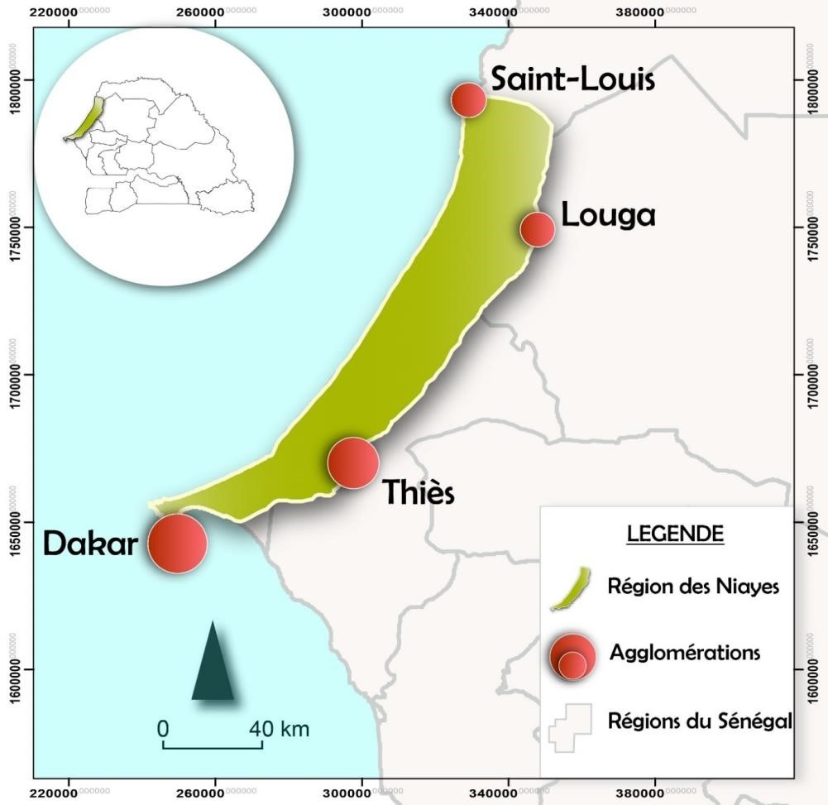
Source: Diop (2018)

